
Personal Development Plan
By

Wing Yan Yuen (1813127)
BCs Cloud Computing

Table of Contents
I. INTRODUCTION ................................................................................................................ 2
1. PERSONAL OVERVIEW ........................................................................................... 2
II. PERSONAL DEVELOPMENT PLAN ............................................................................... 3
1. Brief ………………..................................................................................................... 3
2. Skills Evaluation.......................................................................................................... 3
2.1 Higher Education ………………........................................................................ 3
2.2 Employability....................................................................................................... 4
2.3 Action plans both short-term and long-term goal................................................ 5
III. DATAP ROTECTION ....................................................................................................... 6
IV. TIME MANAGEMENT AND ORGANISATION............................................................ 7
V. EVALUATION BY TOOLS .............................................................................................. 8
VI. CONCLUSION ................................................................................................................ 11
VII. REFERENCE LIST ........................................................................................................ 12
APPENDICES………............................................................................................................. 13
1. PERSONAL PRESENTATION......................................................................................... 13

- INTRODUCTION
- PERSONAL OVERVIEW

This article is related to my personal background and character analysis. In the beginning, I would like to introduce myself briefly to let you know me better.

First of all, my name is Wing Yan Yuen. I was born in Hong Kong which is in China. Hong Kong becomes a famous financial city because of the location nearby sea. One reason is that big ships have to stop in Hong Kong harbour and transport their goods into China. Another reason is a low tax rate in company profit tax. Lots of start-up companies and overseas companies are willing to set the base in Hong Kong for getting into China market. So, it is a competitive and fast-changing city which I was living for 27 years. I have four siblings and we are living in a big house.

Since I graduated from secondary school, I have studied subjects like information technology and finance for getting into financial market in Hong Kong. I started in Associated Degree in Hong Kong. However, I had to drop out to work a full-time job after my family finance turned into a bad situation.

With regarding this situation, I had several experiences in fields which are a sale, a project operator, an insurance seller and a merchandiser. Based on what I have been experienced, I started to think about what my career path is and what I want to become.

I was working in the clothing industry as a merchandiser. The job is an operator between production factories and ordering companies. I could reach some data on production and sales. At the same time, I have learnt some analysis skills from my managers. But it was not having many applications or technologies helping past few years. the analysis skill was based on their experience past few 30 years. In fact, the skill of which they passed to me might contain personal adjustment or opinions. It causes the correction of data analysing to be big differences on each order. However, since the big data being popular, more and more companies would like to use big data to help their business sales, like focusing to target customers to boost their profit or cutting off some unnecessary cost in operations etc. that's why I have made my decision into this field to create my career path.

In the past 10 years, the global environment has been changed rapidly because of internet innovation. more and more related to information technologies degrees and courses started to be popular. Since I was a teenager. I was interested in analysing and problem-solving. after inspiration by my associated degree, I chose to study at the University of Wales Trinity Saint David with the BCS cloud computing. In order to develop my successful career path, I would like to use some personal development tools to analyse my characters and SWOT skills to improve my weakness and enhance my strength.

II. PERSONAL DEVELOPMENT PLAN (PDP)
1. Brief

Personal development planning enables a person to make a clear plan for a future or own learning. Based on the PDP, a person becomes a proactive learner in the process, designed and prioritised to support immediate developments need in short-term and long-term goals. PDP includes several purposes to develop people skills or behavioural attributes. Those three purposes are enhancing performance in their own current role, addressing anticipated changes in their own current role and addressing career aspiration towards a future role (Peter and Alan, 2016) . In the following section, I would like to apply some tools for my own PDP.

2. Skills Evaluation
2.1 Higher education

The learning skills in higher educations would be different from secondary schools. In higher education institutions or above. the whole learning process relies on the students' input effort. Based on basic skills in academic skills such as research skills, writing skills, listening skills and reading skills, there are several skills as mentioned by the lecturer in academic and employability skills lectures.

First one of the skills is adaptive skills. The Cleverism.com has mentioned a skill refers to the ability of a person to change his actions, course or approach to doing things in order to suit a new situation. (Cleversim, 2019). The skill is able to effect changes in a course of action with smoothness and timeliness, without any major setbacks. For example, during students studying in a higher education institution, the skill would be developed by setting goals, achieving the action plan etc. In fact, when students set the short-term and long-term goal, students would adjust their own action to achieve the goal whenever the new situation. students still can change their action with a small adjustment. the skill will be developed by times pass studying in higher education.

The second one is the transferable skill. Dr Deesha defined that the skills are developed within one situation (education) and are useful when transferred to another working area. And also, the Department for skills and Education (DfES, 1995) identify that skills as those cognitive and interpersonal skills such as application of number, communication, information technology, problem-solving, personal skills, working with others and improving own learning and performance are central to occupational competence in all sectors and at all levels. In the higher education situation, most of us know that the situation is similar to the working society. As mentioned above, it includes several important skills which are able to use those skill both learning and employment. For example, communication skill and problem-solving skill are a crucial skill which we apply it every day. students could develop that skill by writing the assignments or presentations, even though in conversation with school mates. students would learn how to explain or express their thoughts or opinions during studying. Another skill such as problem-solving skill is developed by some case analysis and finding some solutions.

In order to express those skills, I would apply those skills in my learning analysis plan by using Learning styles analysis tool provided by Brainbase (Peter and Alan, 2006).
In a class test, the score of mine is 34 that means I am the activists. the activists mean they would love to involve themselves into a fully new experience with enthusiastic being domination. They are open-minded with anything new. however, they act first without considering the consequence. they are easier to get bored from one activity and busy to look for the next one. It is impossible for them to maintain the long-term goal because they tend to thrive on the challenge of new experiences and seek to centre all activities around themselves.

2.2 Employability

Since the employability environment is changing rapidly, some skills might be required to be developed well when we are an employee.

As being successful employees, we should be being ready for developing those skills as following.

First of all, the skills are communication skill and interpersonal skills in a working environment. it would be slightly different from school. the employees would be able to express their ideas with professional terms and receive people feedback to improve their own ideas. the employee should explain what they mean with a clear and concise way through written and spoken means, whenever listening and reacting upon key information and instructions.

Secondly, organization skill is also important when we work. the employees should be organised and methodical and be able to plan work to meet deadlines and targets. and also, they should be able to monitor the progress of work to ensure the progress on track to meet a deadline. Also, the employee should be able to set priority tasks which are mainly focused to be finished as fast as it can.

Thirdly, Team working is being a crucial part skill in working place. the employees should be able to work well with colleagues with different ideas and disciplines, backgrounds and expertise to accomplish a task or goal. Employees should consider themselves as team player. They are willing to share ideas without competitive thoughts and see the whole team as part of themselves.

Last but not least, Negotiation skill is required in working place nowadays. employees should be able to take on board other people's feelings and express their own requirements in an unemotional way to achieve a win-win outcome. Why is the negotiation skill important? It becomes more important which employees should be able to communicate with third parties to make the plans or process to become as they want. Lack of negotiation skills would become as argument with their own emotional feelings.

2.3 Action plans both short-term and long-term goal
As studying in a cloud computing course, there are a short-term goal and a long-term goal based on me.
__________________________________________________________________________
Short- term goal (finished my study years)
- developed and enhanced the academic skills in the first year
Long-term goal (become business data analysist)
- developed well with problem-solving skill, personal skills, communication skill and critical thinking after three years.
__________________________________________________________________________
As a short-term goal, it would be focused on learning the theories and practical skills from lectures, such as the practical skills of creating the networking environment, theories of database design etc. Basically, in the short-term goal, the skills are focusing on academic skills which are writing skill, listening skill, reading skill and numeric skill etc. The purpose of the first year of cloud computing course is creating the environment to let me be an efficient learner. those skills would be developed by finishing a short-term goal.

As a long-term goal, it would be slightly different from the short-term goal. As preparation for being into an employment environment, those skills would be developed within studying in the cloud computing course. For example, problem-solving skills would be developed by applying database design. database design requires students to organize the data and recreate an advanced database design based on clients’ requirements. During these three years, I would be analysis many cases by using the problem-solving skill. and then, I would be able to enhance my communication by expressing my ideas and thoughts.

III. DATA PROTECTION

Since the technologies and the internet are more and more popular, data protection is becoming the main issue of all users to avoid personal privacy and data to the public. Past few years, the news presented lots of personal data to be exposed in public. For example, Facebook captures users’ data to sell to third party to gain profits. It becomes crucial issue for all users to use the free application or tools in Internet world. It causes all users to be caution about personal data privacy. In China, local news also mentioned the privacy of users in China would be zero protection. The news presented couples of users’ background were stolen by overseas hackers, like financial report, personal health report and privacy contact details. So as following, I would like to discuss some data threats and protection. There are several common treats in information as discussion following.

Firstly, some application designer would set a back door which allows a user to circumvent security procedures in order to gain full access to information systems. For examples, Torrents became popular few years ago. Users were easily to download files from online servers to their own computer. Those files might contain the back-door coding for hacker to get access to users’ computer. It might cause the camera in computer which turn on and film the daily life of users.

Secondly, they might set a logic bomb as known as a time bomb, a logic bomb is a destructive computer program that activates at a certain time to trigger a reaction or damaged. Some illegal application would be let user download instead of buying legal version. But user could normally use the illegal version in the beginning. After certain setting by hackers, it would trigger the software damaged because they have gained the access by certain time. The worst case is that the whole computer would be broken down.

Last but not least, the usual crime would be data theft. some software present as free to let users download it. but it contains some code to steal sensitive information or make unauthorised changes to computer records. It is normal crime in the Internet nowadays. For example, data analysis is becoming important thing to companies. Google provides google map for free to use. But they are collecting all the locations information when people use it. It causes lots of sensitive issue in deep down.

In my own data protection, I would like to save my data in several place. Apart from storing in my computer and USB, I would also store my data in the cloud services, such as Dropbox and iCloud. One of reasons is convenient. I could get access anywhere to use my data when I need it. Another reason is protected loss of my all data. Sometimes, it happens data loss in computer when I got repair or suddenly broken down. The iCloud service provided by Apple company is successful tool for apple devices users. Most of their devices are connected to iCloud, like mobile phone, apple watch and computers. When users have Wi-Fi, the data and photos will upload to the iCloud. When people change to new iPhone or other devices, they still get back all of personal data.

IV. TIME MANAGEMENT AND ORGANISATION

What is the meaning of time management? According to Mindtools.com has mentioned " time management " is the process of organizing and planning how to divide their time between specific activities. If people with good time management are able to work smarter not harder. the result is that people get more done in less time, even when time is tight, and pressures are high.

During studying in UWTSD, I need to monitor the process of my studying with time management skill.
Skills as following:
- goal setting
- prioritisation
- self - awareness
- self - motivation

As the beginning of the study year, I have set my goal of studying and career path which is business data analysis. As my study goal, I have set the final credit in the third year which should be the first honour graduate. and then, according to this goal, I would be organising my prioritisation of every single whole week. being an organization would boost my time using efficiently. At the same time, I am always being self-awareness about my actions to achieve my plan and always think positive to my plan.
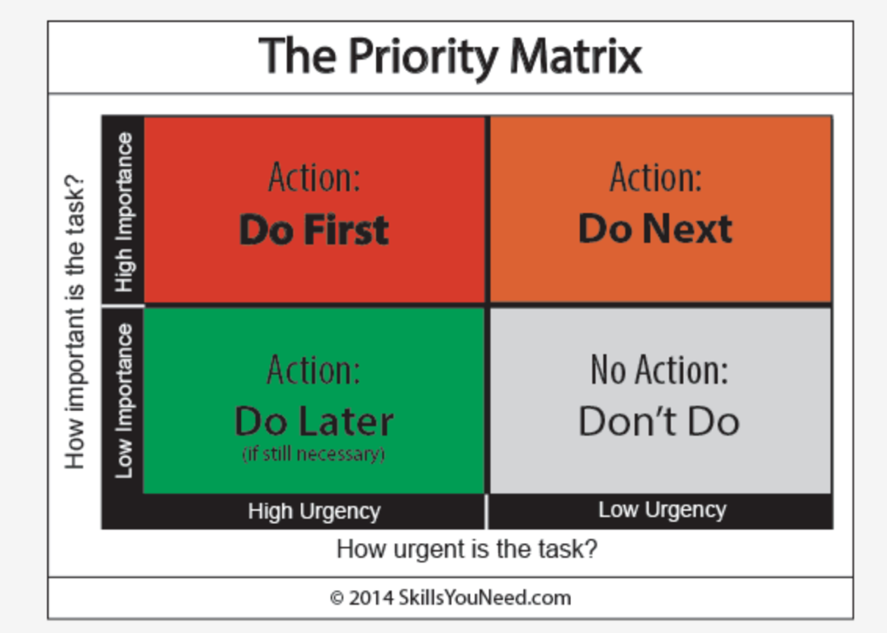
(Sourced by skillyouneed.com)

V. EVALUATION BY TOOLS

TEST YOUR SKILLS ANS FINDS THE RESOURCES THAT WILL HELP YOU MOST

Instructions
For each statement, click the button in the column that best describes you. Please answer questions as you actually are (rather than how you think you should be), and don't worry if some questions seem to score 'in the wrong direction'. When you are finished, please click the 'Calculate My Total' button at the bottom of the test

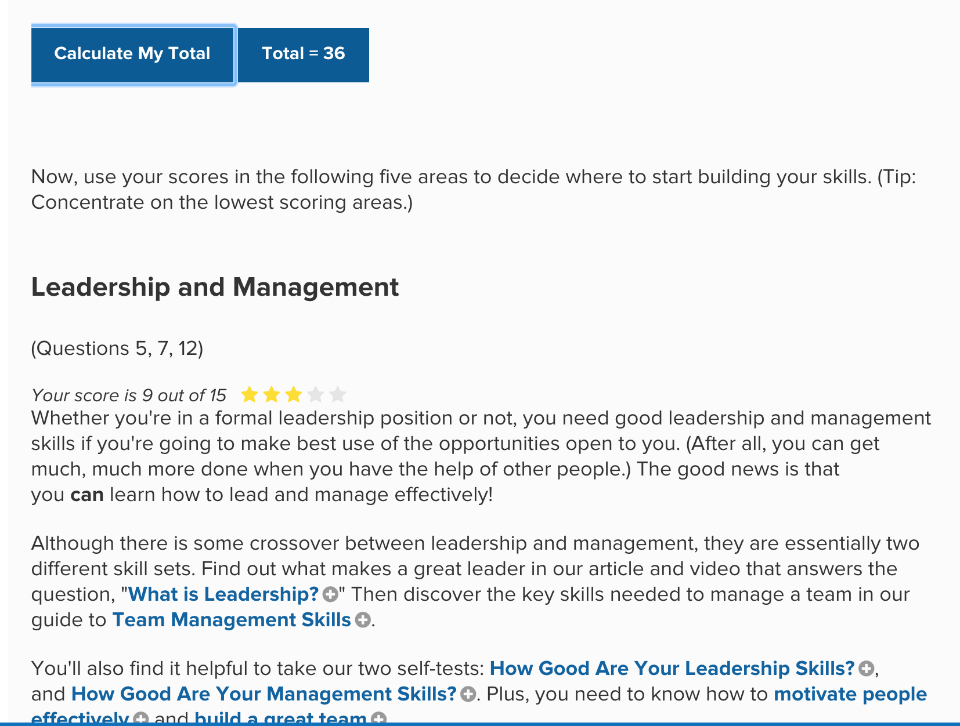
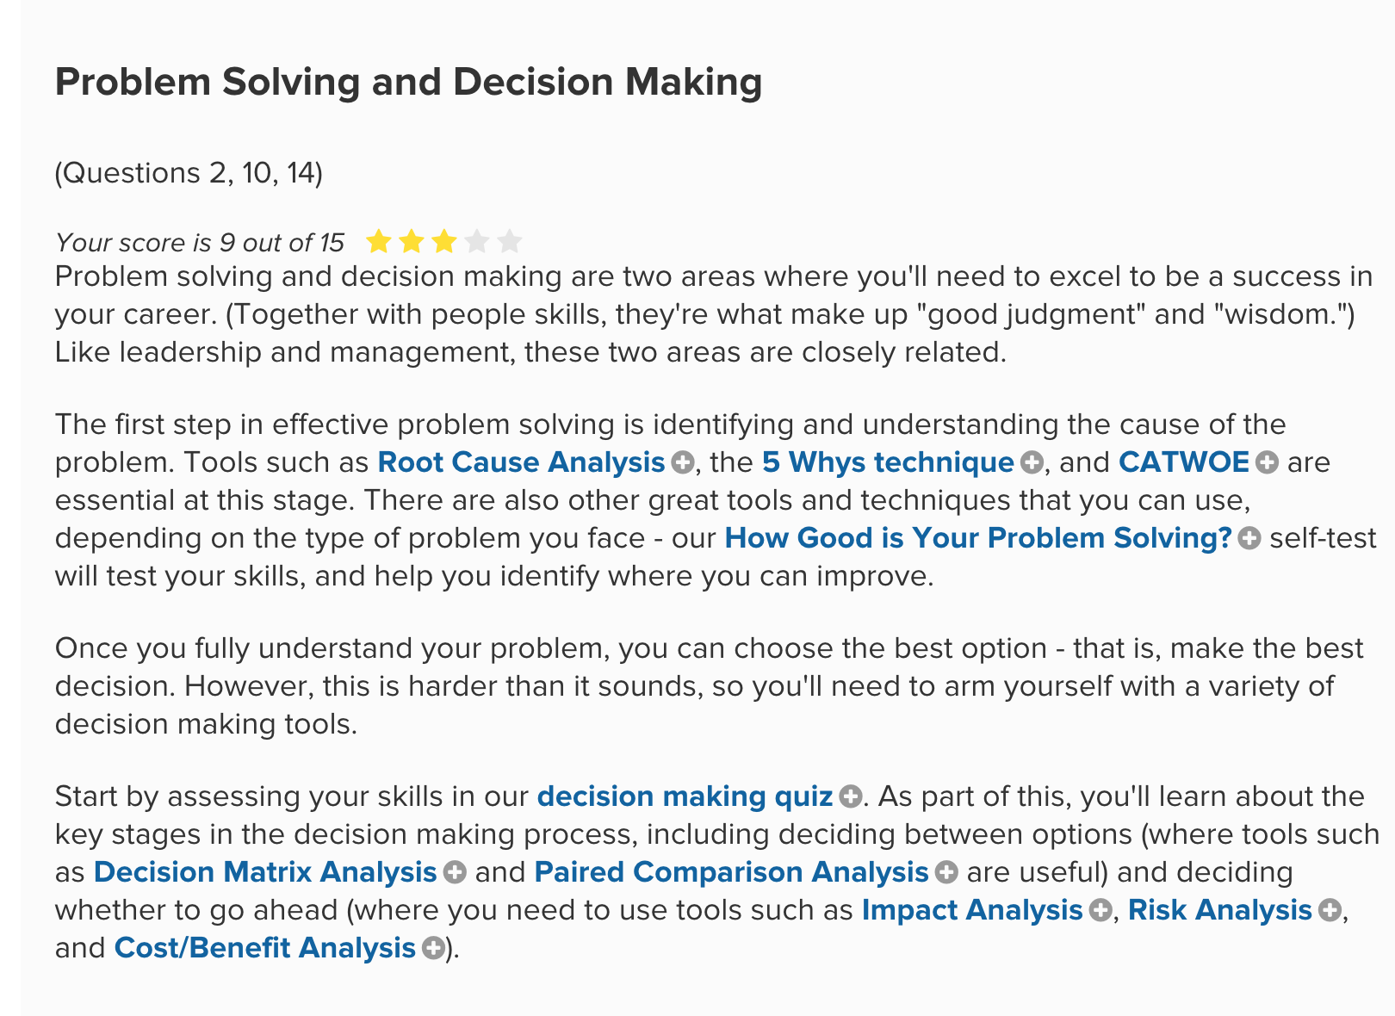
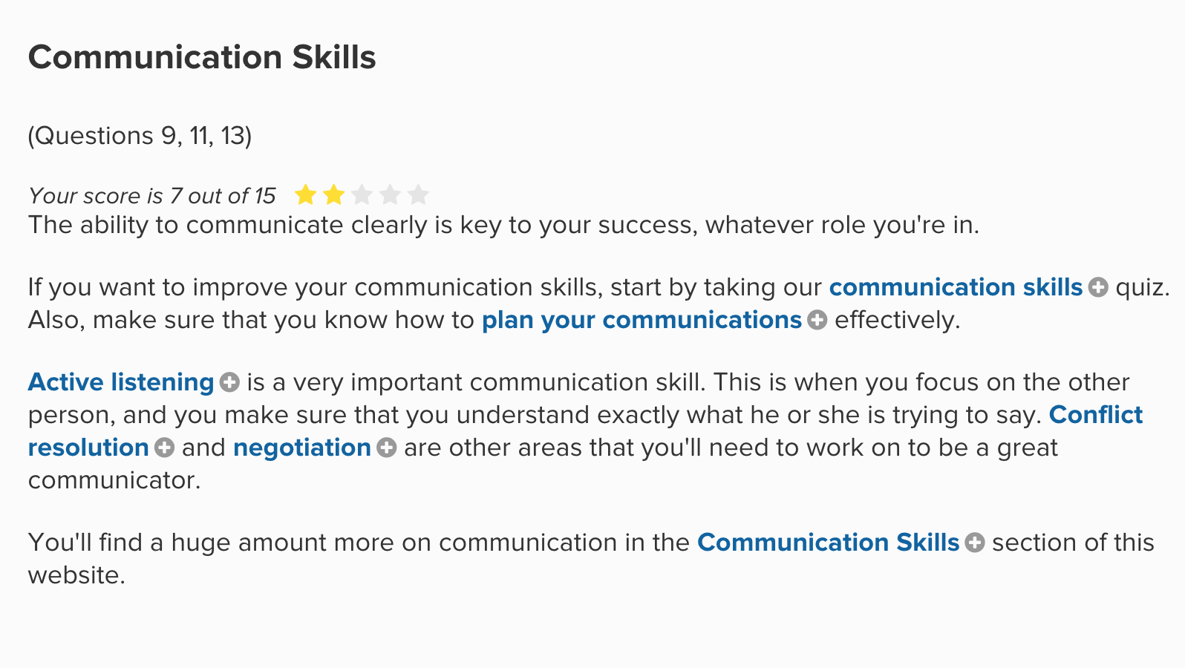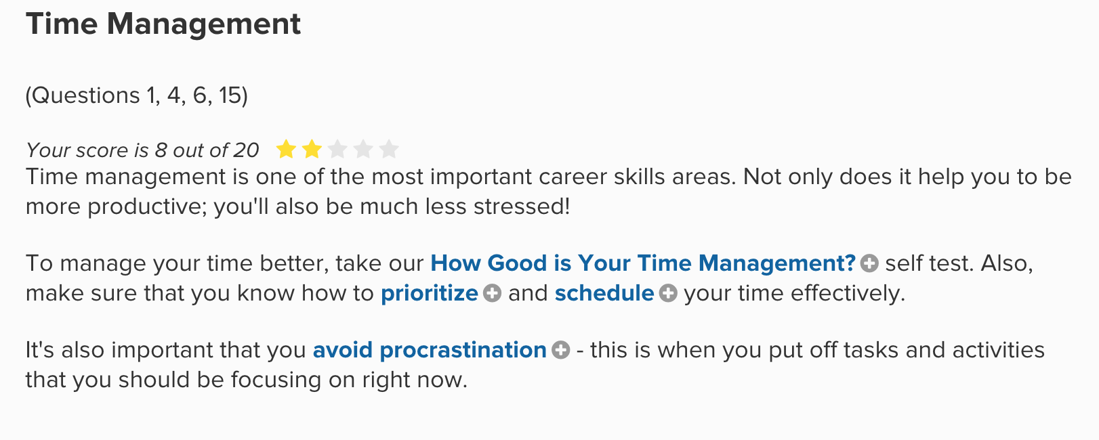
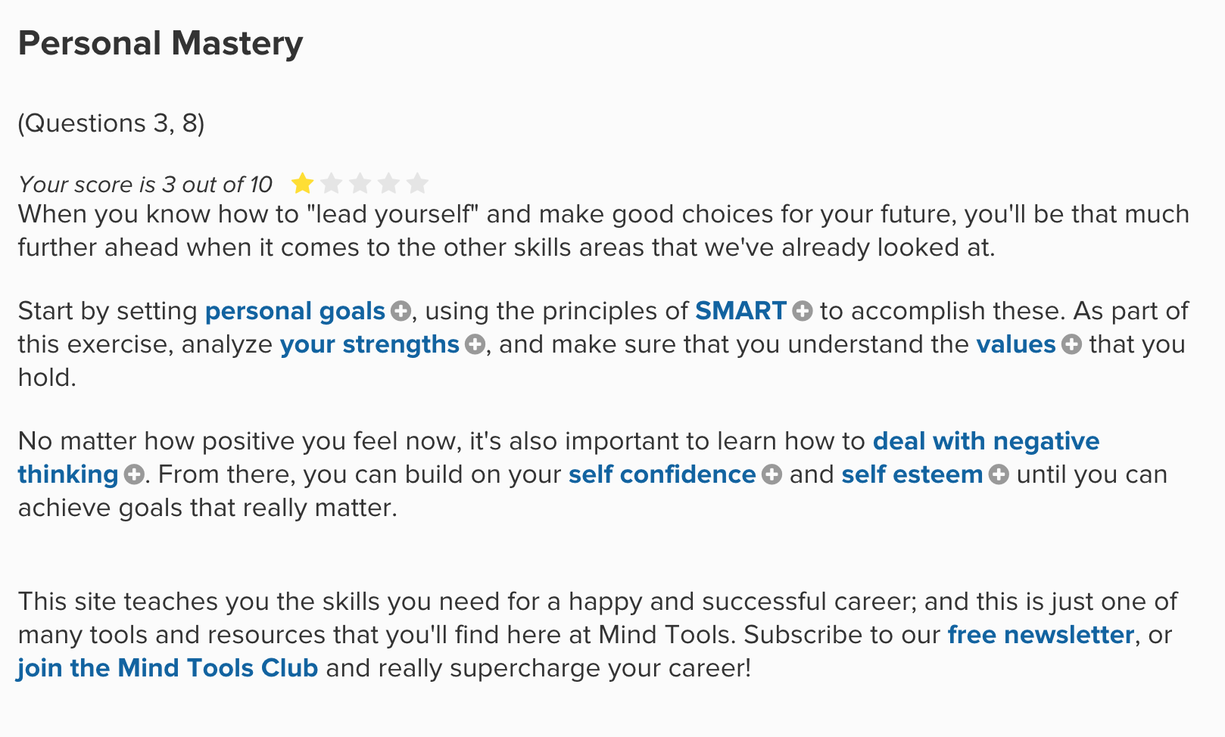
(Sourced by Mindtools.com)

VI. CONCLUSION

It is long process to be a valuable person with time investing and maintains. Individuals would be able to set a clear goal for themselves and have to put lots of effort to learn skills to become what they want. But the important thing is individuals being confident to face the challenge. Thinking positive is another important reason to keep themselves going through the whole process.

VII. REFERENCE LIST

Cleverism “Adaptability skills” u.k.
https://www.cleverism.com/skills-and-tools/adaptability-skills/. [accessed u.k.].

Exeter “Employability skills” u.k.
https://www.exeter.ac.uk/ambassadors/HESTEM/resources/General/STEMNET%20Employability%20skills%20guide.pdf . [accessed u.k.].

Mind tools “Time Management Definition” u.k.
https://www.mindtools.com/pages/article/newHTE_00.htm. [accessed u.k.].

Coachingpositiveperformance “17 Essential time management skills” u.k.
https://www.coachingpositiveperformance.com/17-essential-time-management-skills/. [accessed u.k.].

Mind tools “Test your skills and find the resources that will help you most” u.k.
https://www.mindtools.com/pages/article/get-started.htm . [accessed u.k.].

Stephen, F. and Christine, S. (2000) Integrating key skills in higher education. London: Kogan Page Limited, Pentonville.

Dr. Deesha, C . (2003) ‘Teaching Transferable Skills to Undergraduate Enginering Students: Integration is not the only way”, Kings College London ,2005.

APPENDICES

- PERSONAL PRESENTATION



