MODULE NAME : Project Management
MODULE CODE : LCLM5003
STUDENT NAME: Svitlana Stretynska
STUDENT ID : 2415554
LECTURER: Sukhpreet Grewal
ASSIGNMENT TITLE: A Project portfolio.

Part A: Poster

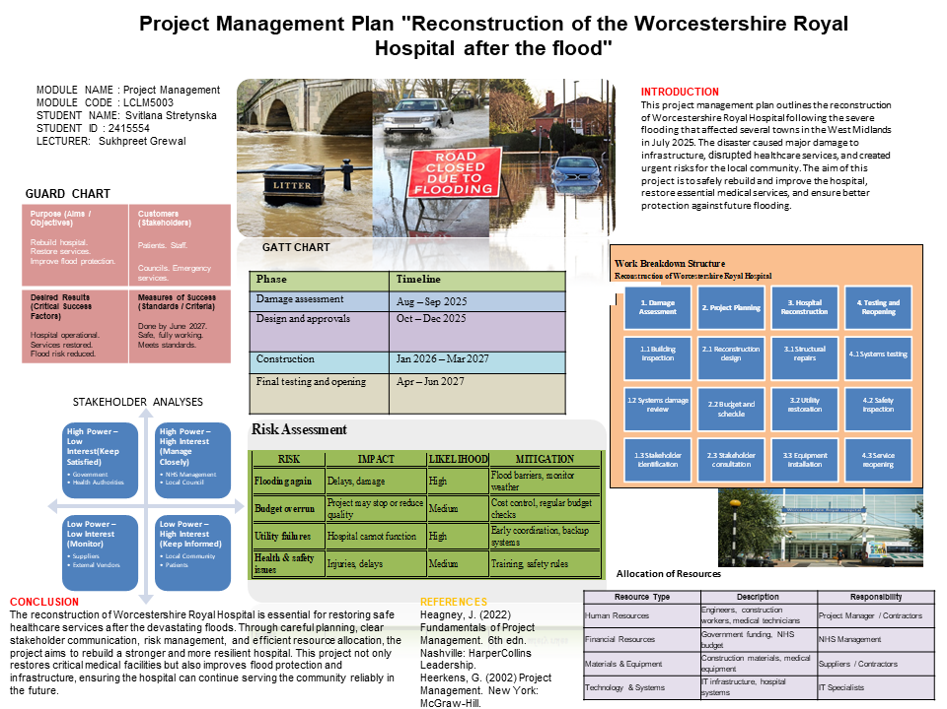

Part B: Reflection on Feedback

After presenting my poster, I received clear and useful feedback from my tutor and peers. This feedback helped me better understand the strengths of my work and the areas that require improvement in my final project plan.
The most important comment was related to the overall aim and scope of my project. In my poster, I focused on the full rebuilding and reconstruction of the hospital over a period of two years. However, it was pointed out that this approach does not match the task requirements. The main objective of the project is to address the damage caused by the flood and to reopen the hospital within a short time frame of approximately two months. This means that my initial plan was too broad and not aligned with the expected outcome. In my final project, I will revise the scope and focus only on essential repair works. I will also adjust the timeline to reflect a two-month recovery period, making the plan more realistic and suitable for an emergency situation.
Another positive aspect of my work was the stakeholder analysis. It was noted that this section was clear, well-structured, and included the main stakeholders such as NHS management, government bodies, and patients. However, it was also highlighted that I need to provide more detail about communication with stakeholders. In particular, I should explain how progress updates will be delivered. In response to this feedback, I will include specific communication methods in my final project. For example, I will propose weekly email reports for key stakeholders, regular meetings with management, and clear updates for the local community. This will demonstrate a more complete and practical communication plan.
In addition, important feedback was given on the risk management section. While I identified relevant risks, my mitigation strategies were too general and lacked clear actions. It was suggested that I need to explain exactly what steps will be taken if a risk occurs. In my final project, I will improve this by providing more specific mitigation measures. For instance, in case of delays in materials, I will include backup suppliers. If there is a shortage of staff, I will plan the use of temporary workers. This approach will make my risk management more detailed and practical.
Finally, the resources section requires further development. It was noted that my description of resources was too general and did not include enough detail. In my poster, I only mentioned broad categories such as human resources, materials, and equipment. In the final project plan, I will expand this section by providing more specific information. This will include the number of workers required, the types of equipment needed, estimated costs, and clear responsibility for each resource. This will improve the clarity and quality of the plan.
In conclusion, the feedback showed that my project has a clear structure and a strong stakeholder analysis, but also highlighted the need to correct the project scope and add more detail in key areas. By addressing these points, I will be able to produce a more focused, realistic, and well-developed final project plan.

Part C: Project Management Plan

MODULE NAME : Project Management
MODULE CODE : LCLM5003
STUDENT NAME: Svitlana Stretynska
STUDENT ID : 2415554
LECTURER: Sukhpreet Grewal
PROJECT MANAGEMENT PLAN: "Reconstruction of the Worcestershire Royal Hospital after the flood"

Table of content:
1. Introduction ________________________________________________6
2. Project description ___________________________________________7
3. Scope______________________________________________________8
4. Work breakdown structure_____________________________________9
5. Quad Chart_________________________________________________10
6. Gantt Chart_________________________________________________11
7. Stakeholders' involvement_____________________________________12-13
8. Allocation of resources________________________________________13-15
9. Risk Analysis________________________________________________15-17
10. Conclusion_________________________________________________17
11. References_________________________________________________18

1. Introduction

In July 2025, serious flooding in the West Midlands disrupted operations at Worcestershire Royal Hospital. The event created urgent operational and safety challenges that required a structured response. Healthcare buildings are critical assets because communities depend on them every day. When a hospital is damaged by a natural disaster, the impact goes beyond the building itself. Patients may lose access to treatment, staff face difficult working conditions, and nearby organisations must manage extra demand. For this reason, recovery projects in healthcare settings require fast decisions, careful planning, and strong coordination. A formal project management approach is necessary to organise recovery work, control time and cost, and ensure that services can return safely.
This Project Management Plan sets out how the recovery project will be managed from initiation to completion. It applies recognised project management principles such as clear objectives, defined responsibilities, scheduling, stakeholder engagement, resource planning, and risk control (Project Management Institute, 2021; Turner, 2023). These principles are especially important in emergency environments where delays can affect public wellbeing.

2. Project Description
The project concerns the physical and operational recovery of Worcestershire Royal Hospital after flood-related disruption. It is a short-term restoration programme focused on returning affected facilities to usable condition and enabling hospital departments to resume priority services.
Work will cover a range of connected activities. Building teams will repair damaged internal areas, replace affected finishes, and restore access routes. Engineering specialists will inspect and recover electrical supply, ventilation, water systems, and other essential utilities. IT personnel will check network connections, communications equipment, and digital systems needed for hospital operations. Clinical teams will inspect medical spaces and confirm readiness before reopening.
Because the site is a healthcare environment, all activities must follow strict safety and compliance standards. Infection control procedures, safe contractor access, noise control, waste handling, and protection of patients in unaffected zones will be required throughout delivery. Each area will be handed back only after inspections and approvals are complete.
The project will be managed through daily coordination between estates staff, contractors, hospital leadership, and service managers. Progress will be measured against milestones, budget limits, and operational readiness targets (Heagney, 2022). Any issues that threaten completion dates or safety standards will be escalated quickly for action.
Successful completion means affected parts of the hospital are functional, compliant, and ready to support patient care again, with selected improvements that reduce vulnerability to future flooding events (NHS England, 2023).

3. Scope
The project scope defines what work will be completed. It ensures that the project remains focused and manageable.
The project includes all urgent actions needed to make affected areas of Worcestershire Royal Hospital safe and ready for normal use again. This includes damage inspections, cleaning of flooded spaces, removal of waste, drying works, minor structural repairs, replacement of damaged floors and walls, and testing of key building systems. It also includes checks of electrical supply, water systems, heating, ventilation, alarms, and fire safety equipment.
The scope also covers operational preparation for reopening. This includes room inspections, equipment checks, IT reconnection, staff access arrangements, signage updates, and final health and safety approval. Temporary measures to lower future flood impact, such as moving equipment to higher storage areas and improving local drainage, are also included where possible.
Project management activities are part of the scope. These include planning, scheduling, budget control, contractor coordination, progress reporting, stakeholder communication, and risk monitoring. Regular review meetings will be used to track delivery and solve issues quickly (Heagney, 2022).
A clear scope helps control time, cost, and quality. . These three elements are equally important and must be balanced (Kerzner, 2022). A change in one element will affect the others. For example, reducing the time available may increase the cost due to the need for additional labour or faster delivery of materials.
In this project:
- Quality must meet the prescribed requirements
- Time is fixed at two months
- Cost must remain within the available budget - £8,5 million
The final result of the agreed scope is a safe and usable hospital environment that can support patient services again.
4. Work Breakdown Structure
The Work Breakdown Structure (WBS) divides the project into smaller tasks. This improves planning and coordination.

Table 1. Work Breakdown Structure

The WBS follows a logical sequence from assessment to reopening. Each phase depends on the completion of the previous phase.
The WBS also helps assign responsibilities. Each task can be linked to a specific team. This improves accountability and reduces confusion.
In addition, the WBS supports time and cost estimation. By breaking the project into smaller tasks, it is easier to estimate how long each task will take and how much it will cost (Heagney, 2022).

5. Quad Chart

A Quad Chart is a simple one-page tool that shows the most important parts of a project. It helps stakeholders understand the project quickly by presenting key information in four sections (Heagney, 2022).
The Quad Chart provides a clear summary of the project.
TABLE 2. Quad Chart

The Quad Chart is useful for communication with stakeholders. It allows them to quickly understand the project goals and progress. This supports better decision-making (Association for Project Management, 2020).
This Quad Chart gives a clear summary of project priorities, outputs, timeline, and control factors. It supports quick review by managers and other stakeholders (Project Management Institute, 2021).

6. Gantt Chart
The Gantt Chart is an important project management tool that shows the project schedule in a visual way. It presents the timeline of the project across eight weeks and shows when each major activity starts and finishes. It also helps the project team understand the order of tasks and the dependencies between them. A dependency means that one task must be completed before another task can begin. Because of this, the Gantt Chart is useful for planning, coordination, and control of project activities.
Table 3. Gantt Chart
 | Week 1 | Week 2 | Week 3 | Week 4 | Week 5 | Week 6 | Week 7 | Week 8
Project planning
Site recovery
Systems recovery
Operational readiness
Reopening and closure

The Gantt Chart helps monitor project progress throughout all stages. It clearly shows which tasks are completed, which tasks are currently in progress, and which tasks are delayed. If delays happen, the project manager can quickly identify the problem and take corrective actions such as reallocating resources or changing priorities.
The chart also helps identify critical activities. These are tasks that must be completed on time because any delay in these tasks may delay the whole project. For example, if site recovery is delayed, systems recovery cannot begin as planned.
Regular updates to the Gantt Chart are necessary during the project lifecycle. By reviewing progress every week, the project manager can compare planned progress with actual progress and make informed decisions. Therefore, the Gantt Chart is not only a planning tool, but also an effective control tool that supports successful project completion (Project Management Institute, 2021).

7. Stakeholders' involvement
Stakeholders are individuals, groups, or organisations that are affected by the project and have an interest in its results. Their support is important because they can influence project success, provide resources, make decisions, or be directly impacted by project activities.
Stakeholders are commonly analysed according to two key factors: power and interest. By understanding these two factors, the project manager can choose the most suitable engagement strategy for each stakeholder group.
Table 4. Stakeholder analyses.

Stakeholder Engagement Strategy
Different communication methods should be used because each stakeholder group has different needs, expectations, and levels of involvement.
- Weekly written reports for NHS management to provide updates on schedule, risks, budget, and recovery progress.
- Weekly meetings for key decision-makers to discuss urgent issues, approve actions, and review milestones.
- Daily internal communication within the project team to coordinate tasks, solve operational problems, and manage resources effectively.
- Public updates through official channels, websites, and media to inform patients and the community about service availability and reopening plans.
Clear communication helps reduce uncertainty and build trust. It also ensures that stakeholders understand project progress and any issues that arise (Too and Weaver, 2014).

8. Allocation of resources
Effective resource allocation is essential for completing the project on time and within budget. Resources include people, money, materials, equipment, and technology. If these resources are planned and controlled correctly, the recovery project can progress smoothly with fewer delays and lower risk. In a hospital recovery project, resource management is especially important because healthcare services must be restored as quickly and safely as possible.

Human Resources
A multidisciplinary team is required because the project includes construction work, technical recovery, equipment installation, and operational planning. Each group has different skills and responsibilities.
- Project Manager (1) – responsible for overall leadership, coordination, scheduling, communication, and control of project activities. The project manager also monitors risks, budget, and progress.
- Engineers (10–15) – responsible for structural inspections, safety assessments, repair design, and technical approval of building works.
- Construction workers (20–30) – responsible for carrying out physical repairs, rebuilding damaged areas, cleaning, and preparing the site for reopening.
- Electricians and plumbers (10–12) – responsible for restoring power supply, lighting, water systems, heating, ventilation, and other utilities.
- IT specialists (5–7) – responsible for restoring networks, servers, patient systems, security systems, and data testing.
- Medical technicians (8–10) – responsible for installing, calibrating, and testing medical equipment before operations restart.

Financial Resources
The total project budget is £8.5 million. This budget is carefully allocated across key areas to ensure efficient use of resources and to support timely project completion.
The budget distribution is as follows:
- £3.4 million (40%) for construction and repair works, including structural repairs and utility restoration
- £2.5 million (29%) for replacement of damaged medical equipment and systems
- £1.7 million (20%) for labour costs, including skilled and temporary workers
- £0.9 million (11%) as contingency funds to manage unexpected costs and risks
Regular cost monitoring is applied throughout the project to ensure that spending remains within budget. Any deviation is reviewed and controlled by the project manager.

Materials and Equipment
The project requires a wide range of materials and equipment, including:
- Construction materials such as steel, concrete, glass, wiring, pipes, and paint
- Medical equipment such as beds, monitors, scanners, and treatment devices
- Safety tools such as protective clothing, barriers, alarms, and inspection tools
- Office and operational supplies for reopening hospital services
Reliable suppliers are necessary to ensure timely delivery. Delays in materials can slow down the whole project. For this reason, backup suppliers should also be identified in advance to reduce procurement risk.

Technology and Systems
Technology plays a key role in hospital recovery because modern healthcare depends on reliable digital systems.
Important technology resources include:
- IT systems for hospital operations such as patient records, appointment systems, finance, and internal administration
- Data recovery systems to restore important records securely and prevent data loss
- Communication tools such as email, mobile devices, project software, and emergency communication channels
- Security systems such as access control, CCTV, and cyber protection tools
Сareful allocation of resources is a critical factor in achieving successful project recovery and restoring healthcare services on schedule (Kerzner, 2022).

9. Risk Analysis
Risk management is critical in this project because the recovery process must be completed under conditions of uncertainty, limited time, and operational pressure. Early identification of risks allows the project team to reduce disruption, protect resources, and maintain project progress. The table below presents the main project risks, their probability, impact, mitigation measures, and response actions.

Table 5. Risk Analysis

 | Risk Description | Probability | Impact | Risk Level | Preventive Mitigation Measures | Corrective Actions if Risk Occurs | Responsible Team
1 | Delay in delivery of materials | Medium | High | High | Use multiple approved suppliers, place orders early, monitor deliveries regularly | Switch to backup supplier and prioritise critical materials | Procurement Team
2 | Staff shortage or labour unavailability | Medium | High | High | Agreements with recruitment agencies, maintain reserve workforce list | Hire temporary staff, approve overtime, reallocate internal staff | HR Team / Project Manager
3 | Hidden structural damage discovered during repairs | High | High | Very High | Conduct detailed inspections, engineering surveys, technical testing | Use contingency budget, revise repair plan, adjust schedule | Engineering Team
4 | Health and safety incidents on site | Low | High | Medium | Safety training, PPE use, regular inspections, daily briefings | Stop work immediately, investigate cause, apply corrective measures | Health & Safety Team
5 | Delay in delivery of medical or technical equipment | Medium | Medium | Medium | Order equipment early, confirm supplier timelines, track shipments | Use temporary or rented equipment until delivery | Procurement / Operations
6 | IT system failure during recovery process | Medium | High | High | Maintain backup systems, data backups, system testing | Activate backup systems and involve IT specialists urgently | IT Department
7 | Further flooding or water damage | Low | Very High | High | Install temporary flood barriers, monitor weather and drainage systems | Stop work, secure site, protect equipment, begin emergency response | Facilities Team
8 | Budget overrun | Medium | Medium | Medium | Cost monitoring, approval controls, regular budget reviews | Reduce non-essential spending, reforecast budget, request approval if needed | Finance Team
9 | Poor coordination between teams | Medium | Medium | Medium | Clear communication plan, regular reporting, defined responsibilities | Increase meetings, improve reporting lines, appoint coordination lead | Project Manager

This structured approach ensures that risks are identified, assessed, monitored, and controlled throughout the project lifecycle. Regular review of the risk register allows the project manager to respond quickly to new threats and changing conditions. Effective risk management increases the probability of completing the project safely, on time, and within budget (Hillson, 2020; UK Government, 2023).

10. Conclusion
This Project Management Plan has presented a clear and structured approach for the recovery of Worcestershire Royal Hospital after the July 2025 flooding event. The report has shown the importance of defined objectives, realistic scheduling, effective resource allocation, stakeholder involvement, and active risk management. These elements are necessary to restore healthcare services safely, quickly, and within budget. Strong coordination between technical teams, management, and external partners is essential for successful delivery. In conclusion, the project not only supports the return to normal hospital operations, but also provides valuable experience to improve resilience and future emergency preparedness.

11. References
Ahsan, K. and Gunawan, I. (2019) ‘Analysis of cost and schedule performance of international development projects’, International Journal of Project Management, 37(1), pp. 65–75.
Association for Project Management (2020) APM Body of Knowledge. 7th edn. Buckinghamshire: APM.
Heagney, J. (2022) Fundamentals of Project Management. 6th edn. Nashville: HarperCollins Leadership.
Heerkens, G. (2002) Project Management. New York: McGraw-Hill.
Hillson, D. (2020) Practical Project Risk Management. 3rd edn. Vienna: Management Concepts.
Kaikini, S., Sneed, R. and Wysocki, R.K. (2014) Effective Project Management: Traditional, Agile, Extreme. 7th edn. Indianapolis, IN: Wiley.
Kerzner, H. (2022) Project Management: A Systems Approach to Planning, Scheduling, and Controlling. 13th edn. Hoboken, NJ: Wiley.
Marnewick, C. and Marnewick, A.L. (2020) ‘Benefits of information technology project management offices’, International Journal of Project Management, 38(8), pp. 529–540.
NHS England (2023) Emergency Preparedness, Resilience and Response Framework. London: NHS England.
Project Management Institute (2021) A Guide to the Project Management Body of Knowledge (PMBOK® Guide). 7th edn. Newtown Square, PA: PMI.
Turner, J.R. (2023) Handbook of Project-Based Management. 5th edn. New York: McGraw-Hill.
UK Government (2023) The Orange Book: Management of Risk – Principles and Concepts. London: HM Treasury.

