HUMAN RESOURCE MANAGEMENT – ASSESSMENT 1
SUBMITID BY -Kiran Kalia

STUDENT NAME: Kiran Kalia
STUDENT ID NUMBER: 2216074.
MODULE: HUMAN RESOURCE MANAGEMENT –A1
LECTURER: Dr Gladius Kulothungan
COURSE: MASTERS OF BUSSINESS ADMINSTRATION GENERAL
SUBMISSION DATE: 4TH JAN 2023
PAGES: 15

Executive Summary
This assignment necessitates the writing of a report that analyses two topics. The first topic involves the current status of the UK labour market. The second topic posits the emerging changes in the post-Covid and post-Brexit scenarios. This report helps managers change their strategies to exploit changes in an organisation's external environment. Moreover, it can also help employees to grasp opportunities effectively. The introduction serves as an entry point concerning the report and outlines the main topics of the report. The second section involves assessing the current labour market in the UK. The third section prioritises the emerging changes in a post-Covid and post-Brexit scenario on human resourcing. Finally, the conclusion provides a closing statement to add closure to the report.

Table of Contents
Introduction 3
Current State of the UK Labour Market 3
Post-Covid and Post-Brexit Changes in Human Resourcing Strategies 7
Conclusion 10
References 12

Introduction
This report requires a close study of UK business environments by consulting several reliable and current sources. It is important to understand the present condition of the labour market to help the general population of the UK to take advantage of opportunities. Moreover, the report also identifies and assesses the impacts of Brexit and the Covid-19 pandemic to create changes in human resourcing in their aftermath. A specific focus is given to the changes in human resourcing strategies to motivate employees after the two major crises. The report might develop the perspectives of HR managers.

Current State of the UK Labour Market
The UK is still struggling with uplifting the labour market to meet the pre-Covid levels. Moreover, the drastic effects of Brexit require sufficient time for new policies to take place and the existing policies to become redundant. A brief outline through statistical data provides a generalised picture of the present labour market scenario in the UK.
It is estimated that the employment rate among employees aged 16 to 64 decreased by 0.2 percentage points or 75.4% between May to July 2022. However, self-employed and full-time employees increased while part-time work decreased. The unemployment rate decreased in the quarter and amounted to a 3.6% fall rate. There is a decrease of 21.75% in the economic inactivity rate of employees in the UK. It involves employees aged between 16-24 and 50-64 remaining unemployed due to education programmes and retirement/old age. The number of vacancies in the UK is estimated to have surpassed the largest quarterly fall since June to August 2020. The number of vacancies in May to July of 2022 is 1,266,000, which is a 3400 fall from the previous quarter. However, the number of workforce jobs increased as it reached more than the pre-covid levels with a 290,000 increase. Pay growth increased by 6% in the private and 2% in the public spheres (ons.gov.uk, 2022).
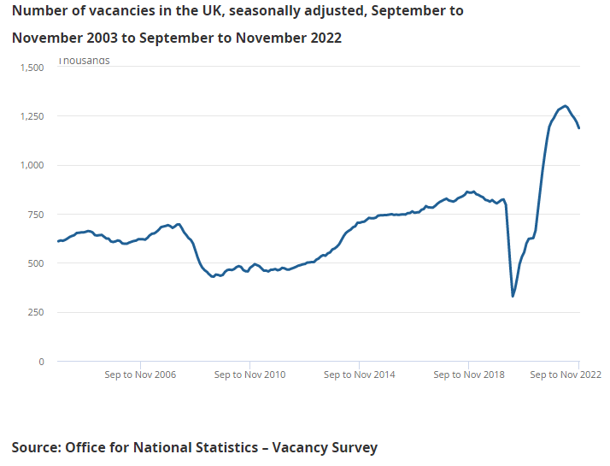
Figure 1: Graph showing a fall in the Number of Vacancies
(Source: ons.gov.uk, 2022)
Sustainability is a pressing issue as it is hallowed as the only solution to the ever-progressing negative effects of climate change. Climate change is caused by an increase in GHG emissions and an increasing carbon footprint enhanced by improper waste disposal, using non-biodegradable materials and deforestation. The existing renewable resources have reduced capacity due to ocean litter, landfill and air pollution. Rebecca et al. (2022) observed that bioenergy crops like the Miscanthus could serve as a biofuel for generating electricity and heat and reduce dependence on fossil fuels. It is posited to have high carbon calories but low ash content. The UK has vast arable lands for growing such crops. Hence, Miscanthus cultivation can serve as a ground for creating new jobs for existing employees as advanced jobs in R&D and management are supported along with labour-intensive jobs like farming. However, the uncertainty regarding the crops' effectiveness and financial return render the whole prospect redundant as the UK government and private sectors are hesitant. This instance proves that the UK needs to be more agile to embrace new ventures to improve the labour market scenario.
The UK harbours academic researchers employed using short-term contracts on long-term employment. This population lacks visibility in the country. The researchers involved in such a scenario involve candidates building a portfolio of skills for securing a lucrative career in the academic field by securing a high job position. Researchers with a research-only career and not opting for lectureship programmes also fall under long-term employment with short-term contract scenarios. Other researchers are adhering to such contracts merely by accident as they succumbed to systematic academic career obstacles (Menard and Shinton, 2022). The higher education sector needs universities and funders to give proper jobs to such researchers, as they might lose interest and give up on their aspirations. Such researchers might prove inconsequential to business organisations' R&D departments for creating innovative products and services. A lack of job provisions renders them ineffective, causing them to lose confidence.
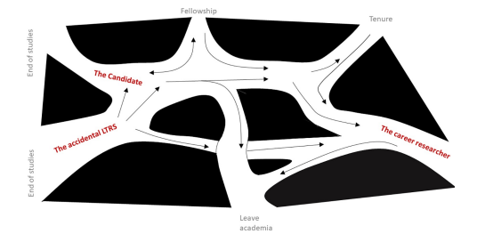
Figure 2: the Career Path undertaken by the Three Types of Researchers in the UK academic Field
(Source: Menard and Shinton, 2022)
The NHS, or the National Health Scheme, is a prospective employment ground for the UK's general population to seek healthcare jobs. It harbours doctors, nurses and caregivers interested in improving the health of others. Whitham et al. (2021) asserted that the field of podiatry proves lucrative as it offers high employability and professional autonomy for medical professionals. It also provides sufficient remuneration to keep the employees motivated. However, it receives declining applicants as the field cannot appeal to the gen Z population. Generation Z, or the employees born between the years 1995 to 2010, needed to be made aware of podiatry as a subject while contemplating career options. This situation leads to misconceptions regarding career availability in the UK health sector. There are 120 vacant positions for podiatry in the UK. Podiatry lacks role modelling in traditional and social media outlets leading to a decline in positive representation of the field. Role modelling becomes detrimental to attracting healthcare workers facing barriers regarding financial limitations, diversity, assessment methods and transport. Universities must establish a healthcare discipline course to improve knowledge of medical fields.
The advent of the Covid-19 pandemic led to an egalitarian distribution of market and domestic work for couples as men and women. Though most of the household chores were relegated to women, men took part in chores and gradually took up additional loads. Such practices led to a shift in lifestyle, and employees nowadays prefer hybrid work timings to better balance household obligations and jobs (Sönmez, 2021). Hybrid working involves employees' ability to interchange between remote working and traditional working from offices at their convenience. More employees are leaving their jobs as there is a drastic increase in remote-working prospects based on self-employment. Nowadays, employees prioritise their health and do not adhere to strict company rules that only benefit the company and render the employees ineffective in the long run. This issue is attributed as one of the reasons behind decreased or fluctuating employment rate (bbc.com, 2021).
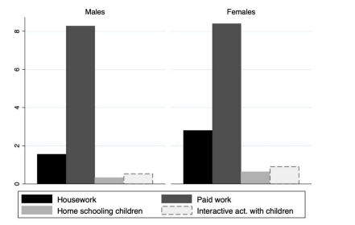
Figure 3: Graph showing Equal Distribution of Chores in the Household
(Source: Sönmez, 2021)
It is estimated that from 2010 to 2015, construction workers in the UK were prone to suicide due to intense mental stress. The disposable quality of low-skilled workers leads to susceptibility to mental illnesses. Construction workers are easily discarded if they encounter a health issue or fail to produce the desired work. Moreover, such workers are repeatedly transferred from one place to another despite their inconveniences. Furthermore, most workers are hired on a short-term temporary basis, leaving them with zero job security. IOSH, or the institution of occupational safety and health in the UK and Ireland, discovered that construction workers seek or come in contact with psychosocial therapy programmes less than other sectors. An integrated workplace mental health programme is effective for dealing with employees individually. A lack of individuality regarding employee management in certain fields is another reason behind decreasing employment rate. Part-time workers might feel inconsequential regarding their disposable job position and choose to become self-employed (Greiner et al., 2022).
Thus, the current state of the labour market in the UK is moderate as the job prospects are lacking. However, due to poor representation, most employees need to be aware of employment opportunities. Moreover, private and public sectors need more bravery and compassion to leverage a new venture and create individualised employee management programmes.

Post-Covid and Post-Brexit Changes in Human Resourcing Strategies
Post-Covid witnessed a reduction in the volume of work-related communication in the healthcare sector of the UK, primarily the NHS. Previously, the impact of work-related communication on an employee's work-life balance should have been more noticed. Employees were expected to give sufficient time for work-related demands and ignore their family issues if needed. The popularisation of digital communication, especially WhatsApp messaging and email, increased technostress as job-related queries disrupt an employee's time with family. The Covid-19 pandemic further exacerbated the situation as the sole reliance of organisations and employees was centred on digital communication. An overload in work-related communication causes excessive burnout and compromises the efficiency of employees. NHS included digital communication workloads in its staff survey and created a national project to understand patterns and variances in digital communication. The NHS well-being framework and helpline are used to provide support to employees suffering from burnout (Bakhai et al., 2022). Hence, the post-Covid change involved prioritising employees' mental health issues that the UK organisations previously neglected.
Sustainable human resource management is a type of human resourcing that involves an inclusive corporate culture that respects the gender, religion, ethnicity and personality of employees. Such a workforce witnesses zero glass ceilings as employees from marginalised backgrounds can gain promotions within an organisation without facing barriers. HR managers after Covid-19 consider the importance of employee mental health, job satisfaction, equity, inclusiveness and diversity. Another change from Covid-19 involves the flexible strategy that includes hybrid working and flexible office hours to enhance job performance and growth of employees. However, the flexible strategy is ineffective in overtime, shift working and flexible working hours (Azizi et al., 2021). Many notable UK-based organisations follow sustainable human resource management to ensure employee attrition in an uncertain time. Unilever is a reputed MNC in the UK that focuses on selling consumer goods and enjoys excellent popularity in different regions, especially South Africa, Brazil, the United Nations and the UK. It openly supports hybrid working to help employees, especially female workers, to support work-life balance. This change can impel other companies to adopt sustainable human resource management (careers.unilever.com, 2022).
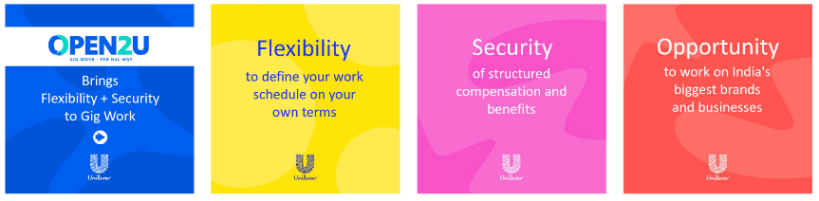
Figure 4: the Open2u Programme supports Sustainable Human Resource Management in Unilever
(Source: careers.unilever.com, 2022)
Kaluarachchi, Nartallo and Emuze (2022) observed that the construction industry in the UK employs 2.7 million employees and shares 6.02% of the GDP. This sector was significantly affected as there was a three times likelihood of employees committing suicide than employees in other jobs. Larger organisations in the UK can provide a well-structured well-being and mental health policy to ascertain employees' generalised mental health issues. Such a policy reduces the propensity of HR managers to micromanage and overwork employees. Small-scale organisations might lack adequate means but can provide individually tailored support to employees to create a sense of belongingness. The UK contains several mental health programmes like mental health champions, buddy schemes, mental health first aiders, mental health apps, free helplines and more that are out of reach of such employees. Post-Covid brought light to such issues and enabled employees to access such programmes for work efficiency.
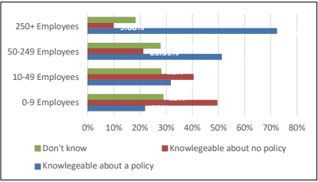
Figure 5: Construction Workers lack Knowledge regarding Mental Health Programmes
(Source: Kaluarachchi, Nartallo and Emuze, 2022)
It is deduced that post covid changes in human resourcing involved increased digitalisation and better stress management that combats workplace issues. It further compels organisations to prioritise the mental health of UK-based employees.
Post-Brexit involved removing foreign nationals from emergency homelessness in the UK government. Amidst widespread protests, the UK government modified its migration policies to include the "Everyone In" approach. However, this initiative should have addressed several groups causing unwanted nationals to get demoted from the UK. This outcome causes the human resourcing of certain organisations to lose migrant workers without having adequate time to recruit more labourers (Serpa, 2021). HR planners must participate in the enquiries undertaken by non-national employees from EU countries regarding their status in the country. HR managers must monitor employees' situations to determine their pre-settled or settled status. HR needs to embrace the change of employee monitoring to enable them to continue or discontinue working depending on their settlement status. The non-national employees with a certain status can gain access to benefits and pension plans (Luthra, 2021).
Green et al. (2020) asserted that HIA or health impact assessment is important for reducing inequalities and safeguarding employees' health. HIA is a flexible tool for assessing the effects of policies regarding the well-being and health of a specific population. HR managers can include this assessment in the support programme for employees as it would help them to assess the changes in employees due to Brexit. Wales already created the Health Impact Support Unit to understand the various determinants of health to reduce negative impacts undergone by marginalised communities. This emerging change can change the workplace atmosphere by emphasising employees' health rather than removing non-national and EU-based employees. Thus, HR managers can handle large-scale employee attrition by gradually preparing employees to persist or leave an organisation. Such an attempt can increase a company's reputation, and employees can feel acknowledged and supported throughout a gruelling process. HIA is formulated by the WHO or the World Health Organisation and is widely esteemed as reputable to implement in traditional and modern organisations to effectuate positive changes.
The post-Brexit scenario might create a war of talent as talent flow in the UK would become restricted due to strict rules in border areas and immigration. It becomes difficult for the UK government, public sector and private organisations to retain existing workers in low-skilled workers as EU workers might leave the UK due to unfavourable migration rules and lack of free facilities. HR managers are required to reskill job roles to allow workers from non-EU countries to accommodate UK-based organisations' requirements and efficiency criteria. Moreover, HR managers should adopt flexible arrangements for work to support a variety of employees from other countries. The UK government might change the rules regarding EU workers and attract employees from within the European countries. An HR manager needs to make strategies changeable and sustainable regarding future changes. Moreover, several European countries that are not part of the EU, like Switzerland, Norway, Iceland and more, might get attracted to the UK as managers and leaders reduce restrictions regarding employment opportunities (Ridgway, 2019).
Hence, it is proved that the emerging changes in human resourcing from post covid and post-Brexit scenarios impact mostly low-skilled workers as they impact their livelihood. Human resourcing shifted towards employee empathy. An increase in digitalisation is always deemed a strong point in the Covid-19 pandemic. However, the pent-up stress resulting from increased digital communication is met with mental illness programmes. Post-Brexit changes involve hiring labourers from non-EU countries and establishing health programmes for them to persist in a changing scenario.

Conclusion
In conclusion, it is stated that the current condition of the UK's labour market has sufficient potential to improve its labour market issues. There is a need for the UK government to increase job opportunities by agreeing to unique ventures. The temporary workers should gain visibility to regain their confidence and apply for better job opportunities. Moreover, the demands and individuality of workers require avoiding attention to align with the changing working environment. Post-Covid changes involved increasing attention given to employees through sustainable human resource management, digital communication stress, mental health programmes and more. Such changes shift attention away from profit-making to employee satisfaction, as human resources are critical for success. Post-Brexit changes involve monitoring the status of EU employees and establishing initiatives to support their livelihood.

References
Azizi, M.R., Atlasi, R., Ziapour, A., Abbas, J. and Naemi, R., 2021. Innovative human resource management strategies during the COVID-19 pandemic: A systematic narrative review approach. Heliyon, 7(6), pp.33-72. https://doi.org/10.1016/j.heliyon.2021.e07233
Bakhai, A., McCauley, L., Stones, L., Khalil, S., Mehta, J., Price, N., . . . Hughes, D. (2022). Shining a light on an additional clinical burden: Work-related digital communication survey study – COVID-19 impact on NHS staff wellbeing. Humanities & Social Sciences Communications, 9(1), pp.1-12. https://doi.org/10.1057/s41599-022-01427-7
bbc.com (2021). 'Hybrid working will become the norm' Available at: https://www.bbc.com/news/business-56331654 [Accessed on 16 December 2022]
careers.unilever.com (2022). Open2U. Available at: https://careers.unilever.com/open2u [Accessed on 16 December 2022]
Green, L., Ashton, K., Edmonds, N., and Azam, S. 2020. Process, practice and progress: A case study of the health impact assessment (HIA) of brexit in wales. International Journal of Environmental Research and Public Health, 17(18), pp.52-66. https://doi.org/10.3390/ijerph17186652
Greiner, B. A., Leduc, C., Cliodhna O’Brien, Cresswell-Smith, J., Rugulies, R., Wahlbeck, K., . . . Aust, B. (2022). The effectiveness of organisational-level workplace mental health interventions on mental health and wellbeing in construction workers: A systematic review and recommended research agenda. PLoS One, 17(11), pp.1-16. https://doi.org/10.1371/journal.pone.0277114
Kaluarachchi, Y., Nartallo, P., and Emuze, F. 2022. How the construction industry can improve the health and well-being of their workers in a post COVID-19 era. IOP Conference Series.Earth and Environmental Science, 1101(3), pp.1-11. https://doi.org/10.1088/1755-1315/1101/3/032013
Luthra, R.R., 2021. Mitigating the hostile environment: the role of the workplace in EU migrant experience of Brexit. Journal of Ethnic and Migration Studies, 47(1), pp.190-207. https://doi.org/10.1080/1369183X.2020.1726173
Menard, C. B., and Shinton, S. (2022). The career paths of researchers in long-term employment on short-term contracts: Case study from a UK university. PLoS One, 17(9), pp.1-17. https://doi.org/10.1371/journal.pone.0274486
ons.gov.uk (2022). Labour market overview, UK: September 2022. Available at: https://www.ons.gov.uk/employmentandlabourmarket/peopleinwork/employmentandemployeetypes/bulletins/uklabourmarket/september2022#:~:text=The%20most%20timely%20estimate%20of,since%20May%20to%20July%201974. [Accessed on 16 December 2022]
Rebecca, v. H., Hastings, A., Kam, J., Rowe, R., John Clifton‐Brown, Donnison, I., and Shepherd, A. 2022. Expanding the miscanthus market in the UK: Growers in profile and experience, benefits and drawbacks of the bioenergy crop. Global Change Biology.Bioenergy, 14(11), pp. 1205-1218. https://doi.org/10.1111/gcbb.12997
Ridgway, M., 2019. Brexit: human resourcing implications. Employee Relations: The International Journal. 41(5), pp.1033-1045. https://doi.org/10.1108/ER-11-2018-0310
Serpa, R. C. 2021. The exceptional becomes everyday: Border control, attrition and exclusion from within. Social Sciences, 10(9), pp.329-350. https://doi.org/10.3390/socsci10090329
Sönmez, İ. (2021). A missed opportunity for men? partnered and employed individuals’ involvement with housework during the COVID-19 lockdown in the UK. Social Sciences, 10(4), 135. https://doi.org/10.3390/socsci10040135
Whitham, D., Whitham, S., Trowell, M., and Otter, S. (2021). Podiatry as a career in the UK - what attracts generation Z? A qualitative exploration with university and college students. Journal of Foot and Ankle Research, 14, pp.1-12. https://doi.org/10.1186/s13047-021-00470-y

