Ways of thinking
By Chloe Wootten-Mitchell

Movement

Minimalism emerged as a reaction to the abstract expressionist movement SaatchiArt. (n.d.). Art History 101: Art History 101: Minimalism. [online] Available at: https://canvas.saatchiart.com/art/art-history-101/art-history-101-minimalism#:~:text=A%20Brief%20History%20of%20Minimalism [Accessed 26 Apr. 2024]. In the 1950s and early 1960s taking inspiration from constructivism and De Stijl. It rose to prominence in America in the 1960s and ‘70s. Also taking place at the time was pop art [1956] and Arte povera [1960].

The technique applied to creating a minimalist art form is to use a small range of prefabricated industrial materials. shapes, forms and colour to eradicate signs of authorship.

The intent behind the movement wasn't to make the viewer question anything but was to shatter any expectation of art or the meaning behind it. Emptied of external references, the art object’s literal presence – it’s physical qualities, relationship to its surroundings, and the phenomenological experience of the viewer encountering the work – is foregrounded.
It wasn't called minimalism at the start, it was an evolving idea for a new direction with the only a purpose to see art for what it is (reference). made purely because one felt like it with no further intent to create a deeper character (reference).

Minimalism is not only applied in art but also to Literature, Fashion; Architecture, Music, Performing Arts and Home Decor.

Practitioners

Several artists published articles helping to shape and identify the idea behind the minimalism art movement, pushing forward their idea of this newly discovered art form. Early Artists: Donald Judd (printer), Frank Stella (painter), Carl Andre (sculptor), Tony Smith (Sculptor) and Angus Martin (abstract painter) were pioneers in the conception of this movement and set out with the intent to explore new directions in their art.

Donald Judd – Sculptor and Painter
Born June 3, 1928
Died February 12, 1994
Studied at Columbia university and the Artist League of New York.

One of the earliest pioneers of minimalism, Donald Judd first started making figurative prints at the art students league, founded in 1875 by a group of artists whom where students at The National Academy of Design in New York and many of them where women with intent to find a new school. by the mid-1950s Judd was transitioning into abstract images, then in 1951 Judd had designed his first prints, initially working with lithographs then in 1953 branching out into woodcuts which then became his primary print medium.

Frank Stella - Painter and Sculptor
Born May 12, 1936, in the USA

Studied at Princeton university and the artist league of New York.

American painter who began painting houses and boats and became
a leading figure in the Minimalist art movement and later became known for his irregularly shaped works and large-scale multimedia reliefs.

In his early series, including the Black Paintings (1958–60), Aluminium Paintings (1960), and Copper Paintings (1960–61), Stella cast aside illusionistic space for the physicality of the flat surface and deviated from the traditional rectangular-shaped canvas.

He was inspired by Jasper Johns, Jackson Pollock, Barnett Newman, Franz Kline and Caravaggio

Carl Andre - Sculptor
Born September 16, 1935, in Quincy, Massachusetts

From 1951 to 1953, he attended the Phillips Academy, Andover, where he studied art under Patrick Morgan

American minimalist artist recognized for his ordered linear and grid format sculptures.

Originally a publisher. Wrote poetry and made drawings along with some abstract sculptures in Perspex.

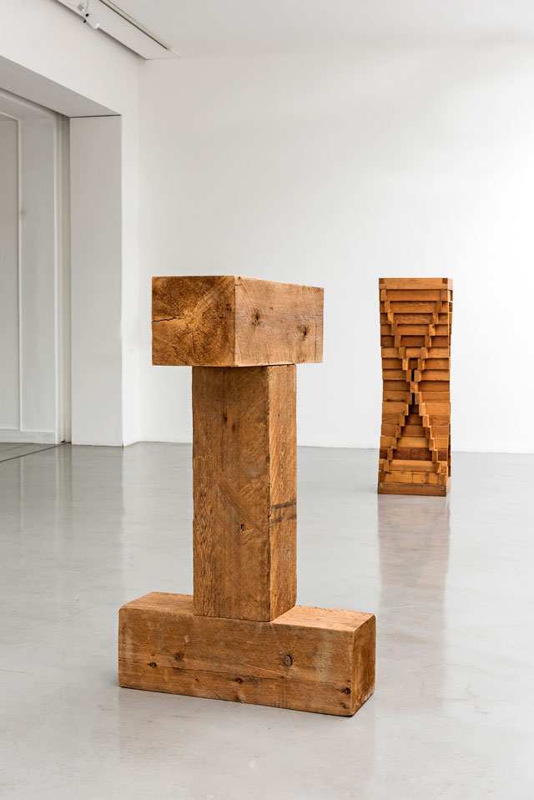
His experience with blue collar labour and the ordered nature of conducting freight trains would later influence Andre's sculpture and artistic personality.

Tony Smith - Sculptor
Born September 23, 1912, in South Orange, New Jersey.
Died December 26, 1980, in New York

Studied architecture at the New Bauhaus in Chicago and apprenticed with Frank Lloyd Wright, he was largely self-taught as an artist.

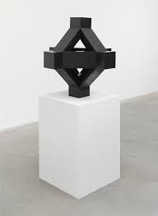
Considered a pioneer of Minimalism and a rare example of an artist who excelled in multiple media. Best known for his abstract sculptures created in the 1960s and 1970s,

Smith's often monumental sculptures, which he called “presences,” were based on geometric principles and simplicity of form, fundamental characteristics of Minimalist art.

Inspired by the works of James Joyce, Walt Whitman, Henry David Thoreau, and Friedrich Nietzsche

Angus Martin - Painter
Born March 22, 1912, in Canada
Died December 16, 2004
Age 92

For over 40 years she created serene paintings composed of grids and stripes. She was deeply influenced by Taoism and Zen Buddhism

Martin's artistic vision, blending minimalism and spirituality, remains an enduring and influential force in the realm of abstract art.
Quote ‘without an awareness of beauty, innocence, and happiness… one cannot make works of art.

Martin said her greatest spiritual inspiration was Lao Tzu's teachings on Taoism.

Prints using etching, aquatint and screen print techniques [Untitled, 1960-1961, printed 1978].
The Art Story (2015). Minimalism Movement Overview. [online] The Art Story. Available at: https://www.theartstory.org/movement/minimalism/.

Critics of the minimalist movement

Of course, like everything the minimalist art movement is not embraced without criticism. Notable artists and thinkers across the world have questioned the style for its lack of emotion, theatricality, and discontinuity. Comparisons to other forms of expression have constantly tried to undermine the philosophy behind minimalism.
there where critics and a following of people who didn't understand it or appreciate it as an art movement. Critics included Michael Fried, in his essay (Art and Objecthood, 1976) who describes the minimalism as Modernism gone wrong. And Art critic Clement Greenberg who described minimal art forms as mere novelty

Semiotics
‘The simplicity of ‘Minimalism created a new perspective of art and how the relationship between the meaning and the image affects the reception of this information. Artists such as frank Stella and Donald Judd who intended to explore new directions in their art wanting to create art that referred only to itself, allowing the viewer an immediate, purely visual response.

Identifying minimalism is easy as it consists of geometric shapes and harsh edges set out to challenge the ideas of what art is and what it could be. The personal semiotic elements are stripped away with the intent to reveal the purity of visual elements in art.’ The art piece (signifier) creates the opportunity to view the information received by the viewer in communication and interpret just this message (signified)

Practice

In my opinion minimalism was ahead of its time and yet, has aged beautifully and remains current today. It is a great concept as not everyone understands art and most look at it as a pretty picture.
Minimalism as a style which interests me as it makes the viewer focus on the art produced by the artist. The artist painted or sculpted whatever they wanted with no question of the meaning they wanted to portray just the viewer response to the art produced.

What interests me in this movement is the intent, the idea that everyone sees it exactly for what it is, it’s like a naked piece, no layers and nothing hidden behind it is purely created to exists as it is and not to be judged for what the intent was.
To make a point of this, in most museums you would expect to gush over beautiful paintings and learn more about historical artefacts, then seeing a few shapes carved from different materials not many would even notice, or if they did it would be seen as a few cubes randomly placed in the corner of the room, it is overlooked because it almost blends in. That is the beauty of minimalism it is seen for what it is, some find it boring, most question it but for a slight few it is the most recognisable art movement in the room.

Bibliography

The History of the Art Students League of New YorkThe Art Students Leaguehttps://theartstudentsleague.org › history-art-students-...

PrintsJudd Foundationhttps://juddfoundation.org › artist › art › print

Donald Judd 1928–1994Tatehttps://www.tate.org.uk › art › artists › donald-judd-1...

Minimalism | History, Characteristics, Artists - Sotheby'ssothebys.comhttps://www.sothebys.com › art-movements-minimalism

The 1950s | Central District of Californiauscourts.govhttps://www.cacd.uscourts.gov › historical-decades › 1950s
Tony Smith (sculptor)
Tony Smith Sculptures, Bio, Ideas

