Q1:In cloud computing we often use the terms Platform as a Service (PaaS) and Container as a Service (CaaS) when referring to the deployment of services. Compare and contrast these approaches and provide arguments for the role that Docker plays in providing such services. In your answer, identify the benefits and drawbacks of Docker.

A1: From the beginning of cloud computing, according to the definition, cloud computing is a kind of data processing method to obtain computing resources from the remote end through the network according to the needs. These computing resources are packaged as services to provide to users, and those who provide these services are called cloud service providers. According to NIST's definition, cloud computing services are divided into three categories, namely Infrastructure as a Service(IaaS), Platform as a Service(PaaS) and Soft as a Service(SaaS).
To understand IaaS, PaaS and SaaS, first define the On Premises, as shown in the following figure 1-1
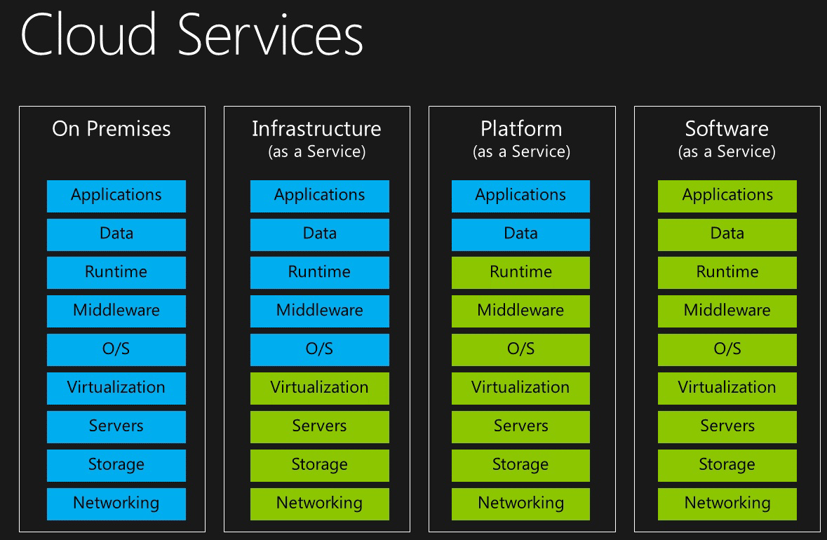
figure 1-1 Cloud services
On Premises means that users have all computing resources from network to application. In cloud computing, we divide these computing resources into three layers: infrastructure, platform, and software. As shown in figure 1-2
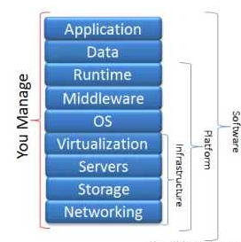
figure 1-2
The contents of each layer are as follows. According to which layers of user management and which layers provided by service providers, we divide cloud computing into three types, namely IaaS, PaaS, and SaaS
Simply put, in IaaS mode, cloud service providers provide infrastructure on which users deploy and run any software, including operating system and application software. Users do not have the right to access and manage the underlying infrastructure, such as servers, switches, etc., but they have the right to manage any function above the operating system. The common IaaS services are virtual machines and virtual network. Compared with local deployment, it can save money to purchase deployment server, network and other equipment.
Under PaaS mode, cloud service provider provides a complete development platform, including infrastructure and operating system, programming language, library, etc. users can directly develop on this platform, users do not have the right to access and manage infrastructure and operating system, but have the right to control and manage the environment and parameters of applications and applications deployed on the operating system. Compared with IaaS, it can further save users' time and resources.
In SaaS mode, cloud service providers provide all computing resources and package these resources into applications for users, which is the most common mode.
This problem needs to compare and discuss PaaS and CaaS. However, a large part of the content above does not mention CaaS. It also mentions IaaS and SaaS and some other cloud computing concepts that are not in the problem. Why? In fact, to explain CaaS, we must have the support of the above concepts.
Containers as a service (CaaS) is a new cloud computing technology and concept. With the development of technology and the improvement of users' requirements for cloud technology, enterprises need to find new software delivery process and IT architecture, so as to realize the platform-based architecture, continuous delivery and service-oriented business. At this time, the limitations and disadvantages of IaaS and PaaS appear. At this time, users need a new cloud computing mode, CaaS came into being and gradually became popular
Containers as a service (CaaS) is a cloud service that allows software developers and IT departments to upload, organize, run, scale, manage and stop containers by using container-based virtualization. A CaaS provider will commonly provide a framework which allows users to make use of the service. Providers typically make use of application programming interface (API) calls or a web portal interface.
Now compare CaaS with PaaS. CaaS is a service between IaaS and PaaS, which is superior to IaaS and PaaS. The simple reason is that CaaS supports the lower layer more flexibly than PaaS, and controls the upper application more easily than IaaS. CaaS takes container as the core, which is between IaaS and PaaS, and plays the role of shielding IaaS, supporting and enriching PaaS. Encapsulate the underlying IaaS into a large resource pool. As long as we deploy our own applications to this resource pool, we no longer need to care about resource application, management, and things unrelated to business development. It can be seen that CaaS gives up some advantages of PaaS. In CaaS, you cannot directly use the operating system, running environment, database and other resources provided by the service provider, but need to manually create or update the image by yourself, which means that users need more learning costs and time costs. But on the basis of the convenience of PaaS, CaaS combines the advantages of IaaS's flexibility and freedom. Users can have more rights, which is the most important advantage, flexibility and freedom of CaaS compared with PaaS
Based on the above discussion, the advantages of CaaS for PaaS are listed as follows
1. High density and elasticity
2. Both the flexibility of IAAs and the convenience of PaaS
3. Faster delivery and deployment
4. More efficient virtualization
5. Very fast startup speed
6. Easier implementation of microservice architecture
7. Efficient resource arrangement
8. Easy to expand and migrate
9. Simpler management.
In a word, CaaS is more flexible and free, but it also brings learning and time costs to users. PaaS is more convenient but has greater restrictions on users. Container will become the standard deliverable of the new generation application, and container cloud will help enterprise users build the R&D process and cloud platform infrastructure. Shorten the application delivery cycle to the cloud and reduce the operational threshold. Accelerate the dual transformation of enterprises to Internet technology and business.
Now let's talk about docker. First, the container technology needs to be explained. Container technology is a kind of virtualization technology. Container and virtual machine have similar resource isolation function and allocation advantages. They get rid of the demand for physical hardware and let us use computing resources efficiently, but they are very different. As shown in the figure 1-3 below,
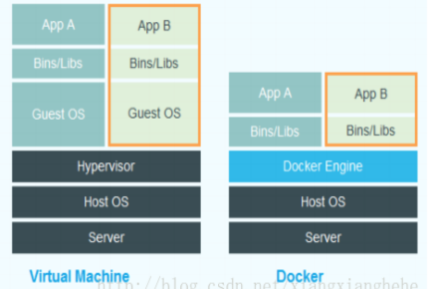
figure 1-3
The virtual opportunity is virtualized at the hardware level, simulating the hardware to build the operating system, while the container is virtualized at the operating system level, reusing the operating system, and running the container on it.
So containers have the following advantages over virtual machines
1. Fast startup speed
2. Less resources
3. Easy to migrate
Because of these advantages, container technology has been used in PaaS for a long time, but the traditional container technology has not been able to provide a standardized operating environment, which makes it unable to be widely used, and the emergence of docker represents a new generation of container technology. Docker started with the goal of providing a standardized operating environment, so that "build once, run anywhere" can be achieved, and the same build version can be used It is used in any environment such as development, testing, pre-release, production, etc., and it is unified with the underlying operating system.
Nowadays, applications are mostly written in multiple dynamic languages and need to be deployed to multiple environments, so the traditional virtualization technology in PAAS cannot meet these requirements, and the introduction of docker technology solves these problems.
Docker is an open source application container engine, which allows developers to package their applications and dependency packages into a portable container, and publish them to various environments, and also provides a standardized running environment. Its easy deployment and portability make docker an important part of PaaS.
More importantly, in the development of docker, a new container technology, CaaS technology has been further developed. It can be said that docker technology is the core of CaaS technology, because docker technology has gradually developed CaaS mode from PaaS mode. It can be said that CaaS is PaaS that uses the core technology and ideas of docker.
Now the role of docker in PaaS and CaaS is easy to explain. Docker is an efficient virtualization technology used in PaaS and CaaS.
Based on the above discussion, we can summarize the advantages of container technology, or docker virtualization technology as follows
1. Because of the lightweight features of docker, the startup speed of docker is very fast, and the resource consumption is very small
2. Docker builds a standardized operating environment
3. It is very suitable for the current application development scenarios of multi language development and multi-platform operation
But docker technology also has limitations
1. Docker is based on 64bit, so it cannot be used in 32bit environment, so compatibility is not very good
2. Docker is not suitable for all application scenarios. Docker can only virtual Linux based services, but not virtual windows services
3. Developing a docker instance is not as simple as creating a virtual machine, adding applications, and then cloning. To successfully create and use docker infrastructure, administrators need to have a comprehensive understanding of all aspects of system management, including Linux management, orchestration and configuration tools such as puppet, chef and salt. These tools are built on the command line and scripts.

Q2: There is a trend amongst cloud computing users to move towards developing infrastructure as code (IaC). Explain this term then critically evaluate the future usage of this technology.

A2: To explain what is infrastructure as code (IAC), we need to first explain what is infrastructure. Generally speaking, we think servers are infrastructure, but in reality, it is much more than that. In fact, infrastructure includes all the basic services and facilities provided to the application, such as DNS, firewall, database, server and so on.
But with the popularity of cloud technology, infrastructure is required to have higher flexibility, faster deployment speed, better self-recovery system and other features, which requires more efficient infrastructure management. Not only in cloud technology, infrastructure is provided through services, compared with IaaS and PaaS models. And the providers of infrastructure are all third-party cloud service providers, which will bring security problems and many unstable factors. Therefore, in order to solve these problems, people think that if the infrastructure can be defined and edited like code, rather than physical hardware, then developers can easily manage and master the infrastructure, so the technology of infrastructure as code (IAC) has been developed, which reflects the developers' demand for higher permissions and security.
But in the future, there will be some challenges in the use and popularization of this technology
1. The tools for implementing IAC are very professional, and it takes a lot of time to learn its principles and grammar to put it into use, which is a great difficulty for many companies
2. Linux infrastructure is easy to write, but Microsoft's products occupy a monopoly position in the market
3. With the increase of hardware components in the infrastructure, the correlation script code of each component will be very complicated

Q3: Kubernetes is a technology used for the orchestration (management) of Docker containers. Investigate this technology and provide a scenario that best illustrates its purpose.

A3: Kubernetes is an open-source container cluster management system of Google. Based on docker technology, it provides a complete set of functions for containerized applications, such as resource scheduling, deployment and operation, service discovery, capacity expansion, etc. in essence, it can be regarded as a micro PaaS platform based on container technology, namely the representative project of the third generation PaaS.
Kubernetes aims to make the deployment of containerized applications simple and efficient. Kubernetes provides a mechanism for application deployment, planning, update and maintenance
In Kubernetes, we can create multiple containers, each of which runs an application instance, and then through the built-in load balancing strategy, realize the management, discovery and access of this group of application instances. These details do not need the operation and maintenance personnel to carry out complex manual configuration and processing.
• portability: support public cloud, private cloud, hybrid cloud, multi cloud
• scalable: modular, plug-in, mountable, composable
• automation: automatic deployment, automatic restart, automatic replication, automatic scaling / expansion
In a word, Kubernetes can make the most of the advantages of container technology, and make it far away from the traditional application deployment mode, and make up for some shortcomings of container. Most importantly, Kubernetes has expanded many functions for container technology.
The framework of Kubernetes is shown in Figure 3-1
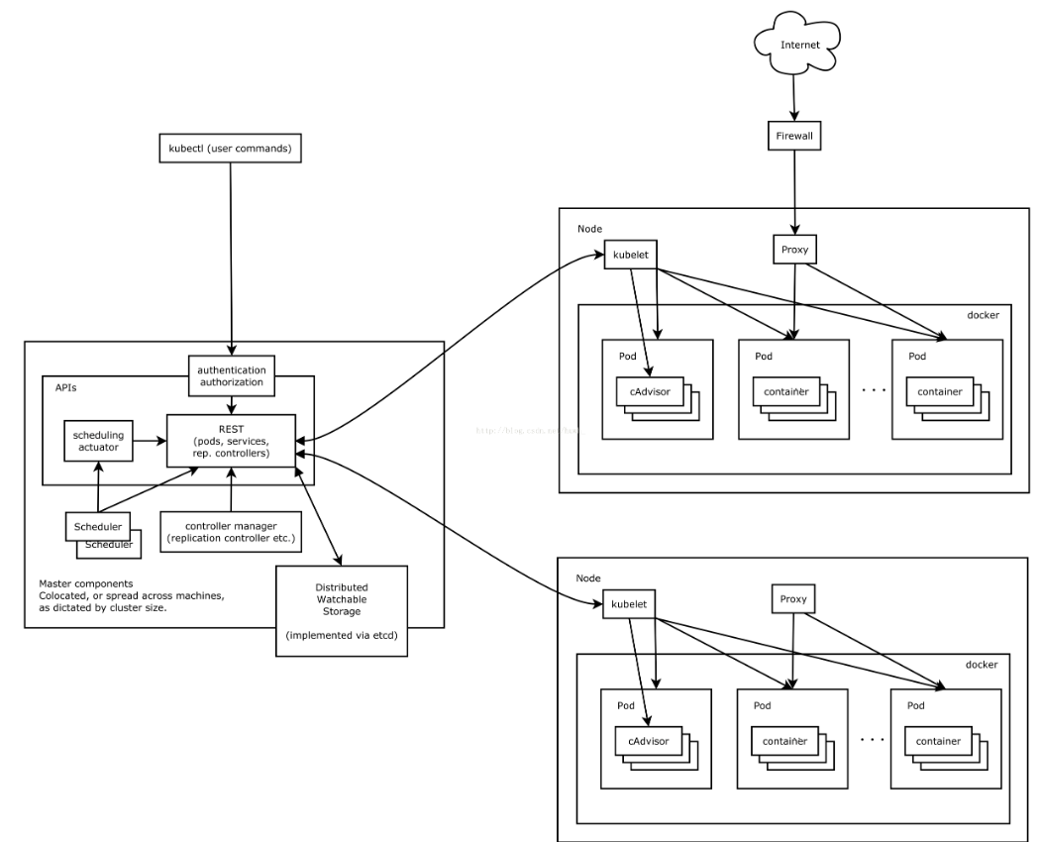
Figure 3-1
11 important concepts in Kubernetes
1. Pod
Pod is the smallest interactive unit in kubernetes. A pod can be composed of multiple containers, which are deployed on a single node to form a unit. A pod has an IP that is shared between its containers. In the world of microservices, a pod can be a single instance of a microservice that performs background work or service requests
2. Node
Node is a machine. They are "bare" (or virtual) machines that kubernetes uses to deploy pod. Node provides available cluster resources for kubernetes to maintain data, run jobs, maintain workload, create network routes, etc
3. Label and annotation
Label is the way kubernetes and its end users use to filter similar resources in the system, and it is also the adhesive for resources to "access" or associate with each other. For example, a service that opens a port for deployment. Whether it's monitoring, logging, debugging, or testing, any kubernetes resource should be labeled for subsequent verification. For example, label all worker pods in the system: app = worker, and then use the -- selector field in the kubectl or kubernetes API to select them.
Annotation is very similar to label, but it is usually used to save metadata of different objects in the form of free strings, such as "change reason: security patch upgrade".
4. Service Discovery
As an orchestration system, kubernetes controls many resources of different workloads and is responsible for managing the pod, jobs and all the physical resources that need to be communicated. For this purpose, kubernetes uses etcd.
Etcd is kubernetes's "internal" database, through which master obtains the location of all resources. Kubernetes also provides the actual "service discovery" for services - all pods use a custom DNS server to get their IP addresses and ports by resolving the names of other services. It is "out of the box" in the kubernetes cluster and does not need to be set.
5. ReplicaSet
Although pod is a physical running task, it is usually not enough to use a single instance. To be redundant and handle the load, the pod needs to be replicated for some reason, such as "scaling.". To implement the layers responsible for expansion and replication, kubernetes uses replicaset. This layer represents the expected state of the system with the number of copies, and maintains the current state of the system at any given time.
This is where auto scaling is configured to create additional replicas when the system is under high load and shrink when these resources are no longer needed to support the running workload.
6. DaemonSet
Sometimes, an application needs no more than one instance per node. For example, a log collector such as filebeat is a good example. In order to collect logs from each node, its agents need to run on all nodes, but each node only needs one instance. Kubernetes' daemonset can be used to create such a workload.
7. StatefulSet
Although most microservices involve immutable stateless applications, there are exceptions. Stateful workloads depend on the reliable support of disk volumes. Although application containers themselves can be immutable and can be replaced by newer versions or healthier instances, all replicas still require data persistence. Statefullset is used for the deployment of such applications that need to use the same node throughout their life cycle.
It also retains its "name": the hostname within the container and the name of the service discovery across the cluster. The stateful set composed of three zookeepers can be named ZK-1, ZK-2 and ZK-3, and can also be extended to more members ZK-4, zk-5 and so on Stateful sets are also responsible for managing persistent volume claim (disks attached to the pod).
8. Job
The kubernetes core team considered most of the applications that use the orchestration system. While most applications require continuous operation to process server requests at the same time (such as web servers), sometimes a batch of jobs need to be generated and cleaned up after they are complete. For example, a mini serverless environment.
To achieve this in kubernetes, you can use the job resource. As its name suggests, the job's job is to build a container to do a specific job and destroy it when it completes successfully. For example, a set of workers reads jobs from the data queues to be processed and stored. Once the queue is empty, these workers are no longer needed until the next batch is ready.
9. Configmap and secret
A key concept of modern applications is no environment, which can be configured through injected environment variables. The application should be completely independent of its location. In order to implement this important concept in kubernetes, configmap is available. This is actually a list of environment variable keys that are passed to the running workload to determine different runtime behaviors. In the same category, secret is similar to normal configuration entries, except that it will be encrypted to prevent the leakage of sensitive information such as key, password, certificate, etc.
10. Deployment
Everything looks good. Pod can work normally. If there is replicaset on the upper layer, it can also scale according to the load. However, there was a rush to replace the application quickly with a new version. We want to build, test, and release on a small scale to shorten the feedback cycle. With deployments, new software can be deployed on an ongoing basis, a set of metadata that describes the new requirements for a specific running workload. lift

Now, introduce a usage scenario that can explain why Kubernetes is now popular and the significance of launching this technology.
Scenario：After discovering the advantages of container technology, company a deployed a large number of applications using docker. As more and more docker instances are put into use, it becomes more and more difficult to manage each docker instance and handle failures. It takes more and more time to expand and reduce business.
In order to improve this situation, company a migrated docker application to Kubernetes for management, and then company a changed as follows:
1. When Kubernetes is not used, the expansion and reduction of business applications need to be handled manually, from purchasing servers, development to deployment environment. This not only consumes a lot of human and material resources, but also easily causes problems in this process. Finding and solving problems will bring a lot of consumption to the company. After using Kubernetes, you can use the elastic computing features of Kubernetes to expand and shrink the capacity with one key, which greatly improves the efficiency of the company
2. When Kubernetes is not used, each process needs to configure the port artificially, and the problems of port conflict and firewall should be considered. After Kubernetes is used, the port can be managed uniformly and the load can be balanced
3. When Kubernetes is not used, developers need to find the corresponding container in the corresponding machine to view the offline test logs. After using Kubernetes, users can directly locate the business container through the namespace, and then directly view the corresponding logs through the console, which greatly reduces the operation time
4. When Kubernetes is not used, the service is unavailable due to server downtime and network problems in the company's business, which need to be repaired by the operation and maintenance personnel. After Kubernetes receives the alarm information, Kubernetes can complete the fault recovery work.

