ACCA5034:DATA SECURITY AND COMPLIANCE
Student University of Wales Trinity St David, Swansea, Wales | 2306723@student.uwtsd.ac.uk
Research and case scenario in Data Security and Compliance
DAVID SHEPPARD
2024
Enhancing physical security and compliance in modern organisations: A comprehensive review and critical evaluation
David Sheppard
Student University of Wales Trinity St David, Swansea, Wales
2306723@student.uwtsd.ac.uk

Abstract- The purpose of this research paper is to define some key elements of physical security requirements in a modern organisation’s information security arrangements. Literature review of a book, peer-reviewed journals and other sources has been undertaken and relevant conclusions drawn. Key findings show that people are the biggest weak link to physical security. An organisation should have robust guidelines and strategy in place to deal with threats.
- Introduction
With the exponential growth of the internet and the number of devices now connected, data security and compliance has become an ever more important consideration for organisations. An increasing reliance on IT systems and infrastructure has posed many challenges to organisations. This, combined with global connectivity, bringing multiple threats, means information security is high on the agenda. This research paper aims, through a systematic literature review, to understand why modern organisations require physical security measures to enhance data security and compliance and how organisations use these measures to create an environment of protection, detection and safeguarding against threats.
- Data Security Landscape:
IBM, one of the world’s largest technology organisations defines data security as the practice of protecting digital information from unauthorised access, corruption or theft throughout its entire lifecycle. This includes physical security of hardware along with software security, policies and procedures [1]. A wide range of tools and techniques are required to ensure data is kept secure. Failure to keep data secure can lead to an organisation facing public embarrassment, litigation, or worse, severe harm to its customers or stakeholders. Modern organisations therefore must embed robust and continually updated data security strategies into their day-to-day activities to mitigate risk and keep pace with an ever-evolving landscape.
In the US, the Comprehensive National Cybersecurity Initiative (CNSS) was launched in 2008 to establish a framework of guidelines, standards and best practice for securing information systems and networks. It provided organisations with the knowledge and measures required to deal with evolving threats [2]. The main goals of the CNSS are described within the CIA triad, three mutually dependent areas guiding policies for information security [3]:
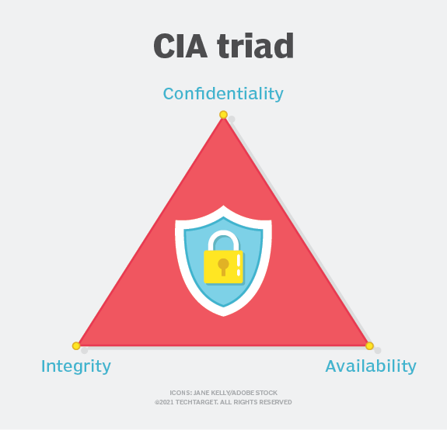
- Image of CIA triad [4]
- Confidentiality: Designed to protect sensitive information from unauthorised access.
- Integrity: Data must remain unchanged, consistent, accurate and trustworthy for its lifecycle.
- Availability: Information should be readily accessible by authorised users.
A 2021 study by Ng [5] found that, despite an increased awareness of information security risks, increasing numbers of companies are still impacted by cybersecurity breaches, leading to privacy violations and personal data leaks. The study concludes that the weakest link in the cybersecurity chain are people and that organisations should effectively manage resources to ensure individuals are discouraged from damaging behaviours.
Research, such as that by Ng, has proven an increasing level of threat modern organisations are facing. The scale of the problem, as identified in table 1 is apparent, with a huge financial impact and a staggering 353 million people impacted by data breaches in 2023 alone according to a study by Forbes [6].
Framework guidelines as set out by the CNSS were established so that organisations are well positioned to deal with any threat they may face, but organisations must be proactive in ensuring they effectively prioritise information security needs within their day-to-day operations. Failure to do so poses a huge risk.
The many types of threats, as set out by Alkhudhayr 2019 [7], Appendix A, describe the complexity of modern cybersecurity, with four main areas open to attack: information system, cyber system, internet of things and network.
TABLE 1. SUMMARISED DATA FROM FORBES STUDY 2023 [6]
Cyberattacks in 2023 | 2,365
Increase since 2021 (previous record) | 72%
Average data breach cost | $4.45 million
Organisations reporting email security incidents | 94%
People impacted by data breaches | 353 million

Alkhudhayr explains that threats are wide ranging and not limited to one area, with most threats having a high-level damage warning. Research such as that by Ng and Alkhudhayr describes why modern organisations need to ensure data security is prioritised, to mitigate threat levels and ensure security measures are focussed on weak links, such as people. One of those areas within data security that needs prioritisation is the provision of physical security.
- Compliance Frameworks and Standards
The most well-known standard for information security management systems worldwide is ISO/IEC 27001. It offers guidelines for creating, implementing, maintaining, and continuously improving an information security management system to businesses of all sizes and across all industries. The standard can support organisations to become more risk-aware and proactively detect and fix vulnerabilities. Being compliant with ISO/IEC 27001 means an organisation has implemented a risk management system for the security of its data and adheres to best practice and principles outlined in the standard [8].
ISO/IEC 27001 measures relating to physical security include some key considerations [9]:
- Secure areas need to be created, maintained and designed to prevent unauthorised access.
- Entry controls are required to allow access to those that are authorised.
- Equipment security to reduce the risk of theft or damage.
- Secure utilities such as water and electricity to maintain a secure and stable working environment.
Regular reviews and audits are required to evaluate effectiveness of controls and identify potential vulnerabilities.
A study by Culot, 2021 [10] detailed a thorough literature review on ISO/IEC 27001 and concluded first that a structured approach should integrate multiple standards, second is the requirement to relate to appropriate government policy, third is to recognise the challenges involved in implementation. A different study by Djebbar, 2023 [11], notes other standards, such as EU Cybersecurity Act (CSA), enacted on April 17, 2019 (Regulation (EU) 2019/881) to mandate EU cybersecurity. Organisations should therefore be aware of their unique position and adhere to local government standards. They should overcome obstacles to implementation of information security and consider other appropriate frameworks and standards relevant to their field. This may present obstacles, such as time and cost, but the long-term benefit outweighs any negative.
- Physical Security Measures
According to Dr Jason Andress, a seasoned security professional, in his book Basics of Information Security, physical security is largely concerned with the protection of three main categories of assets: people, equipment, and data [12]. Like the 2021 study by NG, Andress argues that people are the primary concern, as they are much more difficult to replace than equipment
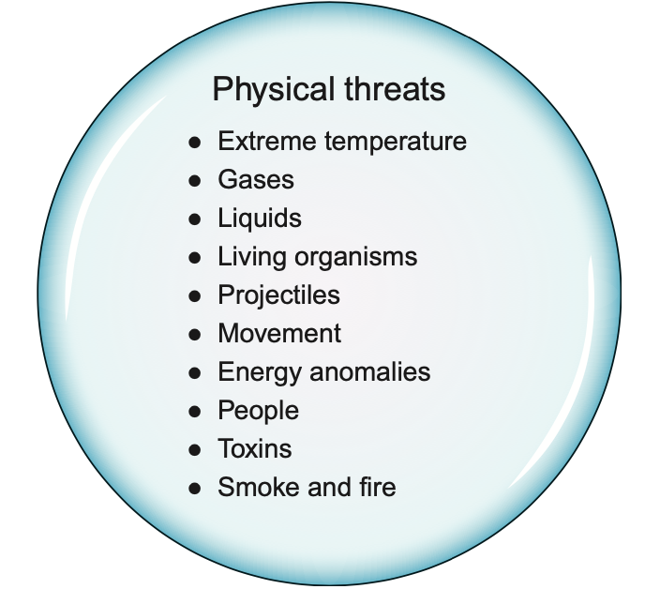
- Physical threats to information security
and data. The protection of data is a secondary concern, as data can be easily lost. Andress suggests that mitigation within all organisation policies and procedures, such as disaster recovery planning, should be developed with consideration of all three assets of physical security in mind. The findings in the studies by Andress and Ng that people are the primary concern carries a lot of traction. After all, as great as people can be, the phrase “we are only human” rings true. People make mistakes. The result of this is modern organisations should consider what tools they have, not only to protect people, but to protect the organisation from the potential incompetence or ignorance of people.
Figure 2 shows the general categories of physical security threats, the first seven of which were first outlined in Donn Parker’s 1998 book Fighting Computer Crime.
Industry specialists TechTarget define physical security as protecting people, hardware, software, networks, and data from physical acts and occurrences that could seriously harm an organization [13]. Effective physical security controls involve layered measures, including deterrence, detection, response [14] and, according to Andress, preventative measures. Andress describes [12]:
- Deterrents as controls designed to discourage those seeking to violate security controls, such as signage in public places, policies and procedures, and other visible deterrents, such as guard dogs, security guards, well-lit areas.
- Detection controls which detect and report physical threats, such as burglar alarms, and environmental monitoring, such as smoke alarms or carbon monoxide monitors.
- Preventative controls used to physically prevent unauthorised users breaching security. Examples include locks, fences, bollards and can be focussed on people, vehicles or other areas of concern.
Without adequate preventative measures, organisations could be susceptible to harm from physical security threats, such as those set out by Donn Parker. Many of the physical security measures that can be put in place are centred around managing individuals and involve a variety of physical safeguards and policies. However, there are many other physical threats that are not influenced by individuals, such as forces of nature, and additional preventative measures need to be in place to manage risk associated with this.
- Key considerations of physical security
- Physical access controls
The type of organisation, and relevant risk assessment, influence the controls and number of measures that need to be employed. Factors involved in the decision-making process include cost, scale of protection needed, type of asset being protected. For example, it would be wise to use a variety of highly secure measures in an organisation containing top secret information and high value assets, whereas an empty building would require fewer physical control measures.
Physical access controls restrict access to physical spaces, such as buildings, rooms, and facilities and are centred around people, achieved through security measures like access cards, biometrics, and surveillance systems. Examples include door swipe access and use of security guards [15]. These controls should be used in conjunction with logical access controls, which limit access to computer hardware and network resources, involving authentication, authorisation, and encryption protocols to protect virtual access to data, files, and networks. Examples include passwords, smart cards and two factor authentication. Both controls are designed to restrict access to secure areas and contribute to the overall security function in an organisation.
- Departmental roles relating to physical security
Internal security arrangements should be split amongst different teams within an organisation.
- The IT department ensures secure access to physical network infrastructure, firewalls and intrusion detection systems. It manages access to IT resources, including physical access cards and authentication and provides safeguards to digital assets from unauthorised access or theft. There should also be a cybersecurity team, protecting against cyber threats to critical infrastructure.
- The security department manages physical access to buildings, rooms and sensitive areas, oversees the surveillance and monitoring via security cameras and co-ordinates incident response or crisis management
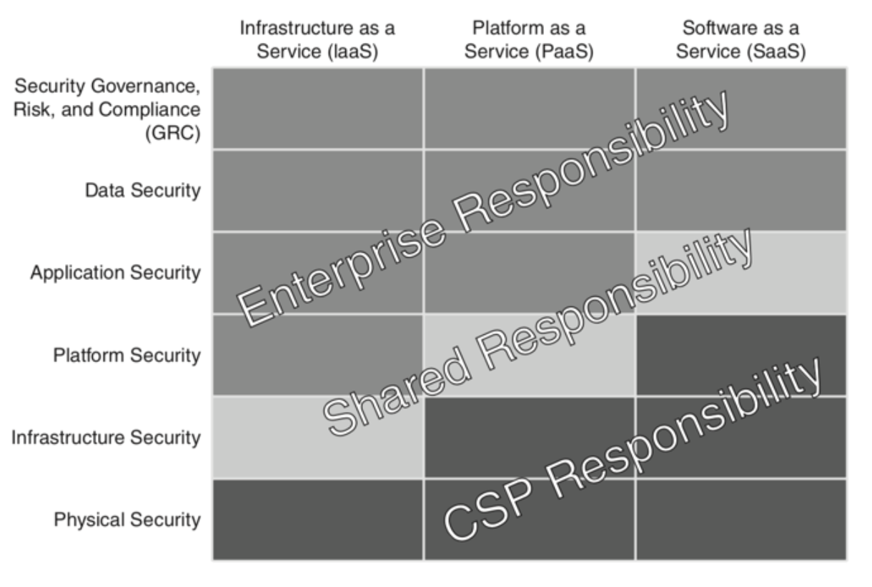
- Responsibility for physical security within an organisation [16]

plans. It should also provide security training and policies to the organisation.
- General management are responsible for completing risk assessments, allocate budgets and resources and develop policies relevant to specific areas. They should also set the tone for security compliance and awareness within the organisation.
As shown in figure 3, physical security is the sole responsibility of the service provider, further compounding the need for organisations to ensure robust physical security measures are in place. Organisations should consider physical security arrangements with third party suppliers if they decide to outsource this facility, to ensure data is safe and secure.
- Fire management
Fire is widely regarded as the most serious physical security threat as it poses significant risks to people, property and operations within an organisation. It can lead to property damage due to its ability to spread, personal injury and death due to burns and smoke inhalation, disruption of operations leading to downtime and reputational harm, and evacuation challenges particularly in large buildings. It is imperative that organisations have preventative measures and are well-prepared [17]. The three essential elements for a fire are heat, fuel and oxygen, known as the fire triangle, as shown in figure 4.
An effective fire suppression system is designed to disrupt the fire triangle and involves cooling to reduce the temperature below the ignition point and smothering to reduce access to oxygen [18].
Research by Dilshad Sarwar [19] explains the need for emergency management systems to minimise or remove the negative impacts from an event such as fire. This research critically evaluates the many different emergency management models, concluding that the best method to deploy is a hybrid model that covers prediction and detection, alert, relief and support after the emergency. Fire management is an essential part of any organisation and prevention measures should be considered as one of the most important safety considerations.
- The concept of a secure facility
A secure facility is a physical location designed with controls to minimise the risk of unauthorised access and mitigate security threats. It aims to provide a safe and efficient working environment by safeguarding against potential risks [20]. The primary goal of designing a secure facility is to prevent attacks from people. The secondary goal is to protect against other factors, including fire protection (prevention measures, evacuation), health and safety (indoor air quality, electrical safety, and accident prevention) and natural hazards mitigation (earthquakes, floods).

- Fire triangle

These goals, however, are to some degree dependent on the area in which the facility is located. For example, an area prone to natural disasters would have natural hazard mitigation as one of the top priorities.
This is particularly true in new buildings in places like Japan where earthquakes are a particular threat, and all new buildings need to be designed to cope with the stress of such an event due to the likelihood of occurrence. Sometimes there will be areas of civil unrest, and this would influence the design accordingly due to the increased threat.
Andress explains that site selection is very important. Computing equipment is very sensitive to changes in power, temperature and humidity and mitigation should be put in place to deal with this. According to Andress, for some types of facilities, such as a data centre, it should be very important to have as problem-free an environment as possible, and where these problems cannot be overcome, an alternative should be sourced [4]. Figure 5 illustrates some of the key considerations when designing a new data centre infrastructure [21].
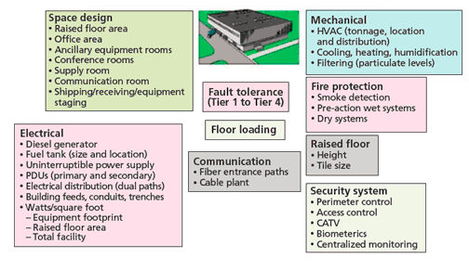
- Case study of typical considerations when planning a new data centre [21]
As a result of these factors and the number of design elements that need to be accounted for, it will often be the case that a secure facility is outsourced to an external company, with existing resources, who take on some of the responsibility, although very careful scoping is needed, with clear guidelines to allocate responsibility accordingly. Costings need to be very carefully explored as it is likely to be more expensive to outsource and it is likely that there would be a long-term agreement needed, which would enforce commitment and could lead to costs escalating as time goes on.
- Conclusion and future direction
Physical security is a broad topic, and the time limitations here have influenced the focus on key considerations. Research has highlighted people as the primary weakness and the need for modern organisations to prioritise physical security arrangements on fire prevention, governance, access control measures, and careful selection of physical sites for information storage.
Avenues for future research include a deep dive case study into some successful and less successful physical security measures established by modern organisations. This deep dive should include a review of key successes and limitations and evaluated against a cost benefit analysis, and risk stratification. This would provide assurance that any investment in physical security measures is worthwhile to an organisation.

Appendix A
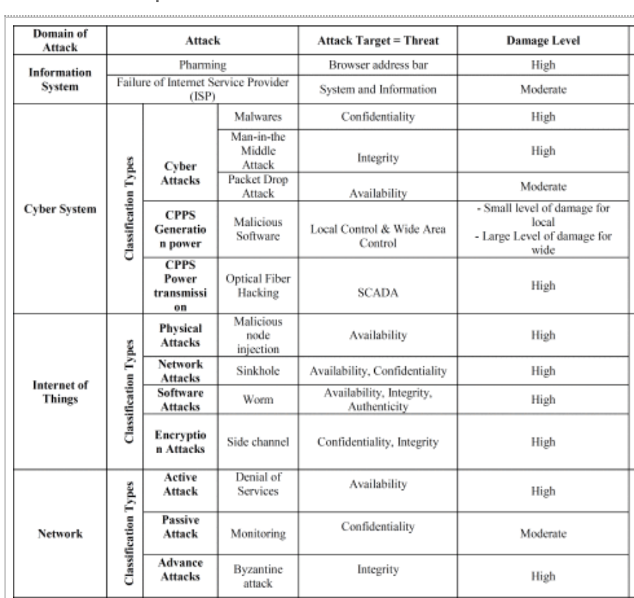
- List of threats as described by Alkhudhayr, 2019 [7]

Task 2: case scenario:
establishing a new information security unit in a healthcare organisation

Table of Contents
Table of Contents 9
List of figures and tables 10
List of Acronyms 11
Introduction 12
Case study discussion 13
Organisational structure 13
Policies and procedures 14
Data protection compliance 15
Security standards 16
Contingency planning 18
Governance and strategic planning for security 19
Risk management 20
Conclusion, recommendation and future work 22
Bibliography 23

List of figures and tables
- Figure 7 – Proposed structure diagram for new Information Security Unit
- Figure 8 – Information Security Policy Architecture example
- Figure 9 – An overview of key functions within ISO/IEC 27001
- Figure 10 – Example of steps within a contingency plan
- Figure 11 – 5x5 Risk Matrix example

List of Acronyms
- CISO - Chief Information Security Officer
- CISSP - Certified Information Systems Security Professional
- CEH - Certified Ethical Hacker
- IT – Information Technology
- HR - Human Resources
- CISP - Corporate Information Security Policy
- ISPA - Information Security Policy Architecture
- GDPR - General Data Protection Regulation
- ISO - International Organisation for Standardisation
- CIA - Confidentiality, Integrity, and Availability
- NIST – National Institute of Standards and Technology
- NHS – National Health Service
- CBA - Cost Benefit Analysis

Introduction
This report is based on a theoretical case study where a healthcare manager has been tasked with establishing a new information security unit. The report considers the approach required to ensure the needs of the organisation are met that will provide assurance to the executive directors and is based on assumptions, including the scale of the department, the lack of information security within the existing structure and new policies, procedures and governance being created.
Various components required for an effective information security unit are detailed, including a relevant organisational structure, policies and procedures, data protection compliance, security standards, contingency planning, governance and risk management.
A review of the research influenced approach is provided, to contextualise the design and offer appropriate justification in the discussion and conclusions drawn.

Case study discussion

In a complex healthcare organisation as per this case study, there are several aspects to consider. It is important to note that no one approach fits all, and therefore relevant research has been undertaken to influence some of the designs.

Organisational structure

An initial step when establishing an information security unit is to generate ideas on what roles are needed and how those roles will fit within existing structures. As documented in research by Al-Aboosi 2022 [22], health systems are particularly vulnerable to cyber-attacks with the increased reliance on healthcare information systems. The study describes vulnerabilities to phishing attacks, ransomware and denial of service attacks due to outdated systems, poor access control management, human error amongst others. This highlights the need for a dedicated information security unit within this organisation.
The overall responsibility for information security ultimately lies with executive management, but the wider organisation structure should reflect adequate governance and controls, with appropriate responsibility sitting with information security system professionals, such as IT security managers and data owners tasked with ensuring appropriate compliance with policy [23].
Within the information security unit, as a minimum there should be [24]:
- A CISO – reporting directly to executive team. Highly qualified with industry certification like CISSP and strong leadership skills.
- Security manager – ensures building safety, conducts safety assessments and supervises security personnel, with relevant licencing.
- Security analyst – identifies and mitigates risks, conducts vulnerability testing and responds to incidents. Has certification like CEH.
Reflecting on the research, highlighting the need for information security in this case study, indicates that this organisation would benefit from a large information security unit, as shown in figure 7.
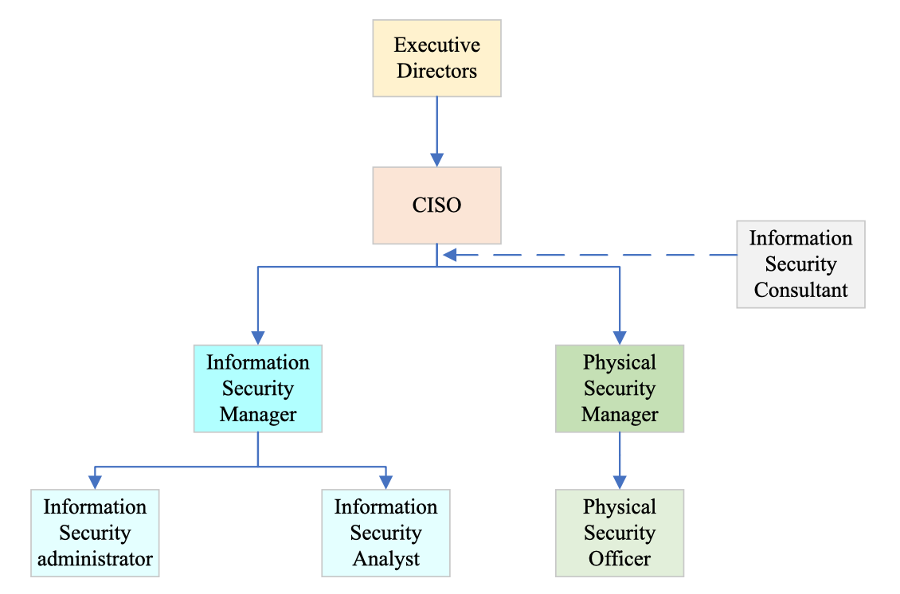
- Proposed structure for Information Security Unit
The CISO reports directly to the Executive Directors but has overall responsibility for leading the unit.
Reporting to the CISO is an Information Security Manager and Physical Security Manager as separate workstreams, although close collaboration is required. The justification for physical security has been outlined in the earlier research paper. A health industry with large estate justifies investment in this area, to ensure adequate protection measures are in place to protect physical assets. The Information Security Manager will lead a team of analysts and is responsible for ensuring system vulnerabilities are sought and investigated. It is recommended that all posts have suitably qualified, industry certified individuals.

Policies and procedures

The Information Security Unit should work closely with existing departments, such as HR to establish relevant governance.
The organisation should be compliant with ISO/IEC 27000 and ISO/IEC 27001. Research by Culot [10] and Djebbar [11] highlights relevant standards that need to be complied with, such as EU Cybersecurity Act (CSA), enacted on April 17, 2019 (Regulation (EU) 2019/881).
Such standards ensure the organisation has implemented a risk management system for the security of data and adheres to best practice and principles outlined in the standards.
A study by Von Solms in 2011 [25] explains that executive direction is usually expanded into the CISP, a strategic, general-level policy. These are the high-level information security policies, with management directives. These policies are then disseminated into lower-level policies, sometimes known as issue-specific policies, and are tactical policies outlining the use of the organisation’s processes, technologies, or systems. These are fed down to operational policies and include email usage, internet policy and incident response, however it is important to note that less research has considered the technical element of operational policies and could be handled outside of the policy as local policies.
Von Solms [25] recommends these policies are organised into an ISPA, in a hierarchical form, such as that shown in figure 8. The strategic level policy should set out direction, filtered into the relevant areas, operational policies are executed and provide assurance back up. Policies should be supported by relevant procedures or standards.
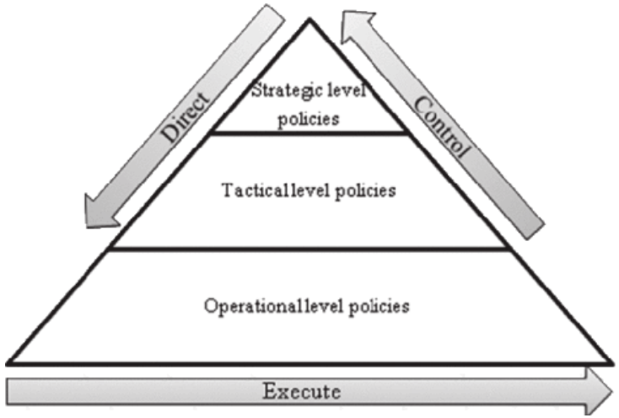
- Policy hierarchy in an ISPA [25]
For this organisation:
- The strategic policy should be drawn up by the CISO with input from the Executive Directors. These policies set out lower-level policies, governance chain, escalation and other management directives and expectations.
- The tactical and operational policies should be filtered to the relevant level of the Information Security Unit, outlining processes. Those policies pertaining to physical security should sit with the Physical Security Manager, such as building regulations, equipment protection policies and intrusion detection policies. The Information Security Manager should own the policies such as software policy, internet usage and personal device policies.

Data protection compliance

The Data Protection Act 2018 controls how your personal information is used by organisations, businesses or government and is the UK’s implementation of the GDPR [26]. It sets out the rules and responsibilities, or data protection principles, and outlines the legal protections in place to protect sensitive information. Organisations have the responsibility for ensuring GDPR is implemented and is aware of individuals rights, including the right to:
- be informed how data is being used
- access personal data
- have incorrect data updated
- have data erased
- stop or restrict the processing of data
- object to how data is processed in some circumstances
Some specific articles within UK GDPR relating to Information Security include:
Article 5(1)(f) – organisations must protect against unlawful and unauthorised processing, accidental loss, destruction or damage to personal data. Article 32(1) sets out what measures can be put in place and what’s available today. Particularly important in a health environment as per the case study is Pseudonymisation (Art 4(5)), ensuring confidentiality of systems and services and some level of encryption in the data, which should be constantly monitored to keep track of threats. Data consistency and data standards are important to ensure data is coded correctly and consistently.
ICO define a personal data breach as a breach of security leading to the accidental or unlawful destruction, loss, alteration, unauthorised disclosure of, or access to, personal data [27]. A UK GDPR breach can be described as accidental disclosures such as including personal data in a freedom of information request or cyber incidents like a data hack.
These considerations should be drawn up in all policies and procedures relating to the new Information Security Unit. Failure to comply with this legal obligation can lead to leak or loss of information, reputational harm, danger to safety or even danger to life.

Security standards

The most well-known standard for information security management systems worldwide is ISO/IEC 27001, offering guidelines for creating, implementing, maintaining, and continuously improving an information security management system to businesses of all sizes across all industries. The standard can support organisations to become risk-aware and proactively detect and fix vulnerabilities. Being compliant with ISO/IEC 27001 means an organisation has implemented a risk management system for the security of its data and adheres to best practice and principles outlined in the standard [8].
A study by Malatji, 2023 [28], identified three types of cybersecurity framework; First, those developed by international standards organisations; second, those initiated by the private sector including professional bodies; and third, those by government-led public-private partnership cybersecurity framework initiatives. However, the study concludes that ISO/IEC 27001is the most widely used worldwide.
Malatji [28] notes the ISO/IEC 27001 standard specifies the requirements for establishing, implementing, maintaining, monitoring, reviewing, and continually improving a governance structure comprised of a set of practices, methods, and processes with which to manage information security risks, with seven mandatory requirements to attain ISO certification:
- Context of organisation
- Leadership
- Planning
- Support
- Operation
- Performance evaluation
- Improvement
Activities and controls are designed to identify, protect, detect, respond, and recover and these functions are set out within figure 9. The 5 key functions split to 23 categories, 108 subcategories and over 300 security controls.
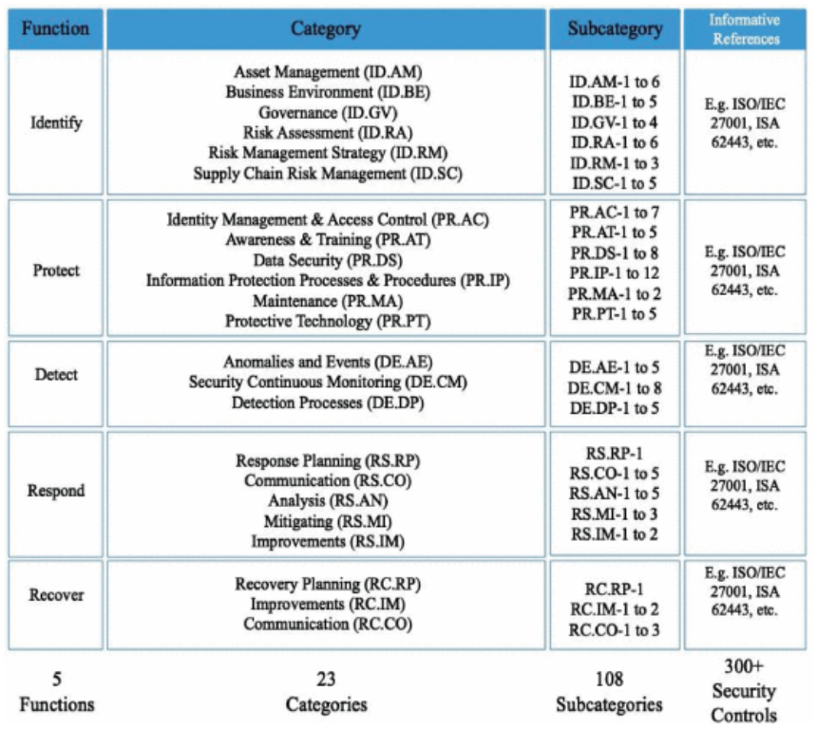
- Key functions within ISO/IEC 27001 [28]
This information should be used to influence the security standards and frameworks used within the Information Security Unit in this report, with functions including:
- Identify: Set out initial governance, risk strategy and understand assets.
- Protect: Increase awareness, set controls, maintenance and training.
- Detect: Find anomalies and integrate detection processes.
- Respond: Analyse, set improvements and mitigation, including communications.
- Recover: Investigate disaster recovery and business continuity planning.

Contingency planning

According to IBM [29], contingency planning involves preparing for unexpected events, incidents or risks that might impact an organisation, a backup plan in case things don’t go as expected. It focusses on handling disruptions and natural disasters. This differs to routine management planning like day-to-day operations and usual business goals. Contingency planning involves a risk assessment, defined trigger events that activate the plan, defined emergency roles and responsibilities, and a communications plan. Contingency plans should be regularly reviewed, and improvements made where needed.
Taking a theoretical case study by IBM [29], focussing on a social network experiencing a customer data breach and applying this to this report, an example three-step contingency plan can be drawn up to consider a similar event, with findings shown in figure 10.
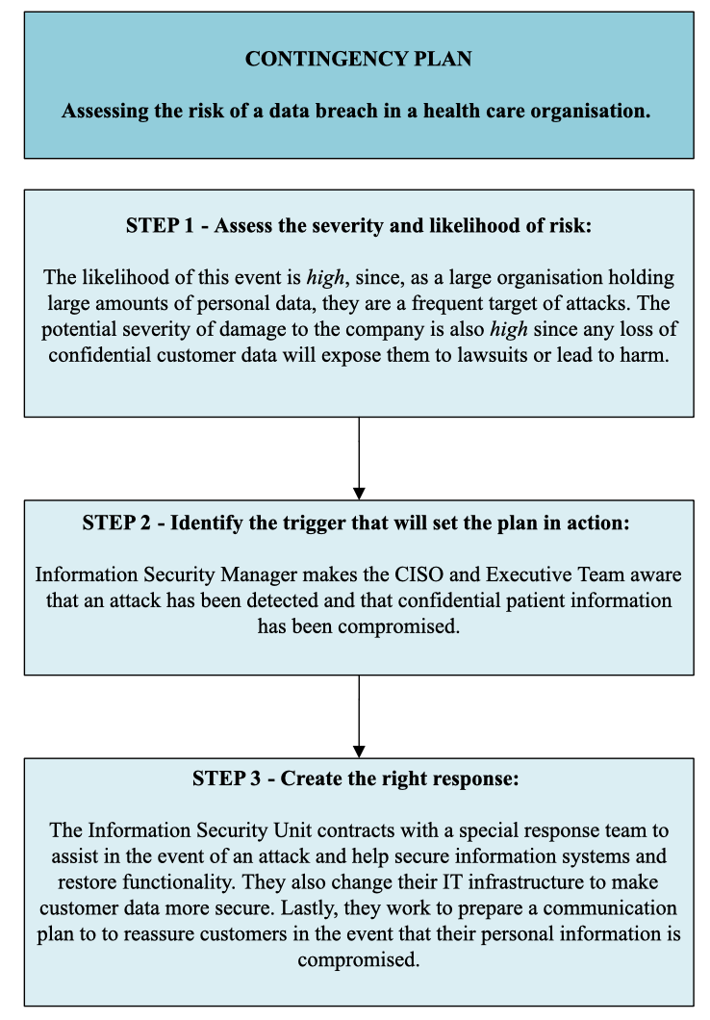
- Example of steps in a contingency plan
The three-step plan shows firstly how to assess the risk by looking at the likelihood and severity, which in this case is high for both due to the amount of personal data held. The second step assesses the triggers and considers the plan for escalation. The third step is a communications plan, including who helps with recovery, what changes need to be made and how messaging is disseminated to stakeholders.

Governance and strategic planning for security

A security framework provides a structured approach to designing, implementing, and managing security within an organisation. The framework provides principles and best practice for making informed decisions, risk management strategies aligned with the CIA triad, standardization to establish common practices, and compliance to align security with legal, regulatory and industry requirements. Examples include the NIST Cybersecurity Framework.
Information security governance is a systematic approach to managing and mitigating risks associated with information assets’ confidentiality, integrity, and availability. It includes a well-defined strategy aligned with organisation goals, comprehensive guidelines, risk management, compliance and audit to encourage adherence to regulations and provides advice on handling security incidents effectively. It is important to note that every member of an organisation has a part to play in information security governance, enforced through information security specialists, such as those within the Information Security Unit [30].
Von Solms [25], highlighted the importance of a robust IT governance infrastructure due to an increasing reliance on IT by all organisations, noting that IT governance should focus on strategic alignment, value delivery, risk management, and resource management through leadership, structure and processes within an organisation. It should maximise good practice and support business objectives. Practices should include strategic direction for information security and activities to ensure executive management directives are implemented and monitor compliance.
According to Von Solms [25], information governance generally comprises two processes, directing and controlling:
- Directing: When executive members provide instructions for what needs to be done to achieve Information Security objectives.
- Controlling: When checking is in place to ensure directives have been complied with.
These processes are described in the section for policies and procedures, as demonstrated in figure 8, policy hierarchy in an ISPA which illustrates directives downwards from strategic (executive) level and the controls in place back up the hierarchy to ensure relevant governance compliance at each level.
This is important as within the hierarchy of a large, complex organisation, it would be easy for instructions to get lost or misinterpreted. Having this robust governance hierarchy, with relevant checks in place along the process, ensures strategic direction is aligned with business needs, and risks or concerns can be identified along the chain.
The recommendation would be to ensure the Information Security Unit is advised of the current governance structure, and to be involved in the establishment of the governance arrangements for information security, using specialist knowledge and skills to advise Executive Directors accordingly.

Risk management

Risk management is the process of identifying, assessing and mitigating threats to an organisation. Analysis of a risk likelihood and impact ensure appropriate strategies can be developed to minimise harm. It is important to identify risks so that an organisation can understand potential threats, assign value to assets, enhance strategic decision making once there is an understanding of risks and controls, and finally overcome negative impacts if mitigated in a timely manner [31].
According to IBM [32], mitigation strategies for controlling risk involve specific action plans to reduce the likelihood or impact of identified risks. It could be described as a proactive business strategy to ensure an organisation is on the front foot. Three planning approaches to mitigate risks can be undertaken:
- Risk avoidance: Including not participating in activities that may have a high risk.
- Risk reduction: Gives the power to reduce frequency or severity of losses.
- Risk transference: Shifting risk to a third party (outsourcing).
One method often used within organisations to score risks and ascertain their likelihood and potential impact is the risk matrix as shown in figure 11 [33] and maintain a risk register. The advantage of the risk matrix is that is allows organisations to logically, accurately and consistently score risks in a way that is visually appealing. The risk matrix is widely used and works on a scoring basis. First an assessment is made to determine the probability of the risk occurring and allocate a score. Secondly an assessment of how severe the outcome if the risk occurred and allocate a score. The scores are multiplied providing an overall score. For example, an almost certain risk (score 5) with a severe impact (score 5) would be an extreme risk (5x5=25).

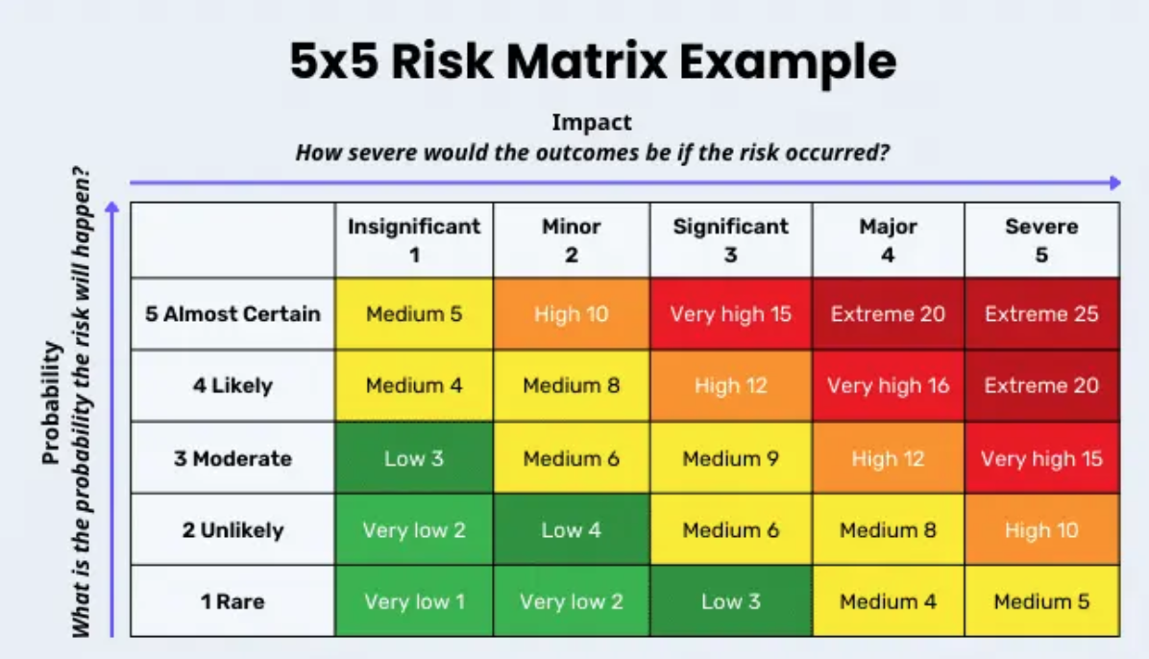
- Example of risk matrix template [33]
In the organisation specific example from figure 10, contingency plan for a data security breach in healthcare, using this risk matrix, the likelihood score would be 4 due to the amount of data and frequency of attacks and the impact would by 4 due to the nature of the data held. This risk would therefore carry a score of 16, very high. This provides justification for creating contingency plans. Upon review of this risk, with contingency plans in place, and potentially other preventative measures, the score could be reviewed and downgraded to prioritise other areas of higher risk on the risk register.

Conclusion, recommendation and future work

This report highlights and recommends the need for an Information Security Unit in modern organisations. Research proves an increasing trend for organisational reliance on IT and associated threats, and therefore justifies investment. It is important to consider governance, planning and policies and hierarchy to ensure resources are allocated appropriately and the need for risk management and contingency planning in information security.
Future work could involve a detailed case study into an organisation such as the NHS to find examples of best practice or lessons learned and apply to this case study. Additionally, a CBA could be provided to further justify the financial benefit of having a dedicated Information Security Unit.

Bibliography

[1] | IBM, IBM, 2024. [Online]. Available: https://www.ibm.com/topics/data-security. [Accessed 8 July 2024].
[2] | infosec-jobs.com, “CNSS explained,” infosec-jobs.com, 6 December 2023. [Online]. Available: https://infosec-jobs.com/insights/cnss-explained/#:~:text=The%20CNSS%20framework%20consists%20of,and%20robust%20approach%20to%20cybersecurity.. [Accessed 8 July 2024].
[3] | C. Hashemi-Pour, “What is the CIA triad (confidentiality, integrity and availability)?,” TechTarget, 2024. [Online]. Available: https://www.techtarget.com/whatis/definition/Confidentiality-integrity-and-availability-CIA. [Accessed 9 July 2024].
[4] | TechTarget, “What is the CIA triad (confidentiality, integrity and availability)?,” TechTarget, 2024. [Online]. Available: https://www.techtarget.com/whatis/definition/Confidentiality-integrity-and-availability-CIA. [Accessed 16 July 2024].
[5] | K. Ng, X. Zhang, J. Thong and K. Tam, “Protecting Against Threats to Information Security: An Attitudinal Ambivalence Perspective,” Journal of management information systems, vol. 38, no. 3, pp. 732-764, 2021.
[6] | Forbes, “Cybersecurity Stats: Facts And Figures You Should Know,” Forbes, 28 February 2024. [Online]. Available: https://www.forbes.com/advisor/education/it-and-tech/cybersecurity-statistics/#:~:text=In%202023%20alone%2C%20more%20than,theft%20constituted%20over%201.1%20million.. [Accessed 14 July 2024].
[7] | F. Alkhudhayr, “Information Security:A Review of Information Security Issues and Techniques,” in 2019 2nd International Conference on Computer Applications & Information Security (ICCAIS), Riyadh, Saudi Arabia, 2019.
[8] | ISO.org, “ISO/IEC 27001:2022,” ISO.org, 2022. [Online]. Available: https://www.iso.org/standard/27001. [Accessed 14 July 2024].
[9] | Security 101, “ISO 27001: an overview of physical and environmental security,” Security 101, 29 November 2023. [Online]. Available: https://www.security101.com/blog/iso-27001-an-overview-of-physical-and-environmental-security#:~:text=ISO%2027001%20physical%20security%20measures,-Secure%20areas%3A%20The&text=These%20areas%20should%20be%20designed,where%20sensitive%20information%20is%20. [Accessed 14 July 2024].
[10] | G. Culot, “The ISO/IEC 27001 information security management standard: literature review and theory-based research agenda,” The TQM Journal, vol. 33, no. 7, pp. 76-105, 2021.
[11] | F. Djebbar, “A Comparative Analysis of Industrial Cybersecurity Standards,” IEEE Access, vol. 11, pp. 85315 - 85332, 2023.
[12] | J. Andress, Basics of Information Security, Oxford: Elsevier, 2011.
[13] | TechTarget, “What is physical security and how does it work?,” TechTarget, 2024. [Online]. Available: https://www.techtarget.com/searchsecurity/definition/physical-security. [Accessed 13 July 2024].
[14] | Charter Global, “Physical security threats and vulnerabilities,” Charter Global, 29 March 2019. [Online]. Available: https://www.charter-global.com/common-physical-security-threats/. [Accessed 13 July 2024].
[15] | identiv.com, “What's the Difference Between Logical Access Control and Physical Access Control?,” identiv.com, 6 August 2020. [Online]. Available: https://www.identiv.com/resources/blog/whats-the-difference-between-logical-access-control-and-physical-access-control. [Accessed 14 July 2024].
[16] | L. Ferrara, LinkedIn, 12 July 2018. [Online]. Available: https://www.linkedin.com/pulse/boundaries-cloud-models-different-aas-liabilities-luciano-ferrara. [Accessed 16 July 2024].
[17] | quizlet.com, “Information Security Chapter 9 Review Questions,” quizlet.com, 2024. [Online]. Available: https://quizlet.com/412607390/information-security-chapter-9-review-questions-flash-cards/. [Accessed 12 July 2024].
[18] | Concept fire suppression LTD, Concept fire suppression LTD, 5 July 2023. [Online]. Available: https://www.conceptfire-uk.com/the-fire-triangle-understanding-the-elements-of-combustion/. [Accessed 9 July 2024].
[19] | D. Sarwar, “An overview of disaster and emergency management system models,” International journal of strategic engineering, pp. 24-37, 2018.
[20] | Whole building design guide, “Secure/Safe,” Whole building design guide, 2024. [Online]. Available: https://wbdg.org/design-objectives/secure-safe. [Accessed 9 July 2024].
[21] | C. Shailaja, “Physical security of a data center,” isa.org, 31 March 2020. [Online]. Available: https://www.isa.org/intech-home/2020/march-april/departments/physical-security-of-a-data-center. [Accessed 10 July 2024].
[22] | A. Al-Aboosi, “Cybersecurity Trends in Health Information Systems,” in 2022 International Conference on Cyber Resilience (ICCR), Dubai, 2022.
[23] | Linford & co, “What are the Roles and Responsibilities of Information Security?,” Linfird & co, 19 June 2019. [Online]. Available: https://linfordco.com/blog/information-security-roles-responsibilities/. [Accessed 16 July 2024].
[24] | Cybersecuirty Guide, “CISO decoded: Your guide to the C-suite of cybersecurity,” Cybersecuirty Guide, 11 April 2024. [Online]. Available: https://cybersecurityguide.org/careers/chief-information-security-officer/. [Accessed 16 July 2024].
[25] | R. Von Solms, “Information Security Governance control through comprehensive policy architectures,” in 2011 Information Security for South Africa, Johannesburg, 2011.
[26] | gov.uk, “Data protection,” gov.uk, 2024. [Online]. Available: https://www.gov.uk/data-protection. [Accessed 17 July 2024].
[27] | ICO, “Personal data breaches: a guide,” Information Commissioner's Office, 2024. [Online]. Available: https://ico.org.uk/for-organisations/report-a-breach/personal-data-breach/personal-data-breaches-a-guide/#:~:text=A%20personal%20data%20breach%20means,or%20access%20to%2C%20personal%20data.. [Accessed 17 July 2024].
[28] | M. Malatji, “Management of enterprise cyber security: A review of ISO/IEC 27001:2022,” in 2023 International Conference On Cyber Management And Engineering (CyMaEn), Bangkok, 2023.
[29] | IBM, “Contingency plan examples: A step-by-step guide to help your business prepare for the unexpected,” IBM, 12 July 2023. [Online]. Available: https://www.ibm.com/blog/contingency-plan-examples/. [Accessed 17 July 2024].
[30] | S. Bougnague, “What Is Information Security Governance?,” cloudficent, 12 July 2023. [Online]. Available: https://www.cloudficient.com/blog/what-is-information-security-governance. [Accessed 17 July 2024].
[31] | SafetyCulture , “Why Risk Identification Is Important for Your Business,” SafetyCulture , 13 December 2023. [Online]. Available: https://safetyculture.com/topics/risk-identification/. [Accessed 17 July 2024].
[32] | IBM, “How to build a successful risk mitigation strategy,” IBM, 8 December 2023. [Online]. Available: https://www.ibm.com/blog/risk-mitigation-strategy/. [Accessed 17 July 2024].
[33] | SafetyCulture, “A Guide to Understanding 5x5 Risk Assessment Matrix,” SafetyCulture, 12 July 2024. [Online]. Available: https://safetyculture.com/topics/risk-assessment/5x5-risk-matrix/. [Accessed 17 July 2024].

