
Skills for the Workplace
Module Assignment Submission
Student Name: | Naomi Elicia Morgan
Student Number: | 1808636
Module No: | BMSK4001
Module Title: | Academic and Employability Skills

Statement of Confirmation of Authenticity
By the act of making this submission, the student declares that this is the work of the student named above. The work has not, in whole or in part, been knowingly presented elsewhere for assessment, or where assessment has been built on a previous assessment, this has been identified. Where materials have been used from other sources it has been properly acknowledged. If this statement is untrue, the student acknowledges that an assessment offence has been committed.
Attention is drawn to the plagiarism and unfair practice policies of both the University and of ILM.

Table of Contents
Introduction 3
Part 1 Employability 3
1.0 Explore ‘Leadership Employability Skills’ in general 3
1.2 Evaluate own Leadership Employability skills 4
1.2.1 Current Employability skills 4
Gap Analysis to identify ‘gaps’ in knowledge/skills 4
1.2.2 Action Plan for Improvement 5
Part 2: Academic Skills 6
2.0 Reflection on Academic Skills required for University Level Study 6
2.1 Evaluate own Academic Skills 6
2.1.1 Current Academic Skills 6
Gap Analysis to identify ‘gaps’ in knowledge/skills 6
2.1.2 Action Plan for Improvement 7
Conclusion 7
References 8
Appendix 9

Introduction

This report will seek to examine what kind of employability and academic skills are needed to apply for a managerial role. I will be assessing what skills I already possess and which skills I will need to learn to fulfil one of these positions. I will be using a range of different analyses to determine these including the GAP analysis, SWOT and PDPS. During this report I will be looking online for a managerial position and taking myself through all the steps to find what I’m missing when applying for the jobs and focusing on the skills IL need in the future to apply. I will then be reflecting on what I already have and what I will need to improve to get me to where I need to be.

Part 1 Employability
What is employability?
“a set of achievements – skills, understandings and personal attributes – that makes graduates more likely to gain employment and be successful in their chosen occupations, which benefits themselves, the workforce, the community and the economy.” (Yorke, M. 2004)

1.0 Explore ‘Leadership Employability Skills’ in general

Employability skills will always vary depending on the role that your applying for, during this report I will be focusing on a set of skills required to apply to a specific managerial role (appendix 1).
During my research I found that the most common set of managerial employment skills were as follows:
Interpersonal skills
Interpersonal skills are the skills that we use to communicate with other people, these include the ability to build relationships and communicate with others. This means being able to work in a team and listen to what others are saying. Most people learn will learn how to relate with others through their own experiences, through trying and testing things.
“Ordinarily, we take notice of our own, or someone else’s, interpersonal skills when they are exceptionally bad, exceptionally good, or simply not at all what we expected” (Knapp and Daly, 2011). Interpersonal skills are so important as they help you understand other people and have empathy when dealing with how other people think or deal with things, even if they are different to your own way. This is a skill which would be majorly important in leadership as you would have to learn to deal with people that are not only similar to yourself but also people from different cultures or different walks of life.
Organisation and delegation
Organisation is also very important when considering employability skills for a managerial role, not only will you have to keep yourself organised but also attempt to keep anyone working underneath you on the same track. This is the reason delegation can be just as important, learning to delegate certain tasks to colleagues doesn’t show weakness but a good mind set to know what is worth your time or would be better off being handed over to an employee who holds that specific skill set. Delegating is a manager exercising one of their most important functions, it also shows trust in their employees and takes full advantages of their ability’s. (Muir. J, 1995)
There are many other employability skills which are just as important as the skills described above these range from numeracy and IT skills, self-motivation and negotiation to learning the ability to learn and adapt. All these skills are just as important as each other but I have chosen the top two as I think they stand out the most when applying for a managerial role.

1.2 Evaluate own Leadership Employability skills
While evaluating my own leadership skills I completed an online evaluation (Appendix 2) which showed how strong a leader I already am, during this evaluation I scored 62 which showed I was in the highest category and am on my way to becoming a good leader. Becoming a leader isn’t something that happens overnight, and you can never be to experienced or too good at leadership so what the test results suggest is to concentrate on the parts of the evaluation that I scored less on and try and improve in those areas. During my findings I also found another evaluation to find my leadership style (Appendix 3) which found me to be Democratic/Participative.

Leadership Style
There are six different leadership styles which are dictatorial, democratic, beaurocratic, Lasse fayre, paternal and autocratic. During my online evaluation (Appendix 3) I was found to be a democratic leader. Democratics involve all team members when making decisions on how and when things should be done, but even though they are fair and always include other people’s opinions they will always hold their authority when making the final decisions. Although democratic leaders are there for guidance and control, they still encourage all other members to voice their opinions and focus on group equality. Delegation is a huge part of democratical leading, Dwight D. Eisenhower said, “Leadership is the art of getting someone else to do something you want done because he wants to do it”. What this means is that true leadership is not only teaching someone how to do something but getting them to want to learn and understand it themselves.

1.2.1 Current Employability skills

Employability and leadership skills go hand in hand, a lot of the skills you need for leadership are your basic employability skills such as time management, teamwork, reflection and networking. All these skills are very important when it comes to general employability and any sort of leadership roles.
Here are just a few of the leadership skills I already possess

Patience
Due to having a job role which consists of dealing with people over the phone on a daily basis and having to listen to constant complaints and moaning having patience can be top of the list. Being the first point of contact when customers are dealing with the company can leave you open for all types of people and learning to treat everyone in the same way can be difficult, especially when customers are unhappy with the service. Learning to have patience with people who have none for you is a very important leadership skill.

Positivity
When working within a team keeping a positive attitude is vital. Although there will be days where you can feel like nothing is going your way keeping upbeat and positive doesn’t only keep your job running smoothly but can also make a big impact on other team members, especially the members who don’t find having a positive attitude easy to uphold.

Active listening
Active listening is also important when working within or when leading a team. Fully concentrating on what someone is saying rather than just passively hearing it can make a massive difference, it involves listening with all senses and taking everything in. I demonstrate this on a daily basis while in work as I need to pay full attention to customers and other members of the team when dealing with queries and concerns of both parties.

Time management
Having good time management allows you to accomplish more but in a much shorter period of time, it allows you to focus on the tasks at hand and frees up your time by managing what you’re doing and when. Time management can also lower your stress levels and helps with focus. I’ve had to learn to manage my time well because of work and my university course. Working 40 hours a week and having to complete assignments at the same time has taught me how to work more efficiently and to get things done quicker but still with the best results.

Gap Analysis to identify ‘gaps’ in knowledge/skills

I have completed a gap analysis (Appendix 4) which shows what I’m currently lacking in the employability department, this has determined what I need to do to move forward with applying for the job in question (Appendix 1). During my analysis it was found that the main experience I was lacking was managerial experience, to be able to apply for a HR managers role of course managerial experience is essential which after completing my Cert HE I will have gained. Other things I could do to gain to managerial experience are asking my current job for work experience in a managerial department, volunteering in a managerial role and attending classes to better myself for the future. Another thing I was lacking in my gap analysis was recruitment experience, although I have done some recruitment in previous jobs I have nowhere near the amount of experience necessary to apply. or any sort of managerial recruitment experience, so what’s needed to better myself in this department is knowledge of the role. One way I could gain knowledge of this is through my current employer again, asking to take on tasks to learn how things are done within the company when it comes to recruitment and maybe applying for other job roles which include more recruitment in the role themselves. The last thing on my gap analysis that I needed to apply for the role was a full UK drivers licence, at the moment I only hold a provisional licence so to be able to apply for the role with the travel side of things I would need to sit my driving test, I have already completed my theory test and had multiple lessons so passing the practical test is something I could do in no time.

1.2.2 Action Plan for Improvement

I have completed a PDP for my personal development (Appendix 5). In this plan I have listed many goals I'd like to achieve by the end of this year starting off with growing confidence in my job role, the reason this is one of my main goals is due to the fact I’d like to progress within my company and learn more about the business. To be able to achieve this I will look at feedback from my employer and ask for regular assessments to ensure I am giving everything I possibly can to my job role at the moment. I have set myself a time limit for this and that is until September this year, reason for this is that there are opportunities to progress up the ladder coming around that time and I am hoping to become a contender for a better role.
Another goal I am looking to achieve is improving my literacy and numeracy skills, I'm hoping to improve my professional writing and basic maths as maths has always been a slight struggle for me. To be able to achieve this goal I will be looking into online courses and courses in my local college for improving on these basic skills, I would like to have these completed by the time I finish my CERT HE.
My last main goal I am hoping to achieve is to make better decisions and focus more while using my own initiative. To succeed with this goal is quite simple, I will need to think harder before doing things, make my own decisions rather than following what others may be doing and focus on making the best choice for the current situation. This plays a big part in day to day life, whether it be in the workplace or at home making good decisions is always just as important. Good decisions have high outcome benefits and low outcome costs (Higgins, E.T. 2000) and making good decisions by yourself with your own initiative is something I will really be beginning to focus on.

Part 2: Academic Skills

Academic skills are skills you need so that you can study and learn efficiently, they are aspects of behaviour learned by students while studying, they are required to be able to operate at the higher education level (Academic Skills About Us, 2020). Academic skills are not only important not only in achieving success on your programme of study but also after you leave the university. Developing these skills will also make you better equipped for the workplace.
Academic skills are about helping you become more of an effective learner at University level, to help you develop research and study skills that will not just help you now but in the future. Developing good academic skills will help achieve the academic success that lets you reach your full potential. They are skills that are transferable to future careers and can help throughout your whole life rather than just while you’re at university. (University, 2020)

Here are the core skills that we refer to in the definition:
- Learning independently
- Writing
- Presenting
- Research
- Referencing
They also underpin more complex skills, which are sometimes harder to develop, these include:
- Critically
- Academic writing
- Managing information
- Understanding assessment
- Producing dissertations and longer pieces of work

2.0 Reflection on Academic Skills required for University Level Study

Reflection helps us develop our understanding more deeply, it makes our knowledge shareable with others and provides the opportunity to step back and take a look at our work and see what we could have done better or worse. (2020). Reflection comes from the Latin reflectere which means to bend back, to turn back or turn around. Reflection means thinking about something, slowing down to pause and reduce information input. The process of reflection helps us makes sense of things, to turn off the auto pilot mentality that we walk around with on a day to day and actually concentrate on what we’ve done. It is important to be careful what we think about and how we think about it.
During this assignment I will be using Gibbs reflective cycle (Appendix six) to reflect on my academic skills, Gibbs cycle has 6 stages these are:
Description:
Description, what happened? This is the part of the cycle where you’ll take a look back at exactly what you did and what the outcome of this was.
Feelings:
What were you thinking and feeling? How did the work go, how did it make you feel and what did you think of the results?
Evaluation:
What went good with the work and what went bad, did you enjoy the experience, and did you reach your end goal with no problems or are there things that could have been done better.
Analysis:
What sense can you make of the situation, break it into elements and parts to better understand exactly what you’ve done.
Conclusion:
What else could have been done, what could have been improved on and did you do everything to the best of your ability.
Action plan:
If it arose again what would you do next time, would you do anything differently or change anything at all.

Here is my reflective cycle on this assignment and what academic skills I need to improve on
Description:
My 4001-assignment needed to be completed by Friday March 27th, the assignment needed to be written professionally, referenced properly and include 4000 words.
Feelings:
I think the work went well but could have gone a lot better. As my first assignment I feel like it too me too long to get the hang of writing it and referencing everything correctly, but I do think the results will be ok.
Evaluation:
I think I managed to grasp the main concept of the assignment but struggled to find relevant research to back up my writing. Next time I will concentrate a lot more on research before beginning to write the text.
Analysis:
When breaking down the assignment part by part I found my action and development plans the easiest. To understand and the research to back my work up the hardest.
Conclusion:
Next time I would allocate more time to my assignment and improve my writing skills making certain that everything was not only written correctly but was also grammatically correct. I would also allocate more time to research and referencing and make sure I fully understand how to do everything to the best of my ability before beginning my work.
Action plan:
The main thing I would make certain to do next time is complete my assignment in plenty of time so that. I can submit draft work and get it all checked and get the feedback needed to achieve my highest marks.

2.1 Evaluate own Academic Skills

Academic skills are important when trying to complete a university course, and to determine which skills lack I have completed a SWOT analysis (Humphrey, A 1960) (Appendix 7)
During my SWOT analysis I found I have many more weaknesses than strengths, my main weaknesses are my written work, whether this is through my professional writing or referencing or even just as simple as making sure I understand the assignment criteria fully, these are all skills that at the moment I am lacking. I need to spend more time researching to make my work more thorough, I can do this through spending more time learning about the modules and looking things up online. Another thing I could do to improve is take online courses to better myself and improve my general knowledge. I could also try and better myself academically by taking more notice of what’s going on in the world around me, by subscribing to google news or reading up on current events. By completing the CERT, HE I am hoping that all the academic weaknesses I have will turn into strengths and in turn opportunities. The main threat I have is failing my course, but I am going to try to the best of my ability to ensure I succeed rather than fail.

2.1.1 Current Academic Skills

My current academic skills are lacking but I’m hoping through concentrating on my SWOT, GAP. Analysis and PDP I can improve these and better myself for the future.

Gap Analysis to identify ‘gaps’ in knowledge/skills

During my gap analysis there were three main things I wanted to do moving forward and they were, complete my CERT HE, complete a professional writing course and complete a numeracy course. To complete my CERT HE I will need to complete all assignments for the 6 modules, I will also need to complete them to a pass level of over 40% but am aiming for higher grades which are more around the 80% mark. To do this I will make the most of all the support offered through lecturers and all the online learning, I have one year to complete the course and am then hoping to go on to degree level.
Secondly, I am hoping to complete a professional writing course which I have found online. I am hoping by attending this extra course it will aid me in completing my studies and will better my writing style overall. The course is a 6-hour course which can be completed online at any point. I am hoping to get this course done sooner rather than later as I think it will help with all future assignments.
Third I am looking to attend with a numeracy course, although this may not be needed with my CERT HE I think this will benefit me overall and make my academic skills in general much better. I have once again found an online course which looks achievable, it is a 70 hour course with 7 modules but I think by completing the course and the end exams I will improve my academic skills massively.

2.1.2 Action Plan for Improvement

I have also completed a PDP for my academic skills (appendix 9). During this PDP I have found that most of my gaols relate to the work I do during my CERT HE, these include improving, research, referencing and concentration. To improve on my research, I should set more time prior to starting the assignment to make certain that my research is all there and ready before I start to write the content. I also feel like it would be helpful to take other avenues of research other than the internet, reading books or newspaper articles would give me a wider range of research. Research and referencing go hand in hand so many of the things I would look to improve on when it comes to research would be the same when it comes to referencing, paying attention to detail and making sure that is all written correctly and in alphabetical order plays a big part also. Harvard referencing is what is expected when completing higher education assignments and I would need to make sure this was all done correctly and up to standard. The last thing that needs improvement is my concentration skills, learning to prioritise my workload and spend an adequate amount of time on each section is important. Staying away from distractions and learning to put myself in a quiet room with nothing around will make certain that all my concentration is on the task at hand.

Conclusion

To conclude I have assessed all my employability and academic skills, which ones I lack and which ones I thrive in. It has come to my attention during the findings that I have more weaknesses than strengths when it comes to the academic side but am stronger in my employability. I will be working towards gaining all the relevant skills I am missing and am hoping that by doing this I will make more employable in a managerial role. When reflecting back on what skills are needed from both sides for the job I was hoping to apply for I can see I have a long way to go before id be ready for it but am also hoping that by completing all these modules and this course it will help me in moving forward.

References

Higgins, E. T. (2000). Making a good decision: Value from fit. American Psychologist, 55(11), 1217–1230. https://doi.org/10.1037/0003-066X.55.11.1217

Knapp, M. and Daly, J. (2011). SAGE Handbook of Interpersonal Communication. Thousand Oaks: SAGE Publications, p.481

Muir, J. (1995), "Effective management through delegation", Work Study, Vol. 44 No. 7, pp. 6-7.
Study.cardiffmet.ac.uk. 2020. Academic Skills About Us. [online] Available at: <https://study.cardiffmet.ac.uk/AcSkills/Pages/About.aspx> [Accessed 27 March 2020].

Yorke, M. (2004), Employability in higher education: what it is - what it is not, The Higher Education Academy/ESECT

University, S., 2020. Academic Skills. [online] Staffordshire University. Available at: <https://www.staffs.ac.uk/support_depts/library/academicskills/> [Accessed 27 March 2020].

University, S., 2020. Academic Skills. [online] Staffordshire University. Available at: <https://www.staffs.ac.uk/support_depts/library/academicskills/> [Accessed 27 March 2020].

Appendix

Appendix 1:
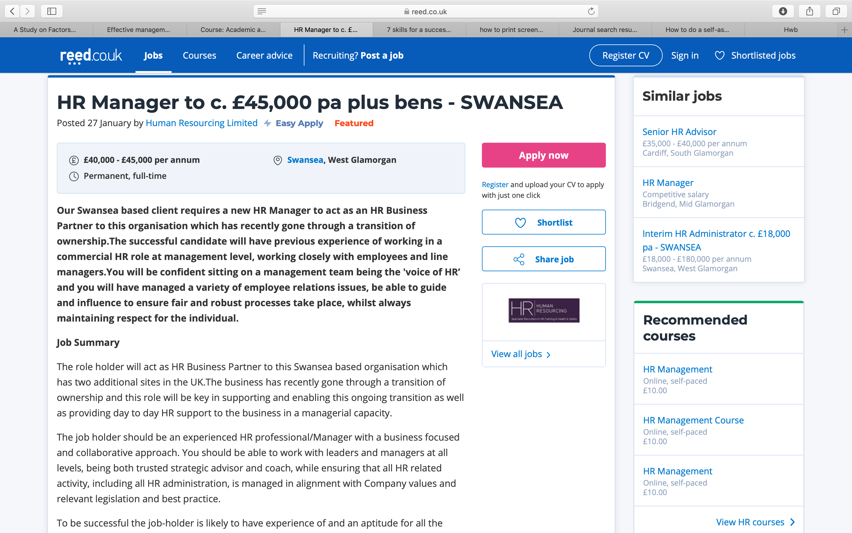

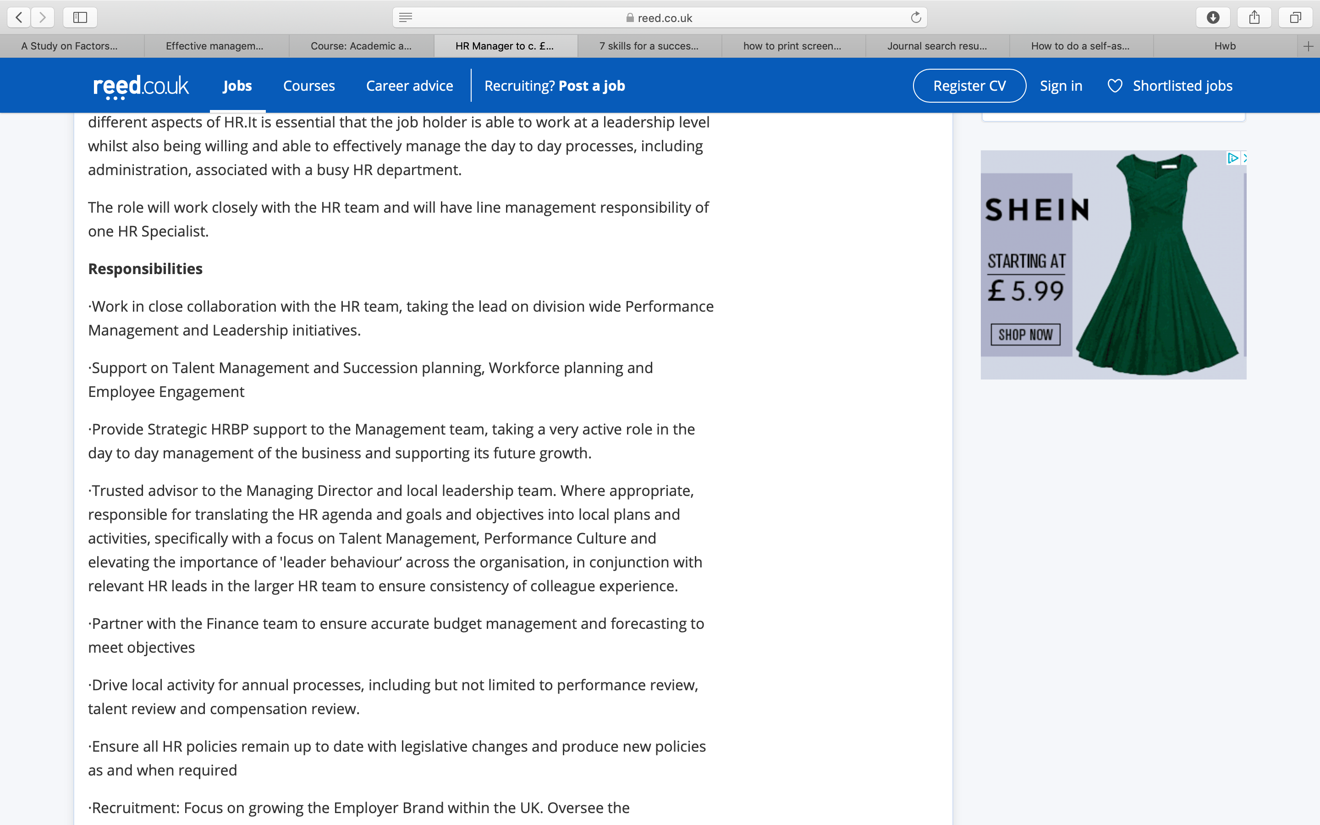
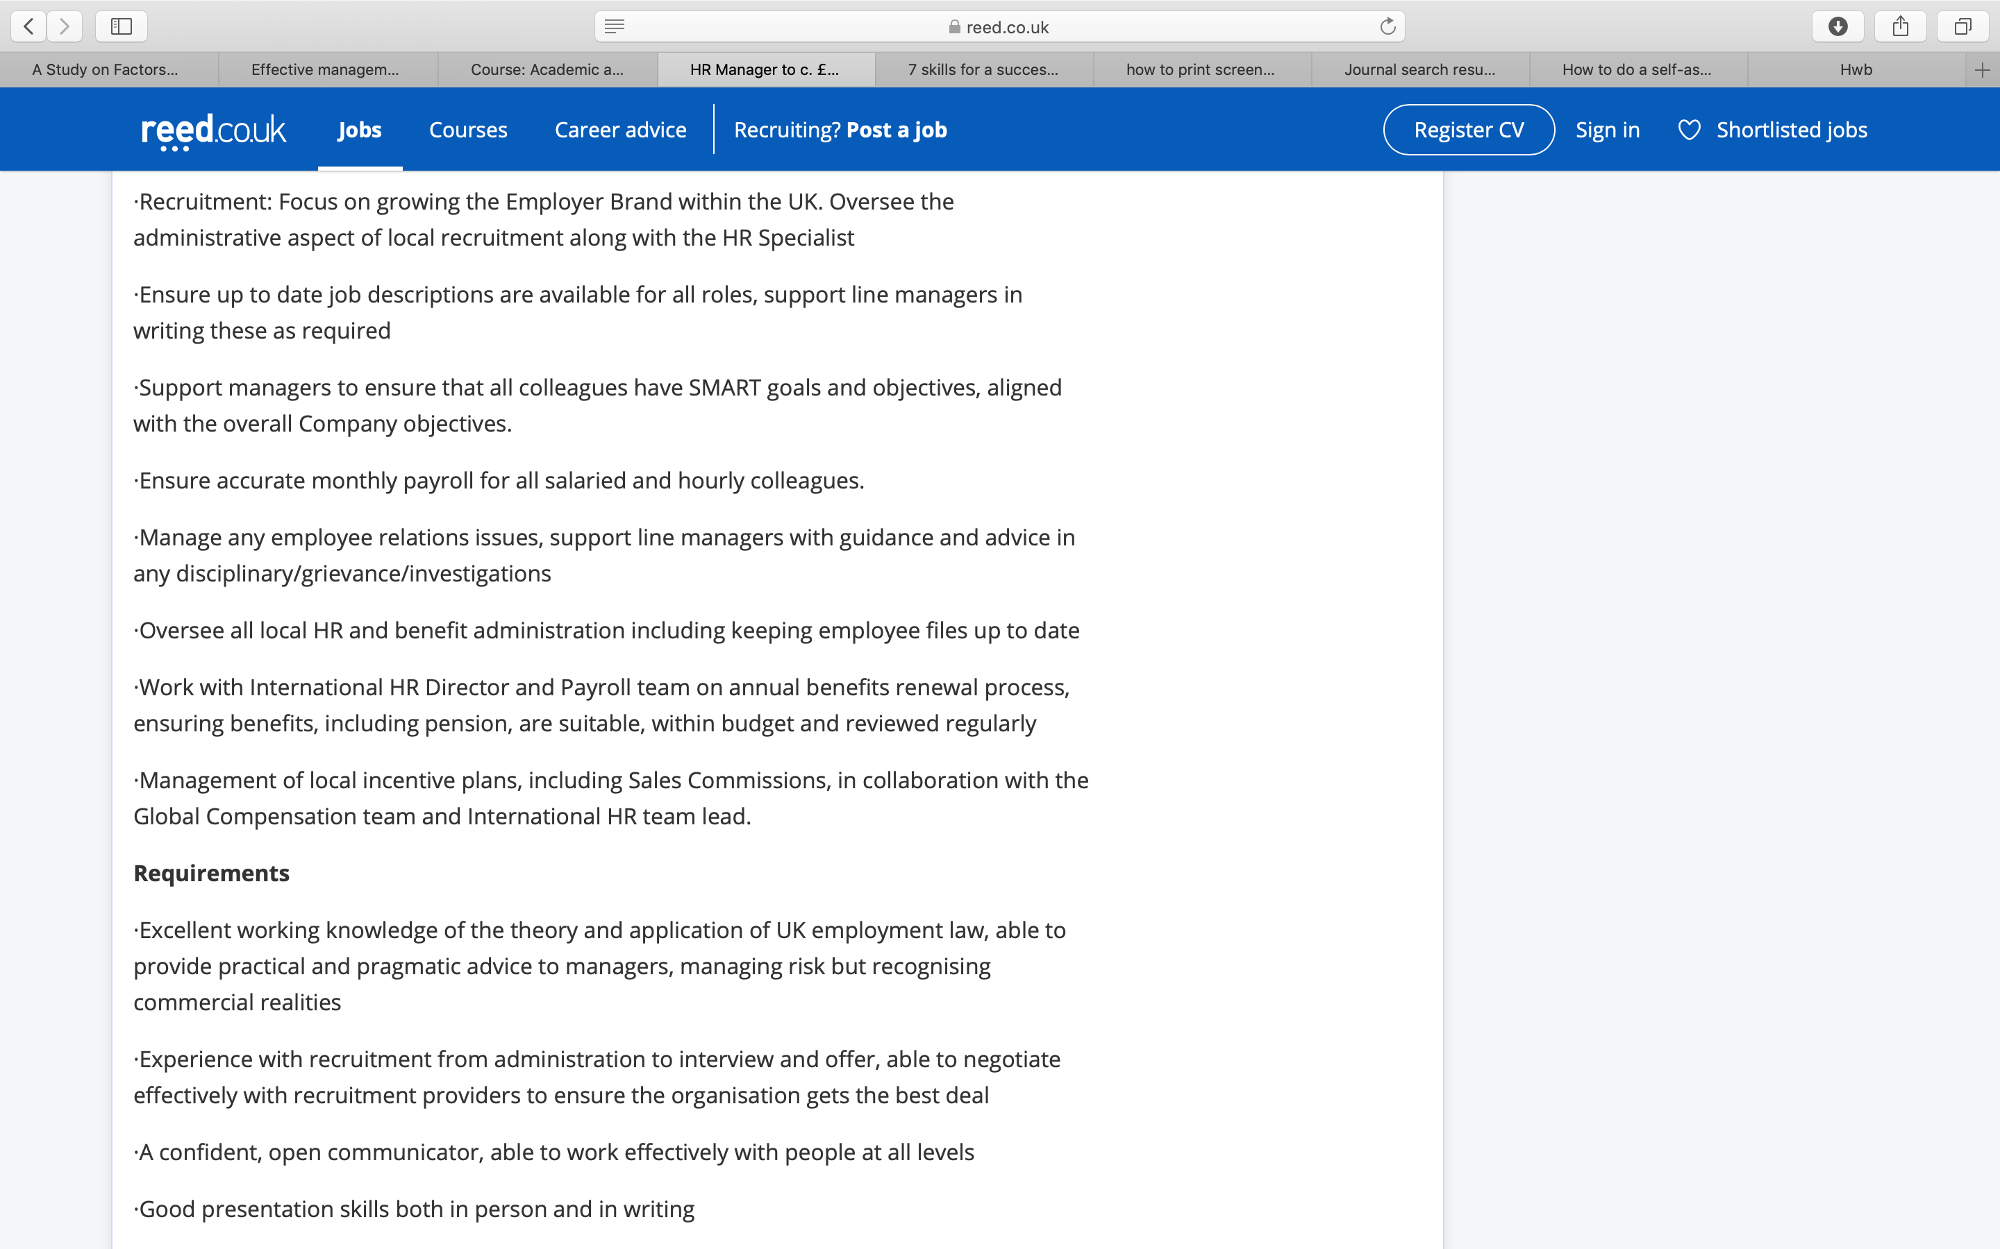
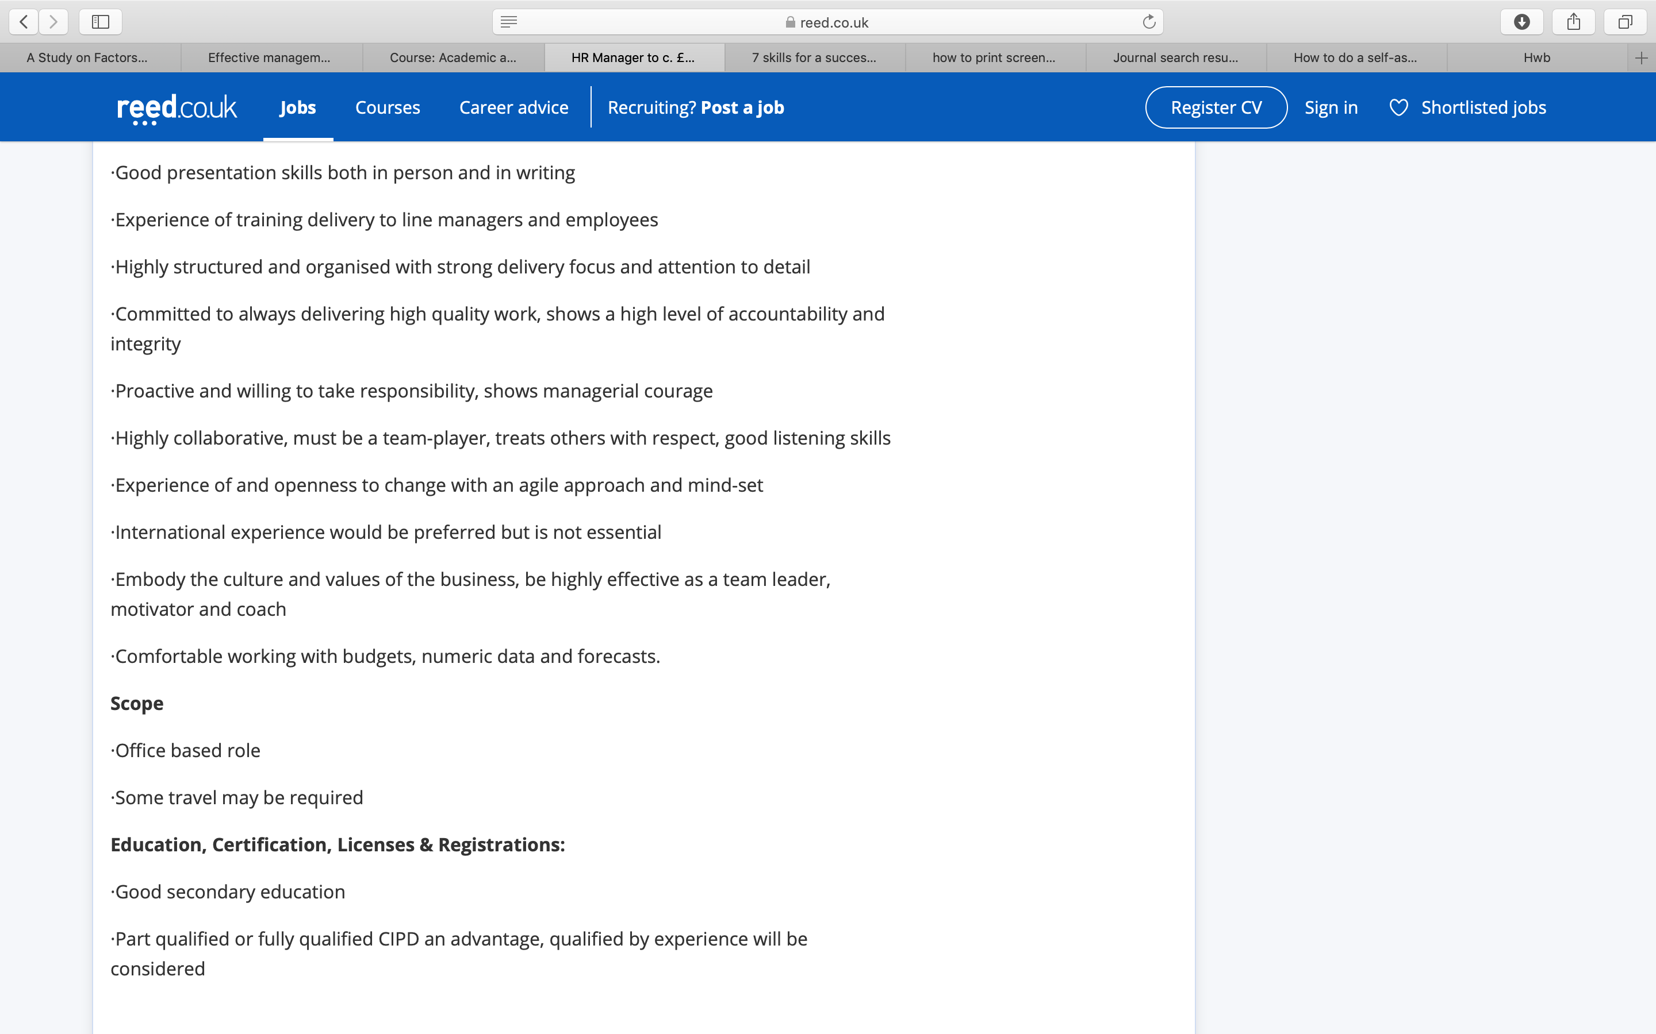
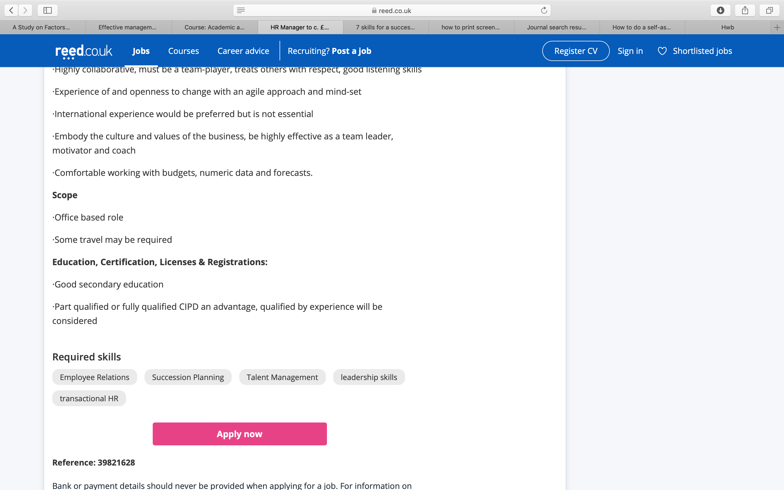

Appendix 2:
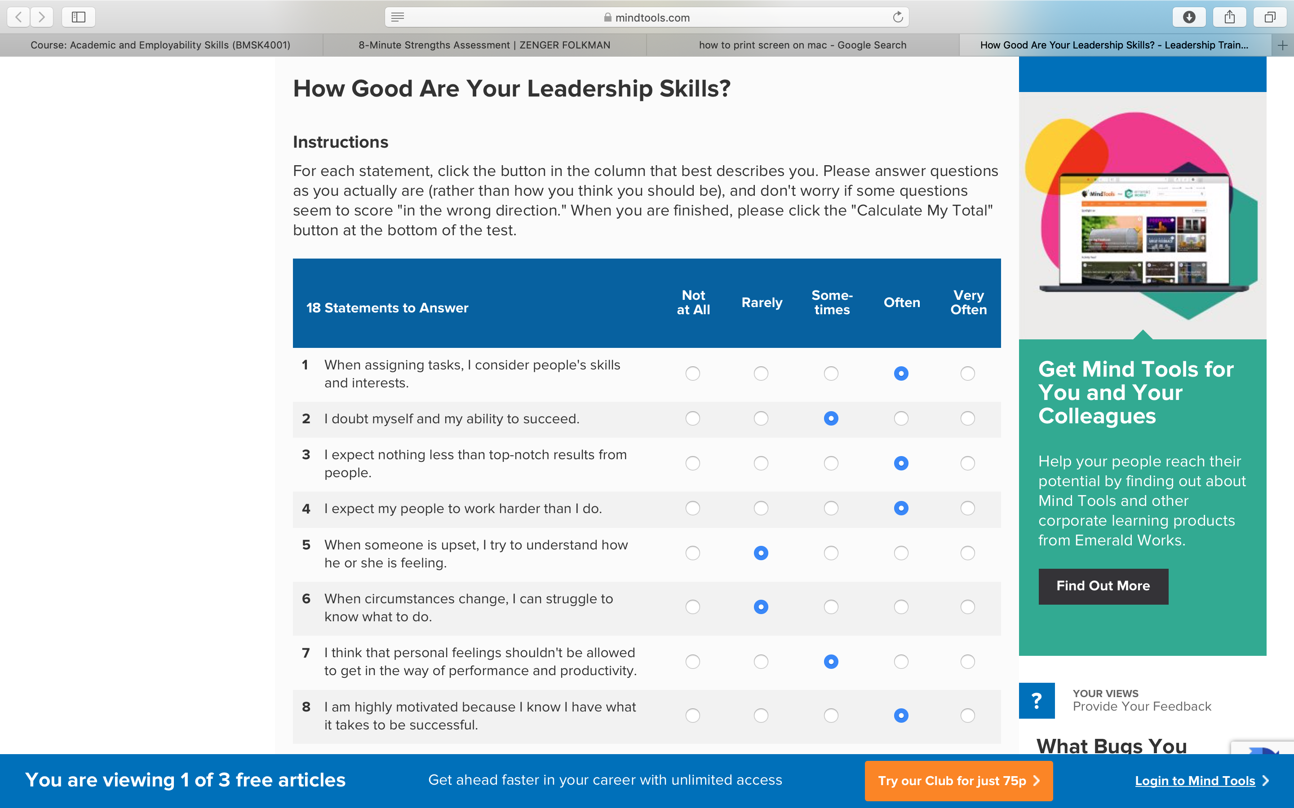
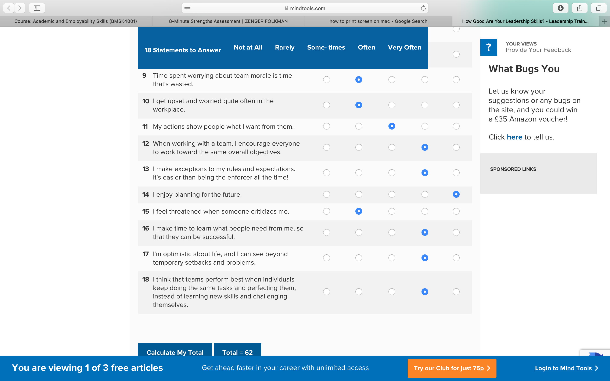
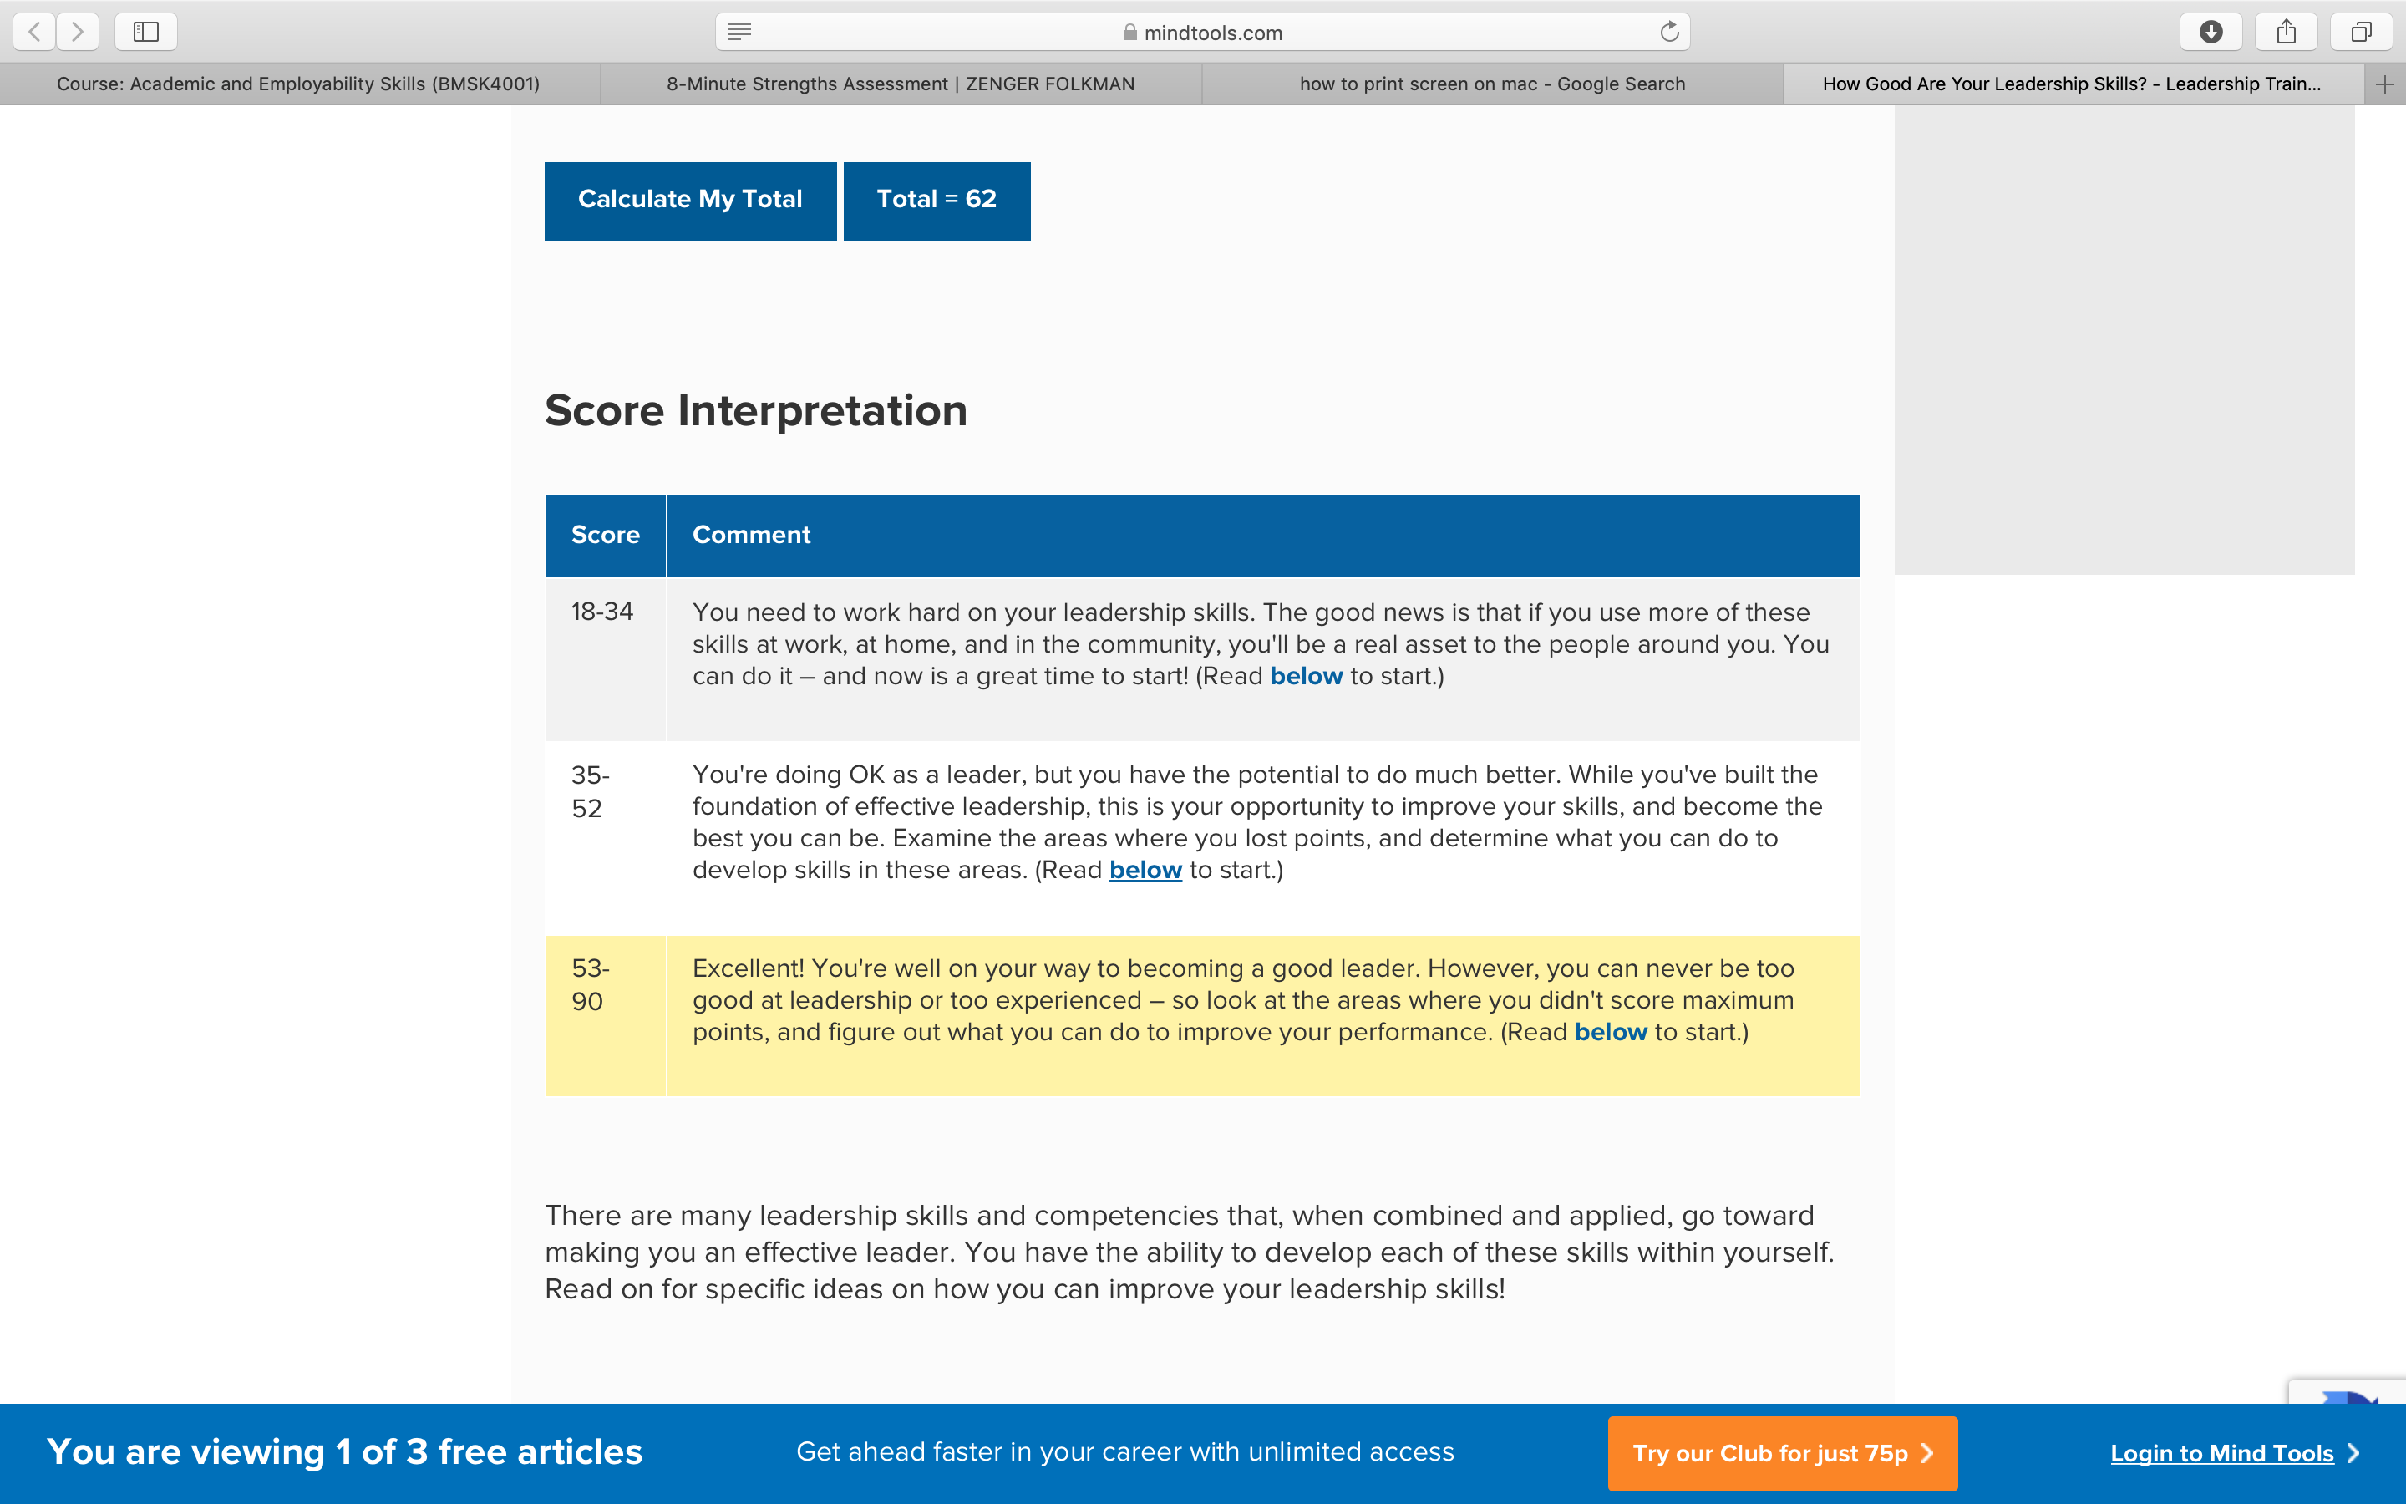

Appendix 3
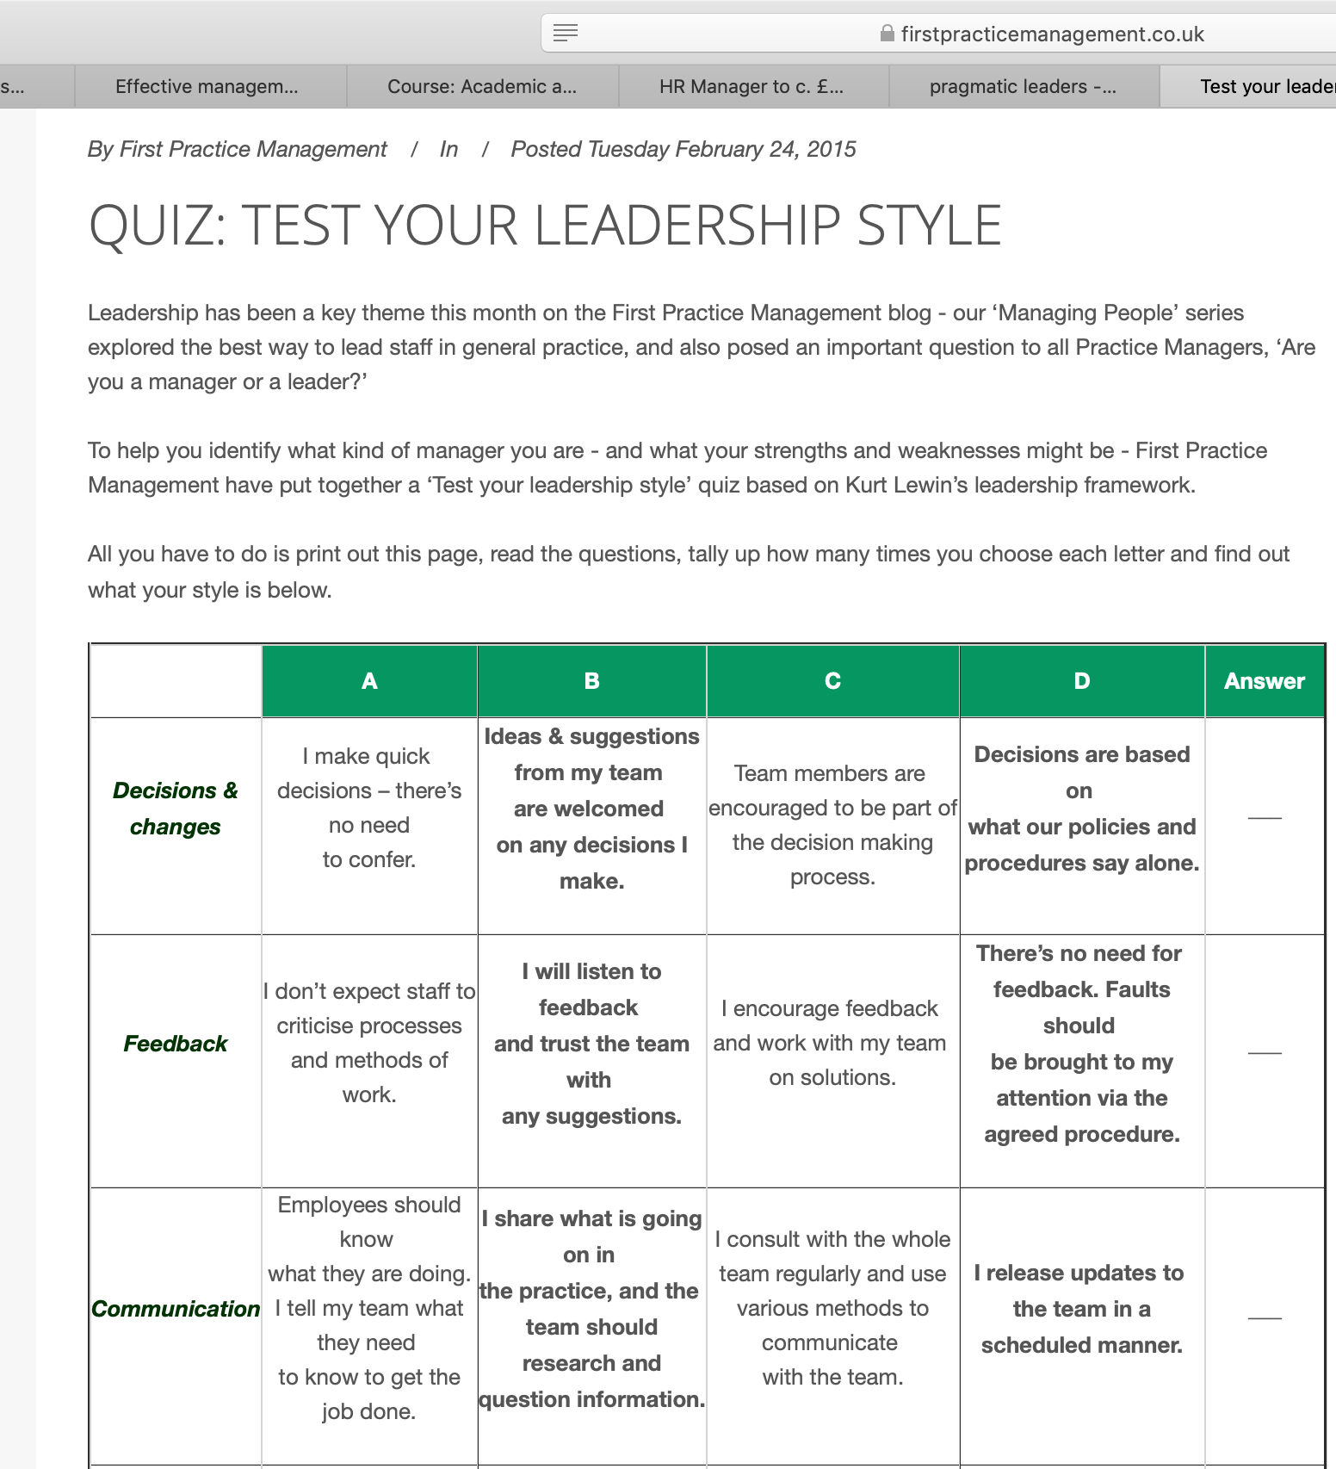

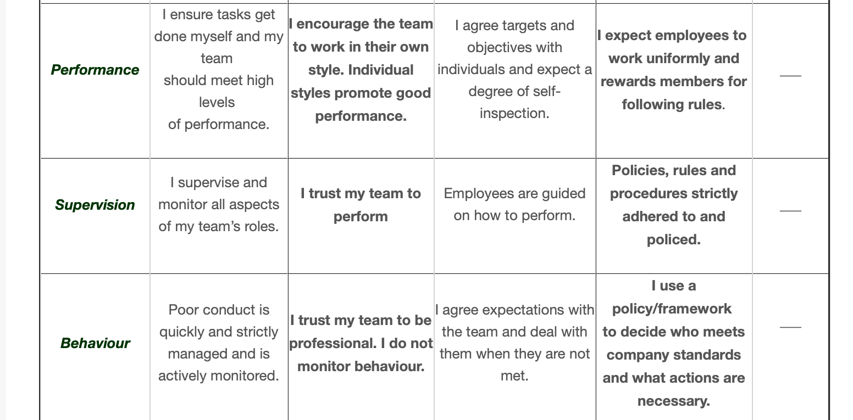
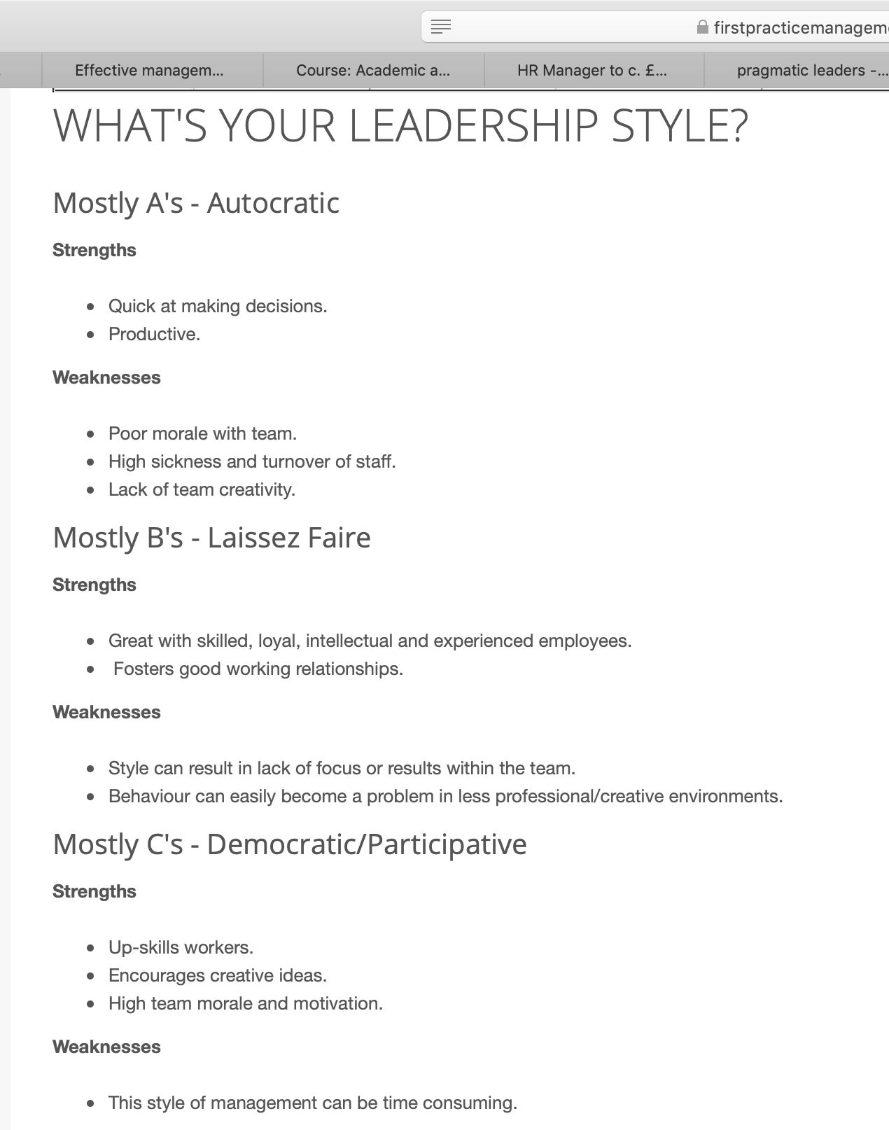
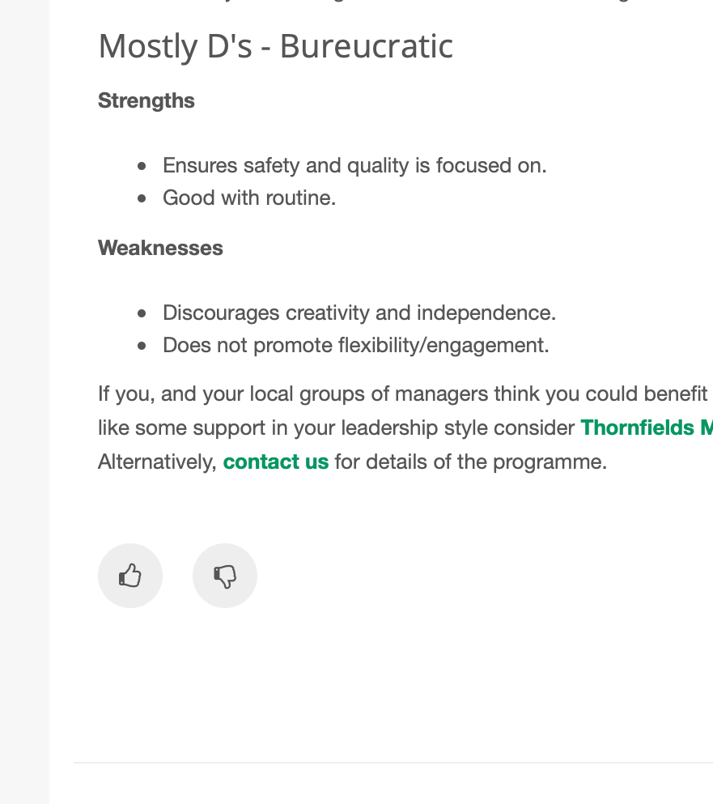
Appendix 4

Objective | Current Position | Deficiency | Action
What do I want to do? | What can I already do? | What am I lacking? | How do I fix this?
Become HR manager | I already possess HR experience from previous employments  Patience from p[ | Managerial experience | Complete Cert HE in leadership and management
Gain recruitment experience to apply for the job | Have a small amount of recruitment experience from previous roles | Managerial recruitment experience | Ask for training in recruitment in my current job
Full UK drivers licence to travel for the job | I can already drive provisionally with a co-driver | Full UK licence | Complete my driving test.

Appendix 5

Objectives | Tasks | Success Criteria | Time Frame | Resources
List your Goals | What do you need to do to achieve these goals? | How will you identify your success? | When do they need to be done by? | Who or what do you need to help you?
Gain confidence in my job role | Try and understand my job role better and what it takes to progress | I will identify my success by asking my employer to asses me regularly | I would like to get this done by September as there are opportunities for promotions then | My employer
Improve literacy and numeracy skills | Take course to improve on them, professional writing classes, maths tutorials. | Results from the courses, feedback from the tutors | Before I finish my current university course | Access to courses
Make better decisions and focus more, using my own initiative | Think harder before making choices that affect my life and work | By taking feedback from my employer, measure how many of the things I did well I did off my own back | By September | My employer  My own mind

Appendix 6

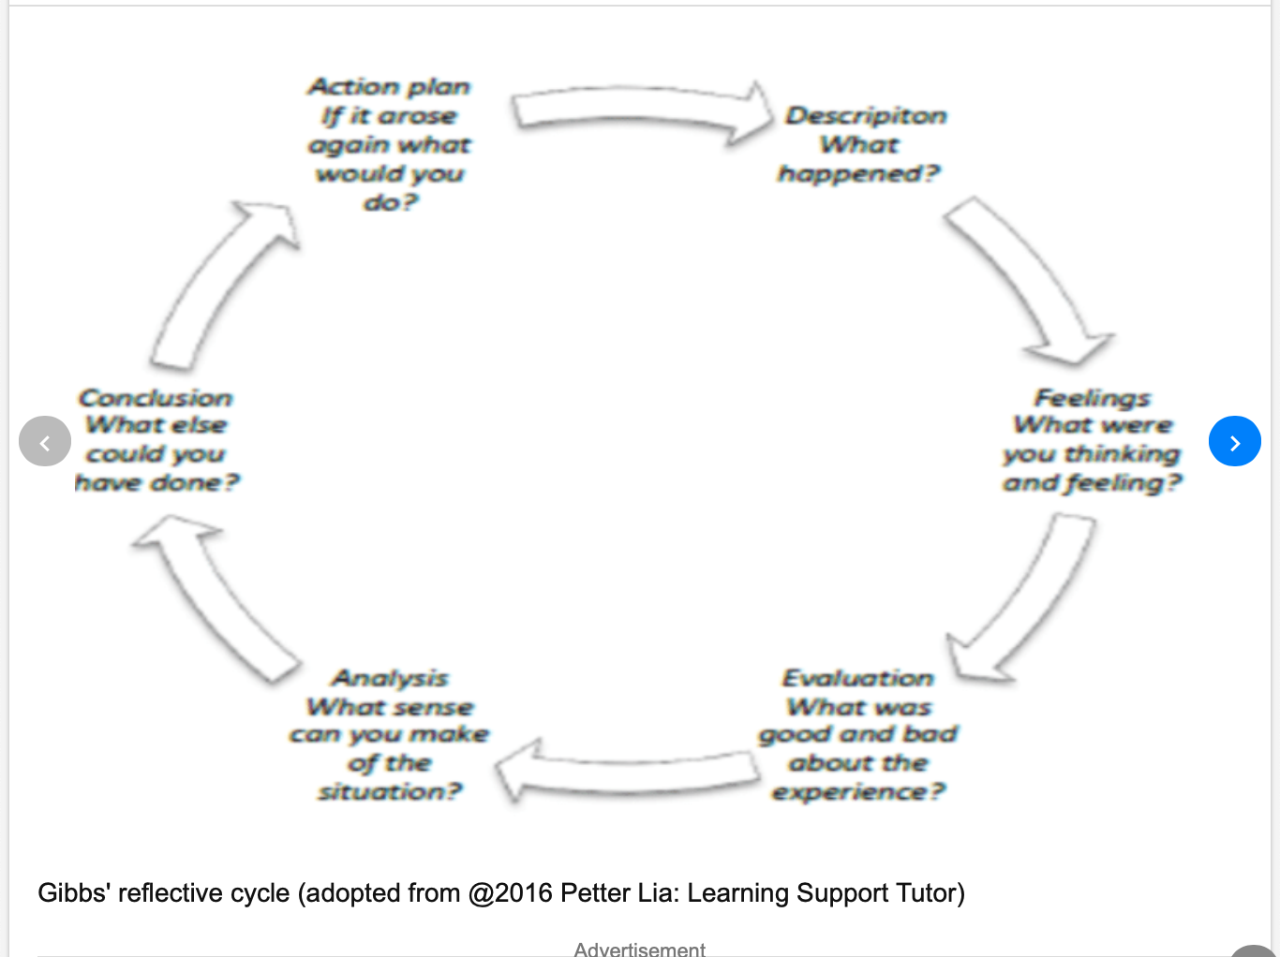

Appendix 7
SWOT analysis

Strengths  Reading  Learning new things and taking things in | Weaknesses  Referencing  Written work  Research  Understanding my assessments
Opportunities  Doing my CERT HE  Online courses | Threats  Failing my CERT HE

Appendix 8

Objective | Current Position | Deficiency | Action
What do I want to do? | What can I already do? | What am I lacking? | How do I fix this?
Pass CERT HE | I have already begun my CERT HE | Passing all the modules | Make sure I concentrate and do all my assignments to the best of my ability
Do a professional writing course | Write to a normal standard | Knowing how to write professionally | Attend a course to fix this
Do a numeracy course | Can do basic numeracy | Anything more than the basics when it comes to maths | Attend a course to fix this

Appendix 9

Objectives | Tasks | Success Criteria | Time Frame | Resources
List your Goals | What do you need to do to achieve these goals? | How will you identify your success? | When do they need to be done by? | Who or what do you need to help you?
Improve written skills | Take a course to improve them | Passing the course | As soon as possible | The online course
Improve research skills | Take more time when researching | Feedback on assignments | End of CERT HE | Lecturers
Improve concentration skills | Get rid of any distractions | Feedback on assignments | End of CERT HE | Lecturers
Improve referencing skills | Pay more attention when referencing | Feedback on assignments | End of CERT HE | Lecturers

