
PROGRAMME: BA (HONS) BUSINESS MANAGEMENT
MODULE: PROJECT MANAGEMENT
MODULE CODE: LCBB6006
COMPONENT 1: COURSEWORK: ESSAY

TITLE:
PROJECT PLAN FOR THE IMPLEMENTATION OF AN INTEGRATED HOTEL MANAGEMENT SYSTEM

NAME: GEORGI METODIEV
ID:2336039
WORD: 2142

Table of Contents
1. Introduction 3
2. Project Aim, Objectives and Scope 3
3. Project Outputs (Deliverables) 4
4. Activities Required to Deliver the Outputs 5
5. Work Breakdown Structure 7
6. Deliverables, Milestones and Timeline 9
7. Resource Planning 10
8. Conclusion 11
References 13

1. Introduction
Another major digital transformation of the hospitality sector in the recent past has been the integration of sophisticated technologies by hotels to enhance efficiency in their operations, quality of services and customer satisfaction. The size of this move is evidenced by industry respondents, with 81% of hoteliers believing that technology will grow increasingly significant to hotel business success in the next five years, and that 99% of hotels will depend on increasingly more technology in the future. Moreover, 39% respondents also state that an increase in operational efficiency is the foremost benefit of the technology implementation by the hotel managers, which proves the increasing strategic relevance of digital solutions in the hotel operations. Customers have become used to being able to make their bookings conveniently online, have quick check-in and check-out, secure payment options and tailor-made services and are urging the hotel to look at substituting manual systems with digital built-in systems. Hotel Management Systems (HMS) consolidate main activities like reservations, front office, housekeeping, billing, guest and reporting with little workload on administration, minimum errors and enhanced communication within the hotel. The project entails the adoption of an elaborate Hotel Management System whereby all these functions are incorporated in one system (Acharya, 2025). The system will optimise hotel operations, improve the experiences of guests, as well as aid informed decision-making by automation and real-time information. The implementation of a new ERP system will be planned and managed effectively to coordinate the resources, control risks, and deliver the project within the accepted scope, schedule, and budget.

2. Project Aim, Objectives and Scope
2.1 Project Aim
The aim is to implement an integrated Hotel Management System that improves operational efficiency, enhances guest services, and supports effective hotel management.
2.2 Project Objectives
- To analyse hotel operational requirements and document functional and technical specifications within the first two weeks.
- To develop, configure, and customise the Hotel Management System for reservations, front office, housekeeping, billing, and reporting within ten weeks.
- To integrate online booking platforms and secure payment gateways before system testing to enable seamless reservation and payment processing.
- To train hotel employees and successfully deploy the Hotel Management System within the planned seventeen-week schedule and approved budget.
2.3 Project Scope
The project encompasses gathering of the requirements, stakeholder consultation, software customisation, database development, reservation management, front office management, housekeeping management, billing and payment integration, guest profile management, reporting dashboard configuration, training of the employees, system testing, and data migration, and ultimate deploying of the Hotel Management System.
The project does not include the construction, or renovation of a hotel, the hiring of new staff to work in the hotel, software maintenance contracts, future software updates beyond the first implementation and marketing or advertising of the hotel.

3. Project Outputs (Deliverables)
3.1 Business Requirements Document
The project will be performed through a designed project lifecycle that will include initiation, planning, execution, monitoring and controlling, and closure. In the initiation process, the business case will also undergo assessment and the project formally accepted. The requirements gathering, scheduling, allocation of resources and risk management will be part of the planning phase. It will be executed through system design, development, integration, testing and staff training and monitor and control will be used to ensure that scope, time, cost and quality objectives are met. Lastly, the delivery of the project will include system deployment, project evaluation and handing over to the hotel management.
3.2 Project Management Documentation
During the project life cycle effective project management documentation will be generated. This will involve project charter with the objectives and responsibilities of the projects, a detailed project schedule with project activities and milestones, a risk register with possible risks and mitigation measures of the project, and a communication plan with the proposed reporting structures, and stakeholder communication procedures.
3.3 Hotel Management Software
The first deliverable is the fully functional Hotel Management System of a number of integrated modules. These are reserve management module, which takes care of reservation of guests, front office management module, which takes care of check in and check out operations, housekeeping management module, which takes care of house room status, guest profile database that stores data of customers, billing and invoice module that deals with financial transactions, payment gateway integration that handles online payment, and lastly report dashboard that gives an idea of the operations and financial performance of the enterprise.
3.4 Testing Documentation
Extensive testing records will indicate that the system works as desired (Astuti et al., 2024). The deliverables to be used include unit testing reports, which confirm each of the modules, integration testing reports, which confirm the interaction between the modules and User Acceptance Testing documentation, which allows confirmation of the stakeholder approval prior to deployment.
3.5 Employee Training Materials
Among deliverables of training, there will be comprehensive user manuals, presentation information and quick reference guides which will aid in training employees and foster uniform implementation of the new system within the hotel departments (Bilgihan and Ricci, 2024).
3.6 Operational System
The ultimate deliverable of the project is the actual launch of the live Hotel Management System where the reservation, front office, housekeeping, billing, payment and reporting modules are integrated into a fully operational project. After successful deployment and user acceptance, the project team will prepare a Project Completion Report that will present a summary of the project performance in relation to the agreed scope, schedule, budget and quality objectives, lessons learned and any recommendations on future system improvements. The Operational System, along with the deliverables, defined in Sections 3.2 to 3.6, will be recorded on the Project Organisation Information Document (POID) along with traceability in the Work Breakdown Structure (WBS) such that it could be ensured that each deliverable is allocated, tracked and formally closed before the end of the project.

4. Activities Required to Deliver the Outputs
4.1 Project Initiation
The project will commence with formal approval of the top management to authorise commencement of the project. Among the most significant stakeholders, one can distinguish the hotel management, the representatives of various departments, software developers, and implementation specialists (Bristy, 2025). Project kick off meeting defines project goals, roles, communication lines, schedule and vision of project performance prior to the commencement of project planning activities.
4.2 Requirement Analysis
Requirement analysis entails interviewing and holding of workshops with the hotel managers and hotel operational staff in a bid to know the current business processes and problems facing the actual operations of the hotel (Das, 2023). The process mapping would be done to capture existing workflows; functional and technical requirements would be documented formally and reviewed. With approval of the requirements by stakeholders, there is consensus on such requirements when system design is about to be implemented.
4.3 System Design
System design is concerned with the formulation of technical basis of the Hotel Management System (Dudnyk, 2024). The tasks involve coming up with database structure design, creating user interface layouts that are easy to use, defining workflow processes to facilitate operations in the hotel and defining the overall system architecture in a way that it assures security, scalability and performance.
4.4 Software Development
Software development activities entail setting up the reservation management module, housekeeping module, billing and invoice module and reporting dashboard to the approved requirements. System functions are developed and tailored to the specific needs of the hotel and its operational procedures, and to avoid conflicts among various software elements.
4.5 System Integration
In system integration, both the Hotel Management System and the external booking sites and secure payment gateways are linked (Gajić et al., 2024). The email notification services are activated to automatically send booking confirmations, invoices, and customer communications and provide a smooth communication between the components, which are all integrated.
4.6 Testing
Tests are done to assure that the completed system is serving as per the specifications. Unit testing checks individual modules, integration testing verifies that there is communication between modules, security testing checks data protection aspects and User Acceptance testing enables employees, in the hotel environment, to make sure that the system meets the requirements before its deployment.
4.7 Employee Training
The training will involve the preparation of user manuals, preparing presentation materials, practical workshops, and hands-on practice sessions to ensure the employees gain confidence and competence using the new Hotel Management System (Giannoukou, 2024).
4.8 Deployment
The last implementation step is to migrate the current customer and booking data to the new system, and to complete system go-live operations, track successful operation during the initial implementation period and report any pending issues, and to officially complete the project on the successful completion of handing over the system to the hotel management personnel.

5. Work Breakdown Structure
A Work Breakdown Structure (WBS) offers a hierarchical breakdown of the project into manageable parts which helps the project team to systematically organise the work, assign tasks, approximate the resources and keep track of the progress of the project in an efficient way (Hassan and Eassa, 2025). The WBS allows accuracy in planning, communication between stakeholders, and enabling effective project control during the implementation lifecycle by defining the project in small work packages as a result of the Hotel Management System Implementation project.
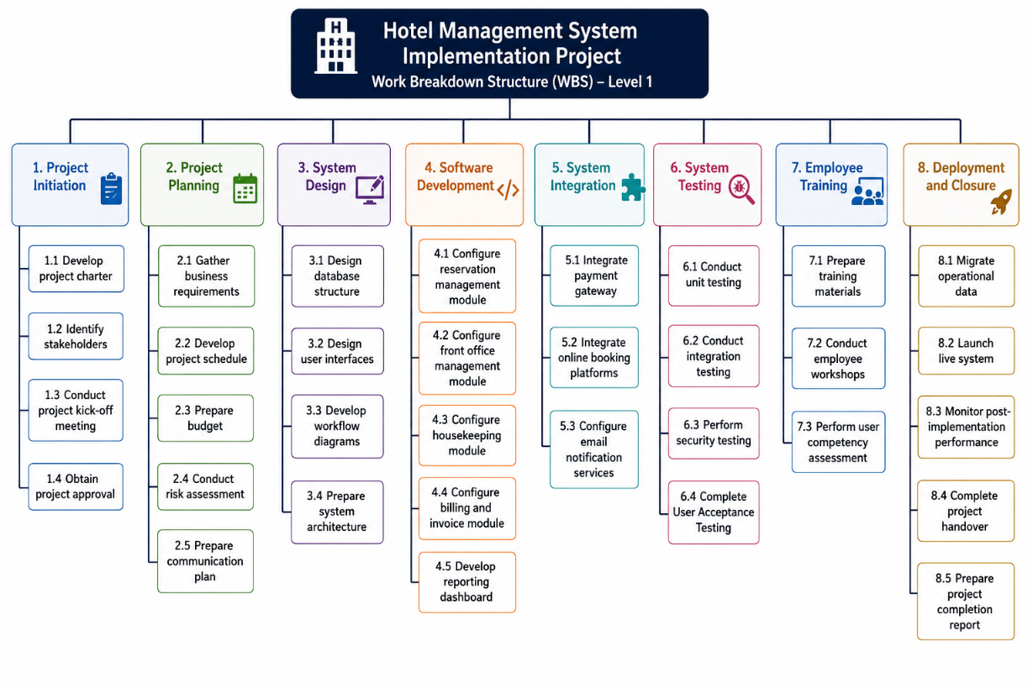
Figure 1: Hotel Management System Implementation Project
(Source: self-created)

6. Deliverables, Milestones and Timeline
The milestones and project deliverables are measurable results of the projects progress and help the project manager manage the project in accordance with the set timeline (Hutsaliuk et al., 2024). All large activities have a certain deliverable and milestone that illustrates a successful completion, and then advance to the next project phase. Setting achievable deadlines also helps in the use of resources, depiction of tasks, and minimising chances of project delays.
Project Task | Deliverable | Milestone | Estimated Duration
Project Initiation | Approved project charter | Project officially approved | Week 1
Requirement Analysis | Business Requirements Document | Requirements approved by stakeholders | Weeks 2–3
System Design | System design specification | Design approval completed | Weeks 4–5
Software Development | Configured hotel management modules | Software development completed | Weeks 6–10
System Integration | Integrated operational system | Integration successfully completed | Weeks 11–12
System Testing | Testing reports and UAT approval | User Acceptance Testing completed | Weeks 13–14
Employee Training | Trained hotel employees | Training successfully completed | Week 15
System Deployment | Live Hotel Management System | Successful system go-live | Week 16
Project Closure | Project completion report | Client acceptance and project closure | Week 17
Each milestone is completed to ensure that the project deliverables meet the set quality criteria, and then the next step is taken. The sequential method has a better chance to mitigate the risk of implementation because it helps identify and fix the errors early enough so that they are not transferred to latter stages of the project.
Dependency management is also supported by the project timeline since it appreciates that some activities cannot start until some other activities are done successfully following the prior ones (Kimani and Scott, 2023). An example of this is that software development will rely on approved system requirements and design specifications before system testing can start and that all the modules will have been configured and integrated. Tracking the milestones would also help the project manager to track schedule variances within an integrated approach to take corrective measures that would keep the entire project performance going.

7. Resource Planning
Proper resource planning will guarantee that the Hotel Management System Implementation project possesses the manpower, technology and resources to accomplish their tasks effectively and achieve their quality, budget and time goals (Limna and Kraiwanit, 2023). Effective resource allocation also minimises any risks in operation and helps in collaboration during the whole project life cycle.
7.1 Human Resources
A multidisciplinary team managed by the technical and managerial skills is necessary in the project. The Project Manager manages the planning, coordination, communication to stakeholders and monitoring of the project. A Business Analyst will collect and record the business requirements, and a System Architect will build the technical infrastructure (Mukiri, Munga and Muema, 2025). The hotel management modules are configured and customised by Software Developers and supported by a Database Administrator who takes care of managing databases and a Network Engineer who ensures a secure connection in the system. Quality Assurance Testers perform system testing, a Trainer provides employee training, and Technical Support Staff come in during deployment. The representatives of hotel departments are also involved in the process by validating the requirements and in User Acceptance Testing.
7.2 Material Resources
The application servers, desktop computers, networking equipment, cloud hosting services, licensed Hotel Management Software’s, database management software, cybersecurity tools, testing software, backup storage systems, and stable internet connectivity are all available as material resources to support system development, testing and implementation.
7.3 Resource Allocation
Each stage of the project is allocated resources in order to optimise the efficiency and reduce costs. These tasks involve their involvement mostly in design, development, integration and testing and trainers aiding in the implementation during training phase (Uzoka, Cadet and Ojukwu, 2024). The Project Manager constantly tracks the resource use to see when resources are short or cause conflict and ensures a proper response when it becomes essential. Having contingent resources is also beneficial in dealing with unforeseen cases of technical problems or unavailability of staff without seriously impacting the project completed on time and its quality.

8. Conclusion
The Hotel Management System Implementation project offers a logical way to enhance the activities of hotels by switching to the application of a single digital management platform. The project plan will create a successful project implementation structure by clearly defining the project aim, objectives, scope, deliverables, activities, Work Breakdown Structure, milestones, timeline and resource requirements (Wilson, 2025). All stages in the project lead towards the realisation of operational efficiency, as reservation, front office services, housekeeping, billing, customer management, and reporting are combined into a single system. Effective resource allocation, risk management, quality assurance as well as stakeholder communication during the lifecycle is also facilitated by the structured planning process. Moreover, set milestones and schedules allow tracking project progress without causing implementation to change course despite the organisational goals. In general, the planning of this project will offer viable basis to schedule the Hotel Management System in time, on budget and per agreed quality standards, therefore improving service quality, operational performance and long-term organisational competitiveness.

References
Acharya, K., 2025. Hotel billing management system project report.
Al-Hyari, H.S.A., Al-Smadi, H.M. and Weshah, S.R., 2023. The impact of artificial intelligence (AI) on guest satisfaction in hotel management: An empirical study of luxury hotels. Geo Journal of Tourism and Geosites, 48, pp.810-819.
Astuti, E., Harsono, I., Uhai, S., Muthmainah, H.N. and Vandika, A.Y., 2024. Application of artificial intelligence technology in customer service in the hospitality industry in Indonesia: a literature review on improving efficiency and user experience. Sciences Du Nord Nature Science and Technology, 1(01), pp.28-36.
Bilgihan, A. and Ricci, P., 2024. The new era of hotel marketing: integrating cutting-edge technologies with core marketing principles. Journal of Hospitality and Tourism Technology, 15(1), pp.123-137.
BRISTY, I.J., 2025. Smart Reservation and Service Management Systems: Leveraging MIS for Hotel Efficiency. Authorea Preprints.
Das, M.P., 2023. Technology and Guest experience: innovations reshaping hotel management. International Journal for Multidimensional Research Perspectives, 1(3), pp.76-95.
Dudnyk, S., 2024. Innovations in hotel management: The impact of new technologies on improving customer service.
Gajić, T., Petrović, M.D., Pešić, A.M., Conić, M. and Gligorijević, N., 2024. Innovative approaches in hotel management: integrating artificial intelligence (AI) and the internet of things (IoT) to enhance operational efficiency and sustainability. Sustainability, 16(17), p.7279.
Giannoukou, I., 2024. Revolutionizing hospitality: Strategic integration of innovation management embracing technological innovation for enhanced customer experiences. Technium Business and Management, 7, pp.24-39.
Hassan, S.A. and Eassa, A.M., 2025. SHMIS: An integrated IoT context awareness framework for hotel management to enhance guest experience and operational efficiency. Information Technology & Tourism, 27(3), pp.579-612.
Hutsaliuk, O., Bondar, I., Zhurylo, I. and Dub, V., 2024. Economic strategizing and integration management of hotel and restaurant business enterprises in the hospitality industry system.
Kimani, C.J. and Scott, J., 2023. Introduction to Front Office Operations and Administrations in Hospitality Management Diploma Level. Finstock Evarsity Publishers.
Limna, P. and Kraiwanit, T., 2023. The role of chatgpt on customer service in the hospitality industry: An exploratory study of hospitality workers' experiences and perceptions. Tourism and hospitality management, 29(4), pp.583-592.
Mukiri, J.F., Munga, J. and Muema, W., 2025. Effects of Technological Integration on Performance of Hotel Industry in Kenya. Academic Journal of Humanities and Social Sciences Research, 2(1).
Uzoka, A., Cadet, E. and Ojukwu, P.U., 2024. Leveraging AI-Powered chatbots to enhance customer service efficiency and future opportunities in automated support. Computer Science & IT Research Journal, 5(10), pp.2485-2510.
Wilson, O., 2025. Enhancing Operational Efficiency and Guest Satisfaction in Hotel Management: A Strategic Approach. OTS Canadian Journal, 4(5), pp.72-81.

