BMIH5007- Financial Management for the Hotel Industry

Student’s Name: Elsa Machado
Student’s ID:2012887
Lecturer’s Name: Dale Clarke
Module Code: BMIH5007

Table of Contents
Executive Summary 3
Introduction 3
Financial Analysis Trends 6
Profitability 6
Liquidity 6
Gearing 7
Benefits and Limitations of Ratio Analysis 7
Conclusion 8

BMIH5007- Financial Management for the Hotel Industry

Executive Summary
Jurys Inn is a chain of hotels operating within the United Kingdom, Ireland and Czech Republic. The companies headquartered in Dublin Ireland but they are spread in the above mentioned three countries within Europe, there are 34 locations on the dressing brand-name and seven others for the Leonardo brand-name. It may be considered that is a middle size hospitality group due to the fact that it has around 4000 employees and the main goal is to satisfy the customers needs as well as generating profits for the company. There are 7500 rooms that may accommodate the guests which are willing to book a room whether there are traveling for business purpose or leisure purpose but also, is important to mention that the hotel is family friendly so if there is needed an extra bed in the room for the kids the customers just have to analysis the concierge and for a certain fee, they will add it (Wikipedia, 2021).
Furthermore, Jurys Inn is a chain of hotels that have successfully achieved a forest our certification for most of their hotels since 2019 which means that the whole 13 is a developing business that it’s meant to growth and it focuses on expansion and get better in the hospitality industry as providing their guests affordable prices for the rooms as well as unique experiences. There are invested huge amounts of money such a 75,000,000 pounds which means that the hotel is giving their best to develop in the industry but it is also expected that all their portfolio Will gain the AA certification for becoming four stars hotels (Eat. Drink. Sleep, 2019).

Introduction

The following report will highlight The company’s performance financial and nonfinancial based on the following tables and ratios that we exactly show how the development of Jurys Inn have emerged in the past three years.
Profitability gearing and liquidity will be further discussed within the report in order to analyze the three concepts within Jurys Inn company which is the main aim to discuss solutions for the eventual problems that are highlighted by the numbers and the results from the past years of the company regarding the above-mentioned objectives.
After carefully analyzing the profitability in revenues there is clear that the hospitality company Jurys Inn has reported an increase in Their income and it states that the company Is positioning itself on an ascending path.
As the calculus was made over the financial analysis table we had to look if the hospitality companies able to pay it’s short time debts So the lake with the ratio for the year 2019 was 2.28 and for the year of 2020 it was 2.00.(CFI, 2021). For this reason, It is clear that Jurys In company is able to pay it short time debts and the liquiddity will be double after paying them this may be concluded as a positive aspect for the company that is making enough revenue to be the required that and also have money for further investments.
Unfortunately, there is no enough that I had to have a broader analyzis about Jurys Inn company due to the fact that it can be stated a clear journey while looking at the history of at least five years. Also, in order to be more specific and create a very competent financial analysis, there is needed of more data for more years and more details about the company so we can conclude more about their development about their investments in new projects such as sustainability.
However the structure of the ratio is allowing the manager or the chief executive to have a more clear rem the funds the company is having and for this reason further opinions will be highlighted. Future planning regarding economic numbers will allow the chief executive to plan every video of every step that can be done from the financial point of view by Jurys Inn company but also, he can see the benefit of having a high ratio and high profits Why is setting some boundaries regarding the next year’s financial plan.
The managers in the hospitality industry should be able to evaluate carefully every financial aspect of a hotel as it management to work properly and setting target to get more easier. Actually the financial part of any business eats dictating its success so for this reason the financial management and the hotel management should go hand hand in order to achieve the business targets even they do not seem to be correlated. Creating an annual budget will help the hotel management to better organize their finances for the next year and also Missing a financial tracking Moldo so for the investments or access would be easily identified if they fit or not the Business (Gittens, 2021).
COVID-19 Pandemic is an aspect to be discussed as it directly impacted the hospitality industry and the fact that governments as told us to close their doors was a breakdown for their financial situation for this reason the hotel management should further take care about their situation due to the fact that having a great plan in matter of finances would help the business re-establish their path to success and also recovering after the pandemic rules and laws were not so strict any more (Heyman, 2020).
The financial Performance of Jurys Inn company Will be largely presented with the help of the ratios Compared on the two year period performances.

Column1 | Column2 | Column4 | Column6 | Column8
Formula |  | Ratio | 2019 | 2020
Gross profits/sales x 100 |  | Gross profit | 5050/5500x100=92 | 5150/6000x100=86
Net profits of the year/ sales x 100 |  | Net profit | 4008/5500x100=73 | 4073/6000x100=68
Net profit of the year + |  | ROCE | 4008+20/6226x100=65 | 4073+18/6274x100=65
loan interest/totral assets
less current liability x100
Sales/total assets less |  | Total assets turnover | 5500/6226=0.88 Days | 6000/6274=0.95 days
current liability
Sales/net profit assets |  | Working capital turnover | 5500/6076=0.90 | 6000/6129=0.97
Current assetes total/ |  | Current ratio | 3065/1339=2.28 | 3240/1616=2.00
Current liabilities total
Current assets total-stock/ |  | Quick Ratio | 3065-1450/1339=1.20 | 3240-1420/1616=1.12
current liabilities total
debtorsx365 days of the year/
Debtorsx365 days of the year/ |  | Debtor days | 1600x365/5500=106 | 1800x365/6000=109
purchases
Trade creditorsx365 days/ |  | Creditors days | 800x365/500=584 | 870x365/850=373
purchases
(Total current liabilities+bank loan) |  | Debt days | 1339+150=1489 | 1616+145=1761
(total current assets+ fixed assets) |  |  | 3065+4500=7565 | 3240+4650=7890
answer divided by one another |  |  | 1489/7565=0.19 | 1761/7890=0.22
Net profit of the year+ |  | Interest cover | 4008+5/20=201 | 4073+5/18=226
cash in hand/loan interest

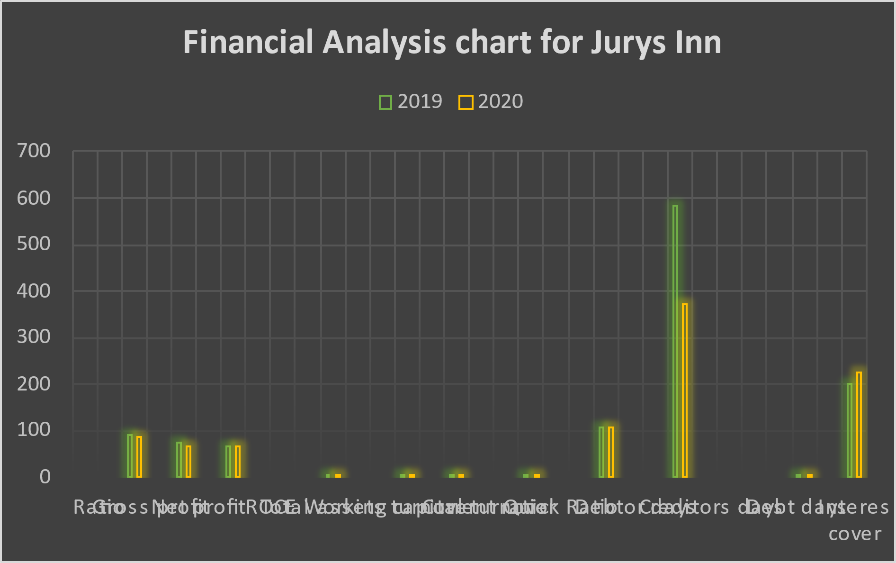

Financial Analysis Trends

Profitability
According to (Hayes, 2021), The profitability ratios are defined as and the possibility of the business to generate revenues. This Concept is based on analyzing on a certain time frame the balance sheet assets, Operating costs But also the shareholders equity.
While analyzing the profitability ratio of Jurys Inn Hotel business it is needed to be mentioned that during the holiday season they will register more revenues then an extra season so the curiosity of the profitability ratio is not as expected. However, the profitability ratio of Jurys Inn in the year of 2019 was bigger than the profitability ratio in 2020 which means that the hotels have decreased their efficiency in 2020.

Liquidity
The thermal for the liquidity can be describe about the cash money the company has due to the fact that this concept also relies on the sum of money that the company can take out four for the investment or pink other things such as that’s without decreasing the market price for affecting it. Partnerships and other assets such as non-collectibles are also considered liquidities for the company (Hayes & Scott, 2021).
After calculating the current ratio and quick ratio we can see that the Jurys Inn hotel chain has a positive equity which means that they are able to invest the money further without affecting their market share but also this is money that is available instantly without taking time to have access to them. It is however important to make sure that in 2019 the ratio regarding liquidity was higher than in 2020 which means that the company has registered a decrease in liquidity in 2020 and power off investing a having access to instant money lower.

Gearing
Did you bring ratio is actually looking after the companies fitness let’s say like that due to the fact that he describes and analyzes The financial leverage of the company which is also related to the owner of equity to the borrowed funds (Boyte-White, 2021).
As in the gearing subject we are looking on the debtors ratio of Jurys Inn, We can clearly see that it increased in 2021 into thousand 19 it was lower. He’s actually means that the company is struggling while having debts. Furthermore, we can discuss about the fact that the liquidity is decreasing while debts are increasing Which is a negative movement of the hotel chain and he needs to be fixed and better management from the financial point of view needs to be discussed within the management board.

Benefits and Limitations of Ratio Analysis
The Ratio Analysis is one tool that allows identifying details about any comoany regarding its liquidity, equity, debts and profitability. In this process there are included all the types of ratios combined with other financial elements that will help in contouring a clear financial analysis. Usually, when an investor is willing to include incentives in a company, there is needed to be hired a professional ratio analyst in order to see how the company is managing their financial aspect as well as generating an ideea of the future gains and performance (Bloomenthal, 2021).
As the hospitality industry is a combination of various sub-categories such as events planning, Tourist destinations or cruise lines, the Jurys Inn ratio analysis is made only regarding the hotel business except other any sub-division. One factor that benefits the stakeholders of Jurys Inn is that the current ratio shows exactly if the hotel chain is capable to pay their liabilities and also, to be on a positive line even when a downturn happens such as Covid-19 Pandemic that have proved that only companies with a very strong ratio were able to survive the Pandemic period (Tarver, 2021).

One of the main benefits of the Analysis is also linked to the results of the decision taken in the past. For example, if the analysis shows lower results after implementing a project within the company, it means that the decisions should be avoided in the future. Moreover, ratio Analysis changed the complicated accountability regime in transforming everything into an efficient operation. Attention regarding the certain areas that are having issues will be possible as the ratio analysis shows the management where the problem started by highlighting the low numbers in all the operations done by the hotel (Sureka, 2020).
In matter of limitations, the Ratio Analysis does not take into account the inflation regarding the changes in the price levels which means that there can be false or un-accurate results. In addition, the current ratio is not a fixed base but it includes several types of formulas which means that the results may differ, depending from which point of view the analysis is done. Last but not least, the ratio analysis is not a problem solver for Jurys Inn but rather identifies where things are not functioning on a positive way (Thakur, 2022).

Conclusion

The debt ratio should be positive in the case of a hospitality company such as Jurys Inn due to the fact that long-term liabilities such as busses or transportation companies should be paid in order to deliver the required services for the hotel’s guests.
However, we can observe a significant decrease Regarding the gross profit which is actually generated by the services of Jurys Inn, so the chef executive should be aware of making smart improvements within the services in order to attract more customers and the numbers to rise in the following years.
Looking at the net profit margins, the same decrease happen when comparing 2019 with 2020 which may generate a certain absence of the investors due to the fact that usually, they are comparing the net profit margins in order to see where the hotel is positioned among competitors.
In conclusion, Jurys Inn should develop a strategic plan in order to increase the numbers of the ratio analysis and bring the company on an ascending path.

References
- Bloomenthal A., (2021), Ratio Analysis, Updated on February 20th, Accessed on February 5th 2022.
- Boyte-White C., (2021), What is Good or Bag Gearing Ratio?, Last Updated on April 27th, Accessed on February 5th 2022.
- CFI, (2021), Liquidity Ratio, Accessed on February 5th 2022.
- Eat. Drink. Sleep, (2019), Jurys Inn and Leonardo Hotels Announce Four Star AA Accrediations Across UK Hotels, Published on March 7th, Accessed on February 5th 2022.
- Gittens C., (2021), Financial management in the hospitality industry, Accessed on February 5th, 2022
- Hayes A., (2021), Profitability Ratios, Updated on April 9th, Accessed on February 7th 2022.
- Hayes A., Scott G., (2021), Liquidity, Updated on August 29th, Accessed on February 5th 2022.
- Heyman M., (2020), How hot does can develop a dynamic budget for COVID-19 and beyond, Published on December 8th, Accessed on February 5th 2022.
- Sureka S., (2020), Advantages of Ratio Analysis, Accessed on February 5th 2022.
- Tarver E., (2021), Key Financial Ratios to Analyze the Hospitality Industry, Updated on May 27th, Accessed on February 5th 2022.
- Thakur M., (2021), Limitations of Ratio Analysis, Accessed February 5th 2022.
- Wikipedia, (2021), Jurys In , Accessed on February 5th 2022.

