

Name – Jake Howells

Student Number – 2407082

Course – HND Quantity Surveying

Module – Research Project Design

Retrofit VS Newbuild: Which is more cost effective for homes in Carmarthenshire
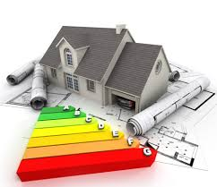
Figure 1

(Blundell, 2021)

Abstract
This research proposal evaluates whether retrofitting existing dwellings or constructing new homes is the more cost efficient strategy in Carmarthenshire when assed across capital and whole life perspectives, including the operational energy, maintenance and the embodied carbon. The UK housing stock is a major contributor to carbon emissions and a significant proportion of homes fall below the Energy Performance Certificate band C which is creating the need for large scale intervention to meet the decarbonisation targets, Carmarthenshire provides a distinctive case dure to its rural context the ageing housing stock and varied socioeconomic conditions all of which influence the delivery cost and feasibility (JLL, 2026)( UK Government, 2025) (Climate Change Committee, 2023).

This study uses mixed methods of approach which combines quantitative costs modelling with qualitive insights from industry stakeholders. Secondary data will be drawn from construction databases, policy documents and academic literature, also an example of how data will be collected if interviews and surveys were fully conducted. The research aims to identify conditions under which retro fit or new build is more cost efficient and to provide recommendations for the policymakers. The findings are to support evidence based decision making in housing delivery and sustainability planning within Wales (BCIS, 2025).
Contents
Retrofit VS Newbuild: Which is more cost effective for homes in Carmarthenshire 2
Abstract 2
Introduction 4
Background Of The Study 4
Research Questions 5
Aims And Objectives 5
Literature Review 6
Retrofit Costs And Variability 6
New Build Cost And Performance 6
Carmarthenshire Specific Factors Affecting Cost Efficiency 9
Rural Delivery Cost And Supply Chain 9
Housing Stock Profile And Condition 10
Land Availability And Viability For New Build Homes 10
Risks, Uncertainties and Non-Monetary Factors 11
Quality And Remedial Risk 11
Future Policy And Carbon Pricing 12
Identification Of Gaps In Current Research 13
How The Research Will Address These Gaps 14
Research Design And Methodology 16
Research Design 16
Data Collection Methods 16
Detailed Timeline Of The Research Activities 19
Expected Outcomes And Potential Findings 21
References 23

Introduction

Background Of The Study
The residential sector in the United Kingdom accounts for a substantial proportion of national energy consumption and carbon emissions which makes it a key focus area for decarbonisation policy and sustainability initiatives (Climate Change Committee, 2023). A large proportion of existing homes were constructed prior to modern building regulations resulting in poor thermal performance and inefficient energy use. This has created a huge need for large scale intervention to improve the housing standards and reduce emissions across the construction sector (UK Government, 2025).
In Wales the challenge is particularly significant dure to the prevalence of older and rural housing stock which often includes solid wall construction and limited amounts of insulation. These characteristics make energy efficiency improvements more complex and costly compared to the newer properties (GOV.WALES. 2022). Carmarthenshire reflects these national trends with a mix of traditional rural dwellings and more modern housing developments, creating varied retrofit and development challenges (Carmarthenshire County Council, 2022).

Additionally, the increasing energy and fuel costs have increased the need to improve housing efficiency. Households living in poorly insulated homes face higher energy bills, making retro fit interventions not only an environmental priority but also a social necessity (Gov.UK, 2019). This adds further importance to understanding which approach between retro fit and new build is more cost effective in the long term (Cookefawcett.com, 2023).
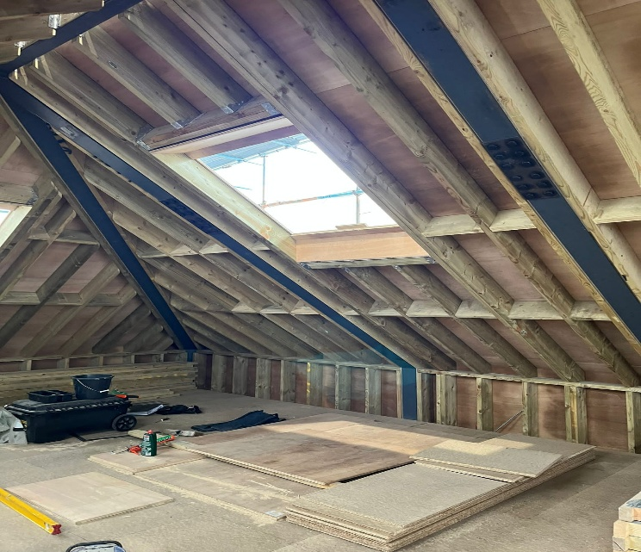

Research Questions
The main research question which is guiding this study is: Which is more cost efficient in Carmarthenshire Retrofit or New Build? This Question Is supported by several sub-questions that will explore different cost comparisons.

The first question examines how the capital costs compare between retro fit and new build housing, considering the significant difference in the upfront investment requirements (BCIS, 2024). The second question focuses on the whole life costs, including the energy consumption and maintenance which are critical to long term efficiency (JLL, 2024).

There are further questions that explore the influence of the Welsh government policies and funding mechanisms on decision making, as well as local factors such as the housing type, rurality and supply chain constraints (GOV.WALES, 2026) (Carmarthenshire County Council, 2022). These questions ensure a comprehensive analysis of cost efficiency within the context (Gov.wales, 2022).

Aims And Objectives
The aim of this research is to evaluate the cost efficiency of retro fit against new build housing withing Carmarthenshire using both financial and environmental factors. This involves comparing the capital costs, lifecycle costs and policy influences to determine the most viable approach.

The Objectives of this study are to compare the capital costs of retro fit and new build housing, asses the lifecycle costs including energy and maintenance, analyse the role of policy and funding mechanisms, examine the local housing conditions and provide recommendations for stakeholders. These objectives guide the research and ensure that it addresses both the theoretical and practical considerations (Scirp.org, 2019)

Literature Review

Retrofit Costs And Variability
Retro fitting existing housing is widely recognized as a key strategy for reducing the carbon emissions and improving energy efficiency, Achieving an EPC band C typically costs between £30,000 and £35,000 per property depending on the level of intervention required (JLL, 2026) these costs often include insulation upgrades, heating system improvements and ventilation enhancements (Highfield, 2024).
However retro fit costs vary significantly depending on the building type, age and condition. Properties with solid walls or structural issues often require more extensive interventions which increases costs substantially . On the other hand properties with cavity walls may require less intensive upgrades therefore resulting in lower costs (Rics.org, 2024).
This variability highlights the importance of context when evaluating retro fit cost efficiency. The national averages may not accurately reflect the local conditions, particularly in rural areas such as Carmarthenshire where the housing stock differ significantly from urban regions(Carmarthenshire County Council, 2022).
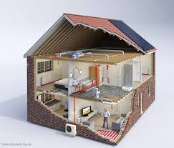
Figure 2
(Tamar Energy Community, 2021)

New Build Cost And Performance
New build housing involves significantly higher upfront costs compared to retro fit. These construction costs range from £1,750 to £3,000 per square metre resulting in total costs of £157,000 to £270,000 for a typical dwelling (BCIS, 2024). These costs are influenced by the material prices, labour availability and the regulatory requirements (Bahar, 2020).
Despite the higher capital costs new homes offer improved energy efficiency and reduced maintenance requirements, the modern construction standards ensure higher EPC ratings which results in lower operational energy costs over time (JLL, 2026). This can partially offset the higher initial investment (BEIS, 2023).
However new construction also involves significant embodied carbon emissions due to material production and construction processes. This then raises questions about the environmental sustainability of new build compared to retro fit (UKGBC, 2024).
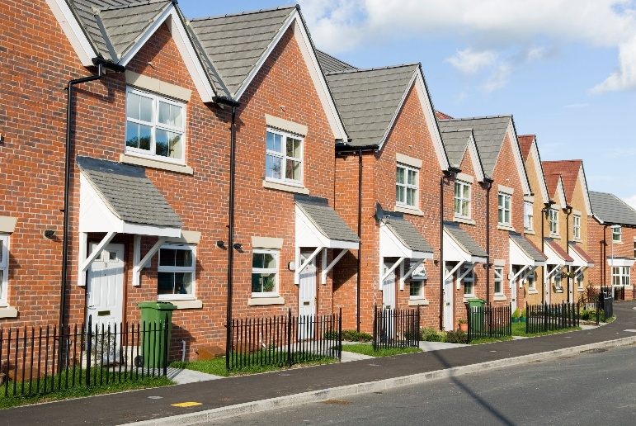
Figure 3
(Joyner, 2021)

Embodied Carbon And Sustainability
Embodied carbon has become an important consideration in construction decision making, new buildings require significant amounts of materials such as concrete and steel, which contribute to high levels of carbon emissions (Rics.org, 2024) and on the other hand the retro fit projects reuse the existing structures which reduces the need for new materials.
Retro fit can significantly reduce the embodied carbon compared to new build construction making it a more sustainable option in many cases(Climate Change Committee, 2023). This has led to increased emphasis on retro fit in national and regional policies.

Policy And Funding In Wales
Wales has several programmes that help people improve the energy efficiency of their homes
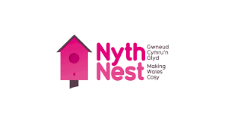
The Nest Warm Homes programme gives free advice and support to low income and vulnerable households, and in some cases it provides funding for energy saving improvements which mean that some homeowners may not have to pay for the upgrades themselves (GOV.WALES, 2026) (Energy Saving Trust, n.d.).
Figure 4

(Mixergy, 2024)

The Optimised Retro Fit Programme (ORP) is a scheme form the Welsh government that focuses on improving social housing. It helps with local authorities and housing associations upgrade their homes using a “fabric first” approach, which means improving the insulation and the building structure before installing any new heating systems (GOV.WALES, 2026).
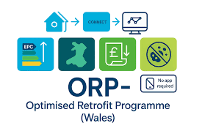
Figure 5
(Vericon Systems, 2026)

The Green Homes Wales scheme offers financial support and interest free loans to homeowners who want to improve the energy efficiency of their homes but may not have the money to pay for the work upfront (Developmentbank.wales, 2022)
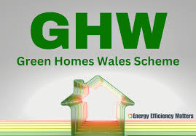
Figure 6
(Joyner, 2021)

These programmes help to reduce the cost of retro fit work by providing funding or financial support. This can make upgrading the existing homes more affordable for homeowners and landlords

Delivery Risks And Quality
Recent reports have highlighted quality and delivery problems in the UK retro fit programmes (Mainly under Energy Company Obligation schemes) with very high failure/ corrective rates in some external wall insulation installations (Elmhurst Energy, 2025), these risks create contingency costs and reputational problems that can undermine apparent cost efficiency. Implementing robust quality assurance is therefore a material cost factors. (Millard, 2025) (Russell, 2025)

Carmarthenshire Specific Factors Affecting Cost Efficiency

Rural Delivery Cost And Supply Chain
In rural areas delivering retro fit projects can be more difficult and expensive as this is because there are usually smaller number of houses in each village, the workers may need to travel further and longer distances and there may be fewer skilled contractors who are available locally to carry out the retro fit work. These factors can increase the cost of upgrading each home compared with projects in the larger towns. However if the retro fit work is organised as part of a larger coordinated programme, the costs can be reduced because the material, labour and planning can be shared across many homes. Programmes such as the Optimised Retro Fit programme and financial support from the Welsh Government are designed to help overcome these challenges by supporting the large scale retro fit projects and making the improvements more affordable.
(GOV.WALES, 2026) (Developmentbank.wales, 2022)
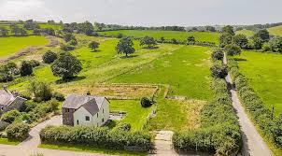
Figure 7
(Ruralscene.co.uk, 2022)

Housing Stock Profile And Condition
Carmarthenshire’s housing market and strategic documents show a diverse stock with rural villages, market towns and a mix of private and social housing needs. The older stock (stone/solid wall dwellings) is common in Wales and these are often more expensive to retrofit for example, the homes with that need solid wall measures, improved ventilation needs and damp remediation. The county’s housing market summary and council strategies highlight demographic changes and local housing pressures that are affecting the priorities. (Carmarthenshire County Council, 2019) (Carmarthenshire County Council, 2023).

Land Availability And Viability For New Build Homes
The ability to build new homes in Carmarthenshire depends on the factors such as land availability, planning and local infrastructure. The land may be available on greenfield sites (Undeveloped land) or on brownfield sites (previously used land). If a site requires significant preparation such as removing any contamination, carrying out ground works or installing new infrastructure the cost of building each home can increase. However when there are several homes being built together on a single site such as through infill development or redeveloping brownfield land, the cost per home can be reduced because the resources, labour and materials are shared across multiple units. The local planning policies and housing strategies from Carmarthenshire’s county council help explain these factors and the decisions that are involved when choosing where and how new homes are developed (Carmarthenshire County Council, 2023) (Carmarthenshire County Council, 2019).

Social And Policy Priorities In Wales
The housing policies in Wales strongly encourage improving existing homes through whole house retro fit programmes. Initiatives such as the ORP and the Nest Warm Homes programme support energy efficiency upgrades and home improvements. For social housing the optimised retro fit programme allows local authorities and housing associations to upgrade many properties at the same time which can make the retro fit projects more cost efficient for the existing housing stock. For the Privately owned homes schemes such as the GHW and nest provide financial help and advice. This support can reduce the amount of money the homeowners need to pay upfront and can make the retro fit improvements more financially worthwhile over time.
(GOV.WALES, 2026) (Developmentbank.wales, 2022)
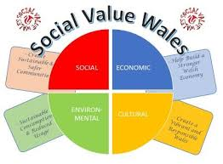
Figure 8

(SOCIAL VALUE POLICY, n.d.)

Risks, Uncertainties and Non-Monetary Factors

Quality And Remedial Risk
One important issue in large retro fit programmes is the installation quality and the risk of remedial work. In some national energy efficiency schemes, there have been cases where retro fit measures such as external wall insulation where it is installed incorrectly and then later requires repairs to be carried out. This can lead to extra costs and reduce the public confidence in retro fit programmes. To avoid these problems the projects, need to have strong quality control, properly trained and accredited installers and clear inspection processes. Although these measures may increase the initial cost of retro fit projects they help to ensure better workmanship and reduce the risk of expensive repairs in the future (Millard, 2025) (Russell, 2025).

Future Policy And Carbon Pricing
Changes in the government policy may also affect the costs of both retro fit and new builds in the future, policies such as environmental taxes, carbon pricing and solicitor rules on inefficient homes could increase the cost of owning or upgrading properties. New housing developments may also face higher costs if the future regulations introduce charges related to embodied carbon, construction waste or environmental impact. In addition recent reports suggest that rising environmental disposal fees and other regulatory costs could increase the overall construction expenses. These factors may make building new homes more expensive over time which could make retro fitting existing homes a more attractive option is certain situations.
(and, 2023) (Scott, 2024)

Social And Place Value
Retro fitting existing homes can help maintain established communities and protect local character as it avoids the need to demolish building and replace them with new developments. This approach can be particularly important in the rural areas of Carmarthenshire where the historic buildings, local heritage and natural landscape are valued by residents and planners. Improving the existing homes allows communities to remain stable while still upgrading housing quality and energy efficiency. Furthermore building large numbers of new homes may sometimes be seen as socially disruptive especially if it changes the appearance of the villages and increases pressure on local infrastructure. Due to these factors the local authorities like Carmarthenshire county council often consider social and cultural impacts alongside financial costs when make housing decisions. Preserving the existing buildings can support community identity and reduce the environmental impact associated with demolition and reconstruction (Gov.wales, 2018).
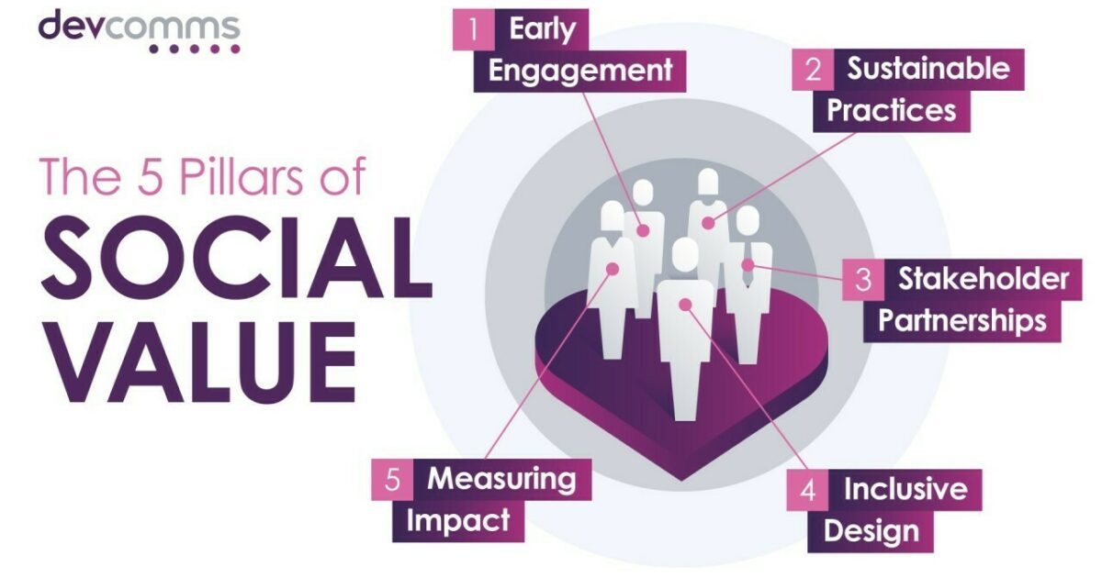
Figure 9
(Devcomms.co.uk, 2024)

Identification Of Gaps In Current Research
Despite the growing amount of research on housing sustainability and cost effectiveness there are several important gaps that still remain particularly in the Welsh and Carmarthenshire context.

Firstly a lot of the existing literature focuses on UK wide data sets which fail to capture regional variations in the housing stock, construction costs and rural conditions. Carmarthenshire contains a high proportion of older and solid wall homes which are significantly more difficult and costly to retro fit compared to standard cavity wall properties. National studies often overlook these regional differences reducing the accuracy of their conclusion when applied locally. (UKGBC, 2024)

Secondly there is limited research offering a direct comparison between retro fit and new build housing within the same geographic context. Many studies review these strategies independently without considering how local factors such as land availability, infrastructure and planning constraints influence their relative cost effectiveness. (UKGBC, 2024)

Another major gap is the lack of comprehensive life cycle cost analysis, existing research frequently separates the capital costs form the operational savings rather than integrating both into a full economic assessment. This is problematic as retro fit projects may appear expensive upfront but deliver long term savings through reduced energy consumption and maintenance costs. (UKGBC, 2024)

In addition there is insufficient integration of environmental factors such as embodied carbon into cost evaluations, the construction of new buildings generates significant emissions through material production and construction processes, yet these impacts are often excluded from financial comparisons. Whereas retro fit is widely recognised as a lower carbon option due to the reuse of existing structures (UKGBC, 2024).

Furthermore the role of policy and funding mechanisms is often underrepresented in research, in Wales there are government initiatives such as the optimised retro fit programme play a critical role in improving the financial viability of retro fit projects. Without considering these interventions the cost comparisons do not accurately reflect the real world conditions (Welsh Government, 2021).

Finally there is a lack of post occupancy performance data especially for retro fit projects, research shows that a significant proportion of UK homes are energy inefficient with many requiring insulation improvements, yet there is limited long term evidence assessing how retro fit improvements perform in use. Because of this it creates uncertainty around the predicted energy savings and the return on investment (UK Green Building Council, 2021).

How The Research Will Address These Gaps
This research aims to address the identified gaps by using a localised, lifecycle based and policy informed approach to evaluating housing strategies in Carmarthenshire.
Firstly the study focuses specifically on Carmarthenshire providing a regionally relevant analysis that reflects local housing characteristics, including the prevalence of the older properties and rural housing patterns. This improves the applicability of findings compared to national level studies.

Secondly the research undertakes a direct comparison between retro fit and new build housing within the same regional context. This allows for a more balanced evaluation of both approaches considering how the local constraints and opportunities influence the cost effectiveness.

A key contribution of this study is the use of a lifecycle cost analysis framework, incorporating capital costs, operational energy savings, maintenance and long term performance. This approach aligns with industry recommendations that emphasises the whole life carbon and cost assessment in the built environment (RICS, 2023).

This research also integrates environmental considerations particularly embodied and operational carbon. The UK built environment is responsible for a significant amount of (UKGBC, 2024)

In addition the study examines the impact of government policy and funding particularly the Welsh Government retro fit programmes, these initiatives are important to achieving net zero targets and improving the housing efficiency, and they significantly influence the economic feasibility of retro fit projects (Welsh Government, 2021).

Finally this study acknowledges the importance of performance outcomes and uncertainty, highlighting the need for improved post occupancy data, given that a large number of current buildings will still be in use by 2050, improving the existing housing stock is critical to achieving long term sustainability goals. (UKGBC, 2021).

Figure 10
(Chaudhry, 2025)

Research Design And Methodology

Research Design
This study will adopt a mixed methods research design combining both the quantitative and qualitative approaches to provide a comprehensive evaluation of the cost effectiveness of retro fit vs New build housing in Carmarthenshire, the quantitative element will focus on analysing numerical data such as construction costs, retro fit costs and energy savings allowing for object comparison between the two housing strategies using measurable indicators including the lifecycle costs and the return on investment. The qualitive element will involve the review of policy documents, government reports and case studies to provide a good understanding of how the regulatory frameworks, funding schemes and local housing characterises influence the housing decisions. A mixed methods approach is appropriate as the cost effectiveness is influenced not only by financial factors but also by environmental and policy considerations (Office for Health Improvement and Disparities, 2020).

Data Collection Methods
This Research will primarily utilise secondary data collection methods supported by case study analysis to evaluate the cost effectiveness of retro fit and new build housing in Carmarthenshire. Secondary data will be gathered from a range of reliable sources including the Welsh government publications, construction cost databases and academic literature. These sources will provide data on retro fit costs, new build construction costs and energy performance outcomes. Government reports such as the Welsh Governments decarbonisation strategies are particularly valuable as they offer detailed insights into housing energy efficiency, funding programmes and regional policy frameworks (GOV.WALES, 2021).

Figure 11
(Jove.com, 2024)

In addition industry data sources such as construction cost data bases are widely used in built environment research to provide benchmark cost information and improve the reliability of the financial comparisons
Case study analysis will also be incorporated to examine the real world examples of both retro fit and new build housing projects. These case studies will enable comparison of actual costs, performance outcomes and practical challenges associated with each approach. This methods is particularly useful in construction research as it allows the findings to be tested against the real world applications providing a more detailed and applied understanding of cost effectiveness. (McCombes, 2022)

Primary data collection methods such as interviews or surveys will not be undertaken in this study dure to time and resource constraints, however just because they are not being used they are still acknowledged as a limitation and they are recognised as a potential area for future research to enhance the depth of the analysis. (Howells)

Sampling Methods
The study will use deliberate sampling to select cases that are the most relevant to the research objectives, this approach involves deliberately selecting specific housing types that reflect the characteristics of Carmarthenshire housing stock rather than random sampling. This sample will include older solid wall properties, rural detached homes and modern new build developments ensuring that the analysis captures the diversity of the housing types within the region. This then enables meaningful comparison between retro fit and new build strategies within a realistic context. Deliberative sampling is widely used in case study research where the aim is to gain in depth understanding of specific situations rather than produce statistically generatable results (Gebrewold et al., 2016)
While this approach may limit the generalisability of the findings it is appropriate for this study as it priorates the relevance and contextual accuracy.

Data Analysis Plan
The data will be analysed using a combination of cost comparison, life cycle cost analysis and cost benefit analysis to evaluate the cost effectiveness of retro fit and new build housing. Firstly a capital cost analysis will be conducted to compare the upfront costs that are associated with each approach, including the construction or the retro fit costs, labour, materials and any other additional expenses such as demolition for new build developments. This will establish a baseline for understanding the financial requirements and feasibility of each option. (Oxand, 2026) (Zero, 2020)

A life cycle cost analysis will then be undertaken to asses the long term economic performance, this will include the ongoing energy costs, maintenance requirements and the replacement of key building systems over time. Lifecycle costing is widely recognised as a critical method in construction economical as it evaluate the total cost of building over its lifespan rather than focusing solely on initial expenditure
(RICS, 2023)

In addition a cost benefit analysis will be applied to evaluate the financial return on investment for both retro fit and new build homes, this will involve comparing the initial costs against the long term savings, especially in relation to reduced energy bills and improved efficiency. Comparative analysis will also be conducted between case studies to identify the key cost drivers, performance differences and practical challenges. This combined approach ensures that both short term and long term economic factors are considered providing a comprehensive assessment of cost effectiveness. (Grath et al., 2013)

Ethical Considerations
As this study relies primarily on secondary data the ethical risks are minimal, however all data will be properly cited to ensure academic integrity and to avoid any plagiarism, the research will also ensure that data is presented accurately and transparently without any misinterpretation or bias and any limitations in the data will be clearly acknowledged to maintain reliability.
Where case study data is used it will be sourced form publicly available reports and documents to ensure that no confidential or sensitive information is disclosed. Although primary data collection methods such as interviews or surveys will not be undertaken in this study, ethical approval would be required if these methods were used in any future research. This study will therefore adhere to the standard ethical guidelines ensuring responsible and professional conduct throughout.
(BERA, 2018)

Figure 12
(Anon, n.d.)

Detailed Timeline Of The Research Activities
This research was conducted over a 16-week period as seen below
Month | Week | Activity | Description | Outcome
Month 1 | Week 1 | Identified the topic | Finalize the research topic and objectives | Confirmed topic proposal
Month 1 | Week 2 | Begin literature search | Search journals and reports | Begin reference list
Month 1 | Week 3 | Literature review (retro fit) | Review retro fit research | Added to notes
Month 1 | Week 4 | Literature review (new build) | Review new build research | Added to notes
Month 2 | Week 5 | Local research | Review Carmarthenshire housing data | Added to notes
Month 2 | Week 6-8 | Draft literature review | Write literature chapter | Draft chapter
Month 3 | Week 9-10 | Research design | Confirm methodology | Research method
Month 3 | Week 11 | Cost data collection | Collect construction cost data | Added to notes
Month 3 | Week 12 | Energy data collection | Collect energy performance data | Added to notes
Month 4 | Week 13-14 | Organize data | Added data to dissertation | Added to notes
Month 4 | Week 15 | Cost analysis | Compare retrofit vs new build | Results added to notes
Month 4 | Week 16-18 | Lifecycle analysis | Analyze long-term costs | Lifecycle results added to notes
Month 5 | Week 19 | Policy analysis | Evaluate policy funding impact | Policy findings added to notes
Month 5 | Week 20 | Write findings | Draft analysis chapter | Draft chapter
Month 6 | Week 21 | Write introduction | Complete background chapter | Section 1 was written
Month 6 | Week 22 | Write research methods | Compared survey methods, interviews etc. | Added research methods to dissertation
Month 6.5 | Week 25 | Proofread | Edit and change where needed | Final draft
Month 6.5 | Week 27 | Submission | Final submission | Completed dissertation

Expected Outcomes And Potential Findings
This research is excepted to demonstrate that retro fitting existing housing in Carmarthenshire can be cost effective in certain scenarios particularly where buildings are structurally suitable and government funding is available. Retro fit may also be more financially viable where the demolition and infrastructure costs for new developments are high especially in rural areas. In addition to the financial benefits retro fit projects contribute to providing a wider and social economic value as well as improved living conditions.

However new build housing is expected to provide better long term efficiency and lower operational costs, the modern construction methods and updated building regulations allow new homes to achieve higher energy performance standards which can result in reduced heating costs and lower energy bills. These long term savings may offset the higher initial costs over time especially where new developments incorporate energy efficient design and materials.

Despite these advantages new build developments typically involve higher upfront costs including obtaining land, labour and materials, furthermore new build construction often results in higher embodied carbons emissions compared to retro fit which may reduce the overall sustainability benefits. Therefore this research will highlight that while new builds may deliver better energy performance, they are not always the most cost efficient solutions when lifecycle and environmental impacts are considered.

This study will identify the importance of policy support and funding programmes when determining project feasibility. Government incentives and retro fitting funding schemes can significantly improve the financial viability of retro fit projects, without this support retro fit solutions may be less attractive due to longer payback times.

Overall the research is expected to find that both retro fit and new build housing p[lay important roles in improving housing sustainability in Carmarthenshire. Retro fit may be more suitable for improving existing stock, while new build developments may be necessary to meet the housing demand. The findings are expected to support informed decision making by policy makers, developers and local authorities when planning future housing strategies.

References
Anon, (n.d.). Ethical Considerations ~ Types & Examples. [online] Available at: https://www.bachelorprint.com/uk/methodology/ethical-considerations/.

Asset Investment Planning for a Sustainable Future | Oxand. (2026). Green Retrofits vs. New Build: How to Compare the Carbon and Financial ROI - Asset Investment Planning for a Sustainable Future | Oxand. [online] Available at: https://oxand.com/en/green-retrofits-vs-new-build-carbon-financial-roi-comparison/?utm_source=

and, C. (2023). The Future Homes and Buildings Standards: 2023 consultation. [online] GOV.UK. Available at: https://www.gov.uk/government/consultations/the-future-homes-and-buildings-standards-2023-consultation/the-future-homes-and-buildings-standards-2023-consultation?pk_campaign=newsletter_6493&utm_source=

Bahar, U. (2020). How Much Does It Cost to Build a House? [House Build Cost UK 2020]. [online] Urbanist Architecture - London Architects. Available at: https://urbanistarchitecture.co.uk/cost-to-build-a-house-uk/.

BCIS (2025). BCIS | Building Cost Information Service Construction Data. [online] BCIS. Available at: https://bcis.co.uk/.

BEIS (2023). Department for Business, Energy & Industrial Strategy. [online] GOV.UK. Available at: https://www.gov.uk/government/organisations/department-for-business-energy-and-industrial-strategy.

BERA (2018). Ethical Guidelines for Educational Research, fourth edition (2018). [online] Bera.ac.uk. Available at: https://www.bera.ac.uk/publication/ethical-guidelines-for-educational-research-2018.

Blundell, S. (2021). Retrofit vs new build – which should take priority? [online] Planning, Building & Construction Today. Available at: https://www.pbctoday.co.uk/news/energy-news/new-build-retrofit/91565/.

Carmarthenshire County Council, 2019. Housing Market Summary for Carmarthenshire. Available at: https://www.carmarthenshire.gov.wales/media/1221665/housing-market-summary-for-carmarthenshire.pdf?utm_source

Carmarthenshire County Council (2022) Local Housing Market Assessment and Housing Strategy. Carmarthen: Carmarthenshire County Council. Available at: https://www.carmarthenshire.gov.wales

Carmarthenshire County Council, 2023. Communities, Homes and Regeneration Scrutiny Committee Report. Available at: https://democracy.carmarthenshire.gov.wales//documents/s69819/REPORT.pdf?utm_source

Chaudhry, D.S. (2025). Identifying Research Gaps: How to Find and Address Research Gaps Effectively. [online] Research Communities by Springer Nature. Available at: https://communities.springernature.com/posts/identifying-research-gaps-how-to-find-and-address-research-gaps-effectively.

Climate Change Committee. (2023). UK housing: Fit for the future? - Climate Change Committee. [online] Available at: https://www.theccc.org.uk/publication/uk-housing-fit-for-the-future/?utm_source

Cookefawcett.com. (2023). Work in progress - 1930s low energy retrofit - Cooke Fawcett Architects. [online] Available at: https://www.cookefawcett.com/news/work-in-progress-1930s-low-energy-retrofit

Devcomms.co.uk. (2024). The 5 pillars of Social Value: Engaging communities. [online] Available at: https://www.devcomms.co.uk/blog/the-5-pillars-of-social-value-engaging-communities.

Developmentbank.wales. (2022). Green Homes Wales - Dev Bank. [online] Available at: https://developmentbank.wales/green-homes-wales?utm_

Energy Saving Trust. (n.d.). Welsh Government Warm Homes Nest scheme. [online] Available at: https://energysavingtrust.org.uk/programme/welsh-government-nest-scheme/.
Elmhurst Energy. (2025). ECO Scheme to End After March 2026 - Elmhurst Energy. [online] Available at: https://www.elmhurstenergy.co.uk/blog/2025/11/27/eco-scheme-to-end-after-march-2026/.

Gov.UK (2019). Research and statistics. [online] GOV.UK. Available at: https://www.gov.uk/search/research-and-statistics

Gov.wales. (2018). Local Development Plan 2018 - 2033 - Carmarthenshire County Council. [online] Available at: https://www.carmarthenshire.gov.wales/home/council-services/planning/local-development-plan-2018-2033/#

GOV.WALES. (2021). Net Zero Wales Carbon Budget 2 (2021 to 2025) | GOV.WALES. [online] Available at: https://www.gov.wales/net-zero-wales-carbon-budget-2-2021-2025?utm_source=

GOV.WALES. (2022a). Home. [online] Available at: https://www.gov.wales/.

Gov.wales. (2022b). Homes - Carmarthenshire County Council. [online] Available at: https://www.carmarthenshire.gov.wales/council-democracy/strategies-plans-and-policies/cabinet-vision-statement-2022-2027-july-2022/homes/?utm_source

GOV.WALES. (2026). Nest Warm Homes Programme | GOV.WALES. [online] Available at: https://www.gov.wales/nest-warm-homes-programme?utm_

GOV.WALES. (2026). Optimised RetroFit Programme | GOV.WALES. [online] Available at: https://www.gov.wales/optimised-retrofit-programme?utm_source

GOV.UK. (2025). Energy Performance Certificates guidance. [online] Available at: https://www.gov.uk/government/collections/energy-performance-certificates

Grath, T.M., Nanukuttan, S., Owens, K., Basheer, M. and Keig, P. (2013). Retrofit versus new-build house using life-cycle assessment. Proceedings of the Institution of Civil Engineers - Engineering Sustainability, 166(3), pp.122–137. doi:https://doi.org/10.1680/ensu.11.00026.
Gebrewold, M.A., Enquselassie, F., Teklehaimanot, R. and Gugssa, S.A. (2016). Ethiopian teachers: their knowledge, attitude and practice towards epilepsy. BMC Neurology, [online] 16(1). doi:https://doi.org/10.1186/s12883-016-0690-4.

Highfield, A. (2024). £35k average home retrofit cost ‘demonstrably inequitable’. [online] The Architects’ Journal. Available at: https://www.architectsjournal.co.uk/news/35k-average-home-retrofit-cost-demonstrably-inequitable.

JLL (2024). Decarbonising UK housing – 2024. [online] JLL Residential Properties. Available at: https://residential.jll.co.uk/insights/article/decarbonising-uk-housing-2024?utm_source

Jll.com. (2026). Capital Flows. [online] Available at: https://www.jll.com/en-uk/insights/capital-flows?sort_by_relevance=relevance

Joyner, L. (2021). Revealed: 10 cheapest places in the UK to buy a new build home. [online] House Beautiful. Available at: https://www.housebeautiful.com/uk/lifestyle/property/a35947350/cheapest-places-buy-new-build-home-uk/.

Jove.com. (2024). Secondary Data Collection Methods. [online] Available at: https://www.jove.com/business-education/v/17047/secondary-data-collection-methods.

McCombes, S. (2022). Case Study | Definition, Examples & Methods. [online] Scribbr. Available at: https://www.scribbr.co.uk/research-methods/case-studies/.

Millard, R. (2025). UK home energy scheme has 98% failure rate on outside wall insulation. [online] @FinancialTimes. Available at: https://www.ft.com/content/59e4ae3c-6713-417a-8a78-79a3880ff3d0?utm_source=&syn-25a6b1a6=1
Mixergy. (2024). Welsh Government Warm Homes Nest Scheme. [online] Available at: https://www.mixergy.co.uk/blog/welsh-government-warm-homes-nest-scheme/

Office for Health Improvement and Disparities (2020). Mixed Methods Study. [online] GOV.UK. Available at: https://www.gov.uk/guidance/mixed-methods-study.

RICS (2023). Construction Standards. [online] Rics.org. Available at: https://www.rics.org/profession-standards/rics-standards-and-guidance/sector-standards/construction-standards.

Rics.org. (2024). Whole life carbon assessment (WLCA) for the built environment. [online] Available at: https://www.rics.org/profession-standards/rics-standards-and-guidance/sector-standards/construction-standards/whole-life-carbon-assessment?utm_source=

Russell, H. (2025). Almost all homes fitted with insulation under government scheme ‘must be fixed’ leaving thousands at risk this winter. [online] The Sun. Available at: https://www.thesun.co.uk/money/36995922/homes-insulation-scheme-must-be-fixed/?utm_source=

Ruralscene.co.uk. (2022). Property for Sale Llanboidy CARMARTHENSHIRE | Rural Scene. [online] Available at: https://www.ruralscene.co.uk/properties/eo8474/

Scirp.org. (2019). Saunders, M.N.K., Lewis, P. and Thornhill, A. (2019) Research Methods for Business Students. 8th Edition, Pearson, London. - References - Scientific Research Publishing. [online] Available at: https://www.scirp.org/reference/referencespapers?referenceid=2651783&utm_source

Scott, M. (2024). Why the building sector needs a ‘make do and mend’ mentality. Reuters. [online. Available at: https://www.reuters.com/sustainability/climate-energy/why-building-sector-needs-make-do-mend-mentality-2024-05-02/.

SOCIAL VALUE POLICY. (n.d.). Available at: https://www.northwales-pcc.gov.uk/sites/default/files/2022-10/NWPCC%20SV%20Policy%20260717.pdf
Tamar Energy Community. (2021). Retrofitting your Home. What’s it all about? [online] Available at: https://tamarenergycommunity.com/retrofitting-your-home-whats-it-all-about/

UKGBC. (2024). Net Zero Whole Life Carbon Roadmap for the Built Environment | UKGBC. [online] Available at: https://ukgbc.org/resources/net-zero-whole-life-carbon-roadmap-for-the-built-environment/?utm_source=

UKGBC (2024). Embodied Carbon. [online] UKGBC. Available at: https://ukgbc.org/our-work/topics/advancing-net-zero/embodied-carbon/

UK Green Building Council (UKGBC), 2021. Net Zero Whole Life Carbon Roadmap: A pathway to net zero for the UK built environment. Available at: UKGBC-Whole-Life-Carbon-Roadmap-A-Pathway-to-Net-Zero.pdf

Vericon Systems. (2026). Optimised Retrofit Programme - Vericon Systems. [online] Available at: https://vericonsystems.com/unlock-housing-funding/optimised-retrofit-programme/

Welsh Government, 2021. Net Zero Wales: Carbon Budget 2 (2021-2025). Cardiff: Welsh Government. Available at: 42949 Second All Wales Low Carbon Delivery Plan (2021-2025)

www.carmarthenshire.gov.wales. (n.d.). Carmarthenshire County Council Website : Gwefan Cyngor Sir Gaerfyrddin. [online] Available at: https://www.carmarthenshire.gov.wales/.

Zero, N. (2020). Retrofit or New Build? - Summary - Net Zero Carbon Guide. [online] Net Zero Carbon Guide. Available at: https://www.netzerocarbonguide.co.uk/guide/early-decisions/retrofit-or-new-build/summary?utm_source=

