University of Wales Trinity Saint David
Wales Institute of Science and Art


AWD Torque Vectoring
Combined Advanced Vehicle Dynamics ACHA6003/6011

Harry Rivers
1902574
March 2022
Contents
1 Introduction 1
2 Calculation 2
2.1 Lumped Mass Model 2
2.2 Calculation of the C of G position 2
2.3 Calculation of the Vehicle’s Moment of Inertia 2
2.4 Position of the inertia conjugate and dynamic index 2

Introduction
The aim of this paper is to analyse the Ferrari’s all wheel drive torque vectoring system. This firstly required establish a base data for the vehicles, this can be obtained through research. Whilst doing this research will be conducted into basic torque vectoring systems. Once research has been conducted on the base model calculations can be done to achieve a number of useful information from the vehicle. This information includes the vehicles C of G, dynamic index and calculation of potential longitudinal acceleration. After these calculations are done, more research will be conducted into looking at the future for control algorithm’s and how these will have and effect on vehicle dynamics.

Calculation

Lumped Mass Model
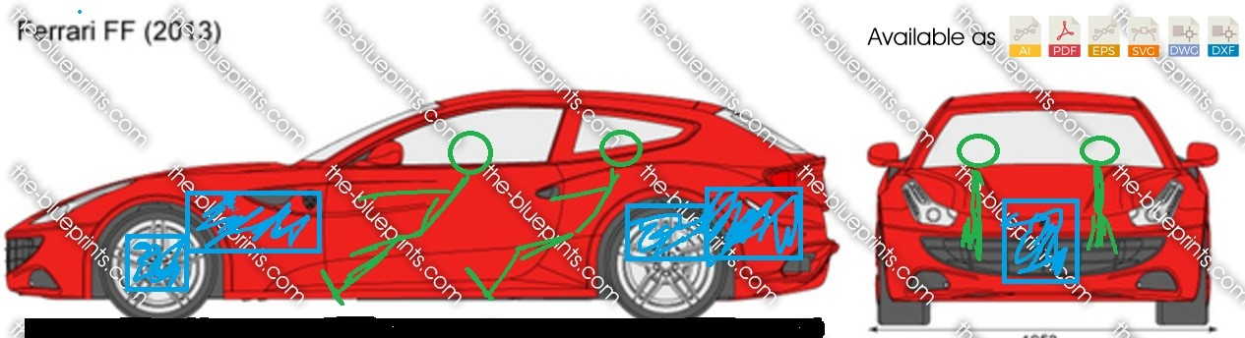
Figure 1 – Lumped Mass Model
A lumped mass model is created to display the position of the masses inside of the vehicle. This allows for a clear visual representation of where the vehicle will be affected by mass. By doing this, the information can be used to with the calculation of the centre of gravity calculations due to the masses being located around the wheel axles which will be used to help with calculations. The masses depicted in the model show the driver and passengers in the vehicle drawn in green. Whilst having the Ferrari’s engine just behind the front axle as well having its sperate gearbox in the front of the vehicle. Whilst the rear of the vehicle contains the controllable E-differential.

Calculation of the C of G position
The C of G (Centre of Gravity) of the vehicle is calculated by using some of the base information that is available. The base information needed is the wheel base size and the rear bias. To calculate the C of G from the side view of the vehicle. The C of G is calculated by multiplying the front and rear bias respectively by the wheelbase. The wheelbase has a value of 2990mm as it was found in the Ferrari’s Technical hand shout sheet. It was also in this sheet where it showed the rear bias as 53%. Meaning to calculate the to calculate the C of G the wheelbase of 2990/1000 to convert it into 2.99m, multiple that by 0.53 and a value 1.58m was given. Then to calculate the distance from the front axle, it is 2.99m * 0.47 which equals 1.40 m.

Calculation of the Vehicle’s Moment of Inertia
To calculate the vehicles moment of inertia it required the front and rear mass of the vehicle. To calculate the mass an equation is used. Firstly, the vehicles kerb weight was used and divided by the percentage of the bias for both the rear and the front. This gave the front a weight of 883.6kg and the rear a weight of 966.4kg. Since having both the figures to calculate the mass at both rear and front of the vehicle the weight was multiplied by the distance from its distance from the C of G squared. Doing this gave a front mass of 1744.993 and a rear mass of 2426.895, add these two numbers together gives the total inertia as 4171.889.

Position of the inertia conjugate and dynamic index
To find the position of inertia conjugate, the value of k2 had to firstly be determined. To calculate k2, the total inertia was divided by the kerb mass giving a value of 2.219. Using this the C of G from front was divided by the k2 value to give a position of 1.58m for the inertia conjugate. To calculate the dynamic index, it required dividing the front mass by the kerb mass multiplied by the distance from both C of G for both for the front and the rear. Doing this gives a value of 2.06, as the value is greater than one the rotation of the vehicle will be Infront of the rear axle line. This number seems a little too high when compared to other SUVs style vehicles, as their dynamic index value normally clocks in around the high 0.9 values.

