Data Warehousing and Data Mining

Assessment 1 : Designing an Enterprise Data Warehouse for NHS England

Prepared by:
Mirela Balabanova-Kehayova
Student ID: 2326292
BSc Applied Computing Level 6

University of Wales Trinity Saint David, London

Contents
Introduction 2
1.1 OLTP vs. Data Warehouse 3
1.2 Data Warehouse Architecture and ETL Process 4
1.3 Data Marts for Management Decision-Making 6
1.4 OLTP Normalisation vs Data Warehouse Dimensional Modelling 8
2.1 Source System Identification 10
2.2 Star Schema Design 10
2.3 Data Marts and Schema 16
2.4 ETL Plan 17
2.5 Data Quality and Governance 17
Conclusion 17

Introduction
Every day, hospitals, GP practices, and care providers across England produce enormous quantities of clinical, financial, workforce, and operational records. As one of the world's largest healthcare providers, NHS England delivers care to millions of people through a network of acute hospitals, community services, specialist centres, and Integrated Care Systems (ICSs). Because modern healthcare delivery increasingly depends on data, converting these raw operational records into usable insight has become a core requirement for sound decision-making, efficient resource allocation, and continuous service improvement.
At present, the bulk of this information sits inside operational platforms — Electronic Patient Records (EPR), Patient Administration Systems (PAS), workforce management tools, and financial systems — each built primarily to handle everyday transactions rather than large-scale analysis. Because these platforms were not designed for organisation-wide reporting, leaders trying to compare performance across departments, trusts, or regions frequently struggle to obtain a joined-up picture.
Data warehousing offers a way through this problem: it draws data out of multiple operational systems and consolidates it inside a single analytical store. Extract, Transform and Load (ETL) routines clean, standardise, and combine both historic and current records into structures purpose-built for reporting and advanced
analytics. Once in place, a warehouse lets an organisation spot trends, track performance over time, and base decisions on evidence rather than assumption.
This report sets out a design for an enterprise data warehouse for NHS England. It contrasts OLTP systems with data warehouses, proposes an overall warehouse architecture, defines suitable data marts, and builds dimensional star schemas covering clinical, workforce, and financial reporting. It then sets out an ETL strategy, identifies the systems that would feed the warehouse, and examines the governance and data-quality safeguards needed for a secure, effective analytics environment.

1.1 OLTP vs. Data Warehouse
Day-to-day care across NHS England depends on a range of operational systems—EPR, PAS, workforce platforms, and finance systems among them. Each functions as an Online Transaction Processing (OLTP) environment: built to record and process high volumes of individual transactions quickly and accurately [1], [2]. The catch is that pulling a patient's history from EPR alone still tells you nothing about the workforce or cost picture sitting in a different system, so joining these domains together for analysis is difficult without further integration.
These OLTP systems exist to handle real-time tasks such as patient registration, appointment scheduling, recording diagnoses and treatments, and processing payments. Their databases are usually built to a high level of normalisation, which cuts down duplicate data and keeps records consistent. The trade-off is that information ends up spread across many linked tables—good for transaction speed, but awkward when it comes to pulling analytical reports together [2], [3].
This becomes a real obstacle once decision-makers need a strategic view. With thousands of patient, staffing, and financial transactions recorded every day, running analytical queries straight against the live operational systems is slow and risks degrading their performance—and in any case, OLTP databases are built around current-state data rather than long historical trends [2].
A data warehouse sidesteps these problems by pulling data from several systems into one analytics-focused store. Rather than reflecting only the current moment, it retains history, handles complex multi-table queries comfortably, and gives a single consolidated picture of how the organisation is performing—covering patient flow, bed use, treatment spend, staffing levels, waiting times, and clinical outcomes across every region [2], [3].
The warehouse proposed here is meant to sit alongside NHS England's existing systems, not replace them: operational platforms keep running patient care as normal, while the warehouse gives senior leaders a dependable, integrated, historical evidence base to draw on for decisions and long-term planning [1], [4].
Table 1: OLTP vs. Data Warehouse – Key Differences
Characteristic | OLTP System | Data Warehouse
Purpose | Supports daily transactions | Supports analysis and reporting
Data structure | Highly normalised (3NF) | Denormalised (star schema)
Data scope | Current, operational data | Historical, integrated data
Query type | Simple, frequent, short | Complex, large-scale, aggregated
Users | Clinical and administrative staff | Executives and analysts
Examples at NHS England | EPR, PAS, workforce systems | FactPatientActivity, FactFinance

1.2 Data Warehouse Architecture and ETL Process
Figure 1 sets out the architecture proposed for NHS England: a single analytical environment built from four layers—the operational source systems, the Extract-Transform-Load (ETL) process, the enterprise warehouse itself, and the business intelligence tools sitting on top. Structuring the solution this way turns scattered operational records into something planners and performance managers can actually use [1], [2]. It also means the warehouse can grow with NHS England: new source systems or regions can simply be plugged into the source layer without having to redesign the whole warehouse.

The source layer draws on five main feeds. EPR and clinical systems hold diagnoses, treatments, and outcomes; PAS tracks admissions, discharges, and referrals; workforce platforms log staff roles, overtime, and absence; and finance systems capture expenditure, tariffs, and treatment costs [1], [4]. Sitting alongside these, a shared metadata catalogue records what each data element means, where it came from, and how often it is refreshed, so analysts across different departments can interpret the same figures the same way.
Bringing these datasets together is the job of the ETL process. Extraction pulls the raw records into a staging area; transformation then validates, cleans, and standardises them—stripping out duplicate patient entries, checking NHS numbers, aligning diagnosis codes to ICD-10, and reconciling date formats between systems, all of which boosts consistency and interoperability [4], [5]. A typical transformation rule, for instance, would map free-text admission descriptions onto a fixed coded list, so that a "day case" logged differently at two hospitals still appears the same way in reporting.
Once transformed, the data is loaded into structures designed for analysis rather than day-to-day transactions, making it possible to track trends and support evidence-based decisions across hospitals and regions. Comparable results have been reported in other clinical data warehouse projects [2], [6].
Senior leaders will naturally ask whether ETL gets in the way of clinical work. It does not: ETL jobs run in scheduled off-peak slots, or incrementally via change-data-capture, so entire datasets are never reprocessed and operational systems stay fully available for patient care. This is worth spelling out for the CEO specifically—clinical teams keep using EPR and PAS exactly as before, because ETL always works against copies of the data rather than the live transactional databases. From there, the warehouse feeds data marts and BI tools that generate the dashboards and KPIs leadership relies on [1], [5].
Bringing operational, clinical, workforce, and financial information together on one analytical platform gives NHS England a single, comprehensive view of its own performance—one that supports better management of resources, outcomes, and overall efficiency.

1.3 Data Marts for Management Decision-Making
A single central warehouse is useful, but different decision-makers need different slices of it, tailored to what they are actually responsible for. That is the role of data marts: subject-specific subsets of the warehouse built around particular business functions. Figure 2 shows three such marts—covering executive management, finance, and clinical performance—each aimed at giving its intended audience exactly the information relevant to them, without wading through everything else [2], [7]. Refresh schedules can also be tuned to each mart's purpose: operational marts might update daily, finance marts weekly, balancing how current the data needs to be against the load this places on the system.
For the Chief Executive, what matters is the big picture. An Operations Data Mart built around bed occupancy, RTT waiting times, emergency admissions, elective backlogs, and regional activity would let leadership spot where capacity is under strain and direct resources accordingly, while benchmarking across ICSs gives a firmer evidence base for policy decisions [1].
The Finance Director's priority is expenditure and budget performance. A Finance Data Mart, drawing together financial records and activity-based costing, would surface treatment costs, departmental spend, tariff reimbursements, and cost per episode—making it easier to spot emerging cost pressures and to forecast more accurately [1], [4].
The Medical Director's concern is clinical quality and patient safety, so a Clinical Quality Data Mart centred on readmission rates, mortality data, safety incidents, and patient satisfaction would let clinical leaders see where providers diverge from one another, feeding into quality-improvement work and population-level analysis of chronic disease [1], [8].
Overall, dedicated marts make relevant information easier to reach, run faster because each one only covers a narrow subject area, and give each decision-maker support tailored to their own objectives—turning raw operational data into intelligence that strategic, financial, and clinical managers can actually act on [2], [7]. Keeping each mart scoped to a single subject also helps governance, since sensitive clinical or workforce records can be locked down to authorised roles rather than leaving the whole enterprise warehouse open to every user. When needed, executives are not limited to one mart at a time either: because every mart is built on the same conformed dimensions, Finance and Clinical Quality data can be brought together, for example to weigh up the cost-effectiveness of a particular treatment pathway.
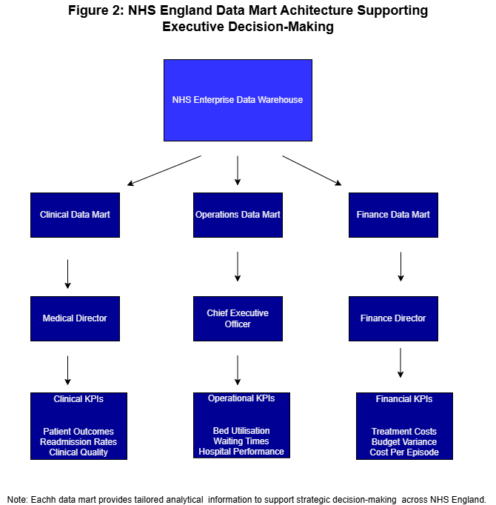 Figure 2: NHS England Data Mart Architecture Supporting Executive Decision-Making
Figure 2 shows how each dedicated mart feeds a role-specific view for executive, financial, and clinical decision-makers.

1.4 OLTP Normalisation vs Data Warehouse Dimensional Modelling
Most of NHS England's operational databases are built around highly normalised structures. Splitting information across multiple related tables in this way cuts redundancy and protects data integrity; systems like EPR, PAS, workforce, and finance platforms typically follow Third Normal Form (3NF) for exactly this reason, keeping transaction processing efficient and consistent [2], [3].
This works well for daily operations, but it is a poor fit for analytical reporting: because the data is scattered across so many interlinked tables, answering an analytical question means running complex joins that take time and, at NHS England's scale, can noticeably slow the underlying system [2].
Data warehouses take a different approach: dimensional modelling, where a star schema puts a central fact table at the middle of a small ring of denormalised dimension tables, cutting the number of joins needed and speeding queries up considerably [3], [7], [9]. The gap matters in practice—reconstructing a patient's full care history from 3NF tables means joining across EPR, PAS, clinical, and financial systems, while the same query against FactPatientActivity only has to join a handful of surrounding dimensions, simple enough for a non-technical manager to build a report from directly. Slowly Changing Dimensions (SCD) add another advantage: the warehouse can track a change over time, such as a patient moving to a new GP, in a way that normalised OLTP systems generally cannot [3].
Figures 4A and 4B show this in practice: FactPatientActivity sits at the centre of a star schema holding measures such as length of stay, treatment cost, and readmission count, surrounded by dimensions describing the patient, hospital, diagnosis, and time involved. The same pattern is repeated for FactWorkforce and FactFinance, applied to workforce and financial data respectively.
Taken together, dimensional modelling delivers faster queries, simpler reporting, and a structure non-technical staff can actually work with—which is why it fits NHS England's analytical needs better than a purely normalised design [2], [3], [7].

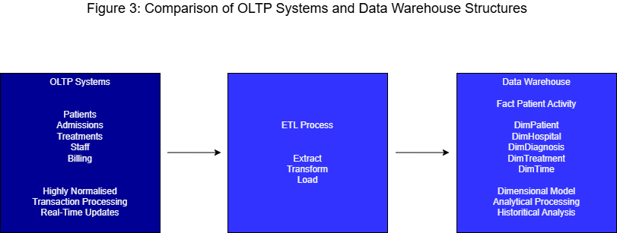 Figure 3: Comparison of OLTP Systems and Data Warehouse Structures
Figure 3 sets OLTP and data warehouse characteristics side by side, and Figure 4A then illustrates the dimensional model proposed for NHS England's enterprise warehouse.

2.1 Source System Identification
Table 2: NHS England Source Systems
Source System | Data Provided | Type
EPR / Clinical Systems | Diagnoses, treatments, outcomes | Internal
PAS | Admissions, discharges, referrals, appointments | Internal
Workforce Systems | Staffing, overtime, shift patterns, absence | Internal
Financial Systems | Treatment costs, budgets, tariffs, expenditure | Internal
NHS Digital Datasets | National activity and performance datasets | External
ONS Demographic Data | Population and demographic statistics | External

Building a complete picture of healthcare performance means drawing on both internal and external sources. Internally, EPR and clinical systems supply demographics, diagnoses, procedures, and outcomes; PAS adds admissions, discharges, referrals, and appointments; workforce platforms contribute staffing levels, overtime, shift patterns, and absence; and finance systems provide treatment costs, budgets, tariffs, and expenditure [1], [4]. These internal feeds are generally refreshed daily to keep operational reporting current, while external data tends to follow a monthly or quarterly cycle tied to national publication schedules.
On the external side, NHS Digital datasets, ONS demographic statistics, and national public health data add the broader context needed for population health analysis, benchmarking between regions, and long-range strategic planning. Combining both internal and external sources is what gives NHS England an analytical environment it can rely on [1], [5].

2.2 Star Schema Design
The warehouse design rests on several interconnected star schemas. Figure 4A shows the three fact tables at its core—FactPatientActivity, FactWorkforce, and FactFinance—which between them cover clinical, operational, workforce, and financial performance within one consistent framework [2], [3]. One design decision matters more than the rest: conformed dimensions. Tables such as DimTime, DimHospital, and DimDepartment are shared across all three fact tables, so figures from different subject areas can be compared directly—treatment costs from FactFinance against staffing levels from FactWorkforce for the same hospital and period, for instance [3], [7].
Each fact table also has a clearly defined grain, to avoid any ambiguity when aggregating: one row per completed episode in FactPatientActivity, one row per staff member per shift in FactWorkforce, one row per cost centre per reporting period in FactFinance. Fixing the grain this precisely up front stops measures being double-counted later, once they are summed across dimensions like hospital or region.
FactPatientActivity (Figure 4B) is the clinical heart of the model, holding LengthOfStay, TreatmentCost, WaitingTimeDays, NumberOfProcedures, and ReadmissionCount, and linked to DimPatient, DimHospital, DimDiagnosis, DimTreatment, DimDepartment, and DimTime. DimPatient carries demographic details—NHS number, age group, gender, postcode area; DimHospital identifies the provider; DimDiagnosis and DimTreatment classify the clinical episode for effectiveness analysis; and DimTime supports trend analysis across days, months, and years.
FactWorkforce (Figure 4C) captures OvertimeHours, AgencyCost, StaffHoursWorked, and SicknessDays against DimStaff, DimHospital, DimDepartment, DimRegion, and DimTime, which together support workforce performance analysis across both hospitals and regions.
FactFinance (Figure 4D) records BudgetAllocated, BudgetSpent, CostPerEpisode, TreatmentCost, and VarianceAmount against DimHospital, DimDepartment, DimRegion, and DimTime, allowing expenditure patterns and cost-optimisation opportunities to be assessed region by region.
Splitting the model into three fact tables rather than one large combined schema reflects the fact that patient activity, workforce, and finance operate at different grains and refresh at different frequencies; keeping them apart avoids squeezing incompatible measures into a single structure, while conformed dimensions still make cross-subject analysis possible whenever it is needed [3], [7]. Together, these star schemas give NHS England an analytical environment that scales well and stays intuitive for non-technical staff, across strategic, operational, clinical, and financial reporting alike [2], [3], [7]. Pre-computed aggregate tables—monthly bed occupancy, quarterly financial variance, and similar summaries—sit alongside the detailed fact tables to keep high-volume dashboard queries fast [2]. Snowflake schemas were considered too, since normalising dimensions further would reduce storage redundancy, but this reintroduces extra joins and complexity; given how important fast, accessible reporting is for non-technical management here, the star schema remains the better fit [3], [9], [10]. Indexing the foreign keys on each fact table gives a further boost to join performance when dashboards query across the conformed dimensions.
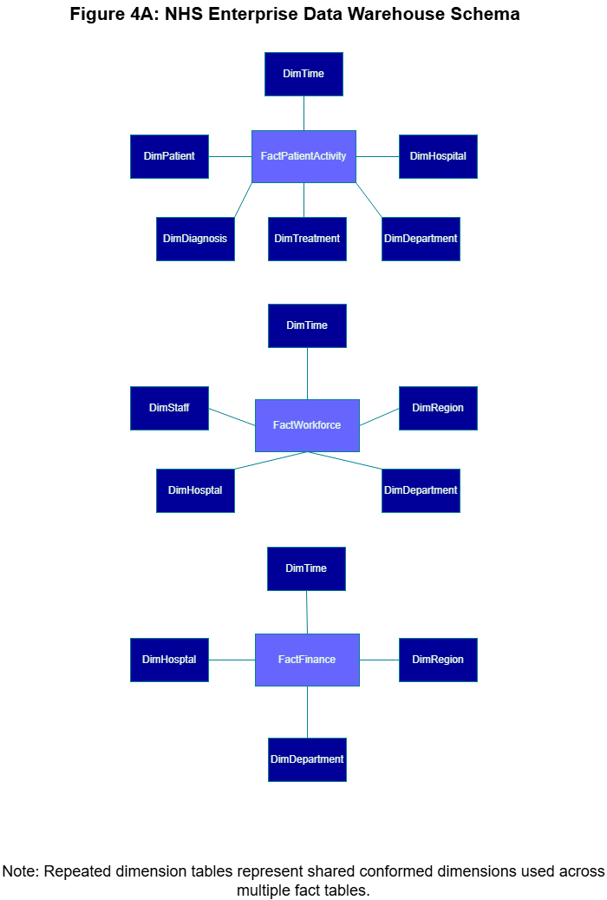
Figure 4A: NHS Enterprise Data Warehouse Schema
Figure 4A brings the three schemas together, showing how the conformed dimensions link them.

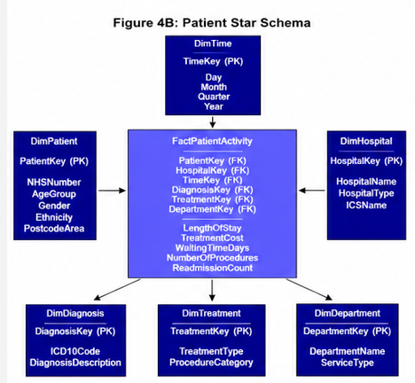 Figure 4B: Patient Star Schema

Figure 4B expands on the Patient Activity schema outlined above.

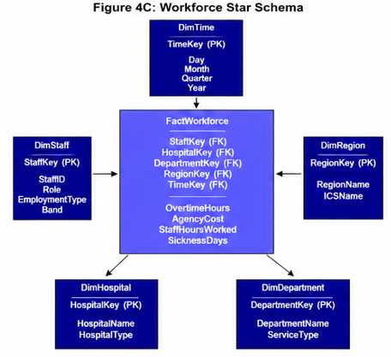 Figure 4C: Workforce Star Schema
Figure 4C expands on the Workforce schema outlined above.
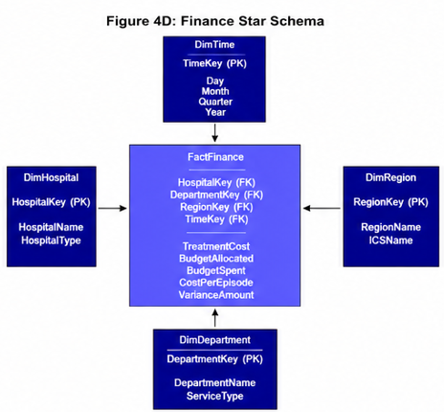 Figure 4D: Finance Star Schema
Figure 4D expands on the Finance schema outlined above.

2.3 Data Marts and Schema
Three subject-oriented marts sit on top of the warehouse—Operations, Finance, and Clinical Quality—each built from the enterprise warehouse to give a specific management function its own focused analytical capability.
The Operations Data Mart looks at service delivery through admissions, waiting times, bed occupancy, and emergency activity, using the Hospital, Department, Region, and Time dimensions so management can track demand and resource use across every ICS. Built mainly on FactPatientActivity, it underpins the Chief Executive's operational oversight [1], [2].
Built on FactFinance, the Finance Data Mart gives the Finance Director budget-monitoring and cost-management data—treatment costs, budget allocations, expenditure, cost per episode, and tariff variances. DimHospital and DimRegion make cross-organisational benchmarking possible, helping to flag cost pressures and identify where efficiencies could be made [2], [4].
The Clinical Quality Data Mart gives the Medical Director a way to evaluate outcomes and service quality using readmission rates, mortality indicators, treatment outcomes, and safety incidents. Because DimDiagnosis is included, it also supports population-level analysis of chronic disease management measured against national targets [1], [8].

Between them, these marts make reporting noticeably more efficient: querying a subject-specific mart is far quicker than querying the whole warehouse, since the dataset involved is smaller and already filtered—a real advantage when hundreds of managers might be hitting dashboards at the same time. Because each view is scoped to a subject area, executives also see only what is relevant to their own accountability, which cuts down on information overload [2], [3], [7]. Drill-through is supported too, so an analyst who notices something unusual on a summary dashboard can dig straight down into the underlying patient- or transaction-level records.
Table 3: Data Mart Summary
Data Mart | Primary Fact Table | Key Measures | Primary Audience
Operations | FactPatientActivity | Admissions, bed occupancy, waiting times | Chief Executive
Finance | FactFinance | Budget, expenditure, cost per episode | Finance Director
Clinical Quality | FactPatientActivity | Readmissions, mortality, safety incidents | Medical Director

2.4 ETL Plan
Extraction pulls data from EPR, PAS, workforce, and financial systems—a full load for reference data, then incremental change-data-capture for ongoing transactional records, so live clinical systems are barely touched. During transformation, duplicates are removed, NHS numbers validated, diagnosis codes standardised to ICD-10, dates reconciled across systems, and referential integrity checked against every dimension key [4], [5]. After each load, a reconciliation step checks record counts and key totals between source and target, flagging any discrepancy for investigation before the figures reach a report.
Load order matters for referential integrity: dimension tables go in first, then the fact tables—patient activity into FactPatientActivity, workforce data into FactWorkforce, financial data into FactFinance. A combination of nightly batch windows and near-real-time incremental updates means operational systems stay fully available for patient care throughout the process [12], [13]. Any load that fails is rolled back automatically and picked up again in the next scheduled window, so partial or inconsistent data never reaches the reporting layer.
Table 4: ETL Source-to-Target Mapping
Source System | Target Table | Key Transformation
EPR / Clinical Systems | FactPatientActivity | ICD-10 standardisation, NHS number validation
PAS | FactPatientActivity, DimPatient | Duplicate removal, date harmonisation
Workforce Systems | FactWorkforce, DimStaff | Shift/absence aggregation, referential checks
Financial Systems | FactFinance | Tariff mapping, cost aggregation

2.5 Data Quality and Governance
None of this works without solid governance behind it—trust in NHS analytical systems depends on it. Every part of the process must comply with UK GDPR and the NHS Data Security and Protection (DSP) Toolkit, which set the rules for data access, storage, and breach reporting [4], [8]. Patient identifiers need to be pseudonymised before loading, access restricted by role so only authorised staff reach sensitive records, and a data steward assigned to each subject area to keep an active eye on quality. Logging who accesses what also supports compliance when subject access requests come in under UK GDPR.
In line with the NHS Digital Data Quality Assurance Framework [5], ongoing monitoring should track accuracy, completeness, consistency, and timeliness across every source feed—transparent reporting on data quality is widely recognised as a precondition for trustworthy healthcare analytics [14].

Conclusion
Across its many healthcare organisations, NHS England produces substantial volumes of operational, clinical, workforce, and financial data. Existing OLTP systems handle day-to-day healthcare operations well, but they were never built to provide the integrated analytical capability that strategic decision-making and organisation-wide performance analysis actually require [1], [2].
This report has set out an enterprise data warehouse architecture that brings together EPR, PAS, workforce management, and financial data through a structured ETL process. Consolidating multiple sources into one central repository in this way would give NHS England a consistent, comprehensive view of its own performance across hospitals, departments, and regions [1], [4].
At the heart of the solution are star schemas supporting patient activity, workforce, and financial analysis. Set against traditional OLTP structures, this dimensional approach offers faster queries, simpler reporting, and stronger support for business intelligence work [2], [3]. On top of this, specialised data marts let executives, clinical leaders, and financial managers reach the information that matters to their own decisions without wading through everything else.
Data quality, governance, and regulatory compliance ran through the report as recurring themes. None of the analytical output is worth much unless it is accurate, secure, and reliable—which depends on sound ETL procedures, validation controls, role-based access, and adherence to GDPR and NHS information governance standards [1], [4], [8].
Taken as a whole, the enterprise data warehouse proposed here would give NHS England a scalable, future-ready analytical environment—one that supports evidence-based decisions, improves operational efficiency, strengthens patient care, and aligns with the goals set out in the NHS's own data transformation agenda [15].

REFERENCES
[1] NHS England, “Protecting and Safely Using Data in the New NHS England,” NHS England, 2025. [Online]. Available: https://www.england.nhs.uk/about/protecting-and-safely-using-data-in-the-new-nhs-england/

[2] Microsoft Corporation, “Dimensional Modeling in Fabric Data Warehouse,” Microsoft Learn, 2025. [Online]. Available: https://learn.microsoft.com/en-us/fabric/data-warehouse/dimensional-modeling-overview

[3] Microsoft Corporation, “Understand Star Schema and the Importance for Power BI,” Microsoft Learn, 2025. [Online]. Available: https://learn.microsoft.com/en-us/power-bi/guidance/star-schema

[4] NHS Digital, “Governance of Data,” NHS Digital, 2025. [Online]. Available: https://digital.nhs.uk/data-and-information/information-standards/governance

[5] NHS Digital, “Data Quality Assurance Framework for Providers,” NHS Digital, 2024. [Online]. Available: https://digital.nhs.uk/data-and-information/data-tools-and-services/data-services/data-quality/framework-for-providers-part-1/about-the-framework

[6] M. Doutreligne, A. Degremont, P.-A. Jachiet, A. Lamer, and X. Tannier, “Good Practices for Clinical Data Warehouse Implementation: A Case Study in France,” PLOS Digital Health, vol. 2, no. 7, e0000298, 2023. doi: 10.1371/journal.pdig.0000298.

[7] DataDef, “Dimensional Modeling Guide: Star Schema and Kimball Method,” DataDef, 2025. [Online]. Available: https://datadef.io/guides/en/dimensional-modeling

[8] NHS England, “Information Governance,” NHS England, 2025. [Online]. Available: https://www.england.nhs.uk/data-services/ig/

[9] Oracle Corporation, “Database Data Warehousing Guide,” Oracle Database 19c Documentation, 2024. [Online]. Available: https://docs.oracle.com/en/database/oracle/oracle-database/19/dwhsg/index.html

[10] IBM, “What Is a Data Warehouse?,” IBM Think, 2025. [Online]. Available: https://www.ibm.com/think/topics/data-warehouse

[11] Snowflake Inc., “Snowflake Key Concepts and Architecture,” Snowflake Documentation, 2025. [Online]. Available: https://docs.snowflake.com/en/user-guide/intro-key-concepts

[12] J. Desmond, R. Wartmann, C. W. Lau, S. Thomas, P. M. Middleton, and J. A. Ginige, “OMOP ETL Framework for Semi-Structured Health Data,” arXiv:2511.09017, 2025.

[13] N. Barret, A. Bernasconi, B. Bikbov, and P. Pinoli, “I-ETL: An Interoperability-Aware Health (Meta)Data Pipeline to Enable Federated Analyses,” BMC Medical Informatics and Decision Making, vol. 25, no. 1, p. 375, 2025. doi: 10.1186/s12911-025-03188-0.

[14] M. Wassell, K. Butler-Henderson, and K. Verspoor, “A Framework for Transparent Reporting of Data Quality Analysis Across the Clinical Electronic Health Record Data Lifecycle,” arXiv:2603.00921, 2026.

[15] Department of Health and Social Care, “Data Saves Lives: Reshaping Health and Social Care with Data,” GOV.UK, 2022. [Online]. Available: https://www.gov.uk/government/publications/data-saves-lives-reshaping-health-and-social-care-with-data/data-saves-lives-reshaping-health-and-social-care-with-data

