

Assessment 1: Reading & Note-Taking
Student Name: Diana Valentina Anghel
Student Id: 2542093

Table of Contents
Assessment 1 – Reading Task Template 3
PART 1: Upload your photo of your A3 in-class notes here: 3
PART 2: Reading Questions 4
Reflection 5
References 6

Assessment 1 – Reading Task Template

PART 1: Upload your photo of your A3 in-class notes here:
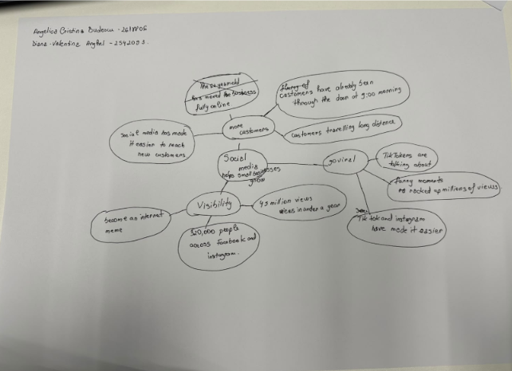

PART 2: Reading Questions
1. What is the main idea of the whole text?
This article will describe the ways that social media can aid in bringing in customers and expanding a small business. It's referring to Honywood Sandwich Shop in Basildon that encouraged people to travel long distances so they could consume its chicken burger. The funny TikTok videos were the way Krystalls Boutique a prom dress shop encountered notoriety and attracted guests from different areas. It also relates the tale of the time when Linda Hunter moved Linda’s Boutique marketing from market stall to online sales as she began posting videos. All these examples illustrate that social media is a tool that can impact how and to whom local businesses sell their products (Deady, 2025).
2. What is one key point that supports the main idea, and which specific example from the text shows this?
A really important thing is, customers published videos will certainly be capable of attracting someone to a small business. Honywood Sandwich Shop in Basildon was highlighted in the article after a regular customer left a post about the shop, which attracted other customers' interest. Some people travelled as much as three hours to try the chicken burger, its owner Murat Mutlu told. The content generated by the customer has also contributed to its sales and the shop has its own videos. The main idea is to catch the eyes of the locals and surrounding areas through social media use by the local sandwich shop (Deady, 2025).
3. What is a different key point that supports the main idea, and which specific example from the text shows this?
Another is that social media can alter the way that a small business sells its products. For 46 years, Linda Hunter made a living as a market seller until the lockdown, when she started making videos. She later launched a unique fashion brand, Lindy Loo's Boutique, 100% online. The article states that she has some 320,000 Facebook and Instagram users and delivers to customers across the UK and even as far as Australia (Deady, 2025). The enterprise could reach customers outside of its market stall, besides establishing an online marketing of its products by posting videos, based on her experience.
4. Which part of the text do you think is most important, and why?
I believe the best element is from marketing specialist Faye Martin who states that individuals react to genuine and relatable material as opposed to noticeable advertisements. To answer some of the examples in the article. Videos shot by customers brought traffic to Honywood Sandwich Shop and funny pictures brought Krystalls Boutique to the attention of people far, far away. I chose the explanation from Martin because this links the explanations and helps elicit reasons why the videos would interest viewers. It's more significant than one business story since it assists in clarifying how various businesses drew in customers all through social media frameworks (Deady, 2025).

Reflection
5. What did you find difficult in this task (including in-class components), and why was it difficult?
When I was working on the A3 mind map, I could not figure out what the central idea was, and what the smaller points and details were. The article mentions a few businesses, and each of the stories contains various facts. For example, I'm not sure if it's best to leave details on the main branches (Honwood Sandwich Shop/320,000 followers, Lindy Loo's Boutique/320,000 followers) or if it works best under the followers figure to create the main branches from. Instead of the information these numbers conveyed about social media, I had my initial attention on these numbers. This meant my notes were not necessarily as structured and I needed to ensure that the more general aspects of customer attraction and selling online, etc., were backed up with examples.
6. What helped you with this difficulty, and how did it help you?
Making the mind map assisted me in structuring the information. The main message, that social media is a useful tool for small businesses to connect with customers, is in the centre. Later, I developed branches for clients' interests and changes in the mode of business sale. Customer interest and Linda Hunter's decision to switch to an online business came under business changes, which included a 3-hour drive to the Honywood Sandwich Shop. The advantage to therapy was that it provided an opportunity to find out which facts supported which assertions. I can use this to help with my college reading homework and with class readings in the future to identify the main idea, choose pertinent examples, and write a complete response, minimising the inclusion of extraneous information.

References
Deady, E. (2025) ‘If you post it, they will come: The businesses turning likes into livelihoods’, BBC News, 19 October. Available at: https://www.bbc.com/news/articles/cm2701py5npo

