Module Title: Foreign Languages & Cultural Awareness

Module Code: BMIH5003

Student Name: Tudor Radu

Student ID: 2243696
Lecturer: Giulia Chifari

Assignment 1 - Portfolio

Table of Contents
Component 1: Professional Reflection 3
Introduction 3
Discussion 4
Conclusion 5
Component 2: Training Plan 6
Identification of the Cultural Misunderstanding 6
Applicable Staff Training Plan 6
Component 3: Student Self-Reflection 7
Experience 7
Reflection 7
Action 8
Component 4: Training Presentation 9
Introduction 9
Advantages of Multilingualism 10
Significance of Linguistic Awareness 11
Background of the Language 12
Appropriate Behaviour in a Business Context 13
Conclusion 14
References 15

Component 1: Professional Reflection

Introduction
The following study is going to elaborate upon the experience of the internship placement at the Hearth Restaurant of the hotel named Heckfield Place located in Hampshire, England. It has to do with the description of a problem that had occurred in terms of languages in the food and beverage department.

Discussion
The issue occurred in Hearth at Heckfield Place concerning a member of the staff of the food and beverage (F&B) team of the hotel restaurant. It is crucial that an eventful experience is relayed initially, prior to it being reflected upon (Christiansen et al., 2020). Even in spite of the fact that the barrier had not happened with me directly during my Level 4 placement, I had been witness to it due to the grounds that it had taken place involving a colleague of mine as well as a customer of the company. The challenge had happened owing to the reason that the temporary coworker of mine was not well-versed in German, whereas the client in particular in question had arrived from Germany and is not a very fluent speaker of the English language. Cultural misunderstandings can frequently happen at the workplace, with special regards to the situation when an individual only speaks one language (Maheshkar and Sharma, 2018). The trouble had happened since the German visitor had asked, over the phone, for their dinner to be brought up to their room as a form of room-service. The apprentice who had spoken to this person had only understood a few words of what had been said, and had asked the kitchen staff to prepare the meal accordingly, which was correct. However, the staff member had failed to realise that they were meant to send it upstairs. After thirty minutes, the guest came downstairs, wherein I observed him complaining to our manager regarding this mistake, following which my colleague was reprimanded.
From the aforementioned occurrence, it can be seen that cultural misunderstandings are significant in nature. The lack of awareness in regards to multiple languages can even cost an individual their job if they do not recognise what a consumer is saying to them (Abramson and Moran, 2018). In order for me to be able to prevent such circumstances from happening to me or my team of employees in the long run, I will need to ameliorate my linguistic skills even further. Firstly, the team of workers at the restaurant would have to learn the basics of the language of Germany as a lot of inbound tourists from the country have begun to arrive in the United Kingdom (UK). Then, must conduct research on different kinds of cultural misunderstandings. These would help them predict potential mishaps, which could then be alleviated quickly.

Conclusion
The reflection above shed light on the cultural misunderstanding which had taken place at Hearth at Heckfield Place during the Level 4 Placement. The tactics for mitigation involve learning German and performing studies regarding a variety of different possible linguistic misunderstandings, which could be curbed by forecasting their probability beforehand.

Component 2: Training Plan

Identification of the Cultural Misunderstanding
Cultural misunderstandings can happen owing to a large number of factors. One of those elements could involve a lack of awareness regarding the behavioural norms of differing demographics and groups of people, while another may include the lack of understanding in relation to the national language of a nation (Deresky, 2017). In this case, the linguistic misunderstanding happened when an F&B workforce member of Hearth Restaurant failed to understand the instructions provided to them in German by a client of the Heckfield Hotel. Therefore, each and every one of the workers of this hospitality venue, including me, will need to go through an extensive training plan.

Applicable Staff Training Plan
Training plans are immensely vital for all employees in any given business organisation within an industrial sector. To do that, ideating upon how sessions are meant to be conducted is of utmost importance (Hampden-Turner and Trompenaars, 2020). As the above-given problem had happened on a cultural and linguistic foundation, this training plan will need to focus on those two subject matters specifically. Culture is the topical concept which encircles the institutions, behaviour, traditions, and norms found within human societies, in addition to beliefs, knowledge, customs, laws, capacities, and manners of individuals (Hofstede et al., 2010). For emphasising effective cultural communication, a linguist would need to be employed, whose help can make sure that all of the workers are capable of learning the basics of a majority of modern languages, and utilising them to write and speak to guests of varying nation-states, thereby aiding them in feeling more comfortable. In doing this, they would know how to help visitors make reservations and even converse with the labourers who have arrived from other places in the continent of the European Union (EU), or other destinations as well. The cultural expert would ideally have to be recruited for a minimum of six months for assisting the employees in accomplishing the wishes of the travellers appearing to the hotel. German should be stressed upon in the case of the employee with whom the phenomenon had happened.
Other cultural factors have to be focused on, too. The subject matter expert of cultures and languages would be required to teach the employees different traditional norms based in Germany. Knowing how to interact verbally, through body language, and also with the aid of sign languages in distinct linguistics, constitute an inclusive practice (Irawan and Sotlikova, 2023). The staff members should then be examined both practically and on the foundation of theories, and those who still remain weak in this aspect must be given special attention. Similar and distinctive situations would be re-enacted via demonstrations and roleplays, thus enabling them to practise handling them. The lessons and classes would take place after the last shift when all workers are available at the restaurant itself. It would ideally be ensured that the hired specialist does not charge too much, which can be assured through thorough research and bargaining. The evolving market changes will be kept in mind while the training is being conducted.

Component 3: Student Self-Reflection

Experience
The ERA Cyclical Model of Reflection is a Theoretical Framework of Learning which is made up of three key stages, which, by name, are Experience, Reflection, and Action. The first step has to do with describing an event in terms of what had happened, when it had taken place, where it occurred, who and what were involved, circumstances and contexts (Couee, 2024). My experience as a placement worker at Hearth of Heckfield Place helped me learn regarding hospitality management and teamwork in the previous semester. I had also noticed a cultural misunderstanding between another food departmental employee and a prominent guest of the hotel. We had then been asked by our managerial leader to undertake more training from an expert on cultures and languages since the visitor had been displeased with this certain performance. The placement also taught us regarding a variety of other skills, professional fluency in German, and the cruciality of cultural awareness and bilingual communication.

Reflection
The second phase is known as Reflection here. It determines how one had felt during an experience, a critical evaluation of what happened, different sorts of responses, reasons for their occurrence, recognising spaces for improvement, and drawn-out learnings (Colomer et al., 2020). The module in my university taught me multiple concepts in regards to cultural knowledge and the importance of linguistic awareness. The fact that I had been able to converse with lots of demographics of employees and customers at the hotel restaurant helped me feel favourably towards the fact that I had gained practical relevant work experience in alignment with my theoretical knowledge. Initially, I had felt negatively towards the issue that I was very poor at speaking languages other than English, since I had only known a few words each of German, Spanish, French, and Romanian. The lack of enough awareness made my colleagues and I nervous, which culminated in them making a mistake while interacting with a diner of German origin and descent, who was understandably dissatisfied with the linguistic misunderstanding, causing a cultural disservice. Fortunately, I felt positively towards the positive fact that we could handle the wants of customers from different countries after the cultural linguist trained us. The unfavourable aspect in this was that though I now could speak the language somewhat well, I still did not know enough regarding Germany's customs.

Action
The third and last stage of ERA is titled Action. It lets people develop action plans to proceed strengthening their weaknesses (Abramson and Moran, 2018). Based on the reflective account, I have discovered that I am not educated enough when it comes to German cultures, norms, and customs. That can be ameliorated by me through the reading of German texts which detail its history and heritage, thereby even enabling me to brush on my linguistic skills. It is important to be done as this can help me understand why and how German individuals interact in ways that are different from Britishers, letting me provide them with special and personalised services.

Component 4: Training Presentation

Introduction
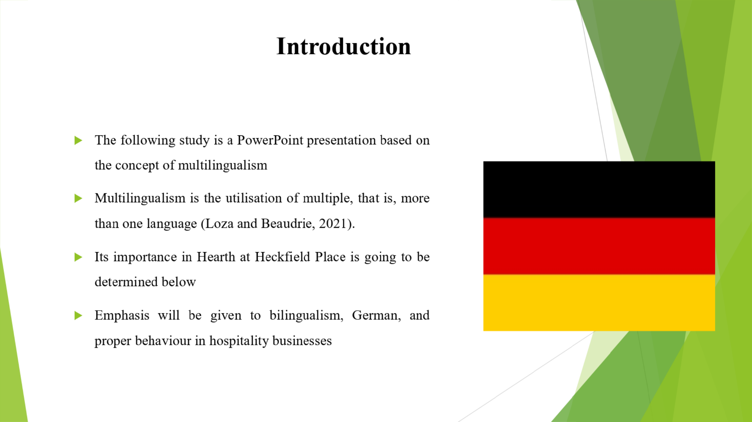
The following study is a PowerPoint presentation based on the concept of multilingualism, bilingualism, German, and proper behaviour in hospitality businesses. Multilingualism is the utilisation of multiple, that is, more than one language (Loza and Beaudrie, 2021). Its importance in Hearth at Heckfield Place is going to be determined below.

Advantages of Multilingualism
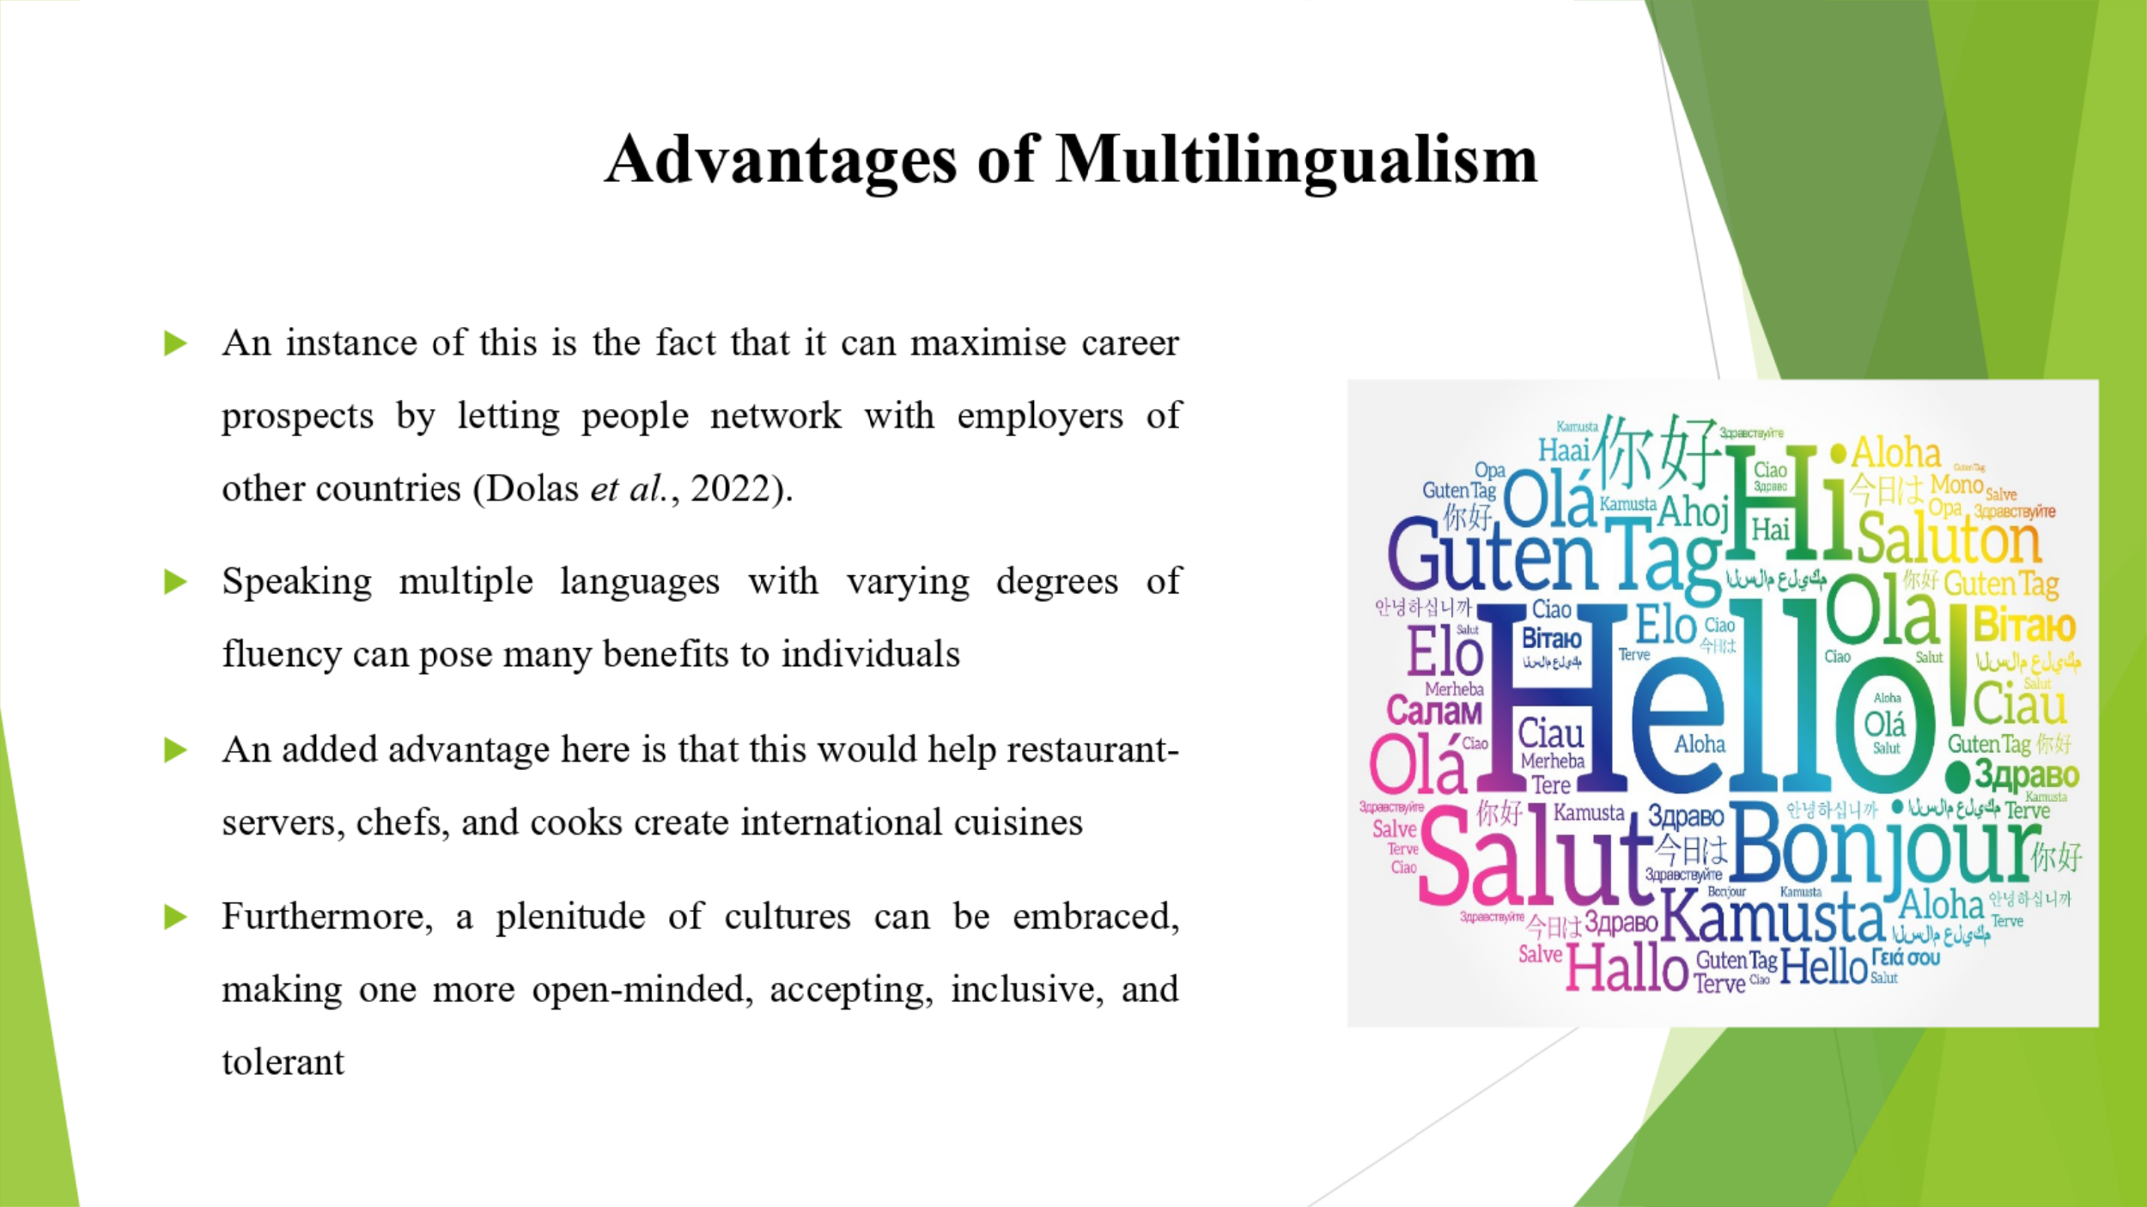
Speaking multiple languages with varying degrees of fluency can pose many benefits to individuals. An instance of this is the fact that it can maximise career prospects by letting people network with employers of other countries (Dolas et al., 2022). Furthermore, a plenitude of cultures can be embraced, making one more open-minded, accepting, inclusive, and tolerant. Travelling will become easier as they can communicate with plenty of different people. Hotel workers can empathise with one another and simultaneously respect the cultures of their guests. An added advantage here is that this would help restaurant-servers, chefs, and cooks create international cuisines.

Significance of Linguistic Awareness
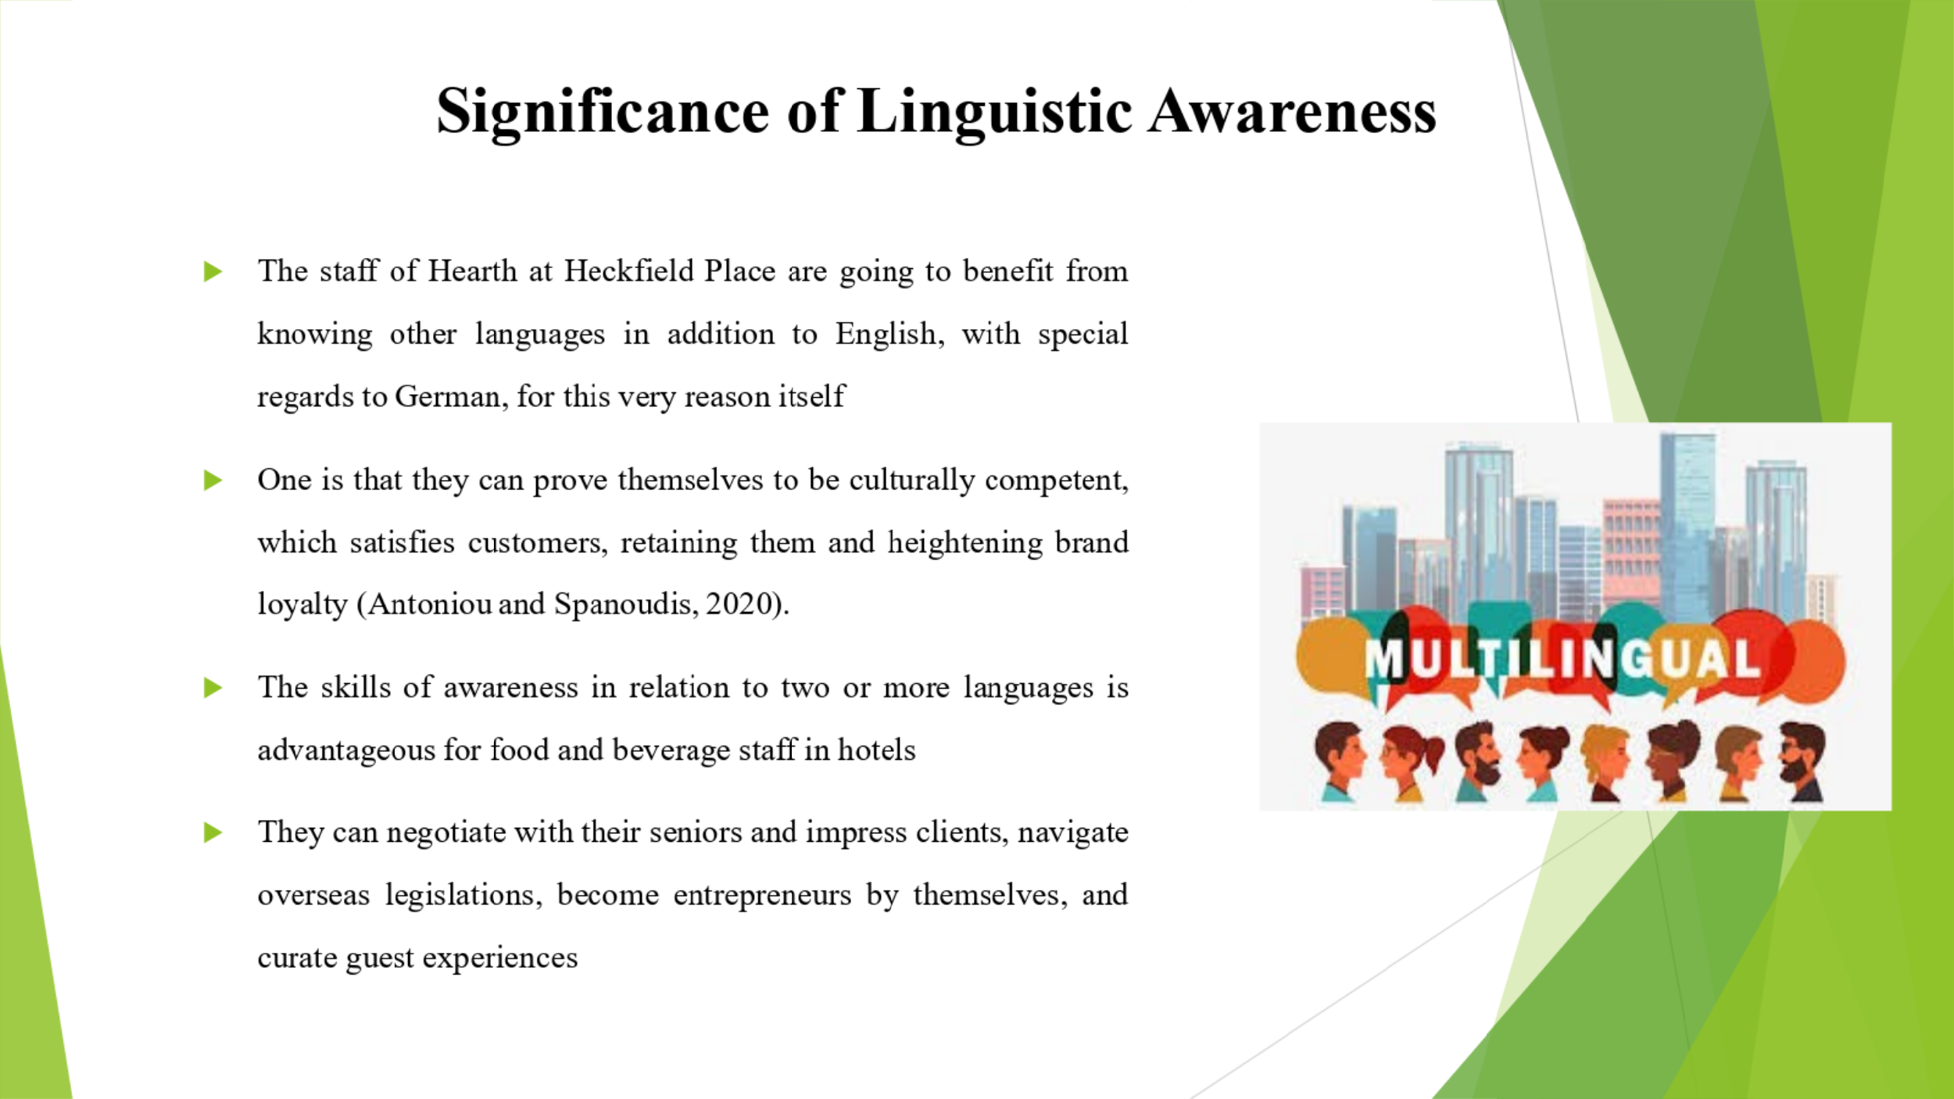
The skills of awareness in relation to two or more languages is advantageous for food and beverage staff in hotels. One is that they can prove themselves to be culturally competent, which satisfies customers, retaining them and heightening brand loyalty (Antoniou and Spanoudis, 2020). The staff of Hearth at Heckfield Place are going to benefit from knowing other languages in addition to English, with special regards to German, for this very reason itself. They can negotiate with their seniors and impress clients, navigate overseas legislations, become entrepreneurs by themselves, and curate guest experiences. They can tailor dining events in correspondence with global tourists.

Background of the Language
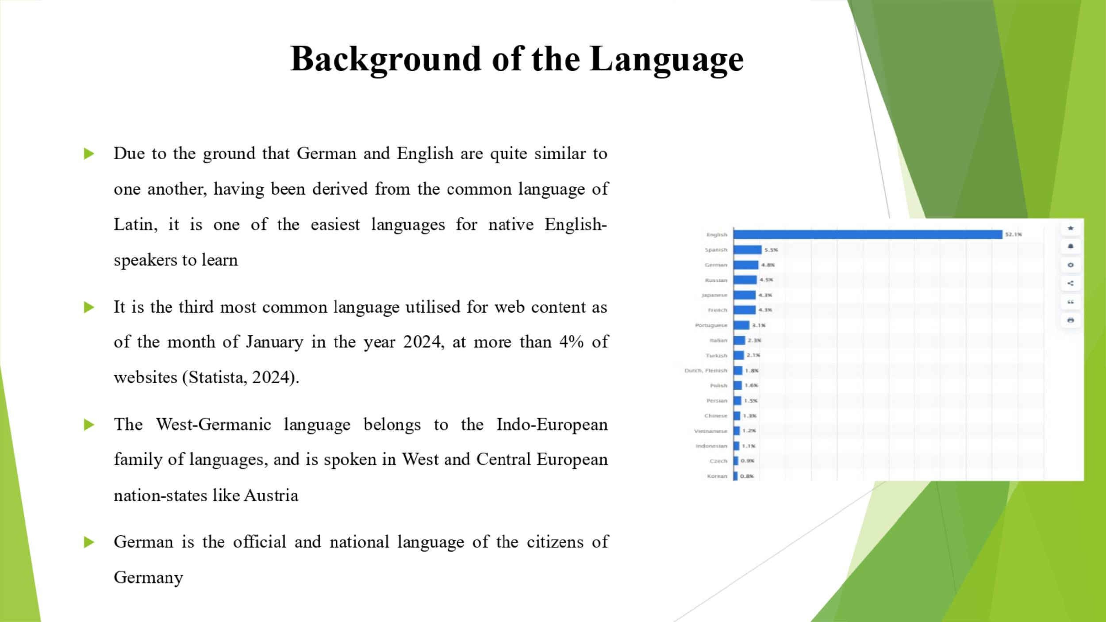
German is the official and national language of the citizens of Germany. It is the third most common language utilised for web content as of the month of January in the year 2024, at more than 4% of websites (Statista, 2024). Due to the ground that German and English are quite similar to one another, having been derived from the common language of Latin, it is one of the easiest languages for native English-speakers to learn. The West-Germanic language belongs to the Indo-European family of languages, and is spoken in West and Central European nation-states like Austria.

Appropriate Behaviour in a Business Context
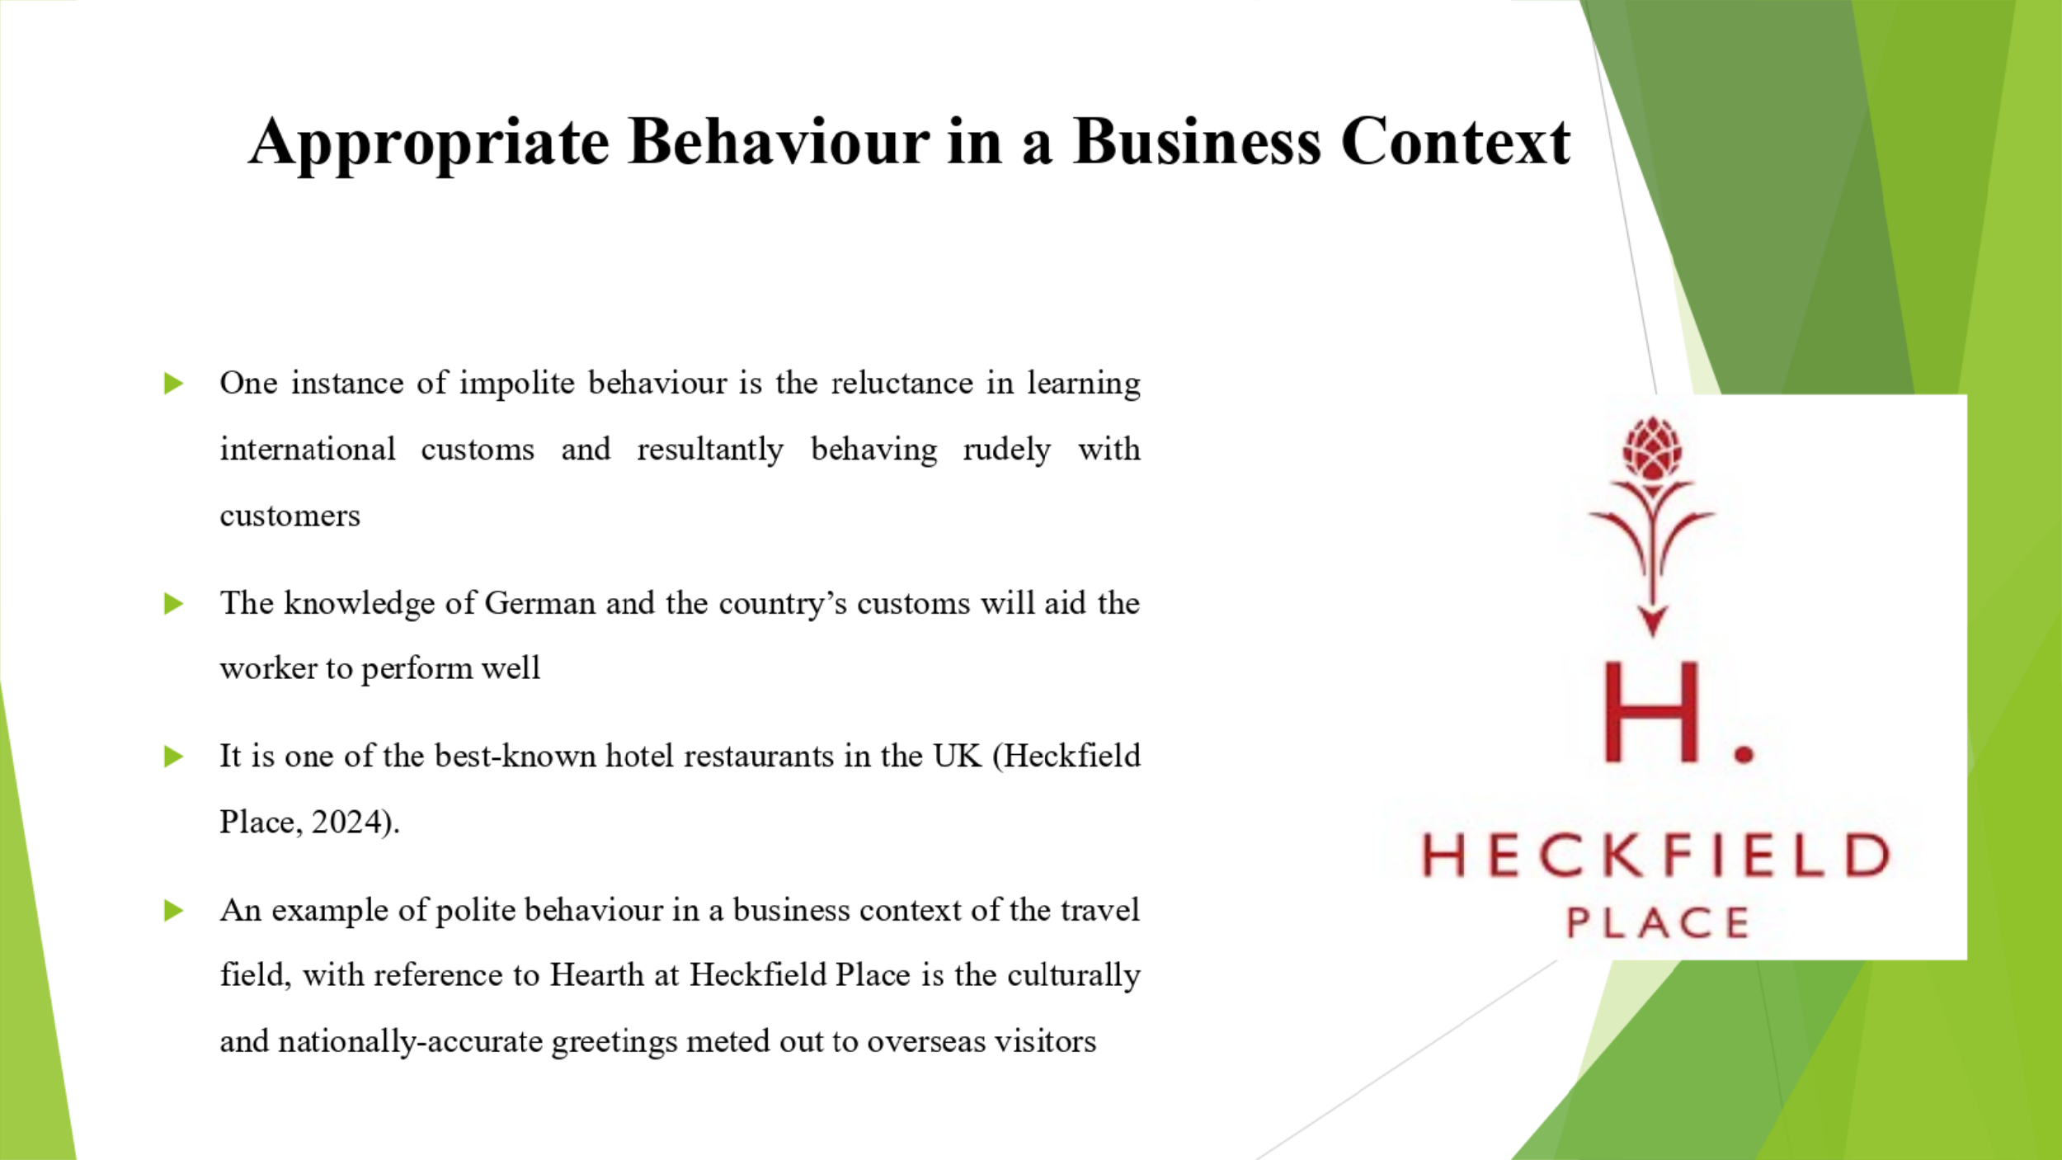
An example of polite behaviour in a business context of the travel field, with reference to Hearth at Heckfield Place is the culturally and nationally-accurate greetings meted out to overseas visitors. It is one of the best-known hotel restaurants in the UK (Heckfield Place, 2024). One instance of impolite behaviour is the reluctance in learning international customs and resultantly behaving rudely with customers. Hence, it can be stated that the staff force of the hospitality arena, especially Heckfield place, needs to apply its multilingual training. The knowledge of German and the country’s customs will aid the worker to perform well.

Conclusion
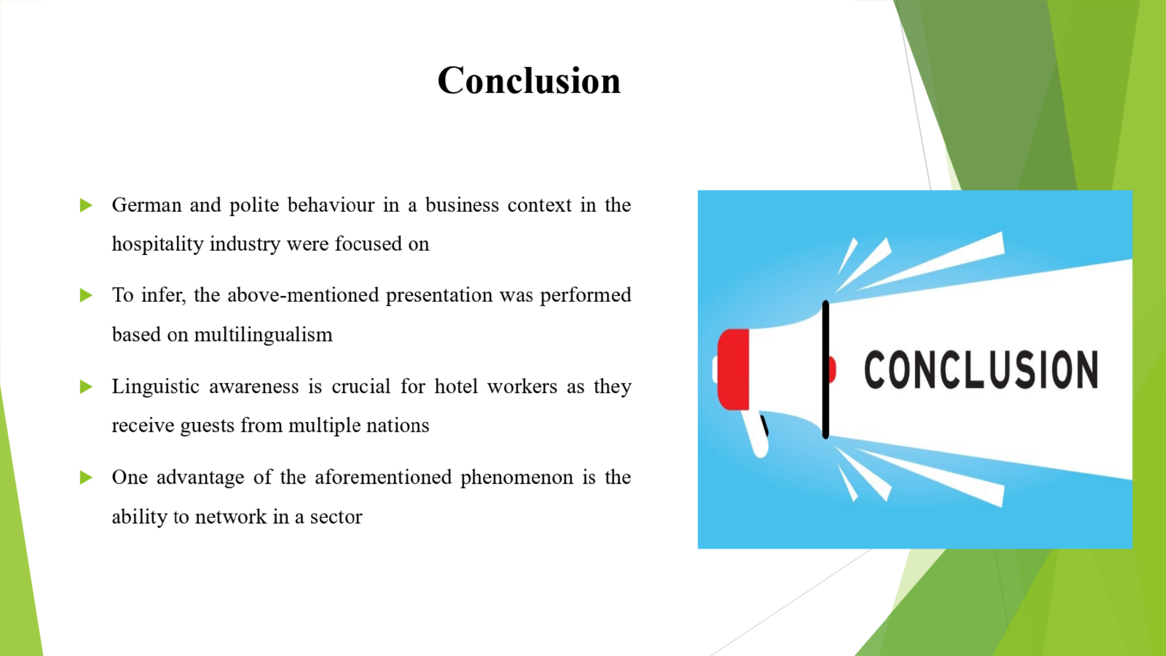
To infer, the above-mentioned presentation was performed based on multilingualism, German, and polite behaviour in a business context in the hospitality industry. One advantage of the aforementioned phenomenon is the ability to network in a sector. Linguistic awareness is crucial for hotel workers as they receive guests from multiple nations.

References
Abramson, N.R. and Moran, R., 2018. Managing Cultural Differences: Global Leadership for the 21st Century. 10th Ed. Abingdon: Routledge.
Antoniou, K. and Spanoudis, G., 2020. An Investigation of the Multilingual and Bi-dialectal Advantage in Executive Control. In CogSci.
Christiansen, B., Branch, J.D. and Karmowska, J., 2020. Cultural Factors and Performance in 21st Century Businesses. Hershey : IGI Global.
Colomer, J., Serra, T., Cañabate, D. and Bubnys, R., 2020. Reflective learning in higher education: Active methodologies for transformative practices. Sustainability, 12(9), p.3827.
Couee, I., 2024. The importance of worldwide linguistic and cultural diversity for climate change resilience. Ecology Letters, 27(3), p.e14410.
Deresky, H., 2017. International Management: Managing Across Borders and Cultures: Text and Cases. 9th Ed. Harlow: Pearson Education Ltd.
Dolas, F., Jessner, U. and Cedden, G., 2022. Cognitive advantages of multilingual learning on metalinguistic awareness, working memory and L1 lexicon size: Reconceptualization of linguistic giftedness from a DMM perspective. Journal of cognition, 5(1).
Hampden-Turner, C. and Trompenaars, F., 2020. Riding the Waves of Culture. 4th Ed. London: John Murray Press.
Heckfield Place, 2024. Hearth. [Online] Available at: <https://www.heckfieldplace.com/food-drink/hearth> [Accessed on: 13 May 2024].
Hofstede, G., Hofstede, G.J. and Minkov, M., 2010. Cultures and organizations: software of the mind. 3rd Ed. New York: McGraw-Hill.
Irawan, L.A. and Sotlikova, R., 2023. Interculture-Based Language Learning Model to Improve Prospective English Teachers’ Speaking Skills Viewed From Linguistic Awareness. JEELS (Journal of English Education and Linguistics Studies), 10(2), pp.471-497.
Loza, S. and Beaudrie, S.M. eds., 2021. Heritage language teaching: Critical language awareness perspectives for research and pedagogy. Routledge.
Maheshkar, C. and Sharma, V., 2018. Handbook of Research on Cross-Cultural Business Education. Hershey: IGI Global.
Statista, 2024. Most used languages online by share of websites 2023. [Online] Available at: <https://www.statista.com/statistics/262946/most-common-languages-on-the-internet/> [Accessed

