The continental hotel
Budget Planner

July 6, 2022
University of Wales Trinity Saint David

By Sandra Poupino
2018518

Table of Contents
Executive Summary 2
Introduction 3
The Continental Hotel Budget Planner 4
Report for Regional Accounts director 5
A) Traditional based Budget 5
Zero base budget 7
B) The process of zero-base budget and how can this be implemented 9
How can this be implemented? 11
C) Can budgeting control support sustainability 12
Conclusion 15
Bibliography 16

Executive Summary

This Report made at the request of the Regional Accounts Director, The Continental hotel, situated in London, and offer fifteen rooms and have ten employees.
Contain a brief analysis of the continental hotel budget planner for 2022 (from January to December).
Include an understanding an analysis of Traditional based budget (TBB), advantages and disadvantages. TBB is easy to prepare and implement and helps promote decentralization.
Interpret Zero based budget (ZBB) and infer about it. ZBB can improve accuracy and efficiency, ensures budget expenses justified.
The research and literature suggest that is beneficial to the organisation to use TBB and ZBB, alternatively five in five years, this combination will be advantages for the organisation better tackle budgets and finances.
Can budgeting control support sustainability, was the questioned, the conclusions drawn show that it is possible and desirable to use this method to help organisations, to keep on track of sustainability.

Introduction

This report will analyse and evaluate of traditional and zero-base budget. The regional accounts director has asked to provide a detailed report to understand the techniques involved in traditional and zero-based budgeting, with the intent of implementing this approach in the future.
The Continental Hotel is situated in London, and offer fifteen rooms, and an excellent restaurant. The hotel charges 250 pounds per night. The Hotel have 20 years of expertise, and count with collaboration of ten employees.
Budget is an economic plan used for business and organisation in advance, helping the business reach their goals. Mangers use this method to help plan and control the financial effort in the organisation.
Normally budgeting used in business and organisations that have management accounting and costing systems (Penning, 2016).
By analysing the benefits of using traditional or zero-based budget in this report, may give the appropriate insight to the organisation to choose the prefect approach, to reach and monitor the objectives proposed for the year.

The Continental Hotel Budget Planner

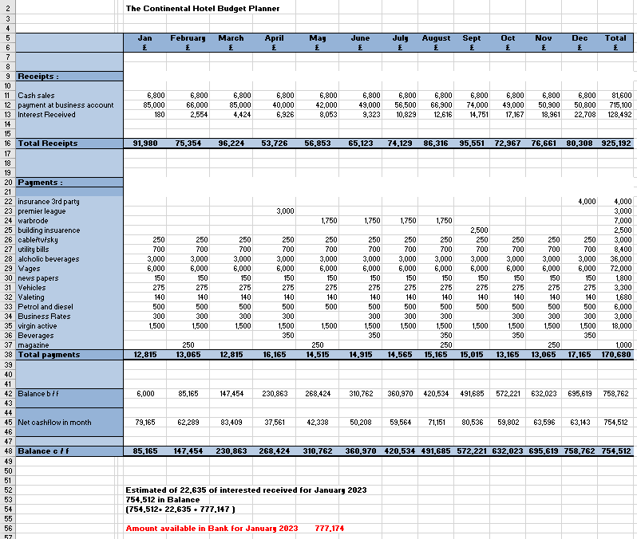

Report for Regional Accounts director

Budgets built around the organisation cost accounting system; therefore, a budget is an economic plan for organisations, put together with time. These budgets normally help organisations to achieve goals for the year, forming a link between where the organisation is, and where wants to reach. Mangers use the budget first to plan and to monitor along the year, to ensure organisation success (Penning,2016).

A) Traditional based Budget
Using incremental budget is the most traditional approach. Traditional budgeting is the extremely ordinary and bygone configuration of budget.
These budgets produced by organisations based on the previous annual budget. When organisations wish to elaborate a traditional budget or renovate it, takes as base the prior period budget as foundation, and change it to acquire a new updated budget. This new budget utilized in the following period. To produce these new, traditional budget organisations, have a particular factor as market demands, environmental factors, and inflation rates (Traditional Budgeting: overview, advantage, and disadvantage - CFAJournal, 2022). Because incremental budgets(traditional), change very moderately, this provide rehabilitee and stability, avoiding conflicts in the organisation departments, in how resources are assign based on budget approval and agreement.
The construction of traditional based budgets (TBB) is amazingly easy when compared with other kind of budgets. However, TBB present advantage and disadvantage.
Advantages are easy to prepare and implement. managers normally can read and understand these budgets without any training. Helps to promote decentralization, allowing all departments in the organisation to have control of their budgets, also provide a framework of control, providing an acknowledgement point, the use of TBB as framework to control and monitoring its performance.
Disadvantages, TBB can be extremely adamant and inflexible, also can be manipulate by managers, TBB do not stimulate development or innovative ideas, either reduce costs, and managers tend to spend all the budget to avoid be reduce in the future. These TBB may contain errors, such if any department had a huge unnecessary budget, these adjustments or corrections may only occur after many years, therefore TBB tend to become obsolete and incorrect.
Organisations use TBB when they already possess data of previous years, and the application of that data to produce the new TBB, can be incorrect, although quite easy to execute (Penning, 2016, CFAJournal,2022)

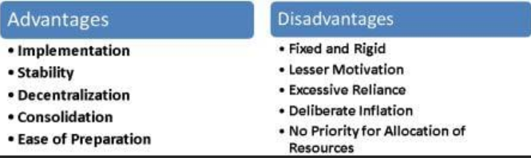
(Borad, 2022)

Zero base budget
Zero base budgeting (ZBB) is a technique of budgeting which all costs must be persuasive and justified for each New Year, it takes the opposite approach of TBB.
Every new period starts from a zero base, having nothing in consideration (no data from previous years), all costs from every department must discuss, justified, and agreed, on the benefit to improve the organisation (not thinking that is lower or higher than last years).
ZBB is normally know as forward looking rather than backwards. To apply ZBB organisations critically examine and scrutinize all costs before issuing them, taking in consideration new goals and benefits for the organisation. All departments must do a judgement and present “decision packages “to demonstrate the gain of allocation of this cost, also ZBB may introduce credit limit. Every new period all costs and benefits evaluated and analysed, and decisions made on the best interest of the organisation (Kagan,2022)
Advantages, ZBB aims to why, while TBB aims to how much, oblige to re-evaluation of the operations within each department and evaluate how they effectively contribute to reach organisation goals, ignoring the past data. Produce efficient distribution of costs and resources, allowing space for innovations. Every new year management may discontinuation to improve for next period, the preparation without any last data, avoid wastage and being slack, management observations to ensure objectives to prove the best allocation of costs being beneficial to the organisation.
Disadvantage, ZBB are very time consuming, expensive, and complex to operate. This budgeting approach may focus on short term benefits, the long term, management may have to overcome the long term, because these should not include in ZBB (example of marketing and training). The discernment of decisions may be laborious and subjective (rigidity). Because ZBB offers benefits vertical and horizontal orientation for the organisation, other managers from different departments may disagree, put top managers and executive Staff very skilled to avoid this conflict.

Literature suggest that would be beneficial for organisations to rotate from TBB to ZBB every five or so years, to obtain the best reduction of costs and still be able to achieve goals and benefits (Penning, 2016, CFAJournal, 2022).

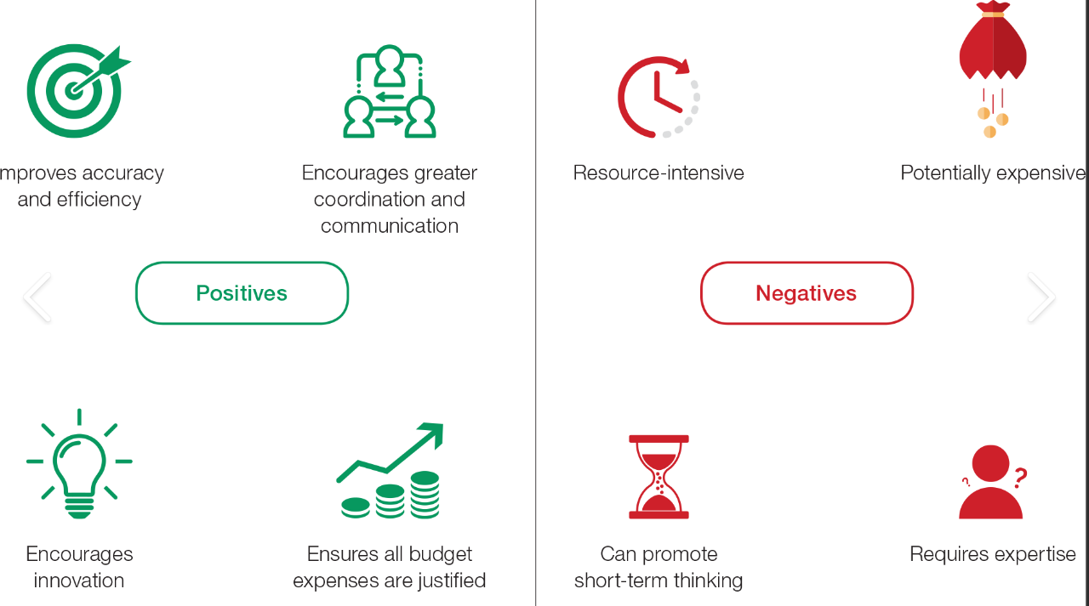 (Zero-based budgeting: a precise model for an unpredictable world | Treasury Today, 2022)

B) The process of zero-base budget and how can this be implemented
The Process of ZBB
Most Literature suggest that ZBB have five steps, Identifying, decisions, classifying decisions, designate resources, monitoring and controlling.
The first step is to identify the departments (decision units), these can divide as clusters or single, those can be independent and suggestively identified. Independent, means a department that can perform alone and do not overlap other departments. In the budget all departments are separated from each other, such as production, HR (human resources), development, marketing, etc. The managers of each department need to justify the costs, and present a budget, and this budget should not have in consideration old data (start from zero) (Borad, 2022).
Second step is decision making (of budgets from departments), top managers then investigate the budget, and try to recognize if align with organisational goals, these budgets should provide clear information of allocation of funds, the benefits must be attractive. Top managers have then to provide a decision based on, operational and technical viability, objectives, and goals, asking does the department need these funds to be successful (What Is Zero Based Budgeting? Definition, Process, Advantages, 2022).
The third step is classifying decisions (given to the budgets of the departments), talks about the importance and priority given to the department budget, to effectively allocate funds, and these decisions made based on cost-benefit. When approaching this step top managers will look for alternative ways, to evaluate all options available, giving them the power to reject or approve these budgets. Top managers need to be realistic and logic to ensure everything is accurate and really bring the goals and benefits for the organisation (CFAJournal, 2022).
The fourth step designate resources (funding), to ensure your department reach this step, department managers need to produce the most attractive and promising budget to ensure top managers do not have any doubt when allocating scarce funding, after top managers give their approval funds are allocated (Borad, 2022).

The fifth step is monitoring and controlling, all decisions About the departments assessed for their executions, to seek if they reach the goals proposed, this helps top managers to achieve the best decisions, and is all is accurate (Penning, 2016).

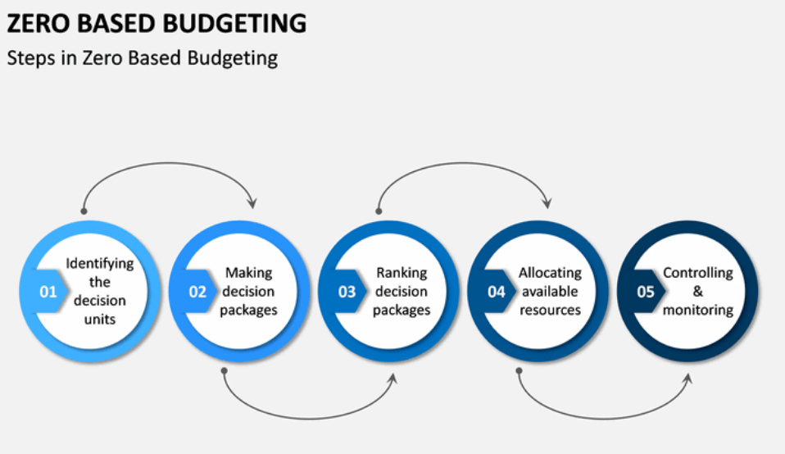
(What is Budget? definition, options, and classification - India Dictionary, 2022)

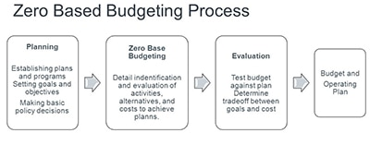
(A zero-based approach to subscription databases | American Libraries Magazine, 2022)

How can this be implemented?
The success or failure of ZBB (zero based budget) application depends on the composition of the organisation and how communications perform. Goals and benefits are shaped in an appropriate period (in respect to ZBB). To guarantee success organisations should define responsibilities and roles, making sure communications are clear and open to empower all employees, giving them the tools to make the best decisions. Also advised to use the best tools available in the market to help track results (Software’s). Validate those goals and benefits are comprehensible to all staff involved, schedule monitoring and evaluations, to analyse reviews and new data. ZBB are the best resources available to ensure cost reduction, allowing enhance performance and efficiency (Gandhi and posts., 2022).

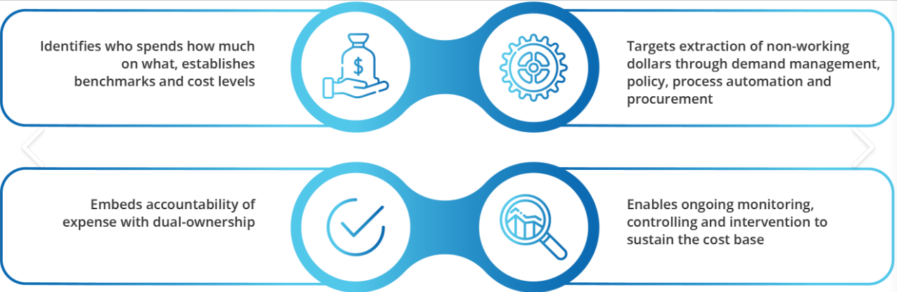
(PAGE and method, 2022)

C) Can budgeting control support sustainability
Budgeting control
The definition of budgeting control, states that is an economic and numeric statement approved and prepared earlier to determine period (normally one year). Due to external factors sometimes is difficulty to align the actual results with the previous budget, (such changings in wages or rising prices (increases or decreases). These involve adjusting to more realistic costs (Penning, 2016).
BC (budgeting control) is characterization as Planning, by elaborating budgets, coordination, to help organisation activities. Is management commitment to estimate potential profits from each department, control of all financial features for cost reduction and control. Accounting system that analyses, review on an appropriate time, these budgets authorized by higher management. Motivation, by empowering staff and appraised to reach targets, may help the organisation to achieve benefits faster. The financial performance is compared with the initial budget and differences calculated (Budgetary Control: Meaning, Objectives, Control, Advantages and Limitations, 2022).
Advantages, maximization on profits, BC is direct to maximise profits, and this is achieved by planning and controlling. Effective coordination, emphasis the effort that managers must implement budgets and the efficiency achieved, is the coordination of all departments to achieve goals. Transparent cuts, targets, and goals, because these are set up prior, give the boost morale to achieve every single goal (here can come into place rewards and rise wages to support). Economy in departments, is set up to help BC to effectively eliminate and use wastage of scare resources. Corrective performances executed when comparing the performance with the initial budget, the deviation is rectified, when organisations do not use BC, this step is done at the end of the year. Shutting down unprofitable departments(activities), helps to close losses and makes departments work hard to improve profitability and goals (Shushila,2022).
Disadvantages, BC is effective method to management. Brings uncertain future, because BC technique use estimative and forecasting, those may not be exact. Changes of circumstances, if this happen (changes)budgets must review and revised, and this may be frustrating for management. Complacence, when staff are

pleased to achieve goals without reaching their full capacity or skills. Conflict in departments, because same can get more funds than others, may create an unstable work environment and conflicts, to find balance and to prevent this may be difficult (Penning, 2016, Shushila, 2022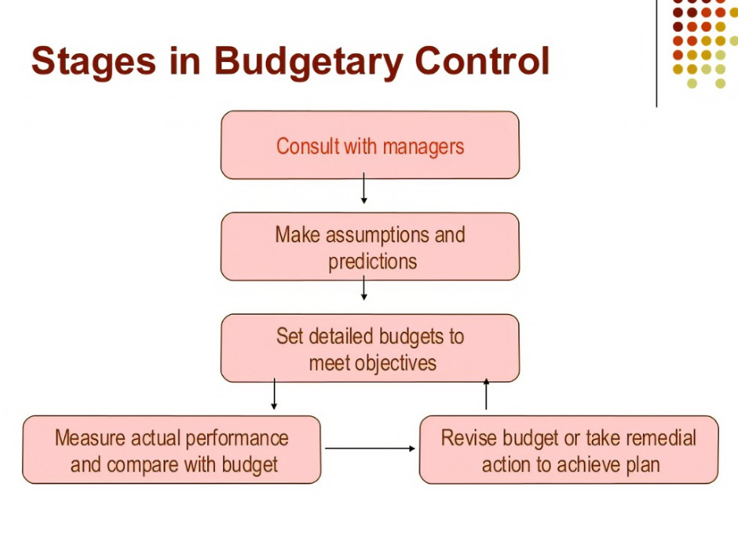
(Budgetary control, 2022)

Can BC (Budgeting control) support sustainability, in instant thought the answer would be mix of no and yes. Although BC is all about cutting losses and profits, seems that organisations must set their own goals about sustainability, which will implicate of ambitious annual budgets to achieve goals in sustainability, organisations need to think forward. Sustainability must play an important part in organisational planning and budgeting to improve indicators. Management may face difficulties when decisions must made, and seek other cuts, to maintain sustainability. BC can support sustainability in ways the fact to reduce the paper consumption, already is working to sustainability. Reducing or cutting crucial sustainable indicative may reflect consequences, special over long term goals and budgets (searcy and ahi, 2022). Organisations that think of cost management to support their goals and strategies, and see cost as investment brings fuel to growth, will perform better. Organisations invest their money in to where the strategy is and regularly cut unwelcome costs and redirect these resources to greater goals (Leinward and Couto, 2022), to evaluate these words, is to describe a Budgeting control (BC), can BC support sustainability, absolutely, with great management, all is possible.
Doing research, come across a pioneering project by a French business school, which is set up to help organisations to account for sustainability. The technique or model helps organisations become more sustainable, by accounting for social and environmental performance in a non-financial way and places the responsibility for sustainability in the financial officer or manager. Prof. Gibassier explains how large organisations, lie their sustainable indicators with a non-financial person. Organisations must be flexible when accounting for sustainable indicators because a change in products or service also change sustainable indicators, meaning the “sustainability budget” may exceed. Gibassier said “our system allows business to see whether their current economic activity falls within the safe and just space for humanity or not. There’s monetisation using what we call a ‘nudge,’ which is making sure that when you integrate a financial version of the impact into your accounts, it is bad enough that internal action taken. We would like to see that companies cannot make a profit if they have not dealt with the capex and opex that they need to take actions to remediate where they are in sustainable terms” (ICAEW,2022)


(Inyathelo, 2022)

Conclusion

In conclusion this report elaborate to evaluate and inform the regional accounts director about Traditional Based Budget, Zero based budget, Control Budget.
Traditional based budget analyses new expenditures, while zero based budget starts from zero. ZBB calls managers to explain expenses to aim for organisation benefits by optimizing costs and not just revenue. Although ZBB are time consuming provides the best approach to allocation of funds.
Can budgeting control support sustainability, yes it can, with great management, having the necessity to cut bad goals, redirected to new greater goal of sustainability.

Bibliography

American Libraries Magazine. 2022. A zero-based approach to subscription databases | American Libraries Magazine. [Online] Available at: <https://americanlibrariesmagazine.org/latest-links/zero-based-approach-subscription-databases/> [Accessed 22 June 2022].

Budget control, 2022. [Online] Available at: <https://simplicable.com/new/budget-control> [Accessed 19 June 2022].

Borad, S., 2022. Steps in Zero Based Budgeting. [Online] eFinanceManagement. Available at: <https://efinancemanagement.com/budgeting/zero-based/zero-based-budgeting-steps> [Accessed 19 June 2022].

Borad, S., 2022. Traditional Budgeting. [online] eFinanceManagement. Available at: <https://efinancemanagement.com/budgeting/traditional-budgeting> [Accessed 25 June 2022].

Collier, P., 2015. Accounting for Managers. 5th ed. west Sussex: John Wiley &Son Ltd.

CFAJournal. 2022. TRADITIONAL BUDGETING: OVERVIEW, ADVANTAGES, AND DISADVANTAGES - CFAJournal. [Online] Available at: <https://www.cfajournal.org/traditional-budgeting/> [Accessed 18 June 2022].

Fpa-trends.com. 2022. Zero-Based Budgeting Implementation - an Overview. [Online] Available at: <https://fpa-trends.com/article/zero-based-budgeting-implementation-overview> [Accessed 22 June 2022].

Geektonight. 2022. What Is Zero Based Budgeting? Definition, Process, Advantages. [Online] Available at: <https://www.geektonight.com/zero-based-budgeting/> [Accessed 19 June 2022].

Gandhi, R., and posts. V., 2022. What is Zero-based budgeting? – How to implement it! - Finlawportal. [Online] Finlawportal. Available at: <https://finlawportal.com/zero-based-budgeting-how-to-implement-it/> [Accessed 19 June 2022].

Icaew.com. 2022. Budgeting for sustainability. [Online] Available at: <https://www.icaew.com/insights/viewpoints-on-the-news/2022/Jan-2022/Budgeting-for-sustainability> [Accessed 20 June 2022].

India Dictionary. 2022. What is Budget? Definition, options, and classification - India Dictionary. [Online] Available at: <https://1investing.in/what-is-budget-definition-options-and/> [Accessed 22 June 2022].

Inyathelo, A., 2022. Budgeting for Sustainability – ASK Inyathelo. [online] ASK Inyathelo. Available at: <http://askinyathelo.org.za/budgeting-for-sustainability/> [Accessed 28 June 2022].

Leinward, P. and Couto, V., 2022. How to Cut Costs More Strategically. [Online] Harvard Business Review. Available at: <https://hbr.org/2017/03/how-to-cut-costs-more-strategically> [Accessed 19 June 2022].

Liberty Advisor Group. 2022. Create a Zero-Based IT Budget. [Online] Available at: <https://libertyadvisorgroup.com/insight/zero-based-budgeting-approach/> [Accessed 28 June 2022].

Learn Accounting: Notes, Procedures, Problems and Solutions. 2022. Budgetary Control: Meaning, Objectives, Control, Advantages and Limitations. [Online] Available at: <https://www.accountingnotes.net/cost-accounting/budgetary-control/budgetary-control-meaning-objectives-control-advantages-and-limitations/17138> [Accessed 18 June 2022].

NerdWallet. 2022. What Is Zero-Based Budgeting? - NerdWallet. [Online] Available at: <https://www.nerdwallet.com/article/finance/zero-based-budgeting-explained> [Accessed 28 June 2022].

Kagan, J., 2022. Zero-Based Budgeting (ZBB). [Online] Investopedia. Available at: <https://www.investopedia.com/terms/z/zbb.asp> [Accessed 19 June 2022].

Pt.slideshare.net. 2022. Budgetary control. [Online] Available at: <https://pt.slideshare.net/malshaibah/budgetary-control-57091147/12> [Accessed 24 June 2022].

PAGE, H. and method, M., 2022. Zero Based Budgeting (ZBB) | Z+Pack. [Online] SAP Global | Platinum Partner - Detaysoft. Available at: <https://detaysoft.com/en-US/manage-your-expenses-with-the-zero-based-budgeting-method-pg-199> [Accessed 28 June 2022].

Penning, A., 2016. Management Accounting: Budgeting. 1st ed. London: Osborne Books Limited.

Ramp.com. 2022. Zero-based budgeting: what it is + how to implement it. [Online] Available at: <https://ramp.com/blog/what-is-zero-based-budgeting> [Accessed 19 June 2022].

Slidetodoc.com. 2022. Implementing Zero Based Budgeting in Kosovo Correctional Service. [Online] Available at: <https://slidetodoc.com/implementing-zero-based-budgeting-in-kosovo-correctional-service/> [Accessed 20 June 2022].

Searcy, c. and ahi, p., 2022. Do not Cut the Sustainability Budget - The European Business Review. [Online] The European Business Review. Available at: <https://www.europeanbusinessreview.com/dont-cut-the-sustainability-budget/#:~:text=Sustainability%20initiatives%20must%20continue%20to%20play%20a%20strong,no%20options%20other%20than%20cutting%20some%20sustainability%20initiatives.> [Accessed 19 June 2022].

Treasurytoday.com. 2022. Zero-based budgeting: a precise model for an unpredictable world | Treasury Today. [online] Available at: <https://treasurytoday.com/treasury-practice/strategic-treasury/zero-based-budgeting-a-precise-model-for-an-unpredictable-world-ttb2b> [Accessed 25 June 2022].

2022. [Online] Available at: <https://www.british-business-bank.co.uk/finance-hub/zero-based-budgeting/> [Accessed 28 June 2022].

2022. [Online] Available at: <https://www.mckinsey.com/business-functions/strategy-and-corporate-finance/our-insights/zero-based-budgeting-gets-a-second-look> [Accessed 24 June 2022].

