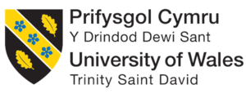

Module Title: International Business Concepts
Module Code: LCMB7034

International Business Analysis of Zerodha's Potential Expansion into Germany's financial services sector
Student Name : Abhishekkumar Pethani
Student id : 2525424
Lecturer name : Akshay Narayanan
WORD COUNT: 5033
Executive Summary
The report examines the current digital infrastructure of Zerodha that has empowered the financial firm to serve the needs of billions of Indian investors through an online platform. The viability of the German market and its financial ventures have also been discussed in this report, which can help the Zerodha leaders to develop suitable entry policies for future European expansion. The FDI inflow within the German market has also been showcased here, which further demonstrates the risk-averse nature of local investors for maximising personal revenue base.

Table of Contents
SECTION 1 4
1. Introduction 4
2. Industry and Country Overview 4
2.1 Overview of the Industry within the Context of Germany 4
2.2 Size, Scope and Economic Importance of the Industry 6
2.3 Major Domestic and Multinational Firms 7
2.4 Relative Positioning of key companies in the industry 7
3. Application of Michael Porter's Diamond Model of National Advantage 8
4. Market Evaluation for Germany 13
4.1 Identification of a major foreign enterprise operating in the country-industry pair 13
4.2 Critical analysis of factors impacting the success of Zerodha operations in Germany 16
4.3 Evaluation of the German market’s attractiveness 18
5. Conclusion 21
SECTION 2 23
Reflective Account Using Kolb's Reflective Cycle 23
Reference List 27

SECTION 1

1. Introduction
The commercial initiative undertaken by prominent operations for transferring goods, services and capital across foreign borders can be referred to as international business to improve brand value among diverse clients (Griffin and Pustay, 2020; Collinson et al. 2020). The report showcases the positive elements involved with the financial industry of Germany that can help Zerodha towards establishing a loyal client base interested in investing through digital platforms. The current state of the German financial market is going to be demonstrated in this report, which can help the administration of Zerodha towards locating local ventures for future investment opportunities. The present cultural and economic circumstances of Germany are going to be conveyed in this report, which can motivate Zerodha towards developing expansion policies to gain an initial revenue stream. The report is going to employ the Diamond Model of National Advantage introduced by Michael Porter for locating the current competitiveness level of the German capital sector for maximising their investment portfolio.

2. Industry and Country Overview

2.1 Overview of the Industry within the Context of Germany
One of the fintech hubs in Europe that is well-developed is the German economy. This is due to the presence of sophisticated financial systems in the country, together with its digitization efforts and increasing adoption of financial services by consumers (Wild and Wild, 2023). Some of the fintechs in Germany include digital banking, online broking, wealth management, digital payments, lending, and even blockchain-based financial services, making Germany an ideal location for fintechs (Hill, 2023).
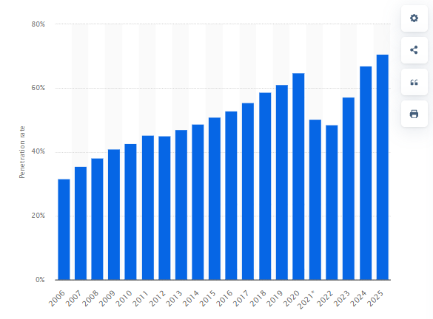
Figure 1: Online banking penetration in Germany from 2006 to 2025
(Source: Elagina, 2026)
As shown in Figure 1, there is a rising trend in terms of the increasing rate of adoption of fintech services in Germany. According to Elagina (2026), there is a population of about 84.7 million people in Germany, out of which the proportion of those using the internet is more than 94%. Likewise, the proportion of smartphone users is above 92%. In addition, the penetration rate of online banking in the year 2025 is 70.71%, which proves that there is an increasing trend in favour of digital financial solutions. Furthermore, there are over 13 million retail investors involved in trading online, while ETF savings are held by over 11 million people, indicating the involvement of people in online investment. Finally, the Frankfurt Stock Exchange, which is among the leading stock exchanges in Europe, has a market capitalization of over €2.8 trillion.

2.2 Size, Scope and Economic Importance of the Industry
The fintech industry in Germany is considered one of the largest in Europe, backed up by a huge number of digital customers, advanced financial technology, and consistent technology innovations.
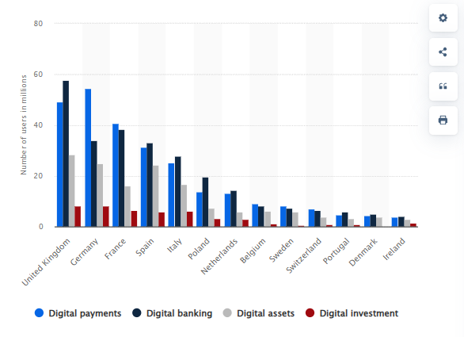
Figure 2: Top 10 Stockbroking Apps in 2024
(Source: Statista Research, 2026)
- Size: Figure 2 gives a picture of the extent of fintech market in Germany across various financial services. In Germany, there are about 54 million digital payment customers, 33 million digital banking customers, 24 million digital assets customers and 8 million digital investments customers, ranking it second largest fintech market in Europe next to the UK (Statista, 2025).
- Scope: The extent of the fintech market in Germany covers a range of services such as digital banking, online brokerage, digital payments, wealth management, Insurtech, blockchain, embedded finance, and digital lending (Patra, 2024). Through AI, cloud computing and open banking technologies, financial service providers have been able to increase efficiency and availability.
- Economic Importance: The contribution of the industry within the economy is very important since it brings about innovations, job creation, investments, and digitization. The German fintech industry is estimated to generate a revenue of $10.5 billion by 2026 (Palekar et al., 2023). Hence playing a role in making Europe one of the fastest growing digital finance environments in the world. This will help to increase the competitiveness of the country.

2.3 Major Domestic and Multinational Firms
The German financial services sector can be described as one that experiences fierce competition because it includes well-known local companies as well as famous multinational companies (Daniels et al., 2019). The top three local companies in this field are Trade Republic, Scalable Capital, and Comdirect because they have the majority of the market share as a result of the state-of-the-art technology and financial services offered by them. At the same time, the top three multinational companies include Interactive Brokers from the US, eToro from Israel, and Saxo Bank from Denmark, and they benefit from their international reach as well as the availability of different types of trading and investment technologies.

2.4 Relative Positioning of key companies in the industry
Company | Strategy | Market Segment | Performance (Numerical Data) | Competitive Positioning
Trade Republic (Germany) | Mobile-first, commission-free investing | Young retail investors | 8+ million customers, €100+ billion assets under custody | Market leader in low-cost investing with rapid expansion across 17 European countries.
Scalable Capital (Germany) | Robo-advisory and subscription-based trading | Long-term retail investors | 1+ million customers, €30+ billion assets managed | Differentiates through automated wealth management and premium ETF investment solutions.
Comdirect (Germany) | Integrated banking and brokerage | Traditional retail banking customers | Approximately 3 million brokerage accounts | Strong reputation through comprehensive banking and investment services.
Interactive Brokers (USA) | Global multi-asset trading platform | Professional and institutional investors | 3.9+ million client accounts, access to 150+ global markets | Global is a leader in sophisticated trading tools and international market access.
eToro (Israel) | Social investing and copy trading | Beginner and digitally active investors | 38+ million registered users across 100+ countries | Strong differentiation through social investing, cryptocurrency and community-based trading.
Saxo Bank (Denmark) | Premium digital wealth management | High-net-worth and institutional investors | US$118+ billion client assets and operations in 15+ countries | Premium positioning through advanced investment products and personalised wealth management.
Justification
From the above, it can be seen that the German Fintech sector is highly competitive because all the companies have implemented distinct strategies that focus on serving different consumers. This is because there are certain local companies that use unique aspects such as free trading, robo advisors, and banks. However, some of the foreign companies have used the strategy of providing investors with access to global markets, social trading platforms, and quality wealth management services. It can be seen that the customer base, assets, and reach have grown immensely within this industry.

3. Application of Michael Porter's Diamond Model of National Advantage
According to Porter’s Diamond model, the business environment of a nation impacts the performance of companies around the globe. The determinants of Porter’s Diamond Model include:
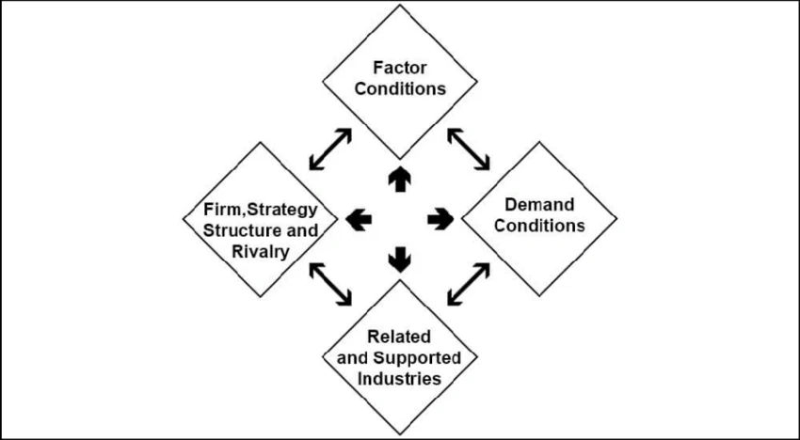
Figure 3: Porter's Diamond Model Framework
(Source: ResearchGate, 2026)
Factor Conditions
Skilled labour, infrastructure, technology, and financing are included under factor conditions. Factor conditions in Germany are very good, which will aid every organisation to do business in this country. As per Upadhyay (2024), in 2025, the nominal GDP of Germany exceeded US$4.4 trillion, while GDP per capita was about US$57,000, as seen in Figure 4. It has more than 47 million employees, of whom over 1.1 million are ICT experts aiding in innovations in the field of fintech and cybersecurity. Germany spends more than € 129 billion annually on R&D, amounting to around 3.1% of GDP, promoting AI, cloud computing, and digital finance.
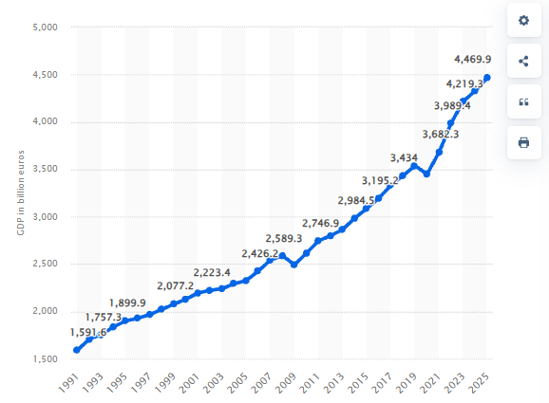
Figure 4: Gross domestic product of Germany from 1991 to 2025
(Source: Clark, 2026)
Digital infrastructure in Germany is equally strong, with internet penetration of more than 94%, broadband of 97%, and smartphone penetration of more than 92%. More than 63 million people utilise online banking in Germany, suggesting high use of digital finance by German citizens (Falck and Czernich, 2025). The securities markets in Frankfurt, which is one of the largest financial centres in Europe, have a market capitalisation of more than € 2.8 trillion (Drechsler et al., 2022).
Demand Conditions
The investment market in Germany is one of the most developed in Europe. Digital remittances accounts of US10,396.96 million, neo brokers accounts of US343.96 million and Robo advisors accounts of US138.55 million, as seen in Figure 5 (Statista Research Department, 2024). More than 13 million retail investors participate in equity investments, ETFs and mutual funds, while ETF saving plans have more than 11 million active clients, growing by almost 22% over recent years.
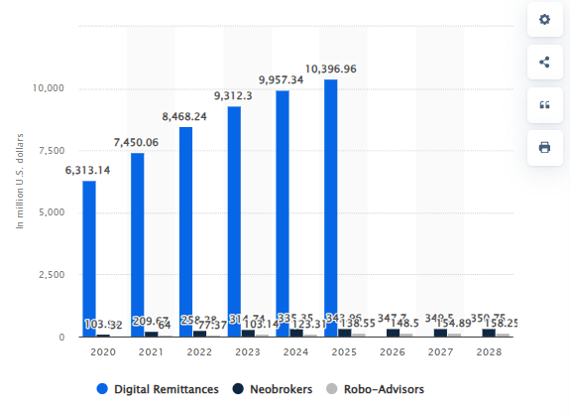
Figure 5: Digital Investment market for different segments in Germany from 2020 to 2028
(Source: Statista Research Department, 2024)
As per Stute and Kühnbach (2023), German investors are financially literate and quality oriented. Around 48% of new brokerage accounts are created by customers in the age range of 18-39, indicating the high level of digitalisation among young investors. Furthermore, annual online securities turnover was more than € 1.4 trillion, indicating the high market activity. However, German investors are oriented towards diversified and long-term portfolio management, not towards speculative operations (Aalbers et al., 2023).
Related and Supporting Industries
There is a well-developed ecosystem in Germany, which contributes to the competitiveness of industry. More than 900 FinTech businesses are located in Germany, and 160 of them specialise in digital investing, brokering, and wealth management technologies (Otto et al., 2022). There are more than 1,300 banks in Germany, which ensures efficient cooperation between brokers, payment service providers, and financial technology companies.
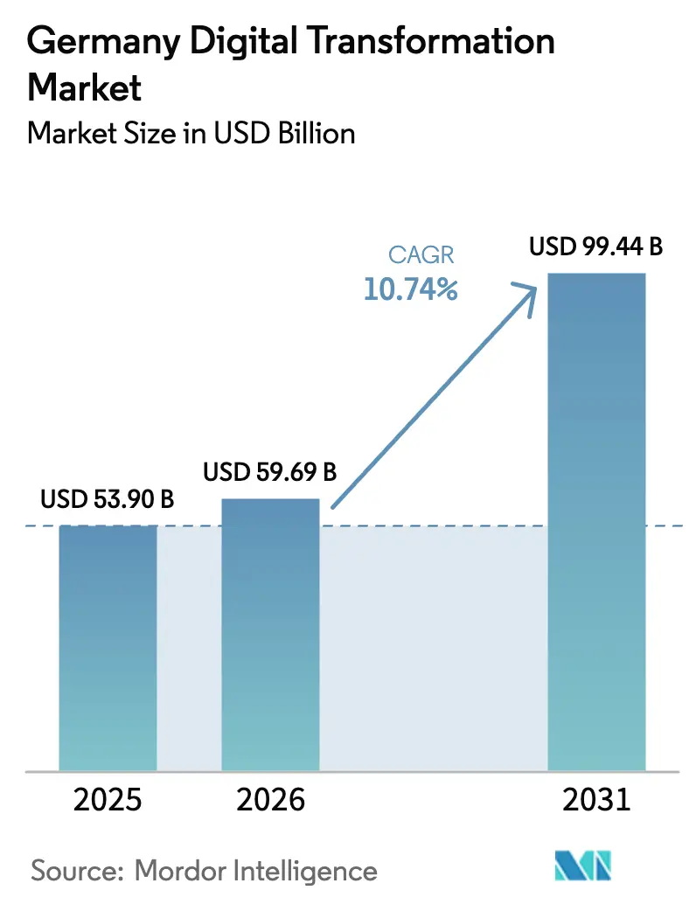
Figure 6: Digital Transformation Market of Germany
(Source: Mordor Intel, 2026)
As per Mordor Intel (2026), investments in the development of digital transformation are expected to amount to more than USD 99.44 billion per year, as seen in Figure 6. This helps in encouraging innovations concerning artificial intelligence, blockchain technology, and cybersecurity. Moreover, there are more than 80,000 STEM graduates annually produced by German universities, ensuring the inflow of highly qualified specialists. There are approximately 1.2 million workers in the financial and insurance sector, contributing to innovations in the area of financial services (Peter et al., 2022).
Firm Strategy, Structure and Rivalry
The online stock trading platform in Germany faces stiff competition from both the players in Germany and other countries as well. As per Dorfleitner and Scheckenbach (2022), the Trade Republic Platform serves more than 8 million clients holding more than €100 billion worth of assets spread across 17 European countries. Scalable capital manages assets worth more than € 30 billion for more than 1 million clients, whereas Comdirect has about 3 million brokerage accounts. The global competition is also stiff in this sector, as Interactive Brokers has 3.9 million client accounts and operates in 150 countries (Freibauer et al., 2025). Organizations at home, including Trade Republic, Scalable Capital, and Comdirect, will compete against other organizations in foreign countries. This includes Interactive Brokers, eToro, and DEGIRO, on the basis of low cost of trading, artificial intelligence, cyber security, and customer experience in the digital platform.
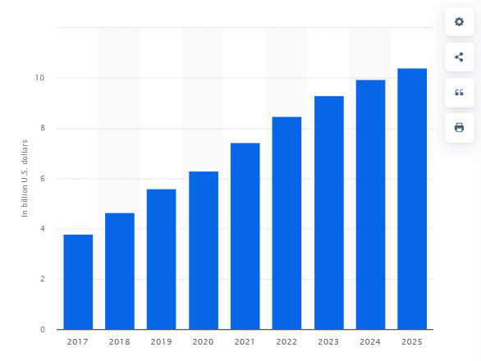
Figure 7: Revenue in the digital remittances segment of the fintech market Germany
(Source: Statista Research Department, 2024)
Explanation of Figure 7 shows the steady growth of the German fintech sector as the revenues of the industry rose from about US$3.7 billion in 2017 to US$10.5 billion in 2025, making the revenues almost triple in eight years (Statista Research Department, 2024). Such a rapid growth is due to increased use of digital banking, proper technology infrastructure and increased consumer demand for online investment platforms. Hence, there is a need for constant innovation among firms in the German fintech sector.

4. Market Evaluation for Germany

4.1 Identification of a major foreign enterprise operating in the country-industry pair
Identification of Zerodha
Zerodha can be identified as an India-based financial services corporation, first established in the financial year of 2010 to deliver investment opportunities to customers in the open market. The digital platform adopted by Zerodha has created a ground-breaking infrastructure for clients in terms of 24/7 support, costs and technological advancements to recommend suitable investments from the Indian marketplace. Every year, over 1.6 billion consumers utilise Zerodha's online platform for locating suitable enterprises from the local retail sector to perform risk-free investments (Zerodha, 2026). Almost 15% of retail market investments are presently being performed by the client base of Zerodha, which has empowered Indian enterprises to procure financial assistance for continuous operations (Zerodha, 2026). Hence, the current digital infrastructure and risk-free investment ecosystem of Zerodha can motivate the local client base to invest in emerging retail businesses for maximising personal investment returns.
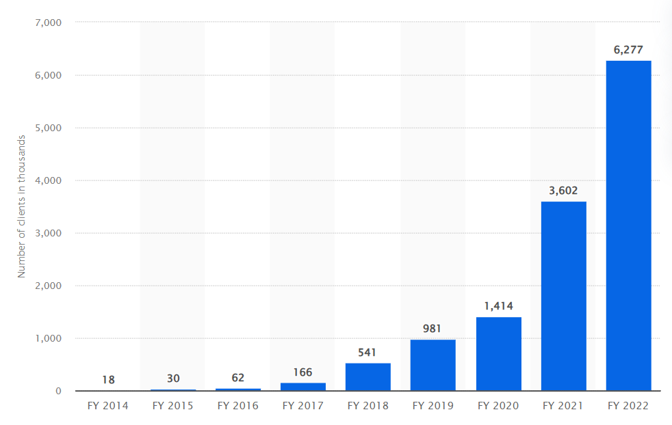
Figure 8: Gradual increasing of client base of Zerodha
(Source: Scholle, 2021)
The above Figure 1 showcases the increasing online user base of Zerodha, which further showcases a strong financial performance of the online investment firm in the last decade. In 2019, the investment corporation had a record of almost 981,000 registered clients that regularly utilised the organisation's digital processes for investing their personal capital towards local businesses (Scholle, 2021). The overall customer base for Zerodha was recorded to be nearly 6.227 million users in 2022, which further showcases heightened interest among local investors in acquiring personalised financial solutions (Scholle, 2021). As a result, the expansion of Zerodha’s online investment operations throughout the German marketplace can help the organisational leadership to diversify its present client base.
Financial sector of Germany
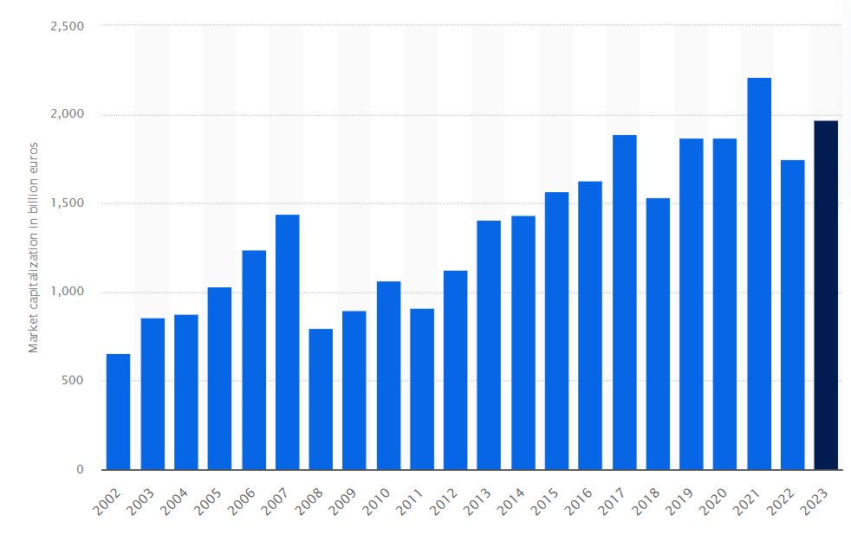
Figure 9: The overall market capitalisation level in Germany for the last two decades
(Source: Scholle, 2024)
The German investment industry can be considered the largest among the rest of the European markets in terms of procuring foreign investment opportunities based on the sheer number of institutional players. The Frankfurt Stock Exchange is considered the financial capital of Germany, which is known towards trading trillions of Euros worth of revenue. For example, in 2021, nearly 2.21 trillion Euros of financial revenue were generated from the financial district of Germany that have been used to deliver a steady revenue stream towards local corporations (Scholle, 2024). On the other hand, almost 2 trillion Euros have also been produced in the Frankfurt Stock Exchange in the fiscal year 2023, which further demonstrates the economic stability of the German marketplace (Scholle, 2024). Therefore, the steady financial performance of the German investment sector can prove to be effective for the Zerodha administration to establish a local market presence by providing online investment features to local citizens.

4.2 Critical analysis of factors impacting the success of Zerodha operations in Germany
In the German financial and brokerage industry, multiple factors such as the technological conditions, regulatory environment, and competitive landscape exist that can dictate the success level of Zerodha's market expansion.
Technological circumstances of Germany
The technological landscape of Germany is currently experiencing rapid enhancement powered by ICT systems and AI tools for automating repetitive processes in major industries such as finance, manufacturing and retail. For instance, in 2024, the German ICT sector generated almost 222.6 billion euros of market revenue, which showcases the heightened reliance on local enterprises towards developing advanced digital infrastructure (ITA, 2025). It can be mentioned that Zerodha leadership can also utilise the ICT environment of Germany for developing their initial business infrastructure during the expansion process to develop a localised digital investment platform. In 2025, almost 55% of business corporations operating in the German marketplace mentioned their collective interest towards investing in AI technologies to develop a smart organisational infrastructure (ITA, 2025). Hence, the creation of an AI-based investment platform can be created by Zerodha officials to cater to the needs of local German investors and provide them with personalised recommendations on investment portfolios.
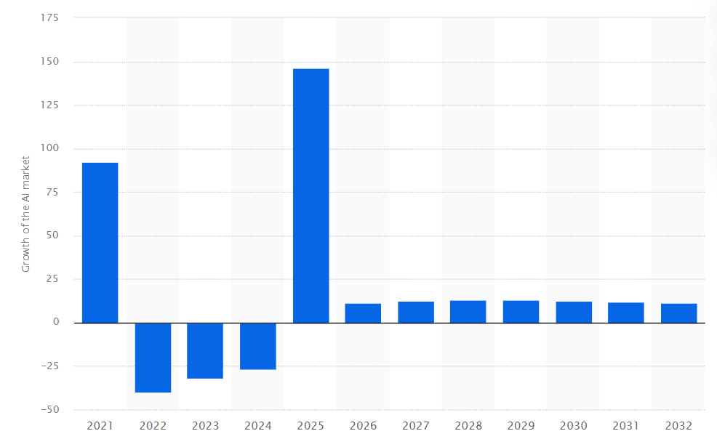
Figure 10: Growth of the AI industry in Germany
(Source: Statista, 2026a)
However, the lack of AI competency among the modern workforce can prove to be a major issue for Zerodha towards developing a smart investment platform for local clients. For example, almost 20% of workers operating in the global financial markets are currently worried about being replaced after AI integration, which signifies their lack of AI competency levels (Lane et al. 2023). The administrative body of Zerodha needs to develop an AI training infrastructure for improving its local German workforce's competency before proceeding with the expansion operations.
German regulations for financial entities
The regulatory environment of the German financial sector has been supervised by the Federal Financial Supervisory Authority (BaFin) and the Deutsche Bundesbank for performing major transactions. The local government has also instigated the German Banking Act (Ge­setz über das Kre­dit­we­sen) for monitoring the daily operations of different financial and investment firms across the nation (Bundesbank, 2026). Apart from that, the Payment Services Oversight Act (Zah­lungs­diens­te­auf­sichts­ge­setz) have also been introduced by German authorities for overseeing the online transactions being performed by German citizens and local establishments (Bundesbank, 2026). In current times, almost 1,680 credit institutions and 100 payment institutions have been supervised by the authorities in the Bundesbank to maintain a transparency level in liquidity operations (Bundesbank, 2026). Therefore, the Payment Services Oversight regulation needs to be followed by the Zerodha officials operating in the German marketplace for establishing their online investment operations in future.
The investment industry of Germany consists of both private and public enterprises dedicated towards providing sound financial assistance to its local customer base. During the German market expansion, the Zerodha administration can face major competition from rival investment firms operating in the German marketplace with an established customer base. For example, in 93% of cases, German banking institutions are known for providing adequate financial assistance to domestic clients who have slowly developed a loyal client base (Main and Theurer, 2026). As a result, the heightened competition can prove to be a major factor for Zerodha that directly influences the expansion operations of the financial platform in the German market.

4.3 Evaluation of the German market’s attractiveness
Political Factors
The Republic of Germany has been structured as a federal state which operates under the supervision of a constitutional democracy system. The Federal President can be considered the highest political figure of the nation, who is represented by the President of the Bundesrat, endorsing the interests of the 16 German states (Deutschland, 2026). Germany operates under a multi-party system with the Social Democrats (SPD) and Christian Democrats (CDU/CSU) being the major forces within the country. Since 2025, Friedrich Merz has been operating as the German Canceller who belongs to the CDU party that won a decisive political victory over their rivals in the last electoral process (Deutschland, 2026). Hence, the democratically elected government of Germany further showcases the national political stability, and governmental aid can prove to be financially feasible for Zerodha in streamlining expansion operations in the European nation.
The ongoing conflict between Russia and Ukraine has adversely affected the political hierarchy of Europe, which includes German leadership that has facilitated major financial and logistics support to the Ukrainian government. At the beginning of 2026, the German government approved the exportation of military arms worth around 2.5 billion Euros that can help the Ukrainian government towards dealing with the overwhelming Russian forces (Ukrinform, 2026). On the other hand, between January and June of the current year, German arms export licenses have been approved by the local government of almost 13.87 billion Euros for the betterment of Ukrainian military forces (Ukrinform, 2026). It can be highlighted that the successive arms exports towards the Ukraine-Russia conflict have put a massive financial burden on the German government since the beginning of the war. Therefore, the current leadership of Zerodha needs to navigate carefully through the current political climate of Europe for operating financially feasible investment functions.
Economic Factors
Germany has been considered the fourth-largest economy in the world, which further showcases the economic prosperity level of the European nation in terms of living standards. In 2025, the inflation level of the German market is recorded to be around 2.3%, which indicates positive financial conditions across its different industries (Statista, 2026b). However, in 2022, the national inflation index encountered a major spike, reaching around 8.67%, which might have adversely affected the purchasing capabilities of regular German residents (Statista, 2026b). It can be noted that the Eastern European war contributed towards the economic unravelling of the German marketplace, which forced the local government to consider alternative sources of energy. As a result, despite the financial volatility level in the German marketplace, it still remains the most viable financial market in all of Europe for Zerodha to proceed with financially feasible expansion plans.
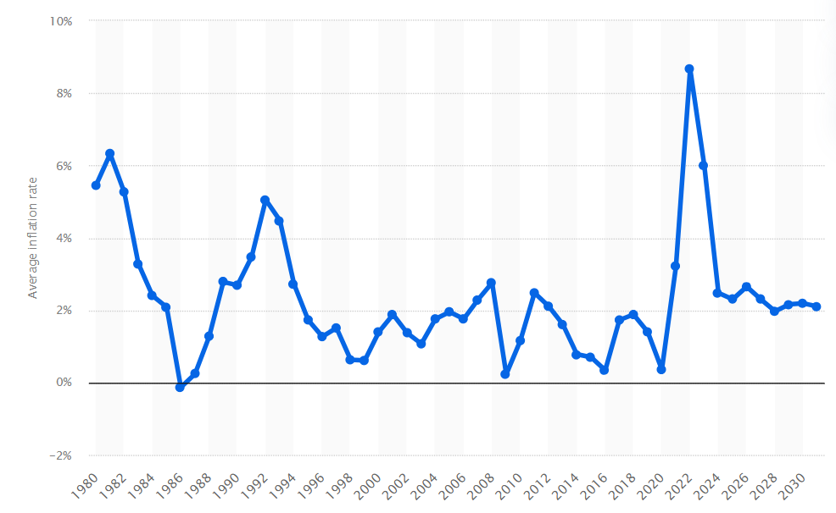
Figure 11: Gradual changes in German inflation for the last half century
(Source: Statista, 2026b)
In the last 4 years, the German economy has been adversely affected by the Ukraine-Russia war that has forced the local government towards diversifying energy supplies from the global marketplace. Previously, Germany was heavily reliant on Russia to meet nearly 50% of its crude oil needs and almost 20% of its natural gas requirements of the nation (Schmitz, 2026). However, after the initiation of the Ukraine conflict, Germany decided to eliminate reliance on the Russian energy supply, which has increased the national energy expenses by almost 40% (Schmitz, 2026). The negative economic downturn has also enabled major business enterprises of Germany to lay off nearly 124,000 employees in every financial year, which also reduces consumer purchasing capabilities (Schmitz, 2026). Therefore, the delivery of effective discounts in platform membership can prove to be financially feasible for Zerodha to better handle the current economic conditions in Germany and reach out to the maximum number of clients.
Legal Factors
Multiple legal frameworks operate in the German marketplace, which includes the General Data Protection Regulation (GDPR) created by the EU government for safeguarding confidential information for both the public and enterprises. On the other hand, the local government has also introduced their very own German Federal Data Protection Act (BDSG) in 2018 to dictate the data processing regulations across member states (DLA Piper, 2026). The introduction of BDSG legislation also motivates the German government to utilise the Law Enforcement Directive (EU) 2016/680 passed by the EU Parliament to instigate law enforcement involvement during client data processing (DLA Piper, 2026). It can be shown that multiple German and EU-based legislative acts are currently operational in the local marketplace that can help protect customer information from being stolen by nefarious online entities. Hence, the application of BDSG and GDPR can become highly relevant for the Zerodha leadership towards protecting German consumer financial information from falling into the hands of third-party enterprises and maintaining financial feasibility in global market expansion.
Cultural Factors
The German financial industry further showcases a risk-averse culture among the local population that can be capitalised on by Zerodha to deliver personalised recommendations through the official digital platform. In terms of FDI inflow, the overall market of Germany procured almost 166.29 billion Euros of global investment towards different local industries such as manufacturing, technology and finance (GOV US, 2024). The different financial establishments across the German continent have procured around 11.07 billion pounds of investment in the form of FDI, which further showcases a robust investment culture among local clients (GOV US, 2024). It can be indicated that the current investment suggestions provided by Zerodha's technological systems help attract potential investors from the German market to procure organisational financial assistance. Hence, the current risk-averse culture demonstrated by the German investors has better shaped the FDI inflow into the European country for maximising financial feasibility during Zerodha’s market entry.

5. Conclusion
Based on the above findings, it can be concluded that Zerodha is a prominent financial entity in the Indian marketplace that has developed a digital platform for providing relevant suggestions to investors. The report also sheds light on the viability of the German market and its financial sector towards developing an initial foothold for Zerodha in the European continent through delivering personalised services. The current investment level of 2 trillion Euros has also been showcased in this report, which can help demonstrate the overall strength of the German financial ventures for retaining cash inflow. The report emphasises the current AI use in the German marketplace, which can motivate the Zerodha administration to include a smart recommendation system within its digital platform.
The current political instability in Germany has also been shown in this report due to the growing conflicts between Russia and European nations towards a potential military action in the future. The report also underscores the gradual reduction of German purchases of Russian crude oil by almost 50%, which has facilitated additional financial burdens on its national economy. The positive effects of the EU GDPR and BDSG legislation have also been examined here, which can help Zerodha officials towards dictating their financial disclosure policies for local authorities.

SECTION 2

Reflective Account Using Kolb's Reflective Cycle
The Kolb Reflective Cycle is one such structure that can be used to assess learning through the process of evaluation of four stages, which are related to each other. These stages include Concrete Experience, Reflective Observation, Abstract Conceptualisation, and Active Experimentation. The use of this structure helped in systematically reflecting upon the process involved in researching, analysing, and compiling the international business report on Zerodha's possible entry into Germany.
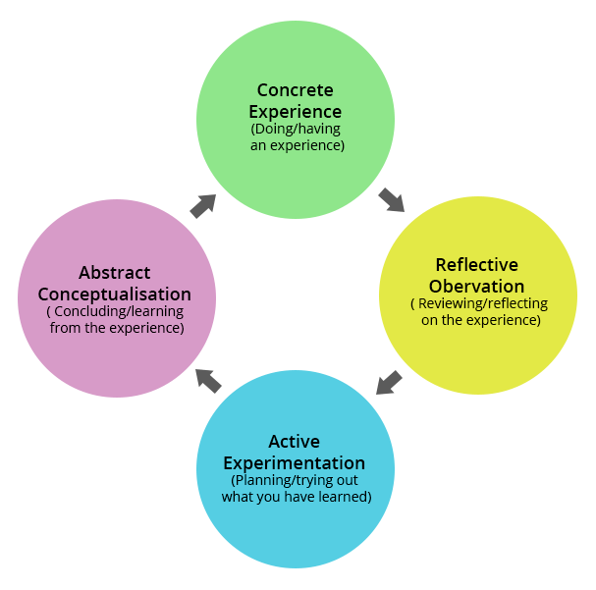
Figure 12: Kolb’s Reflective Cycle
(Source: Vinukonda, 2026)
Concrete Experience
The purpose of stage one was to determine suitable sources of information to evaluate the capability of Zerodha to enter the industry of financial services in Germany (Bhuiyan et al., 2023). Initially, I had an assumption that I would have to look for organisational information only. It occurred to me after a while that I needed a mixture of analysis of countries, industry and international business theory, in addition to organisational information. Sources of quantitative data that were gathered included the economy of Germany, the financial markets of Germany, the retail investment industry of Germany, the digital infrastructure of Germany and the company along with its competitors (Götz et al., 2022). In addition, I found some data about the political stability of Germany, laws, investors' behaviour and financial regulations, which are related to the external environment of business. Besides, I compared the local players, including Trade Republic, Scalable Capital and Comdirect, to the multinational companies such as Interactive Brokers, eToro and Saxo Bank. I conducted an online search to verify that the information gathered was reliable using various academic and industrial databases, news articles, journals and finance-related periodicals. This experience gave me a better sense of confidence in my selection of information that is relevant and reliable, and in my ability to relate theories to practice.
Reflective Observation
As far as my learning experience during the research process is concerned, there were several problems that influenced my learning. First, the most critical issue was the lack of presence of Zerodha in Germany (Al-qararah, 2023). Initially, this was the reason why I had some doubts concerning the possibility of using the concept of international business without making any unsupported assumptions. It is only after the detailed study of the criteria of the assessment. I understood that I had to assess Zerodha as the company entering Germany, but not the company that is competing there. Thus, the change in the process of the research took place due to the fact that the company does not operate there at present. The second problem which emerged during the process of my research was related to the necessity to deal with a huge amount of statistical data. There are a lot of statistics in regard to GDP, retail investors, household wealth, ETF investments and FinTech in Germany (Götz et al., 2022). I realised that the numbers become valuable academic data only when they are used in order to support some kind of analysis. Therefore, I chose the most relevant indicators in order to avoid redundancy. Furthermore, as I experienced while performing this paper, I actually must keep changing the framework of the report based on any information I've obtained. This helped me learn the need to be flexible while conducting research, as well as to critically evaluate whether every source helps develop academic and business arguments.
Abstract Conceptualisation
Evaluation made me realise the importance of having proper knowledge regarding environmental factors for an effective international business strategy. The use of the diamond model by Porter showed that in the case of Germany, favourable conditions for businesses, like good factor conditions, satisfied customers, the existence of supportive industries and competitive markets, made German firms competitive (Abdeen et al., 2026). In addition, with the use of some used models, it became obvious how political stability, economic strength, legal framework and culture were connected to each other in making the market attractive. Another important lesson learned was the need to use analytical skills when writing. Instead of simply providing the facts, it was necessary to analyse how different factors like the economy, the legal framework and the customers of Germany could create opportunities and threats for Zerodha (Hassan et al., 2024). Comparative analysis of Zerodha and other multinational as well as local competitors made me aware of the concept of strategic positioning, which meant gaining competitive advantage through price, innovation, or customer segmentation. Additionally, I knew that having to make a decision while taking into account the strengths and weaknesses of an organisation, while also considering the market conditions, was essential. Understanding how theory and practice relate gave me an insight into how to analyse market situations better. Further, this experience helped me to develop a greater awareness of the need to make decisions on an evidence-based basis.
Active Experimentation
This reflection has affected the ways of carrying out future academic research and business analysis. In the following assignments, I am going to start from identification of the main theoretical concepts that need to be considered first in order to keep the research consistent with the assignment requirements. Besides, I am going to develop my critical thinking abilities by analysis of several sources of information instead of using just one statistic. In addition, I understood the importance of using numerical data in my reports instead of collecting all kinds of data without any analysis. Further reports are going to include information about such indicators as financial, operational and market ones in order to prove the critical point (Al-qararah, 2023). I am going to develop my ability to analyse market entry strategies by means of strategic management theories and industry analysis. This reflection has increased my confidence while making an analysis of the international business environment and its competitive positioning. All these abilities are going to be very important both for my future postgraduate education and for my professional life. One positive change from this assignment is that I will be more time-efficient with all subsequent assignments. Additionally, I wish to enhance my academic writing abilities even more by coming up with a stronger argument with up-to-date information.

Reference List
Essential Readings
Collinson, S., Narula, R., and Rugman, A. M., (2020). International Business. 8 ed. Essex: Pearson Education Limited.
Daniels, J.D., Radebaugh, L.H. and Sullivan, D.P., (2019). International business: Environments and operations. Pearson.
Griffin, R.W. and Pustay, M.W., (2020). International business: A Managerial Perspective. Global Edition, 9th Edition. Pearson.
Hill, C. W. L., (2023). International Business: Competing in the global marketplace. McGraw-Hill.
Wild, J. J. and Wild, K. L., (2023). International Business: The Challenges of Globalization. Pearson Education Limited.
Journal Articles
Aalbers, M.B., Taylor, Z.J., Klinge, T.J. and Fernandez, R. (2023). In real estate investment, we trust: State de-risking and the ownership of listed US and German residential real estate investment trusts. Economic Geography, 99(3), pp.312-335. https://www.tandfonline.com/doi/abs/10.1080/00130095.2022.2155134
Abdeen, H., De-Pablos-Heredero, C., Cosculluela-Martinez, C. and Montes-Botella, J.L., (2026). Strategic leadership and its impact on dynamic capabilities and sustainable competitive advantages. Management Decision, 64(5), pp.1845-1868. https://www.emerald.com/md/article/doi/10.1108/MD-07-2024-1682/1259234
Al-qararah, E.A., (2023). An empirical study of the effect of FinTech infrastructure on competitive advantage and performance. International Journal of Information Technology and Language Studies, 7(1). https://ijitls.journals.publicknowledgeproject.org/index.php/ijitls/article/view/333
Bhuiyan, F., Rana, T., Baird, K. and Munir, R. (2023). Strategic outcome of competitive advantage from corporate sustainability practices: Institutional theory perspective from an emerging economy. Business Strategy and the Environment, 32(7), pp.4217-4243. https://onlinelibrary.wiley.com/doi/abs/10.1002/bse.3362
Dorfleitner, G. and Scheckenbach, I., (2022). Trading activity on social trading platforms–a behavioural approach. The Journal of Risk Finance, 23(1), pp.32-54. https://www.emerald.com/jrf/article/23/1/32/250244
Drechsler, K., Grisold, T., Gau, M. and Seidel, S., (2022). Digital infrastructure evolution: A digital trace data study. https://aisel.aisnet.org/icis2022/is_design/is_design/4/
Falck, O. and Czernich, N. (2025). The Digital Economy in Germany. ASEAN Digital Community 2045 Global Insights, p.17. https://eria-old.stagingserver.id/uploads/ADC-2025-Global-Insights.pdf#page=24
Freibauer, J., Rieger, M.O. and Grawert, S., (2025). Panel survey data on the investment and risk behaviour of Neobroker users in Germany. Data in Brief, 61, p.111775. https://www.sciencedirect.com/science/article/pii/S2352340925005025
Götz, F., Buck, C., Rosemann, M. and Meckl, R. (2022). Digital business ecosystems: a comparison of different industries. In Handbook on digital business ecosystems (pp. 530-548). Edward Elgar Publishing. https://www.elgaronline.com/edcollchap/edcoll/9781839107184/9781839107184.00043.xml
Hassan, S.S., Meisner, K., Krause, K., Bzhalava, L. and Moog, P. (2024). Is digitalisation a source of innovation? Exploring the role of digital diffusion in SME innovation performance. Small Business Economics, 62(4), pp.1469-1491. https://link.springer.com/article/10.1007/s11187-023-00826-7
Otto, B., Ten Hompel, M. and Wrobel, S. (2022). Designing data spaces: The ecosystem approach to competitive advantage (p. 580). Springer Nature. https://link.springer.com/content/pdf/10.1007/978-3-030-93975-5.pdf
Palekar, P., Mahapatra, G.P. and Patankar, P. (2023). Start-Up to Scale-Up: The Changing Entrepreneurs’ Competencies. In Business Cases in Organisation Behaviour and HRM: Perspectives from India (pp. 157-172). Singapore: Springer Nature Singapore. https://www.poornaprajnapublication.com/index.php/pijtrcs/article/view/47
Patra, A.R., (2024). Benchmarking Zerodha: A Comparative Study of Indian Stock Broking Firms. http://biitm.dspaces.org/bitstream/123456789/1151/1/AMIT%20RANJAN%20PATRA%20SIP-4.pdf
Peter, S., Le Provost, G., Mehring, M., Müller, T. and Manning, P. (2022). Cultural worldviews consistently explain bundles of ecosystem service prioritisation across rural Germany. People and Nature, 4(1), pp.218-230. https://besjournals.onlinelibrary.wiley.com/doi/abs/10.1002/pan3.10277
Stute, J. and Kühnbach, M., (2023). Dynamic pricing and the flexible consumer–Investigating grid and financial implications: A case study for Germany. Energy Strategy Reviews, 45, p.100987. https://www.sciencedirect.com/science/article/pii/S2211467X2200181X
Web References
Bundesbank (2026). Financial Supervision, Available at: https://www.bundesbank.de/en/tasks/financial-supervision/financial-supervision-622544 [Accessed: 18th July 2026]
D. Clark and 9, M. (2026) Germany: GDP 2025, Statista. Available at: https://www.statista.com/statistics/295444/germany-gross-domestic-product/ [Accessed: 18th July 2026]
Deutschland (2026). How does the political system function in Germany?, Available at: https://www.tatsachen-ueber-deutschland.de/en/politics-germany/political-system [Accessed: 18th July 2026]
DLA Piper (2026). Data protection laws in Germany, Available at: https://www.dlapiperdataprotection.com/index.html?t=law&c=DE [Accessed: 17th July 2026]
Elagina, D. (2026). Germany: online banking penetration 2006-2025, Statista. Available at: https://www.statista.com/statistics/380823/online-banking-penetration-in-germany/ [Accessed: 18th July 2026]
GOV US (2024). 2024 Investment Climate Statements: Germany, Available at: https://2021-2025.state.gov/reports/2024-investment-climate-statements/germany/ [Accessed: 17th July 2026]
ITA (2025). Information and Communications Technology (ICT), Available at: https://www.trade.gov/country-commercial-guides/germany-information-and-communications-technology-ict [Accessed: 18th July 2026]
Lane, M., Williams, M. and Stijn Broecke, S. (2023). The impact of AI on the workplace: Main findings from the OECD AI surveys of employers and workers, Available at: https://www.oecd.org/content/dam/oecd/en/publications/reports/2023/03/the-impact-of-ai-on-the-workplace-main-findings-from-the-oecd-ai-surveys-of-employers-and-workers_ad686e91/ea0a0fe1-en.pdf [Accessed: 18th July 2026]
Main, F. and Theurer, M. (2026). Competitiveness of the German banking sector: the interplay between regulation and competitive conditions, Available at: https://www.bundesbank.de/en/press/speeches/competitiveness-of-the-german-banking-sector-the-interplay-between-regulation-and-competitive-conditions-997932 [Accessed: 18th July 2026]
Mordor Intel (2026) Germany Digital Transformation Market Forecasts 2031, Mordor Intelligence. Available at: https://www.mordorintelligence.com/industry-reports/germany-digital-transformation-market [Accessed: 18th July 2026]
ResearchGate (2026). Available at: https://www.researchgate.net/figure/Porters-Diamond-Model-of-Nations-Advantage-Porter-1990_fig2_384281761 [Accessed: 18th July 2026]
Schmitz, R. (2026). Affected by the war in Ukraine, Germany works to recover its economy, Available at: https://www.npr.org/2026/02/27/nx-s1-5722866/affected-by-the-war-in-ukraine-germany-works-to-recover-its-economy [Accessed: 17th July 2026]
Scholle, K. (2021). Number of active clients with Zerodha from financial year 2014 to 2022, Available at: https://www.statista.com/statistics/1056530/india-zerodha-number-of-active-customers/ [Accessed: 18th July 2026]
Scholle, K. (2024). Total market capitalization of all domestic shares listed on the Frankfurt Stock Exchange from 2002 to December 2023, Available at: https://www.statista.com/statistics/1203216/frankfurt-stock-exchange-market-cap/ [Accessed: 18th July 2026]
Statista (2026a). Growth of the AI market in Germany from 2021 to 2032, Available at: https://www.statista.com/forecasts/1462145/ai-market-growth-germany/?srsltid=AfmBOoqK-Cb1Mi_H_-dOeOVN-4dOM8HBp0Jm7TjykL0h43o-LoyWXzCN [Accessed: 18th July 2026]
Statista (2026b). Average inflation rate in Germany from 1980 to 2031, Available at: https://www.statista.com/statistics/375207/inflation-rate-in-germany/?srsltid=AfmBOoodwQni0giFP26kAFAudsEPmHTv20wk-FyIKd_nEI7aYHw-omba [Accessed: 17th July 2026]
Statista Research (2026) Fintech users in Europe by segment 2025, Statista. Available at: https://www.statista.com/statistics/1384900/fintech-users-europe-by-country/ (Accessed: 20 July 2026)
Statista Research Department (2024) Revenue in the Digital Investment market for different segments Germany 2020-2028, Statista. Available at: https://www.statista.com/forecasts/1443757/revenue-digital-investment-market-for-different-segments-germany/ [Accessed: 18th July 2026]
Statista Research Department (2024) Revenue in the digital remittances segment of the fintech market Germany 2017-2025, Statista. Available at: https://www.statista.com/forecasts/1437695/revenue-digital-remittances-digital-investment-market-germany/ (Accessed: 20 July 2026).
Ukrinform (2026). Germany grants Ukraine largest share of arms export licenses in H1 2026, Available at: https://www.ukrinform.net/rubric-economy/4144955-germany-grants-ukraine-largest-share-of-arms-export-licenses-in-h1-2026.html [Accessed: 18th July 2026]
Vinukonda, P. S. (2026). Using Kolb’s Learning Styles to Create Engaging Custom eLearning Courses. eLearning Industry. Available at: https://elearningindustry.com/using-kolbs-learning-styles-engaging-custom-elearning-courses [Accessed: 18th July 2026]
Zerodha (2026). About Us, Available at: https://zerodha.com/about/ [Accessed: 18th July 2026]

