STUDENT NAME: Salena Wallace
STUDENT NUMBER: 1919087
MODULE: CHANGEMAKERS CREATIVITY AND VALUE CREATION
MODULE CODE: BMHP5014_BIRM
LECTURER: DR AZORA HURD
CONTENTS PAGE

ARTEFACT 4 3
INTRODUCTION 4
ARTEFACT 4 FLYER MY IDEAS AND APPROACH 4-5
ELEVATED SPEECH ARTEFACT 3 5-6
REFERENCES 7
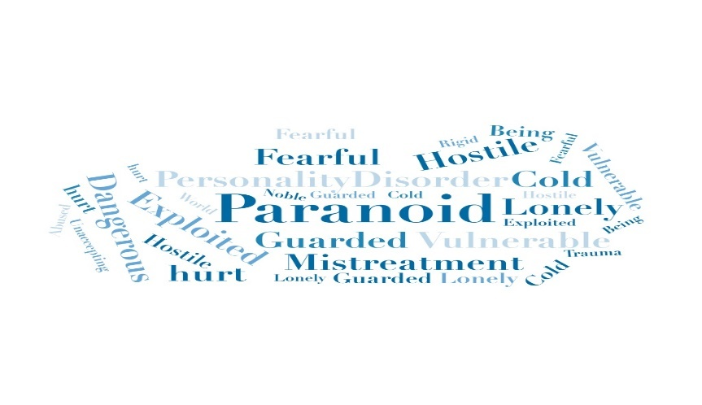
PARANOID PERSONALITY DISORDER MENTAL HEALTH HELP YOUR NOT ALONE SUPPORT CARE LOVE SAFE SPACE CONSIDERATE IMPORTANT ENCOURAGEMENT LAUGHTER RELAXATION COMFORT SKILLS PAIN HAPPY BRIGHT CONFIDENCE HOPE FUTURE LOOK UP STRUGGLE MIND STAND TALL REINFORCE NEVER GIVE UP TODAY IS A GOOD DAY POSTIVE PURPOSE POWER SUCCESS MOTIVATION CHEER ASSITANCE MIND STRONGER UNDERSTANDING LIVE LIFE BATTLES DOUBTING DREAMS CAPABLE POSSIBLE BLESSINGS MOVEMENT GLAD ACCOMPLISH SEEKING

PPD Together We Can Beat IT
2456 Blue Green Avenue Birmingham B25 2MW Tel 0121 556 2347
07932071821  
We are not counselors.
We are a support network
We understand those that seek treatment may not trust their therapist and we understand the constant battle that partners and family members may endure on a daily basis.
We will work with you to develop a care plan so why not come along to our open day to find out more.
What is personality Disorder?
- When a person has a long-term pattern of distrust and suspicion of others
Symptoms
- Distrust or suspicion of others
- Hesitation to confide in others
- Reacts aggressively to slight situations
- Tendency to hold grudges
MENTAL HEALTH
PARANOID PERSONALITY DISORDER
for more information…
www.PPDtogetherwecanbbeatIT.com
how to treat paranoid personality disorder doctor explains… https://youtu.be/lD25x7rc08s
paranoid personality a day in the life… https://youtu.be/drzKThkBLOc

- Group and individual discussions
- A safe space to talk and not be alone
- Coping mechanism to help recovery for the individual and family members

- Open Day: Tuesday 28th July 2022

- STARTS: 7.30pm

- SESSIONS START…

- WOMAN WEDNESDAY 6TH AUGUST 7.30pm

- MALE THURSDAY 7TH AUGUST 7.30pm

- MIX FRIDAY 8TH AUGUST 7.30pm

- THE SAME DAY EACH WEEK

Support for You
Coping with Paranoid Personality Disorder…
Are you or anyone you know suffering with a Mental Health Disorder?
Are you showing signs of Paranoia or do you do know someone that is Paranoid?

INTRODUCTION
I have chosen ARTEFACT 3 & 4 based on how passionate I am about individuals that are suffering from Paranoid Personality Disorder. I decided to develop a campaign of my own to support the local community.
I chose this as a thought to share with other people. My idea was for it to be compelling and interesting and not to be dismissed or ignored. My intention is not to create harm but to create a safe space and highlight the issues that affect individuals who suffer from a Mental Health Disorder, particularly Paranoid Personality Disorder and the impact it has on family members. You Need Help, well this flyer was aimed to provide that help. A communicative flyer that is simple but focused and shows a clear understanding, and is straight to the point.
Support without the need for shame.

- ARTEFACT 4 FLYER MY IDEAS AND APPROACH

My flyer is based on that feeling of wanting to support another person but feeling afraid, frustrated and helpless. This support can be essential in helping everyday people like ourselves. Support without the need for shame.
Talking to people that have an understanding and have the skills to support and encourage those who may have been in a similar situation. Ultimately, we can learn and educate one another.
I decided to keep my flyer brief, well presented and noticeable as it is an important tool for promotion. I presented my design with a clear understanding of the services we provide. My Flyer has brief information but is straight to the point with a clear understanding of the services we provide. The title and the picture images are eye-catching and grabs your attention. Having the option to contact us through social media was a priority for me. Given the easy access to help and support on the go.

It can be difficult to deal with a loved one that is constantly suspicious of you. Paranoid Personality Disorder has a close relationship with childhood trauma and social stress. According to the Psychiatric Nosology, DSM-IV and 5 mention, that Paranoid Personality Disorder is a disorder of suspicious, unforgiving and jealous traits, most often individuals that have these traits and feelings are in a relationship or are unable to maintain long-lasting relationships. My concern is for the individuals that are in a relationship and the effect the disorder can have on the partner. Obsessive thinking can put a lot of pressure on loved ones and can be very upsetting, stressful and frustrated, because of their inability to help. When you suffer from Paranoid Personality Disorder you tend to over analyse your behaviour as well as, have paranoid thoughts about different aspects of your relationship. Mostly accusing with no facts.
I believe that group meetings are essential for the partners to break free for a short time.
Group meetings can give you the resources to look at a problem from a different perspective. Having the opportunity to ask open-minded questions and even brainstorm to help solve simple problems.
Participating in various activities is a great tool to help destress. For example
- Getting plenty of sleep
- Deep breathing exercises
- Resources to explore emotions and safe behaviours
- Hear from multiple people that share the same situation but from a different perspective.

Group meetings or one-to-one meetings can give you a sense of value and belong with a direct link to improving Mental Health and Social Activities. Social activities are essential for our well-being. The aim is to provide a stress management tool to equip individuals with the correct tools to destress.
Mental Stimulation, Emotional Awareness, Relaxation, Practising Handling Stress and Decision Making is corporated in having a successful group meeting. I understand the needs that are required and the impact of emotions and frustration. Creating a self-care plan within the group by looking at HOW TO COPE WITH A PARANOID PERSON. Remembering not to take the words you hear from them seriously, knowing that, they are not intentionally wanting to hurt you. Try to be sensitive to their feeling, and support them while still considering your well-being. (Singh,2020) (World Health Organisation, 2020)

ELEVATED SPEECH ARTEFACT 3

Good morning everyone my name is Salena Wallace. I am speaking to you today about our organisation. We are a company called PPD TOGETHER WE CAN BEAT IT. PPD is a form of Mental Health called Paranoid Personality Disorder. We focus on the wellbeing of individuals that are showing symptoms of Paranoia and the effects it has on loved ones.
A few of these symptoms are…
- Generalised Mistrust
- Pervasive Suspiciousness
- Hypersensitivity
- Easily Insulted and Eager Observation

The cause for this behaviour is not 100% known. There are many statements that mention it may stem from childhood trauma or a relative with Psychological or Delusional Disorders. For the long term there are consequences and complications when left untreated… For instance, difficulties maintaining personal relationships and working among peers can lead to a loss of employment and the individual may develop a psychotic illness.
There are steps in place to encourage love ones to get help and support. Trying to establish boundaries being in a relationship with a person who’s acutely mistrustful and suspicious of you and others can be very demanding and challenging. We need to understand how they view the world as being Paranoid can distort their view.
Paranoid Personality Disorder is intense and plays tricks on your mind. Interfering with thought patterns, behaviour and daily functioning. If you know someone or may it be yourself you can understand the problems that are they are experiencing. An individual with PPD will always be wary of others. Thoughts of being treated unfairly and deceived. They enjoy deflecting blame onto innocent people and may have outburst of controlling behaviour. Having a partner that is Paranoid can be very exhausting because of their continual accusations and being beaten down by their hostility and stubbornness against you. For some reason they seem to exaggerate aspects of any situation. Unfortunately, because of the nature of the disorder. The majority of PPD do not seek professional help. Some are in denial and believe their views and thoughts are justified and any attempts to set the record straight will only confirm their suspiciousness that they are right and people are out to get them in one way or another. Having experience, myself a love one suffering with PPD I have learnt of several steps to encourage support, help and some sort of treatment, to help perform boundaries for your own wellbeing.

Support from the community
Research has suggested that an individual with Paranoid Personality Disorder never sees their suspicious behaviour as unusual. They see themselves as defending against bad intentions and deceptive
Most common problems

- Suspecting without justification
- Obsessed with lack of loyalty
- Unable to confide in others
- Finding malicious meanings in innocent situations
- Repeatedly suspecting without facts accusing of infidelity.

There is no particular medication to treat PPD but we need to recognise their pain
We need to not argue about the words they say or their mistaken beliefs
We need to set boundaries, encourage communication and exercise.
To provide the right support I would like to raise a small donation. This will help to reach a goal of £1500 to be able to provide professional support for our weekly group sessions. Your donation will go towards ongoing research, educational events, tools and resources.
We all deserve a good quality of life despite the challenges we face. Having your support would mean so much, having the touch to transform an individual life.

There are a few options to donate. You can donate online at www.ppdwecanbeatit.com
Come to our open day event or send a cheque in the pre-paid envelope I have provided.

Thank you in advance for your contribution. You have no idea how much this means for our organisation having your support.

Salena

Bibliography
How to Medicate. (n.d.). How to treat Paranoid Personality Disorder The doctor explains. Retrieved from You Tube: https://www.youtube.com/watch?v=lD25x7rc08s
Kvarnstrom, E. (2017, november 17). Bright Quest Treatment Centre. Retrieved from How to help someone with mental health illness top 5 tips: https://www.brightquest.com/blog/top-5-tips-supporting-someone-severe-mental-illness/#:~:text=Even%20if%20you%20deeply%20want%20to%20support%20your,that%20they%20are%20not%20alone%20in%20this%20struggle.
M.D, C. B. (2016, January 2016). 7 Tips for Coping with a Paranoid Partner. Retrieved from Psychology Today: https://www.psychologytoday.com/us/blog/the-creativity-cure/201601/7-tips-coping-paranoid-partner
MedCircle. (n.d.). Paranoid Personality Disorder A day in the life . Retrieved from You Tube: https://www.youtube.com/watch?v=drzKThkBLOc
Personality Disorder Help Guide. (n.d.). Paranoid Personality Disorder (PPD). Retrieved from Help Guide Your trusted nonprofit guide to mental health & wellness : https://www.helpguide.org/articles/mental-disorders/paranoid-personality-disorder.htm
Relate the relationship people. (n.d.). Retrieved from Relationships and anxiety and OCD: https://www.relate.org.uk/relationship-help/help-relationships/mental-health/relationships-and-anxiety-and-ocd
Singh, A. (2020, august 12). 10 Effective Ways to Deal With Paranoid Personality Disorder. Retrieved from Calm Sage: https://www.calmsage.com/how-to-deal-with-paranoid-personality-disorder/
World Health Organisation. (2020, April 29). World Health Organisation. Retrieved from Doing what matters in times of stress: https://www.who.int/publications/i/item/9789240003927?gclid=EAIaIQobChMIioGXyPXh-AIViZntCh1DbwzaEAMYASAAEgI-l_D_BwE

