Alexandru Popovici
2322380@student.uwtsd.ac.uk
Business and Web Management
CERTHE COMPUTING SKILLS FOR WORKPLACE
ACCA5019
ASSESSMENT 1
REPORT

Contents
1. Introduction 2
2. MealSwift Website Redesign 2
3. Responsive Design Implementation 4
4. Implementation Screenshots 5

b. Home Page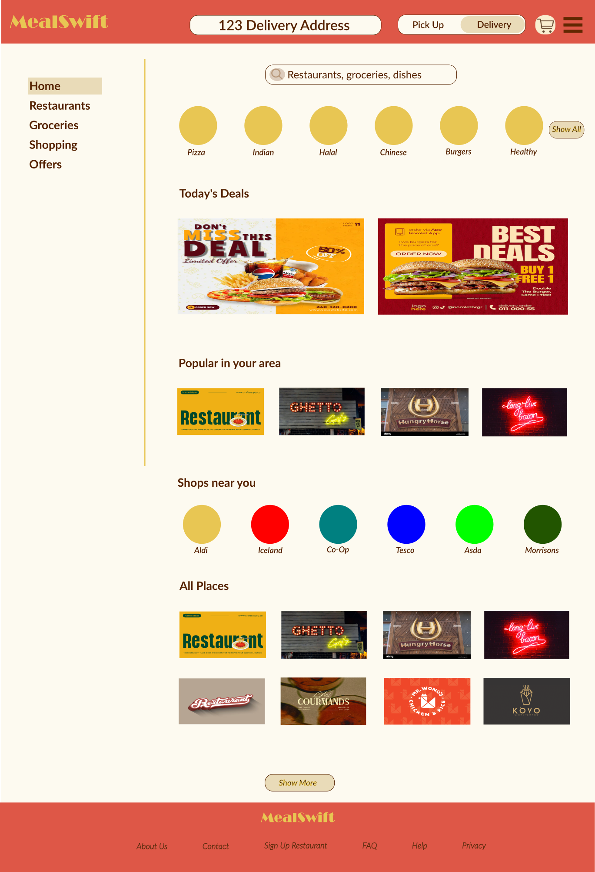 6
c. Menu Page 7
d. Cart Page 8
e. Checkout 9
f. Moodboard 10
g. Wireframes 10
h. How the Moodboard and Wireframes influence the design 12
5. Conclusion 13
References 13

Introduction

This report covers the redesign of the MealSwift food delivery website, focusing on improving the overall user experience, usability, and functionality. MealSwift is a growing platform, but its current website has several issues that make it harder for users to navigate and place orders efficiently. These include confusing navigation, a complicated ordering process, and an outdated design.
To improve this, a structured UI/UX design process was followed. This involved creating a mood board to define the visual style, developing wireframes to plan the layout and user flow, and building an interactive prototype to show how users would interact with the main parts of the website.
The final design aims to be more modern, clear, and easy to use. It simplifies navigation, makes the interface more accessible, and improves the overall ordering experience. This report explains the design decisions made and shows how the new design better meets both user needs and business goals.

MealSwift Website Redesign

The current MealSwift website has several usability and design issues that negatively affect the overall user experience and make the platform less efficient. One of the main problems is confusing navigation. Users may find it difficult to locate restaurants, browse menus, or understand how to move through the ordering process. This increases effort and can lead to frustration or users leaving the site. To improve this, the redesigned interface introduces a clearer and more structured navigation system, including a simplified header, a visible search function, and category-based browsing. This makes it easier for users to find what they need quickly. [1]
Another issue is the outdated visual design. The current interface lacks modern UI elements and clear visual hierarchy, which makes it less engaging and harder to understand at a glance. The redesign improves this by using a cleaner layout, consistent spacing, card-based components, and more readable typography. Important elements such as headings, images, and buttons are more visible, making the interface easier to scan.
The website also lacks responsiveness, which affects usability on different devices. Since many users access food delivery services on mobile, this is a major limitation. The redesigned version follows a responsive approach, allowing the layout to adapt to different screen sizes while keeping the experience consistent.
The ordering and checkout process is another weak point. If the process is too long or unclear, users are less likely to complete their order. The redesign simplifies this by creating a smoother flow from browsing to checkout. Clear buttons like “Find Food,” “Add,” and “Checkout” guide the user step by step. [2]
There is also limited information about restaurants and menus in the current design. This makes it harder for users to decide what to order. The new design improves this by adding structured restaurant cards and menu layouts with images, ratings, delivery times, and prices. This helps users compare options more easily.
Another limitation is the lack of personalised content. While full personalisation is not implemented, the design introduces sections like popular items and deals, which give users more relevant options and improve engagement.
Finally, the current design lacks strong call-to-action elements. Without clear guidance, users may not know what to do next. The redesigned interface uses more visible and well-placed buttons to guide users through the process and encourage interaction. [3]
Overall, the redesign improves navigation, updates the visual design, simplifies the ordering process, and makes the layout more structured and user-focused. These changes aim to make the platform easier to use and improve the overall experience.

Responsive Design Implementation

Responsive design is an important part of modern e-commerce websites, especially in the food delivery industry where a large number of users access services on their phones. It allows a website to adapt to different screen sizes and resolutions, making sure the experience remains consistent and easy to use across desktops, tablets, and smartphones.
One of the main benefits of responsive design is improving user experience. When a website is responsive, elements like navigation, buttons, and content adjust properly to fit smaller screens. This makes everything easier to use without needing to zoom in or scroll excessively. For a platform like MealSwift, this is important because users often want to place orders quickly and expect the process to be smooth.
Responsive design also improves accessibility. By making sure content is clear and easy to interact with on different devices, more users are able to use the platform comfortably. This includes people using different screen sizes or devices. Better accessibility leads to higher satisfaction and makes users more likely to return.
It also has a direct impact on mobile sales and conversion rates. If a website is not optimised for mobile, users may experience slow loading times, poor navigation, or difficulty completing an order, which can lead to abandoned carts. A responsive design reduces these issues by creating a smoother experience, helping users complete their orders more easily and increasing overall sales. [4]
From a business point of view, responsive design also improves how the brand is perceived. A website that looks consistent and works well across all devices feels more reliable and professional, which helps build trust with users.
In the MealSwift redesign, responsive design ensures that key features like searching, browsing menus, and checking out are easy to use on any device. This helps improve usability, keeps users engaged, and supports higher mobile sales.

Implementation Screenshots

Hero Page
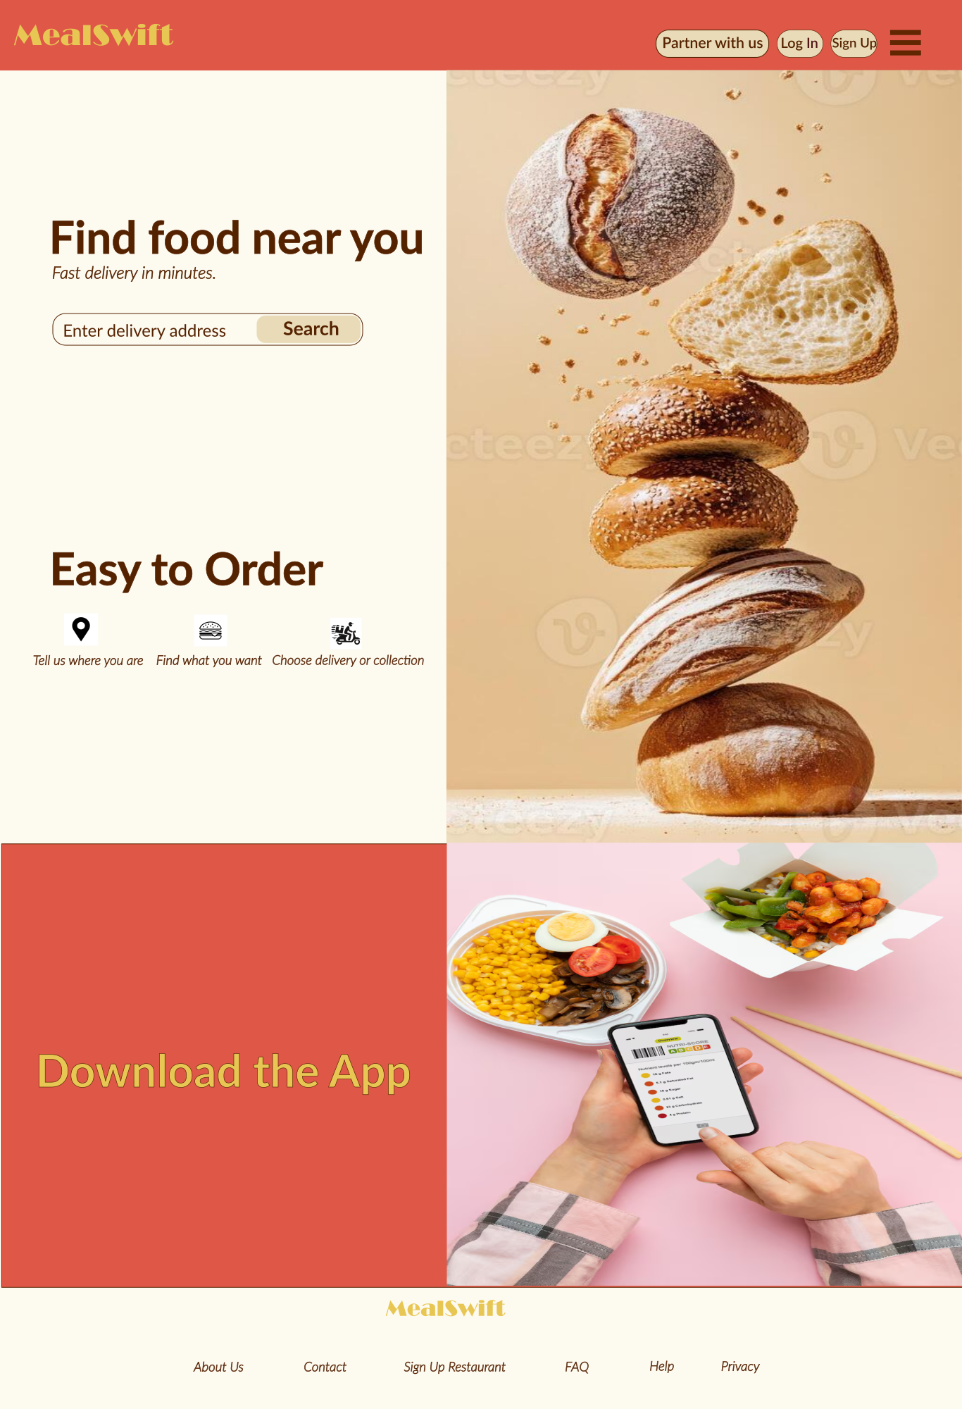

Home Page

Menu Page
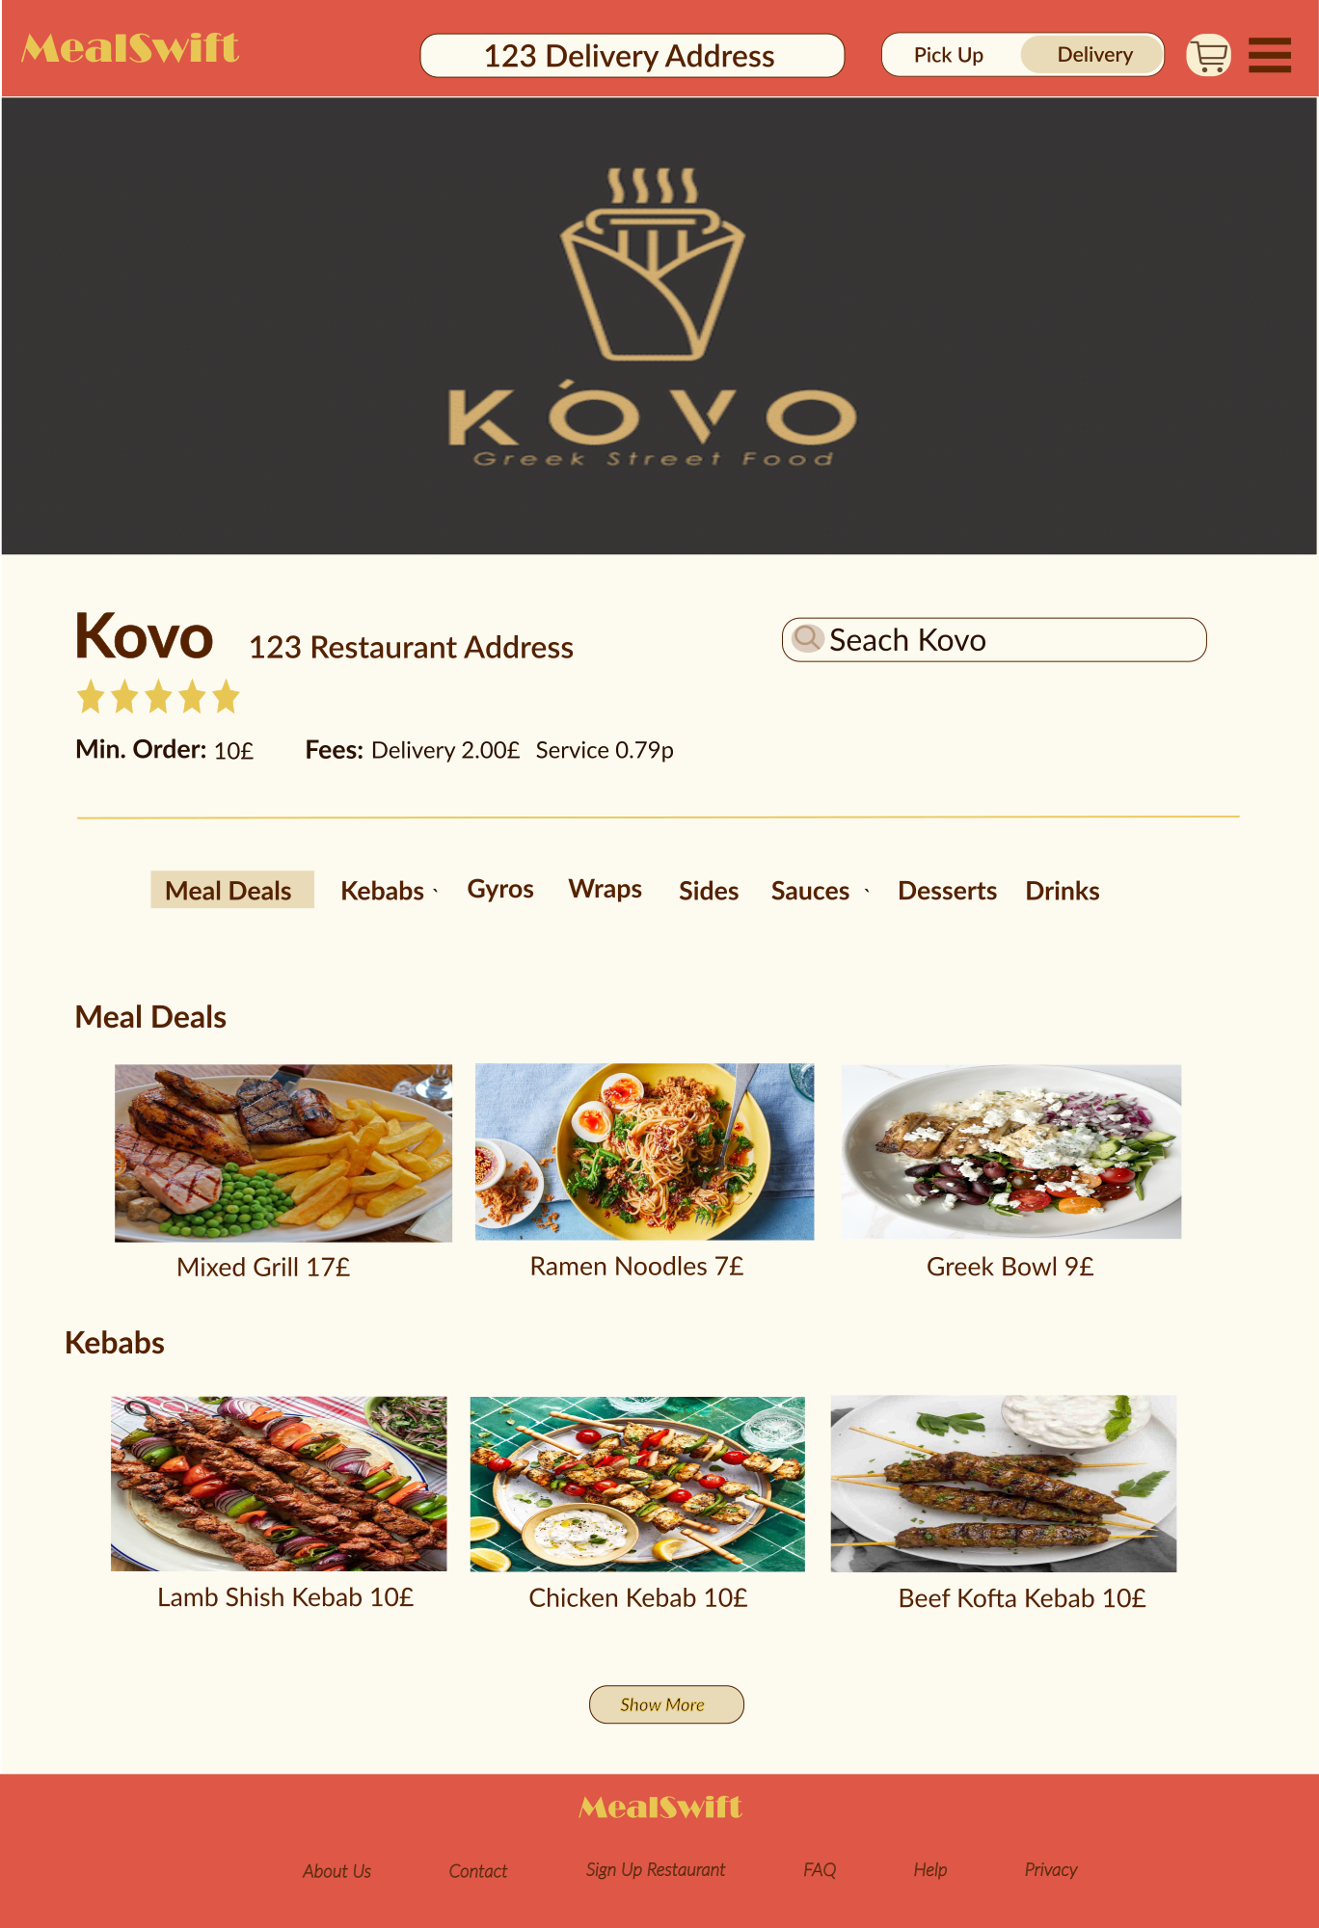

Cart Page
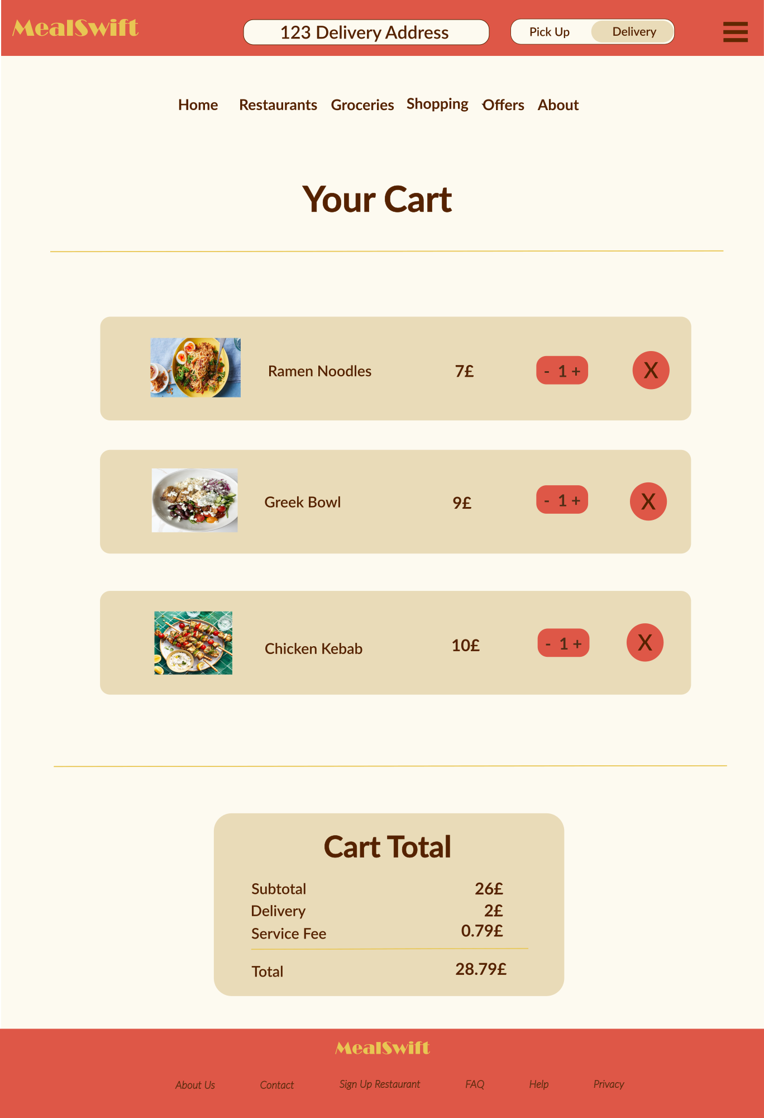

Checkout
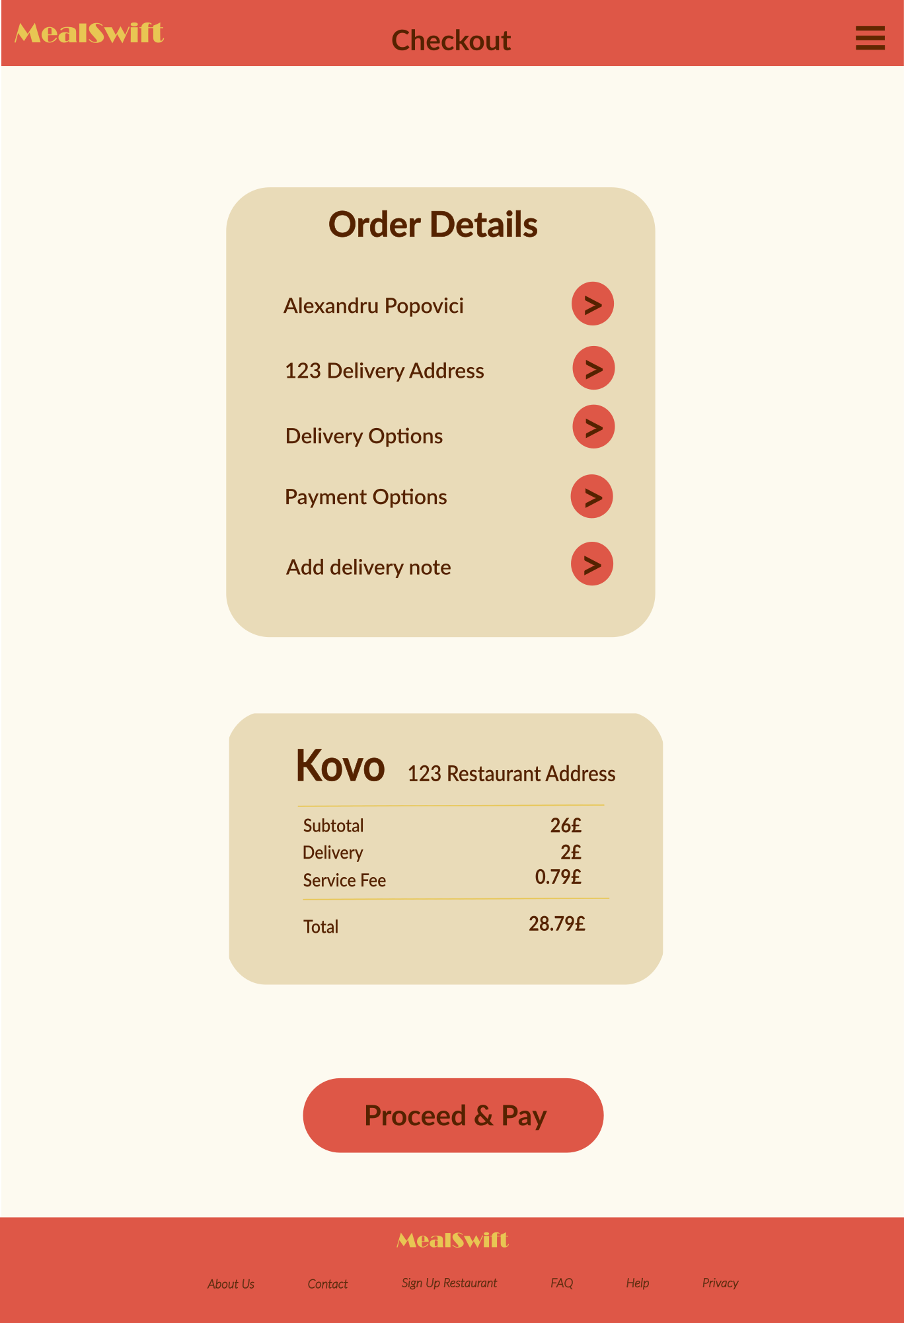

Moodboard
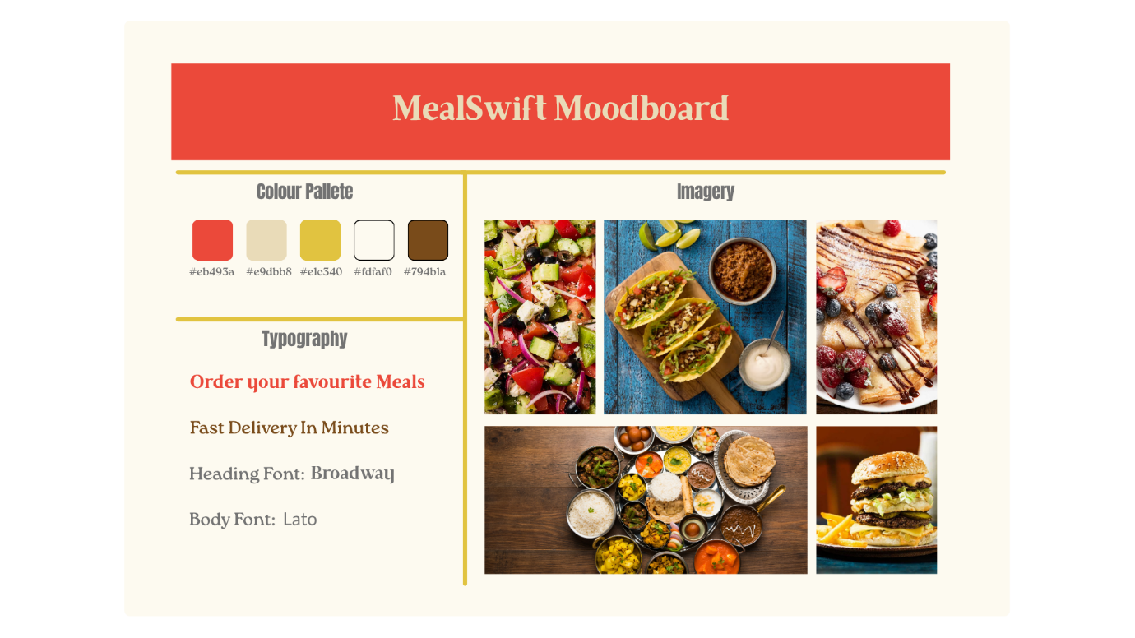

Wireframes

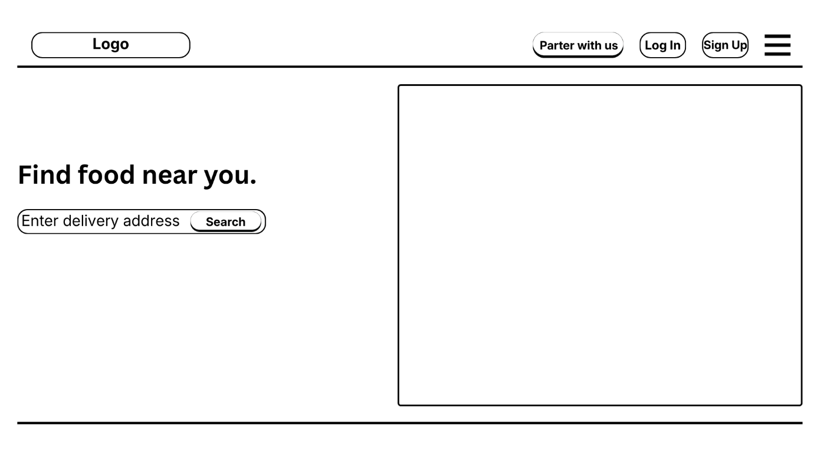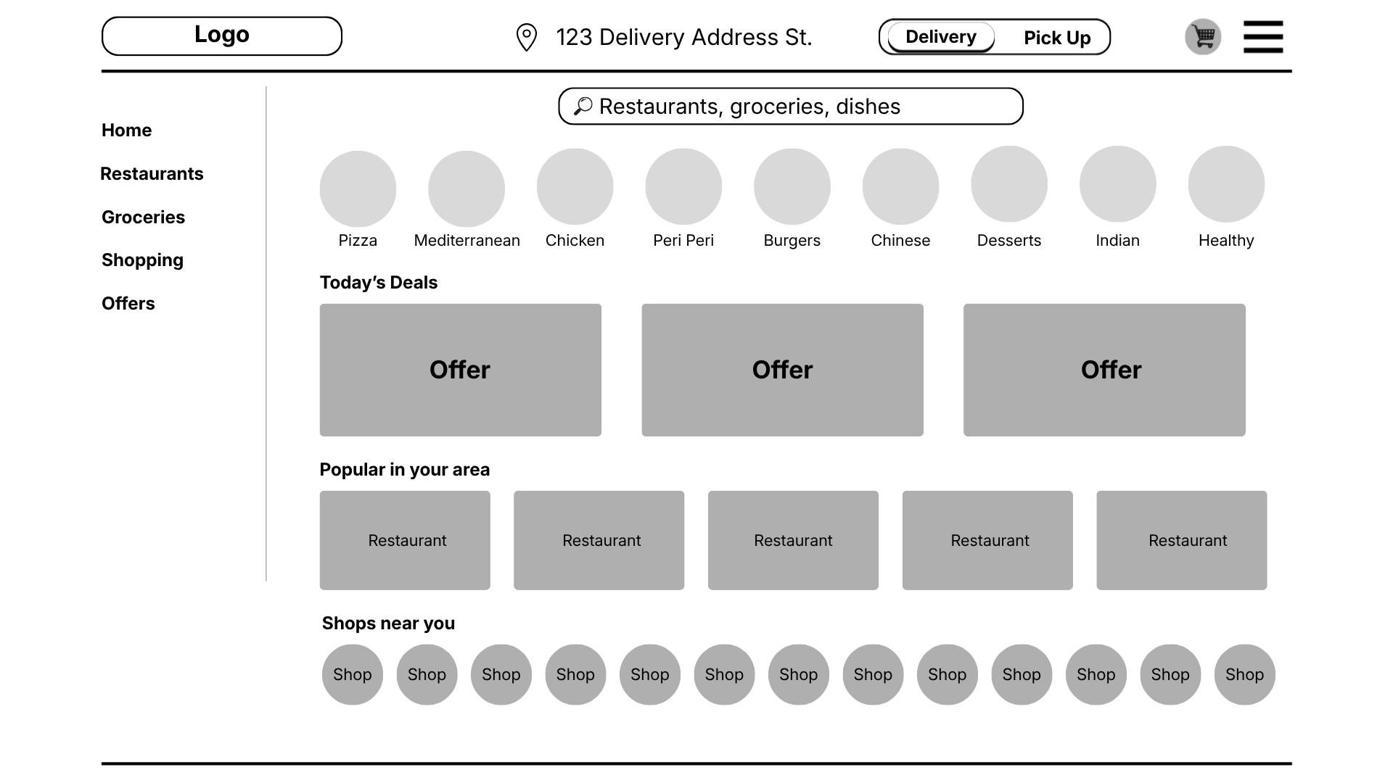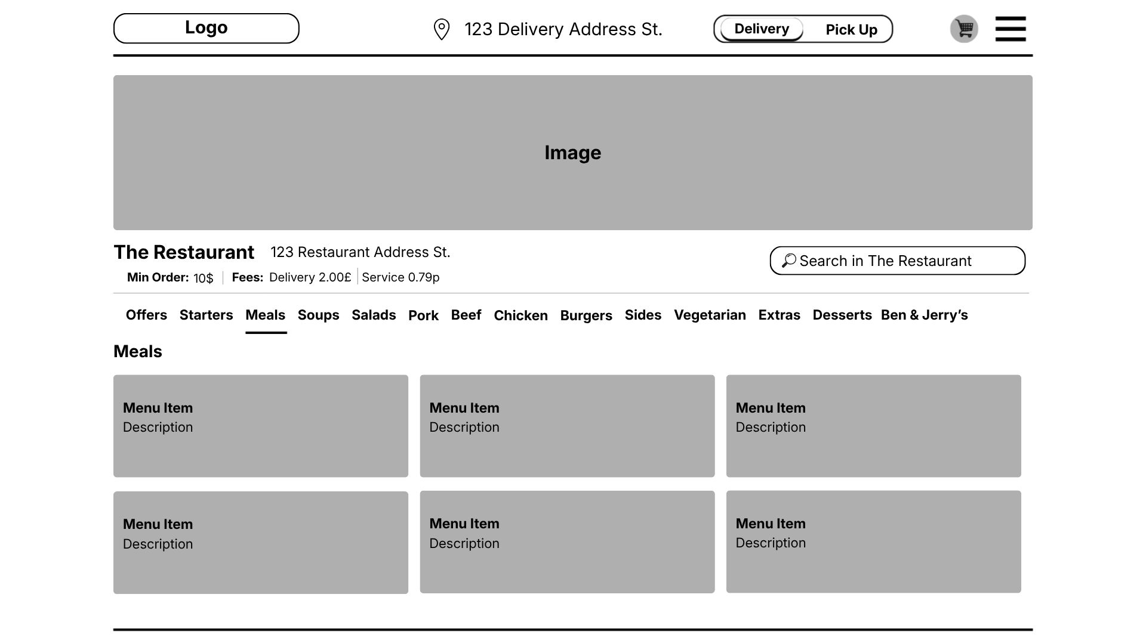

How the Moodboard and Wireframes influence the design

The mood board and wireframes played an important role in shaping the final design of the MealSwift prototype. The mood board was used to define the overall visual direction, including colours, typography, and the style of imagery. Setting these elements early made it easier to keep everything consistent across all pages and helped create a clear and recognisable design. The colour palette was used to highlight key elements like call-to-action buttons, while keeping the background clean to improve readability. The typography choices also supported clarity and made important information easier to notice.
The imagery style from the mood board influenced the use of high-quality food images in the prototype. These were used to make the interface more engaging and visually appealing, which is especially important for a food delivery platform where visuals can influence what users choose to order.
The wireframes acted as the base structure for the design by showing the layout and functionality of each page. They helped define where key elements should go, such as navigation, search bars, content sections, and interactive components. This made it easier to focus on usability and user flow before adding visual details. [5]
They also helped create a clear and consistent user journey. By planning how users move from the homepage to browsing restaurants, selecting items, and completing checkout, the final prototype reflects a smooth and logical flow.
Overall, the mood board guided the visual side of the design, while the wireframes shaped the layout and functionality. Together, they helped create a prototype that is consistent, easy to use, and focused on the user experience.

Conclusion

In conclusion, the MealSwift website redesign shows how important a structured UI/UX design process is for improving usability and the overall user experience. By identifying key issues in the original platform, such as confusing navigation, inefficient ordering, and poor visual hierarchy, the redesigned version provides a much clearer and easier-to-use interface.
The use of a mood board and wireframes helped guide both the visual style and the layout from the beginning. This made it easier to keep the design consistent and ensure that the user journey, from searching for food to completing an order, was clear and logical.
The final prototype shows how simple design improvements, like better navigation, clear call-to-action buttons, and more organised content, can make a big difference. These changes help users interact with the platform more easily and reduce friction during the ordering process. At the same time, they support business goals by improving customer satisfaction and increasing the chances of users completing orders.
Overall, the project shows how thoughtful design can improve a digital platform and make it more efficient, accessible, and engaging for users.

References

[1] | C. Staff, “What Is Usability? Designing for Ease,” Coursera, 1 December 2024. [Online]. Available: https://www.coursera.org/in/articles/what-is-usability-and-why-it-matters?utm_medium=sem&utm_source=gg&utm_campaign=b2c_emea_x_multi_purchase_career-academy_cx_dr_bau_gg_pmax_x_gb_en_m_hyb_26-01_ga4-purchase-event&campaignid=23483146766&adgroupid=&device=. [Accessed 27 March 2026].
[2] | Figma , “Website structure: How to plan the perfect site layout,” Figma, [Online]. Available: https://www.figma.com/resource-library/website-structure/. [Accessed 27 March 2026].
[3] | Figma, “What is user experience (UX) design? Process + principles explained,” Figma, [Online]. Available: https://www.figma.com/resource-library/what-is-ux-design/. [Accessed 27 March 2026].
[4] | Coursera Staff, “What Is Responsive Web Design? And How to Get Started,” Coursera, 12 March 2025. [Online]. Available: https://www.coursera.org/gb/articles/responsive-web-design. [Accessed 27 March 2026].
[5] | Team Kaarwan, “Website Anatomy 101: Moodboarding and Wireframing Essentials for UI-UX Design,” Kaarwan, 1 September 2024. [Online]. Available: https://www.kaarwan.com/blog/ui-ux-design/website-anatomy-101-moodboarding-wireframing-for-ui-ux-design?id=907. [Accessed 27 March 2026].

