Easmin Khatoon
1711689
BMSW6102
Developing innovation and creativity for business advantage
Dr Md Nazmul Hassan

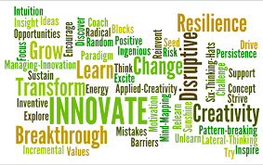

Contents
Introduction……………………………………………………………………………………………3
Innovation…………………………………………………………………………………………...…3
Innovative product…………………………………………………………………………………….4
E-commerce…………………………………………………………………………………………..4
Marketing…………………………………………………………………………………………..….6
Conclusion…………………………………………………………………………………………….6
Reference……………………………………………………………………………………………...7

Introduction
Covid 19 has dramatically changed lives in ways which one can never comprehend. It is evolving lifestyles everyday that it is requiring individual to adapt to newfound strategies or to adapt to one that is convenient. Being able to go out meet families or just to hug is out of question as these everyday norms we take for granted is farfetched desire. Social distancing of 2 metres when everybody is out to stop spread of covid 19 wearing masks and washing hands every so often is the new lifestyle that the economy is being adjusted to. As goes for any product or services apparent mindset while staying true to its purpose is required more than ever. An innovator must stay optimistic and focus on opportunity like this as often unexpected event can lead a business to defeat or paralysis.
If innovators are focused, then there are many options to rising to the challenge with ideas for introspection to, how to adapt to technology as this will also bring business closer to its customers for they will be more in tune with issues arising from customers perspective. Clever innovators will always find new ways to use a familiar item, you need to be following where the attention is as ideas mostly follow there after even if it may not be a success this will still at least pursue a business innovative mindset.
Innovation
Innovation is designing something new that will add value to customers (skillicorn 2016) it can be intangible a form of system or a manufacturing formula that has not be trialled before. There are 4 types of innovation which Schumpeter stated (Sledzik 2013) from product innovation that has been not yet developed, increment innovation product that is altered or small upgrade made to it, radical innovation new invention and disruptive innovation where a product shakes up an existing market or creates a new place in the market for itself . This will also have an impact on the continuous of the product e.g. if its in high demand how to bring new features or dimension to it or if no demand to discontinue and bring about a new idea.
Few of the drive for innovation amongst this pandemic are changing economy, demand in customer expectation regards to service and quality, and the financial pressure amongst business to reduce cost and do more with less. This will lead to knowledge push where thoughts outside the box is pushed to develop new ideas through research and opportunities arising constantly and need pull where there is an unfulfilled need in the market that needs to be met. The stage-gate model (sjodin et al 2010) is a prime example of how an innovation should be dealt with in order to avoid loss occurring. Each stage consists of concept, feasibility, development, implementation. At each crucial stage there is a gate which scrutinizes whether satisfying criteria are met in order to meet investors expectation, funding and resources and prompt execution to the market at the required time. Only then it can go to the next stage depending the outcome.
Any type of innovation brings growth to an economy that helps the economy go forward, market orientated innovation would be where my focus is on as I am looking into this pandemic and what I can bring out to the consumer which will benefit both of us. This will also bring a profit for me which will be an open innovation principle as I will be profiting from others
Creative thinking consist of motivation-in which how strong my drive is or ambition to be creative, resources- to what extent am I knowledgeable and am I able to access any relevant information which is necessary to me, lastly my creative thinking to what level can my creativeness take me to come up with new ideas thinking out of the box and out of the normal status quo.

Innovative product
My covid 19 innovation would be social distance buzzer which would cost £10.00.This would be a relative competitive price as there are other out there that are personal alarms at a price of £5.50-£8.50 but with no accessory, the social buzzer would come with accessories. At this moment there is no competitors in this field as here is no prototype with same features as socials buzzer. The social buzzer would help people maintain their social distance when outside as this seems to be a big problem regardless the measurement on the floor, or signs everywhere in stores people just do not seem to understand this. This portable social buzzer is easy, and it delivers reliable performance. It can be used for personal use or for professionals in healthcare and education, this will allow anyone to work safely around this covid 19 situation.
Social buzzer is a wearable device that scans for anything that within 2 metres and if something is closer than the expected metres it blip with an audible alarm and white led will emit to alert user.it will only switch of alarm after user has pressed reset button underneath by the clip. Instead of relying on individuals to keep distance the social buzzer facilitates
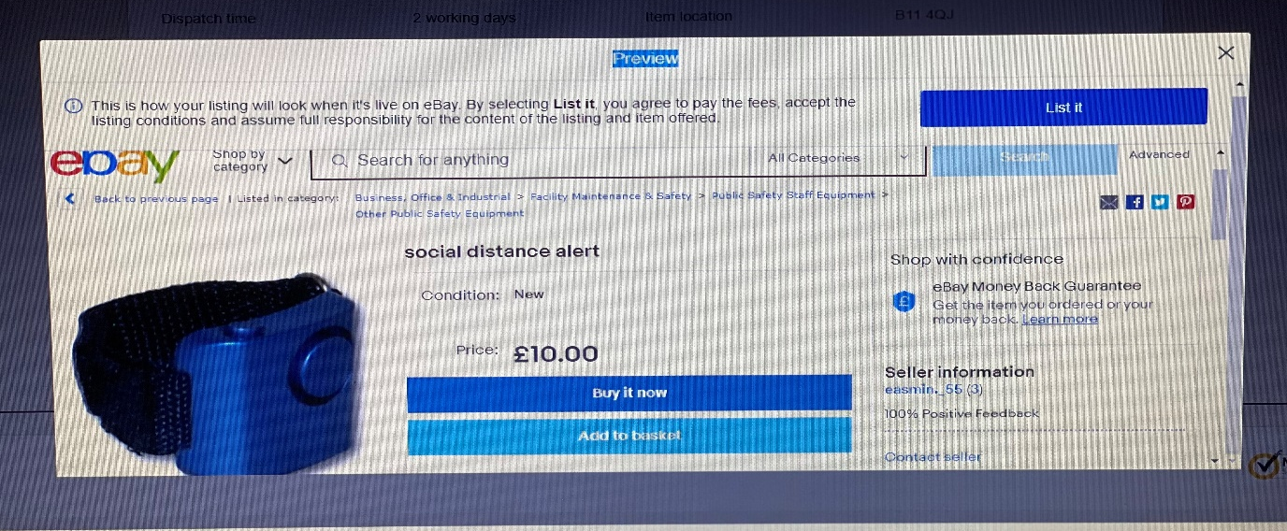
allowing you to shop a little more freely. It is lightweight, relatively low costing as this will be an increment innovation so the cost would not be so high as it is not a new invention. It has a 12 hour battery life and when there is no charge you just plug into usb socket, so it is not always necessary to charge it at home instead you can charge it while you are driving or at the office. Social buzzer needs no software update as it is already installed you just work it out the box. There is however a 10 second recording option should you not like the sound of the alarm. The social buzzer can be attached to garments, it can be used as a lanyard in case you do not want to wear it on your wrist. At the end of the day it can be sanitized with wipes as it is waterproof. The buzzer is compliance with social distancing as this is necessary for current covid 19 it will enable to reduce cross contamination.
E-commerce
This product will be sold online as this would be the most appropriate action in this moment in time. I will sell it on my eBay account as everyone knows this platform not only that it will save me money as I would not need to pay a website developer to design one for me. I will customise it on my account so that if anyone types in the word social my social distance buzzer will so hope on the search engine. Ebay sellers retain more profit than amazon with millions of active buyers (capital 2020), with transaction up to two billion daily eBay would be ideal place to make money online. Ebay is also easy to set up and start selling it only couple of minutes as there are prompts on each stage on what to do, after that you connect with buyers around the world. There is no end to what you sell on eBay and eBay can also point you toward what is in high demand and of trend before it happens. I can also choose from eBay five subscription tiers starter, basic, premium, anchor, enterprise from this eBay can help by making recommendation additional tools depending on listing I do per month. Not only that I would also be able to see what others are selling for similar item to mine and I can leverage the price.
In regard to setting up a payment method I will set up a automatic payment method on eBay this will enable me to not worry about fees or charges that will be taken from my account on subscription. It will also take care seller fees and any fee for product being listed and sales made. This will also cover refunds made to buyer and any postage label charges. By being on top of my fees it will help me maintain great experience for the buyers, as many times I have experienced where I bought something from eBay but the transaction did not go through due to sellers issue, therefore that seller lost a sale and I walked away with bad experience allowing me to give negative feedback to that seller and not purchase future transaction with that seller. Every sale and good experience are essential on eBay as good feedback and higher ratings indicates a very reputable seller and buyers will need to look no further or investigate but rather shop with ease of mind. Buyers also tend to buy from seller with 98% feedback and above as less feedback and rating tends to be taken as scammers when it could be a new seller set up account.
My account will set to managed seller as forms of payment will automatically be set for me. My buyers will be able to choose from paying with their credit or debit card, google pay or apple pay as at times you can lose sale due to buyer not having card details on them. This also gives options to buyers to purchase with gift cards and vouchers. Products that are solely paid for via PayPal will always be eligible for eBay money back guarantee.
As a seller on eBay I need to understand my obligation on GDPR. Ebay map analyse and document personal information from when they collect to when they destroy it. From May 2018 any information I receive during my trading such as name, address and payment details will not be fully my responsibility. This will fall under eBay compliance and I would need to adhere to their rules or end up getting banned on my account. This will help me as I will not be sharing details of buyers nor will I breach the contract. When invoices are sent to my account after payment have gone through, I will keep hold of it until after buyer has received the product and is satisfactory only then I will destroy in case a dispute was to arise.
PCI DSS is required for business to handle credit and debit payments; it is a requirement that you must comply with regardless of transaction put through or however the amount (PCI Compliance 2020) This helps massively by reducing the likelihood of financial data, identity theft, fraudulent payment and unauthorized transactions. In this case I would not need to worry about this as I will eBay checkout which consist of PayPal pay flow system although there is a process on which you can take payment manually but I am not willing to take that risk. The DSS also helps by mandating to not storing data of cardholder unless necessary and ensuring all stored data is unreadable through hashing and encryption.
Although this is not a business on a bigger scale the loss would not be significant but the platform for innovation would still be the same. Business model and platform value would still require me to know what my network capabilities are and keep on top of my values and financial at all time and a reminder as to what is my focus for the business. Customer expectation and experience would allow me to focus on the brand value, through route market this will help me to keep stakeholders interest of establishing product and keeping it relevant and overall staying firm in the long run in unknown times like this.
Product offering and design support can enable me to make sure I am meeting manufacturing standards, still staying ahead of competitors and service so customer is still top priority in case of issue with the product should it arise. There are many risk factors that can hinder the value of a innovation changes in customer wants and need, economy situation, what the trends are in industry in current time, and impact of technological development.
To be able to critically think, observe, analyse, evaluate and explain this can greatly affect a innovation success. Being able to see a situation and recognise the problems arising is the first step to achieving something. Gathering relevant information related to the situation is also crucial. Being able to judge accurately regardless of one’s belief based on experience is a skill not everyone is able to manage. There are tools that can help to break down these perception and failure DATT` tool has 10 tools which vary allowing business and innovator to focus and know which tool they are using and where they are applying it. To think of ways use it objectively that will support your point of view or in time also defend it. Be as comprehensive as you can in order to feed in everything you can to make sense of it later in the process.
Scamper is a great technique created by Bob Eberle 1971,(Serrat 2017, p.311-314) that helps to develop an idea or improve on existing product and it was also method that I used in order to make sure my innovation was relevant and that there was niche in the market for it. This is also important to R&D of any business or innovation as it picks out any trial and error scenario through the stages. Each innovation is always modified, improved through this to avoid failure my product has been thoroughly thought of as new innovation often suffer from failure and this could be either wrong timing or market is not ready for this kind of new change and neither are the customers, therefore a product development strategy must be put in place to avoid this.
Marketing
I will reach out to buyers by advertising on Instagram, Facebook. I can market through google ads as it is a free online advertising platform that will enable me to pay for ads to be shown all google display network so every time a user clicks on my ad, I will pay a fee. This will also allow my adverts to be placed on non-search websites, videos and mobile apps. It will also help me to notify my local area people of my product. Using the Facebook widget, I would be able to spread the word on my social distance buzzer and they would also be able to forward it to their friends and family as this will help my product gain more publicity.
Conclusion
My plan would be to buy small amount of unit and see how the sales go from there but as this would be imported from china this would save me production cost in the uk and finding material and distributors. All this would be already handled as this would be an increment innovation and only little alteration would be made to it. Although product life cycle consists of 5 stages product development, introduction, growth, maturity, decline not all would be applicable to this product as it would be a FAD and this phenomenon would be short lived as it will popular for a short time. For any innovator this would be a perfect time to come out with a break through innovation that is relevant to this scenario which will help the economy and its consumer get back to some form of normality as if the idea is right and timing is of the essence then a great amount of money can be made from this.

References
Capitalism.com. (2020). How to make money on eBay. Available: https://www.capitalism.com/how-to-make-money-on-ebay/. Last accessed 09/10/20
Hough.C. (2020). 14 Different type of innovation, why one size doesn’t fit all. Available: https://ideadrop.co/different-types-of-innovation/. Last accessed 07/11/20
Serrat, O. (2017). The SCAMPER technique. In Knowledge Solutions (pp. 311-314). Springer Singapore
Skillicorn.N. (2016). What is innovation. Available: https://www.ideatovalue.com/inno/nickskillicorn/2016/03/innovation-15-experts-share-innovation-definition/#nicks. Last accessed 07/11/20
Sledzik.K. (2013). Schumpeter’s view on innovation and entrepreneurship. Available: https://www.researchgate.net/publication/256060978_Schumpeter%27s_View_on_Innovation_and_Entrepreneurship. Last accessed 07/11/20
Sjodin.D, Gronlund.J, Frishammar.J. (2010). In California management review. Open innovation and the stage gate, a revised product for new development. 52 (3), p109-110
PCI Compliance. (2020). welcome to PCI compliance guide. Available: https://www.pcicomplianceguide.org/faq/. Last accessed 25/10/20

