Sacred music – its evolution from the ancient times to modern days

Dissertation proposal

Written by: Adrienn Fuscsics
P151781

Introduction

This paper is aiming to portray the beginning of the sacred music and its progression over the years up to modern days. To do that the author would like to articulate the important stages of the development and find key events that promoted further growth. Such events had smaller or greater effects with a different speed of change, yet it helped for all nations to eventually come to a common ground and unify their practices.

Chapter 1
Early days – monophonic chants

Christianity started its formation in Jerusalem and Palestine, but the first community that was called ‘Christian’ was in the city of Antioch, the land that belongs to the modern-day Syria. The earliest written works of Christianity originate from Syria, as well as the first missions heading towards Armenia and Greece.
Christian bishops gathered in Ecumenical Councils to decide about the nature of Jesus. The third Ecumenical Council established the belief of Jesus being a God who was born in a human body. The east Syrian Nestorians declined the definitions and remained persistent in their beliefs, they called themselves ‘Assyrian Church of the east’. The west Syrians decided to adopt the new beliefs that there was a single nature to Jesus and they were called ‘monophysites’, their church is known as ‘Syrian Orthodox’. A third group formed, the ‘Maronites’, who shared their faith with Nestorians at the beginning, but at the time of the Crusades meeting the Romans, they have adopted Roman authority. Within each of these groups there were subgroups that carried on with their beliefs of the Greek Byzantium., and the supporters were called ‘Melkites’. Between these groups the religious services had a sizable amount of similarities and the ‘orthodox’ and ‘catholic’ groups may have shared their service books.
A troop that was perceived as heretical by most of other Christian groups adopted the poems of Bardesanes (c. 154-222), who put in writing a psalter that competed the Hebrew Psalter. The poems were sung to well-liked melodies which were composed (it was said) by Harmonios, Bardesanes’s son. The response from the orthodox church came from Ephrem the Syrian (306?-73), who recorded his poems as contrafacta to Harmonios’s tunes incorporating orthodox teachings.
Yet another fashion of chanting appeared around this time, the ‘antiphonal’ singing. Whilst its origin has no real evidence, all reports seem to originate it from Syria. As the end of the fourth century was coming, the antiphonal singing extended to the west to Constantinople and Milan, and so it turned into one of the common practices of chanting in all Christian services.
An example of Syriac hymn:
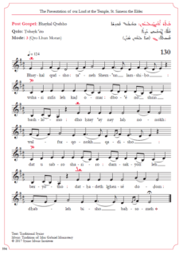

Most of the poems used in Syrian services were recorded in Syriac, but some remained to be written in Greek. The poetry of Severus of Sozopolis have been thought to be the earliest instances of a compilation containing references to the ecclesiastical modes, the Byzantine echoi. Another Syrian poet to be mentioned is Romanos, whose liturgical poems were written around the same time of Severus (6th century). In addition, Syria created the form of qala (or qolo), which means ‘tone’ or ‘tune’. Syrian Christian services also incorporated some Greek forms as well as their own, in particularly the kanon from Byzantium.
The official adaptation of Christianity in Armenia happened under King Tiridat III. Tiridat was influenced by Gregory (‘son of Anak’), called the ‘Illuminator’ and their pursuits led to Armenia becoming the first state that recognized Christianity as its official religion.
The first Armenian hymnody seem to have emerged by paraphrases of psalm verses, alike in the Greek-speaking areas of the near east. Scholars in Soviet Armenia realised a connection between folk-songs and folk-singers and the growing numbers of religious hymnody. The actions of the musicians resulted in Armenian folk-song elements moved in to melodies exercised in churches.
By the 8th century kanons arise and administer to the growth of poetry paraphrasing the Canticles of the Old and New Testament. Armenian musicologist T’ahmizyan identified 2 stages in the development of Octoechos. First, an ‘early’ Octoechos of the 5th century, which he connected to chanting psalms and biblical Canticles. Second stage relates to the kanon poems of the 8th century. Since by then the texts were new creations rather than extracts from the Bible.
Armenians notated their chants only in monophonic way.
The Coptic chant came from the monophysite Christians of Egypt. This tradition is missing musical notation, which practice has a connection to Eastern Mediterranean Jewish communities. Majority of Coptic hymnography derived from Byzantine and the true Coptic formation have not yet been studies thouroughly.
The Ethiopian religious history is a blend of Hellenic traditions of Alexandria, of Byzantine, of Syrian missionary activities., as well as some Hebraic traditions. The 6th century great Ethiopian poet, St Yared created the three basic ‘modes’ of Ethiopian chanting. Alongside the traditional chants, the dabtara (Ethiopian singers) had to learn a sacral dance ( aquaquam) and also to play musical instruments to enhance the services, adding a huge amount of sounds.
The Byzantine chants are monophonic, sung in the Greek orthodox church. One theory says that Byzantine chants may have originated from the pre-Christian Greek traditions. The other theory claims since the beginning of Christianity was in Jerusalem, Jewish religious and musical traditions played the most prevailing part in the evolution of Christian regional practices, including Byzantine chant. The Imperial Court and the Christian church had a very close connection, which resulted in the imperial pomp and circumstances penetrating the practice of chanting, and equally liturgical chants have become indivisible part of imperial ceremonies and possessions.
There are two names to be mentioned, Basil the Great and John Chrysostom, the authors of the two basic types of Byzantine liturgies. Their contemporaries are St Ambrose of Milan, St Augustine and St Jerome (translator of the Latin Bible) and St Hilary of Poitiers.
It is not yet discovered when and to what extent did the congregation become more included in the services, but it was notably more significant as the congregation’s numbers grew as well as the need to occupy the time as liturgical practices took longer to prepare. It when they started chanting the Cherubic hymn. Where there were less texts available, composition had an outburst, creating new melodies for the same texts.
In the last two centuries there were more musical styles and compositions appearing, as well as more complex melodies – even in hymn, which were meant to be performed in a more reputable, majestic manner.
The best-known Byzantine chants are Trisagion and the Cherubic hymn, they are both from the Liturgy.
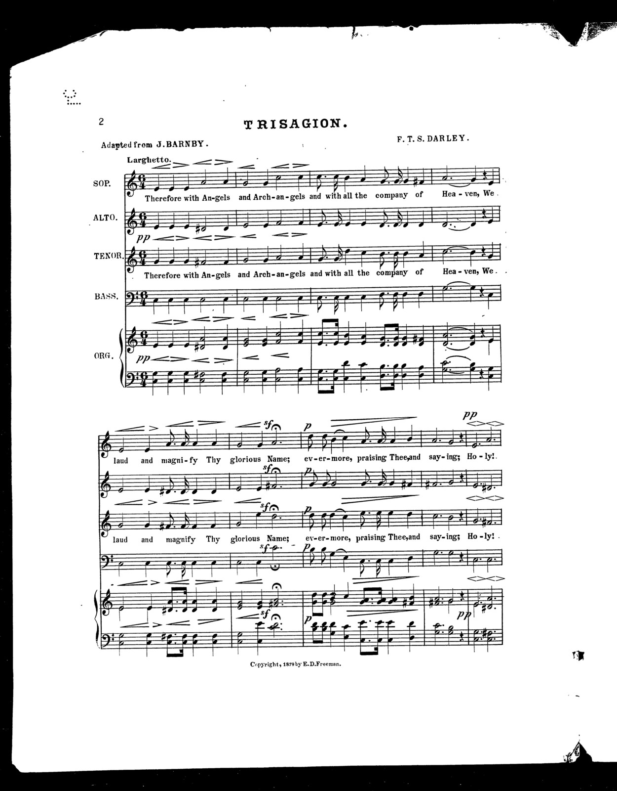
(https://picryl.com/media/trisagion-1, 2019)
In the western churches we have to mention the Latin chants: the Beneventan chant, Milanese and Ambrosian chant, Celtic chant, Gallican chant and Old Spanish chant. Before the Roman liturgical and musical rules, the Carolingian Emperors urged, Western Europe used local plainchant repertories. There are four main repertories: (1) Frankish-Roman or ‘Gregorian’ chant, that later became the common idiom if the Latin church; (2) the Urban-Roman chant and the (3) Milanese or Ambrosian chant; (4) the Hispanic, Old Spanish, Visigothic or ‘Mozarabic’ chant of the Iberian Peninsula.
Chapter 2
Middle Ages – Introducing tritone
‘Probably the most common reason given for the evil reputation of the tritone is its connection to the number '666,' the Number of the Beast referenced in the Biblical Book of Revelation.’ (Merrick)
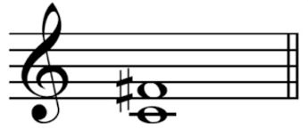
(https://www.classicfm.com/discover-music/music-theory/what-is-a-tritone/, 2019)

The tritone, or the augmented 4th or diminished 5th is a dissonance that sounds rather ‘unholy’. It was named ‘the devil in music’ in the medieval times. There are rumours that the church decided to ban this discord from the church music composition as it did sound rather unpleasant, but in fact it was avoided because it was very difficult to sing in tune.
The tritone is an interval comprising two notes, that are separated by three whole notes, and it is on a C major scale C->F. Johann Joseph Fux did include it in his writings, Gradus ad Parnassum. There were several composers who used the tritone, like Perotin and Gesualdo in the Medieval times and Renaissance. Yet it only really has become more popular in the 19th century. Franz Liszt used the tritone to describe the devil in his Apres une lecture du Dante: Fantasia quasi sonata, the Dante Sonata [https://www.youtube.com/watch?v=EeqfQCnMusE], and Danse macabre [https://www.youtube.com/watch?v=YyknBTm_YyM] by Camille Saint-Saëns. Similarly, Bach (in pre-romantic times) tried to paint the picture of Judas in his St John Passion.
Around the middle of the 16th century there was a need for some development in music, debates were present. After monophonic times, polyphony was introduced and started to develop. When Bach started his musical works, polyphony was rather advanced. He devoted himself from a young age to compose sacred music, which he was doing for many years. Then seeing the changes that came with the effect of secular music, he turned to that direction. Unfortunately, it proved unsuccessful and he started composing sacred music once again, and he continued to do so until the end of his life.
Benjamin Britten’s War requiem is another great work to mention. His piece comments on human cruelty during the World War II, matching Wilfred Owen’s poetry to powerful music.
The piece of the 11th century Notre Dame Organum Quadruplum has got 3 Bb-E tritones, an example that if often mentioned, the composer is the above mentioned Perotin.
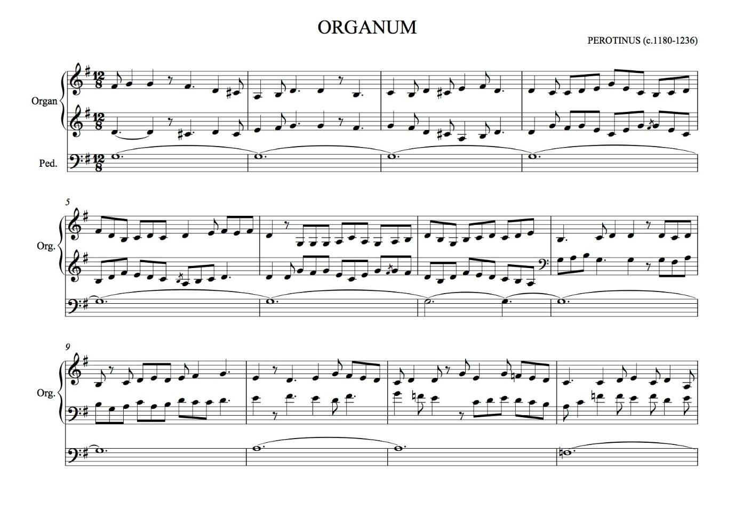
(https://musc520-musical-styles-s14.fandom.com/wiki/Perotin_-Organum_Triplum, 2019)
It is interesting to note the symbolic meaning of the number 3 in tritone (3 whole notes). The number appears in religious historical events, like the symbol of the holy trinity, the three wise man looking for Jesus, the resurrection of Jesus 3 days after his death. The symbol of the number three can be found in pagan rituals too. Their goddess, triquetra also exist as a being of three nature, the mother, the maiden and the crone. The Alchemical symbols are all triangle-based, and in Norse mythology the symbol of Valknut consist of locking triangles.
Chapter 3
Tristan chord
‘There is no country, no town, no village that I can call my own. Everything is alien to me and I often gaze around, yearning for a glimpse of the land of Nirvana. But Nirvana quickly turns back into 'Tristan'; you know the Buddhist theory of the origin of the world. A breath clouds the clear expanse of heaven: The yearning motive. it swells and grows denser, and finally the whole world stands before me again in all its impenetrable solidity.’ (Wagner, 1860)
The Tristan chord term originates from Wagner’s Opera, Tristan und Isolde. It was pointed out by Hauptmann that there is evidence of the chord appearing in the start of Wagner’s Prelude. Moritz Hauptmann wrote down the exact harmonic progression.
As a matter of fact, the chord stem from Wagner’s yearn for Nirvana, and the motif cell as well as the Tristan chord appear in the named piece. Nirvana was composed by Hans von Bulow who was a good friend of Wagner. Although Wagner criticised Bulow for composing dissonances and for the not disguising them, yet he took inspiration from the discovery and used the chord in his opera Tristan und Isolde.
Several writers claimed to have found instances of the use of the Tristan chord in other composers works, namely: Mozart (Dissonance quartet K.428), Beethoven (op.31 no.5), Spohr (Concerto for two violins, Quartet op.4 no.1), Gottschalk (The Last Hope), Chopin (op.68 no.4), Liszt ("Die Loreley", "Ich möchte hingehen").
Ernst Kurt recognized the typical features of romantic harmony that is the chromatic accent of a chord by raising or lowering one of its constituent notes by a semitone. It was named the ‘French sixth’, where if where if a note was changed it generated a Tristan chord.

Research question
From the above chapters it is clear, that sacred music had remained monophonic for a long period of time, but the Gregorian unification started a new division. The evolution of sacred and secular music resulted in new ideas emerging and a kind of diffusion between secular and sacred music. The Christian church had never accepted the new suggestions with an ease, but several factors eventuated changes for the better. What was strictly sacred for a long time finally started to implement secular practices that helped with a growth. Folksongs and singers and dances were making their way into the sacred traditions, expanding the existing rituals to accommodate the sizeable congregation.
Why have the Christian church ever been so strict with its traditions? Have they recognized the positive effects of the spread of the secular rituals? Were the new scholars more acceptive and understanding towards the changes? Where does modern sacred music stand? How has it changed and is it changing in modern days?

Bibliography
Richard Merrick, Secret - Tritone / Devil's Musica
Richard Wagner to Mathilde Wesendonk, 3rd March 1860
Martin, N. (2019). The Tristan Chord Resolved.
Medieval.org. (2019). How was the tritone used?. [online] Available at: http://www.medieval.org/emfaq/harmony/tritone.html [Accessed 9 May 2019].
Sharperiron.org. (2019). How Bach Used the "Devil's Music" | SHARPER IRON. [online] Available at: https://sharperiron.org/article/how-bach-used-devils-music [Accessed 9 May 2019].
Monsalvat.no. (2019). Everything you wanted to know about the Tristan chord but were afraid to ask. [online] Available at: http://www.monsalvat.no/tristanchord.htm [Accessed 9 May 2019].
News.bbc.co.uk. (2019). BBC NEWS | Magazine | The Devil's Music. [online] Available at: http://news.bbc.co.uk/1/hi/magazine/4952646.stm [Accessed 9 May 2019].
Cmuse.org. (2019). [online] Available at: https://www.cmuse.org/medieval-tritone-superstitions-proved-popular-in-19th-century-music/ [Accessed 9 May 2019].
Dcu.ie. (2019). [online] Available at: https://www.dcu.ie/sites/default/files/centre-for-interreligious-dialogue/2_rea2016_mark_duley.pdf [Accessed 9 May 2019].
Sacredmusicmatters.files.wordpress.com. (2019). [online] Available at: https://sacredmusicmatters.files.wordpress.com/2015/03/schuler-essay.pdf [Accessed 9 May 2019].
The Catholic Sun. (2019). A short history of liturgical music. [online] Available at: https://www.catholicsun.org/2012/01/19/a-short-history-of-liturgical-music/ [Accessed 9 May 2019].
Schrade, L. (1973). BACH : THE CONFLICT BETWEEN THE SACRED AND THE SECULAR. NEW YORK: DA CAPO PR.
Crocker, R. and Hiley, D. (1990). The New Oxford history of music. Oxford: Oxford University Press.
Sacred Music Radio | Peace & Relaxation Through Music. (2019). Christian Sacred Music | Sacred Music Radio. [online] Available at: https://sacredmusicradio.org/christian-sacred-music/ [Accessed 9 May 2019].

