
APPENDIX GA36d
LEVEL 7 ASSESSMENT SPECIFICATION

Student name: | Pranjal Sinha | Student ID number: | 2220277
Programme: | Computer Networks and Cyber Security
Module: | Network Security
Module code: | ACCA7019 | Contribution to Overall Module Assessment (%): | 100%
Lecturer: | Dr Carlene Campbell | Internal Verifier: | Nitheesh Kaliyamurthy
Assignment Title: | Construct and mitigating security vulnerabilities and weaknesses. | Word count (or equivalent): | 6,000
Submission  deadline: | May 5th 2023 | Return date of provisional marks & written feedback:

Table of Contents
1. Network Security Threats 1
1.1 Network Security 1
1.2 Network Security Threats & Attacks 1
1.2.1 Malware Attack 1
1.2.2 Phishing Attack 2
1.2.3 Dos/DDoS Attack 2
1.2.4 MITM Attack 2
1.2.5 Brute Force Attack 2
1.3 Attacks Mitigation Tools and Procedures 3
1.3.1 Anti-malware Program 3
1.3.2 Email Filtering and Security Awareness Training 3
1.3.3 Network Defenses and Traffic Management 3
1.3.4 Encryption and Secure Communication Protocols 4
1.3.5 Strong Authentication and Access Control 4
1.4 Fundamental Principle of Network Security 4
1.4.1 Defense-in-Depth 4
1.4.2 Zero-Trust 5
1.5 Cisco Network Foundation Protection (NFP) 6
1.6 Endpoints Security 7
2. Secure Testbed Network Configuration 7
2.1 Securing Cisco Routers 8
2.2 Implementation of AAA 9
2.3 Implementation of ZBP Firewall and ACLs 11
2.4 Secure Configuration of Cisco Switches against Layer-2 Attacks 12
2.5 Configuration of Firewall 13
2.6 Configuration of IPS 14
2.7 Configuration of IPSec VPN 15
3. Secure Network Infrastructure Proposal 18
3.1 Initial Cost Analysis 19
3.2 Tentative Project Plan 19
3.3 Potential Attacks 20
3.3.1 Phishing Attacks 20
3.3.2 Malware Attacks 20
3.3.3 Denial of Service (DoS) Attack 20
3.4 Recommended Security Tests 21
3.4.1 Black Box Testing 21
3.4.2 Grey Box Testing 21
3.4.3 White Box Testing 21
3.5 Invoice for the Professional Services 22
References 23
Appendixes 25
Appendix A: An IP Addressing Scheme 25

List of Tables
Table 1: Proposed Secure Network Infrastructure for A2Z Technologies Ltd 18
Table 2: Initial Cost Analysis for Secure Network Implementation at A2Z Tech 19
Table 3: Tentative Project Plan 19
Table 4: Defensive Mechanisms to be applied 20

List of Figures
Figure 1: A Secure Network Topology 8

Network Security Threats

Network Security
Network security is the practice of protecting computer networks and their related infrastructure from unauthorized access, misuse, or harm [1]. It involves implementing various strategies, tools, and techniques to safeguard the integrity, confidentiality, and availability of data and network resources [1]. Network security aims to prevent cyber threats such as hacking, malware, ransomware, and phishing attacks, as well as to maintain the proper functioning and reliability of the network.
To achieve network security, multiple layers of protection are employed, including the use of firewalls, intrusion detection and prevention systems, encryption, and strong authentication protocols. Additionally, security policies and procedures are established to guide users and administrators in maintaining a secure environment. Regular monitoring, vulnerability assessments, and timely updates of software and hardware components further contribute to the overall security of the network.

Network Security Threats & Attacks
Security threats and attacks are closely related but distinct concepts in the context of network security. A security threat is a potential danger or risk to a computer network, which could lead to the compromise of its confidentiality, integrity, or availability [2]. Threats can be intentional or unintentional and may originate from various sources, such as human, natural, or technical factors. Examples of security threats include unauthorized access, data breaches, natural disasters, and software vulnerabilities.
An attack, on the other hand, is the actual exploitation of a security threat, where a malicious actor or entity deliberately attempts to compromise a network or system [3]. Attacks are typically categorized based on their methods, targets, or objectives. Examples of network attacks include:

Malware Attack
Malware is a broad term encompassing various types of malicious software designed to infiltrate, damage, or disrupt a system [4]. Viruses, worms, ransomware, and Trojans are common examples [4]. Viruses attach themselves to legitimate files and spread when the infected files are executed or shared. Worms self-replicate and propagate through networks without user intervention. Ransomware encrypts a victim's data and demands payment in exchange for the decryption key. Trojans disguise themselves as benign applications but carry out malicious actions once installed. Malware can lead to data theft, system corruption, unauthorized access, and financial loss.

Phishing Attack
Phishing attacks involve cybercriminals attempting to deceive users into providing sensitive information, such as login credentials, credit card numbers, or personal data, by posing as a trustworthy entity [5]. These attacks typically occur through email, instant messaging, or social media platforms. Attackers may craft convincing messages with a sense of urgency, directing users to malicious websites or attachments that harvest their information [5]. Spear phishing targets specific individuals or organizations, often using personalized information to increase the attack's success rate [5].

Dos/DDoS Attack
Denial of Service (DoS) and Distributed Denial of Service (DDoS) attacks aim to overwhelm a network, system, or service with excessive traffic or requests, rendering it unavailable to legitimate users [6]. In a DoS attack, the flood originates from a single source, while a DDoS attack involves multiple, often compromised, devices working in coordination. Attackers may exploit vulnerabilities in protocols, flood systems with traffic, or send malformed packets to cause crashes [6]. These attacks can disrupt businesses, result in financial loss, and damage an organization's reputation.

MITM Attack
In a Man-in-the-Middle attack, a cybercriminal intercepts the communication between two parties, such as a user and a server, without their knowledge. The attacker may passively monitor the exchanged data or actively manipulate it, potentially stealing sensitive information or injecting malicious content. Common MITM scenarios include eavesdropping on unsecured Wi-Fi networks, DNS spoofing, and HTTPS interception. These attacks undermine the confidentiality and integrity of data transmission and can lead to data theft, financial loss, or unauthorized access.

Brute Force Attack
Brute-force attacks involve an attacker systematically attempting to gain access to a system by guessing passwords or encryption keys through trial and error [7]. These attacks can target login credentials, cryptographic keys, or other sensitive data. Attackers may use automated tools to generate a large number of possible combinations or rely on dictionaries, commonly used passwords, or other known data. Brute-force attacks can be time-consuming and resource-intensive but may eventually lead to unauthorized access, data breaches, or system compromise.

Attacks Mitigation Tools and Procedures
The following is a brief description of some tools, techniques, and procedures that can be considered to mitigate network-related attacks:

Anti-malware Program
Anti-malware software is a crucial tool for detecting, preventing, and removing malware from computer systems and networks. It utilizes signature-based detection, behavioural analysis, and heuristics to identify and neutralize various forms of malicious software, including viruses, worms, Trojans, and ransomware. Regularly updating the software and maintaining a comprehensive malware signature database is vital to ensure effective protection against emerging threats. Additionally, configuring the software to perform scheduled scans and real-time monitoring can help maintain system security.

Email Filtering and Security Awareness Training
To mitigate phishing attacks, organizations can implement email filtering solutions that identify and block suspicious messages based on predefined rules, sender reputation, and content analysis. Additionally, security awareness training for employees can help them recognize phishing attempts and understand the importance of verifying the legitimacy of email communications. Organizations should emphasize safe browsing habits, such as avoiding suspicious links and verifying website authenticity before submitting sensitive information.

Network Defenses and Traffic Management
To counter DoS/DDoS attacks, organizations can deploy a range of network defences, including firewalls, intrusion detection and prevention systems, and traffic management solutions. Firewalls can be configured to block malicious traffic or limit the rate of incoming requests. Traffic management techniques, such as load balancing and traffic shaping, can help distribute traffic efficiently across network resources and prevent system overloads. Cloud-based DDoS protection services can also help absorb and mitigate volumetric attacks by distributing traffic across a wide network of servers.

Encryption and Secure Communication Protocols
To defend against Man-in-the-Middle attacks, organizations should implement strong encryption and secure communication protocols, such as HTTPS, SSL/TLS, and VPNs. These technologies help ensure the confidentiality and integrity of data transmitted between parties by encrypting the communication and validating the authenticity of involved parties.

Strong Authentication and Access Control
To thwart brute-force attacks, organizations should enforce strong authentication and access control mechanisms. This includes implementing robust password policies that require the use of long, complex, and unique passwords, and encouraging the use of password managers. Two-factor authentication (2FA) or multi-factor authentication (MFA) can add an extra layer of security by requiring users to provide additional verification methods, such as a one-time code or a biometric identifier [8]. Account lockout policies and rate limiting can also help deter brute-force attempts by temporarily disabling or slowing down access after a certain number of failed login attempts.

Fundamental Principle of Network Security

Defense-in-Depth
The fundamental principle of securing a network is "defence in depth," which involves implementing multiple layers of security measures to protect the network, systems, and data from various threats and vulnerabilities [9]. The concept is based on the idea that no single security measure is foolproof, and a multi-layered approach provides redundancy and enhances the overall security posture.
Defence in depth encompasses various security aspects, including technical, administrative, and physical controls [9]. Technical controls involve the deployment of security hardware and software, such as firewalls, intrusion detection and prevention systems, encryption, and authentication mechanisms. Administrative controls include the establishment of security policies, procedures, and employee training programs to ensure that network users and administrators follow best practices [9]. Physical controls focus on securing the physical infrastructure and assets, such as server rooms, network equipment, and access points [9].
By adopting the defence in-depth strategy, organizations can mitigate risks more effectively, as an attacker must bypass multiple security layers to compromise the network, systems, or data. This approach also helps in detecting and containing threats, minimizing the impact of a security breach, and maintaining the confidentiality, integrity, and availability of information and resources.

Zero-Trust
Zero Trust is an alternative security paradigm that shifts the focus from traditional perimeter-based defences to a more comprehensive approach, emphasizing the continuous verification of identities, devices, and access requests [10]. Under the Zero Trust model, no user, device, or application is inherently trusted, regardless of whether they are inside or outside the network perimeter. This approach requires the implementation of strong authentication, least privilege access control, micro-segmentation, and real-time monitoring to validate every access request and ensure that resources are only accessible by authorized entities. By adopting the Zero Trust principle, organizations can enhance their security posture, minimize the attack surface, and better protect their network and data from potential threats, attacks and vulnerabilities [10].
In light of the existing literature reviewed above, the following is a list of some other recommendations to mitigate the effects of common network attack methodologies in a small to medium-sized business:
- Deploy a strong firewall to filter incoming and outgoing traffic, block malicious connections, and control access to network resources.
- Install reputable anti-malware software on all devices and keep it updated to protect against viruses, worms, Trojans, and ransomware.
- Keep operating systems, applications, and firmware updated with the latest security patches to minimize vulnerabilities that attackers can exploit.
- Enforce complex password policies, encourage the use of password managers, and implement multi-factor authentication to prevent unauthorized access. Establish the principle of least privilege to limit user access to the resources necessary for their job roles.
- Implement email filtering and security awareness training to combat phishing attacks. Encourage safe browsing habits and use secure communication protocols (e.g., HTTPS) to protect sensitive data.
- Regularly back up critical data and store it offsite or in a secure cloud storage solution to ensure data recovery in case of a breach, malware attack, or hardware failure.
- Divide the network into smaller segments, isolating sensitive information and critical systems from other parts of the network. This limits the lateral movement of attackers in case of a breach.
- Implement network monitoring tools and intrusion detection systems to identify and respond to potential threats in real time. Regularly review logs and conduct security audits to ensure compliance with security policies and identify areas for improvement.
- Provide regular security training and awareness programs to educate employees about security best practices, threat identification, and incident reporting.
- Create a detailed plan outlining how the organisation will respond to security incidents. This plan should include roles and responsibilities, communication protocols, and recovery steps to minimize the impact of an attack and facilitate a swift return to normal operations.

Cisco Network Foundation Protection (NFP)
Cisco Network Foundation Protection (NFP) is a security framework designed to protect the underlying infrastructure of a network, ensuring its availability, integrity, and confidentiality [11]. NFP focuses on three key functional areas: management, control, and data planes [11]. By securing these planes, it aims to maintain the stability and reliability of the network, preventing unauthorized access and minimizing the impact of potential attacks.
The management plane includes the processes and protocols used to access, configure, and monitor network devices. NFP aims to secure the management plane by implementing strong authentication and access control, encrypting management traffic, and restricting the use of insecure protocols [11]. This helps protect the network infrastructure from unauthorized access and configuration changes.
The control plane is responsible for establishing communication paths and maintaining routing tables in network devices [11]. NFP seeks to protect the control plane by deploying mechanisms like Control Plane Policing and Control Plane Protection, which limit and filter traffic destined for the control plane. Additionally, securing routing protocols with authentication and route filtering helps maintain the stability and integrity of the network topology.
The data plane is responsible for forwarding traffic through the network [11]. NFP's goal is to secure the data plane by implementing techniques such as ingress and egress filtering, rate limiting, and Quality of Service (QoS) policies. This helps prevent various types of network attacks, including Distributed Denial of Service (DDoS) and address spoofing. Employing encryption and secure communication protocols ensures the confidentiality and integrity of transmitted data.

Endpoints Security
Endpoint security vulnerabilities are weaknesses or flaws in devices connected to a network, such as computers, smartphones, and IoT devices that can be exploited by malicious actors to compromise the network and access sensitive information. These vulnerabilities can stem from outdated software, misconfigurations, poor security practices, or inherent flaws in the device or its applications.
To protect endpoints and address these vulnerabilities, organizations can implement the following measures:
- Implement a strong and robust Bring Your Own Devices (BYOD) policy in the organization.
- Keep operating systems, applications, and firmware updated with the latest security patches to minimize vulnerabilities that attackers can exploit.
- Install reputable anti-malware software on all endpoint devices and keep it updated to protect against various forms of malicious software.
- Enforce robust password policies and implement multi-factor authentication to prevent unauthorized access to endpoint devices.
- Apply the principle of least privilege, granting users and applications the minimum level of access necessary to perform their tasks.
- Use encryption to protect sensitive data stored on endpoints and ensure the confidentiality of data transmitted between devices.
- Harden endpoint devices by disabling unnecessary services, removing unused applications, and configuring security settings according to industry best practices.

Secure Testbed Network Configuration
In order to demonstrate the effectiveness and importance of network security, a testbed network is configured in this section in a secure manner. The following figure illustrates the topology adopted in this practical activity of secure network configuration.
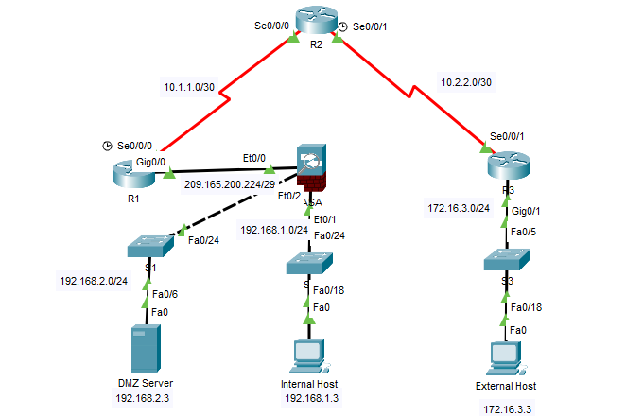
Figure 1: A Secure Network Topology
An IP Addressing scheme followed in this secure network configuration is given in Appendix A of this report. The following order is followed to ensure the robust security configuration of the network:
- Securing Cisco Routers
- Implementation of AAA on Cisco Routers
- Implementation of Zone-Based Policy Firewall and ACLs on Cisco Routers
- Configuration of Cisco Switches to Mitigate Layer-2 Attacks
- Configuration of Firewall
- Configuration of IPS on Cisco Router
- Configuration of IPSec VPN

Securing Cisco Routers
To secure Cisco routers, it is essential to set up several security measures, including configuring the security banner, setting access passwords for local and remote login via console and VTY lines, and encrypting passwords using strong encryption. Furthermore, it is essential to encrypt passwords using strong encryption mechanisms. By implementing these security measures, organizations can significantly enhance the security posture of their Cisco routers, protect against unauthorized access, and ensure the confidentiality, integrity, and availability of their network resources.
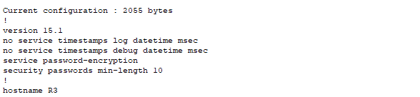
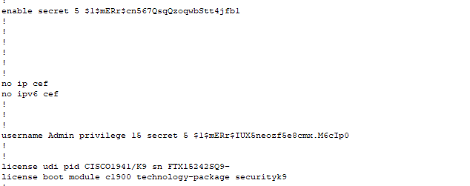
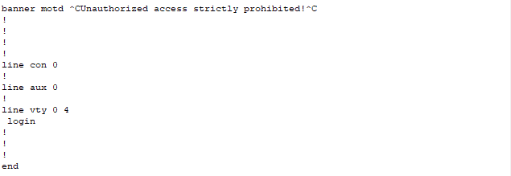

Implementation of AAA
AAA (Authentication, Authorization, and Accounting) is a crucial component of network security that provides a framework for controlling access to network resources, enforcing policies, and auditing network activity.
Authentication is the process of verifying the identity of a user, device, or application trying to access the network. AAA ensures that only authorized entities can access network resources by requiring valid login credentials, such as usernames and passwords, certificates, or biometric information. This helps prevent unauthorized access to the network and protects against identity theft and other cyber-attacks.
Authorization involves determining what resources and actions a user is allowed to access or perform based on their identity and role. AAA policies enforce access control by assigning permissions to users or groups, limiting their access to only the resources and services they require to perform their jobs. This helps minimize the risk of data breaches and insider threats by preventing users from accessing sensitive data or systems they should not have access to.
Accounting involves tracking and recording network activity to maintain an audit trail of who accessed what resources and when. AAA provides detailed logs of network activity, including login attempts, system changes, and data access, enabling network administrators to identify security incidents, monitor compliance, and investigate potential threats.
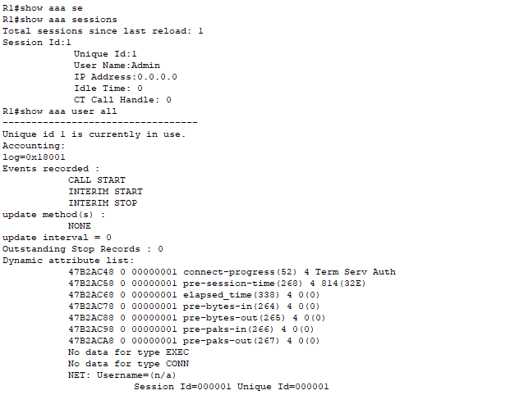

Implementation of ZBP Firewall and ACLs
Zone-Based Policy Firewall (ZFW) is a security feature on Cisco routers that provides an advanced stateful firewall solution, allowing network administrators to define security policies based on traffic flow and logical zones [12]. ZFW simplifies the configuration and management of firewall policies by defining traffic flow between zones, rather than using traditional access control lists (ACLs) based on interface or IP address.
To implement ZFW on a Cisco router, the following steps were followed:
- Identify the network segments that require protection and assign them to separate zones.
- Assign interfaces to their respective zones and define interface characteristics, such as IP address and security levels.
- Identify traffic types and categorize them based on their characteristics, such as protocol type, source/destination IP address, and application type.
- Create policy maps that define the actions to take on traffic matching specific traffic classes, such as permit, deny, inspect, or drop.
- Associate policy maps with specific zones to enforce the defined security policies.
- Create an ACL by defining the permit or deny statements that describe the traffic to be allowed or blocked.
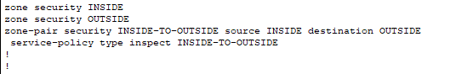
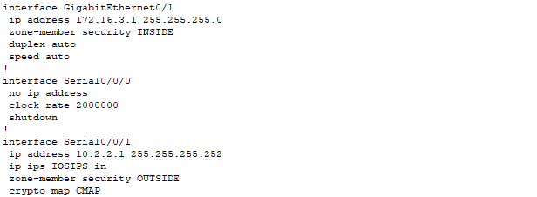

Secure Configuration of Cisco Switches against Layer-2 Attacks
Layer-2 vulnerabilities are security weaknesses that can be exploited by attackers to compromise network devices, access sensitive information, and disrupt network operations. Some common layer 2 vulnerabilities that can affect switches-level operation are MAC address spoofing, VLAN hopping, ARP spoofing, Spanning Tree Protocol (STP) manipulation, and DHCP Spoofing [13].
Cisco switches can be configured to mitigate various layer 2 attacks, which target vulnerabilities in the data link layer. The following are some of the key configuration options that can be used to enhance layer 2 security [13]:
- Enable port security to restrict access to the network by allowing only specific MAC addresses on each switch port.
- Use BPDU Guard to prevent rogue switches from connecting to the network and disrupting the Spanning Tree Protocol (STP). BPDU Guard shuts down the port if it receives a BPDU from an unauthorized switch, preventing the switch from affecting the network topology.
- Enable DHCP Snooping to prevent rogue DHCP servers from assigning IP addresses to network devices, causing connectivity issues and security vulnerabilities. DHCP Snooping intercepts DHCP messages, validates the information in the message, and only allows valid DHCP messages to pass through.
- Use Dynamic ARP Inspection (DAI) to prevent ARP spoofing attacks by validating ARP messages before allowing them to be forwarded. DAI maintains a trusted ARP table and discards ARP messages with mismatched IP and MAC addresses.
- Shutdown unused ports of switches
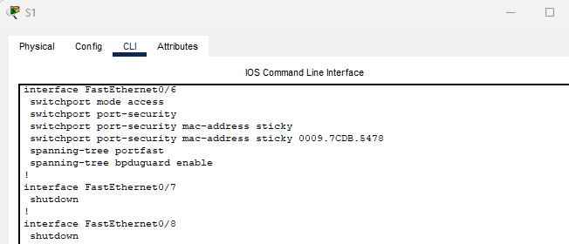
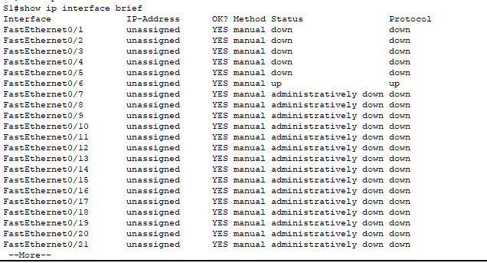

Configuration of Firewall
Access Control Lists (ACLs) are a critical component of network security and are commonly used in firewalls to filter traffic based on specific criteria. Cisco Adaptive Security Appliance (ASA) firewalls provide a comprehensive set of ACL features that enable network administrators to filter traffic based on source/destination IP address, port numbers, and protocol type. By implementing ACLs on Cisco ASA firewalls, network administrators can improve the security posture of the network and reduce the risk of network attacks. ACLs provide a simple and effective way to filter unwanted traffic and restrict access to network resources, helping to prevent data breaches and limit the potential impact of security incidents.
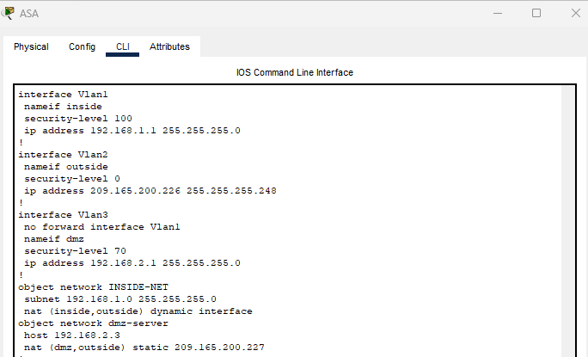
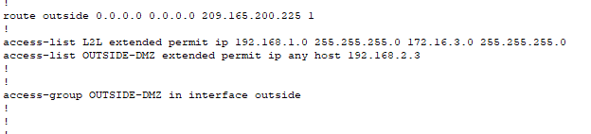

Configuration of IPS
Network Intrusion Prevention Systems (IPS) are security solutions that provide real-time protection against network-based threats by detecting and blocking malicious traffic. IPS solutions use signature detection to identify known threats, such as viruses, malware, and cyber-attacks, based on patterns or characteristics of the network traffic.
Signature-based detection is a technique used by IPS systems to identify malicious traffic by comparing network traffic against a database of known attack signatures. This database contains information about the characteristics and behaviours of known threats, such as IP addresses, port numbers, protocols, and payload content. When an IPS system detects traffic that matches a known signature, it can block or alert the network administrator of the threat.
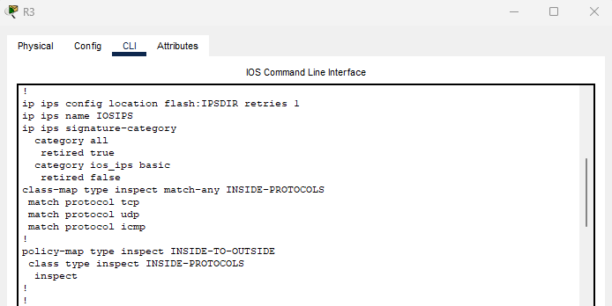
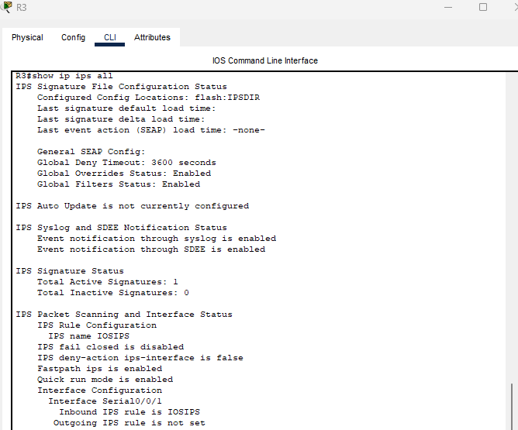

Configuration of IPSec VPN
The purpose of a VPN (Virtual Private Network) is to provide a secure and private connection between two or more devices or networks over the public Internet or other public networks. VPNs allow remote users or branch offices to securely access the resources of a private network over a public network, such as the Internet. This is accomplished by creating an encrypted tunnel between the user's device or the branch office network and the private network, using protocols such as IPsec, SSL/TLS, or PPTP.
IPsec (Internet Protocol Security) is a protocol suite used to secure IP communications by authenticating and encrypting each IP packet of a communication session [14]. IPsec VPNs use this protocol suite to establish secure and encrypted tunnels between devices over the Internet or other public networks. The following is the summary of how IPSec VPN operates:
- The VPN devices authenticate each other's identities using digital certificates, pre-shared keys, or other authentication methods.
- The VPN devices use a key exchange protocol to generate a shared secret key used for encryption and decryption.
- The VPN devices establish a secure tunnel between them using the shared secret key and the IPsec protocol suite.
- Each IP packet that is sent over the VPN tunnel is encrypted and authenticated using the shared secret key and IPsec protocol suite.
- Once the VPN tunnel is established, data can be transmitted securely and privately between the devices over the public network.
- When the VPN session is complete, the VPN devices terminate the secure tunnel and the shared secret key is deleted.
Following screenshots illustrates the configuration of IPSec VPN with pre-shared keys between the Cisco Router and ASA:
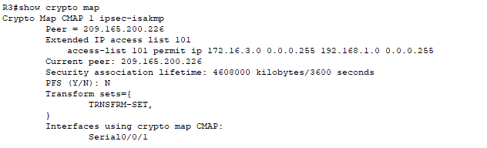
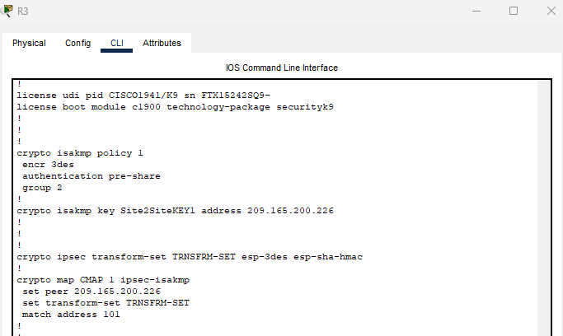
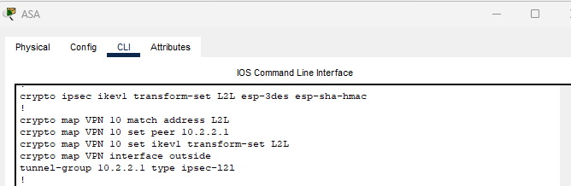

Secure Network Infrastructure Proposal
Based on the scenario provided, Table 1 summarizes the proposed secure network infrastructure for A2Z Technologies Ltd:
Secure Network Infrastructure | Description of Choice
Endpoint Security | To protect the company's endpoints, including laptops, desktops, and mobile devices. This includes antivirus software, firewalls, and regular software updates and patches.
Access Control | Strict access controls for both on-premises and remote access to the company's resources. This includes two-factor authentication, password policies, and secure VPN connections.
Cloud Security | To protect the company's cloud-based resources, including cloud access security brokers (CASBs), encryption, and secure authentication and authorization mechanisms.
Regular Security Audits | Regular security audits to identify vulnerabilities and weaknesses in the company's network infrastructure. This includes penetration testing, vulnerability scanning, and regular security assessments.
Network Segmentation | To separate different departments and functions within the company. This reduces the risk of lateral movement of cyber-attacks, limiting their impact.
User Training | Provide regular security training to all employees, including training on phishing attacks, social engineering, and best practices for data protection.
Network Monitoring | To detect and respond to security incidents in real time. This includes intrusion detection and prevention systems (IDPS).
Data Backup and Recovery | To ensure business continuity in case of data loss or system failures. This includes regular backups, offsite storage, and disaster recovery planning.
Table 1: Proposed Secure Network Infrastructure for A2Z Technologies Ltd

Initial Cost Analysis
Based on the recommended network infrastructure, Table 2 gives the initial cost analysis.
S. No | Item | Expected Cost
1 | 1 Firewall Appliance | $2,500
2 | 2 Switches | $5,000
3 | 1 Router | $1,500
4 | 1 VPN Appliance | $3,000
5 | 100 Endpoint Protection Licenses | $10,000
6 | Cloud Access Security Broker | $2,500
7 | Implementation and Configuration Cost | $6,000
Total Cost |  | $30,500
Table 2: Initial Cost Analysis for Secure Network Implementation at A2Z Tech
In addition to the hardware and software costs, there will be installation and configuration costs for the network engineer, as well as training costs for the employees on the use of the new security software and tools. The estimated costs for these services will vary based on the vendor and the level of service required.
Overall, the proposed cost for implementing the secure network infrastructure for A2Z Technologies Ltd is £30,500, which includes hardware, software, and professional services costs.

Tentative Project Plan
Month | Tasks | Defensive Mechanisms
1 | Procure hardware and software, hire a network engineer, conduct security assessment, configure firewall, implement IPS | Firewall, IPS
2 | Configure VPN access, implement endpoint protection, configure ACLs on switches, implement zone-based policy firewall on router | VPN, Endpoint Protection, ACLs, Zone-based policy firewall
3 | Implement CASB, conduct employee training, conduct testing and validation, conduct final security assessment | CASB
Table 3: Tentative Project Plan
Defensive mechanisms to be applied are:
Defensive Mechanism | Implementation
Firewall | Configure to allow necessary traffic and block all other traffic.
IPS | Implement and configure signatures for known threats.
VPN | Implement VPN access for remote workers and partners.
Endpoint protection | Implement endpoint protection software on all devices.
ACLs | Configure access control lists (ACLs) on switches and routers.
Zone-based policy firewall | Implement on the router to secure the network perimeter.
CASB | Implement a cloud access security broker (CASB) to monitor and control cloud application usage.
Table 4: Defensive Mechanisms to be Applied

Potential Attacks
Three common types of attacks that can plague an organization's network infrastructure are:

Phishing Attacks
Phishing is a social engineering attack type in which the attacker attempted to lure the victim by creating the sense of urgency, or by manipulating the victim psychologically.

Malware Attacks
Malware is a type of software designed to damage or disrupt computer systems. Malware can be introduced to a network through a variety of means, including malicious email attachments, infected websites, and unsecured devices connected to the network. Once malware infects a system, it can spread to other devices on the network and cause significant damage, such as stealing sensitive data or disabling critical systems.

Denial of Service (DoS) Attack
DoS attacks are a type of attack in which an attacker floods a network or server with traffic in order to overwhelm it and cause it to stop responding to legitimate requests. DoS attacks can be particularly damaging for organizations that rely on their network or online services to conduct business, as they can cause significant downtime and disrupt normal operations.

Recommended Security Tests
Three types of tests that can be conducted periodically after the implementation to ensure the network infrastructure are:

Black Box Testing
In this type of pen testing tester don’t know about the internal workings of the system being tested [15]. In the context of network security, black box testing involves simulating an attack on the network infrastructure without any prior knowledge of the network configuration or security measures in place. This can help identify vulnerabilities that may be overlooked by internal security teams.

Grey Box Testing
In this type of testing, the tester holds some information about the targeted network [16]. In the context of network security, grey box testing involves simulating an attack on the network infrastructure with limited knowledge of the network configuration or security measures in place. This can help identify vulnerabilities that may be missed by external attackers but are known to internal security teams.

White Box Testing
In White box testing, the tester holds the entire information of the targeted network [15]. In the context of network security, white box testing involves simulating an attack on the network infrastructure with full knowledge of the network configuration and security measures in place. This can help identify vulnerabilities that may be overlooked by both internal and external security teams.

Invoice for the Professional Services
Invoice Number: 1234
Date: May 4, 2023
ABC Network Security Consulting
Email: info@abcsecurity.com

Bill To:
A2Z Technologies Ltd.
Head Office
Swansea, UK 67890
Phone: (44) 123-456-7890
Email: info@a2ztech.com

Description of Services:
- Conduct a security assessment of network infrastructure and provide recommendations for improvements.
- Configure firewall, IPS, and VPN access for remote workers.
- Implement endpoint protection, ACLs, and zone-based policy firewall on routers and switches.
- Conduct employee training on cybersecurity awareness.
- Provide testing and validation of security measures.
Hourly Rate: $100
Project Fee: $6,000
Total Cost: $6,000
Taxes: $0
Grand Total: $6,000

References

[1] | Khan, Muhammad Jamshid, "Securing network infrastructure with cyber security," Securing network infrastructure with cyber security, vol. 17, no. 2, pp. 803-813, 2023.
[2] | Samonas, Spyridon, and David Coss, "The CIA strikes back: Redefining confidentiality, integrity and availability in security," Journal of Information System Security, vol. 10, no. 3, 2014.
[3] | Elahi, Golnaz, Eric Yu, and Nicola Zannone, "A vulnerability-centric requirements engineering framework: analyzing security attacks, countermeasures, and requirements based on vulnerabilities," Requirements engineering, vol. 15, pp. 41-62, 2010.
[4] | Cobb, Stephen, and Andrew Lee, "Malware is called malicious for a reason: The risks of weaponizing code," in In 2014 6th international conference on cyber conflict, IEEE, 2014.
[5] | Mokhtar, Ainnur Hafizah Anuar, Fauziah Redzuan, Wan Adilah Wan Adnan, Rosalind JS Vincent, Akhmad Sagir, Fazli Abdul Hamid, and Mohd Saleh Abbas, "A Preliminary Investigation on User Factors of Phishing E-mail.," Central Asia and the Caucasus, vol. 23, no. 1, 2022.
[6] | Gulihar, Prachi, and Brij B. Gupta, "Cooperative mechanisms for defending distributed denial of service (ddos) attacks," in Handbook of Computer Networks and Cyber Security: Principles and Paradigms, 2020, pp. 421-443.
[7] | Wanjau, Stephen K., Geoffrey M. Wambugu, and Gabriel N. Kamau., "SSH-brute force attack detection model based on deep learning," 2021.
[8] | Ibrokhimov, Sanjar, Kueh Lee Hui, Ahmed Abdulhakim Al-Absi, and Mangal Sain, "Multi-factor authentication in cyber physical system: A state of art survey," in In 2019 21st international conference on advanced communication technology (ICACT), IEEE, 2019.
[9] | Mughal, Arif Ali, "The Art of Cybersecurity: Defense in Depth Strategy for Robust Protection," International Journal of Intelligent Automation and Computing, vol. 1, no. 1, pp. 1-20, 2018.
[10] | Pavana, B., and Suneel K. Prasad, "Zero trust model: A compelling strategy to strengthen the security posture of IT organizations," in In AIP Conference Proceedings, 2022.
[11] | Paquet, Catherine, "Implementing Cisco IOS Network Security (IINS 640-554) Foundation Learning Guide: Imp Cisco IOS Netw Sec," Cisco Press, 2012.
[12] | C. Press, "Network Security Technologies and Solutions".
[13] | Mahmood, Shahid, Syed Muhammad Mohsin, and Syed Muhammad Abrar Akber, "Network security issues of data link layer: an overview," in n 2020 3rd International Conference on Computing, Mathematics and Engineering Technologies (iCoMET), IEEE, 2020.
[14] | Malik, Ritu, and Rupali Syal, "Performance analysis of ip security vpn," International Journal of Computer Applications, vol. 8, no. 4, 2010.
[15] | Kumar, Manish, Santosh Kumar Singh, and R. K. Dwivedi, "A comparative study of black box testing and white box testing techniques," International Journal of Advance Research in Computer Science and Management Studies, vol. 3, no. 10, 2015.
[16] | Acharya, Shivani, and Vidhi Pandya, "Bridge between black box and white box–gray box testing technique," International Journal of Electronics and Computer Science Engineering, vol. 2, no. 1, pp. 175-185, 2012.

Appendixes

Appendix A: An IP Addressing Scheme


