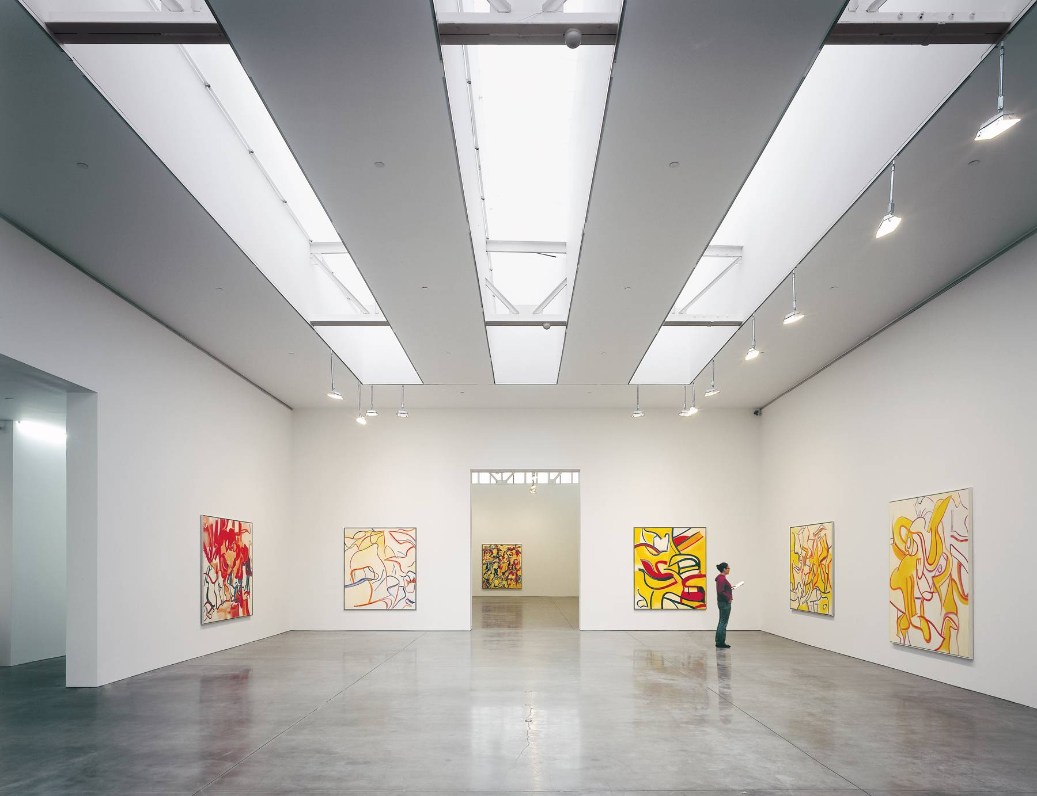

Curating an Exhibition
  - The contemporary condition- womens rights
Amy Bean- 1707951 | Advertising & Brand Design | 02/04/2019 words: 1520

The Contemporary Condition- Introduction
“We are a culture that relies on technology over community, a society in which spoken and written words are cheap, easy to come by, and excessive. Our culture says anything goes; fear of God is almost unheard of. We are slow to listen, quick to speak, and quick to become angry.”
― Francis Chan, Crazy Love: Overwhelmed by a Relentless God

With social media dominating modern culture, we have more access than ever to communicate within our society, easily expressing our ideas and thoughts through multi media platforms such as Facebook, Instagram and Twitter. 10% of the world’s photographs have been taken in recent years. This is an incredible amount of information and history being posted at a daily rate.
Through online articles, news and advertisements we are constantly aware of the creativity and diversity we have across the globe, inspiring and influencing constant new trends and inventions. Yet more than this, we are aware now more than ever of some of the most problematic issues we have ever had within our society. In an era that should be flourishing through these new technological advancements, out trial and error generation proves to have a disconnect within our culture. Our relationships are brief and passive, our body image is scrutinized through constant comparison and our mental health is suffering through social pressures. These problems which are enforced upon us feel too large to comprehend and make a real difference in, as it is not a lack of awareness but a lack of knowing on how to make significant changes.
I alone cannot change the world, but I can cast a stone across the waters to create many ripples- Mother Theresa
The aim of this essay will be to curate an exhibition looking at the role of women within society over the years, challenging the topical perception of equality, self-image and our future moving forward; just one of the many topical issues within our society today.

Women in Art & Selecting a Gallery for the Exhibition
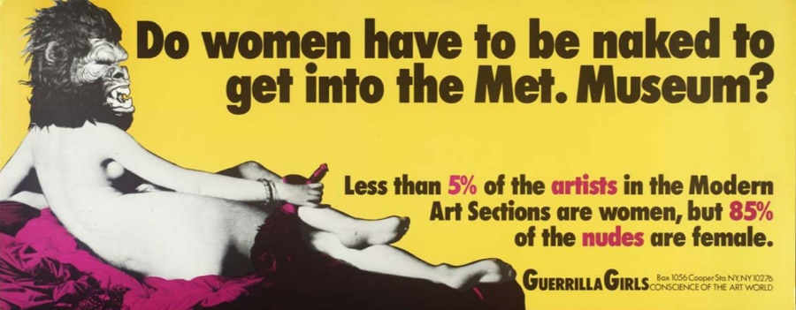

The 20th century was renowned for being one of the greatest times in history fighting for equality within women’s rights. The movements highlighted the way women were being objectified, especially within the art industry by male artists and tackled issues surrounding the idea of superiority and hierarchical status. Some fulfilment was found legislating some basic rights which led to women having the right to vote and inspiring the feminism movement to be founded.
Art was a key role during this time, challenging perceptions surrounding the idea of what a woman should be and their role in society regarding their behavior and status. A good example of work which looks at this was ‘Cut Piece’ by Yoko Onu in 1964.
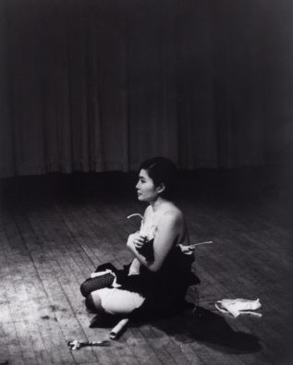

‘Cut Pieces’ was a performance piece in which the artists Yoko Onu sat alone on stage dressed in her best suit. The audience members were instructed that they were allowed to cut pieces of the material to keep if they wished, using the scissors left on stage. Bit by bit as time went on more and more people approached to snip the material until she was left naked. The psychological & social experiment although at the time had the focus on protesting loudly against violence towards women, what it does is reflect beyond that into what society is willing to except and the lengths people will go to when thought of as acceptable or the cultural norm. This piece of work is similar to that of …….. in which she similarly invited people to do as they wished with the surrounding objects left on the table. These pieces bring an awareness into the human behavior and reflects the challenges we have within our contemporary condition towards attitudes and beliefs.

Choosing a Location
Inspired by the work of the Guerilla Girls and the above history and artworks, one of the main influences of the exhibition will be to encourage communication with the public. For this reason, the location will be set in New York. This is a conscious choice directly linking to the statement the Guerilla Girls made with their project, asking if women had to be nude to be featured in the MET gallery NY. The intention is to encourage a positive attitude in how far we have progressed whilst still dealing with current issues towards women’s self-image presented within the media. New York is also one of the most culturally diverse cities estimated with over 800 languages being spoken across the state. With a long history in representing a wide range of art movements such as DADAISM and Graffiti art, it is perfect for instigating the idea of change and challenge.

In this area of the exhibition, the public will be free to use a variety of art tools left on a table to spread their own messages and statements on a blank wall; for example, commenting on the content of the gallery and what they have taken away from it. This would be set at the front of the gallery with the idea of moving passed a ‘blocked wall’ as the public look through the exhibition. Being the first thing you see as you enter and the last thing as you leave, it will also immediately invite people to share images across their social media platforms with the hashtag #myvoicemyrights to spread word of activism and positivity. This will be used as a more expressive gallery commentary ‘book’.

Chosen gallery
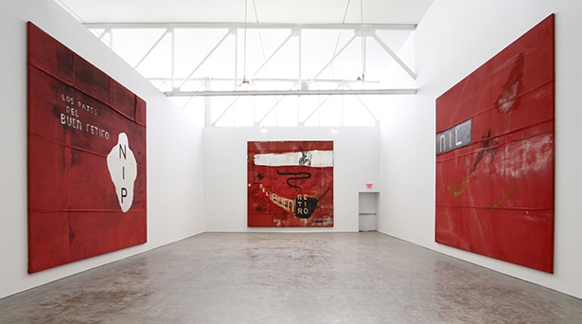

Gagosian Gallery, Madison Avenue New York City
The gallery is spacious, with large areas where natural light can enter the room. The white walls add to opening up the given space to make it appear larger. This contributes to creating the feel of an open environment. The space around prevents the chosen artworks from becoming overwhelming as the idea is to begin provoking and instigating the idea of change, reflecting on what has happened and where we still stand today. This is the overall design of the gallery.

Other Features Of The Exhibit – Selecting Art Works
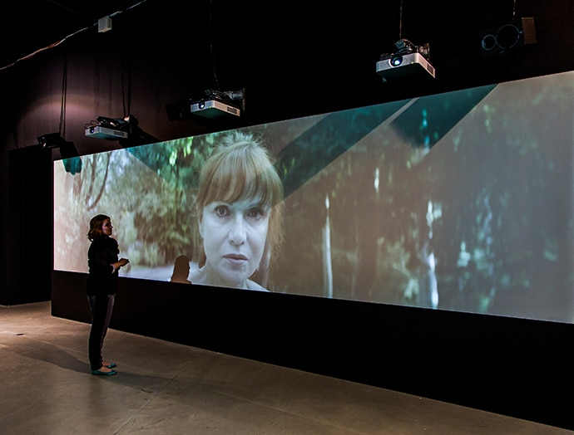
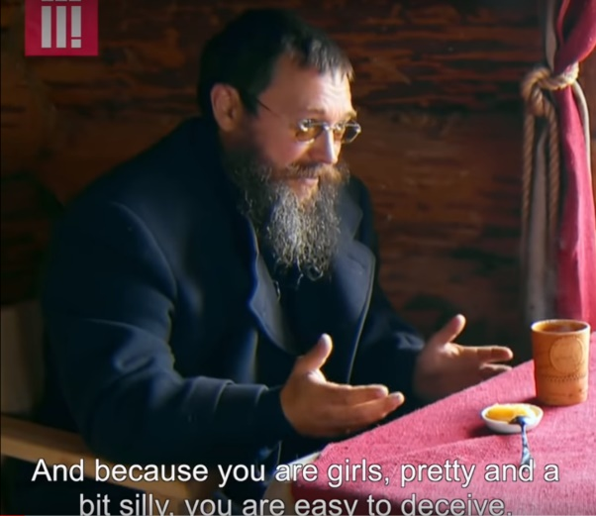
Central Hub/Sit down area- Stacey Dooley Documentaries.

https://www.bbc.co.uk/programmes/b03h2nqh
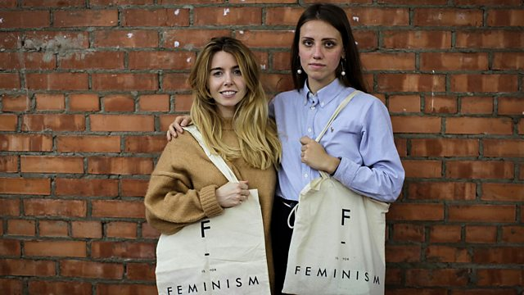

Russia’s War on Women:
Stacey Dooley is most known for her reports on hard hitting, controversial and gutsy documentaries which explores global issues, where she travels to the world most problematic areas. For this exhibition in particular, Russia’s War on Women series explores the reasons behind Russia’s decriminalization of domestic violence acts in 2017 and the impact it’s having across the country. The documentary explores the ideas of large topical issues addressing feminism, love, abuse and religion. This documentary is a way of setting the tone for the surrounding artworks featured in the gallery and a place to meet others and commute. The aim is to look beyond just solely women’s rights, but also reflect on the human behavior towards culture and values.

Back of the gallery- Artists Work :
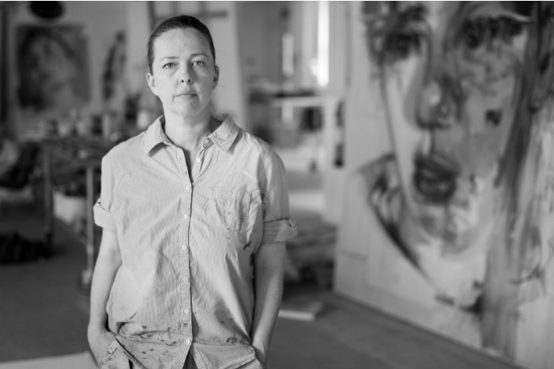
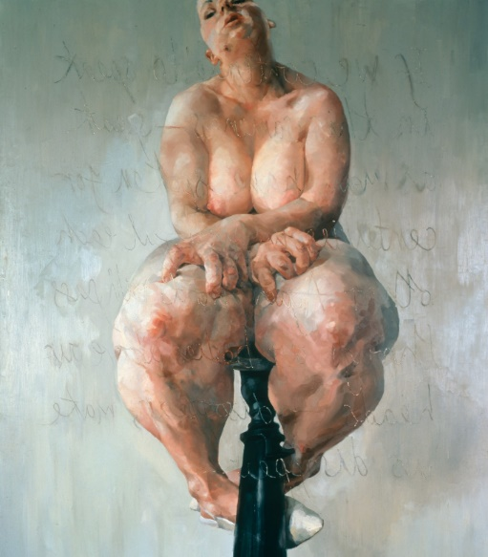

Jenny Saville
Human perception of the body is so acute and knowledgeable that the smallest hint of a body can trigger recognition.
—Jenny Saville

Saville builds her layers using oil paint which in itself resembles the idea of flesh and growing. Using both classical figuration and modern abstraction, Saville is able to present the women’s form in a new light, her inspiration drawing on from the idea of imperfections and social taboos. Having experienced the works of plastic surgeons in New York, Saville was interested in the resilience of the human body as well as the fragility. This balance of fragile and abstract is apparent in her work and will fit well to the theming and intention of the exhibition.

Martha Wilson

Wilsons ‘thump’ artwork places itself around the idea of performance artworks and their place within activism in politics. Trumps role in presidency has been a highlight in topical discussions and is a trending, contemporary theme which arouses conversations. With current headlines questioning Trumps authority and integrity, it makes for a conversational piece within the exhibition. Placed next to the painting by Saville, the connection will be to relate the comments Trump has made towards the idea of women in particular but also again reflect on other issues surrounding our contemporary society.

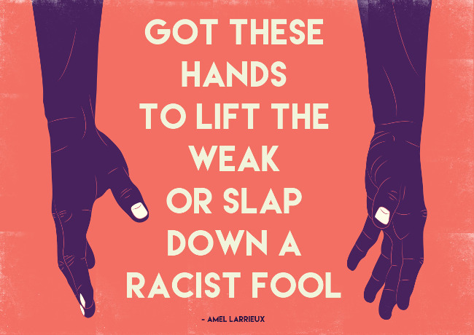
Final Artwork:Thandiwe Tshabalala

Tshabalala is a graphic artist which specializes in illustration on topics such as life, love, poverty and politics. Different to the thump piece, Tshabalala incorporates bright, loud colours to tackle darker, more serious subjects. This is done through drawing in the attention of the viewer through brave (and sometimes humorous) concepts within her design work. Similarly, to the Thump piece however is the idea of opening up discussion and interest towards female artists/designers.

Conclusion
Therefore, to conclude the exhibition will be aimed to focus around the idea of conversation. Using women’s rights as an example relates to a contemporary topic and begins a conversation with even larger, global issues in relation to acceptance and the human behavior. With news headlines being very much centered around global cultures and differencing opinions, it’s the perfect opening for the public to come together and discuss these issues.

Bibliography
Websites
02/10/2018, 10 worst countries to be born a woman, The Talko (https://www.youtube.com/watch?v=sQdMN9MuIEE)
20 best art museums in the world,Widwalls (https://www.widewalls.ch/10-contemporary-art-museums/the-reina-sofia-museum/)
Buffenstein A, 22/11/2016, 10 young female artists’ perspective on feminism today’, Art World (https://news.artnet.com/art-world/10-young-female-artists-feminism-753911)
Cut Pieces, Moma Learning (https://www.moma.org/learn/moma_learning/yoko-ono-cut-piece-1964/)
Iveta, Today’s society Captured in 102 Brutally honest illustrations, (https://www.boredpanda.com/todays-problems-illustrations-john-holcroft/?utm_source=google&utm_medium=organic&utm_campaign=organic)
Kordic A, 8/03/18, How Art Fought For Women’s Rights, Widewalls(https://www.widewalls.ch/how-art-fought-for-womens-rights-feature-2015/the-feminist-art-movement/)
Learoyd R, 03/04/2019, PACE, (https://www.pacegallery.com/)
Maw K, 16/10/2018, Michelle Obamas Speech about women’s rights and their body, (https://www.youtube.com/watch?v=TmRw1Yd2zeQ)
Molloy M, 06/02/2018, How far have women’s rights advanced in a century, The Telegraph (https://www.telegraph.co.uk/women/life/far-have-womens-rights-advanced-century/)
Reilly M, 26/05/2015, Taking The Measure Of Sexism: Facts, Figures and Fixes ,Art News http://www.artnews.com/2015/05/26/taking-the-measure-of-sexism-facts-figures-and-fixes/
Richards D, 19/05/2016, The Pressures Of Modern Living, British Psychoanalytical Council,(https://www.bpc.org.uk/news/pressures-modern-living-living-diverse-society)
Sarah, 18 mind-blowing and scary facts about todays society, The Wonder list, (https://thewonderlist.net/18-mindblowing-scary-facts-todays-society/)
The Feminist Artists Who You Need To Know,Google Arts and Culturehttps://artsandculture.google.com/theme/IQISUC6SwwhEKw

Books & Journals
Freedman J ( 2001) , Feminism, Buckingham : Open University Press
Barry, P (2017) Beginning Theory: An Introduction to Literary and Cultural Theory, Sections on Postmodernism. Manchester: MUP
Obrist, H. U. (2016) Ways of Curating. New York : Farrar, Straus and Giroux

