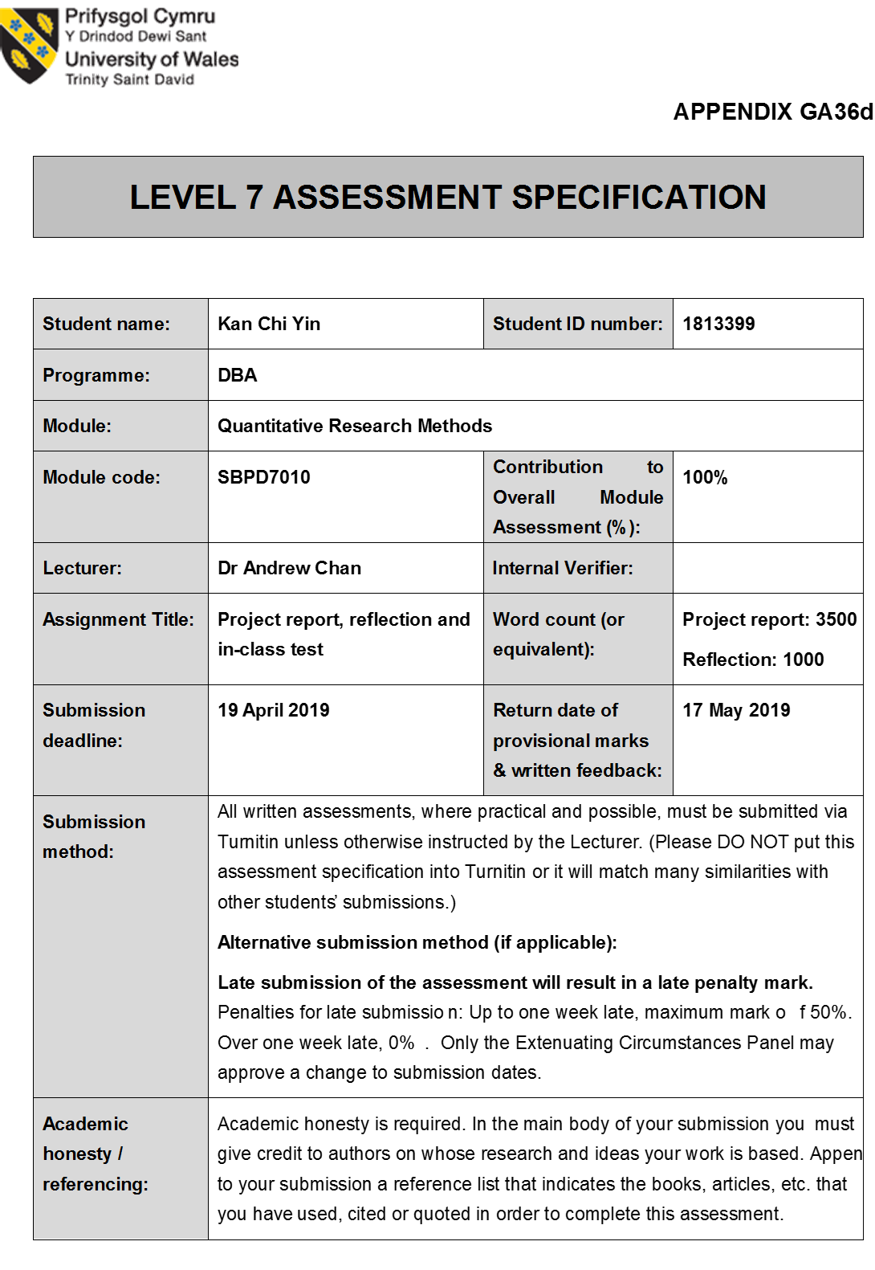

Priority of job satisfactory in Hong Kong financial industry:
An additional factor influencing Gen Y quit their job from bank to insurance sector and broker film

By Natural Kan

University of Wales Trinity Saint David
Apr 2019

Content

Introduction P.4
Literature review
  - Conceptualisation P.6
  - Hypotheses development P.9
Methodology
  - Measurement/scale development P.10
  - Sampling P.12
Findings P.15
Conclusion P.17
Reference list P.19

Introduction

If you had the chance to work in bank twenty years ago. No matter in what position that would be labelled you were elite group in Hong Kong society. Banking jobs can be classified the ideal career position as top as some professional industry such as Doctor, Lawyer and Accountant. Indeed, there are so many fresh graduates had been chosen the banking industry to be the 1st choice of their lifelong career path rather than general professional last decade.

However, there was a radical change because of financial tsunami since 2008. So many famous financial institutions were shut down during these years. The most impactful thing must be the black sheep among the industry introduced some inappropriate products to the layman to incur that they had suffered a huge financial loss eventually. Besides, some of educated person and even tycoons were recommended to invest some structure products which has been derived a profound effect for the financial market. The public started to doubt the creditability of this industry not only the corporation’s level but also their issued products, previous regulations and system even their most important asset – staff. To solve this problem, both the government and financial industry has kicked off to formulate the new regulation for monitoring the chaotic financial environment. Certainly, more and more regulations implement to oversee the financial market order. We can see that new market pattern has been generated since they are some rules have been derived to guide the practitioners such as Anti-Money Laundering (AML) and Foreign Account Tax Compliance Act (FATCA).

In reverse, more guidelines will let the bank staff elevate their alertness but these monitoring also loom the pressure for them simultaneously. Nowadays, banking industry is no longer the best job in the young generation’s mind anymore. Despite the financial industry is still higher pay than the other industry relatively. Gen Y look for the work-life balance more and they weigh it as the top priority for selecting their career path in long run. Literally, there are some young men willing to join the financial industry because the remuneration is still attractive, but the pressure of workload is not positive correlated with the salary pay now. They are struggling how to strike the balance between the pay and effort each other.

For these recent years, a new phenomenon has been come up in the market. Some new generations join the financial industry who does not insist to join the bank but trends to entry into some insurance companies or broker firms. This is only reason and solution that how Gen Y can be satisfied with high salary but also enjoy the work-life balance because of this kind of platform are relatively less pressure on compliance monitoring and the working hours could be flexible when compare with working in traditional bank. Moreover, these new types of financial institutions to attract more and more new comers joining into their families, they can offer the comprehensive package is much higher than bank in additional terms. Then how can bank industry still retain their talents in their group anymore. Is that banking now in the dark side now?

Literature Review - Conceptualisation

This section is going to review 3 parts as below:

First, how we applied our survey to know the job satisfaction of the practitioners in Hong Kong banking industry. Why we need to do this topic and our goal eventually? Second, how we apply the Herzberg’s Motivation Theory – Two Factor Theory in our banking industry. Finally, what is the difference of our survey between with others?

As you all know the research of job satisfaction has been discussed completely by some scholars. Most research are used to study how to enhance the job satisfaction for their staff. (Grandey, 2013) Their study proved that most of employees maintaining positive emotions with customers as part of the job — depend on the ﬁnancial rewards. However, our new generation of labour force must come from the Gen Y. Nowadays, there are many evidences telling us that “Money” may not be the key motivation factor for our new generation devoting their job especially in financial industry. (Spea, 2003) We found that they may consider more about the career development opportunities, communication between the stakeholders and manager but the most crucial factor is employee autonomy and independence. For the competing environment, if you want to make your teammates staying loyal in the company. Willing to listen and self-criticism are the most important part for facing with the staff in bank. There are many management training programs in banks included this syllabus to train up their managers to enhance their skills dealing with Gen Y. (HOUSE, 2019)

Working in bank is no longer the ideal job for the fresh graduate anymore. Because most of the frontline staff need to bear unrealistic target and pressure which is not in direct proportion to the reward. (Anon, 2015)
.
After the financial tsunami in 2008, there are so many regulatory problems that need to be overcome in the financial industry. One of the top priorities should rebuild the financial market system and regain lost confidence from the public. (Schieffer, 2009) Then more and more rules and regulations have been launched last 10 years for frontlines to follow it. This was absolutely towards more pressure for staff apart from the performance ranking among the peers.

Also, here are many broker firms and insurance companies expanding their network in Hong Kong even in China and Asia pacific. According the greater bay area is forming and promoting by China in these recent years, it must speed up the financial market reforming rapidly. It comes up more career moving opportunities for banking industry staff. (Chan, 2019).

For this survey, we would like to explore the new generation how they feel the prospective of Hong Kong banking industry and will analyse it for the banking managerial staff to guide them for retaining their high productive performers in their company. Indeed, the we hope to know more their job satisfaction and apply the Herzberg’s motivation theory with it.

There are 2 factors that a bank can adjust to influence motivation in their working environment. They are Motivators and Hygiene factors respectively.

If the manager can make the motivation factors in the workplace, then the employee job satisfaction would be increased.

In reverse, if poor hygiene factors exist, it would be decreased the job satisfaction in the company.

We have 6 elements in the motivating factors, they are Achievement, Recognition, The work itself, Responsibility, Advancement and Growth.

Nowadays, the fintech application is the hot topic for the financial industry. Is their company aligned with the business environment for facilitating the personal growth with the high technology application would be the crucial factor in motivation?
Moreover, most of the new generation are looking for recognition and career autonomy in their job. (EHS, 2008)
Is that banking environment provided it for them?

For the hygiene factors include 7 elements, they are Company policies, Supervision, Relationships, Work conditions, Salary, Status and Security.

Young people like their working environment which is “Work hard and play hard”. Obviously, the flexibility of working hours and the workload would be the top priority for choosing their job in Gen Y’s group instead of higher paid. Also, the work conditions and company culture are the crucial points for holding Gen Y’s loyalty in the company (SAGE, 2019). Therefore, how the manager plays the role for facilitating between the company and staff are very important currently.

In summary, the main difference of the traditional survey and research with us that we are going to do the 360-degree feedback with the employee and with the supervisor even participating with senior management in our main survey. It is the good chance for both sides to know more their prospective each other. And the most important thing is we can synchronize the relevant parties of their controversy and finalize the way for retaining more talents stay in banking industry.

Literature Review - Hypotheses development

As we mentioned that there are many talents in banking industry leaving now and moving to other financial institutions.

Is there a relationship between talents’ job satisfaction, perceived fairness and their intention to quit? To answer this question, we tried to run a correlation analysis. (Web, 2011)

We tried to define the dependent and independent variables are representative for performance and job satisfaction respectively. Basically, most of employees are satisfied their job because they can deliver the best performance in the career path. They can be recognized by their peers and praised by management team which may be one of the key factors for their job satisfaction reason.

Ho: There is no association between the two variables (Performance and Job satisfaction).
Ha: There is an association between the two variables (Performance and Job satisfaction).

Methodology - Measurement / Scale development

There are 4 levels of measurement can indicate the information obtained about a variable and the statistics that can be used to describe its variation. They are nominal, ordinal, interval and ratio scale.

We set up a scale for the survey which followed by the scale development guidelines by 8 steps. (DeVellis, 2nd ed., 2003). For this section, we used the interval scale because we assumed to have equal distance between each of the scale element. We nearly followed the scales development guidelines to set up the survey but somehow there were some steps skipped but we will align it in our main survey later.

We tried to collect the data from the practitioners who are working in banking industry or some of them may consider joining in financial industry for knowing more their prospective on it. The descriptive statistics targeted to testing how diverse working environment in banks affect the talents especially Gen Y leaving it and considering joining in other financial institutions platforms.

We have developed an organized survey was used to consolidate data for studying. Our questionnaire construction is targeted to use a simple language and short questions. Also, the principles of question are single focussed, non-leading and free from ambiguity as our priority tasks. A detailed interview was carried out to refine the instrument.

The survey was made up by 3 parts. The 1st part of the survey collected respondents their basic information and ensuring that only the targeted practitioners were involved in the study. As the material part of the survey was section 2. Our targeted bank staff of their view of job satisfaction was segmented into 5 items, namely: (1) Direct Benefit, (2) Working Environment Factor, (3) Indirect Benefit, (4) Interaction with your stakeholders and (5) Feeling of your manager.

For each item, there are 3 components were summarized belonging to the fundamental dimensions of each bank staff consideration which are emotional, practical and logical. Each practitioner was asked to select every dimension on a scale of 1 (very dissatisfied) to 5 (very satisfied). 5 points overall satisfaction scale was also used separately because it was categorised as an objective of each bank staff’s experience job satisfaction.

The 3rd part of the questionnaire focused on the bank staff characteristics and asking their prospective for the banking industry of the interviewees.

The questionnaire was preliminarily tested on a group of banking members, and we did not use the 3rd part of data in the pilot test for SPSS analysis but we will reserve it for main survey as reference in future. A non-probability sampling was the best choice to be adapted. We used the convenience sampling for this study. We selected the nearest and most convenient people to participate in this research. Indeed, a restriction of the study is that the findings may not be concluded.

Methodology - Sampling

To minimize possible sample bias, the target population and the sampling frame was defined as bank staff working in banking industry, or they intend to work in banking environment in future and who had been working in bank in their past working experience. We chose the non-random sampling method and the snowball sampling procedure were used to select, and these 3 groups of respondents are asked to identify others who belong to our target population of interest for exploring those people feeling of banking industry of their prospective.

There are 22 respondents of different diversities were interviewed. All respondents spent around 2 minutes for replying the survey respectively. We did the great follow up process with all participants. Finally, we left 21 useable questionnaires for further analysis. The participation rate was almost 100%

SPSS statistical package analysed the collected data. Both descriptive and Inferential statistics applied in this research. The general characteristics of the respondents summarized by the descriptive
statistics. Moreover, Inferential statistics for a series of correlation was performed to compare data from respondents of job satisfaction, performance and category of working experience level in bank. (Iosrjournals, 2018) Pearson’s correlation analysis was not necessary to be used for testing the relationship between overall job satisfaction and the performance. Because we tested the readiness for measuring to conduct a survey of respondents with 21 practitioners in the pilot version. The number of respondents was insufficient for pilot one and we will invite more participants to get involve it in our main survey in future. We expect the T-Test and ANOVAs will be applied in the next level too.

Table 1
Pilot Survey Respondent Characteristics (n = 21)
 | Value | %
Gender
Female | 6 | 28.6
Male | 15 | 71.4
Age
18- 29 | 6 | 28.6
30 - 39 | 5 | 23.8
40 -49 | 7 | 33.3
50 - 59 | 3 | 14.3
Marital Status
Single | 10 | 47.6
Married | 11 | 52.4
What is the highest level of education you have completed
Bachelor | 5 | 23.8
Master | 14 | 66.7
Doctoral | 2 | 9.5
How long have you worked at bank
Less than 1 year | 6 | 28.6
1 - 3years | 1 | 4.8
3 - 5 years | 1 | 4.8
More than 5 years | 7 | 33.2
No experience | 6 | 28.6

Table 2
Working Environment in Banking Industry Feedback
Item | Mean | Std. Deviation | Cronbach Alpha
Direct Benefit | 3.97
1. Salary and Benefits | 4.10 | 0.995 | 0.961
2. Frequency and amount of bonuses | 3.90 | 1.044 | 0.961
3. Connection between pay and performance | 3.90 | 1.136 | 0.961
Working Environment Factor | 3.91
4. Workload | 3.43 | 1.363 | 0.902
5. Flexibility of work hours | 3.81 | 1.123 | 0.902
6. Physical working environment | 4.19 | 1.030 | 0.902
7. Opportunity for advancement | 4.00 | 1.049 | 0.902
8. Job security | 4.10 | 0.944 | 0.902
Indirect Benefit | 4.01
9. Competence to influence decisions that affect you | 3.95 | 1.117 | 0.924
10. Competence to affect day-to-day company success | 4.00 | 1.000 | 0.924
11. Opportunity to use new technologies | 3.86 | 1.108 | 0.924
12. Opportunity to participate with interesting projects | 3.95 | 1.024 | 0.924
13. Access to company-sponsored training and seminars | 4.29 | 0.644 | 0.924
Interaction with your stakeholders | 4.16
14. Communication with your supervisor | 4.10 | 0.889 | 0.964
15. Recognition received from your supervisor | 4.14 | 0.854 | 0.964
16. Your supervisor's management capabilities | 4.14 | 0.854 | 0.964
17. Your supervisor's active involvement in your career development | 4.00 | 0.894 | 0.964
18. Your relationship with your peers | 4.43 | 0.598 | 0.964
19. Your relationship with customers/clients/end users | 4.14 | 0.793 | 0.964
Feeling of your manager | 4.18
20. Effectively leads the department | 4.29 | 0.717 | 0.960
21. Communicates well with subordinates | 4.14 | 0.910 | 0.960
22. Recognizes good work | 4.14 | 0.910 | 0.960
23. Has good leadership qualities | 4.14 | 0.910 | 0.960
For items 1–23 were shown using 5-point Likert-type scales, with 1 = Very dissatisfied and 5 = Very satisfied.
Finding

To determine whether the studied items within scales correlated as our prediction. We conducted an item analysis and erased some irrelevant which did not correlate well within scales for our job satisfaction research. There are 2 measures mainly were considered in the item analysis.
Cronbach alpha for reliability which items are measuring each construct and Mean for verifying the appropriateness of the questions setting. The minimum threshold of .70 for Cronbach alpha and result of Mean closed to middle of 5-point Likert-type scales would be revealed the survey has the discrimination power.

Survey Respondents

There are 21 employers finished the pilot survey (Table 1). Over seventy percent of the sample (71.4%) came from male practitioners and the remaining participants are female. One third of the participant (33.3%) came from prime age group in 40 – 49 in majority. Almost half of them (52.4%) were married, and over two thirds of participants have completed the master degree. Over one third of practitioners have been worked at bank more than 5 years.

Scale Characteristics

The items were defined the scales representing into five constructs. They are (Direct Benefit, 3 items; Working Environment Factor, 5 items; Indirect Benefit, 5 items; Interaction with your stakeholders, 6 items; and Feeling of your manager, 4 items). All items were graded using 5-point Likert-type scales (1 = very dissatisfied, 5 = very satisfied). We deleted the part of “prospective for banking industry” that did not fulfill the minimum threshold for scale reliability.

Each construct ranged from 3.91 of mean scale scores (Working Environment Factor) to 4.18 (Feeling of your manager), and Cronbach a ranged from .902 (Working Environment Factor) to .964 (Interaction with your stakeholders; Table 2).

Most items of the mean were ranged 4 except the Working Environment Factor and Direct Benefit. Among the working environment items, the workload and flexibility of work hours has shown at 3.43 and 3.81 respectively. These 2 items of indication were closed to the mean and it could be explained that they both have a discrimination power among the group. And all items of Cronbach alpha were larger than .70.
All items met the threshold for scale reliability. Working environment in banking industry feedback questionnaire items includes 23 items, which are presented in Table 2.

As I mentioned before, we provided the 3rd of survey which focused to know more the respondents of their prospective for banking industry. These questions would like to explore the practitioner’s mindset of their career outlook especially on whether they will leave the banking industry and joining other financial institution. These question items were binary (0 = no, 1 = Yes). However, many respondents did not reply this section because of skip patterns.

Conclusion

We pilot tested a theory based on job satisfactory of practitioners in Hong Kong financial industry especially the Gen Y quitting their job from bank to insurance sector and broker firm

This questionnaire may ultimately help practitioners and their managers identify the job satisfaction in their working environment and induce them to explore which items are the key motivation and hygiene factors respectively. This questionnaire can be an indicator for those banking managerial staff to review their existing company policy for finding out the way to retain their talents and setting up the new strategy to attract more elites especially Gen Y retaining in banking environment. Literally, this survey can fulfil this purpose, but we should try to polish some items in our main survey later.

First, in the table 2, items with means did not close to the middle of the scale very much because most of our mean value at 4. We have the room to adjust the questions more precise and understandable. There is the problem if items with means near the ends are not good enough and it may make some certain values cannot be detected. Then we make the items with large variances in our main survey.

Secondly, internal consistency can be measured by Cronbach Alpha. However, all 5 items were above .90. Even anything higher than .70 is a good alpha. I will also consider shortening the scale of these items in main survey.

Indeed, the result also provides important support for Hertzberg’s two factors theory. As we mentioned before, the result of questionnaire proved that Workload was the most of practitioners concerned area. The next highlighted item was the Opportunity to use new technologies. These two items with means close to the middle of the scale at 3. It matched with our expectation.
There are four steps we need to determine for the job satisfaction in banking industry feedback questionnaire. We are now studying the job satisfaction in banking environment, but it is linking with the performance directly in the hypotheses development. In future, this type of performance measurement questions will be added in the main survey. Also, 2 of key elements we did not find it out in the pilot survey. For this research, we would like to explore whether the Gen Y leaving the bank and they will join similar nature of institutions such as insurance companies and broker firms. For this aspect, we expect to use the 3rd part of the questionnaire to investigate it. However, the size of the sampling and the preciseness of questions will improve it and the revised version will be delivered it to our respondents for answering in main survey.

Our mission is to prepare the better working environment in banking industry feedback questionnaire therefore it expects to find out the reason behind of the correlation between job satisfaction and performance, quitting reason and their coming direction of career path. It will be the reliable and practical tool for practitioners and their managers for company review in future.

Reference list:

- Anon, (2015). [online] Available at: https://www.researchgate.net/publication/290020721_Occupational_stress_in_banking_sector [Accessed 22 Apr. 2019].

- Chan, W., Mak, B., Lee, D. and Zhang, C. (2019). A framework of environmental mitigation for the convention and exhibition centers in the China greater Bay area.

- EHS Today. (2008). Gen Y Workers Report Low Job Satisfaction Levels. [online] Available at: https://www.ehstoday.com/safety/news/workers [Accessed 22 Apr. 2019].

- Grandey, A., Chi, N. and Diamond, J. (2013). Show me The Money! do Financial Rewards for Performance Enhance or Undermine The Satisfaction from Emotional Labor?

- HOUSE, R. and WIGDOR, L. (2019). HERZBERG'S DUAL-FACTOR THEORY OF JOB SATISFACTION AND MOTIVATION: A REVIEW OF THE EVIDENCE AND A CRITICISM.

- Iosrjournals.org. (2018). [online] Available at: http://www.iosrjournals.org/iosr-jbm/papers/Vol20-issue5/Version-7/I2005077681.pdf [Accessed 22 Apr. 2019].

- SAGE Journals. (2019). The Relationship Between Message Distortion and Job Satisfaction—a Field Study. [online] Available at: https://journals.sagepub.com/doi/abs/10.1177/002194367401100405 [Accessed 22 Apr. 2019].

- Schieffer, J. (2009). Be prepared for the regulatory Tsunami - Derivsource. [online] Derivsource. Available at: https://derivsource.com/2009/02/02/be-prepared-for-the-regulatory-tsunami/ [Accessed 22 Apr. 2019].

- Spea.indiana.edu. (2003). [online] Available at: https://spea.indiana.edu/doc/undergraduate/ugrd_thesis2012_mgmt_burton.pdf [Accessed 22 Apr. 2019].

- Web.usm.my. (2011). [online] Available at: http://web.usm.my/aamj/16.1.2011/AAMJ_16.1.4.pdf [Accessed 22 Apr. 2019].

