
Contemporary issues in Marketing management
Strategic response to Diversity and Inclusion

January 1, 2020
Jessica Rees
1703037

Contents

Executive Summary……………………………………………………..Page 2

Introduction…………………………………………………………………Page 3

Background to Organisation……………………………………Page 3

Aims and Objectives…………………………………………………Page 3

2.3 Opportunities…………………………………………………………..Page 4

Diversity and Inclusion ………………………………………………….Page6

Implementation and Impact……………………………………...Page 7

Advantages and Disadvantages…………………………………Page 8

Conclusion……………………………………………………………………Page 9

Recommendations…………………………………………………………Page 10

References…………………………………………………………………….Page 11

List of Figures

Figure One: Starbucks Aspirations …………………………………………….Page 4

Figure Two: Diversity and Inclusion at Starbucks ……………………….Page 5

Figure Three: Starbucks Current Environment …………………………...Page 5

Executive Summary

The purpose of this report is to identify how Starbucks is carrying out diversity and inclusion within the company.
The American coffee company and global coffeehouse chain, Starbucks, was founded in Seattle, USA in 1971 and almost 50 years later, the company now operates globally with over 30,000 locations. (Starbucks, 2020) Since the rise of Starbucks, the company has popularised artisanal coffee, as well as hot and cold drinks. Starbucks mission statement “to inspire and nurture the human spirit – one person, one cup and one neighbourhood at a time.” (Starbucks, 2020) The aims and objectives of the company link well with their mission statement.
Throughout the research conducted in this report, it is found that through their aims and objectives, they are taking diversity and inclusion in their stride, to make not only Starbucks to be a diverse and cultural workplace, but a place people can come to feel included and welcome. On the Starbucks website, the company shows impressive figures of how their current environment has been impacted by diversity and inclusion, with more minority workers being employed, people of different cultures, as well as the number of women employed who are also in higher up positions. Although with these impressive figures, there is always the element of bias that can affect the productivity of inclusion, through conscious and unconscious bias, although some may argue this is through ill-education of these important factors today. Even though there are advantages and disadvantages to every way diversity and inclusion can be taken and moulded to any company, it is important that Starbucks continue to develop on creating a diverse and inclusive workforce. This may be considered through employing more disabled people, as this group is considered an underemployed group as a lot of company’s employee people that ‘fit’ the position, and not look at what more the person could bring to the table. Overall, Starbucks do well to become a diverse workplace, but the company could continue to do more to spread this globally, to see more of these figures in more of their coffeehouses around the world.

Introduction

Biologically, we are all the same as humans, but at the same time, we are all unique. It is within no doubt that in recent years, contemporary issues such as equality, diversity and inclusion have become a forefront matter within society, and as mentioned by Price (2019) business leaders have since recognised that a more inclusive and diversified workforce results in greater engagement from employees, having the same domino effect on innovation as well as financial position and of course, market share. More specifically, diversity refers to the act of empowering people by learning to respect and appreciate them as an individual regardless of their gender, sexual orientation, religion and so forth. (Young, 2002) Inclusion is having a sense of belonging, with practises and organisational effort to socially accept and equally treat everyone with fairness. By having an inclusive culture, specifically within a workplace, can make individuals feel valued which can often have visible effects such as access to information, participation within meetings and so forth. (Frost, 2016)

2.1 Background of Starbucks

The American coffee company and global coffeehouse chain, Starbucks, was founded in Seattle, USA in 1971 and almost 50 years later, the company now operates globally with over 30,000 locations. (Starbucks, 2020) Since the rise of Starbucks, the company has popularised artisanal coffee, as well as hot and cold drinks. Starbucks mission statement “to inspire and nurture the human spirit – one person, one cup and one neighbourhood at a time.” (Starbucks, 2020) The aims and objectives of the company link well with their mission statement.

2.2 Aims and Objectives

Starbucks already have many aims and objectives that they are constantly working towards. On their website, they have set out a list of aspirations, ensuring that these are their daily aims as well as creating objectives to constantly work towards.
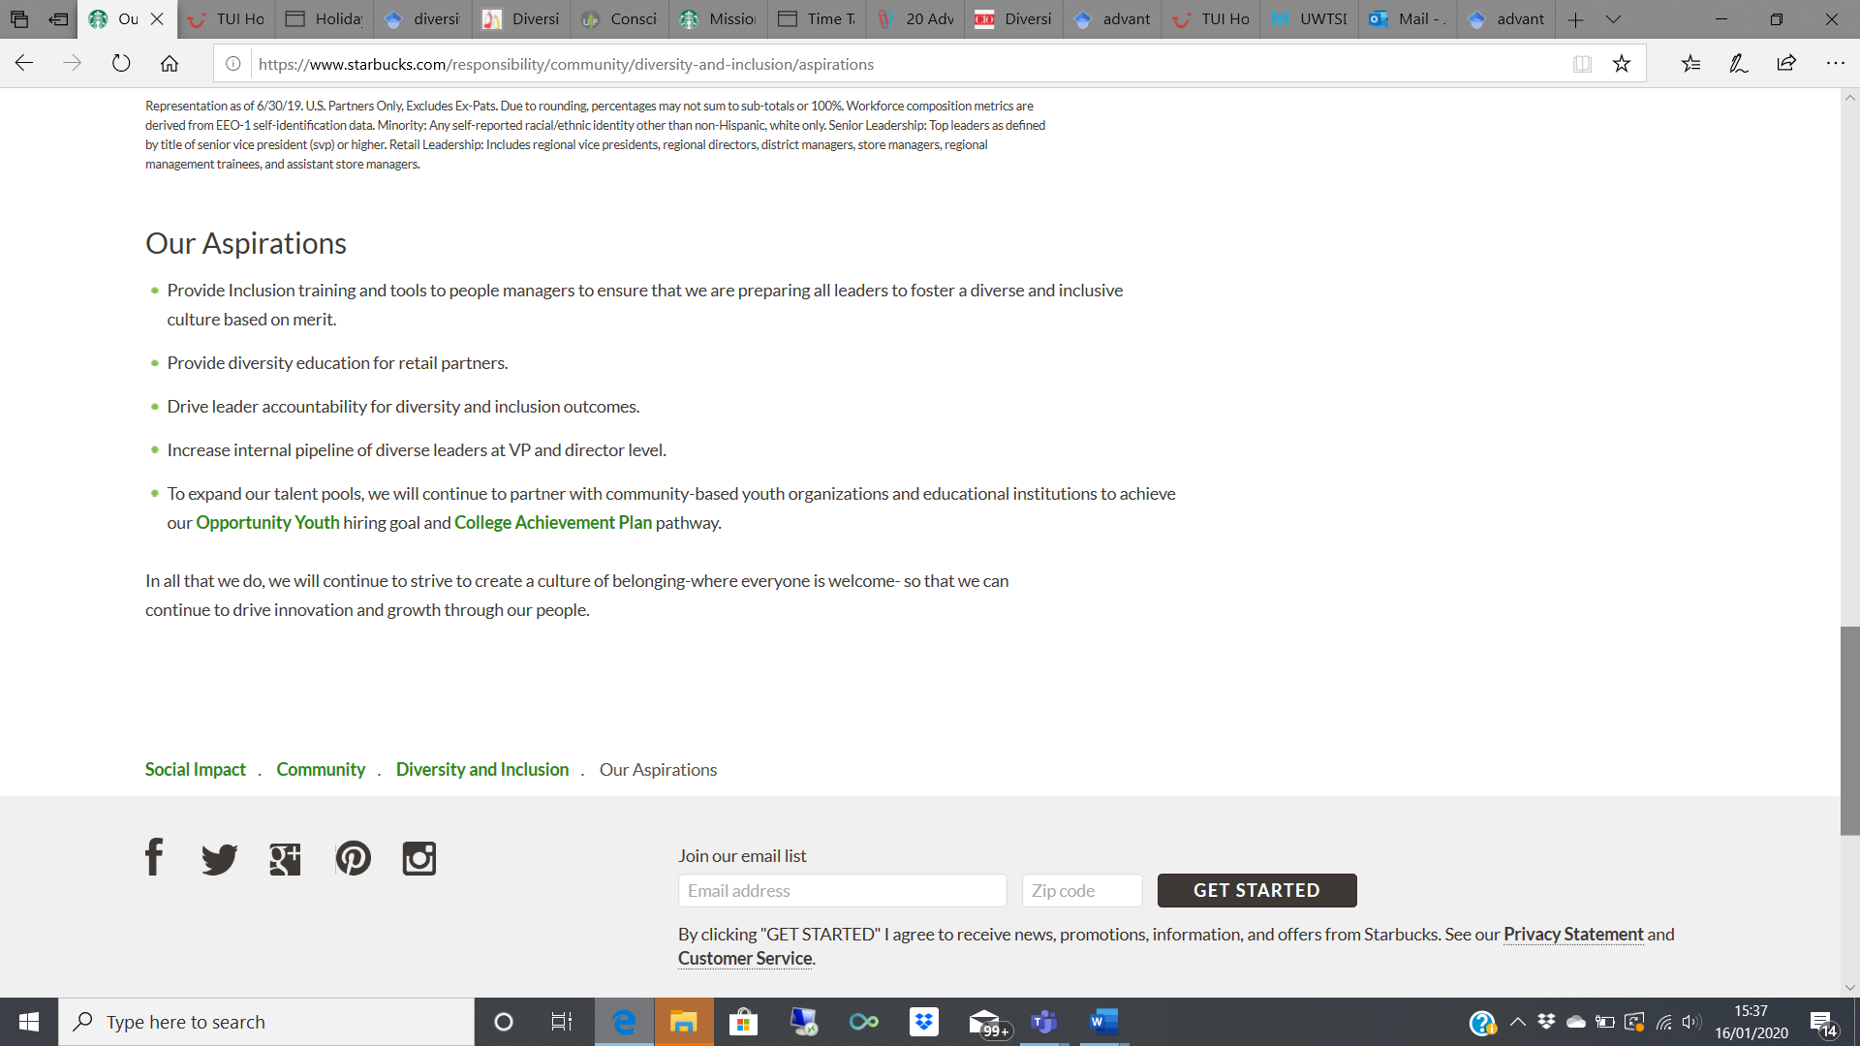
Figure One: Starbucks Aspirations. Source: www.starbucks.com/responsibility/community/diversity-and-inclusion/aspirations

Imposingly so, many of these objectives are built around diversity and inclusion, regarding issues such as providing inclusion training for leaders, providing diversity education for the company’s partners, as well as continuing the drive for diverse leaders at higher levels like director levels and so on.
As acknowledged by Syed (2019) he mentions “The disabled community, in particular, face significant barriers to obtaining employment. In societies around the world, they are more likely than other workers to be unemployed or underemployed and experience disproportionate inequality in the workplace, facing barriers that are beyond their perceived functional limitations.” This is interesting as it shows that Starbucks could perhaps go further than taking pride in employing a majority group, or more women and look at positions that could be available to more disabled people.

Opportunities

Starbucks have been big activists of diversity and inclusion and keep it at the heart of their business. On their website, Starbucks dedicate a page ‘Creating a culture of belonging, inclusion and diversity’.
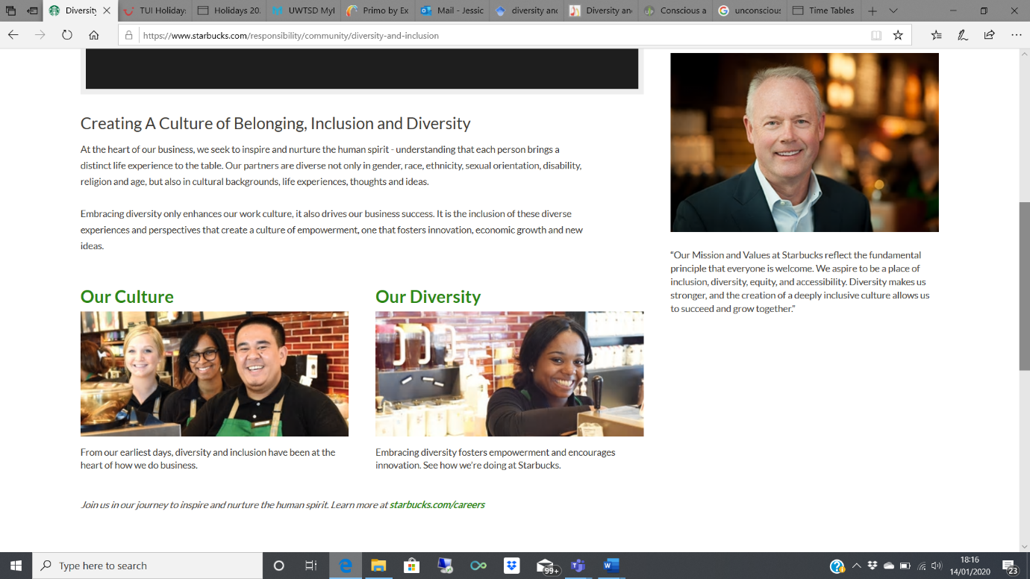
Figure Two. Diversity and Inclusion at Starbucks. Source: www.starbucks.com/responsibility/community/diversity-and-inclusion

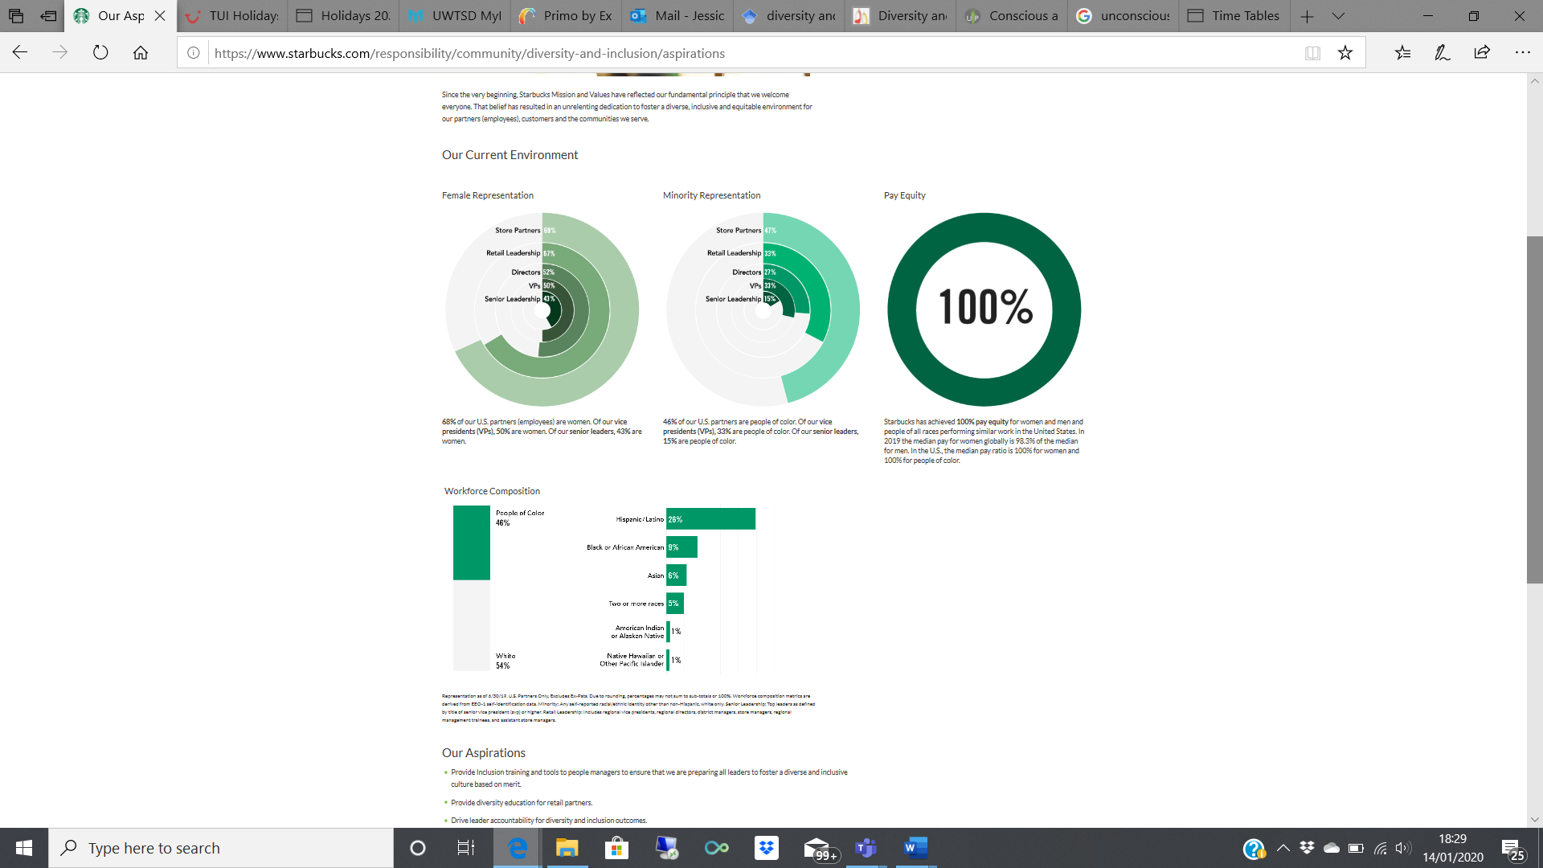
Keeping this at the forefront of the company, as well as having this page easily accessible on their website shows their willingness to creating a belonging culture, a place where everyone is welcome. Starbucks does not shy away from showing their current environment, regarding their female representation, minority representation and their pay equity.
Figure Three. Starbucks Current Environment. Source: www.starbucks.com/responsibility/community/diversity-and-inclusion/aspirations

Starbucks are extremely proud of their female representation which shows impressive figures, 68% of employees are women, with 50% being vice presidents and 43% as senior leaders. Starbucks have done impressively well to tackle the gender bias and gap between men and women, showing that women can do the same jobs as men. The company’s minority representation shows that 46% of U.S partners are people of colour, with 33% being vice presidents, and a further 15% of people of colour are senior leaders. These figures combat the stigma of an undiversified workplace, accepting everyone of all ages and differences and coming together as one. Another big part of diversity that has been a huge issue from 100 years ago to now, is equal pay. Starbucks has achieved a 100% pay equity between men and women with similar job titles in the united states alone, leaving no gaps in the gender pay gap, allowing all employees and partners to feel apart of an inclusive workplace.

Diversity and Inclusion

The awareness of diversity and inclusion has become far more popular through the rise of social change. Social change regards the adjustment of social order within our society, and most recently, these changes have involved social behaviours, social relations and social institutions. (Roberson, 2006) With social change pushing through a more diverse and inclusive society, this is referred to as global diversity practise. Global diversity practise is the range of differences that describe a group of two or mor people in either a cross-cultural or multi-national context. It also means ensuring that all voices are heard and considered whilst understanding, accepting and valuing differences.
Whilst understanding diversity and inclusion, there is the unfavoured element of bias, determined mainly in conscious and unconscious bias. Bias of often defined as prejudice held against an individual or group in a way that’s often considered unfair. Conscious bias is to be aware of the influence it is having on your actions, perhaps in the way individuals converse or how an individual is treated, for example, gender bias or stereotyping. (Keogh, 2003) The idea of conscious bias is often being uneducated about other’s personal experiences, and differences they may have compared to yourself. (Lee, 2005)
Unconscious bias however, refers to “your background, personal experiences, societal stereotypes, and cultural context can have an impact on your decisions and actions without you realising.” (Advance H.E, 2019) In 1920, psychologist Edward Thorndike develop the Halo Effect theory. Thorndike noticed a correlation between how people create an overall impression of someone through their personality or characteristics with another unrelated trait, which then develop positive or negative perceptions known as subjective judgement. (Grcic, 2008)

3.1 Implementation and Impact

Although its established that Starbucks already has a diverse and inclusive workforce, there is always room to find more ways to continue making Starbucks a positive place to go or work. When a new employee is recruited, they come into the company and bring their best self forward so having a connection to a company or other workers can create a sense of belonging and knowing that everyone’s self-value is valued. (Florentine, 2019)
Within every company there are managers, team leaders and so forth, those who have the responsibility to take leadership in their stride. “Diversity and inclusion are often treated as a single initiative owned exclusively by HR. But for real change to happen, every individua l leader needs to buy into the value of belonging – both intellectually and emotionally.” For a manager or someone of a higher position in Starbucks to be empathetic with their staff means that not only can they develop a relationship with staff members to provide a person to turn to, it can help apply these issues outwardly. So, if someone feels excluded, leaders can then look to counteract this for the future.
It is often noticed that a lot of companies take on a ‘top-down’ approach, meaning that a system or strategy is specified, but not detailing any specifics, whereas a bottom-up approach requires piecing together different elements to give a more detailed and specified result. Although this may seem intricate, Starbucks can take these approaches and identify differences with employees, perhaps such as experience, of which then relevant changes can be made. Doing this means employees can feel valued. (Kinchla, 1979)
An arguable habit of many companies, regarding their internal strategic infrastructure, is focussing too much on employing and training people who ‘fit’ the mould of the position. Although Starbucks are already ahead of this, they can continue to focus on helping individuals thrive, creating a culture where every employee can build up and contribute their potential. Finding a ‘fit’ can be dangerous as it can exclude rather than uplift individuals. Counteracting this would mean identifying true organisational values, mission and purpose and define a ‘fit’ so that it adheres to those. (Florentine, 2019)

3.2 Advantages and Disadvantages

By Starbucks creating a diverse workforce, it means every employee’s skills can be known and complemented by fellow workers. That way, leaders are not forced to guess who may be best suited for a task of which greater specificity is generated, meaning that strengths and weaknesses are maximised and minimised respectively, overall creating better productivity. (Regoli, 2019)
As seen on the Starbucks website, the number of job opportunities for minority workers is impressive. For an employer of Starbucks to be looking at all types of population demographics, this allows he or she to find the best possible person for the job, as they are then not limited to a specific group. Starbucks have since seen the effect of this, with figures now showing 68% of employees in the U.S are female.
Taking on a more diversified perspective could create more revenue-earning opportunities. Aulack (2017) mentions that companies that take this perspective tend to see more sales and revenues due to these efforts. Gender diversity alone can help grow sale revenues by 40%, resulting in access to new markets.
Although the theme of a more diverse and inclusive workplace may seem to have inevitable benefits, too much focus on diversity and inclusion could create disproportion. Managers need to be aware of retaining and nurturing the talent and ability of those who have had experience as a forefront matter, whilst keeping in constant mind of what conditions can promote more inclusion, and making the change if needs be. If partners and employees of Starbucks hold a meeting, insisting on diverse and inclusive behaviours will see more questions being asked, such as who is invited? Who is speaking and how often? Is there anyone possibly being left out that proved valuable to this meeting? (Salend, 2002)
An increase in diversity can create hostility. Jehn (1994) acknowledged that different perspectives always create different opinions and approaches to work, which could result in disagreement. So if an employee in Starbucks was to disagree with information a colleague has shared, some may take that as a personal attack, blasting their character, integrity or knowledge.
Having a diversified workforce could cause communication issues. Individuals with cultural differences to their colleagues may cause communication issues such as language. Although hiring people from different backgrounds and areas can bring new perspectives, it can cause issues with how workers speak to each other. Even if the same language is being spoken, there can be certain words or jargon that can cause confusion. (Harris, 1991)

Conclusion

To conclude, Starbucks are already a very diverse and inclusive company, with impressive figures showing how they have taken diversity and inclusion in their stride to create a workplace free from gender discrimination, stereotypes and so much more whilst creating more global diversity practise and accepting cultural differences. It is clear through the research that Starbucks can keep striving to reach these diverse and inclusive aims, by looking at how they can improve their current situation and expand this globally throughout more of Starbuck’s coffeehouses. Although the company may encounter some benefits and pitfalls, overall they will develop a greater sense of how a diverse and inclusive company will help them go even further through our modern society.

Recommendations

For the future of Starbucks, there are still many more ways they could take diversity and inclusion even further. Although Morais (2014) mentions the efforts the company takes to support movements such as LGBT, it seems it may only be seen in, perhaps, only in America or certain shops. By spreading the movement of using LGBT cups or advertisement, this will inevitably spread awareness, and make Starbucks seem more inclusive when everyone is involved.
A recommendation Starbucks would use wisely is to look at employing more disabled people and looking at more jobs to suit this underemployed group. Barnes (2005) highlights that especially within European countries, there are higher expectations on employers to be more proactive in employing and accommodating to disabled people in the workplace. Not only this, but this will help Starbucks to keep striving for their objectives of a more diverse and inclusive company.

References

Aulack, S., Charlwood, A., Muzio, D., Tomlinson, J. and Valizade, D., 2017. Mapping advantages and disadvantages: Diversity in the legal profession in England and Wales.
Barnes, C. and Mercer, G., 2005. Disability, work, and welfare: Challenging the social exclusion of disabled people. Work, employment and society, 19(3), pp.527-545.
Barnes, T. (2018) ‘Starbucks closes 8,000 stores to give staff diversity training amid race storm’ https://www.independent.co.uk/news/world/americas/starbucks-stores-closed-diversity-training-racial-bias-philadelphia-arrests-racist-a8374426.html (Accessed: 16th January 2020)
Florentine, S. (2019) Diversity and inclusion: 8 best practices for changing your culture. https://www.cio.com/article/3262704/diversity-and-inclusion-8-best-practices-for-changing-your-culture.html (Accessed: 15th January 2020)
Frost, S. & Kalman, D., 2016. Inclusive talent management : how business can thrive in an age of diversity,
Global Diversity (2019) https://kwhs.wharton.upenn.edu/term/global-diversity/
(Accessed: 3rd January 2020)
Grcic, J., 2008. The halo effect fallacy. Electronic Journal for Philosophy, 15(1), pp.1-6.
Harris, P.R., Moran, R.T. and Andrews, J., 1991. Managing cultural differences (Vol. 3). Houston, TX: Gulf Publishing Company.
Jehn, K.A., 1994. Enhancing effectiveness: An investigation of advantages and disadvantages of value-based intragroup conflict. International journal of conflict management, 5(3), pp.223-238.
Keogh, E., Thompson, T. and Hannent, I., 2003. Selective attentional bias, conscious awareness and the fear of pain. Pain, 104(1-2), pp.85-91.
Kinchla, R.A. and Wolfe, J.M., 1979. The order of visual processing:“Top-down,”“bottom-up,” or “middle-out”. Perception & psychophysics, 25(3), pp.225-231
Lee, A.J., 2005. Unconscious bias theory in employment discrimination litigation. Harv. CR-CLL Rev., 40, p.481.
Morais, U.P., Pena, J., Shacket, K., Sintilus, L., Ruiz, R., Rivera, Y. and Mujtaba, B.G., 2014. Managing diverse employees at Starbucks: Focusing on ethics and inclusion. International Journal of Learning and Development, 4(3), p.35.
Price, Mandy, 2019. Diversity Alone Is Not Enough: Inclusion matters too! Leadership Excellence, 36(5), pp.31–33.
Regoli, N. (2019) 20 Advantages and Disadvantages of Diversity in the Workplace. https://futureofworking.com/11-advantages-and-disadvantages-of-diversity-in-the-workplace/ (Accessed: 2nd January 2020)
Roberson, Q.M., 2006. Disentangling the meanings of diversity and inclusion in organizations. Group & Organization Management, 31(2), pp.212-236.
Salend, S.J., Garrick Duhaney, L.M. and Montgomery, W., 2002. A comprehensive approach to identifying and addressing issues of disproportionate representation. Remedial and Special Education, 23(5), pp.289-299.
Syed, J. and Ozbilgin, M., 2019. Managing diversity and inclusion: An international perspective. SAGE Publications Limited.
Unconscious bias (2019) https://www.advance-he.ac.uk/guidance/equality-diversity-and-inclusion/employment-and-careers/unconscious-bias (Accessed: 2nd January 2020)
Young, I.M. & Oxford University Press, 2002. Inclusion and Democracy. ., Oxford: Oxford University Press.

