Computational Thinking - Lego Mindstorms

By Sharla Passariello
Use Case ID: | 1
Use Case Name: | Draw 3 Rectangles
Created By: | Sharla Passariello
Date Created: | 05/01/2020

Actor(s): | Lego Mindstorms Robot
Description: | - The Lego Mindstorms Robot will hold a pen and draw 3 rectangles. Each one 10cm larger than the previous.
Preconditions: | - Code has been setup in the Lego Mindstorms EV3 program for the robot to execute the use case  - Robot is connected to the program
Postconditions: | - 3 rectangles have been drawn  - There is a 10cm increase for each rectangle drawn  - Calculations of the area of each rectangle are printed to the display
Normal Course: | - Robot draws rectangle and returns to start point, prints area size to display  - Robot draws a second rectangle 10cm bigger than the previous rectangle and returns to starting point, prints area size to display  - Robot draws a final rectangle 10cm bigger than the previous rectangle and returns to starting point, prints area size to display
Alternative Courses: | - If obstruction appears along the drawing path and is red the robot halts, raises a sound alarm, removes object, and continues course  - If obstruction appears along the drawing path and is not red the robot halts, raises sound alarm, and stops drawing
Initial Shape: | 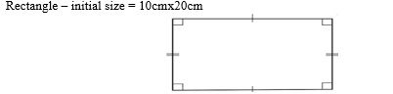

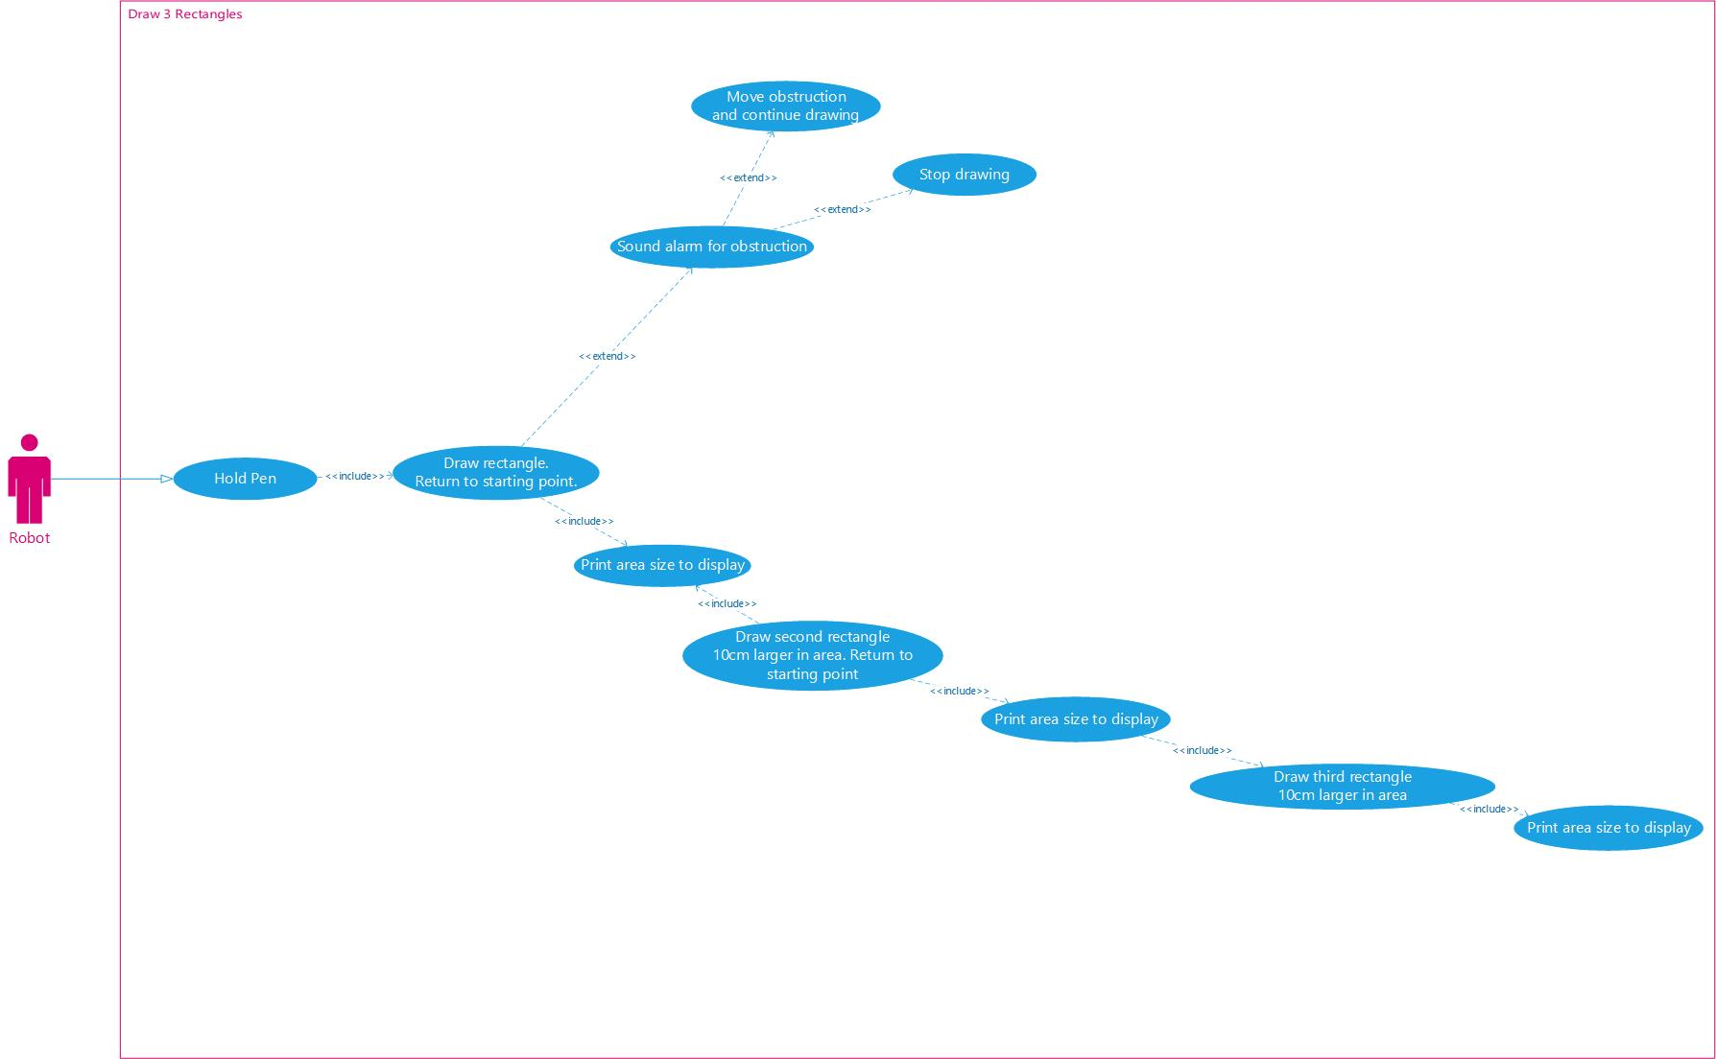

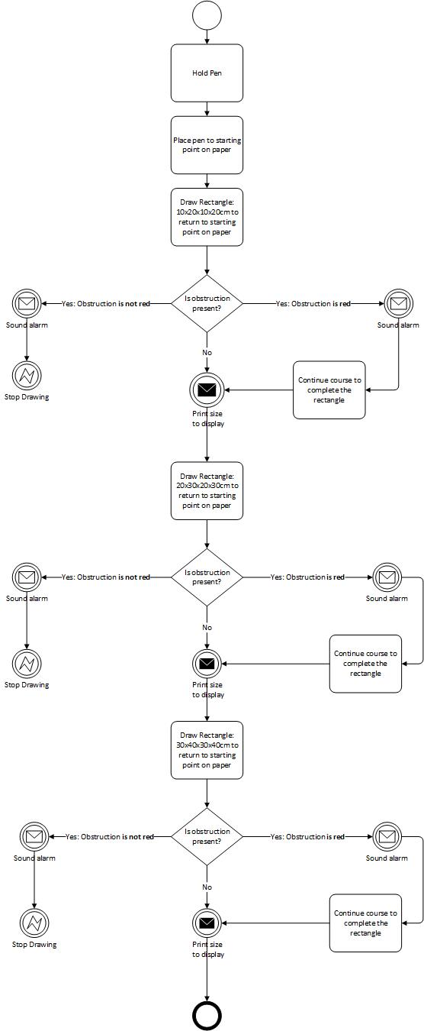
Rectangle BPMN:

Use Case ID: | 2
Use Case Name: | Draw 3 Right-angled triangles
Created By: | Sharla Passariello
Date Created: | 05/01/2020

Actor(s): | Lego Mindstorms Robot
Description: | - The Lego Mindstorms Robot will hold a pen and draw 3 right-angled triangles. Each one 10cm larger than the previous.
Preconditions: | - Code has been setup in the Lego Mindstorms EV3 program for the robot to execute the use case  - Robot is connected to the program
Postconditions: | - 3 right-angled triangles have been drawn  - There is a 10cm increase for each triangle drawn  - Calculations of the area of each triangle are printed to the display
Normal Course: | - Robot draws triangle and returns to start point, prints area size to display  - Robot draws a second triangle 10cm bigger than the previous triangle and returns to starting point, prints area size to display  - Robot draws a final triangle 10cm bigger than the previous triangle and returns to starting point, prints area size to display
Alternative Courses: | - If obstruction appears along the drawing path and is red the robot halts, raises a sound alarm, removes object, and continues course  - If obstruction appears along the drawing path and is not red the robot halts, raises sound alarm, and stops drawing
Initial Shape: | 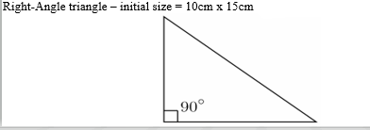
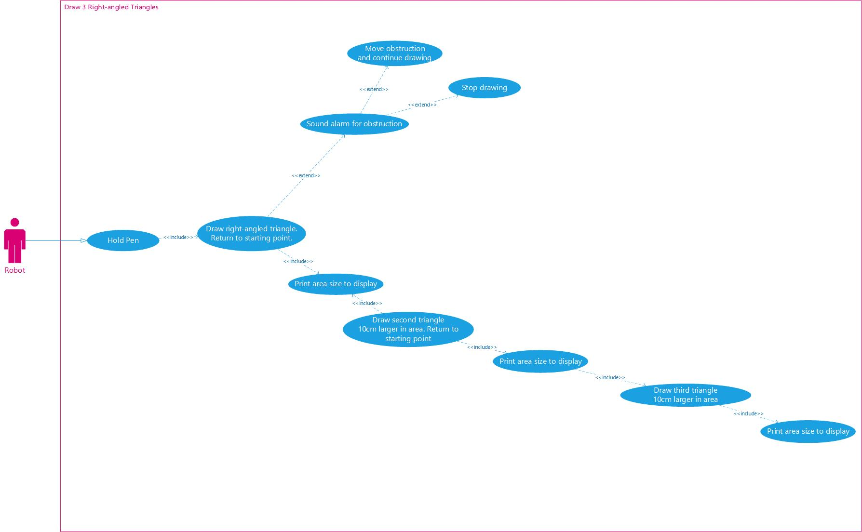

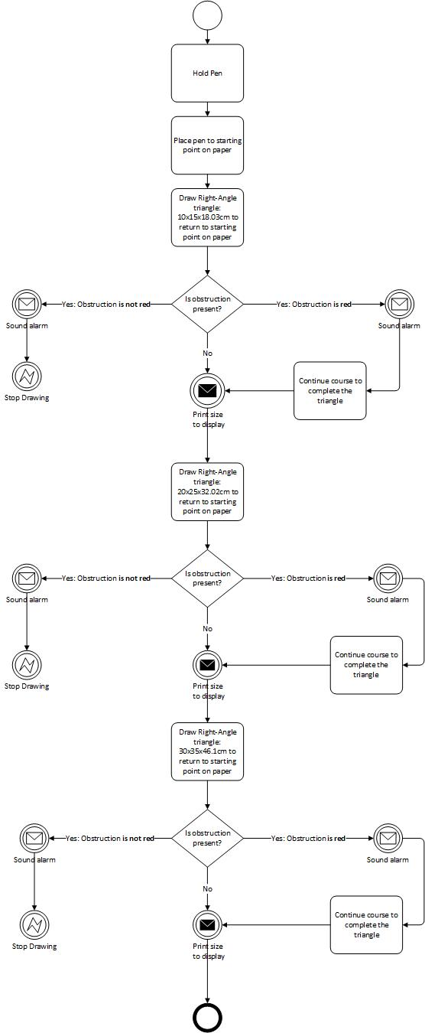
Right-angled Triangle BPMN:
Use Case ID: | 3
Use Case Name: | Draw 3 Squares with a Circle in Each One
Created By: | Sharla Passariello
Date Created: | 05/01/2020

Actor(s): | Lego Mindstorms Robot
Description: | - The Lego Mindstorms Robot will hold a pen and draw squares, each square will have a circle inside of it. Each shape will be 10cm larger than the previous.
Preconditions: | - Code has been setup in the Lego Mindstorms EV3 program for the robot to execute the use case  - Robot is connected to the program
Postconditions: | - 3 squares with a circle in each one have been drawn  - There is a 10cm increase for each shape drawn  - Calculations of the area of each shape are printed to the display
Normal Course: | - Robot draws a square with a circle in and returns to start point, prints area size to display  - Robot draws a second square with a circle in 10cm bigger than the previous shape and returns to starting point, prints area size to display  - Robot draws a final square with a circle in 10cm bigger than the previous shape and returns to starting point, prints area size to display
Alternative Courses: | - If obstruction appears along the drawing path and is red the robot halts, raises a sound alarm, removes object, and continues course  - If obstruction appears along the drawing path and is not red the robot halts, raises sound alarm, and stops drawing
Initial Shape: | 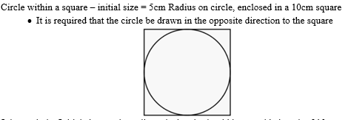

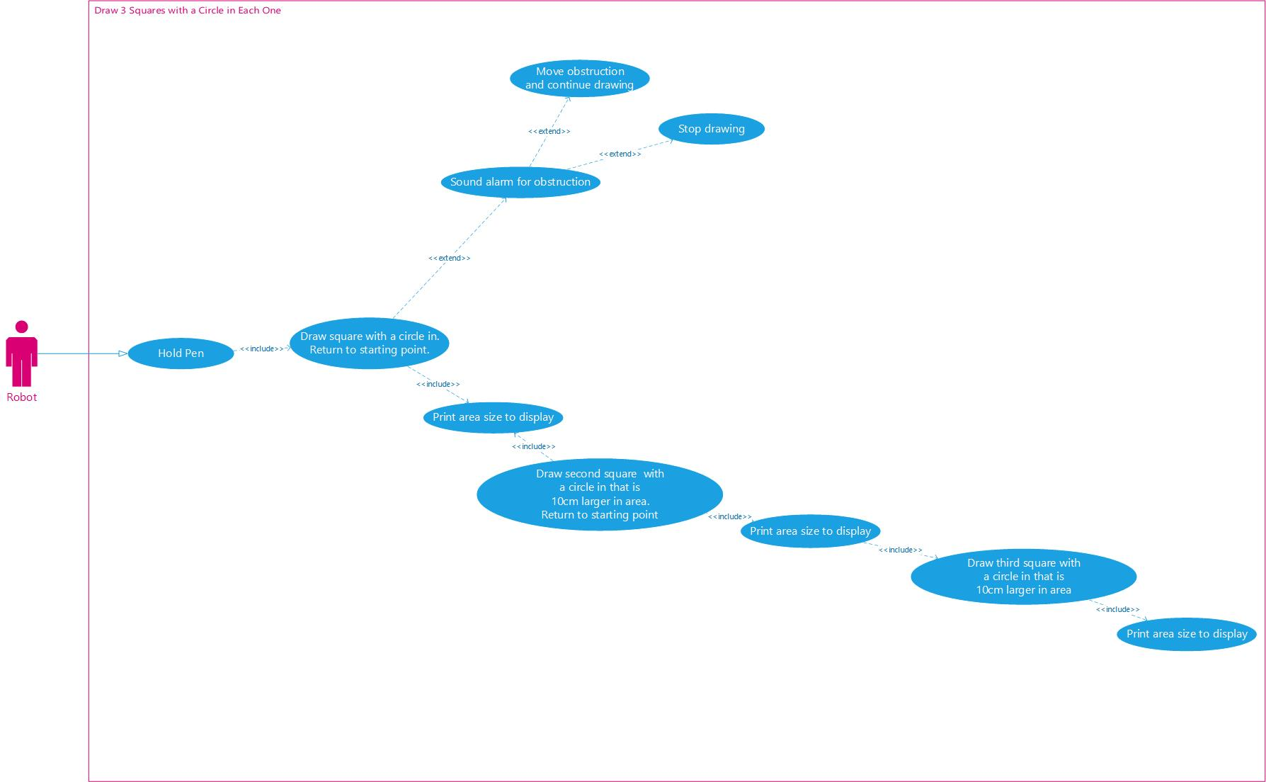

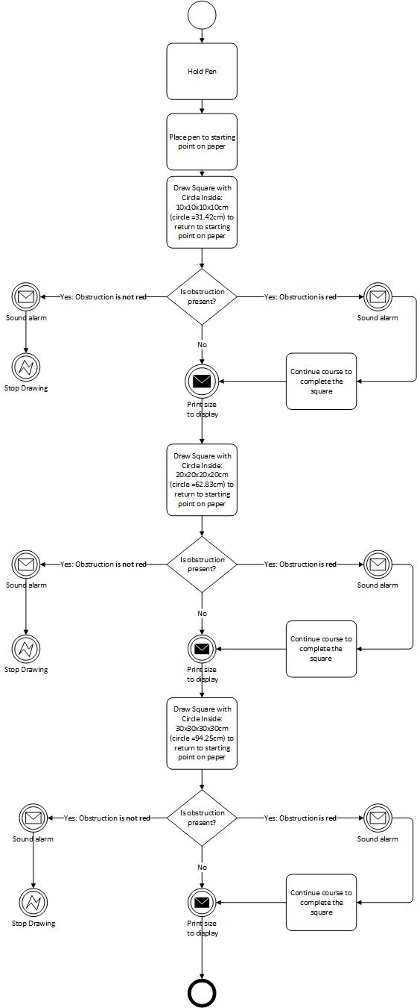
Square with Circle Inside BPMN:
Use Case ID: | 4
Use Case Name: | Draw 3 Join Symbols
Created By: | Sharla Passariello
Date Created: | 05/01/2020

Actor(s): | Lego Mindstorms Robot
Description: | - The Lego Mindstorms Robot will hold a pen and draw 3 join symbols. Each shape will be 10cm larger than the previous.
Preconditions: | - Code has been setup in the Lego Mindstorms EV3 program for the robot to execute the use case  - Robot is connected to the program
Postconditions: | - 3 join symbols have been drawn  - There is a 10cm increase for each shape drawn  - Calculations of the area of each shape are printed to the display
Normal Course: | - Robot draws a join symbol and returns to start point, prints area size to display  - Robot draws a second join symbol 10cm bigger than the previous shape and returns to starting point, prints area size to display  - Robot draws a final join symbol 10cm bigger than the previous shape and returns to starting point, prints area size to display
Alternative Courses: | - If obstruction appears along the drawing path and is red the robot halts, raises a sound alarm, removes object, and continues course  - If obstruction appears along the drawing path and is not red the robot halts, raises sound alarm, and stops drawing
Initial Shape: | 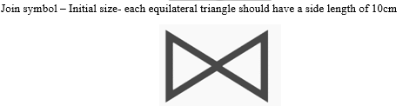

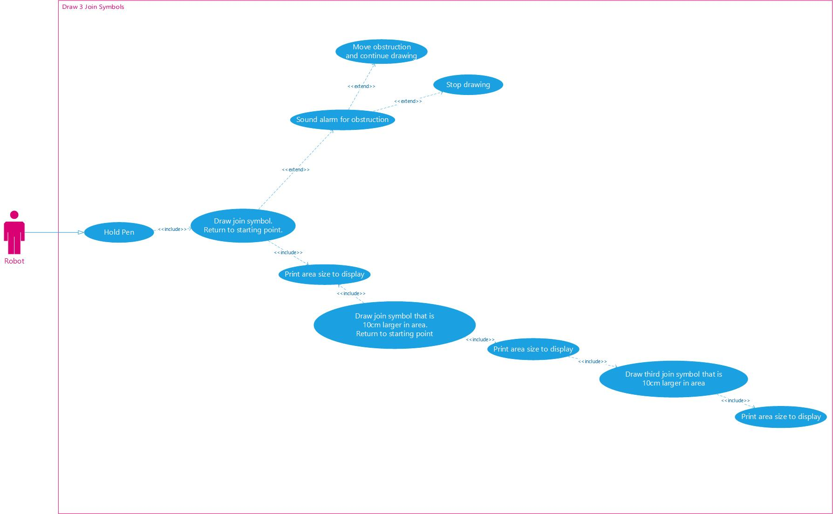
1
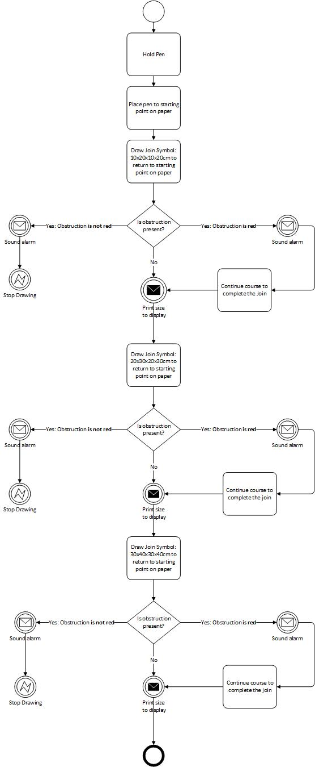
Join Symbol BPMN:

Practical Session

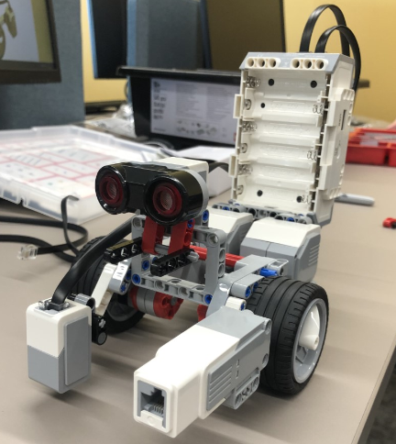
Our group consisted of five people and the following robot was built:
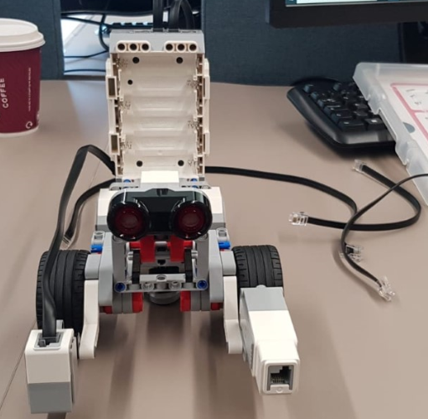

The following code was compiled to practically demonstrate the use case and BPMN diagrams
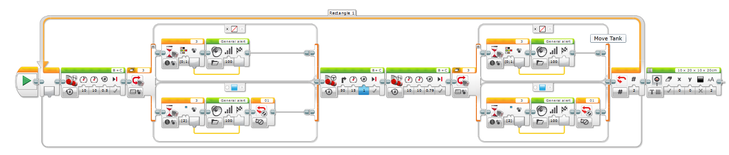
Rectangles:

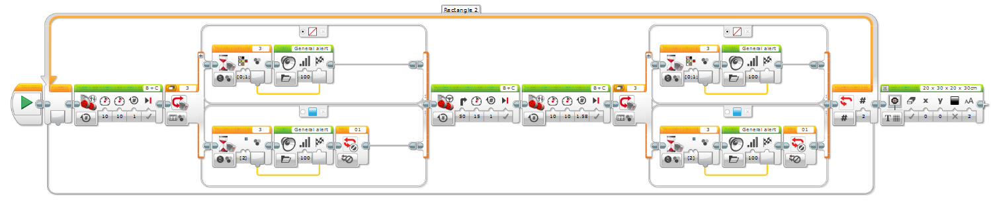

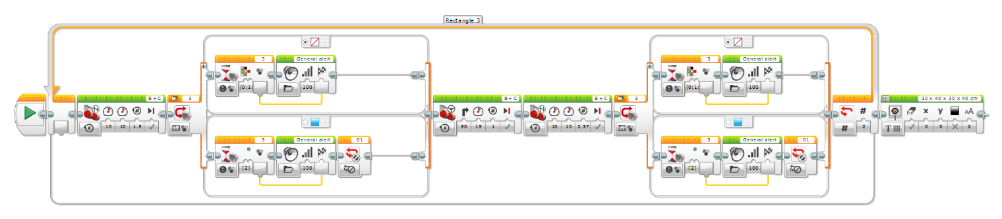

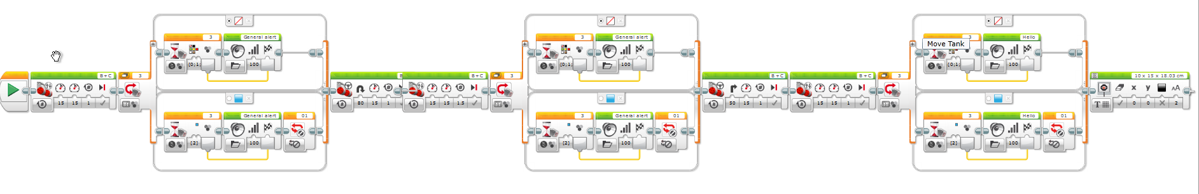
Right angled triangle:

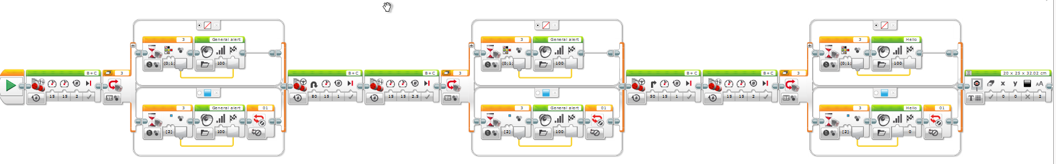

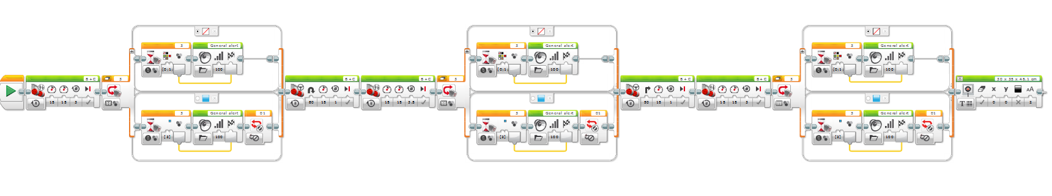

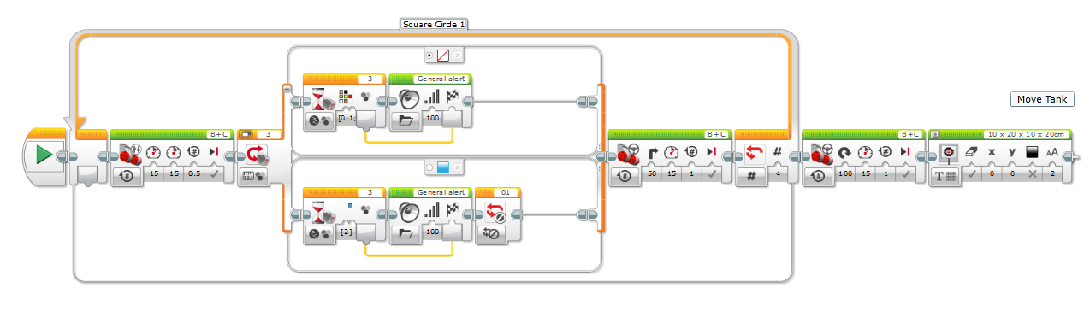
Square with Circle Inside:

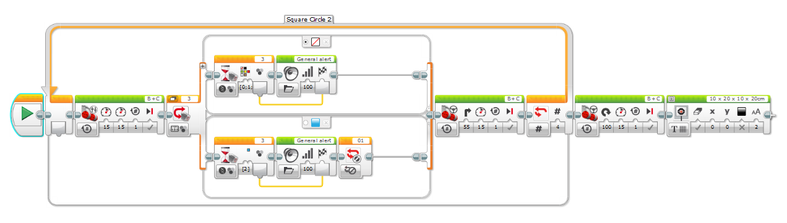

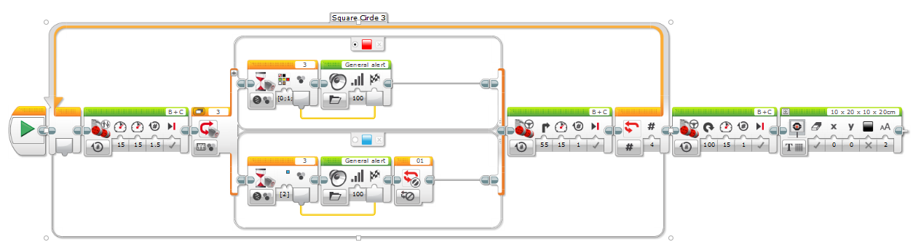

Join Symbol:
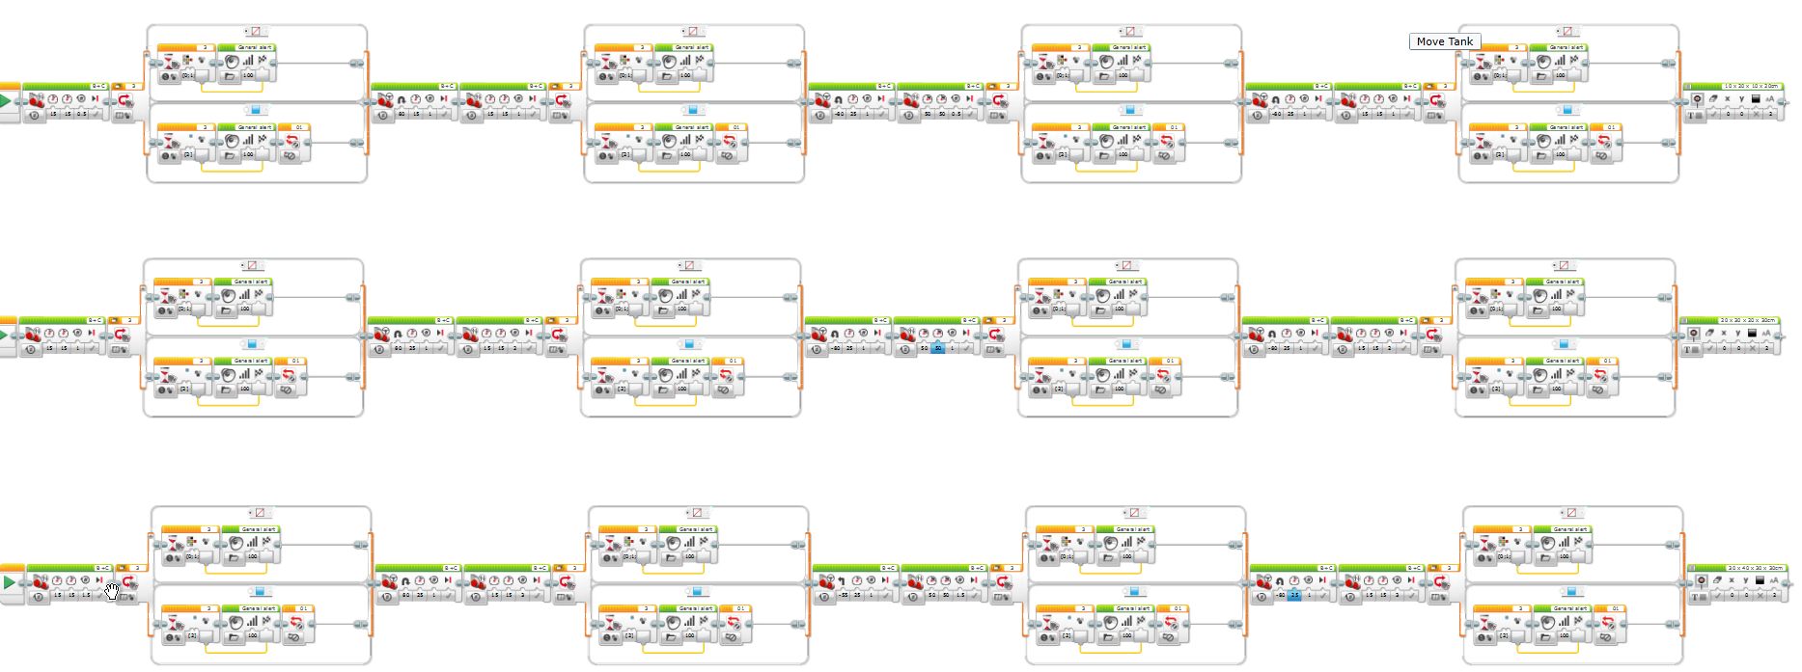

Testing
Once we had built the robot, we tested the shapes.
The rectangles came out rounded at the corners. The length of the sides were close to the specified length in the design.
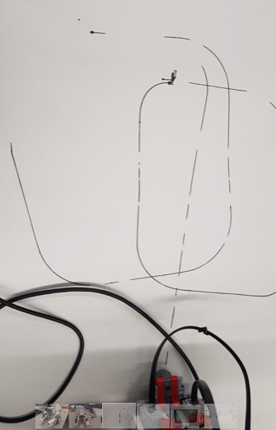

The right angled triange also had rounded corners. It was difficult to join back on the right angle
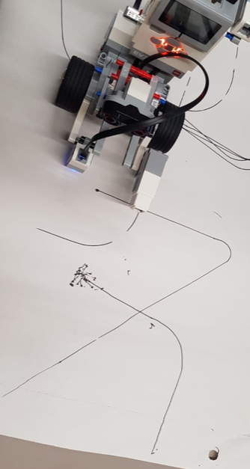

The square with a circle in was not complete and came out as a square and a squiggle. The Join symbol started off well however the corners and final line needed improvement
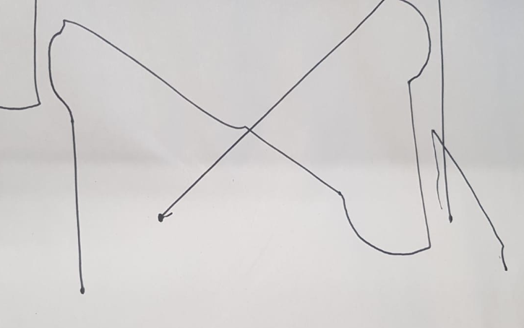

All symbols displayed the size of the code on the the display brick once the shape was finished
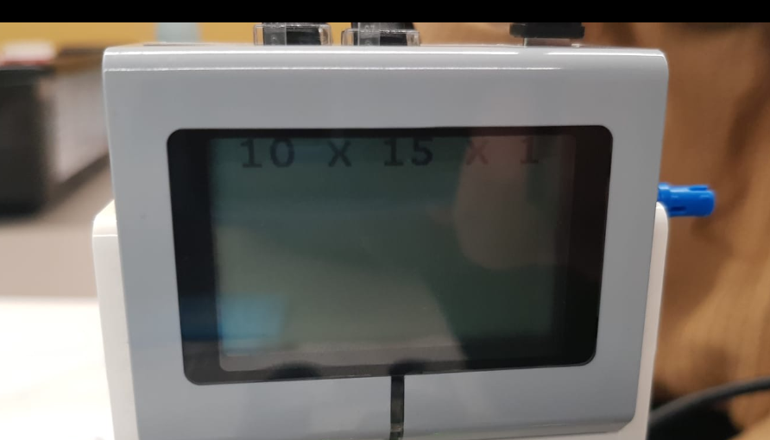

Conclusion
Overall the project was difficult and our shapes did not come out to the standard we were hoping for. The battery was not charged for the robot and so we were unable to test the code for a period of time. By the time we had built the robot and then discvovered the battery needed to charge, we had lost time to test the code. We think the code needed improving but also thought our robot did not have its weight fully balanced, so it was not able to execute the code as well as it could have. We didn’t feel we had enough time to rebuild the robot without sacraficing more testing time, to which we were already battling with a dying battery. I think if we had more time we could have rebuilt the robot, tested the code more thoroughly and adjusted what was needed to achieve better results.

