FINANCIAL MANAGEMENT FOR THE HOTEL INDUSTRY BMIH5007
Student name: Ionela Madalina Cananau
Student number: 2243593
Module lead: Tristan Hawkins

I confirm that I have not used any AI tools in the research and creation of this assignment. I confirm that I have not presented any AI generated materials as my own work. I confirm I have copies of my drafts, notes and other resources I used, which I may be asked to provide in evidence.

Executive Summary
Based on financial analysis the following key findings can be made for City Hotel: The financial position of City Hotel is poor because the business has recorded low revenue, high operating expenses and high leverage. It maneuverer a drop in its revenues that are disaggregated over the last three years especially in 2023 due to external challenges such as competition and COVID-19. Yet, the cost reductions proved to be not very effective as the hotel's operating income and liquidity declined, and the operating margin became negative and equal to -52.41% in 2023 while the hotel's net loss reached £1,134,950. Raw material cost, which relates to food and beverages, fluctuates often, while the employee's cost has gone up due to an increase in wages hence increasing the hotel’s finance cost besides experiencing a rise in fixed costs such as long-term borrowing and lease liabilities. , to eliminate this problem the hotel must adopt the following tactical strategies, turning point, cost, deform, price sensitivity, and improved customer perceptions to bring stability and increase profitability to the hotel.

Table of Contents
Introduction 4
Scope and Objectives 4
Financial Analysis 4
Income Statement Analysis 4
Key financial metrics 10
Key Causes of Decline 11
Turnaround Strategy 12
Conclusion 13
References 15

Introduction
The City Hotel is an experienced city-based hotel that offers food services through a restaurant, beverages through a bar, and facilities for events. In recent years the hotel like many others has experienced a financial downturn in terms of revenues, occupancy, and customer satisfaction. The owner of the hotel is dubious of its sustainability and has consulted with an advisor to determine potential possibilities of its continued sustainability. The objectives of this report are as follows: To evaluate the hotel’s financial position, determine why its financial position has deteriorated, present a plan whereby the financial position of the hotel can be improved or at least establish the best and most feasible outcome that the owner of the hotel can hope to achieve.

Scope and Objectives
- To analyse the hotel’s financial performance over the last three years, focusing on revenue, expenses, profitability, liquidity, and solvency.
- To investigate the root causes behind declining profitability, including economic conditions and industry-specific challenges.
- To propose a strategy aimed at revitalizing the hotel's financial health and restoring its reputation or determine an alternative viable financial solution for the owner.

Financial Analysis

Income Statement Analysis
Revenue Trends (2021-2023)
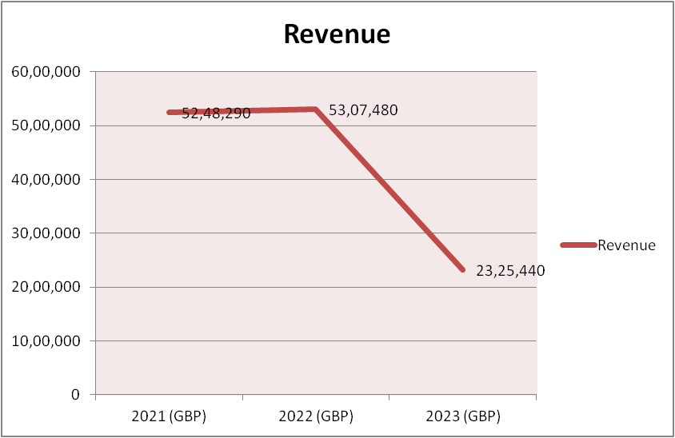
The City Hotel reveals the decrease in revenue during the three years. The revenue in 2021 was £5, 248, 290 which has a marginal increase to £ 5, 307, 480 in 2022. However, in 2023, total revenue dropped to £2,325,440, which shows that there is poor operating revenue in business nowadays. This decrease might have been a result of external forces including competition, business environment or negative consumer force (Handoyo et al., 2023).
Cost of Goods Sold (COGS)
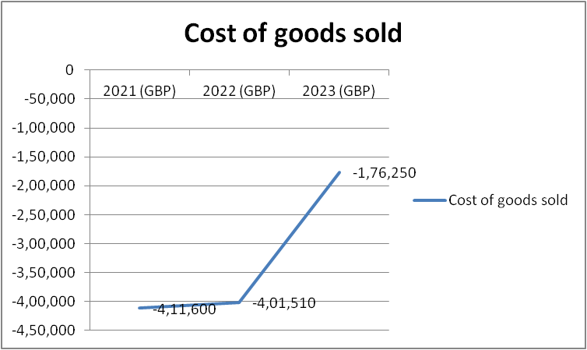
Looking at the Olympus Corporation case gross margin reduced and this corresponds with decreasing cost of goods sold or rather COGS. The same services cost £411,600 in 2021 and reduced to £176,250 in 2023. This is directly contrary to what happened to the company’s COGS, as the decline in revenue, which formed the basis of profitability, was significantly worse in comparison to the reduction of the cost of goods sold (Beaver, 2021).
Employee Costs
Continued to be among the many expenses incurred by the hotel during the fiscal year 2021 and 2022, with the former being £1,724,760 and the latter rising slightly to £1,770,700. Nevertheless, these costs were lower in 2023 to £1,233,160 maybe due to the financial issue that the hotel passed through. Employee costs, however, continued to be a substantial part of the total expenses even after relatively lower than the manufacturing cost (Ogbonnaya et al., 2022).
External Expenses
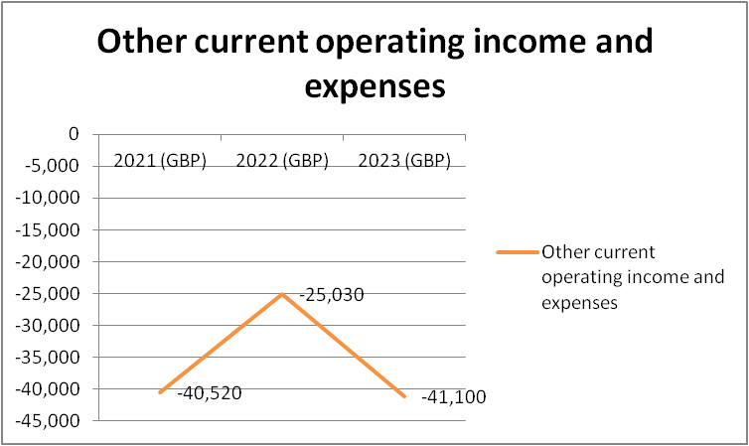
Years-wise wise trend of external expenses which refer to operational costs other than direct labour and material purchases also went down. For the year 2021, the external expenses stood at £ 1,894,720 and the figure went down to £ 1,071,030 in 2023. Although means outside of the store were successfully minimized to control losses, revenues plummeted much more steeply (Liuyi, Yunchan and Feirong, 2023).
Taxes and Duties
These included payments made in taxes and duties excluding income taxes, which also showed a decline over the three years. For the year 2021, the hotel disbursed £144,070 while in the year 2023, the amount was £88,950. This reduction is expected in the circumstances of deteriorating operational performance and the lower taxable income of the hotel.
Operating Income
There was an improvement financially within the operating income in the year ended 31st of December 2021 and 2022 being £664,160 and £674,730 respectively. However, the forecast results stated that at the beginning of 2023, the hotel expected to have a net loss of - £ 1,218,850 mainly due to the sharp decline in revenue. Concerning the negative operating income experienced by the hotel in 2023, this shows a lot of financial pressure exerted on the hotel and means that, there is a dire need to arrest the operating losses (Shapoval et al., 2021).
Net Income
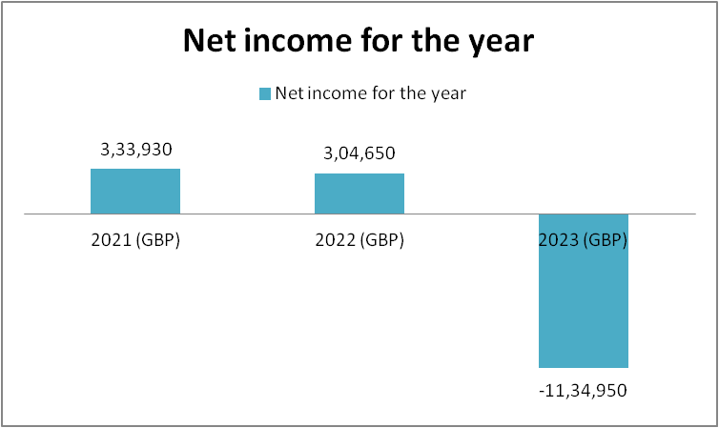
As with the operating income, net income also increased to $1,084 million in the third quarter of the year 2010. While 2021 net income was £333,930, the hotel's performance in 2023 depicted that the hotel has a Net loss of -£1,134,950 which clearly illustrates the extent of the financial crisis the hotel faced.
Balance Sheet Analysis
The total assets of City Hotel reached £12,941110 in 2021 and reached £15,921080 in 2022 and slightly decreased in 2023 to £15,653970. The rise in 2022 means either investing in new assets or improving the current ones, while the fall in the same year shows that the hotel’s deteriorated financial outlook and lower asset value. Employee benefits, which include goodwill, property, plant and equipment, and intangible assets also reduced slightly from £11,049,140 in 2021 to £14,368,100 in 2023. Nonetheless, property plant and equipment were £4,053,590 in the year ended 31st December 2021 and reduced to £3,574,710 when financial statements were prepared for the year ended 31st December 2023, suggesting depreciation or reduced investment in fixed assets in the period of financial stress. From £4,644,940 in 2021 to £4,558,200 in 2023, goodwill slightly deteriorated and this means that the hotel’s brand has not eroded though in the long run, if it continues experiencing cash shortages, the goodwill may start declining.
Analysis of the recent financial statements showed the current assets were a little low, at £1,285,880 in 2023, down from £1,891,970 in 2021. This decline can be a result of a decrease in both the trade receivables and the cash and cash equivalent. Inventory declined from £300,000 in 2021 to £100,000 in 2023 but cash and cash equivalents fell to £295,510 and this suggests serious challenges in funds realization probably occasioned by declining performances and increasing expenses. Trade receivables also dropped down from £691,380 in 2021 to £479,180 in 2023; this may be attributed to either low sales revenue or difficulties in recovering most of their amounts. Stocks also reduced, from £35,230 in 2021 to £29,470 in 2023, in line with low business operations.
Total liabilities rose from £10,684,940 in the year ended 2021 to £14,243,390 in the year ended 2023, due to higher utilization of debt to fund activities. Borrowings longer than one-year rose marginally from £8,113,710 in the year ended 2021 to £8,290,570 in the year ended 2023, perhaps due to the hotel sinking into more debt or to fund property investments. Long-term lease liabilities At £2,844,970, long-term lease liabilities made their first appearance in the year ended December 31, 2022, and, again rose to £3,353,260 in the year ended December 31, 2023, exposing extra financial obligation. Today’s liabilities rose slightly from £1,957,360 in the year ending 2021 to £2,014,600 in the year ending 2023.
Equity further eroded in this financial year reducing from £2,152,750 in the year 2021 to £1,334,370 in the year 2023. This decline can be explained by sustained operational losses. From the same year and to 2023, retained earnings reduced to -£151, 050 from -£801,550 respectively but remained in the negative and this means that the hotel has been incurring operating losses and could not generate enough profits to offset past operating losses. The net operating loss of -£1,134,950 for the year ended 31st December 2023 eroded the equity of the hotel which exposed the owner and creditors to greater risks of credit Crunch.

Key financial metrics
Ratios | 2021 | 2022 | 2023
Gross Margin | 1.08 | 1.08 | 1.08
Operating Margin | 12.65% | 12.71% | -52.41%
Net Profit Margin | 6.36% | 5.74% | -48.81%
Current Ratio | 0.97 | 0.93 | 0.64
Debt-to-Equity Ratio | 4.96 | 5.40 | 10.67

1. Gross Margin
Gross margin now settles at 1.08 for the three years which keeps the hotel's competency at stemming down its cost of sales in revenue. Nevertheless, given that this value is rather stable, global operational activity may affect other factors, for instance, employing costs or external expenditures, to the same or greater extent (Reinartz, Wiegand and Imschloss, 2019).
2. Operating Margin
In the financial years ended 31 December 2021 and 2022, the hotel received a positive operating margin of 12.65% and 12.71% respectively. Nonetheless, in 2023 the operating margin sharply dropped and reached -52.41 % which means severe operating loss. This shows that it reduced drastically its profitability which can be attributed to an ultimate condition of declined revenues next to operational costs that cannot be cut down to an equal proportion (Shabalov et al., 2021).
3. Net Profit Margin
Net profit margin reduced from 6.36 in 2021 to -48.81% in 2023. This general decline also points to the fact that perhaps the hotel is even losing money in operations or otherwise, in tax, depreciation, and interest. The hotel group also faced a serious deterioration of its financial position in 2023, when losses exceeded all the revenues since its foundation (Shabalov et al., 2021).
4. Current Ratio
The current ratio for the same years was 0.97 in 2021 and reduced to 0.64 in 2023. The current ratio is the business’ liquidity and ability to pay off short-term obligations using short-term resources such as cash and near cash totals (Kontuš and Mihanović, 2019). A current ratio below 1 may point to issues of liquidity, and the score of 0.64 in 2023 shows the deteriorating future ability to meet short-term liabilities because of cash conversion cycle problems.
5. Debt-to-Equity Ratio
The debt level analysis depicted that total debt has been increased from 2021 debt of 4.96 to 2023 debt of 10.67 stating a high degree of reliance on debt in hotels. A high D/E ratio implies higher financial risk because the hotel has greater borrowed funds than owners’ equity. The peak at 2023 to levels that depict that the hotel’s solvency is more vulnerable to external financial pressure is another sign in this context.

Key Causes of Decline
Declining Revenue
This work picks out the following as the major reasons for the decline in the financial performance of City Hotel; But the major reason for the high loss is low revenue as indicated early and especially in 2023, based on the above analysis. Income declined significantly from £5,248,290 in 2021, £5,307,480 in 2022 and £2,325,440 in 2023. This dramatic reduction may be attributed to several external factors including competition from markets, changes within the awareness of the market, or economic performance including effects from the COVID-19 pandemic that significantly impacted the hospitality industry across the globe (Liu et al., 2023). It is not surprising to hear that hotel services have less demand, fewer bookings, and a slowdown in the number of events that are held.
High Operating Costs
Thus, the operating costs remained high, within the course of which the hotel was generating fewer revenues. Wages and salaries continued their persistent rise to cross 40% of sales in 2019 and plateau through 2023 although other expenses, externally related, and taxes slowly declined. For example, Lynn (2021) pointed to £1,724,760 as the employee costs in 2021 and £1,233,160 in 2023 when there is low business volume. This was further compounded by the fact that it was not possible to proportionately slow down the rate of operating expenses as revenues were reduced (Arhinful and Radmehr, 2023). External costs also remained persistently high hence exerting pressure on the operating income.
Increase in Credit and Financial Burdens
The City Hotel showed growth of debts during the three years under analysis of long-term borrowings at £8,113,710 in 2021, while it was £8,290,570 in 2023 of the long-term lease debt also raised from £2,844,970 in 2022 to £3,353,260 in 2023. Larger financing needs worsened the cash flow and solvency of the hotel even during its improved performance in the year 2004. With higher amounts of debt liabilities, interest and repayment costs rose, thus limiting the extent of capacity for investment in such enhancements or new revenue streams (Altavilla et al., 2021).
Liquidity Issues
The City Hotel witnessed a quite poor liquidity situation throughout the period, and the current ratio showed the worst picture here, as it shrank down from 0.97 in 2021 to 0.64 in 2023. This unearths an implication on the steadiness of the existence of cash in hand and other current assets whose purpose was to support current obligations and any operational constraints were bound to be witnessed (Maina, 2024). Current assets have reduced from £740,590 in 2021 to £295,510 in 2023, meaning there is a widening cash flow problem, primarily due to a decrease in revenue and necessary service debts.

Turnaround Strategy
Reducing costs and improving operation efficiency
This means that the hotel needs to adopt measures to constrain its costs in all departments of the hotel service. This includes staff levels matching the occupancy level, cutting unessential outside costs, and rebidding the suppliers (Dubay et al., 2020). Areas of operation could also be reorganized by operating the company with fewer working hours at some other times or by cutting down on jobs and giving those to machines.
Debt Restructuring
Therefore, due to the pressure now arising from high levels of debt, the City Hotel needs to seek its lenders’ help to refinance the debt (Dewi Desak Putu Nitya et al., 2020). This may include lengthening the loan period, receiving low-interest charges, or grouping of existing accounts into better financial obligations (Dewi Desak Putu Nitya et al., 2020). Eliminating a portion of the debt will unclog money for areas which can produce profits or enhance the customers’ perception of the company’s hotels.
Revenue Management and Dynamic Pricing
There is one final weak business area that has to be addressed: P&L mostly relies on Gross Revenues, which creates the need for more flexible pricing structures in the hotel (de Bastos, 2022). There should be flexible pricing strategies that would allow the organization to change room rates in a bid to reflect current demand, the number of vacancies available and general trends in related markets (de Bastos, 2022). Adjusting prices, giving special offers during low season or targeting corporate guests for those long-term accommodations will help to maintain occupancy while achieving good cash flow.
Improve Customer Satisfaction and Service Delivery
They have to increase customer satisfaction and occupancy rates to get customers to come back and leave good comments (Petricek, Chalupa and Melas, 2021). This means developing the training of the staff to provide improved customer care, improving customer amenities in the rooms, and increasing cleanliness in the rooms and other facilities offered in the institution.

Conclusion
This analysis reveals that the future of City Hotel is quite unsustainable, as the company is struggling to increase its revenues, which have been decreasing steadily over the years; its debts are becoming larger; and its liquidity is worsening. This means that some form of corrective action needs to BE taken since the decline in profitability and the increase in the companies’ debt-to-equity ratio imply further losses are inevitable. With the proposed turnaround strategy, the hotel will be able to start addressing some of the pertinent challenges such as cost control, excessive indebtedness, variable pricing, and customer experience. Also, digital marketing strategic application, enhancing the corporation’s assets productivity, and exploring new diversified income sources are some potential strategies for more growth.

References
Altavilla, C., Burlon, L., Giannetti, M. and Holton, S. (2021). Is there a zero lower bound? The effects of negative policy rates on banks and firms. Journal of Financial Economics. doi:https://doi.org/10.1016/j.jfineco.2021.06.032.
Arhinful, R. and Radmehr, M. (2023). The Impact of Financial Leverage on the Financial Performance of the Firms Listed on the Tokyo Stock Exchange. SAGE Open, [online] 13(4). doi:https://doi.org/10.1177/21582440231204099.
Beaver, S. (2021). A Guide to Cost of Goods Sold. [online] Oracle NetSuite. Available at: https://www.netsuite.com/portal/resource/articles/financial-management/cost-of-goods-sold-cogs.shtml [Accessed 24 Oct. 2024].
de Bastos, B.P. (2022). Contribution of hotels’ revenue management for supply chain sustainability. Journal of Revenue and Pricing Management. doi:https://doi.org/10.1057/s41272-022-00380-z.
Dewi Desak Putu Nitya, Putu, S.I., Dwirandra Anak Agung Ngurah Bagus and Ary, G. (2020). DEBT REFINANCING DECISION MAKING: A PHENOMENOLOGICAL STUDY IN A NOT-FOR-PROFIT ORGANIZATION. Russian Journal of Agricultural and Socio-Economic Sciences, [online] 104(8). Available at: https://cyberleninka.ru/article/n/debt-refinancing-decision-making-a-phenomenological-study-in-a-not-for-profit-organization.
Dubay, L., Aarons, J., Brown, K. and Kenney, G. (2020). RES E A RC H RE P O RT How Risk of Exposure to the Coronavirus at Work Varies by Race and Ethnicity and How to Protect the Health and Well-Being of Workers and Their Families. [online] Available at: https://www.urban.org/sites/default/files/publication/103278/how-risk-of-exposure-to-the-coronavirus-at-work-varies_0.pdf [Accessed 24 Oct. 2024].
Handoyo, S., Suharman, H., Ghani, E.K. and Soedarsono, S. (2023). A business strategy, operational efficiency, ownership structure, and manufacturing performance: The moderating role of market uncertainty and competition intensity and its implication on open innovation. Journal of Open Innovation: Technology, Market, and Complexity, [online] 9(2). doi:https://doi.org/10.1016/j.joitmc.2023.100039.
Kontuš, E. and Mihanović, D. (2019). Management of liquidity and liquid assets in small and medium-sized enterprises. Economic Research-Ekonomska Istraživanja, [online] 32(1), pp.3247–3265. doi:https://doi.org/10.1080/1331677x.2019.1660198.
Liu, Y., Cheng, X., Liao, S.S. and Yang, F. (2023). The impact of COVID-19 on the tourism and hospitality Industry: Evidence from international stock markets. The North American Journal of Economics and Finance, [online] 64, p.101875. doi:https://doi.org/10.1016/j.najef.2022.101875.
Liuyi, Y., Yunchan, Z. and Feirong, R. (2023). Does government investment push up manufacturing labor costs? Evidence from China. Humanities and Social Sciences Communications, [online] 10(1), pp.1–10. doi:https://doi.org/10.1057/s41599-023-02180-1.
Maina, S.K. (2024). Cash Flow Volatility and Firm Market Value of Companies Listed at the Nairobi Securities Exchange. [online] ir.jkuat.ac.ke. Available at: http://ir.jkuat.ac.ke/handle/123456789/6379 [Accessed 24 Oct. 2024].
Ogbonnaya, C., Dhir, A., Maxwell-Cole, A. and Gorny, T. (2022). Cost-cutting actions, employment relations and workplace grievances: Lessons from the 2008 financial crisis. Journal of Business Research, [online] 152(1), pp.265–275. Available at: https://www.sciencedirect.com/science/article/pii/S0148296322006646.
Petricek, M., Chalupa, S. and Melas, D. (2021). Model of Price Optimization as a Part of Hotel Revenue Management—Stochastic Approach. Mathematics, 9(13), p.1552. doi:https://doi.org/10.3390/math9131552.
Reinartz, W., Wiegand, N. and Imschloss, M. (2019). The Impact of Digital Transformation on the Retailing Value Chain. International Journal of Research in Marketing, [online] 36(3), pp.350–366. doi:https://doi.org/10.1016/j.ijresmar.2018.12.002.
Shabalov, M.Yu., Zhukovskiy, Yu.L., Buldysko, A.D., Gil, B. and Starshaia, V.V. (2021). The influence of technological changes in energy efficiency on the infrastructure deterioration in the energy sector. Energy Reports, [online] 7, pp.2664–2680. doi:https://doi.org/10.1016/j.egyr.2021.05.001.
Shapoval, V., Hägglund, P., Pizam, A., Abraham, V., Carlbäck, M., Nygren, T. and Smith, R.M. (2021). The COVID-19 pandemic effects on the hospitality industry using social systems theory: A multi-country comparison. International Journal of Hospitality Management, [online] 94(102813), p.102813. Available at: https://www.ncbi.nlm.nih.gov/pmc/articles/PMC8631802/.

