

LCLM 4001

Task 3 - Reflective Report

Student Name: Cristina dalila Nica
Student ID: 2432935

Contents
Reflective Report: Module Academic Skills 3
Introduction 3
Description of Experiences 3
Analysis and Personal Reflection 4
Conclusion 5
References: 7

Reflective Report: Module Academic Skills

Introduction
Becoming a first-year student may be thrilling and frightening at the same time, as one will be confronted with new academic demands as well as introductions to new places. The Academic Skills module aims to provide students such as me with the necessary provisions in order to ensure I walk through this change with high success rates. In my reflective report, I am going to talk about my learning during the module, using Gibbs model. The skills that I learned, the problems which I faced, and the improvement as a learner. In particular, I will consider valuable evaluation of such tasks as Task 1 and Task 2, or classroom activities, cooperation with classmates, and conversations (Cameron and Rideout, 2020).

Description of Experiences
Task 1 was one of the first and most significant activities of the module. It was an academic skills quiz on the subjects such as time management, referencing, and academic misconduct. I initially found it difficult since I was not conversant with academic referencing and citation styles. The quiz preparation allowed me to comprehend the significance of academic integrity and the ways to prevent plagiarism.
To prepare to this quiz, I revised the materials of our lectures and made practice referencing exercises offered by the tutor. This served to strengthen the concept of ethical use of sources and appropriate referencing of the sources. The skills of searching the library of the university and finding credible academic articles were also useful, and I practised them on the university library site (Cameron and Rideout, 2020).
Task 2 was a 90-minute in-class exercise focused on note-taking, paraphrasing, and writing a paragraph. This helped me practise essential academic writing skills. I had to read a short academic text, take structured notes, paraphrase specific sentences, and write a coherent paragraph in formal academic style. This task was difficult at first, but I improved my confidence through preparation and applying what we learned in lessons (Rochon, 2022).
The feedback from this task made me realise I needed to work on sentence clarity and academic tone. I started practising by rewriting short paragraphs at home and comparing them with examples given in class. Over time, I noticed that I was better able to summarise key ideas while avoiding plagiarism.

Analysis and Personal Reflection
A retrospective look through my experience in the Academic Skills module with the help of the Gibbs Reflective Cycle has shown me the extent of my growth both personally and academically. The first time I tried Task 1, I did not know all the ins and outs of how to structure an academic response. My work was not clear, and I did not refer in Harvard format. The first responses disappointed me, but I also understood the importance of constructive criticism.
Positively, I found out that I am an active and engaged learner, particularly when learning with others. In the process, since we as a group engaged in classroom discussion, I was capable of making substantial points, and I oftentimes posed questions which led to additional debate. A case in point is that, during a session on referencing, I raised the question about the perception of plagiarism in various cultures, wherein an interesting discussion took place in a group; that was quite an eye-opening experience (Dunne, Penman and Nisbet, 2023). This taught me the significance of being inquisitive and open-minded in learning institutions and how to be bold in expressing my thoughts.
Task 2 was more practical. I found it difficult to paraphrase without copying the original sentences too closely, especially under time pressure. But after reviewing classroom examples and receiving tips from my lecturer, I improved in choosing the right vocabulary and sentence structure. This task helped me better understand how to summarise academic ideas in my own words, and I now feel more confident when writing short assignments or essays.
My reading skills have also improved tremendously. First, I used to read passively and wasn't able to remember. Having discovered the SQ3R (Survey, Question, Read, Recite, Review) method, I began to use it regularly. The plan assisted me in being more active in readings and in determining what information is essential to complete work. This ability aided me in this module, yet it will also assist me in future classes.
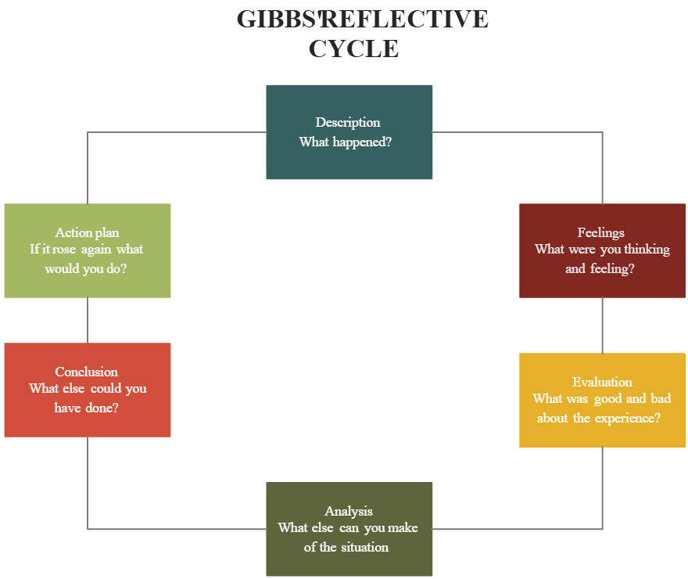
Source: (Dunne, Penman and Nisbet, 2023)
One of my strengths in this module has been that I have been an active member of the group, and I have always been ready to develop, as well as take the feedback and use it to improve my performance (Dunne, Penman and Nisbet, 2023). This was demonstrated both in homework and in classroom discussions. Conversely, I am aware that I should further make improvements in aspects like proper referencing and elimination of nervousness upon speaking. I also intend to go to some additional support sessions and exercise more to develop these abilities.
Additionally, I aim to improve my academic vocabulary by reading more journal articles and noting down useful phrases. I believe this will help make my future writing clearer and more formal, which is expected in university-level assignments. I’ve also registered for academic writing workshops offered by the university's learning support team. These extra steps will hopefully make me more confident and accurate in referencing.
The module has bestowed on me the most important needed improvement as a more mature and conscious learner. Then I knew that academic achievements are not only shown by the knowledge stored but also by good strategies, cooperation, and endurance. I have acquired the habit of achieving academic goals, appraising my achievement, and finding assistance in case I need any (Rochon, 2022). It has helped me get more prepared and more confident in going about my studies.

Conclusion
This report reflects on my development throughout the Academic Skills module. Through completing Task 1 and Task 2, I have improved in academic reading, referencing, paraphrasing, and writing. These are core skills I will continue to build on during my studies. The module has given me a strong foundation and helped me understand how to succeed in university by applying practical strategies. I now feel more prepared to tackle future academic challenges.

References:
Cameron, R.B. and Rideout, C.A. (2020). ‘It’s Been a Challenge Finding New Ways to learn’: first-year Students’ Perceptions of Adapting to Learning in a University Environment. Studies in Higher Education, 47(3), pp.1–15. doi:https://doi.org/10.1080/03075079.2020.1783525.
Dunne, M., Penman, M. and Nisbet, G. (2023). Exploring the Outcomes of a Reflective Teaching Strategy with students: a Feasibility Study. International Journal of Speech-Language Pathology, [online] 26(4), pp.1–12. doi:https://doi.org/10.1080/17549507.2023.2223373.
Rochon, R. (2022). Live brief projects in higher education: a contextualized examination of student and staff perceptions of experiential learning. [online] bnu.repository.guildhe.ac.uk. Available at: https://bnu.repository.guildhe.ac.uk/id/eprint/18506/.

