The Evolving Role of HR in the Contemporary Business World
HRM Fit for the Future
Sharon Bowen EUI Ltd 2/21/2019

Strategic human resource management (strategic HRM) is an approach to managing human resources that supports long-term business goals and outcomes with a strategic framework. The approach focuses on longer-term people issues, matching resources to future needs, and macro-concerns about structure, quality, culture, values and commitment(CIPD,2019)

.

The Evolving Role of HR in the Contemporary Business World
NOW
HRM Fit for the Future
Introduction
Manual – often using only paper files with limited reporting. Some basic spreadsheets e.g. payroll
Technology
Automated - More sophisticated reporting/MI. Specialised software. More time to focus on strategy.
The world of HR, like the people it aims to support, is constantly evolving and changing as a result of both internal and external forces. This handout aims to enhance today’s discussion and provide further insight into current thinking; and remind us the role is more relevant than ever due to far more people-centric thinking in the business world. Wellbeing and engagement are now being seen as KPI’s alongside profit and loss. Hopefully, today’s session will provide encouragement to us all as HR professionals, to be pro-active, stay abreast of new developments and innovate within our roles to face the future motivated and prepared.
Strategic – specialised with a broad set of analytical and softer skills.
Transformational – involved in helping the organisation set and achieve strategic goals. Pro- active HRM.
Transactional – process driven, managing payroll, dealing with issues as they arise. Re-active Personnel.
Function
Clerical - Often titled “Personnel Administration” may include one or two specialised professionals.
Skillset
Then and Now – Personnel Vs HRM
We have already come a long way from the origins of our function, when we were known as Personnel Officers and hidden away from our organisations until we were called on to deal with a major issue or arrange a disciplinary hearing. Although there may be a few of these organisations still around, most businesses see HR for the positives it can bring to their overall success when incorporated in the right way, by the right people.
Business – working closely with managers to provide advice and support required to meet goals.
Compliance – following legislation, contracts and minimising risk of tribunals/union conflicts.
Focus
.

Figure 1: HR then and now
THEN
Structuring HRM within our organisations
The way HR is incorporated varies from organisation to organisation depending on size, structure and goals. There isn’t a universal structure that will fit all, but generally organisations need structure to integrate HR to allow the function to be a more strategic contributor, the higher up our involvement goes, the greater the likelihood of a truly integrated HRM team.
How and when this integration should occur is open to discussion and has been debated for many years, but there seems to be significant movement in recent years towards some formal structure.
“There seems to be no HR function that is not embarking on, is not part-way through, or has not recently completed major change in the way it organizes itself and how it delivers its services to the organisations it supports”. (CIPD (ed.), 2015)
David Ulrich has written extensively on the subject. His initial idea, popularly known as the “Three Legged Stool” (1997) has evolved over time, revised to the four role specialization model (figure2), clearly defines the remit of each role required within the function, and firmly places HRM at all levels of the business from board room down.
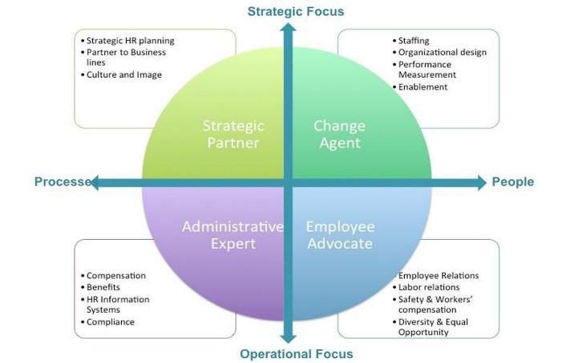
“Whatever model we use to organize HR, the road to effectiveness lies not only in deeply understanding the business strategy, but in using that understanding to help shape positive change that contributes to achieving business objectives” (CIPDb, 2018)
Figure 2: The Ulrich model of HR specialization (Rawn Shah 2015)

However, Ulrich is not without his critics, there are some who feel the model, if followed to rigidly, can result in HR professionals being pigeon holed into one of the roles at the expense of developing a fully rounded knowledge of all aspects of HR. (Shah, 2015). Also, in some instances the HR practitioners may not be perceived has having the business acumen required (Deloitte, 2009).
A more traditional HR centralized model is still preferred in some organisations. This will usually consist of a mixture of administrators, and generalists situated separately from the main business. This seems to be a missed opportunity to integrate the HR team as good HRM function can contribute so much and “act as catalysts for change, anticipating problems and making things happen” (Hutchinson & Wood, 1995). It will also perpetuate a them and us culture between HR and the business.
Admiral’s function is an example of a business developing from the more single team/centralised structure into a more strategic one. Each People Service Executive (PSE) looks after their own department or area, and basic administration is carried out by a team of less experienced coordinators. The L&D function is separate, as is payroll and we use external practitioners for Occupational Health support for long-term absences. Gradually we are developing specialist roles very similar to figure 2 and including more people centric elements into the function such as health & wellbeing and employee assistance schemes to ensure we are providing a holistic approach to support people who support the business.
It’s important, according to the CIPD (2015) that any change in HRM is reflective of the overall aims and culture of the business and not just a structural change for change sake.
We should also at this point, make reference to the role of line managers, in many organisations, they are the first port of call and need to deliver triage for issues faced by employees, and are therefore a significant influence on success and need to work in full partnership with HRM.
They are fundamentally responsible for the interpretation, communication and management of HR policies and practices. If these are miss-interpreted then the repercussions for the individual and the business can be significant.
Performance management is one example; dealing with an agent who is consistently underperforming can be very frustrating for line managers with targets to hit and benchmarks to set. But, if they take the policies we have in place on performance capability without considering the individual situation of that agent, or fail to adopt an ethical approach, we could be in danger of falling short on our psychological contract as we should always be fair and consistent, checking for underlying causes rather than use policy as a way of reducing a line manager’s workload. We could also find ourselves facing tribunals if we don’t deal with this fairly, risking reputational damage.
HRM & Supporting Business Strategy
Strategy is the high level plan that integrates the goals, policies and practices of an organisation to provide guidance and direction toward a desired and agreed, common outcome or achievement.
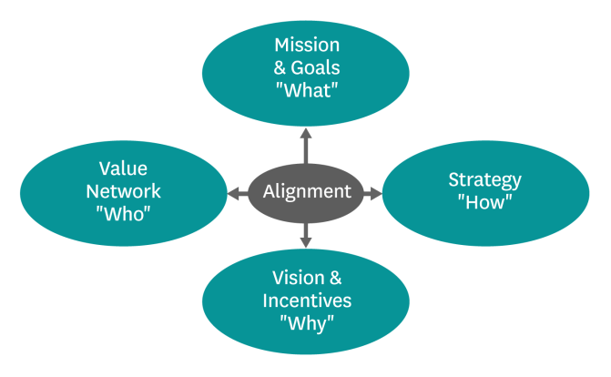
Figure 3: Strategy (Watkins, 2007)

In this figure from the Harvard Business Review website, Michael Watkins clearly lays out the main principles involved in contemporary business strategy. If we can align the commercial goals with vision, and incorporate culture and people (ideally with HRM) there is a far greater chance of success.
When we think about how HRM fits into strategy, we need to look at our contribution as a vital working part of each stage.
Stage 1: Assessment of current internal & external situation.
Alongside accepted business KPI’s, we can provide the people analytics, advise on current resource.
Stage 2: Strategy Formulation.
We can provide insight into the complications that may arise around implementing change, and support and prepare the business for any ethical and legal considerations. We are also likely to be best placed to understand the potential for redeployment or re-training as required.
Stage 3: Strategy Implementation.
Here we will help by implementing proven change management techniques and pre-empting problems. We will be vital in helping communicate the positives of change and reassuring staff that the long -term plans are well thought out.
Stage 4: Evaluating the strategy
Reviewing the effectiveness of the change and making necessary adjustments as required. The business will need to ensure performance is heading in the right direction. From an HR perspective we need to ensure the business has followed through on commitments made to employees.

So, when it comes to strategy, we are there to provide guidance on best practice, i.e. practices proven to contribute towards success such as:
- Teamworking/Flexibility
- Employee involvement
- Employee voice
- Employee ownership
- Performance related reward
- Sophisticated selection
- Internal promotion
- Employment security
- Commitment to learning
- Harmonisation of working conditions
(Kew & Stredwick, 2016)
By then adapting these practices in line with the clear business strategy we can ensure we have best fit. This way we can achieve symmetry between the needs of the business and HR practices and policies.
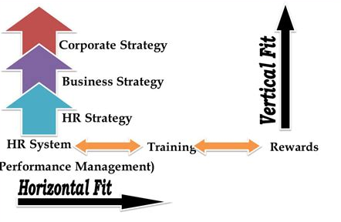
Figure 4: Vertical & Horizontal Alignment

Let’s not forget throughout the strategy process, HR professionals must take the lead in guarding the ethical well-being of our organisation.
The CIPD reminds us that work can be a force for good, and part of our rule is to ensure that the forces that drive the right behaviour, fairness, integrity, honesty etc. are threaded to through all aspects of the business strategy (CIPDa, 2018)

How to devise a strategy
Broadly speaking strategies generally involve the formulation of goals, plans to implement changes and some sort of evaluation method (Quinn, 1980) Approaches vary by organisation and usually fit under one of the following headings:
Rational/Classic – Usually a top-down approach by board/senior manager level looking at internal and external factors.
Emergent/Logical Incrementalism – More about strategy decisions made more often and constantly reviewed due to the changing nature of the business environment.
Symbolic/Radical - No strategy at all, just the hope that drive ambition and innovation will be enough to achieve goals with no formal plan.

Some organisations prefer a more rational approach with a clear process involving the use of tools (more on these later) to take the measure of forces both internal and external to plan ahead.
Whilst others prefer a more fluid or incremental approach with regular re-evaluation allowing for smaller more frequent changes in keeping with a fast changing world. Netflix is a good example, the thinking there is that innovation rules over tired old processes that put constraints on new ideas and innovation when taking a business in a new direction (McCord, 2018)
An alternative and again potentially more relevant (Deloitte, 2009) strategy in some cases would be a resource- based view, more of an inside –out process. Unlike the contingency based models, we’ve spoken about, the focus here would be on the internal resources and practices, culture and or values that set us apart and work at developing by expanding or refining them.

McKinsey’s strategy model below splits into hard and soft elements. The hard elements reflect the formal processes involved, and the soft elements are the more cultural and less tangible elements.

Figure 5: 7S Model

As the diagram below demonstrates, although the elements in the model are split as above, they are all interconnected and centre around shared values.
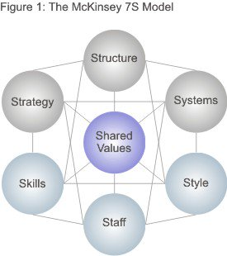
Figure 6: 7S Interconnection (MindTools, 2019)

Strategy Tools
I mentioned earlier that there are tools we can use to help form and direct our strategies. Tools help us focus more clearly on the internal and external factors that will impact our businesses and influence the direction we move in for the greatest chance of success.

Three of the most widely used are:
S.W.O.T- This is used frequently in many of our business areas, but for strategy it can be a powerful way to start the discussion and generate thoughts. The strengths and weaknesses tend to be focused on internal elements of the organisation, whilst the threats and opportunities have a more external overview. This can be overly simplistic though, quick in practice, but can be too general, and lack enough detail in specific areas.
P.E.S.T.L.E – This type of analysis is more specific than the SWOT and directs analysis to specific areas that impact business. Political, economic, social, technological, legal and environmental factors. There is a risk here though in spending far too much time gathering data “paralysis by analysis” (CIPDb, 2018).
Porter’s Five Forces – This tool is specific to business settings as the factor he uses relate to industry, competitive rivalry, supplier power, buyer power, threat of new entry and threat of substitution. This is a pretty high -level tool but can be useful if you have enough knowledge around your specific industry.
Whichever tool is selected, the information needs to be gathered in each area, captured somehow and linked to future goals and plans in order to foster a detailed thought process around strategy. Let’s look at a couple of factors that relate to our organisation in more detail.

Factors which Impact Business & HR
External Factors
Political: Many external factors will affect strategy at various stages, political/legal issues impacted us in 2017/2018 with changes in the Ogden discount rate, this meant compensation payments to injured parties would increase. This had a knock- on effect around the business resulting in higher claims costs, reduced profits and tightening of our belts from a growth perspective.
As HR professionals we were there to support the business as it communicated the changes that this would bring, growth was reduced, including planned expansion of some departments and although there were no redundancies to contend with, we did need to redeploy temporarily.
Legal: We also managed the change in National Living Wage, this was a positive for many as they saw their salaries increase, however, impact on our wage budget has meant that there has been a cap introduces in some business areas and pay freezes for others. There was pressure on payroll to administer the changes in a timely fashion as well as the responsibility on our executives in HR to manage expectations and update policy.
Internal Factors
Reduced Growth/Opportunities Throughout 2017 and 2018 there was a company wide focus on improving efficiency from the point of view of reducing unnecessary support roles. One of the outcomes of this was the removal of the senior consultant role, this meant a layer of managers were removed reducing opportunities for advancement.
Before this move was made, People Services (PS) were consulted, and a plan was put in place to manage the change. This is a vital role for any HR function, there are many change management models and guides to help. When a significant change like this occurs it can be very unsettling and distressing. The figure below demonstrates this perfectly, although the long- term benefits may be clear, there is often no way to avoid the initial emotional reactions when the change is initially announced.
Figure 7: Kubler-Ross Change Curve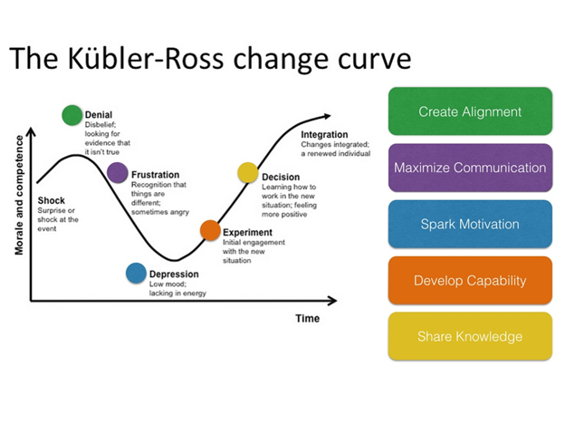
Due to being involved from the early stages we could prepare and communicate in a positive way and provide alternative options for staff development. A Development Programme was put into place allowing staff to enrich their knowledge and experience with a view to becoming better at the current roles; considering horizontal movement around the business as a next step not just vertical. This is on of the ways the CIPD recommends in order to improve retention:
Career development and progression - Maximise opportunities for employees to develop skills and careers. It's also important to understand and manage people’s career expectations. Where promotions are not feasible, look for sideways moves that vary experience and make the work more interesting (CIPDa, 2019).
AI/Technology An organisation the size of EUI Ltd with over 5000 UK employees has its issues to manage. We pride ourselves on innovation and forward thinking, but this can be problematic.
Early in 2018 we launched our robotics initiative, the idea being that automation could reduce the number of low skilled manual/data entry roles and allow us to move experienced agents into roles that were more engaging.
In practice this proved to be difficult, many staff who had been responsible for the roles now passed to robots, were unable to be redeployed initially due to either outdated skills or shifts that could not be accommodated by other areas of the business.
The scale of the issue was underestimated by the business, neither People Services nor L&D were involved during the early stages and were therefore unable to prepare for managing the change, therefore we didn’t have adequate resources to manage the scale of retraining required. The result was more distressing that it needed to be, we needed to act quickly to reassure and support staff involved, and were in more of a disaster recovery role, on the back -foot firefighting as issues came up as opposed to being ahead of the change.
This can be a difficult process to manage; and is becoming more common across the working world.
The challenge lies in retraining the workforce and providing workers with the new skills they need as quickly as they are required—no small feat given the rapid advances in automation technologies
(Woetzel, et al., 2017).

Evaluating Business Performance

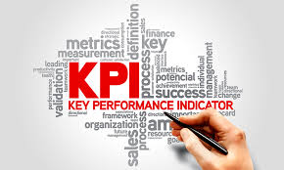

A significant element of planning and strategy is a deep understanding of where we are as a business, what do we do well and where must we improve. As a company with internal and external stakeholders, and of course our shareholders to answer to, its vital we have accurate methods of reporting that stand up to scrutiny.

Traditionally, we would measure this in very simple commercial terms, by the profit we deliver. This was (and still is) the main metric that tells our stakeholders how we have performed. We would simply deduct our operating costs from our revenue and use that figure as our benchmark to beat each quarter. From an HR perspective we would look at the cost of recruitment and training to backfill staff lost.

Now, there are many more factors to help evaluate and improve our performance in all areas, it’s no longer relevant to look at the bottom line, we need to consider a broader range of KPI’s.

Productivity = time spent on calls to customers
Answer Rate = percentage of calls answered
Attrition = staff turnover
Attendance = sickness and absence rates
Wellbeing/Engagement= impact on all of the above

All of these are easy metrics to gather and analyse thanks to the introduction of tools like balanced score cards. The aim of the Balanced Scorecard was:

To align business activities to the vision and strategy of the business, improve internal and external communications, and monitor business performance against strategic goals. (Kaplan & Norton, 1996)

They gave us the ability to consider not only where we are now, but also to incorporate goals, tie in with strategy, include innovation and, most importantly, track improvements gained from these changes.
Although, there is a caveat around adding too many metrics and overcomplicating the scorecard.

From and HR perspective we gather additional information in a variety of ways such as:

- Annual Reviews
- 360 -degree feedback
- Exit interviews
- Benchmarking

These help us to gather an abundance of “big data” that is very large data sets that can help us identify trends or patterns in behaviour. We can use this information to add to the more specific business or department data to get some specific information around people analytics.

People analytics uses both people-data, collected by HR systems (such as payroll, absence management) and business information (for example, operations performance data). At its core, people analytics enables HR practitioners and employers to gain insights into their workforce, HR policies and practices, with a focus on the human capital element of the workforce, and can ultimately inform more evidence-based decision making. (CIPDb, 2019)

We can then use this data to highlight areas we need to change, for example if we find a particular source of candidates for recruitment has led to high levels of attrition, we may not use that source in future, or if feedback at exit interviews highlights a lack of support during the on-boarding process, we can take measures to ensure more resource is diverted for future intakes.

A great tool for gaining some real insights are staff surveys. Each year we compete against businesses in the UK to win the coveted title of Sunday Times Best Companies to work for, this involves all our staff completing a confidential anonymous survey about how we behave as a business, all aspects are covered from leadership to our environmental and community policies. We have featured in the top 25 big companies each year for the past 16, and I am very proud to say we came first in 2019.

Further to that, we achieved two awards specific to our HR function, we won the Wellbeing award and the L&D initiative award for our “buy a book” scheme which allows all staff members to order a book or audio book each month in order to help their career or wellbeing.



We do also rely on external data sources too in many areas, for example the current labour market conditions will have an impact on how and when we factor in our recruitment, we may decide to recruit ahead of schedule if predictions are that the market will tighten up in the near future.

A very topical issue is Brexit, we have to make provision for recruitment or relocation of our current EU member employees and prepare additional administration staff to manage the requirements for those who are able to stay; and set up new procedures for after the 29th March.

Summary & Conclusion

So, we’ve been on quite a journey today, and covered a great deal of information confirming that as we move into a demanding but exciting future as HR professionals, we are, more than ever, indispensable to our organisation.

But I hope I have demonstrated clearly that the more involved and integrated we are in every aspect of our organisation, the more effective and valuable our contribution will be.

Strategic Human Resource Management is all about us working in partnership with our business and sharing in its success.

Thank you for your time.
Notes:
________________________________________________________________________________________________________________________________________________________________________________________________________________________________________________________________________________________________________________________________________________________________________________________________________________________________________________________________________________________________________________________________________________________________________________________________________________________________________

References
Armstrong, M. & Baron, A., 2002. Strategic HRM: The Key to Improved Business Performance. London: CIPD.
CIPD (ed.), 2015. Changing HR Operating Models. [Online]
Available at: https://www.cipd.co.uk/Images/changing-operating-models_tcm18-10976.pdf
[Accessed 15 January 2019].
CIPD, 2015a. HR Business Partnering Factsheet, London: CIPD.
CIPD, 2016. Studying Human Resource Management. 2 ed. London: Chartered Institute of Personnel and Development.
CIPDa, 2018. CIPD Ethics. [Online]
Available at: https://www.cipd.co.uk/knowledge/culture/ethics/role-hr-factsheet#23816
[Accessed 2019].
CIPDa, 2019. Improving staff retention :Factsheet. [Online]
Available at: https://www.cipd.co.uk/knowledge/strategy/resourcing/turnover-retention-factsheet
[Accessed February 2019].
CIPDb, 2018. CIPD. [Online]
Available at: http://cipd.co.uk
[Accessed October 2018].
CIPDb, 2019. CIPD: Factsheet people Analytics. [Online]
Available at: https://www.cipd.co.uk/knowledge/strategy/analytics/factsheet
[Accessed 20 February 2019].
David, F. R., 1986. Fundimentals of strategic management. 1 ed. London: Merrill Publisonh Company.
Deloitte, 2009. Shaping Up:evolving the HR functionfor the 21st Century., New York/London: Deloitte.
Farnham , D., 2015. Human Resource Management in Context: Insights, Strategy and Solutions. 4 ed. s.l.:Kogan Page Publishers.
Higgins, J. M. & Vincze, J. W., 1993. Strategic Management Concepts. s.l.:Thomson Learning .
Hutchinson, S. & Wood, S., 1995. Personnel and the Line. London: CIPD.
Kaplan, S. R. & Norton, D. p., 1996. The Balanced Scorecard. 1 ed. Boston: Harvard Business School Press.
Kew, J. & Stredwick, J., 2016. Human Resource Managenebt in a business context. London: CIPD.
McCord, P., 2018. Powerful:Building a culture of freedom and responsibility. s.l.:s.n.
Moore, K., 2011. Porter or Mintzberg: Whose View of Strategy Is the Most Relevant Today?. [Online]
Available at: https://www.forbes.com/sites/karlmoore/2011/03/28/porter-or-mintzberg-whose-view-of-strategy-is-the-most-relevant-today/#5079234b58ba
[Accessed 11 January 2019].
Quinn, J. B., 1980. Strategies for change: local incrementalism. Ilionois: Homewood.
Shah, R., 2015. Taking HR Analytics Beyond Technologists. [Online]
Available at: https://www.forbes.com/sites/rawnshah/2015/04/13/taking-hr-analytics-beyond-technologists/
[Accessed 26 January 2019].
The World Economic Forum, 2016. The Future of Jobs:Employment Trends. [Online]
Available at: eports.weforum.org/future-of-jobs-2016/employment-trends/
[Accessed January 2019].
Ulrich, D., 1997. Human Resource Champions:the next agenda for adding value and delivering results.. Boston: Harvard Business Review Press.
Watkins, M. D., 2007. Demystifying Strategy: The What, Who, How, and Why. [Online]
Available at: https://hbr.org/2007/09/demystifying-strategy-the-what
[Accessed 29 January 2019].

Bibliography
Armstrong, M. & Baron, A., 2002. Strategic HRM: The Key to Improved Business Performance. London: CIPD.
CIPD (ed.), 2015. Changing HR Operating Models. [Online]
Available at: https://www.cipd.co.uk/Images/changing-operating-models_tcm18-10976.pdf
[Accessed 15 January 2019].
CIPD, 2015a. HR Business Partnering Factsheet, London: CIPD.
CIPD, 2016. Studying Human Resource Management. 2 ed. London: Chartered Institute of Personnel and Development.
CIPDa, 2018. CIPD Ethics. [Online]
Available at: https://www.cipd.co.uk/knowledge/culture/ethics/role-hr-factsheet#23816
[Accessed 2019].
CIPDa, 2019. Improving staff retention :Factsheet. [Online]
Available at: https://www.cipd.co.uk/knowledge/strategy/resourcing/turnover-retention-factsheet
[Accessed February 2019].
CIPDb, 2018. CIPD. [Online]
Available at: http://cipd.co.uk
[Accessed October 2018].
CIPDb, 2019. CIPD: Factsheet people Analytics. [Online]
Available at: https://www.cipd.co.uk/knowledge/strategy/analytics/factsheet
[Accessed 20 February 2019].
David, F. R., 1986. Fundimentals of strategic management. 1 ed. London: Merrill Publisonh Company.
Deloitte, 2009. Shaping Up:evolving the HR functionfor the 21st Century., New York/London: Deloitte.
Farnham , D., 2015. Human Resource Management in Context: Insights, Strategy and Solutions. 4 ed. s.l.:Kogan Page Publishers.
Higgins, J. M. & Vincze, J. W., 1993. Strategic Management Concepts. s.l.:Thomson Learning .
Hutchinson, S. & Wood, S., 1995. Personnel and the Line. London: CIPD.
Kaplan, S. R. & Norton, D. p., 1996. The Balanced Scorecard. 1 ed. Boston: Harvard Business School Press.
Kew, J. & Stredwick, J., 2016. Human Resource Managenebt in a business context. London: CIPD.
McCord, P., 2018. Powerful:Building a culture of freedom and responsibility. s.l.:s.n.
Moore, K., 2011. Porter or Mintzberg: Whose View of Strategy Is the Most Relevant Today?. [Online]
Available at: https://www.forbes.com/sites/karlmoore/2011/03/28/porter-or-mintzberg-whose-view-of-strategy-is-the-most-relevant-today/#5079234b58ba
[Accessed 11 January 2019].
Quinn, J. B., 1980. Strategies for change: local incrementalism. Ilionois: Homewood.
Shah, R., 2015. Taking HR Analytics Beyond Technologists. [Online]
Available at: https://www.forbes.com/sites/rawnshah/2015/04/13/taking-hr-analytics-beyond-technologists/
[Accessed 26 January 2019].
The World Economic Forum, 2016. The Future of Jobs:Employment Trends. [Online]
Available at: eports.weforum.org/future-of-jobs-2016/employment-trends/
[Accessed January 2019].
Ulrich, D., 1997. Human Resource Champions:the next agenda for adding value and delivering results.. Boston: Harvard Business Review Press.
Watkins, M. D., 2007. Demystifying Strategy: The What, Who, How, and Why. [Online]
Available at: https://hbr.org/2007/09/demystifying-strategy-the-what
[Accessed 29 January 2019].

