
knowledge and information management skills for the workplace-bmsw5106
Argos and eBay Talent and Knowledge Management

LECTURER: OLUWASEUN ADEGBITE
Student name: Paulina Andone
STUDENT NUMBER: 2027237

Table of Contents
1. Introduction- eBay and Argos main activities as organisations 2
2. Knowledge Management System (KMS) 3
3. SWOT analysis of eBay and Argos in relationship with KMS 4
3.1 Strengths 4
3.2 Weaknesses 5
3.3 Opportunities 6
3.4 Threats 6
4. Critical Evaluation of both Organizations’ Knowledge Management Value Chain 7
5. Argos talent retention in relationship with KM 9
6. eBay talent retention in relationship with KM 10
7. Conclusion 10
8. Recommendations 12
References 13

Introduction- eBay and Argos main activities as organisations

eBay Inc., is a global e-commerce platform established in 1995 in San Jose, California. A leader in connecting millions of sellers and buyers, and in managing the payments from customers to buyers without using PayPal (Kassem 2022, p. 1). They accomplish this by using GSI, which enables e-commerce, digital marketing, and multichannel retailing for multinational corporations (Zarra et al. 2019, p. 3). Argos Limited, purchased by Sainsbury’s in 2016 and doing business as Argos, is a catalogue retail store based in Ireland and the United Kingdom (UddinAhmed et al. 2020, p. 3). Unlike eBay, in addition to online visitors, they have physical stores in demand. Argos and eBay are among the leading e-commerce marketplace that enables users to sell and purchase. The two companies have programs and tools to ensure their talents develop and grow as they work for them.
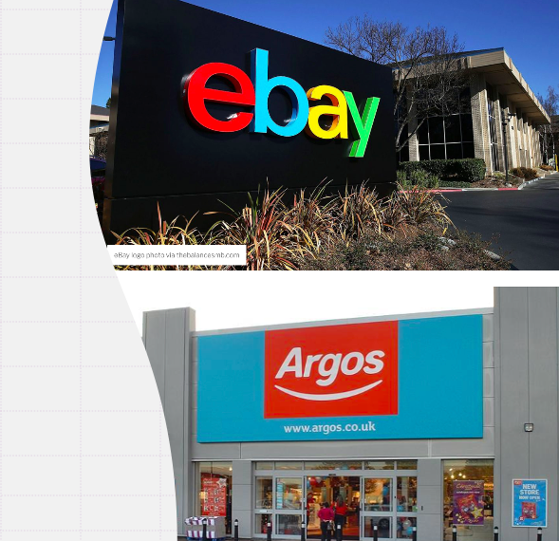

Knowledge Management System (KMS)

Roberts (2015) concludes that Knowledge Management involves a lot of effort because, first, the knowledge must be acquired. According to Ackoff (1999) and his DIKW triangle, to acquire knowledge all starts with researching and collecting data both qualitative and quantitative and transforming it into information. Information becomes knowledge when is used with purpose and understanding of the concept. When decision making is established on knowledge, that knowledge becomes wisdom, and therefore, knowledge management is the tool used by organisations to maximize the use of information through knowledge and with wisdom.
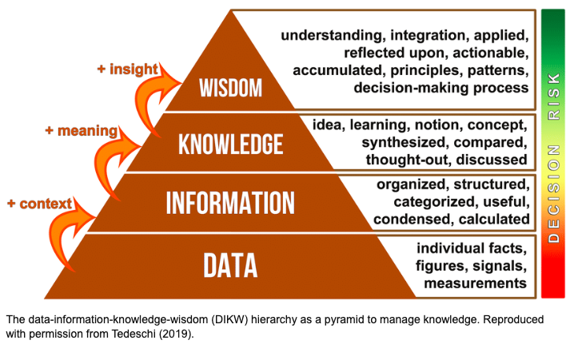
Source: https://www.researchgate.net/figure/The-data-information-knowledge-wisdom-DIKW-hierarchy-as-a-pyramid-to-manage-knowledge_fig6_332400827
Any IT system that saves and retrieves knowledge to enhance comprehension, teamwork, and process alignment is referred to as a Knowledge Management System (KMS). KMS can be used to organise knowledge base for employees or customers as well as among companies or teams.

SWOT analysis of eBay and Argos in relationship with KMS
SWOT analysis is a strategic vehicle used to identify Strengths, Weaknesses, Opportunities, and Threats inside organisations.

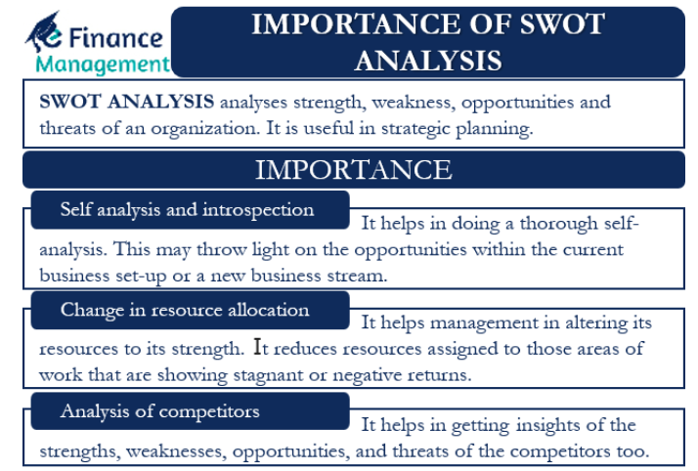
Source: https://efinancemanagement.com/financial-management/importance-of-swot-analysis

3.1 Strengths
A measure of management effectiveness strongly impacts employee productivity and company results. If the manager’s competence is insufficient, the situation may get out of control, and the employees lose their desire to work. A loss of motivation and a decrease in enthusiasm may result in dismissal, and struggle to find a better job. Such cases are provided for by the company’s Knowledge Management System (KMS) respectively, managers should be able to prevent such situations. The performance and effectiveness of the team and the manager’s interaction with their subordinates are directly correlated (Ban et al. 2018, p. 1681). Argos is an example of a company that encourages the enthusiasm of its employees and allows them to express themselves. This is ensured through their KMS, which gives employees the opportunity to participate in strategic development. In order to implement successful strategies for all regions of its work, Argos supports the enthusiasm’s growth of its employees. The principles of Argos allow the company to succeed and not be afraid of change, leading to sustainable business development. Additionally, the business uses initiatives focused on enhancing employee satisfaction and advancing leadership practices consistent with sustainable development to recruit, keep, and develop talent (Ban et al. 2018, p. 1680). All mentioned factors are strengths that are important for creating a
positive working climate in the company and contributing to the development of employees and management.
Employees and line managers actively use the implementation plan in employee development plans as working materials, which correlates with their KMS. They provide personal development for the employee, increasing their ability to perform better, retain the best talent, and achieve company goals. This enables performance management and is a component of a long-term plan that prioritizes business expansion and system improvement (Mahmoud et al. 2019, p. 112). Argos and eBay need to use one of their greatest assets- the talent of their employees- to keep their sales momentum. An example is the case of Chris Agarpao, the first employee of eBay, hired as company coordinator and still employee of the organization (eBay- Our History, 2022). Employees will be much more motivated and show more professional qualities when they understand they are essential and valued. All these development plans are a perfect example of how the company implements its Knowledge Management Systems.

3.2 Weaknesses
One of the main weaknesses of e-commerce companies is scammers. Companies like Argos and eBay can often run into scammers who pose as sellers but swindle people out of money. In addition, scammers can pretend to be employees of this companies’ whit the attempt to lure customers out of their personal information. This significantly harms the working climate of companies and reduces the enthusiasm of their employees, which can negatively affect the expected outcome of the organizations. This weakness damage the KMS and becomes difficult to identify a dishonest seller.

3.3 Opportunities
To improve the performance, eBay employees work on their development plans to help them improve their skills. They may partner with managers and other team members for coaching and mentorship. In addition, they invest in cutting edge technologies that facilitate continuous learning and teaching, such as on-demand courses, personalized learning environment, and unique channels for ongoing employee feedback. The development of technology helps to improve the KMS, which will facilitate the work of employees.
Argos is committed to continuing the education of its employees and offers financial assistance for region-specific professional degrees and certifications. Argos is using a 10-20-70 approach to address development gaps. According to this framework, learning occurs through direct performance in 70% of cases, 20% through interaction with colleagues, and 10% through theory (Trinidad 2022). The phrase “performance evaluation” describes the routine evaluation of labor productivity and overall business value (Al-Jedaia and Mehrez 2020, p. 2077). This is a great example of how a company’s strategy fits into its Knowledge Management System. Performance appraisal, sometimes called an annual appraisal, performance review, or employee appraisal evaluates an employee’s ability, success, and development or lack thereof. At Argos, managers and employees evaluate each other’s contributions to corporate goals and how they can improve their skills to acquire the capabilities the company needs. This process is cyclical and continuous.

3.4 Threats
Items, users, and the reputation system are the components of an e-commerce system. Such as organization is directly related to the KMS because it is part of the data. In their online store, merchants promote their products and list the price for each item (Bogenschneider 2021). Customers making purchases in online stores can leave reviews about sellers to tell how the product matches its description. This results in a reputation system for sellers on sites such Argos and eBay. However, the main disadvantage of such a system is that reviews can be easily cheated, thereby editing the statistics in the right direction. This can significantly threaten online stores as it destroys fair competition and negatively impacts employees.
Another threat may be the trend of isolationism in the economy. Some laws govern how user data can be used, how employees are treated, and how to protect the environment. These strict rules challenge Argos, as an example is the Paris Agreement 2016 (Allan 2019, p. 5; Zimm and Nakisenovitch 2020, p. 460). Pandemics such as COVID-19 also threaten e-commerce and physical stores and are associated with currency fluctuations, especially given the unpredictable political environment and bilateral laws in many international markets. However, since eBay does not have an offline store, this has affected Argos more.
After conducting a SWOT analysis of these companies, we can say that their Knowledge Management Systems are quite similar and differ only in certain areas.

Critical Evaluation of both Organizations’ Knowledge Management Value Chain
The company's management adheres to a value capture strategy created along the chain to maintain competitiveness. This approach has a substantial competitive difference, such as the difference between the value chains of competing companies. Value is the price customers are willing to pay when prices are competitive. Total revenue, which reflects the price a company's product attracts and the number of units it can sell, is used to measure value (Grebe et al. 2021, p. 190). The business can be considered profitable if the product’s final cost exceeds its manufacturer’s cost.
The most crucial element in promoting goods so that buyers are ready to purchase them at a suitable price for the company, is marketing. Fundamentals such as finance, skilled workforce, unique services, and products are some critical areas considered brand strength (El-Ebiari, 2021, p. 6532). Growth during the COVID-19 pandemic was a turning point for companies as it prevented them from collapsing or falling in the face of the pandemic and provided a better user base.
eBay and Argos acquire every worker’s performance, skills, and abilities through the KM value and use this knowledge to incentivize their talents. The organization must establish and manage complex practices in the knowledge management value chain to improve the efficiency of factor knowledge. Similarly, it is an essential competitive tool during pandemic. The KM value chain process includes knowledge inventory, development, exchange, application, and evaluation of knowledge.
Using strategic objectives, the company can decide what knowledge and skills employees need to solve the tasks. One of the key methods of knowledge creation for managers is the integration of different types of knowledge into a new body of knowledge (Sanchez 2003, p. 108). This can be achieved in various ways, including training employees and acquiring knowledge from third parties. Knowledge must be shared throughout the company after it has been created so that everyone can use it and create high value for knowledge.
Employee records should be structured so that it would be clear to navigate what talent shortage the company have among their personnel. The data of employees currently working in the organization is easier to control than to create a list of necessary ones (Sajjad et al. 2005, p. 104). Detailed knowledge results from processing, organizing, structuring, and interpreting data. Similarly, it is easier to collect, share and store data, which is most relevant for knowledge management (Hill 2022). It is this knowledge that eBay, and Argos use to promote employees and help them develop. The practical implementation of explicit knowledge is known as tacit knowledge. Implicit knowledge is likely to exist throughout eBay and Argos (Loudon and Loudon 2014, p. 3). A good example would be completing a task with other co-workers. Brainstorming different ways to see the work done can lead to discussing the methods available to accomplish a task (Miller and Dess 1993, p. 555; Senge 1990, p. 11). Brainstorming using tacit knowledge identifies critical areas and necessary actions to implement. People retain abilities from personal and past environmental commitments called tacit knowledge (Smith 2001, p. 312). Implicit knowledge implements implicit knowledge, unique to eBay and Argos, in the workplace.
Numerous methods are constantly being improved to support the evaluation of streaming data. eBay uses several tools, including Apache Spark, Kafka, Hortonworks HDF, and Storm Zhu et al. 2022, p. 2). This means that as many people can use the information as possible with the appropriate degree of permission and security. This allows business data engineers to look for information markers associated with data. In addition, it uses Presto, Hadoop’s collaborative query engine. The firm has pioneered the use of big data and is actively celebrating the open-source community by sharing its expertise.
Heavy use of data lakes has limitations, as HR often has more problems than explanations. Without knowledge of what data is available, how it can be used, what it assumes, the parts that can be trusted, and how it was obtained, data users may not be able to efficiently maximize data (Porter 2008, p. 81). Working in a data lake can be daunting without an easy way to ask for help or even find someone who might have an explanation. eBay has turned the idea of ​​data management on its head to achieve this. Because of its independent and innovative culture, eBay requires an open strategy that gives data users access and control and encourages innovation and experimentation (Caruso 2017, p. 45). eBay's approach to data management is based on gaining in-depth knowledge of each data item and making it available to customers as part of their standard workflows in an algorithmic manner rather than restricting and controlling access. Understanding customer habits is important (Frésard and Valta 2015, p. 3). eBay tracks every aspect of how data assets are used, how often the information is accessed, who accesses it, and how it is accessed, right down to the fulfillment of specific requests.

Argos talent retention in relationship with KM
After competitive bidding, Argos decided to test the eGain KnowledgeAgent with a small group of its resellers in the Appliances Aftermarket and Services department. With the help of the knowledge base, it became intuitively more accessible for Argos representatives to solve complex customer requests, knowing about this particular problem in the past (Newing et al. 2020, p. 460). To improve customer satisfaction, the efficiency of contact center consultants, and the level of detail of the first contact, it was decided to implement a rigorous knowledge management system due to the increasing complexity of requests for household goods and services (Porter and Advantage 1985, p. 168). However, knowledge is not only a consequence of filtering or algorithms. It is the product of a much more purposeful, complex social, cultural, and contextually limited process (Weinberger 2010). Based on the pilot project, they noted a significant quality of the operational service processes, with a 10 percent reduction in repeat calls and a sharp decrease in avoidable returns and technologist consultations.
The company has programs such as the Network Engineering Apprenticeship, which helps workers hone their skills and advance in their careers (Newing et al. 2020). The scale of Sainsbury’s allows employees to become familiar with different technologies, procedures, and people. The organization also provides opportunities to participate in meaningful projects and provide workplace assistance for critical business systems. Colleagues of the organization receive the skills they need for their professional future and the opportunity to earn while studying through an apprenticeship program that connects them with experts in their field who have specialized knowledge.
Early careers programs help employees and job seekers develop a career at Sainsbury or change career paths. The Jumpstart program, one of several programs they offer, helps high-potential graduates and undergraduates applicants succeed (Newing et al. 2020). The company also offers a paid internship program that helps second, and third-year students develop business knowledge and experience where it is appropriate to use their studies. Helping their internal workers to adapt and advance their professions quickly, they run a Bootcamp program during the onboarding period.

eBay talent retention in relationship with KM
eBay has several employees and executive development programs. These programs, such as the Financial Leadership Development Program (FLDP), are designed to meet the company's needs. Through this competition initiative, participants can develop their technical and leadership skills while enhancing their business skills. Working on challenging projects, each FLDP cohort receives intensive leadership training and senior management mentorship. Participants are provided with important positions that qualify them for future financial leadership positions upon completion of the program. Participants of the program meet in San Jose a week before the start of each cycle, at which time they concentrate on the study of management. Employees become more familiar with the dynamics of different teams and groups through methods they learn in a matter of weeks. eBay's investments are driven by a desire to keep up with the rapid pace of digitalization to make it easier for data customers to use and find the data they want (Zhu et al. 2022, p. 2). The incentive plans for both eBay and Argos are similar in that bonuses and allowances are added to the base salary.

Conclusion
In the modern world, the specifics of work are changing dramatically due to the development of technology. However, Argos and eBay still use the same workforce planning and human resource management methods. Argos, like eBay, must adapt to the digital age by redesigning the workplace. Argos talent management and planning need to become more strategic, comprehensive, rigorous, and data driven. Companies restructuring using traditional analog methodologies will lag more forward-thinking competitors. According to an analysis by eBay and Argos, both companies face various challenges ranging from knowledge development to retain talent within the organization (Bocij et al. 2018, p. 44). Argos, compared to eBay, has a higher attrition rate. Argos’ high turnover rates mean they have little to no employee retention. Both companies can retain individual workers and avoid hiring costs by changing this. The measures taken to retain workers do not seem to be working enough. By selecting suitable candidates, the respective HR departments of the two companies have the responsibility and the ability to influence the rate of employee turnover and therefore ensure the availability of available talent in the future. eBay and Argos, which must deal with a repetitive workflow, make most employees feel bored, which contributes to not fulfilling their potential in personal and career development. It is imperative that the two companies reconsider which skill sets will be most valuable in a progressive technological future, cultivate them among the working population, and attract the best talent after they emerge from a pandemic that has challenged assumptions about workplace behavior to meet requirements ( Ryport and Sviokla 1995, p. 76; Porter 1980, p. 6). Both companies must understand what future talent and their current employees may want from them to stay ahead of the curve. Future managers would be looking for a job with a value proposition that was very different from what attracted employees five or ten years ago, regardless of the pandemic. This generation's demands include diversity, flexible hours, autonomy, inclusion, and a deep connection with their managers.
Human-machine learning algorithms should be used across the entire range of HR activities as eBay gathers more and more data about current and future employees, including information about each person's potential, capability, performance, and ability to learn new skills and adapt to new roles upon assignment. With the help of information technology, both companies were able to hire, use, develop and retain talent much more efficiently and cheaply. Both Argos and eBay have not fully utilized the labor force data they have. They have just begun to scratch the surface.
The report states that eBay and Argos have put in place several programs to ensure that their talent develops and grows throughout their time with them. eBay has programs such as the Financial Leadership Development Program. In contrast, Argos has initiatives such as early career development programs and network engineering training that enable workers to continue their careers while earning. These programs ensure that these companies retain their best employees as they are trained in managerial skills to take on future higher positions in the company. Since the respective companies support these programs, it motivates employees to develop and grow, and the reward also becomes attractive as they climb the hierarchical ladder in the workplace.

Recommendations

When dealing with resource management, security, information systems, and talent management programs in general, eBay and Argos must consider the knowledge protection aspect of IP security. Information security of IP is a knowledge-intensive task, which largely depends on the abilities and knowledge of IP specialists and the consciousness of end users. While Argos has well-trained staff, eBay should emphasize training its staff, so they become more familiar with knowledge management and information-sharing tools. Argos should focus on forecasting tools that can drive their knowledge to ensure they can forecast demand as it comes.
Another recommendation is encouraging innovation among the company's talent to create a competitive advantage. Argos and eBay can compete in the e-commerce sector through innovation. Market share can be increased by creating or improving an innovative product that can support eBay's corporate purpose and goals. Another suggestion is to create more strategic alliances with other parties, including courier services. This offering improves service reliability to counteract the significant bargaining power of customers. Such strategic alliances also partially offset the modest bargaining power of suppliers noted in this external study. According to this study by eBay Inc. and Argos, the company's plans should also consider the dangers of replacements and new members. To address these issues, continuous development of the service is recommended.

References
Ackoff, R. L. (1999) Ackoff’s Best. New York: John Wiley & Sons, pp 170 – 172.
Al-Jedaia, Y. and Mehrez, A. (2020) ‘The effect of performance appraisal on job performance in governmental sector: The mediating role of motivation’, Management Science Letters, 10, pp. 2077-2088.
Allan, J.I. (2019) ‘Dangerous incrementalism of the Paris Agreement’, Global Environmental Politics, 19, pp. 4-11. Doi: https://doi.org/10.1162/glep_a_00488
Ban, N.C., Frid, A., Reid, M., Edgar, B., Shaw, D. and Siwallace, P. (2018) ‘Incorporate Indigenous perspectives for impactful research and effective management’, Nature ecology & evolution, 2(11), pp.1680-1683. Doi: 10.1038/s41559-018-0706-0.
Bocij, P., Greasley, A. and Hickie, S. (2018) Business information systems: Technology, development, and management. Pearson Education.
Bogenschneider, B. (2021) ‘eBay Frauds: Specific Illustrations and Analysis’, Loyola Consumer Law Review, Forthcoming.
Caruso, J. (2017) ‘A foundation for understanding knowledge sharing: Organizational culture, informal workplace learning, performance support, and knowledge management’, Contemporary Issues in Education Research, 10, pp. 45.
El-Ebiary, Y.A.B. (2021) ‘eBay e-commerce platform opportunities and obstacles’, Turkish Journal of Computer and Mathematics Education (TURCOMAT), 12(10), pp. 6531-6536. doi: 10.17762/turcomat. v12i10.5505
Frésard, L., & Valta, P. (2015) ‘How does corporate investment respond to increased entry threats?’ Review of Corporate Finance Studies, 5(1), pp. 1-35. doi: 10.1093/rcfs/cfv015
Grebe, T., Ivanova-Stenzel, R. and Kröger, S. (2021) ‘How do sellers benefit from Buy-It-Now prices in eBay auctions?’ Journal of Economic Behavior & Organization, 183, pp. 189-205. Doi: 10.1016/j.jebo.2020.12.015
Hill, J. (2022) Different types of knowledge: Implicit, tacit, and explicit, Bloomfire. Available at: https://bloomfire.com/blog/implicit-tacit-explicit-knowledge
Kassem, S. (2022) Can third-party sellers on Amazon rely on the platform as their only source of income. Available at: https://urn.fi/URN:NBN:fi:amk-2022052612285
Laudon, K., & Laudon, J. P. (2014) Management information systems: Managing the digital firm. London: Pearson.
Lim, S.F.W. and Winkenbach, M. (2019) ‘Configuring the last-mile in business-to-consumer e-retailing’, California Management Review, 61(2), pp. 132-154. Doi: 10.1177/0008125618805094
Liu, Y. and Tang, X. (2018) ‘The effects of online trust-building mechanisms on trust and repurchase intentions: An empirical study on eBay’, Information Technology & People. 31 (3), pp. 666-687. doi: 10.1108/ITP-10-2016-0242
Mahmoud, A.A., Shawabkeh, T.A., Salameh, W.A. and Al Amro, I. 2019 ‘Performance predicting in hiring process and performance appraisals using machine learning’, 2019 10th International Conference on Information and Communication Systems (ICICS), pp. 110-115.
Miller, A., & Dess, G. G. (1993) ‘Assessing Porter’s (1980) model in terms of its generalisability, accuracy and simplicity’, Journal of Management Studies, 30(4), pp. 553-585 Doi: 10.1111/j.1467-6486. 1993.tb00316.x
Newing, A., Hood, N. and Sterland, I. (2020) Planning support systems for retail location planning. Edward Elgar Publishing.
Porter, M. E. (1980) Competitive strategy: Techniques for analyzing industries and competitors, Competitive Strategy. New York: Free Press.
Porter, M. E. (2008) ‘The five competitive forces that shape strategy’, Harvard Business Review, pp. 78-93
Porter, M. E., & Millar, V. E. (1985) ‘How information gives you a competitive advantage’, Harvard Business Review, pp. 149-160.
Porter, M.E. and Advantage, C. (1985) ‘Creating and sustaining superior performance’, Competitive Advantage, pp.167-206.
Rayport, J.F. and Sviokla, J.J. (1995) ‘Exploiting the virtual value chain’, Harvard Business Review, 73(6), pp.75-85.
Robert, J. (2015) ‘Knowledge, Acquisition, Retention and Transfer’, A Very Short Fairly Interesting and Reasonably Cheap Book about Knowledge Management. London: SAGE, pp.56-78.
Sajjad, M.J., Jonathan, H.K. and Con, C. (2005) ‘The paradox of using tacit and explicit knowledge. Strategies to face dilemmas’, Management Decision, 43(1), pp. 102-112. Doi: 10.1108/00251740510572515
Sanchez, R. (2003) Knowledge management and organizational competence. New York: Oxford University Press.
Senge, P.M. (1990) The art and practice of the learning organization. New York: Doubleday.
Smith, E.A. (2001) ‘The role of tacit and explicit knowledge in the workplace’, Journal of Knowledge Management, 5(4), pp. 311-321. Doi: 10.1108/13673270110411733
Trindade, P.H.A. (2022) DVB-RCS2 satellite return link: Queuing model and resource allocation optimization based on game theory.
UddinAhmed, J., Mazid, T. and Ahmed, A. (2020) Argos: Revolution in non-food retailing. SAGE Publications.
Weinberger, D. (2010) The problem with the data-information-knowledge-wisdom hierarchy, Harvard Business Review. Available at: https://hbr.org/2010/02/data-is-to-info-as-info-is-not
Xiao, B., Chen, Q. and Yu, Z. (2021) ‘Research on the Investment Value of Sainsbury’s’, 6th International Conference on Social Sciences and Economic Development, pp. 108-115. Doi: 10.2991/assehr.k.210407.022
Zarra, A., Simonelli, F., Lenaerts, K., Luo, M., Baiocco, S., Shenglin, B., Li, W., Echikson, W. and Kilhoffer, Z. (2019) ‘Sustainability in the Age of Platforms’, EMSD Challenge Fund-Final Report.
Zhu, F., Xu, L., Ma, G., Ji, S., Wang, J., Wang, G., Zhang, H., Wan, K., Wang, M., Zhang, X. and Wang, Y. (2022) An Empirical Study on Quality Issues of eBay’s Big Data SQL Analytics Platform.
Zimm, C. and Nakicenovic, N. (2020) ‘What are the implications of the Paris Agreement for inequality?’ Climate Policy, 20(4), pp. 458-467. Doi: 10.1080/14693062.2019.1581048

