

Skills for the Workplace
Assignment Submission

Student Name: | Maryna Krainiuk
Student ID: | 2011437
Module No: | BMSW4002_LON
Module Title: | Effective Team Working and Communication
Lecturer: | Diya Ganguly

Contents

1.Introduction 1
2. Models of Communication 1
2.1. The Shannon - Weaver Mathematical Model (1948) 2
2.2. Berlo’s Model of Communication 3
2.3. Schramm’s Model of Communication (1954) 4
3. Communication Skills for Effective Interaction 5
4. Analysis Case Studies of Communication Scenarios 7
4.1. “Maria and Pedro” (Appendix 1) 7
4.2. “The Professor and the Village People” (Appendix 2) 8
5. Analyzing Examples of Poor Communication in the Workplace 8
5.1. Case in Hospitality 8
5.2. Case in Healthcare 8
6. Conclusion 9
References 10
Appendix 1 11
Appendix 2 12
Appendix 3 13

1.Introduction

Communication is one of the basic skills that make up human life in the modern world. The ability to clearly express your thoughts to the interlocutor, to understand the course of the opponent's missions, to properly interact with the environment, taking into account the individual characteristics of the interlocutor, as well as to equally effectively interact with the management, colleagues, patients or customers of services. All mentioned above are skills that are integral to building a successful career.
The development of communication skills contributes to both life and professional success.
Communication skills are the ability to build friendly relationships with people, find an approach to them, thus disposing them to themselves.
Communication skills are the ability to communicate effectively. This is the ability to understand the interlocutor, and to be understood, the ability to negotiate, to achieve your goal through communication.
In this report, we will discuss at various models of the communication process. We will also give examples of poor communication in the workplace. We will determine which communication models the study cases relate to. Also, we will suggest possible ways to improve for more effective interaction between the parties in emerging situations.
In addition, we will analyze what skills are a component of communication skills.

2. Models of Communication

A very important aspect of communication is how the sender transmits the message and how the addressee receives the message. Using communication models, the message transmission process can be visualized. That is, to put it simply, communication models are a visual representation of the communication process.
The communication models that we will consider are widely known and are used to explain the human communication process.

2.1. The Shannon - Weaver Mathematical Model (1948)
The communication model, which was first proposed by Claude Shannon and Warren Weaver in 1948 in the article "The Mathematical Theory of Communication", is widely popular and known as the "mother of all models."
This is a linear model that represents how messages are sent and received, and also explains how messages can be lost and corrupted in the communication process.
Claude Shannon in his article "The Mathematical Theory of Communication" outlined the purpose of this model as follows:
“The fundamental problem of communication is that of reproducing a message sent from one point, either exactly or approximately, to another point” (Shannon, 1948, p. 379).
Accordingly, using this mathematical theory, the author hoped to more effectively identify the source of noise that distorts communication.
The model consists of such components (Sender, Encoder, Channel, Decoder, Receiver, Noise) and is presented as follows:

RECEIVER
(Destination)
SENDER
(Information source)
ENCODER
(Transmitter)
DECODER
(Reception)
CHANNEL
N

NOISE
- Internal
- External

FEEDBACK

Initially this theory was developed mainly for technical communication. For example, telephone communication.
Accordingly, the model has its advantages and disadvantages:
Advantages | Disadvantages
- the model shows the source of "noise", that is, it helps to find out where the information break is formed, thereby identifying areas in which you need to improve communication  - divides communication into understandable parts, visualizing important stages of message transfer from start to finish | - linear model with insufficient attention to feedback  - not indicated problems with one sender and several recipients

The relevance in the fact that no sphere of human life can do without the theory of communication, and the mathematical theory of information as the basis of the communication model substantiates the basic provisions of the communication structure.

2.2. Berlo’s Model of Communication
American communication specialist Dr. D. Berlo in 1960 proposed an extended linear communication model called "SMCR". The name of the model is an abbreviation of the elements of the model Source-Message-Channel-Recipient.
Individually element of the presented communication model has sub-elements presented below:

RECIEVER
CHANNEL
SOURCE
MESSAGE

Communication Skills
Attitude
Social System
Culture
Seeing
Hearing
Touching
Smelling
Communication Skills
Attitude
Social System
Culture

Structure
Content
Code
Treatment

Accordingly, the factors included in each stage have an impact on the result of communication.
Nevertheless, this model also has disadvantages: it is one-directional, there is no feedback analysis, noises or barriers are not taken into account in the communication process.
According to the author of the model, the success of the communication process is determined by the coincidence of knowledge and attitudes of the sender and the addressee.
Therefore, communication will be effective if two items are qualified.

2.3. Schramm’s Model of Communication (1954)
In 1954 Wilber Schramm pointed out that communication is a cyclical process and a linear approach is not entirely correct.
Criticizing the already known linear models, Schramm argued:
“In fact it is misleading to think of the communication process as starting somewhere and ending somewhere. It is really endless. We are really switchboard centers handling and re-routing the great endless current of information.” (Schramm, 1955)
The Osgood-Schramm model is circular, that is, in which messages go in two directions. Consequently, communication is mutual and equal.
The theory integrates communication mainly through speech, writing and conversation.
Basic principles of the model:
- circular communication based on the interaction between two subjects. Each of which is both a sender and a recipient at the same time. Accordingly, they interact with each other, and not in one-sided direction;
- interpretation of messages for better understanding. However, messages can be misinterpreted. This is due to semantic barriers (values, beliefs, knowledge) that affect the information sent and received. Nevertheless, communication in this model is two-way and communicators can give each other additional explanations of the message;
- each subject in the process of communication sequentially performs three steps: encoding, decoding, interpretation;
- equal and reciprocal connection. Dialogue participants are equal participants, which is good for understanding face-to-face conversation.
A possible point of criticism is that the model does not provide multi-level communication in mass communication. In addition, the author does not take into account that the communication process is "unbalanced". Consequently, the circular model distortedly reflects the participation of individuals.

3. Communication Skills for Effective Interaction

Communication skills are the ability to effectively transmit and receive information. The transmission of information can be oral (speech), written (book, email, website), visual (diagrams, graphs, photographs), non-verbal (body language, gestures, tone of voice). In practical terms, communication consists of a combination of these elements.
Verbal communication is the main form of manifestation of thought and concretization of a person's desires. However, it is also necessary to consider non-verbal means and their role in communication. With the interaction of both types, the optimal transfer of information and influence on the interlocutor is achieved.
Consider a few essential communication skills:
1. Good verbal communication skills are always of high importance in any area of ​​human life. According to the classification, verbal communication is divided into the following:
- intrapersonal - internal dialogue with oneself;
- interpersonal - a conversation between two or more people;
- communication in small groups - interaction through conversation in a group with a small number of participants;
- mass communication- the process of disseminating information to numerically large audiences.
A fundamental element of verbal communication is conversation. During the conversation, it is important to observe the following components:
- empathy - a reflection of the feelings of the interlocutor, the ability to imagine oneself in the place of another and to understand his desires, ideas and actions
- the ability to ask questions, thereby showing the level of understanding of the message
- clear and understandable formulation of thought
- paraphrasing - repetition of what the interlocutor said, but not verbatim, but in a modified form
- summarizing - highlighting the main idea from what has already been said by the interlocutor
2. Non-verbal communication (Body Language).
Body language can greatly affect how others perceive us. Understanding non-verbal cues can help you better understand the other person.
The key aspects of non-verbal communication are:
- Facial expression. Mimic of face can convey the whole spectrum of emotions from joy to anger, express agreement or disagreement. One fact about facial expression that an appropriate smile will always add a positive attitude to the conversation.
- Eye contact. Establishing proper eye contact is an important part of a conversation. The eyes are always transmitting our feelings, no matter what we say.
- Posture. The pose that a person takes during a conversation conveys a message in the same warmth as spoken speech. Thus, for example, we can broadcast interesting or bored, attentive or distracted.
- Gestures. Each individual gesture is like a word in a sentence, with their help we express a clearer attitude towards the interlocutor or any event.
- Dress code. The appearance forms the first impression of the interlocutor, the level of professionalism, social status. Very often, non-observance of the dress code leads to a misperception of the interlocutor.
3. Active listening. Listening is one of the most important skills that affects the efficiency of work and the quality of relationships with people. Active listening is to hear not only the words, but the entire message being transmitted.
Therefore, for an effective hearing result, we must:
- focus on the interlocutor
- not be distracted by the environment while talking
- do not interrupt or interrupt the speaker
- do not mentally prepare counterarguments
- listen with empathy
- focus on what the person is saying
- pay attention to the speaker's body language
- demonstrate non-verbal engagement (head nod, smile, open posture)
- provide feedback, ask questions after the speaker has finished each part

4. Writing skills are also an important element in the communication process. Good writing skills make it possible to more clearly and understandably present information in messages, when writing a report, a plan, or any communication through writing. Thus, creating a good first impression of us.
Written communication can be:
- formal - mainly used for writing for academic, professional, legal purposes;
- informal - used for personal and everyday conversation.
The key components of quality written communication are:
- politeness (choice of words and tone)
- accuracy, brevity, transparency of words
- avoidance of clichés, tautology, abbreviations, slang
- express one thought in one sentence
- using active verbs
- correct grammar, punctuation, spelling
- clear formulation of thoughts

4. Analysis Case Studies of Communication Scenarios

4.1. “Maria and Pedro” (Appendix 1)
The misunderstanding between Pedro and Maria is a direct result of an incorrectly encoded / decoded message. Since the message was transmitted by telephone and Pedro was at work at the construction site, it is possible that during the conversation with Maria there was interference - "noise".
Applying the Shannon-Weaver model to this case, we can see the reasons for the misunderstanding between sender and recipient. Namely, the presence of "noise" and the absence of a feedback. Therefore, the obvious solution to the problem is to provide feedback that will provide a more accurate explanation of the message.

4.2. “The Professor and the Village People” (Appendix 2)
Exploring this case of communication, we must remark that the professor and the villagers are not on the same social level. Different culture of communication, a significant difference in vocabulary also played a role in the process of interaction between the communicator and the communicants.
For the presented case, the Berlo’s model is applicable. According to which, for an effective result of communication, people must be at the same level (of the same qualification), speak the same language or use the same vocabulary.

5. Analyzing Examples of Poor Communication in the Workplace

5.1. Case in Hospitality

Considering the case of Indira, we see obvious factors that influenced the result. Firstly, the room was noisy; secondly, the manager outlined her request fast. As a result, the information was received in a distorted manner. The above factors significantly reduced the effectiveness of communication between the manager and Indira.
I assume that this example of communication follows the linear Shannon-Weaver model as it includes acoustic and phonetic "noise". Also, there is no quality feedback. However, feedback would be the best solution for an effective outcome when the two sides interact.

5.2. Case in Healthcare

Discussing the current situation in the workplace, we note that the misunderstanding arose due to incorrectly provided information and poorly structured communication process. Also, among the participants in the dialogue, there is no coincidence of knowledge and professional qualifications. In addition, it should be noted that neither the sender nor the recipient paid due attention to the feedback process.
Most likely, the considered case best reflects the Berlo’s model. Because in this case communicators are at different levels, with different levels of knowledge.
In any case, strong feedback is fundamental to effective communication.

6. Conclusion

As a closing remark, communication is extremely important tool for the interaction between people both in personal and professional life.
The successful result of communication is a consequence of the fact that the addressee not only receives the message, but also correctly interprets and applies the information according to the sender's intentions.
The ability to communicate well undeniably helps in all aspects of our life. Accordingly, the communication arsenal must always be replenished.
Nowadays, overwhelmed with information, it is vital to communicate clearly, concisely and effectively.

References

Shannon, C. E., & Weaver, W. (1949). The mathematical theory of communication. Urbana: University of Illinois Press.
Shannon, C. E. (1948), 'A mathematical theory of communication.', Bell Syst. Tech. J. 27 (3), 379-423.
Berlo, D. K. (1960). The process of communication: An introduction to theory and practice. San Francisco: Reinhart and Winston.
Schramm, W. (1955). How communication works. In: Schramm, W. (Ed.). Process and Effects of Mass Communication. Illinois: University of Illinois Press.
Cobley, P. and Schulz, P.J. (2013) Theories and models of communication. Walter de Gruyter.
Quain, S. (2018) ‘Examples of verbal communication in the workplace’, Chron. Available at: https://smallbusiness.chron.com/examples-verbal-communication-workplace-10936.html (Accessed 18 March 2021).
AITO Corporation (no date) ‘Four types of verbal communication’. Available at: http://www.atio.co.za/index.php/careers/60-latest-vacancies.html (Accessed 18 March 2021).
Baer, D. (2014) ‘17 tactics for reading people’s body language’, Entrepreneur. Available at: https://www.entrepreneur.com/article/239840 (Accessed 21 March 2021).
Mosaic projects (no author, n.d.) ‘Active listening and effective questioning’. Available at: https://www.mosaicprojects.com.au/WhitePapers/WP1012_Active_Listening.pdf (Accessed 21 March 2021).
Horowitz, S. (2012) ‘The science and art of listening’, New York Times. Available at: https://www.nytimes.com/2012/11/11/opinion/sunday/why-listening-is-so-much-more-than-hearing.html (Accessed 21 March 2021).
Benjamin, T. (n.d.) ‘How to effectively communicate remotely’, Chron blogpost [Online]. Available at: https://smallbusiness.chron.com/effectively-communicate-remotely-33662.html (Accessed 21 March 2021).

Appendix 1

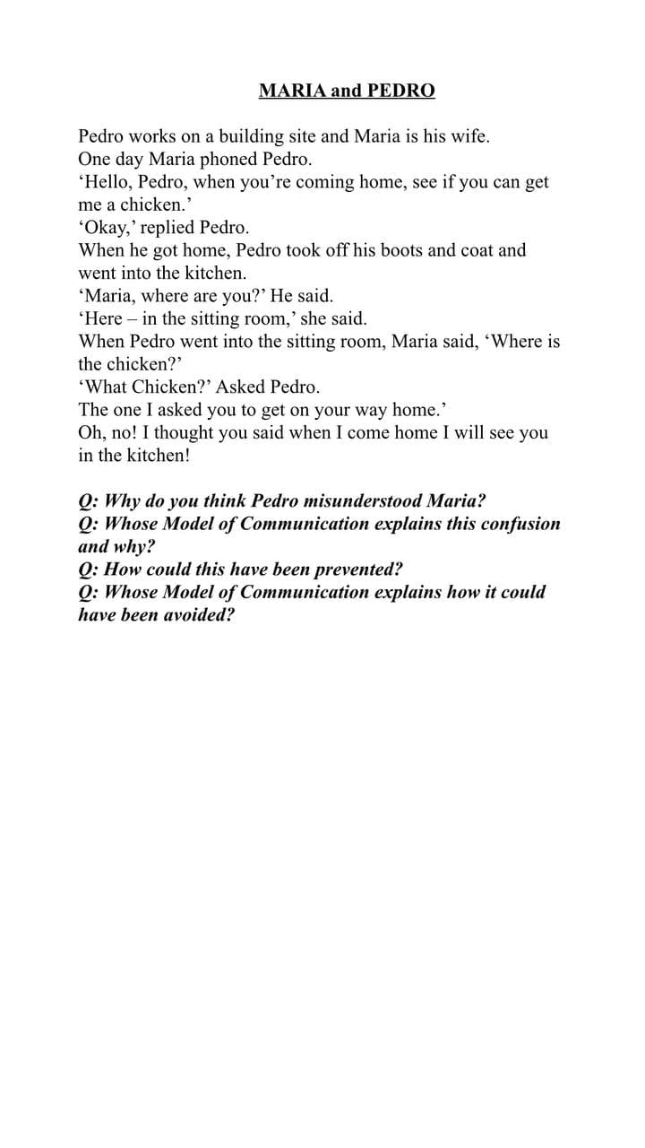

Appendix 2
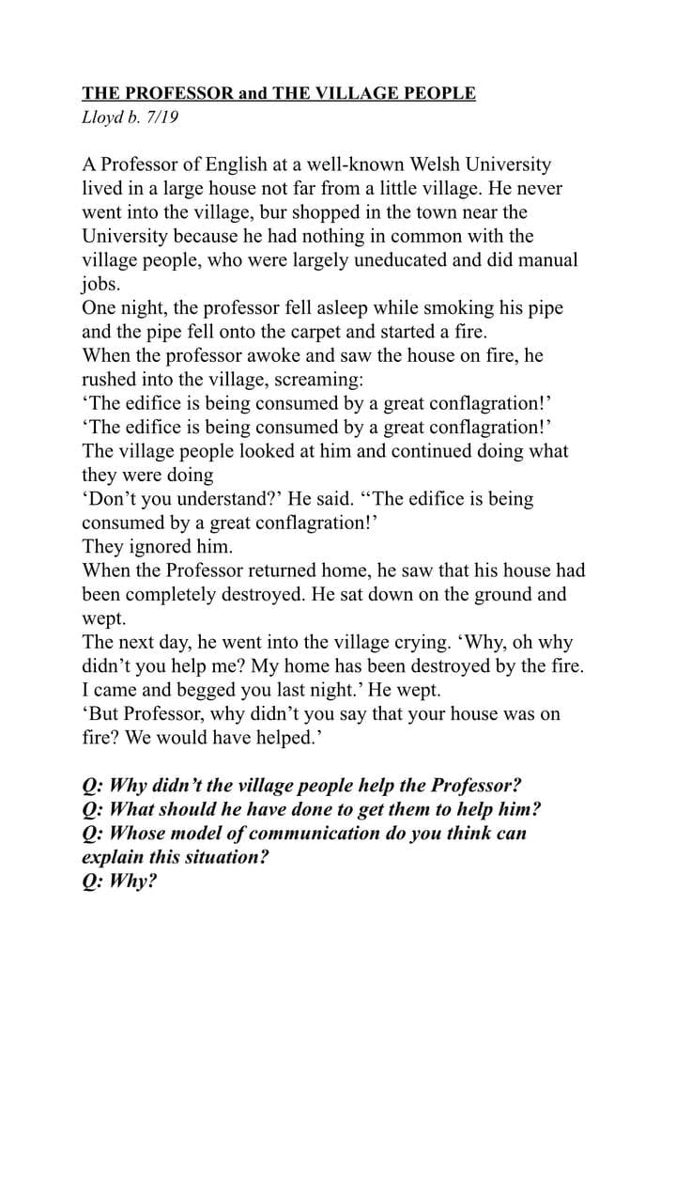

Appendix 3

Case 1
My friend Indira just got a job at a restaurant. At her first working day, the restaurant organized a lunch for 100 people who came to the meeting in the conference room located nearby.
During lunch, all the guests of the restaurant chatted with each other.
At one of the tables, a vegetarian dish finished and the manager asked Indira in hurry: "Could you bring it from the kitchen?"
Indira went to the kitchen and returned in a couple of minutes with a plate. There was a great portion of chicken.
The manager looked at the plate and said, "Why did you bring the chicken? I asked you to bring a vegetarian dish from the kitchen."
Indira replied that she heard a request like: "Could you bring the chicken?"
Case 2
My colleague nurse was on duty from 4 pm to 8 am. It was her first day at work after holidays.
At 6 pm she got a phone call, it was the Chief Nurse. She asked to make a list of patients admitted with COVID-19 and send her this list by 7 o'clock.
At that moment, many ambulance patients were admitted and department was extremely busy. After a phone call my colleague continued with her main duties.
At 7 pm the phone rang again. It was a call from the Chief Nurse. She asked if the list she had asked for an hour ago was ready. But my colleague did not prepare it, as she was going to do it by 7 in the morning.
Explaining this by the fact that usually the list was submitted before the end of the shift and a report was submitted at 8 in the morning.
During the second dialogue, it turned out that the list of patients with COVID-19 is now submitted 2 times a day, at 7 pm and at 7 am. Because the number of cases of COVID-19 has increased in last two days, and these cases are under strict control. Then all information is transferred to the statistics department.

