BMSW4006
Managing Enterprise in the 21st Century
Assessment 1
Task 1
Group Report
Kremena Katsarova-1921377

Mario Nedev-962991

Ekaterina Hristova -1919046

Jose Cruz-1918686

George Paskalev-1921408

Tutor:

Mohammad Rahman

Table of Contents
Introduction 4
Company Overview 5
Product description 7
Advantages of wooden toy products 8
Market Audit 10
S.M.A.R.T Goals 11
1. S – Specifics 11
2. M – Measurable 12
3. A- Achievable 12
4. R- Relevant 13
5. T- Time-Based 13
Target Market 14
Selecting Target Market 14
Types of Target Marketing 14
Target Market Strategies 15
Market Segmentation 16
Market Targeting Procedures 18
Market Specialization 19
Target Market for Pinocchio Toys Ltd. 19
Marketing plan 20
Swot analysis of the market 22
Strengths 22
Weaknesses 22
Opportunities 23
Threats: 23
Management Team 24
Product Designer and Online Marketing Manager: 24
Bookkeeper 26
Assembler 26
Packager 27
Online Sales Manager 27
Democratic Business Structure 29
Financial plan 30
Finance and its classification and occupations 30
What is financial planning? 32
The objectives of financial planning 32
The step-by-step process of financial planning 34
Step 1 35
Step 2 35
Step 3 36
Step 4 37
The importance of financial planning process 38
Conclusion 40
Reference 41

Introduction
In today's competitive business environment, businesses are growing ever so increasingly. The number of new enterprises joining the market is on a gradual rise. With the rapid growth of enterprises, the industry too has been working to bring notable changes to evolve with the ever-changing market environment.
Most successful start-ups demonstrate superior levels of delegation and decision making in all levels of management. Even small business enterprises now adopt robust HR management systems that allow them to run their businesses without having internal troubles (Ananthan, 2010). Enterprises are progressively rising with the purpose of sustaining and surviving in today's vast market landscape, and hence they are taking all the necessary steps to manage their business efficiently.
The purpose of this report is to inspect and analyse a business idea and formulate a proper business proposal. It also focuses on a wide range of employee skills that are crucial for administrating a business enterprise seamlessly.

Member 1

Company Overview
The name of the company is Pinocchio Toys Ltd. The overview below mentions relevant information regarding the company with a proper explanation if necessary.
Company Name: Pinocchio Toys Ltd.
Origin: United Kingdom.
Legal Structure: The company will be established as a private limited company.
A private limited company in any type of business where ownership is private. The maximum number of shareholders for a private company is 50. Usually, private companies do not trade shares publicly. In this system, the shareholders are the owners and the directors are the managers.
Management Team: The management team of Pinocchio Toys Ltd. includes the following members:
Student Name 01: Product Designer, Online Marketing Manager.
Student Name 02: Bookkeeper.
Student Name 03: Assembler.
Student Name 04: Packager.
Student Name 05: Online Sales Manager.
The company management team members should be selected according to each person’s skill and ability. Online marketing managers are also known as design marketing managers. It will be a position that is compatible to fill with the product designer. A bookkeeper keeps a record of all the financial transactions of the company and thus it should be someone proficient with numbers (Keasey, Thompson and Wright, 2019). Assembler puts together the final product; they should have a good sense of organizing. The packager should be someone creative and swift. The Online Sales Manager needs to be tech-savvy, people-oriented, and proficient with a computer.
Mission Statement: Pinocchio Toys Ltd. will be a company that retails durable wooden children’s toys online.
A mission statement should shortly summarize the purpose of the company. It is the road map followed to achieve the company vision. The objectives, the type of product or service, the target customer or market are some components of the mission statement of the company.
Company History: The company will be formed by the management team within the year 2021. It will start with five people on the management team.
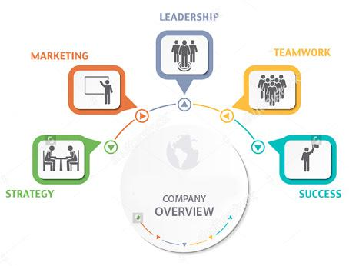
Figure 1: Company Overview (Keasey, Thompson and Wright, 2019).

Objectives:
Based on the time allotted for achieving a particular goal, the objectives of a company can be of three types.
Short-term objectives are the goals that can be attained quickly. These objectives are broken down into discrete components and arranged in a hierarchical order. A good example of short-term objective is the annual objective a company sets at the start of a new fiscal year.
- Gaining customer interest through social media and online advertisement.
- Offering the company’s products representing their advantages.
Medium-term objectives are the goals that can be attained in the time of 18 months to 3 years. The time length varies depending on the people and organization setting the goals. A good example of a medium-term objective is introducing a seasonal pack for an existing product.
- Acquiring a contract with an educational institute.
- Sponsoring content makers to review the products.
- Increasing production and selling on platforms such as Amazon.
Long-term objectives are the goals of an organization that are attained in 5 years or more. As the name suggests long-term objectives are long and continuous goals. Specific activities in long-term objectives can include an organization's competition spot, technology, cost-effectiveness, leadership, return on investment, workplace relations, and corporate image (Sjåfjell, 2019). Example: 60% reduction of carbon footprint by 2030.
- Offering customized toys and expanding into other wooden pieces.
- Gaining contracts with 15 educational institutes and a customer base of 2000.

Product description
Pinocchio Toys Ltd. Being a children’s toy company, obviously aims to produce toys for children however, the company is giving value to their product beyond being just a child’s toy. Toys are one of the most important fundamental items that helps children develop their motor skills and skills od perception. A child who had plenty opportunity to play and interact with other children especially during interactions with toys, develop their neural capacity and perception skills at a faster rate than children who had objectively less opportunities to play with toys (Craig, 2019).
In the modern times, especially owing to the mass market production from China and their export throughout the world, drove down the demand for wooden toys in children. The art and joy of wooden toys, their durability and their potential to portray the culture and taste of the time that it was made in is being driven to extinction (Cohen, 2016). The main force to cause this is plastic made toys. Although the pricing of the toys made in plastic is much higher than producing toys made of wood, plastic toys can be produced in greater quantity at an incrementally faster rate.
The founders of the Pinocchio Toys Ltd. Are adamant to bring back the beauty, the joy and the art of wooden toys. Wooden toys are durable and can be used years after intense use by children (Byrne, 2017). So, the use of the toys made by the company far exceeds its necessity, after the toy has been joyfully enjoyed by the children, attaching precious childhood memories with the toys made by the company, they can be kept as mementos of the past and can even be passed down to generations.
The toys that will be made by Pinocchio Toys Ltd will not only be valuable as toys, it will also be educational and bear cultural heritage and wisdom that the child will be acquainted with at the earliest of age. The company believes that children are born curious, and it is through the curiosity that children learn about the world that exists beyond their comprehension (Craig, 2019). The toys will bear cultural and historical connotations that will add this educational value to the toys.
The main goal of producing the wooden toy products by the company is to create something that exceeds expectation and time. The toys that Pinocchio Toys Ltd. will produce will not only be toys for children to play and enjoy, but also to learn about their surroundings, the cultures, the history and the different times that countries all around the world has travelled through (Byrne, 2017). The goal of the company is to product artefacts that children can keep throughout their life and relive precious memories.

Advantages of wooden toy products
There are certain advantages that wooden toy products have over plastic made toys. Although plastic made toys have gained popularity and has become of the most produced items in the world market, there are some shortcomings that come along with it (Law, 2014). The popularity of plastic toys has come to be due to its rapid rate of production and versatility. However, Pinocchio Toys Ltd. will be producing wooden toys. The advantages and reason for choosing wooden toys over plastic toys by the company is briefly explained below;
- Durability: Although produced in greater number, the biggest weakness of plastic made toy products is its malleability. Children under the age of 3 do not fully articulate the concept of durability and capacity to break. And so, children play with toys very intensely and they’re always trying to push the toy to its limits to find out the point in which it stops holding form and breaks down (Byrne, 2017). It is necessary to mention that plastic products a difficult to repair once their body is damaged. This problem is negligible for wooden products. The children can play as hard and intensely as they want to but it will be difficult for them to break the wooden toy (Law, 2014). The company guarantees the product to hold its form intently for four to five years of intense playing. However, the toys will last a lifetime. In case a toy does break, it is easy to repair wooden toys, even at home under adult supervision.
- Safety: The second advantage wooden toy products have over plastic products is the matter of safety. As mentioned in the previous section, plastic toys break very easily when used roughly. This create the issue of sharp edges that are potential threat to the child’s well-being (Smith, 2020). It can hurt them seriously which may require medical attention. Since wood is far more durable than plastic in terms of toy products, there is little to no chance of wood breaking down and create sharp shards that might harm the child. Moreover, the company aims to design their products by keeping in focus that the possibility of sharp edges is irradicated.
- Cost effectiveness: The cost of producing plastic products is quite steep and they are also comparatively more expensive than wooden products. It is because producing plastic toys require a lot of initial investment to establish the technology and machinery that such operation demands. Wooden toys are much more cost effective than plastic toy products. It is not only that wooden toy products are more durable than plastic toy products, wooden toy products are also cheaper to make (Smith, 2020). They use wood and skilful craftsmanship to produce the toy products. This allows them to be sold at a lower price than plastic made toy products.
- Educational value: As mentioned earlier in this report, the founder of the company believes children are born curious. They are always trying to find out the deeper meanings of the world and understand their place in it. They are constantly imitating their parents are other grown-ups to form their individuality and practising expression. The wooden toys that the Pinocchio Toys Ltd. offers will give value to the children because they will be designed to reflect the cultural and historical values of the different places and times around the world.

Member 2

Market Audit
Market audit or marketing audit refers to a comprehensive review of the marketing strategies, objectives, plans and current activities of a company. The aim of conducting a market audit of a small business to see the difficulties, prospects and answers. In easier words, the purpose of market audit is to see what is working for the company and what is not. A marketing audit is the analysis and evaluation of both the internal and external part of the marketing environment. After assessment the executives of the organization decide and recommend different actions to pull the company further ahead. Components of marketing audit include SWOT Analysis, customer and prospect research, a PESTLE analysis, competitor analysis and market overview of the internal communication. There are mainly three types of marketing audit, external audits, internal audits, and Internal Revenue Service (IRS) audits. Generally, a third person or a person outside the company conducts the audit. An auditor must be inclusive, methodical, autonomous, and periodical while providing an unbiased review.
Pinocchio Toys Ltd. will be a part of the manufacturing industry. In an industry full of plastic toys, wooden toys are considered rare and sophisticated. Just like every other industry the toy industry is also suffering from the effects of the global pandemic, especially in sectors of resourcing, manufacturing, and retailing. The want for durable, environment-friendly toys has increased now more than ever as parents work from home while simultaneously keeping their children engaged.

Figure 2: Marketing Audit (Gerakos and Syverson, 2013).

S.M.A.R.T Goals
A SMART goal is an acronym that is used to set and achieve goals. It can be applied to both individuals and organizations. This term was first used by George T. Doran in ‘Management Review’ in the November issues of 1981 (Abraham, 2019). Professor Robert S. Rubin stated that S.M.A.R.T stands for different things for different people based on the situation. The SMART technique helps an organization set realistic goals and guide it to help achieve them. There are specific criteria and time frames for these goals. The acronym S.M.A.R.T stands for five different components that altogether increase the success rate of the organization in that specific objective.
S.M.A.R.T goal of Pinocchio Toys Ltd.: To operate in a niche market within the toy industry.
Initial Goal: Pinocchio Toys Ltd. will be a company that retails durable wooden children’s toys online.
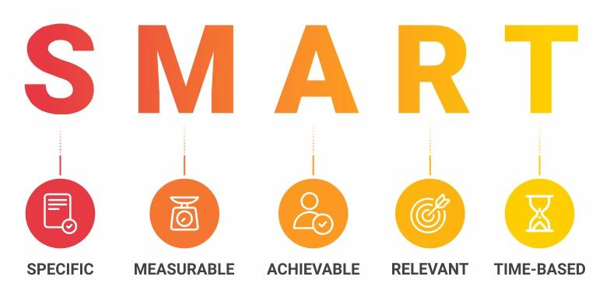
Figure 3: S.M.A.R.T Goals (Abraham, 2019).

S – Specifics
The first letter in S.M.A.R.T is S which stands for specifics most of the time. S can also mean simple, sensible, or significant. The goal should be clear and specific. While deciding on a goal it is necessary to answer five W-questions. What, why, who, where and which? When a company answers these questions, it comes to a distinct objective.
Specific goal of Pinocchio Toys Ltd.: To produce wooden toys that have cultural and historic ties. This is an important goal because the current toy industry is full of expendable products. With the new generation's parents being environmentally aware and avoiding plastic products, wooden toys seem to be the best possible solution. Furthermore, plastic toys not only break easily but also break into sharp shards that can injure a child. Comparatively, wooden toys are much safer and sturdier. Pinocchio Toys Ltd.’s wooden toys will contain a sense of culture and history in its making. It will be an excellent way to teach kids about the background of the world. It is known that children learn much quicker through touch, thus wooden toys will avail as the option of kinesthetic tool for them. The above-mentioned team of five members will take on different roles and manufacture the toys. The toys will be sold digitally within a month.

M – Measurable
The second letter is M which usually means measurable but can also stand for meaningful or motivating. Quantifying or measuring the goals will make it easier for the company to track progress, feel motivation and meet the deadline. Having solid numbers for the goal also makes it more real and tangible. A measurable goal can be achieved by asking questions of how? How much, how many, and how will it? Answering these questions leads to a concrete aim.
Measurable goal of Pinocchio Toys Ltd.: The primary goal of the company is to establish a customer base of 50 by the first two months. The plan is to reach out to educational institutions, day-cares, and kid-friendly cafes to increase the customer range. The secondary goal is to increase production enough to sell 700 units per month and it is to be achieved by the first six months (Gerakos and Syverson, 2013). Alongside that, reaching out to content makers and toy reviewers will give the company much-needed digital attention. It will ensure a steadier, positive presence in the market. The final goal is to have a customer base of 2000 within the first two years. During this time, the company should have a supplier deal with at least 15 educational institutions and organizations.

A- Achievable
The third letter A stands for Achievable, agreed, or attainable. This step is the reality check. The goal selected by the company should be realistically attainable. It should be something that can be achieved by the organization that chose it. In short words, the goal should be challenging but it should not be impossible to reach. Questions like how can I accomplish this goal or how realistic is these goals based on the current situation should be asked and answered. The goal should be set with the currently available resources, ability, and limitations in mind.
Achievable goal of Pinocchio Toys Ltd.: Products are to be sold through social media and company website. The plan is to encourage product users to leave positive reviews and gain 50 customers with the first two months. Positive feedback will also attract more attention from interested consumers and boost marketing (Hillyer and Norbury, 2013). The profits from the 50 customers will be used for production and equipment. With a woodcarving machine increasing production the company will meet the rising demand and mass produce parts for the future. As production and marketing increase, the company will use e-commerce websites to sell its products. Another achievable step will be to reach out to interested educational institutions and daycare centres to create supply links and further strengthen the presence of Pinocchio Toys Ltd. in the industry.

R- Relevant
The fourth letter R is for relevant, reasonable, realistic, or resourced, results-based. This step is to figure out how much the goal matters to the organization and how relevant it is to its other objectives. It is important to retain control and take responsibility for the goals that are being set by the company. Questions like is it worth it, is this the right time and match, and is it applicable for the current modern world should be asked. If the answers are in the affirmative only then can the procedure go ahead.
Relevant goal of Pinocchio Toys Ltd.: In the second year of a worldwide pandemic, mass-producing wooden toys is very relevant. There has never been a better time for wooden toys than now. Children are stuck at home with minimal interaction with other people and the outside world. To keep them busy attractive, durable toys are a reasonable solution. To tackle the lack of babysitters and the tight financial situation, Pinocchio Toys Ltd.’s wooden toys are a very realistic path. The company has enough resources and staff to meet consumer demand.

T- Time-Based
The final letter T stands for time-based. It can also mean time-bound, time-limited, time/cost limited, timely, or time-sensitive. In one word, it concerns time. Good goals have a deadline. It cannot go on forever (Byrne, 2017). The company and its employees need to be on the same page about the time length available for the goal. This step helps prevent everyday tasks to take priority away from the long-term goal. Questions of when, what can be done in six weeks, what can be done in six months, and what can be done today should be answered.
Time-Based goal of Pinocchio Toys Ltd.: The time needed by Pinocchio Toys Ltd. to reach an appropriate profit and a good number of customers in two months. The company plans to start by accumulating resources, manufacturing toys and marketing its products, and reach a capital increase within the first six months. Within this time, the company also plans to purchase equipment and mass produce products to meet market demand.

Member 2

Target Market
The word target market refers to a collection of potential customers to whom a company is willing to sell its products or services. This collection of customers involves particular customers to whom a company directs its marketing strategies and efforts. It is crucial for companies to identify their target market in order to implement their market strategies fruitfully. Lack of proper determination of the appropriate target market can cause substantial financial loss to the company.
When it comes to targeting a specific customer base, companies should take a moment to evaluate the market segments to identify particular types of customers who can actually not only utilize but also benefit from the products and services.

Selecting Target Market
Before initiation, a company should gather information of the market condition, competitors, customer's needs and demands from the industry, market environment and much more. All this information will enable the company to determine the size of the market segment that it is willing to serve, demographics within each segment, internal competition with the segments, segments with higher potentials and the segments that comply with the company's goals and objectives (Smith, 2013). So, while selecting a target market, all these things have to be carefully considered, and thorough research has to be conducted to understand the pros and cons of each segment.

Types of Target Marketing
There are mainly four types of target marketing. These include:
- Undifferentiated Marketing: This is often referred to as Mass Marketing. In this type of marketing, a company manufactures one product or service and tries to draw the attention of the entire market with that one product or service. For example, many small businesses put up flyers and distribute promotional cards to draw the attention of a vast customer base.
- Differentiated Marketing: This is popularly known as Segmented Marketing. In this sort of marketing, the companies divide the entire market into several segments and offer different types of products for different segments (Cohen, 2016). Maruti-Suzuki can be a classic example of differentiated marketing as it provides various kinds of cars to other classes of buyers.
- Concentrated Marketing: Concentrated marketing is also called Niche Marketing. In this type of marketing, the company focuses on an exclusive customer base that is willing to pay more to obtain exquisite products and services. For example, many companies have launched athletic wear for kids. As this market is not too saturated, companies can attract a lot of customers who will be willing to pay for these commodities.
- Micromarketing: This type of marketing is also known as local or individual marketing. With this marketing strategy, companies can target individual or local customers with their products and services.
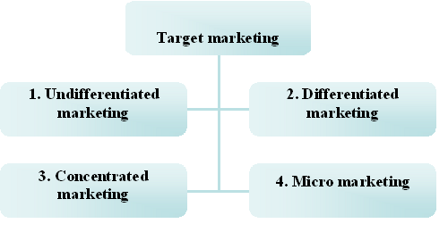
Figure 4: Types of Target Marketing (Cohen, 2016).

Target Market Strategies
After executing in-depth research, companies should start analysing their resources and allocate them to formulate a proper market plan that can maximize revenue. The goal of most companies is to get incredible returns on every penny spent on marketing, publicizing, advertising and promoting. Mainly market can be segmented into four distinct categories. These include:
- Age: Being aware of the age of the customer base can enable companies to suitably communicate with different age groups. This is important because not all audience will belong to the same age group, which is why their tastes will not match with each other. The tastes of millennials differ from that of baby boomers, and the needs of a grandparent will vary from that of a parent. So, by determining the age of the customer base, companies can direct their strategies and concentrate their efforts on specific aspects that attract particular age groups.
- Income: Income is one of the most crucial factors that directly dictate our spending habits. Most individuals' wants and desires are constructed around their financial and economic status. Assessing customers' income can allow companies to price their products and services accordingly and also assist them in developing and running several types of discount offers throughout the year.
- Gender: If a company is focused on creating gender-based products, it is imperative to understand the demands of the customers. If the company can identify a specific demand that its competitors are not addressing and use it to their benefits, then the company can have a competitive advantage. Forecasting the needs and managing them way ahead of competitors can help the company to acquire customers and simultaneously retain them.
- Geographic Location: Companies should curate their products and service by considering the geographical location. Being aware of the customers' location enables the companies to advertise their products according. For example, a customer residing in a cold country will prefer winter clothing and boots. Companies who are aware of the location can advertise and promote their winter collection and thus attract customers.

Market Segmentation
Understanding the best ways to market a company and promote its brand image is crucial for being able to reach out to and communicate with potential customers. Conducting a target market analysis can enable businesses to their potential as well as actual customers. There are multiple ways for companies to interact with the targeted customer base. Some of the popular market strategies include:
- Geographical Segmentation: This type of segmentation is easy to determine as customers are grouped on the basis of their physical location, which includes- country, region, city and postal code. This is especially useful for focused advertising on social media platforms where marketers promote their brands to customers who register as residents of a particular region (Best, 2013). An example of this can the segmentation used by restaurants and food delivery applications where they advertise their food products in their surrounding areas as they might not perform well in other areas.
- Demographic Segmentation: This type of segmentation focuses on age, gender, race, ethnicity, income, language, educational qualification and so on. This is a very straightforward method of identifying customers. This enables companies to locate customers on the basis of essential features such as their income. This help companies to save marketing budgets on directing messages and advertisements to people who cannot afford their products.
- Psychographic Segmentation: This type of segmentation focuses on the customers’ personalities and interests. A lot of research goes into segmenting customers on the basis of their hobbies, life goals, values, beliefs, lifestyles and so on. But psychographic segmentation allows incredibly effective marketing that speaks to the consumers on a personal level.
- Behavioural Segmentation: This segmentation is beneficial and makes e-commerce efficient and effective. This, too, requires a considerable amount of data as it focuses on consumers spending habits, purchasing habits, browsing habits, interaction with brands, brand loyalty, product ratings and so on. This type of segmentation allows companies to distinguish between first-time visitors and regular customers so that the customer support team can tailor their messages accordingly.
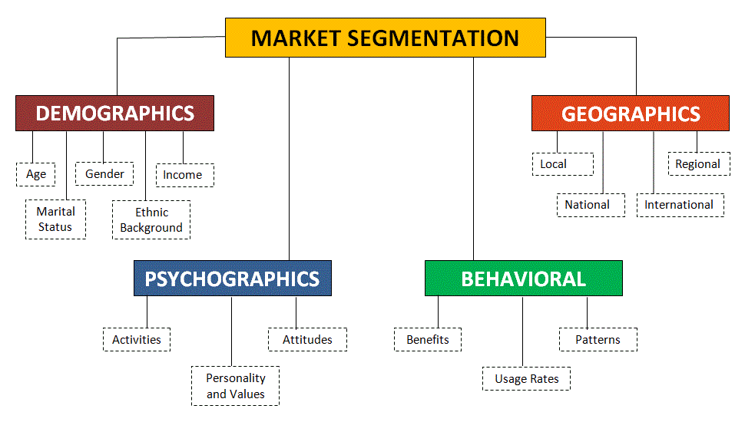
Figure 5: Market Segmentation (Best, 2013).

Market Targeting Procedures
Market targeting procedure consists of two essential steps. These are:
- Analysing the Market Segments: Analysing the market segment calls for the appropriateness of the segments. The segments are analysed on the basis of relevant criteria that determines practicality. Identification of the overall attractiveness or suitability of the segments takes two stages:
- The appeal of the Segment: The company must identify the characteristics and conditions of the products that make these appear attractive to the customers (Cohen, 2016). Attributes and features such as size, profitability, quantifiability, approachability, actionable, potential for development, the scale of economy, differentiability and so on act as deciding factors on whether the products are attractive or not.
- Goals and Resources of the Company: The company has to determine and consider whether the segment aligns with the objectives of the company or not. The company must also consider and analyse its resource capacity. The segment must be with the material, technological, human and informational resources of the company.
- Choosing the Market Segment: Once the analysis of the segment is over, the company has to make the decision of selecting appropriate market segments. The company has to decide on the number of segments, and this is associated with selecting the target market. The target market is made up of different buyers to whom the company wants to sell. Choosing the right market segment depends on the internal and external circumstances of the company.

Market Specialization
Market Specialization refers to strategies that consist of fulfilling several needs of a particular segment. In this case, there are multiple products for a single segment. The company can experience rapid growth and earn a reputable position in the competitive market by specializing in serving a particular segment. But the reduction in the size of the market, lower buying capacity of the segment, or the entrance of competitors with superior product range can detrimentally affect the company's position in the competitive business market.

Target Market for Pinocchio Toys Ltd.
Pinocchio Toys Limited has ventured and promoted its business in various social media platforms, websites and affiliated links. The company’s target market is the online marketplace which is exponentially growing with the advancement of technology. The customers who purchase the company’s products are also a significant part of the market. So, the customers must be reported correctly so that the company has a proper understanding of the number of prospect customers and the number of customers the company could attain over time. The target market includes:
- Online Market: The clients and customers who actually purchase the products and commodities of this company comprised of the parents of children with the age group of two to eleven years old. Parents with children of this age group are on the lookout for durable and long-lasting toys that also have educational value (Langton and Campbell, 2011). As Pinocchio Toys Limited provides precisely that, it has a large set of loyal customers. At present, the company is targeting millennials who have children. As millennials are more used to shopping online, the company is taking its promotional campaigns to online platforms.
- Employed Millennials with Children: Millennials have the habit of purchasing minor things from online stores. Pinocchio Toys Ltd is utilizing this habit to their benefit. The number of target customers has escalated due to the global COVID-19 pandemic, and everything switched online to reduce human contact. Due to the global pandemic, customers have been relying on the internet for all of their purchases. Starting from groceries to clothes, electronic gadgets, kids' toys and much more. During this pandemic, the parents' interest in buying products to pacify and soothe their children has increased exponentially. Despite not having the same purchasing power as the older generation, millennials do have the habit of spending graciously. Particularly the families that have one or both working parents (McDonald, 2012). With so much time working from home and spending hours browsing the internet, they cannot help but purchase products that they lay their eyes on. In addition to that, as children cannot be babysat during this pandemic, they get increasingly more restless and crankier when they cannot find something entertaining to do, and their attention span wears out far more quickly. As most millennials are involved in entry-level jobs, they need to put more working hours into their jobs which is why they look for ways to distract their kids for a more extended period while they are busy working and Pinocchio Toys Ltd have a wide range of wooden toy collections to mitigate this need.
- Educational Institutions: Children's educational institutes are also prospective customers of Pinocchio Toys. These institutions have to ensure that their toys and equipment last long and wooden toys meet that condition. Selling wooden toys to educational institutes would be B2B. This company ensures that these institutions get to purchase toys at affordable price points. So, Educational institutes that can buy above 100 products will be the prospects to form contracts with.

Member 3

Marketing plan
One of the most important functions that an organisation must carry out is to communicate their product and message to the entire customer base as a whole. The customers are constantly interacting with the company and expressing their needs, wants, and expectations. It is through marketing that a company can truly satisfy their customers by understanding them, their needs and expectations, and then, it is the objective of companies who lead in the market to exceed those expectations and give the customers what they truly need (Cohen, 2016). And for this reason, it is crucial for Pinocchio Toys Ltd, to come up with a solid marketing plan and analyse their current situation and the environment that surrounds them.
In the recent years, during the Covid-19 corona virus pandemic, the producers of toy products are having difficulty to operate. The conditions of the workplace and the health security of the workers have become a huge concern. As is the norm of the toy product industry that the workers have to work in large enclosed factories with a large number of employees (Cohen, 2016). This is not possible in the current situation. According to the safety guidelines, the operations can only continue if the workers can practise social distancing. Which means the workers cannot work in close proximity and they cannot employees cannot even use the same machines without taking precautions such as gloves or disinfection. In such a situation, the production of toy products has taken a huge toll. The production of toys in the past year has decreased substantially.
However, people at home who are isolating themselves for the safety of their families have grown to demand more and more toys. So, the situation since 2020 has been that the demand for toys is increasing but the production capability of companies is decreasing. In such a situation, small businesses who already have fewer employees are facing no difficulty to operate. These are the small businesses that are supporting the industry and fulfilling the demand of the market in the current state. Pinocchio Toys Ltd. is one of these companies. Since the production of the wooden toy products depend on craftsmanship and not high-tech machinery, it is possible to spread their message through their products to the market in times like these.
It is found that over time, the demand of toys in the market has increased by 15% just over the time of the pandemic. The size of the toy industry as of 2018 is 90.2 Billion dollars in revenue (Smith, 2020). The revenue is increasing, by 2019 the revenue increased by 0.4 billion dollars and by 2020 the revenue had become to 91 billion dollars by the year 2020.

Swot analysis of the market
It is necessary to administer an analytical tool to find out more about the market under which Pinocchio Toys Ltd. will be operating in. In order to investigate the strengths, weaknesses, opportunities and threats of Pinocchio Toys Ltd in the market that it will be operating under is briefly discussed below;
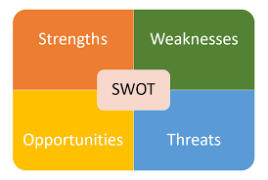
Figure 6: Swot analysis (Ananthan, Appannaiah, and Reddy, 2010).

Strengths
- The biggest strength of Pinocchio Toys Ltd. is that it will be producing long lasting, high quality, and valuable product that customers can keep throughout their life as a memento of their childhood. It’s durability and capacity to uphold rough handling give the product a boost compared to their rival plastic toy producing companies.
- The production capacity of the company is not relevantly affected by the recent devastation of the Coronavirus pandemic due to its minimal requirement of workforce and dependence on craftsmanship.
- The products give children an opportunity to develop their minds by using their cultural and historical values (Smith, 2020). It gives children an opportunity to look beyond the toys and having a deeper understanding of the world that surrounds them.

Weaknesses
- The biggest weakness that Pinocchio Toys Ltd. has is their small size. The company is still in their earliest stage in the business life cycle. Which means although they do not have any recognition or share in the market, there is huge potential for growth.
- The production capacity of the company is very limited. Since it depends heavily of human craftsmanship, it is not logical for them to primarily challenge and take a stand as opponents to companies that can produce 50,000 products a day (Smith, 2020).
- Being a start-up, the company also has a huge limitation in their available financial and non-financial resources.
- There is no definite method of quality control for the company. Being in its initial stages of the business life cycle, the company has a long way until they can fully articulate and form a systematic method to check the quality of their products in a mass scale.

Opportunities
- As discussed earlier in this report, in the recent times, the demand for toys has increased greatly but due to health guidelines and safety measures, the operating capacity of the companies has decreased. And so, there is a gap in the market between the demand for the product and amount that is being produced by large companies (Smith, 2020). Pinocchio Toys Ltd.
- Customers are demanding toys with educational value.
- The customers are looking for durable and safe toys.
- Larger companies are struggling with production, lowering their output.

Threats:
- The issue of quality control may end up ruining the brand image of the company.
- The company may fail to reach customers with its social media marketing.
- Customers may feel that wooden toys are antiquated.
- The company may fail to make enough capital to expand, and gain a sustainable customer base.

Member 4

Management Team
The management team plays the most crucial role in the company. They are responsible for coordinating different functions in the company. Product procurement, manufacture, development, improvement, delivery, etc all are planned by the management team. As a toy company, the procurement of high-quality products is the priority for every company (Adams, 2018). Good quality products are more durable and long-lasting. This will make the toys much more favorable to the customers. The management team will consist of five people and the roles they will play are as follows:

Figure 7: Management Team (Bach, 2018)

Product Designer and Online Marketing Manager:
The product designer will determine how the consumers will enjoy and experience the product. The products are designed on the basis of what the customer demands from the product. The role they play is quite complex. A product designer is responsible for the visual features of the product. They should also determine the quality of the products since designing a product is dependent on how durable and flexible the materials provided are (Adams, 2018). Now since the company is a startup company, they should keep an eye on what a customer. In this case, the one assuming the role can be called a customer interaction designer and a customer experience designer. The design of the products will be improved based on the feedback given by the customers. A company is capable of getting a lot of benefits from a product designer. They play a key role in the product development stages. The products provided by the company gradually begin to grow and get more features. During this time, the product designer is capable of refining the product to get more user experience. Product designers are seen as grandeur in the company and it will try its best in order to retain that one employee. Their works are not only based on user experience. They also have the responsibility of operating on a high-level design as well as the granular structure of the product (Adams, 2018). The key advantage is the company will not only have a designer whose only target is to submit the design of the product. The member will also work with the product development team to secure a high-quality toy product. The process does not end with the launch of the product. After the product is launched, the designer should keep an eye on the customer feedback. In accordance with their demand, the member will try to make the product more appealing to the audience. This also includes familiarizing oneself with the latest trends of the world.
The member responsible for designing the product will also be an online marketing manager. This role can also be defined as a digital marketing manager (Bach, 2018). They are responsible for creating awareness of the products the company is providing. They are responsible for coming up with and applying different online marketing strategies in order to maximize customer onboarding. To be a successful digital marketing manager, the person should have an insight into what the customers truly need. They should also have good project management strategies and up-to-date knowledge about digital trends of the world. They should also have the capability of retaining their customers on social media. The member assuming this role has a lot of duties and responsibilities. These duties and responsibilities are as follows:
- The member is responsible for coordinating the activities on social media.
- The member should come up with newer online marketing tactics.
- The member is responsible for maintaining communications with the customers via social media and gaining necessary feedbacks.
- The member is responsible for maintaining the cash spent on social media.
- The member is also responsible for handing in daily, weekly and monthly reports to the rest of the team.
An online marketing manager should have flawless communication skills to gain optimum customer interaction (Bach, 2018). They should also have extensive knowledge about technologies and the structure of social media platforms. Last but not the least, it is quite preferable if they have quite the experience on social media platforms and online marketing tools.

Bookkeeper
Maintaining the information of purchases and expenditure of the company is the core responsibility of a bookkeeper. We know that there are eight steps in an accounting cycle. A bookkeeper is responsible for completing the first six steps of the accounting cycle. The remaining step is handled by the accountant (Bach, 2018). Maintaining the financial records is very complex work because the person doing it should keep an eye on every detail of the financial records. But in modern times, keeping the details is not an issue at all. The member should have an idea of how to use the software and applications necessary for bookkeeping. The skills related to bookkeeping are as follows:
- The member should know the basics of accounting quite well.
- The member should know how to apply accounting skills in the practical field.
- The member should be aware of each and every detail of the financial records.
- They should display professionalism and should also have great organizing skills
These skills are required for:
- Maintaining necessary financial records.
- Constantly updating and maintaining financial records.
- Noting down the credits and the debits.
- Monitoring the budget, purchase, and expenditure of the company.
A good bookkeeper should have a keen eye in order to track how much money is being used by the company. One of the prime responsibilities is to maintain proper records to avoid unnecessary problems when it comes to tax-paying season. Bookkeepers are crucial for any type of business. They play a critical part in collecting and inputting necessary data. This is important for preventing fraud.

Assembler
An assembler is responsible for producing a component by assembling different parts acquired from production. They play a critical role in delivering the final product. An assembler is also responsible for finding out the errors with the components they receive (Campbell, 2018). Following their feedbacks, a company tries to develop its production system. The core duties of an assembler have been given below:
- Through following the instructions and using the necessary tools, the final product is assembled.
- They are responsible for maintaining a safe work environment.
- They tend to not waste resources as much as possible. This efficient mindset increases the profitability of the company.
- They provide optimum support to the team so that they are not bound to do extra work.
- They are concerned with the quality of the product. Now if the quality of the product is below the required standard then this will lead to problems in the assembling phase.

Packager
Packagers are responsible for packaging the items and adding labels to them before finally delivering the products to the customers. They are also responsible for giving the final check to prevent malfunctioning products from reaching the customers (Campbell, 2018). The packager acts like the final stop between the buyers and providers of the product. They are to make sure that all the production process is functioning at a stable pace. This includes throwing away defective objects or sending them back to the assembler.
The assembler should have a keen eye for their line of work. After labeling the package, the products are to be taken to a designated location. If the packager fails to do this then the product may end up in some other places (Campbell, 2018). Due to this, the packager should always pay attention to every granular detail. Thorough work is highly appreciated in their line of work. Packagers are to make sure that the packages they are sending reach the designated location. The core responsibilities of a packager are:
- Packaging, weighing, and labeling the products.
- Finding out the defective items and disposing of them cautiously
- Packaging hazardous materials with extra caution.
- Make a record of all the products that have been through the packaging process.
- Maintaining cleanliness of the workstation.
There are a few requirements in order to be a successful packager. He should be capable of following the given instructions flawlessly. He should have great communication skills to coordinate the activities in a proper manner.

Online Sales Manager
An online sales manager delivers the final product to the customers. An online sales manager is responsible for utilizing social media efficiently for selling products, increasing customer interaction, and branding their image (Dawson, 2018). They are responsible for gaining feedback from the customers to add value to the products manufactured by the company. The internet has become the prime platform for marketing and selling products in the past few years. Due to the pandemic situation, the general public has become much more dependent on social media. This is quite a blessing for all the online sales managers out there. The face of online shopping has been changing in a drastic manner and other companies are adding newer features in order to make online purchases much easier. Online sales managers are responsible for promoting the company name and image on an online platform.
They are responsible for providing services to the assigned clients. The member uses various online communication software in order to interact with the customers and gain feedback from them to develop and improve their products. They will be using tools with a real-time integration system (Dawson, 2018). He tries to ensure that the customer has an idea about their products and is interested in the features of the products. They play a crucial role in the branding of the products. They also try to handle the issues in social media. The core responsibilities of an online sales manager are as follows:
- They try to overcome the weekly sales made by the company and maximize profit via social media.
- They are to identify the target audience and persuade them to buy the company’s products.
- They try to interact with the customers as much as possible. Most of the time a chatbot is used in their online system which answers all the queries asked by the customers. These bots also guide them through the web page.
- They coordinate the sales team for maximum efficiency and profit.
- They analyze the monthly sales to know who their actual target customers are.
- They strategize newer plans in order to increase sales.
- They are responsible for designing the layout and of their web page in order to attract more customers.
To perform most of the aforementioned duties, the online sales manager should have excellent communication abilities. Perfect coordination of work can be achieved with communication. He/she should also be skillful in using different software and technological tools. Last but not the least, the member assigned to this role should be passionate about using the internet and learning more about technological advancements.

Democratic Business Structure
In a democratic structure, employees hold the power of controlling the business. Employees in this structure are capable of participating in decision-making alongside their employer.

Figure 8: Democratic Business Structure (Dawson, 2018).
This type of company is quite transparent. The employees working in this company have a clear view of their goals and to who they should report their work. This type of structure encourages innovation and creativity (Dawson, 2018). Due to this, the organization is capable of evolving at a fast pace. This work environment increases the working capabilities and also motivates them to do better. This type of business structure makes the employee feel that their opinions matter and they also feel valued.
This structure is excellent for a toy company such as Pinocchio ltd. The products from this company can be easily upgraded (Findley, 2019). Besides that, there are various ways in which a company can modify the products manufactured in the company. Skillful and Creative employees’ opinions matter a lot when the company is trying to increase the customer base.

Member 2

Financial plan

Finance and its classification and occupations
When creating a business company, finance is the most important factor to consider. Finance is one of the main pillars of commerce. A business organization without any financial aims is like a ship without a rudder (Thompson, 2002). Finance can be referred to as the management and control of money or any type of currency. It can also be defined as the regulation of monetary funds of a company by estimating the per capital requirements by analyzing the adjacent competitions (Thompson, 2002). Basically, any sector related to the overall funds, revenue, profit, and loss of a company falls under the financial bracket.
Financing can include various types of activities. They are mostly related to accounting and commerce. Some of these jobs are investment, lending, borrowing, budgeting, budget proofing, withdrawal, deposit, forecasting, saving, bookkeeping, projection, etc. (Thompson, 2002). There are many more jobs relating to finance which are divided according to categories and functions. There are also various types of financing in the current commercial fields (Thompson, 2002). Mainly 3 types of financing options are utilized by the majority of the organizations and companies. These are:

Figure 9: The Importance of Finance and its Planning (Alexander, 2017)

- Personal or private financing
- Corporate or corporal financing
- Public or governmental financing
Other financing systems such as micro financing and non-governmental financing also exist. It is very important to choose the correct financial options (Alexander, 2017). The future of the company depends on how well the financial sector of an organization is organized. Pinocchio Toys Ltd. is an example of an established personal or private financial company. They work outside of the governmental and public boundaries (Alexander, 2017). They are also not owned by any big corporate or corporal business chains. This company was established by individual efforts and personal funds without any assistance from external agents.

What is financial planning?
To maintain a good and effective financial structure, the company in question must have an excellent financial planning strategy. Just like marketing strategies and sales strategies, financial planning is also very important to run a successful business (Alexander, 2017). Financial planning can be defined as the process of estimation of the total budget required by analyzing the surrounding competition. It is the first step of finance when building a company. Financial planning can also be defined as the framework created by the company for efficient management of the entire financing process and its resources (Alexander, 2017). This phase initializes an entire field of possibilities in the business world. Pinocchio Toys Ltd. needs to have a viable financial planning strategy in order to stay in the competition. The toy shop industry is extremely competitive and most start-up businesses fail in the face of such great adversity.

The objectives of financial planning
The objectives of having an established financial process are simple, yet very important. These objectives showcase why financial planning is required to run a company without strains (Brady, 2011). Some of the most significant objectives of financial planning are:
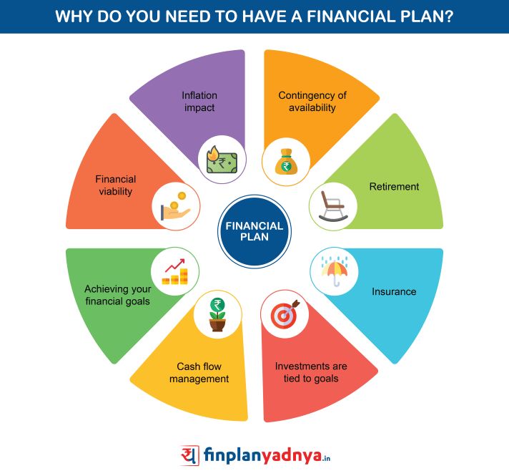
Figure 10: The Objectives of Financial Planning (Brady, 2011)
- The first and foremost aim of financial planning is to determine the capital requirements. Aspects such as cost of fixed assets, cost of current assets, long-range plans, and promotional expenses, etc. (Brady, 2011). are taken into consideration while measuring this factor. Both the short-term and the long-term are vital parts of this planning.
- Financial policies are created through financial planning. These policies determine how the organization will handle profits and losses moving forward (Brady, 2011). A list of financial policies is vital for running the financial sector of a company.
- In an enterprise, there are activities such as investment, procurement, and administration of company funds. These are complicated jobs that require flawless maintenance (Foley, 2015). The overall profit margin of the business increases through these occupations. These affairs are also maintained by thorough financial planning.
- Budgeting and budget-planning are two extremely important steps to be taken in the financial department. Budgeting means to properly assess the existing funds of a company (Brady, 2011). This is done to make sure that the production sector does not face any obstacles while producing products. And, budget planning means planning the budgeting system. This is also done through financial planning.
- The overall capital structure has to be determined in order to stay ahead of the competition. The capital structure refers to the composition and constituents of the capital income (Foley, 2015). This can indicate both proportional and relative funds required in the toy business. This also handles issues like debt equality ratio in both the short-term and the long-term. Financial planning also aids in these kinds of crucial decisions.
- Cash control is a serious problem in this department. Lending and borrowing are complex and serious issues. Even though these topics are complex, they are key aspects in the financial field (Foley, 2015). Keeping these factors under control requires a lot of manpower and skills. Expert personnel are recruited for handling these situations. And, these expert employees use the financial planning model to maintain the activities.
- The financial resources of a company are limited. They are not sustainable and can wither away quite fast. So, these resources need to be protected (Foley, 2015). These assets must be utilized in such a way that there is no loss of materials. The production rate must be higher than the sales rate. And, to accomplish this important task, financial planning needs to be done.

The step-by-step process of financial planning
The main goals of financial planning have already been discussed. To have these many objectives, it is necessary to carefully plan out the entire process of financing (Thompson, 2002). Pinocchio Toys Ltd. has to create a step-by-step activity log that they can follow in order to create a perfect financial planning process (Foley, 2015). These steps can be individually identified and implemented. Each step represents a specific set of actions to be followed by the company. These steps are described below in detail:
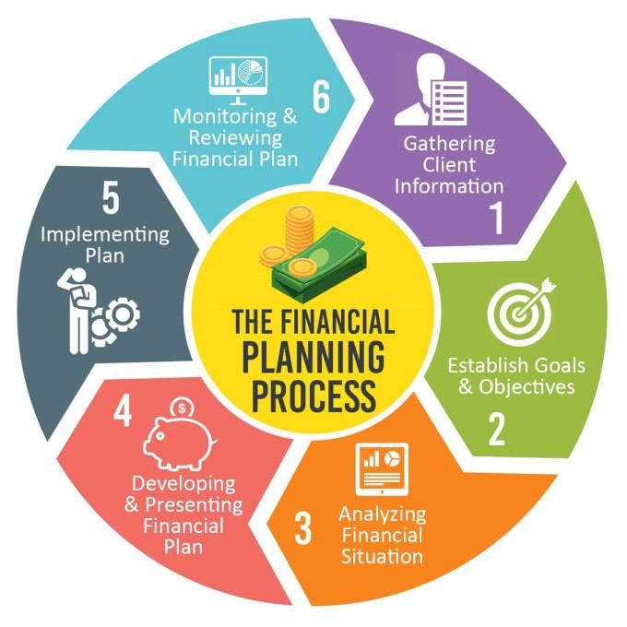
Figure 11: The First Segment of the Financial Planning Process (Stevenson, 2006)

Step 1
The first step in creating a financial structure is to evaluate the current financial condition of the company. The point of this step is to assess the present economic situation of the organization in regards to living standards, annual income, annual savings, impending debts, and investments (Stevenson, 2006). Pinocchio Toy Ltd. must prepare a list of all the debt balances and the current assets. They must also take into account all the money spent on different items. This will create a good foundation for all the financial activities.

Step 2
The second step is to set some organizational goals for the company. The business enterprise needs to have a goal they can aim to achieve. Having an aim will help the company operate efficiently (Stevenson, 2006). They will strive to work harder. Every company should have its own sets of financial goals. Pinocchio Toys Ltd. is no different. The financial goals need to be periodically analyzed. Goals can change depending upon the company policies and the economic differences (Stevenson, 2006). So, a company must keep track of its financial goals and update them if necessary. The main purpose of this step is to separate the needs from the wants (Stevenson, 2006). This can range from immediately spending all of the company resources or using all of the current assets in extensive investment and savings. Financial security also falls in this step.

Step 3
This step focuses on identifying alternative courses of operations. Sometimes, the company faces problems while pursuing its goals. Or, other circumstances might arise that might force the company to take drastic measures for changing company policies (Jordan, 2018). In these cases, the company has to evaluate proxy or substitute methods of action in order to avoid losses and other implications (Jordan, 2018). Being a toy manufacturing company, Pinocchio Toys Ltd. will have kept up with the latest trends upgrade their production menu following the trends. Facing obstacles and reacting accordingly holds a lot of weight in the commercial world. Making good and productive decisions based on the hurdles faced is a very useful ability (Jordan, 2018). Organizations that have these qualities don't stumble during impediments. They use their efforts and talents to overcome any hardships that may or may not come. They are always prepared. And, this is crucial in financial planning.
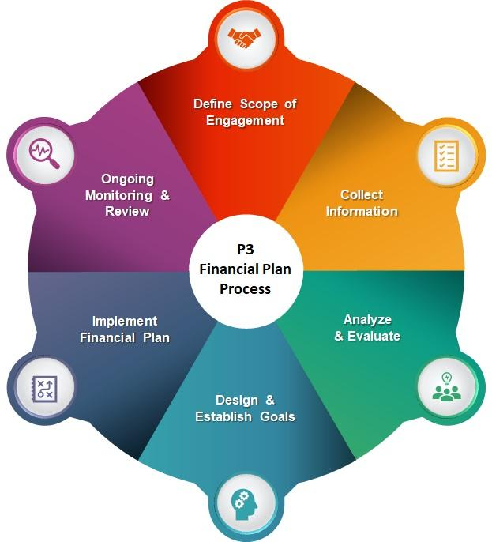
Figure 12: The Final Segment of the Financial Planning Process (Stevenson, 2006)

Step 4
Financial action plans are some of the most rewarding experiences for any company. In this step, the main objective is to choose the methods of success (Jordan, 2018). This phase allows companies to select specific criteria for their companies. These criteria can be related to anything in the commercial world. They can be connected to both short-term and long-term goals (Jordan, 2018). Financial action plans can be organized for budget plans, investment plans, saving plans, etc. This will also help the company realize its priorities and achievements (Jordan, 2018). This will also allow companies like Pinocchio Toys Ltd. to have a chain of goals. So, if one goal is achieved, they can quickly move on to the next goal. Time management issues are resolved in
this step. Thus, this step is pivotal in the overall financial planning process.

Step 5
The final stage of the financial planning process is to reevaluate and revise the entire plan created from scratch. At this level, the total risks are judged. Decisions will be taken on how to resolve the unavoidable issues (Brady, 2011). This phase is also not a one-time step. This stage will be ongoing for the company. Reevaluation is a continuous process. Pinocchio Toys Ltd. will have to be in the constant process of reassessing their courses of action throughout their business lifespan (Brady, 2011). Opportunities will also be appraised in this position. The series of decisions taken by the company will also be considered. Policies will be changed or reformed based on the conclusions reached in this segment. Company adjustments are a requisite (Brady, 2011). These adjustments are made by comparing annual profit or revenue with other companies. The change in focus will also be determined in this segment. Customer feedbacks are also collected here. The critical reception of the public will play a major role during this step of the financial planning process.

The importance of financial planning process
We have already elaborated on the objectives and the main procedures of the financial planning process. It is detrimental to the growth of a company (Alexander, 2017). It is safe to say that a company can't function or proceed very far without the intervention of a well-planned model. Although, it is called a "financial planning model", its influence and impact can expand to other sectors of the commercial field (Alexander, 2017). This business structure model is beneficial to the management sector, production sector, accounting sector, etc. Therefore, it has immense significance. Some of the major points are written below:
- Financial planning helps the company maintain adequate funds and resources. As a result, the manufacturing team is always ahead of the sales team.
- This model also ensures sufficient supplies from the suppliers. This means that the company storage sector never has a shortage of materials.
- The model creates a perfect balance between the outflow and inflow of assets. For this reason, no imbalance is ever created.
- The stability of the enterprise is maintained by this planning system. This prevents the crumbling of the company infrastructure.
- This paves the path for a smooth and long-term investment schedule. This results in a flawless transition of savings.
- The expansion of the company also becomes easier due to the implementation of this model.
- Uncertainties and massive risks can be refrained from utilizing this model. On the other hand, it can also guide a company to successfully overcome threats.
- The overall growth of the company and its profit margin will increase significantly by applying the planning process. This can also create scopes for internationalization.

Conclusion
Although Pinocchio ltd will be formed this year through the initiatives of the management team, it is believed that it will achieve a lot of popularity by the year 2022. The reason behind this is that the business structure is very much organized and optimized. Each member of the team has a specific goal and it can be easily assumed that these members are skillful in their line of work. A startup company needs a lot of effort and attention to detail. People who have an insight into what the customer wants and the structure of the company can easily thrive in the long run.

Reference
Abraham, K., 2019. S.M.A.R.T Goals. 2nd ed. Newark: John Wiley & Sons, Incorporated.
Adams, K., 2018. Business management. 5th ed. London: The star publications.
Alexander, D., Stonehill, A. and Moffett, M., 2017. Multinational Business Finance. 14th ed. Wembley: Jaxon Books Publication.
Ananthan, B., Appannaiah, H. and Reddy, P., 2010. Business management. Mumbai [India]: Himalaya Pub. House.
Bach, S., 2018. Communication and Interpersonal skills in business. 4th ed. London: The Sun Publication.
Best, R., 2013. Market-based management. Upper Saddle River: Pearson.
Brady, W., Brady, J. and Brady, A., 2011. A Modern Perspective of Economics and Finance. 12th ed. Yorkshire: Brady Brothers Books Ltd.
Byrne, C., 2017. A profile of the United States toy industry, second edition. 2nd ed. New York: Business Expert Press.
Campbell, J., 2018. Business Analysis. 6th ed. London: The moon publications.
Cohen, W., 2016. The marketing plan. Hoboken, NJ: J. Wiley & Sons.
Craig, G., 2019. Child development. 13th ed. Englewood Cliffs NJ: Prentice-Hall.
Dawson, J., 2018. Supply Chain Management. 10th ed. London: The boar publications.
Findley, J., 2019. Principles of Management. 6th ed. London: Penguin publications.
Firby, J., 2017. How to build a startup company. 3rd ed. London: Boar publications.
Foley, D. and Fedorowicz, Z., 2015. Financial Planning. 14th ed. Warsaw: Pravillion Press Ltd.
Gerakos, J. and Syverson, C., 2013. Competition in the audit market. 5th ed. Cambridge, Mass.: National Bureau of Economic Research.
Hillyer, J. and Norbury, I., 2013. Woodcarving. 8th ed. New York: Lark.
Jordan, A., Dwyer, D. and Junior, S., 2018. The Five Stages of Financial Planning. 9th ed. Chicago, Ill.: Longman Financial Services Press.
Keasey, K., Thompson, S. and Wright, M., 2019. Corporate governance. 3rd ed. Cheltenham: Edward Elgar.
Langton, D. and Campbell, A., 2011. Visual marketing. Hoboken, N.J.: Wiley.
Law, P., 2014. Product management. 11th ed. London: Harper & Row.
McDonald, M., 2012. Market Segmentation. Wiley.
Sjåfjell, B., 2019. Towards a sustainable European company law. 1st ed. Alphen aan den Rijn: Kluwer Law International.
Smith, E., 2020. The Toy industry in the United Kingdom. London: British Toy & Hobby Association.
Smith, K., 2013. Target Market Series. Newburyport: The National Underwriter Company.

