Everyday Life in Athens and Rome (HPHP4020)
Ancient Sport in Greek Art – Part 1

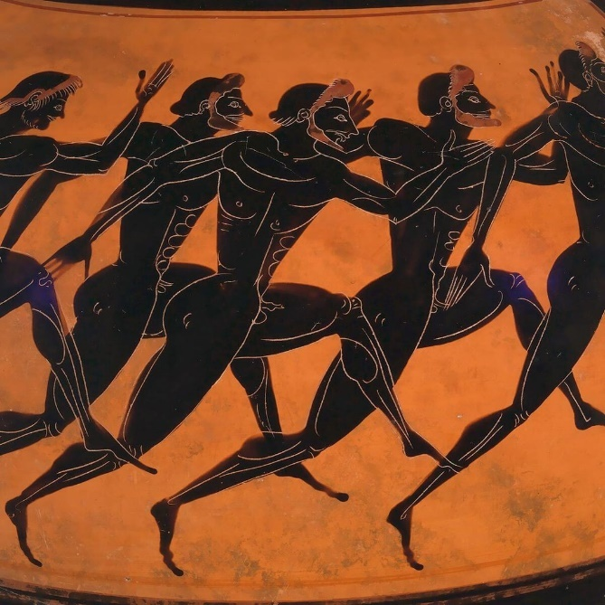

In this workshop we will explore ceramic iconography, reliefs, frescos, and mosaics of athletes from Classical Athens. You should examine this imagery (given below) and see what interpretations can be drawn that are of socio-historical value. Be mindful of how these images might express cultural values and aesthetics, as well as they might prove useful reconstructing activities or “narrative actions”. Accompanying these images is a series of specific questions for consideration.

If you wanted to explore this topic further, you could consider taking a look at: Neils, J. 2014. “Picturing Victory: Representations of Sport in Greek Art”, in P. Christesen and D.G. Kyle (eds.), A Companion to Sport and Spectacle in Greek and Roman Antiquity. Chichester: Wiley Blackwell, pp. 81-97.

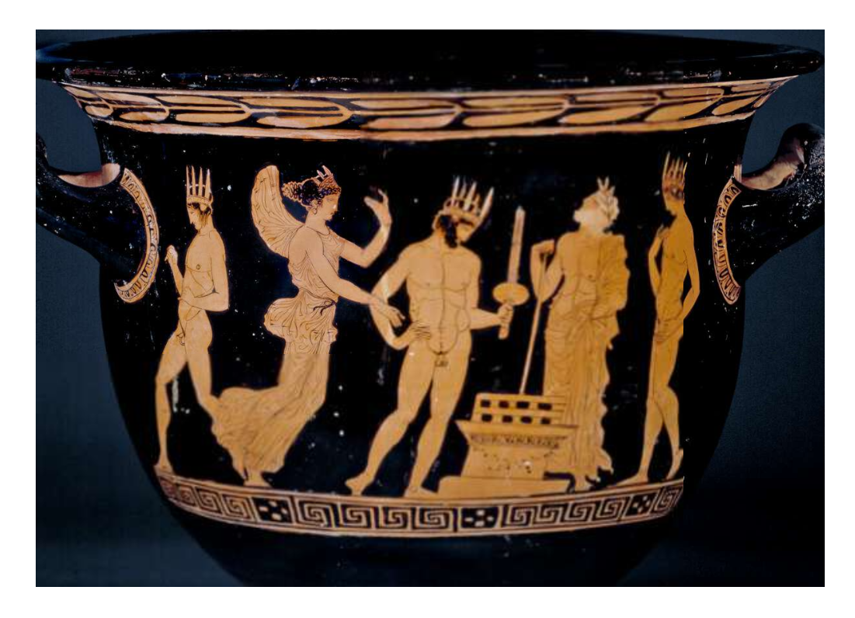
Athenian krater (mixing vessel) attributed to the Nikias Painter (ca. 420 BC) [Tribe of Antiochis]. British Museum 1898. Pathanthenaic games (probably alluding to the torch race).
What appears to be going on in this scene? Can you identify the winged figure (green arrow), man in the centre (blue), man just to the right (pink), and man at the far left (red)?

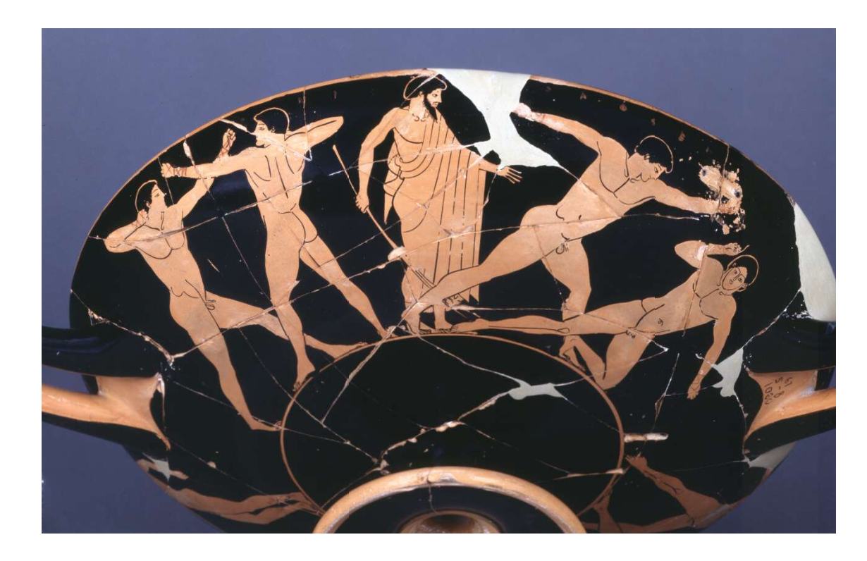
Athenian cup, attributed to Douris (ca. 480 BC). British Museum 1867.
What appears to be happening in this scene – what sport are these individuals engaged in? What might the men on the left be doing (red arrow)? Who is the person in the centre likely to be and what is he holding? What might the significance of the poses of the men centre right (green) and right (pink) – in the latter case, what is noticeable about his gestures?

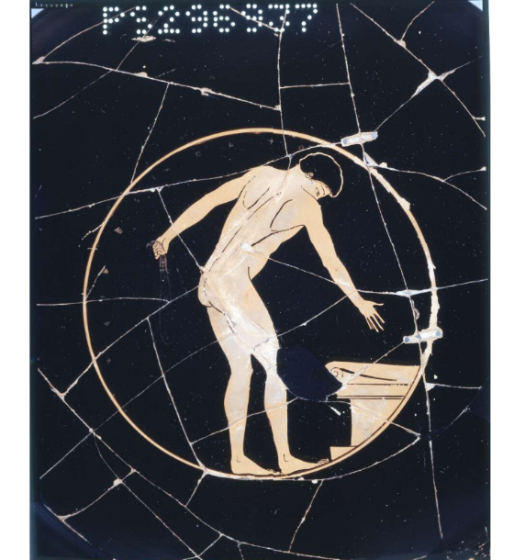
Interior of the cup (depicted above) – British Museum 1867.
How might be understand the meaning of the image inside the cup?

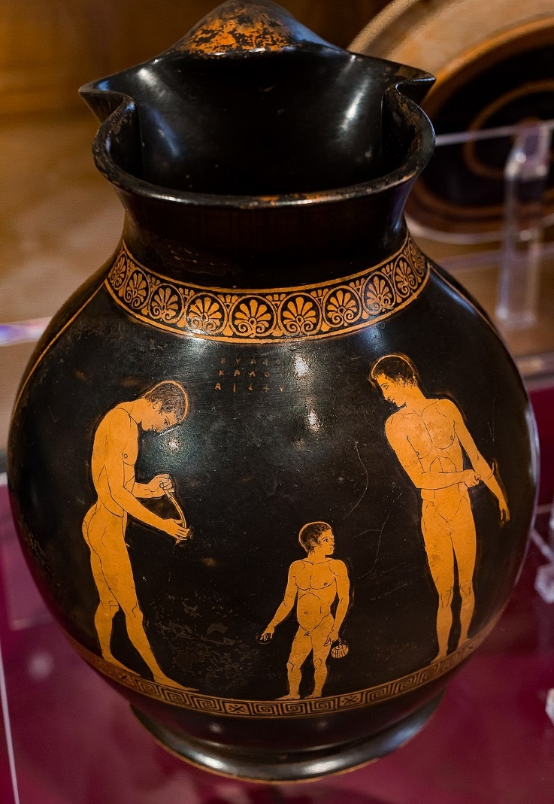
Athenian chous (wine jug), attributed to Achilles Painter, ca. 440 BC. Basel, Antikenmuseum und Sammlung Ludwig (Switzerland) BS 485. “Euaion the son of Aeschylus is lovely”.

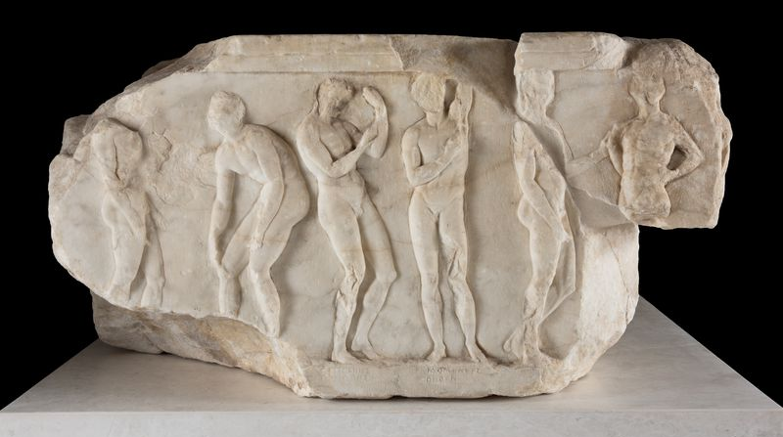
Fragmentary pedestal (likely a base for statue(s)) found during excavations of the eastern part of the Propylaia. Post-350 BC. Acropolis Museum (Athens) 3176. “Lakiades, from the deme of Lakiades, Oethen, from the deme Oe, and Acharneus, from the deme of Acharnes” [Oineis tribe].
What activity do these two images (chous and pedestal) appear to depict?

