Engine Performance Characteristics
Programme: BEng Motorsport/Automotive Engineering
Module: Motorcycle/Motorsport/Vehicle Technology
Module Code: ACHA4003/4004/4012
Student Name: Will Davies
Student Number: 2400569
Lecturer Name: Andrew Harrison
Date of Submission: /03/2025
Word Count: 1329

Contents
Engine Performance Characteristics 1
Introduction 3
Aims & Method 4
Engine Performance Testing and Analysis 5
My Calculated Results 8
Conclusion 12
Evaluation 12
Bibliography 13

Introduction
In this assignment, I will be showing detailed knowledge and understanding of the principles of an engine and the vehicles technologies alongside the practice of analysis of powertrain and chassis systems. I’ll be demonstrating the skills applied for an automotive problem obtaining and interpreting data which has been collected in a laboratory.

Aims & Method
The aims of the dynamometer test are to measure the output of the engine with an outer casing being fed by a current forming an electromagnetic field. When the outer casing wants to turn as there is a load on the engine its restricted by a strain gauge. This strain gauge sends a signal to the computer inside the control cell, which allows us to see programmes within the system and allow us to calculate any type of value.
Equipment & Method
The equipment used are:
- Sensor modules – these are recording modules which feed the computers allowing us to read the data
- CTC – a coolant temperature sensor, measuring the temperature of the engine ensuring it isn’t overheating, and being able to see if its at operating temperature
- Flow Metre – measuring the about of fuel being drawn into the engine
- Lambda Sensor – this is measuring the emissions being emitted after combustion
- Dynamometer – this is the whole testing equipment allowing us to have a voltage being sent to the sensor modules.
- Speed Sensor – Measures the speed of the engine
- Strain Gauge – sending a voltage to the sensor modules
- Calibration Arms – designed and calibrated to be a specific length of 815.776mm
Method
The engine is connected to the dynamometer by a driveshaft connected straight to the crankshaft of the engine. The dynamometer has an inner core which is spinning due to the driveshaft and the outer casing being fed by a current. This then produces an electromagnet field, putting a load on the engine which tries to slow the engine down. The mass on the outer casing makes it to turn, and when it turns its restricted via a strain gauge. This then sends a voltage to the sensor modules allowing us to read data from the engine and to see how its operating. This then allows us to calculate programmes within the system. With the machine also being calibrated as it has calibration arms either side of the dynamometer, which are designed and calibrated to a specific length of 815.775mm. That is the distance from the pivot to the hook-eye. With mass applied we can know the torque being applied on the outer casing. Mass being applied, turns outer casing, resulting in hitting the strain gauge and sending a voltage.

Engine Performance Testing and Analysis
Dyno Results
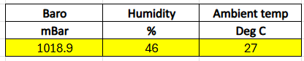

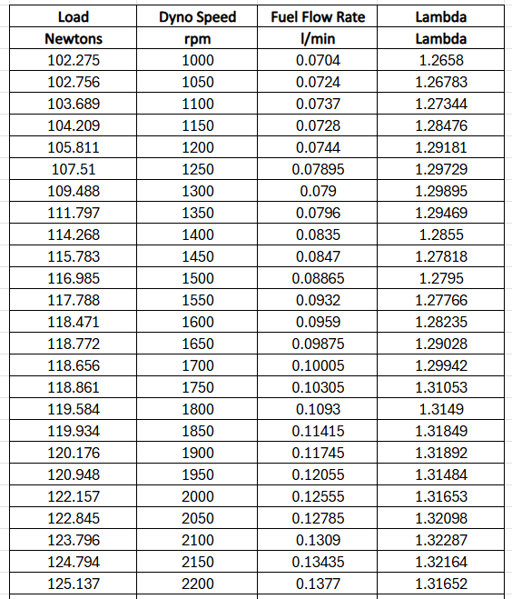

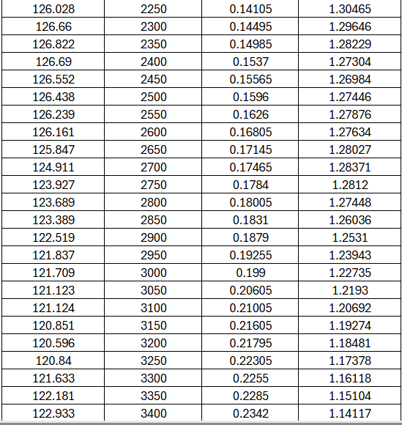

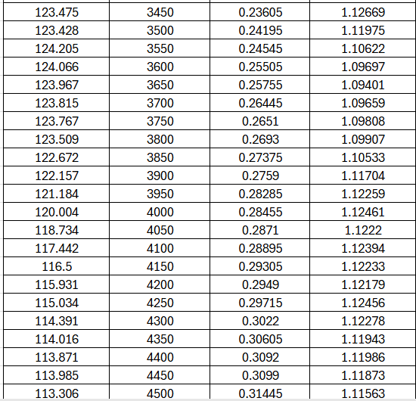

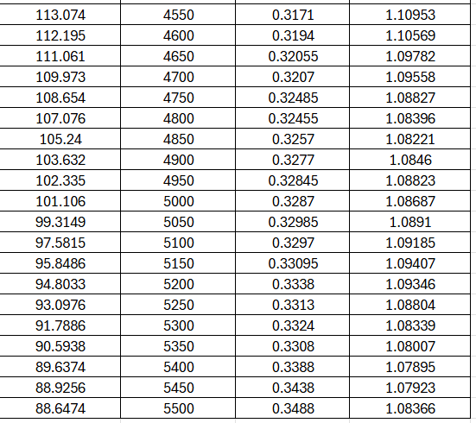

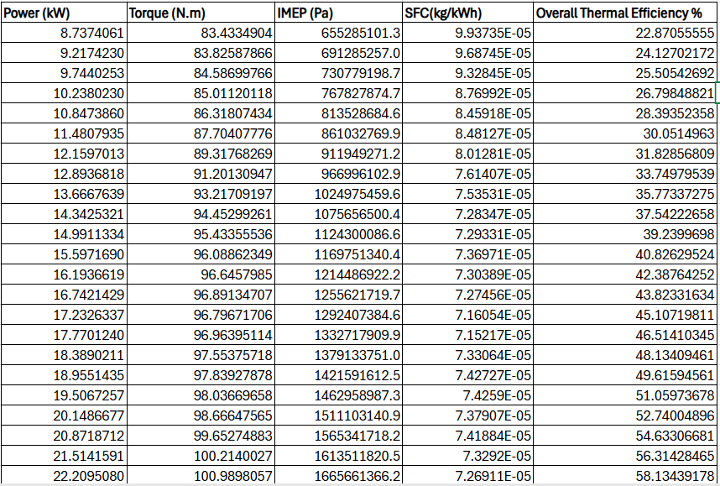
My Calculated Results

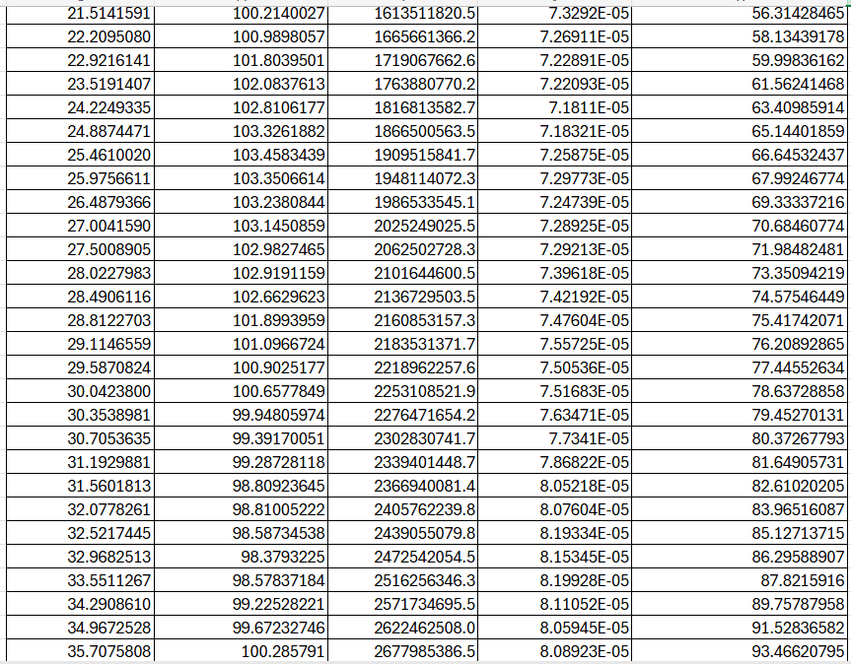

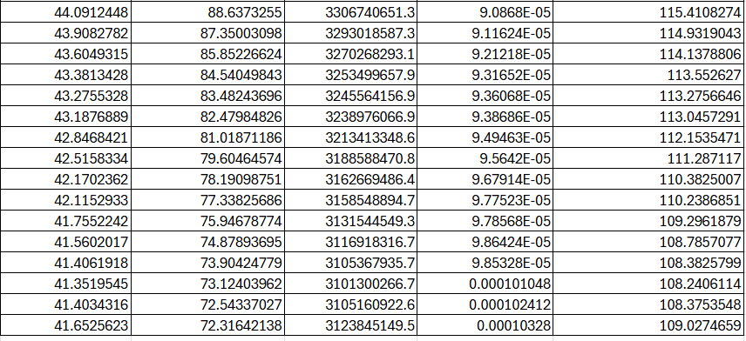
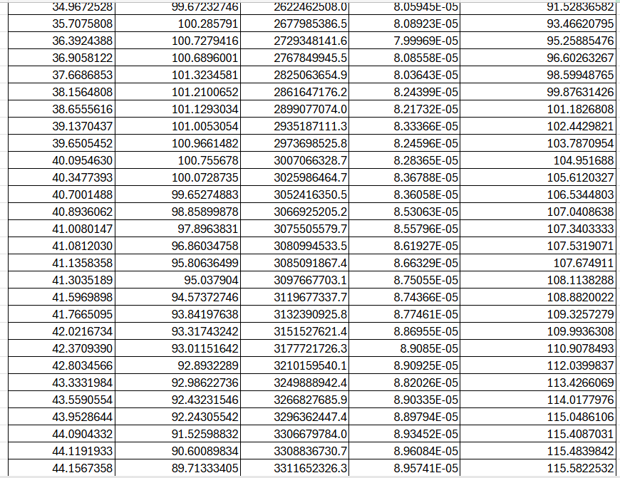

As the engine speed the SFC varies. I think that this is due to the efficiency of combustion. Having a high SFC at very low RPM is caused due to the inefficiency of combustion keeping SFC high. It then drops off and as RPM increases the efficiency is improving lowering the SFC. But looking at the graph, at very high RPM the SFC starts to increase. This is due to the friction and the pumping losses during combustion, and the fuel system limitations which start to increase the SFC. At a low RPM there is an improved combustion efficiency allowing there to be a good SFC, however when the RPM keeps increasing the combustion efficiency is going to start getting poor, resulting in the SFC to increase. Different type of fuels can also affects this, depending on the difference in octanes or where you get your fuel from.
Looking at the graph the torque goes up, it peaks and then drops off as the RPM increases. I think the torque rises as when the RPM is low the torque will rise along side the increasing RPM due t the improved combustion efficiency and volumetric efficiency. The torque then peaks at the RPM which the engine is breathing and working the most efficiently. Therefore, when the RPM keeps on increasing, the torque declines due to the increase in friction, the reduced air intake efficiency and the combustion limitations. The increase of torque can be up to the improved volumetric efficiency when at a low to mid-range RPM, but when at high RPM, there are factors like increased frictional losses and a combustion timing efficiency.

By looking at the graph you can see that the power is increasing alongside the RPM, and as it gets to a peak, the power starts to decrease but the RPM is still increasing. This is due to the power hitting its peak just after torque hitting its peak, and as the RPM still increases there is no more power to keep on producing, therefore the power gets to a peak and drops off and very slightly picks up a little. Power output can be affected after a certain point as after the peak power, the engine power may struggle to inject fuel and ignite efficiently, with also some exhaust backpressure at excessive amounts, due to being at very high RPM’s. Frictional and mechanical losses can also be a matter to the question of the power dropping off.

Conclusion
From my results I can conclude that SFC, Torque and Power all have peaks and then drop off due to similar circumstances. With torque it has a steadier increase with the dyno speed compared to power and SFC. However, power has a much greater increases compared to the other two. In all graphs I added a trendline to represent that if the data, increase and the decrease was all linear then that’s what it would’ve looked like. When looking at SFC you can see that at low RPM it is high then it drops off when RPM increase, but when it starts to increase its peak is just above where it started. I can fully conclude with that, as RPM increases the SFC decreases and the starts to increase, but with torque and power they both increase alongside the RPM but then hit a peak and then drop off even though the RPM is still increasing.

Evaluation
I felt like I have performed well during these tasks. After watching and understanding the videos that I had to watch, I felt confident in what I was saying as I understood the task. Calculating the data was the most time consuming as to use the formula to get your answer you had to displace and find other answers beforehand, however it all made sense. Producing the graphs was a good indication of the calculations and it shows how the dynamometer performed. I felt like I should be remembering the equations more and thoroughly as I had to research and remind myself how to do the equations. Other than that, I felt quite confident with the tasks. I think one thing that could’ve gone better for the investigation is that if the dynamometer was up and running. The results used where secondary results. However, if the dynamometer was working then I would’ve had primary data to use. Other than that I think that the investigation and all the tasks went well and not much could’ve been improved.

Bibliography
Powertrain Calculations: Powertrain_25.url. Accessed on 17/03/2025
Dynamometer Video: https://www.youtube.com/watch?v=-WajOAp2LUE&feature=youtu.be. Accessed on 17/03/2025
SFC Vs Dyno Speed: Variation of Sfc with engine speed | Download Scientific Diagram. Accessed on 17.03.2025
Torque Vs Dyno Speed: Speed vs Torque - Power Electric. Accessed on: 17/03/2025
Torque Vs Dyno Speed: Torque vs. Speed: The Relationship Between RPM and Torque in context of power screw formula torque | True Geometry’s Blog. Accessed on 17/03/2025
Power Vs Dyno Speed: Power vs. Torque – x-engineer.org. Accessed on 17/03/2025

