Georgia McDonald (1702499)

Authority, Power and activism: How does graffiti influence the psychogeography of the ephemeral urban environment?
[Submitted in partial fulfillment of the requirements for the degree of BA (Hons) Graphic Design, University of Wales Trinity Saint David, Swansea (11th December 2019).]

Independent Inquiry.

Course Title: BA Graphic Design

Word Count: 6,482

Tutor Name: Phil Thomas

Table of Contents

Table of Contents……………………………………………………………….….……1
List of Figures…...…………………………………………………………….….…….. 2
Summary of Topic…………………………………………………………….…….…...3
Glossary of Terms……………………………………………………………….……....4
Introduction……………………………………………………………………….….…...5
Chapter 1: Contemporary Graffiti and its Modern Evolution.……...………..……….8
Chapter 2: Activism, Authority and Power…………………………………….....…..23
Activism…………………………………………………………24
Authority…………………………………………………………28
Power……………………………………………………………29
Chapter 3: Concluding Statement: Communicating Impactful Social Change with Graffiti …………………………………………………………………………....…..…..30
References……………………………………………………………………………….32

List of Figures

Fig 1: Lucius Pinxit……………………………………………………………..……..…5

Fig 2: SAMO is DEAD………………………………………………………….………18

Fig 3: Untitled subway drawing……………………………………………..…………14

Fig 4: Rats……………………………………………………………………..……..….16

Fig 5: Untitled………………………………………………………………..….…….....18

Fig 6: Guide psychogéographique de Paris: discours sur les passions de l’amour…………………………………………………………………………….……...23

Fig 7: Slave Labour Bunting Boy…………………………………………….…….…..27

Fig 8: Evade…………………………………………………………………….………..35

Fig 9: AQUI !TORTURAN!......................................................................................35

Fig 10: Free Hong Kong………………………………………………………………….36

Summary of Topic

This independent inquiry aims to discuss how the psychogeography of the urban environment interacts with the ephemeral nature of graffiti. In turn developing a discussion of how graffiti is perceived, how it is valued and how this form of ‘vandalism’ can affect society. Can graffiti harness the struggle of communities and give them a powerful voice. Graffiti allies with activism and social protest and it will thrive where authority and power are abused.

Glossary of Terms

Tag: Graffiti writers’ name/alias/self-named nick name, done quickly. (Walsh, 1996)
Tagger: A writer who only does tags. (Walsh,1996)
Writer: Someone who writes graffiti. A member of the subculture. (Macdonald, 2001)
King: The most accomplished or prolific writer. (Macdonald, 2001)
Old school: An older generation of writers. (Macdonald, 2001)
Piece: A painting, short for masterpiece. To paint a word or image with more than two colours. (Macdonald, 2001)
Throw up: A quick outline of a writer’s name with a black or white painted interior. (Macdonald, 2001)

Introduction

“Poverty is the parent of revolution and crime.” — (Aristotle)

Aristotle proclaimed that poverty is a catalyst for revolution and crime and even today this statement holds merit as it relates to modern society. Protest and graffiti have become common place in our current times. This has been a constant and growing movement that can be traced throughout history. Artists have used the impact of protest art to their advantage and deployed graffiti as a political and social platform to share their voice directly to the people situated in their immediate environment. Graffiti is a versatile and timeless act that anyone can do. A very early example, from as far back a 79 C.E. in Pompeii, “Lucius Pinxit” scribed on a street wall in Pompeii which directly translates into English as “Lucius wrote this” (Anonymous, 2013). History shows us that graffiti is not a new concept. People have tagged the streets and left their mark long before anyone currently alive was born.
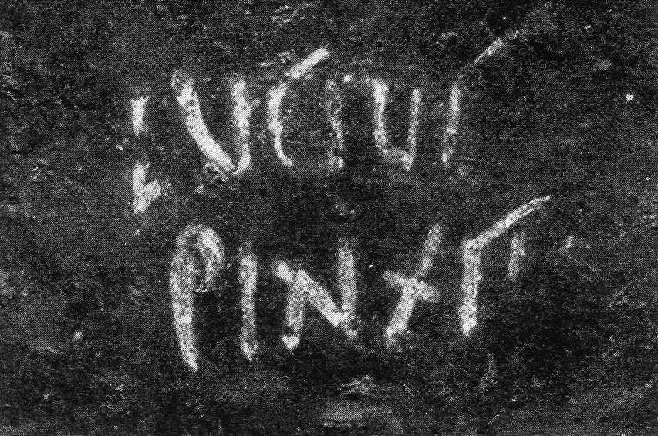
Fig. 1: Lucius pinxit

This independent inquiry will investigate the ephemeral narrative of graffiti. It will be argued here that graffiti is a voice of the social protest and the oppressed which manifests itself in displays of public art. Whether graffiti is art, or a criminal act, it is much debated, and this will be examined through three themes; graffiti, psychography and the ‘ephemeral’.

The three themes above will be discussed through the work of four significant individuals; illustrating and examining the relationship between theory and practice. It should be noted here that these are only four of many practitioners who could be considered, but within the scope of this assignment it has been important to focus this discussion on a small but significant sample.

Graffiti is more than just ‘mindless vandalism’. Graffiti may also be about creative growth and learning, ‘tags’ are improved upon and develop into ‘throw ups’ (Walsh 1996; MacDonald 2001). There can be evolution in the writers’ work as they start to think about composition, colour and even typography. This in turn helps the writers gain prestige among the community and subgroup which recognises their commitment to the art of graffiti.

To summarise, the viewpoint of this Independent Inquiry is culturally orientated. The intention of this inquiry is not to glorify the act of graffiti but to gain insight into its world. The role graffiti plays in influencing the town and city scape is considered as is the ways in which it connects with the urban community. What role does it play within the urban community? Graffiti artists create an intriguing subculture that has formed a strong foot hold in our society. It will be argued that it has a powerful voice that critiques and comments on cultural values and promotes social change. A case will be made that graffiti gives a voice to connect symbiotically with the community, in an act of disestablishment protest against government and societal oppression.

It is not intended to delve into the argument of what is right versus what is wrong, but to identify the motivation behind actions, their consequences and how this effects the psychogeography of the environment that surrounds the urban population. Does this outlawed subculture influence the counterculture and mainstream culture? Some graffiti writers have more notoriety than others which brings up the discussion of ‘value’, ‘fame’ and ‘monetarisation’ of graffiti and street art. To what extent does its rise in financial value reduce its social power and this will be discussed within this study into graffiti. Furthermore, the extent to which its meaning and value are context bound will be explored. This sentiment will help to inform the debate between the relationship of graffiti, environment and monetisation.

The following chapters are split into three main areas literature review, discussion and conclusion. The first chapter contains several sub chapters outlining the artists and key subjects used to help answer this independent inquiry’s question. The second chapter will discuss the intentions of the research conducted in the literature review to help further develop an answer. Then finally the third chapter shall summarise the main findings of this research.

Chapter 1: Contemporary Graffiti and its Modern Evolution

Graffiti is regularly defined as a delinquent subculture, known to have negative connotations such as crime and anti-social behaviours (Macdonald, 2001). It could be argued that because graffiti has such poignant implications associated with this illegal subculture, that this stigmatisation of graffiti obscures the creative and artistic values which are left unappreciated and discouraged among the youth. With its vibrant energy that is uncontrolled but full of creative talent is too engaging to be ignored by society.

A well-established graffiti researcher Nancy MacDonald (2001) summarises Cloward & Ohlin’s (1961) theory of delinquency into three categories: criminal, conflict and retreatist. The second category, conflict, is summed up as “violent frustrations from working class people who are denied access to societies legitimate opportunities” (Macdonald, 2001). One of the ways these frustrations can surface is through the use of graffiti, as stated by a government official. The same government official stated that graffiti is “Destroying our lifestyle” in the documentary (Style Wars, 1983). Was this statement a true reflection of the interpretation of the establishment by a white middle-class male? It brings into question, who’s lifestyle is being destroyed? That of the middle class or of the same community where graffiti was brought to life? Graffiti is a concept that is not bound by age, class or race yet people perceive it in different ways therefore the interpretation of the audience can manipulate graffiti into what they envision it to be.
Men can see nothing around them that is not their own image; everything speaks to them of themselves. Their very landscape is alive. (Debord 1959 in Knabb 2006, p.63)

Is graffiti destroying the lines between the middle and working classes, by sharing influences and situations with each other to form opinions which often challenge the upper establishment and government? This can in turn as part of protest and civil unrest, cause an upheaval in the economic climate as differing attitudes and rising frustrations create conflict within our communities.

The hierarchy of social class is a huge factor within our society. It impacts the way society works and to a large degree how people live their daily lives. Marxist theory provides material for a debate about the monetisation of graffiti and street art, through the use of notoriety and collectability. Hebdige (1979) states that political and social pressure can force those under scrutiny to push for change which in turn helps our society grow and improve into something new.

Another way to understanding the differences between classes is through the distinctions between high and low art. Markus (2013, p.128) states that if there is a ‘high culture’ it automatically infers that there is a ‘low culture’. By this definition graffiti would fall into the bracket of low art in comparison street art would be classified as high art. These distinctions are used by the government to decide what is kept and what is removed. Pierre Bourdieu (2007) brings forth the discussion of social class in relation to what is accessible to the masses and how its collectability determines its desirability and worth.

Marxist theory brings a fresh commentary to the debate of the commodification of graffiti and street art and how this raises status, fame and fortune. For example, art gets ‘stolen’ and sold in galleries for exorbitant amounts of money (The Infographic Show, 2018). Marxist theory analyses social values and constructs by studying society and how it works. How politics, class, legal systems, authority, and power are all interlinked and connected. In simple terms this view of Capitalism suggests that the upper classes, people who have wealth, in the form of property, have more ‘power’. In this system the ‘owners’ make a profit. The workers earn a wage, determined by the employer. The laws of the land; via politics, government, are made by and to the benefit of the upper classes for the detriment of the lower classes who have less wealth, power, legal standing and ability to make changes.

According to Marxist theory, the upper classes rule by virtue of wealth and power via laws and government in favour to itself – not in favour to the ‘masses’, the ‘common people’ – the proletariat.

For the ‘common’ people to improve their situation there inevitably will be social unrest, activism and political protest and civil agitation for a more equitable sharing of ‘profits’. Marxist theory has relevance to contemporary society as there is social protest currently in Santiago, Chile because people can’t afford to pay the increase in tube fares and pay for electricity and water (Gordon-Zolov, T & Zolov, E, 2019).
Even though in theory we live in a Democracy, where all adults have a right to vote, we are vastly limited by the power of the wealthy classes who can manipulate all systems to their own ends and their own profit.

In a time where social protest on the streets has become a common appearance in our daily lives all across the world. In a society where the act of Graffiti is deemed illegal and social protest which is performed to inspire and promote positive change is illegal. People who engage in social protest are branded ‘troublemakers’, rioters’, criminals. The powers that be protect their own. It makes one question the system: A system where Banksy’s graffiti sells for millions. Yet he himself does not earn those millions. Who made the laws? Who owns the property? Who makes the profit? Not the ‘vandal’ or the protester.

The governments classifications and attitudes towards graffiti have always been in a position of contempt as the law states;

Graffiti is an offence of criminal damage and can be reported to your local police force via 101. If prosecuted, the offender could face a fine or even imprisonment. (Ask the police, 2019)

Graffiti is punishable by law, which seems hypocritical given the government distinguishes between what is labelled as graffiti and street art. This is understandable given where graffiti came from and why it became prominent in our society.

Tristan Manco reveals that graffiti was ‘born’ from the hip-hop culture during the 1970s in New York (Manco, 2004). Shortly after this ‘street art’ was classified as a term which was first used in the late 1980s. Any art on the street that was not in the hip-hop style would fall under the bracket of street art. “It’s not that it can’t be viewed as vandalism but in my mind, every sticker, every tag seen on the street has the same merit” (Hundertmark, 2003, p.6). Hundertmark does not expand further on what that merit is. However, the audience could interpret that graffiti and street art should be equal under the definition of law and public values.

The line between what is street art and what is graffiti has begun to blur over the past decade. As the style of graffiti has evolved and expanded so has the definition of graffiti changed with it. No longer carrying the same harsh stigma as it had in the 1970s, graffiti has had a revival, as the likes of Banksy have become a household name and infiltrated the art world. Graffiti has become something that can affect and challenge mainstream attitudes towards society and its laws.

The definition of graffiti is described as “writing or drawing scribbled, scratched, or sprayed illicitly on a wall or other surface in a public place”. (Oxford Dictionary, 2019)

As the dictionary states graffiti is public and has illegal connotations but perhaps it illegality adds weight to the pieces created “You are…an acceptable level of threat and if you were not you would know about it” (Shove, 2008, p.25). This harsh stance can cause graffiti to have an impactful presence, given that it is already an act of defiance to even create it.

Jean Michel Basquiat (1960-1988) and Keith Haring (1958-1990) had a large impact on the early scene of graffiti in the 1970s and 1980s. Their influence is contested however the evidence of contribution to the subculture is still as vastly prominent today. They both used the streets to connect with the mainstream audience and share their art, the streets became their canvas.
‘The original ‘old school’ graffiti artists didn’t accept the way Keith Haring and Jean-Michel Basquiat were labelled ‘graffiti artists’ as they clearly came from a different world’ (Manco, 2004, p. 9).

As (Marshall, 1996) described Basquiat began his journey into the graffiti world as Samo which stands for “Same old shit”. He mainly tagged the downtown streets of New York choosing to spread his message to the public directly. He sadly passed away in 1988 at the age of 27 years old. Even though his art career was short it had such a dominant impact on the art world. As a successful black artist Basquiat questioned the suppression and role of black people in society and his success contradicted the inherent racism of American society (Laing, 2017). “
The graffiti that began to cover virtually everything in New York City in the 1970s prophesied a sociological shift in this urban landscape, from an environment of suppressed disorder, to an atmosphere of virtual chaos and decline. But rather than being emblematic merely of society’s ills, these ink marker scrawls and spray paint “tags” -produced mostly by Latino and African American youth- transmitted information, such as neighborhood boundaries, social rankings, artistic nom de plume, and even creativity itself.” (Powell, 1997, p.167)

He invited the community around him to engage in a debate through unconventional means, discussing difficult cultural issues and by using graffiti, helped communicate directly to the audience.
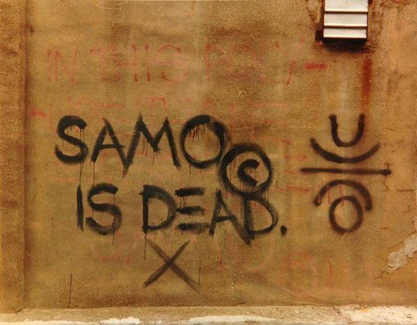
Fig. 2: SAMO is DEAD

Keith Haring (1958-1990) remains a source of inspiration to many, through his activism and art commentary on the political and social conflicts of the times.

Compelled to speak for his generation, his art responds to urgent issues including political dictatorship, racism, homophobia, drug addiction, AIDS awareness, capitalism and the environment. (Tate, 2019)

Tate Liverpool’s Keith Haring exhibition (14 June -10 November 2019) showed he was a prominent figure for the unrepresented and for marginal communities. His art brought people together to help raise understanding and awareness of important causes of the decade like homophobia, Aids awareness and promoting public understanding and helping to reduce fearmongering among the public. He combined his bold style with graffiti and brought his activism straight to the public by graffitiing subway stations in downtown New York in the 1980s. He saw an opportunity to make a change and he took it. Graffiti has often been seen as a big ‘screw you’ to the government because of its challenging attitudes towards society and the law.

It’s all about leaving your mark. A trace of existence, to taunt or humor [sic] the public as well as a liberating Fxxx You to the powers that deem our work vandalism. (Hundertmark, 2003, p.6)

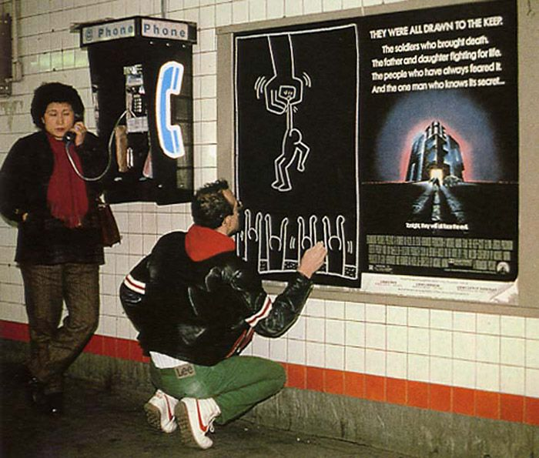
While Haring is not necessarily famous for his graffiti but for his pop art style, he was regularly arrested for graffitiing the subway stations throughout New York. Nevertheless, it did not deter him from consistently continuing to exhibit his work directly to the public. He was an activist for human rights and equality.
Fig. 3: Untitled Subway Drawing
Blek le rat (b.1952) is a Parisian graffiti artist and has been described as one of the most prolific names in the graffiti subculture. He began by spraying stenciled rats around the streets of France in the early 1980s (Prou & Adz, 2008). He often used stenciled depictions of rats as a form of protest against capitalist society and to express his distrust in the ‘rat pack’ mentality.

“He was making a stand against globalization, militarism and discrimination”. (Prou, S. & Adz, K., 2008. P7)

The iconic graffiti, pictured below, of rats was stated by Blek that “The rat is the only free animal in the city” (BBC Radio 4, 2019). This draws on similarities to the public accepting without confirmation that this is just the way the world is, trapped unfree to roam the cityscape. His work uses visual based content to express his opinions rather than a typographic based message.
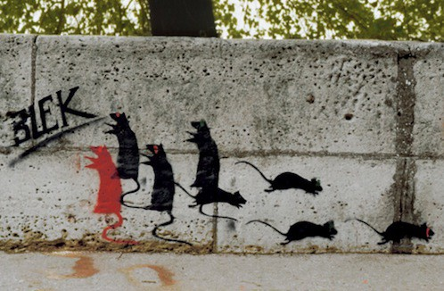
Fig. 4: Rats

Blek’s early work always had a socio-political subtext responding and to the social economic unrest of the 1980s.
“A decade that saw the emergence of a new kind of selfishness and greed, of mass unemployment and of yet another convulsion in the nuclear arms race”. (Prou, S. & Adz, K., 2008, p.7)

Understandably his work gained a lot of attention from the public because of the controversial stance against the establishment and status quo. There have also been some ruffled feathers over the past ten years with the emergence of Banksy on the graffiti scene. Some have noted a remarkable similarity to Blek’s work which has produced some defamatory claims. Some even going as far to say Banksy stole from Blek le rat.
“Every time I think I’ve painted something slightly original; I find out that Blek le Rat has done it as well. Only twenty years earlier” (Martin, 2017)

However, it should be considered that the strong comparison between works is not because of plagiarism but because of the same societal issues are still prominent in our current social climate. These accusations could be a veiled attempt to dismiss their important commentary.

“Most of his work no longer exists and was painted illegally.” (StreetArtNews, 2016)
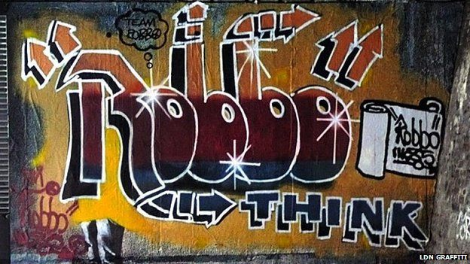
Robbo was spraying the streets of London back in 1980’s (BBC News, 2014) his piece, illustrated below was ‘gone over’ by Banksy in 2009, sparking a war between the two of them and subsequently bringing to light on the differential treatment of what the council deemed graffiti and street art. He was referred to as a “King of the London graffiti scene” (BBC News, 2014) which is high praise as ‘King’ in the graffiti world means the best of the best, you’re the most respected ‘writer’ in the area.
Fig. 2:Untitled

In the documentary, Graffiti Wars, Robbo continuously criticised Banksy for not being a ‘real’ graffiti artist, “he doesn’t do free hand he can only use stencils” implying that one stylistic choice is better than the other (StreetArtNews, 2016). However, one interesting thing to note is that although Robbo was critical of Banksy and his mainstream audience and success within the art world, Robbo also strived to have the same notoriety as his rival. Even showing his art in the same gallery Banksy first showcased his work.

If the work was taken out of its urban context, placed on canvas, given a hefty price tag and hung up in a gallery, its likely those same people that viewed it as vandalism would see it as art. (Hundertmark, 2003, p. 6)

Even though Robbo’s argument against Banksy is a convincing one, it starts to become hypocritical as it could be debated that Robbo was following the same path and potentially could have seen the same commercial success until his sudden and unexpected death.

Robbo, however, always strived to rebel against authority and without question had a rebellious nature that sparked emotion in everyone who saw his work and as Team Robbo will confirm, be remembered as an icon for all those who believed in his message (Street Art News, 2016).

Psychogeography is integral in using the landscape to communicate with the people.
Psychogeography is a term that was conceived in 1955 by Guy Debord (Tate, 2019).
Coverley a well-documented psychogeographer describes psychogeography as;

The study of specific effects of the geographical environment, consciously organised or not, on the emotions and behaviour of individuals. (Coverley, 2006, p.90).

Psychogeography examines the concept of the dérive and the flâneur. The dérive is a practice that was born from the Situationist International movement. The dérive when translated from French means to ‘drift’. It relates heavily to the flaneur (wanderer) who transverses the urban environment, observing the environs without being taken in by them: developing a more critical viewpoint of the physical environment and the structures of society that we are obliged to live in.
The dérive, the playful drift through urban space that liberates other modes of social existence, appear to persist, stubbornly, long after the death of the SI itself. (Birnbaum & West, 2016, p.8)

The Situationists would say: it is all about creating your own path and experiencing new things by ambling in ways which are not along the predetermined path paved by a town planner. By seeing things with a different perspective, the wanderer can perceive and engage with the physical and social environment to form their own interpretations. “The flaneur, the wanderer in the modern city, both immersed in the crowd but isolated from it, an outsider (even a criminal)” (Coverley,2003, p.60).

A derive, for example, may be considered a desire paths which in simplified terms is the most desirable paths people choose to take as people will find the most direct route to their destination, could be considered a contemporary development of psychogeography. Through understanding the paths people, quite literally walk. It can help us build society in a way that works for the people. People might believe they have freedom to roam the city as they wish but are in fact implicitly controlled by the architects and town planners, therefore limiting an infinite number of possible routes to a much smaller number of determined paths. The psychogeographer is both influenced by, and in turn, influences the social spaces within the urban environment.

An architect, Rem Koolhaas, designed the Institute of Technology of Illinois campus by observing the way students traversed the environment. Through understanding how the people naturally moved around the landscape Koolhaas created a building in which the residing students could instinctively know how to navigate, because he listened and understood the psychogeography of the surroundings.

In 1997, he had a team go and observe the campus. The way they cut to and from residential halls and academic buildings across this lot under the train tracks. He used those desire lines to inform the interior layout of the building. (Cheddar, 2018)

Instead of dictating the way pedestrians should go he used this information to his advantage in his design and created and efficient building worthy of the many awards it won. Showing that it is possible to improve the immediate environment by listening to the people.

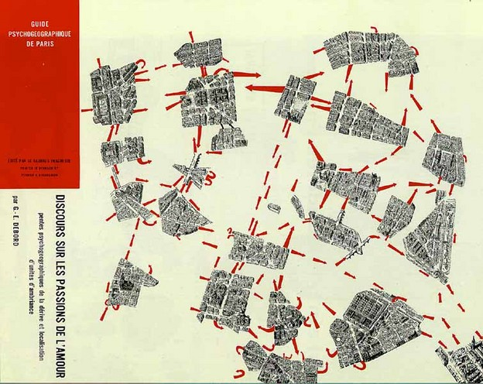
Psychogeography has strong ties with the Situationist International art movement, because this is where it was brought to life. Guy Debord had an enormous impact within the foundation of the SI and psychogeography. The work of the Situationists partly informed and inspired the huge protests and riots in Paris, in 1968. (Stracey, 2014). Through this form of protest the SI questioned what it means to trespass. By wandering a path not designated by the authorities could you violate the law, just for drifting off their course. A French anarchist said, “all property is theft” (Proudhon,1995) questioning the authority of power and ownership.
Fig. 6: Guide psychogéographique de Paris: discours sur les passions de l’amour

If you stray from the path, break the rules, you are a criminal. It is a fact that our laws decree, but should they since the laws were made by property owners? Isn’t it for our own wellbeing to question the way of things? Those who are disenfranchised by poverty or lack of wealth must break the law to establish equality because the laws are set against them? The Situationists wanted to question the ‘powers that be’. To question who decides why we should follow someone else’s path and finding ways to create their own path and determine your own way forward.

“Ephemeral by nature, graffiti is an art form that celebrates change and feeds on new ideas” (Manco, 2004, p.7). Ephemeral by definition means short lasting, fleeting in essence. Something that does not remain for long. An example of the ephemeral is graffiti, characteristically graffiti typically does not last long often due to a wide variety of reasons: for example, the local council power-washing it off walls. Due to this fact, it has made the medium of graffiti into a collector’s item especially in the case of graffiti produced by artists with prominent recognition in today’s society. The works of Keith Haring and Banksy now reside in art collections, pieces which are estimated in value in excess of millions of pounds.

“Graffiti exists in one specific place with its own particular atmosphere for a limited amount of time and then disappears” (Manco, 2004, p.9). The art world deems that this ephemeral art must be collected as its rarity increases the value. Its lack of accessibility increases the significance of the ‘must have’ commodity. Hundertmark (2003) refers to removing graffiti from its place of origin to an art gallery, in relation to the context of the urban environment, loses a part of its integrity as now it can no longer interact with its original and intended location and audience. “The kids in the park spraying the playground and leaving their mark the ones in the street shouting after dark” (Airways, 2017).

Shove (2008) brings forward the argument of what would happen if graffiti disappeared altogether? What if people chiseled off all the graffiti and sold it on eBay? People would say “Sweet that was Banksy” because they would only see the remnants of where the piece had once been, prior to removal due to the ‘collecting’ of graffiti.

Ephemerality defies conventional expectations around the preservation, display, and commodification of art and confounds the museum’s mission to preserve works in perpetuity. (Purpura 2009, p.11)

Theoretically with the presence of graffiti removed from within the urban environment it could be argued that “graffiti” can no longer hold the categorisation it once did. If it can be accepted that the role of graffiti is to provide a voice for a disempowered community by removing it from its intended context changes its meaning. Taking the graffiti from the streets changes its purpose from a political act to a commodity and by doing so nullifies it as a social protest. Through its removal, to the gallery or the art market, graffiti loses the context of the message between the city scape and the public. There is an apparent parallel between the role of the derive challenging the predetermined patterns of movement and graffiti’s ability to disrupt the dominant discourse through its compelling narrative.

Chapter 2: Activism, Authority and Power

The themes below have emerged from chapter one and will be discussed through the three subheadings activism, power and authority. It is recognized that these themes do not exist in isolation and there is inevitably a relationship between the three. However, they are presented here in order to consider a number of key points that relate and inter-relate to each theme.
Graffiti is a subculture that has continued to proliferate throughout the past fifty years and through this growth the subculture has rooted itself in many different areas and theories. These subjects have been broached in earlier chapters, here we begin to discuss the relationship between the material analysed trying to address the question - authority, power and activism: how does graffiti influence the psychogeography of the ephemeral urban environment?
It should be noted that three out of the four artists reviewed are now deceased which may not be of any significant consequence to this Independent Inquiry, but it is an interesting thought that notoriety after death increases their status. Which in turn brings up the discussion about who profits from the sale of their work, as the original creator cannot profit from the work. It is interesting to note that Banksy did not make money from the sale on his removed street graffiti that was sold at auction.
The graffiti subculture may be the only art form that truly transcends boundaries. In the world of a graffiti writer, the only thing that one is judged by is artistic skill and attitude. Race, gender, social class and age of a writer aren’t considered. (Walsh,1996, p .10)
The sub-themes, activism, power and authority have been informed by Nancy Macdonald’s (2001) book ‘The graffiti sub-culture: youth, masculinity and identity in London and New York, and serves to provide an external agenda to inform this discourse.
Activism

Graffiti has often been used as a tool for protest. For instance, Blek the Rat uses graffiti to engage the audience in a social debate. All the graffiti artists cited in this dissertation have, in some way, used their art as a form of protest. According to Walsh (1996) graffiti will always be an act of protest because graffiti is, by definition, anti-establishment (The Infographic Show, 2019). It is not always the intention of the artist to create a deliberate visual protest but through the act itself they engage in active protest. The categorisation of graffiti as protest art means that it can be a platform for people in the community, giving those without a public voice and force an engagement with the passing public and the local council even if it is simply through its systematic removal and therefore cannot be ignored (Zaimakis, 2015).

Challenging the establishment through the use of graffiti is similar to psychogeography, creating graffiti art is not risk free (Stracey 2014; McAuliffe and Iveson 2011). There are consequences for graffiti artists practicing their art form on the streets. For instance, Keith Haring was repeatedly fined and arrested.

Graffiti, a form of protest, helps inform the design of the urban environment by trying to make it better for everyone through the use of generated discussion in the community that and how over time graffiti can evolve the city scape.
Graffiti is not necessarily about improving the environment, but it is about improving society. Therefore, the act of graffiti is promoting social change by using the visual landscape to reach a large audience. Whether the government determines graffiti to be art or vandalism, is not the priority of this discussion. What matters is whether the public believe in the messages expressed and their reactions to the piece directly. What will society do with all this information? Will they engage and revolt or cast aside and cite the mantra, ignorance is bliss? Society progresses when the authorities listen to the people. As proved by Rem Koolhaas (Cheddar, 2018) through listening and understanding the will of the people you can shape the environment around you which can improve society for everyone.

Desire paths affect more than just one static environment as stated by Cheddar (2018) they also affect, and if used correctly can affect, the design of the area around us. If desire paths can be used to improve user experience on a campus, it could be argued that the same could be done with graffiti. Can we use desire paths (Nichols, 2014) to help shape the landscape to suit the community and society? To some extent, the ephemeral nature of graffiti challenges the consumerist nature of the establishment through defying its ability to be commodified (Purpura 2009).

As former ‘traditional’ graffiti artists begin to use new techniques and point in new ways it becomes more difficult to distinguish ‘street art’ and ‘graffiti’. (Manco, 2004, P.7)

King Robbo’s work is an example of traditional graffiti art. His form shows his respect for the ‘old school’ style. Banksy’s style is more inclined to cotemporary graffiti (Manco, 2004). His graffiti war with Banksy (Street Art News) where they repeatedly would ‘go over’ (Macdonald 2001) each other’s work to effectively silence the voice of the other. The conflict between the two writers, epitomised the ephemeral nature and traditions of graffiti but knowing that their work was being deliberately overlaid not only created a rift between them, it also generated conflict within the wider community as people took sides, and publicised this antagonism through the media.

Of all the work Banksy did out on the street there is often an issue around ownership. Several pieces of Banksy’s work have been removed and sold and a notable court case that explored the legal ownership of ‘Slave labour bunting boy’, which was a protest piece (The infographic Show, 2018). The debate as to whether the work belonged to the artist or the property owner of the site of the work. The piece went missing from London and turned up for sale at auction in America selling for an estimated $700,000. The London city council stated that the art belonged to them and the Banksy piece was returned. However, the London city council later sold the artwork for £1.1 million. Banksy did not profit from this (The infographic Show, 2018).
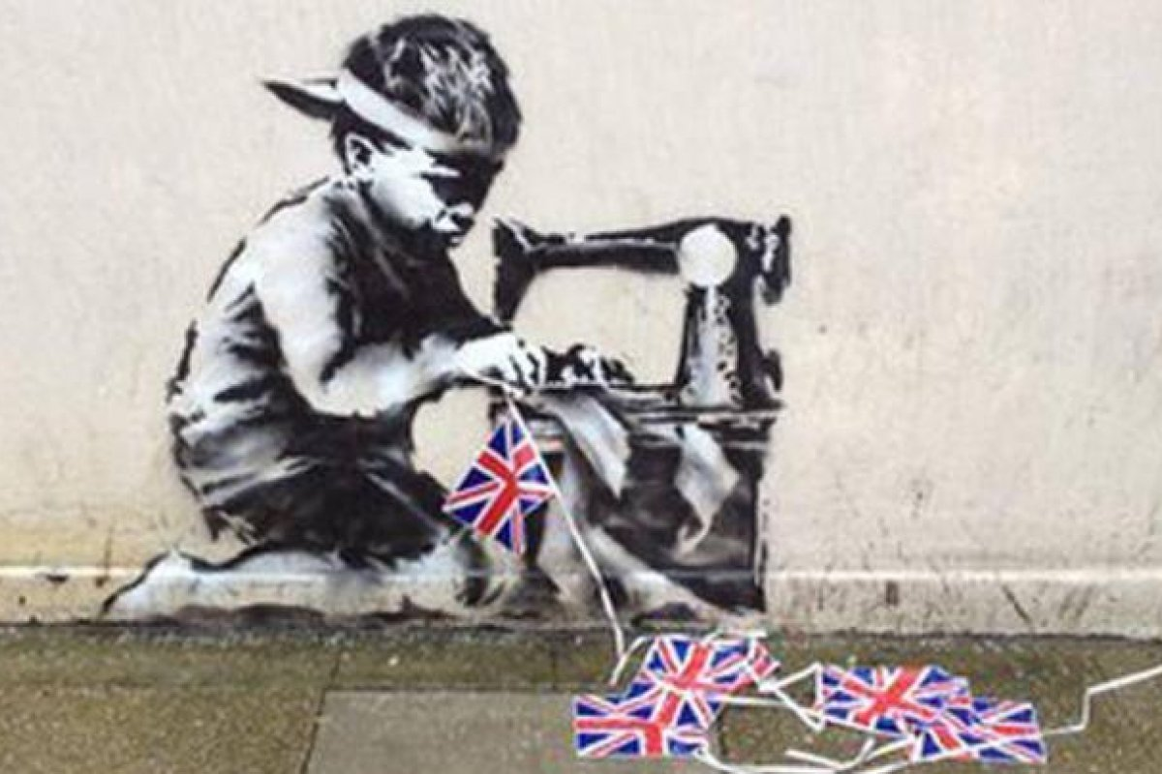
The monetary value of graffiti art is, at least in part, determined by the author of the work. An example being Banksy selling originals for sixty dollars at an art fair. Where authorship has been claimed sometime after the work has been produced has significantly raised its monetary value up to $125,000 (The Infographic Show,2018). In the definition of graffiti, it is all about leaving your mark, having your platform and being seen (Oxford Dictionary, 2019). Graffiti in the urban environment is not about making money, thereby challenging the monetisation of the ephemeral works.
Fig. 7: Slave labour bunting boy

According to Walsh (1996), as the work of graffiti artists, such as Basquiat and Haring, become accepted by the establishment, their work is collectible and commands high prices, negates the power of their work to carry a social message. This point is contested, however, in that this is not the case for all graffiti artists. Banksy, for instance, continued to use his work to carry a political message, reaching a wider audience in pieces such as Girl with Balloon (Calfas, 2018) where on purchase the work was publicly shredded, gathering even more publicity (The Infographic Show, 2018).
Everything in everyday life is dependent on the representation which the bourgeoisie had and makes us have of the relations between men and the world. (Barthes, 1972, p.139)

Markus (2013) and Bourdieu (2007) suggested high and low art create distinctions between the classes causing a hierarchy to form based on wealth, commercial value and commodification. Graffiti and street exist in almost every city, but it is not within its nature to be collected. It naturally challenges the capitalist regime with its ephemeral nature. Graffiti subverts the notions of power.

Authority

Trump is not the first President to want to build a dividing wall. President Kruschev of Soviet Russia did just that, in Berlin in 1961. The world politics of the 1960’s was dominated by the ‘Cold War’. Kruschev built a concrete wall across the divided city of Berlin to prevent ‘soviet dissidents’ from fleeing to the West. After World War II Germany was divided up by the Allies and USSR. Berlin was divided by a border, separating east and west. Many people, unhappy with the communist regime were illegally crossing the border into Berlin and migrating to European countries.
On the western side the wall became the largest canvas for graffiti in the world. The eastern wall remained as clean as the day it was put up.

It wasn’t until 1990 that the wall was taken down in part due to the political and social protest of the berlin wall which drew media attention from across the global. Parts of the wall were sold, pieces of the wall still now exist, complete with its original graffiti, in different countries around the world in military museums and exhibition centres.
The authorities have the power to make impositions on the people, but the people can subvert these impositions to challenge the authority’s agenda.

The stigmatization of graffiti has stemmed from government classification and attitudes which still remain biased because its valuation is based on notoriety and ‘success’. However, graffiti continuously appears in our environment and it cannot be silenced or ignored. The location and the piece harmonize giving context for the audience, without the context of the cityscape the piece may not communicate as powerfully. Societies values and opinions can emerge through this innovative form of protests effectively communicating the fractures and imbalance within the patriarchal systems.
Power
The benefits of wealth bestow power and if you have power you may acquire authority. The legal system benefits those with wealth, power and authority. Those who have power and authority may choose to serve their own needs in preference to the less wealthy. Democracy offers the possibility of a fair ‘distribution of wealth’. However, democracy itself is not static, it is a continuous process of communication, discussion, arguments and the ability to vote who represents you in Parliament.

Graffiti, as an element of social protest, has the power to help change society despite the strategies of the capitalist consumer market turning graffiti into yet another item to be sold. Graffiti still retains its significance within the local community and retains its influence for political and social discourse. It may well be acquired and commodified with exorbitant price tags. Its ‘success’ in the art world does not disempower its ability to consistently question authority.

Chapter 3: Concluding Statement: Communicating Impactful Social Change with Graffiti

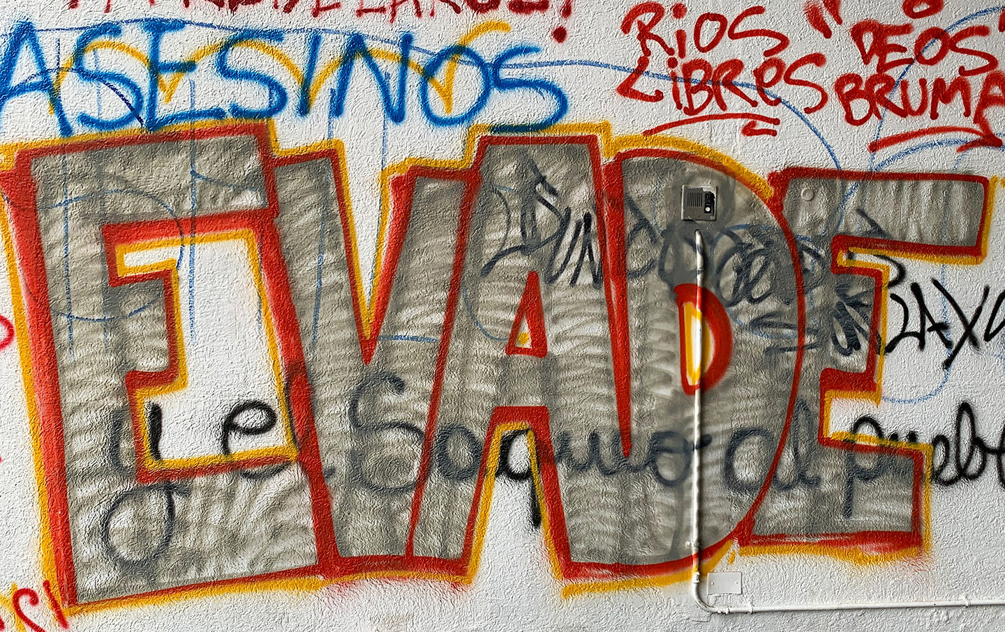
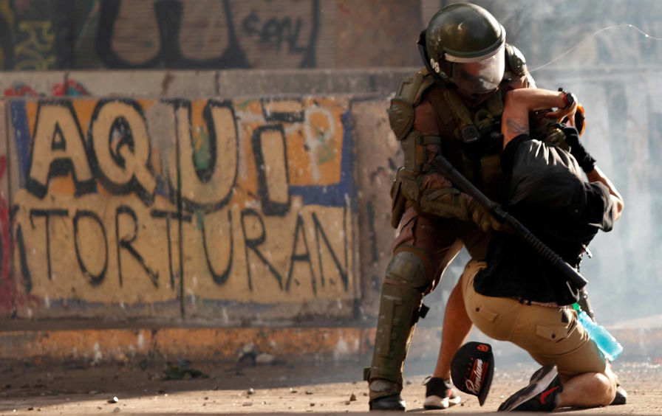
In conclusion, it can be theorised that graffiti can have both a positive and negative impact on the urban environment depending on your viewpoint about graffiti (broken window effect). If by chance you are a property owner - for example a local graffiti writer or a well-known and notorious graffiti writer can cause a reduction in property value or a rise in financial value. However, its effectiveness to communicate societal problems remain as prevalent and important all over the world today. Presently, the current protests in both Hong Kong and Chile, Santiago are highly supportive of this argument.
Fig. 8: Evade
Fig. 9: AQUI !TORTURAN!
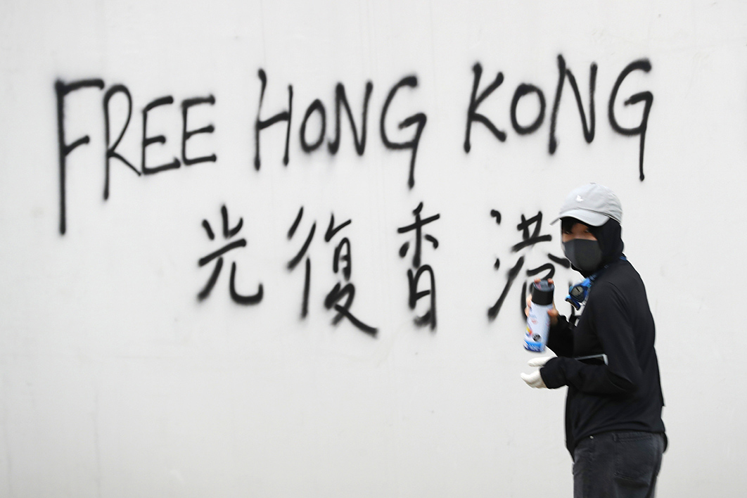
In Chile (Gordon-Zolov & Zolov,2019) the city’s government tried to sensor the graffiti “Evade” (Fig.8) but it was in vain as the protest ‘call to arms’, would not disappear from the streets. One day removed by authorities, the next day replaced by protestors. In these situations, graffiti has genuine power to challenge inequality. In Chile the peoples’ frustrations with a system that does not serve the majority of people. Protesters have been described by the Pinera government as ‘vandals’ and ‘delinquents’. Ordinary people fighting for their rights now become delinquents in the rhetoric of the government. “The effort is in vain, of course; everyday more street art goes up” (Gordon-Zolov & Zolov, 2019).
Fig. 10: Free Hong Kong

Genuine and contemporary examples of how graffiti is a bold and powerful voice, asserting the rights of ordinary people in the face of oppressive regimes, to a fair share in modern society. Graffiti has been an integral part of social protests and civil rights activism in modern times and has proven useful in in Chile and Hong Kong.
Authority determines graffiti to be an act of civil disobedience, punishable by law, the actions of political protest can have the capability to overcome the authority’s austerity measures. By harnessing the visual dexterity of graffiti, protest can have a more impactful voice. Rebelling against authority establishments to improve urban landscapes. Proving that graffiti is a powerful tool, fighting for societal improvement. Graffiti is the rhetoric of legitimate and necessary social protest.
Graffiti gives power to the people.

References:

Books:

Barthes, R. (1972) Mythologies. New York: The Noonday Press.

Birnbaum, D. & West, K. (2016) Life on Sirius: the Situationist International and the exhibition after art. Berlin: Sternberg Press.

Bourdieu, P. (2007) (translated by Richard Nice) Distinction: a social critique of the Judgement of Taste. Massachusetts: Harvard University Press.

Coverley, M. (2006) Psychogeography. Harpenden: Pocket Essentials.

Ford, S. (2005) The Situationist International: a user's guide. London: Black Dog

Hundertmark, C. (2003) The art of rebellion: world of street art. Hamburg: Gingko Press Inc.

Macdonald, N. (2001) The graffiti subculture: youth, masculinity and identity in London and New York. Basingstoke: Palgrave Macmillan.

Manco, T. (2004) Street logos. London: Thames & Hudson.

Marshall, R. (1996) Jean Michel Basquiat: King of crowns. London: Serpentine Gallery.

Powell, R.J. (1997) Black art and culture in the 20th century. London: Thames and Hudson.

Prou, S. & Adz, K. (2008) Blek le rat: getting through the walls. New York: Thames & Hudson.

Naar, J. (2007) The birth of graffiti. London: Prestel Publishing.

Shove, G. (2008) Untitled: street art in the counterculture. Darlington: Pro-Actif communications.

Stracey, F. 2014. Constructed situations: a new history of the situationist international. London: Pluto Press.

Wark, M. (2013) The spectacle of disintegration. London: Verso Books.

Walsh, M. (1996) Graffito. Berkeley, Calif: North Atlantic Books.

E-Book:

Proudhon, P.J. (1995) What is property? Gutenberg project.

Journals:

Markus, G. (2013) The Path of Culture: From the Refined to the High, from the Popular to Mass. Critical horizons, Vol. 14, Issue. 2, pp. 127-155.

McAuliffe, C. & Iveson, K. (2011) Art and Crime (and Other Things Besides …): Conceptualising Grafﬁti in the City. Geography Compass, Vol. 5, Issue. 3, pp. 128–143.

Nichols, L. (2014) Social Desire Paths: An Applied Sociology of Interests. Social Currents, Vol. 1(2), pp.166–172.

Zaimakis, Y. (2015) Welcome to the civilization of fear’: on political graffiti heterotopias in Greece in times of crisis. Visual Communication, Vol. 14(4), pp.373–396.

Song:

Airways. (2017) White Noise Boys. Peterborough: 569825 Records DK.

Websites:

Aristotle. (2008) Quotable quotes. Available at: https://www.goodreads.com/quotes/63444-poverty-is-the-parent-of-revolution-and-crime?page=8 (Accessed: 3 December 2019).

Ask the police. (2019) Q572: What is the law with regards to graffiti? Available at: https://www.askthe.police.uk/content/Q572.htm (Accessed: 3 December 2019).

BBC News. (2014) Veteran graffiti artist King Robbo dies aged 45. Available at: https://www.bbc.co.uk/news/uk-england-london-28605694 (Accessed: 19 November 2019).

BBC Radio 4. (2019) Blek le Rat. Available at: http://www.bbc.co.uk/radio4/today/galleries/3253/4/ (Accessed: 3 December 2019)

Calfas, J. (2018) Banksy Shredded a Piece of Art That Sold for $1.4 Million. Now It's Worth Double, According to an Art Expert. Available at: http://money.com/money/5418695/banksy-girl-with-a-balloon-self-destruct-double/ (Accessed: 19 November 2019).

Gordon-Zolov, T. & Zolov, E. (2019) The walls of Chile speak of suppressed rage. Available at: https://www.thenation.com/article/chile-protest-art/ (Accessed: 2 November 2019).

Laing, O. (2017) Race, power, money – the art of Jean-Michel Basquiat. Available at: https://www.theguardian.com/artanddesign/2017/sep/08/race-power-money-the-art-of-jean-michel-basquiat (Accessed: 8 November 2019).

Martin, G. (2017) Blek le Rat – an inspiration. Available at: https://medium.com/@GlennNetworks/blek-le-rat-an-inspiration-c7c4c88166c7
(Date Accessed: 28 November 2019).

Tate. (2019) Keith Haring. Available at: https://www.tate.org.uk/whats-on/tate-liverpool/exhibition/keith-haring (Date Accessed: 15 September 2019).

Unknown. (2013) Holy Shit, Ancient Graffiti. Available at: http://holyshitthatsinteresting.blogspot.com/2013/04/holy-shit-ancient-graffiti.html (Date Accessed: 2 December 19).

YouTube Videos:

Ben, B. (1983) Style Wars. [Documentary]. Available at: https://www.youtube.com/watch?v=r4jniA9QsNI&list=WL&index=124 (Accessed: 15 October 2019).

Cheddar. (2018) How Footpaths Help Shape Our Technology - Cheddar Explains. Available at: https://www.youtube.com/watch?v=LN6_S5_FE3o (Accessed: 30 October 2019).

StreetArtNews. (2016) Robbo vs Banksy “Graffiti Wars” Full. Available at: https://www.youtube.com/watch?v=S9CdAS3dORg (Accessed: 7 October 2019).

The Infographics Show. (2018) How does Banksy make money? Available at: https://www.youtube.com/watch?v=8QS-HN1Wfyg&t=2s (Accessed: 19 November 2019).

List of Figures:

Figure 1: Anonymous (79 C.E) Lucius Pinxit [ Painted on wall in Pompeii ] Available at:http://www.pompeiiinpictures.com/pompeiiinpictures/R2/2%2002%2002%20p9.htm (Accessed: 2 December 2019).

Figure 2: Basquiat, J. (1980s) SAMO is DEAD [ Spray paint on wall ] Available at: https://www.stencilrevolution.com/blogs/profiles/jean-michel-basquiat (Accessed: 2 December 2019).

Figure 3: Haring, K. (1980s) Untitled subway drawing [ Chalk on black paper ] Available at: https://publicdelivery.org/keith-harings-subway-drawings/ (Accessed: 2 December 2019).

Figure 4: Rat, L. B. (1990s) Rats [ Spray paint on wall ] Available at: https://medium.com/@GlennNetworks/blek-le-rat-an-inspiration-c7c4c88166c7 (Accessed: 2 December 2019).

Figure 5: Robbo, K. (1985) Untitled [ Spray paint on wall ] Available at: https://www.bbc.co.uk/news/uk-england-london-28605694 (Accessed: 2 December 2019).

Figure 6: Debord, G. & Jorn, A. (1956) Guide psychogéographique de Paris: discours sur les passions de l’amour [ Screen-printed map] Available at: https://thedesignedplace.wordpress.com/2012/10/23/theory-of-the-derive/ (Accessed: 2 December 2019).

Figure 7: Banksy. (2012) Slave Labour Bunting Boy [spray paint on wall] Available at: https://www.scmp.com/news/world/article/1154136/banksy-slave-labour-bunting-boy-london-2012-put-auction (Accessed: 3 December 2019).

Figure 8: Unknown. (2019) Evade [Spray paint on wall ] Available at: https://www.thenation.com/article/chile-protest-art/ (Accessed: 2 December 2019).

Figure 9: Unknown. (2019) AQUI !TORTURAN! [Spray paint on wall ] Available at: https://www.thenation.com/article/chile-protest-art/ (Accessed: 2 December 2019).

Figure 10: Unknown. (2019) Free Hong Kong [Spray paint on wall] Available at: https://insidestory.org.au/how-beijing-sees-hong-kong/?fbclid=IwAR3M6L6n1gRMNov0201q8g44n1gYc3Qk6_3htQFUrlMlrWsSNuD-wa94bkc (Accessed: 2 December 2019).

