Connor McGuinness
1803076

Engine Performance Testing

Powertrain Technology
Abi Summerfield
M4X02196
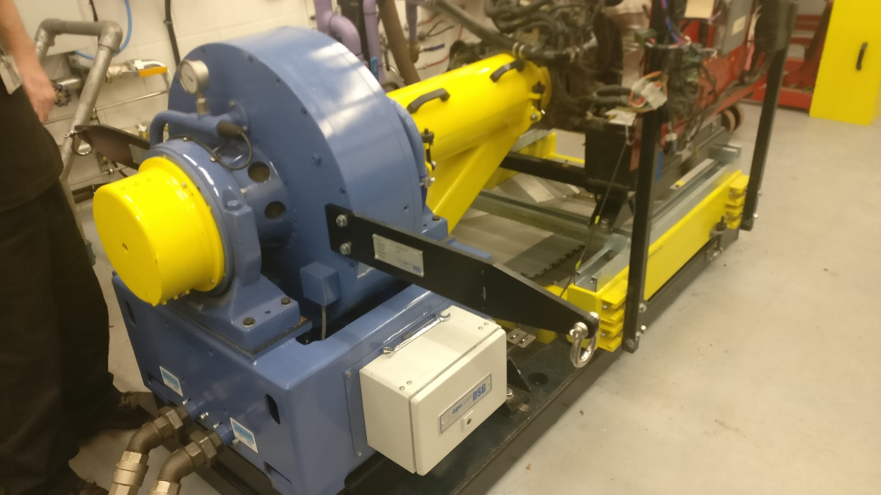

Contents
Table of Contents
Engine Performance Testing 1
Contents 2
List of Figures 3
1.0 Introduction 4
2.0 Experimental Procedure 5
3.0 Results 6
4.0 Analysis 8
5.0 Conclusion 13
6.0 Evaluation 14
7.0 Further Work 15
8.0 References 16
Appendices 17

List of Figures
Table 1 : A Graph to Show Torque Against Engine Speed 10
Table 2 : Graph to show Brake Power Against Engine Speed 11
Table 3 : A Graph Showing Torque and Power Against Engine Speed 11
Table 4 : Graph to Show SFC Against Engine Speed 12
Table 5 : A graph Showing SFC against Engine Speed 12

1.0 Introduction
  - 1.1 – Background
This test involves using an engine dynamometer test to obtain data on the load acting on the engine, the engine speed and fuel consumption of a throttle opening of 100%. With the raw data, calculations should be made to get the corrected power, torque, BMEP, and the thermal efficiency of the engine. Graphs should be made to show specific fuel consumption against engine speed, torque against engine speed and brake power against engine speed.
  - 1.2 – Aims
The aims of this test are to relate research done to the calculated results and graphical data and comment on why the values vary as they do. Knowledge of the underlying principles of engine and vehicle technologies for analysis powertrain systems should be gained from this test. Knowing how to operate an engine dynamometer and know how to interpret the data.

2.0 Experimental Procedure
The following is a step-by-step guide on how to use the engine diagnostics machine to carry out this test.
- The dyno has calibrator arms that can be fitted to either side of the dyno with two bolts on both sides. Use a 13mm spanner to tighten these bolts.
- Using a computer start the DETAQ software.
- Start the engine, using manual control, control the engine speed and the load on the engine using the dials.
  - Using the dials one can increase the engine speed and the load on the engine at different rates. Although, while doing this, there is a chance of stalling the engine.
- Programme a sweep and a step test. The Step test give more detailed results, thus it shall be used for this test.
- The step test should start at a certain rpm and end at a certain rpm while recording data, e.g. every 50 rpm.
- After the test has completed, the DETAQ software that the dyno uses brings the engine back down idle.
- Stop the engine, take off the calibrator arms. The recorded data from the dyno will be used to calculate different values such as, torque, brake power, corrected power, specific fuel consumption, BMEP and brake thermal efficiency.

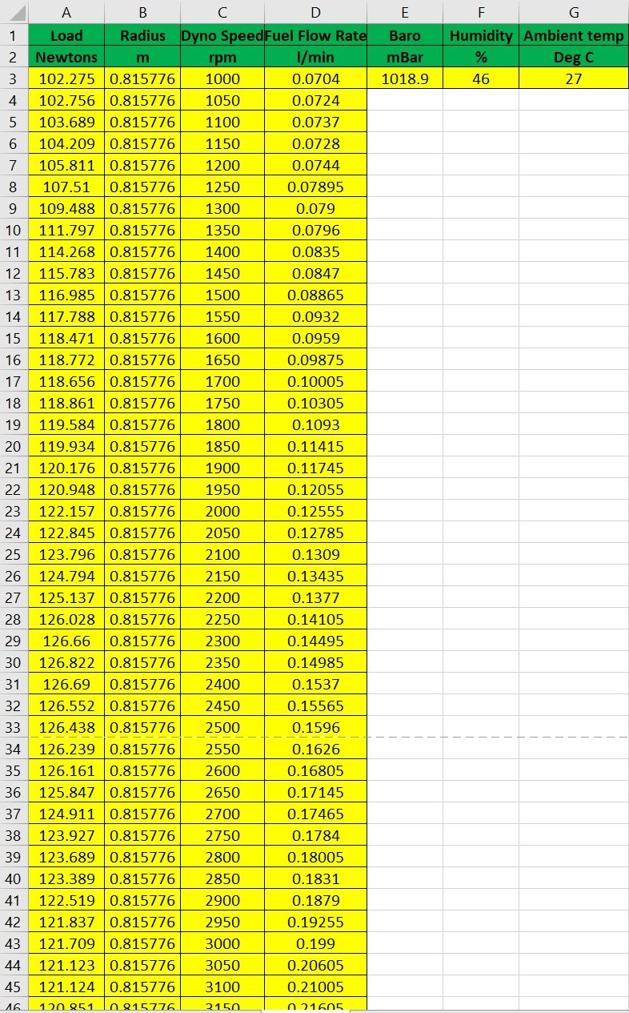
3.0 Results
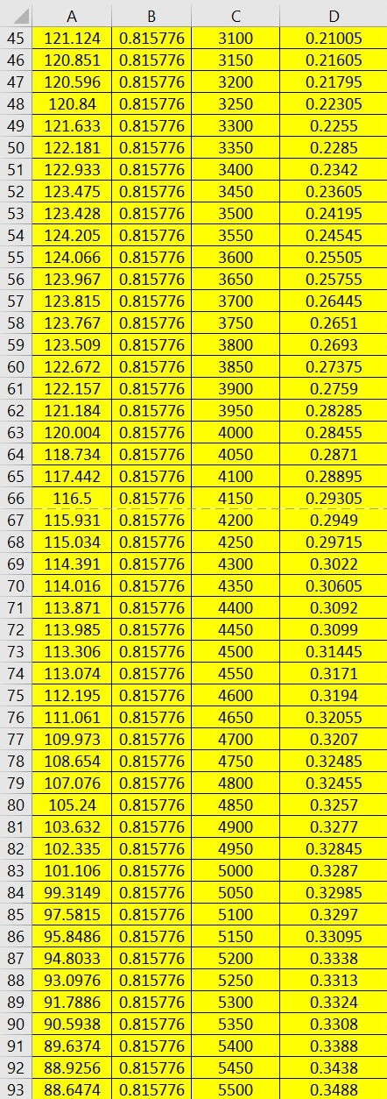

4.0 Analysis
W | Load – Measured in Newtons (N)
R | Radius – Measured in meters (m)
T | Torque – Measured in Newton meters (Nm)
N | Engine Speed – Measured in rpm (rpm)
BP | Brake Power – Measured in Watts (W)
$$P_{s}$$ | Corrected Power – Measured in Watts (W)
V | Fuel Flow Rate – Measured in Litres per minute (l/min)
SFC | Specific Fuel Consumption – Measured in kg/KWhr)
Ta | Ambient Temperature – Measured in °C
Pa | Pressure – Measured in millibars (mBar)
d | Bore – Measured in metres (m)
L | Stroke – Measured in metres (m)
A | Area – Measured in metres squared ($m^{2}$)
n | No. of Cylinders
BMEP | Brake Mean Effective Pressure
$$η_{t}$$ | Brake Thermal Efficiency as a Percentage (%)
4.1 - Formulae and Calculations

The following formulae are used:
- To carry out the following calculations these values should be known;
  - Load, engine speed, fuel flow rate, radius of torque arm, temperature, pressure, bore, stroke and the calorific value of the fuel.

$T=WR$
- A graph should be made to show torque against engine speed.
$BP=\frac{2πNT}{60}$
$\frac{P_{s}}{BP}=\frac{1.01325}{Pa}\sqrt{\frac{T_{a}}{293}}$
- Rearrange this formula to make corrected power the subject of the formula.
$P_{s}=\frac{1.01325}{Pa}\sqrt{\frac{T_{a}}{293}}(BP)$
- A graph should be made to show engine power against engine speed.
$SFC=\frac{V\left(0.75\right)\left(3600\right)}{t\left(1000\right)\left(BP\right)}$
- Multiply this by the specific gravity of fuel to convert into kg/min.
- Multiply by 60 to convert into kg/hr.
- Divide by brake power(kW) to convert into kg/kWhr.
- A graph should be made to show SFC against engine speed.
$A=\frac{πⅆ^{2}}{4}$
$$BP=\frac{BMEP\left(L\right)\left(A\right)\left(N\right)\left(n\right)}{60\left(2\right)}$$
- Rearrange this formula to make BMEP the subject of the formula.
$$BMEP=\frac{BP(60)(2)}{(L)(A)(N)(n)}$$

$η_{t}=\frac{\left({BP}/{1000}\right)}{SFC\left(\frac{kg}{sec}\right)\left(CV\right)}$

- The calorific value of the fuel used should be researched for this calculation.
- Multiply the number given by 100 to give a percentage.
The numerical data gathered from these calculations can be found in the appendices on pages 17-18

4.2 - Graphical Data
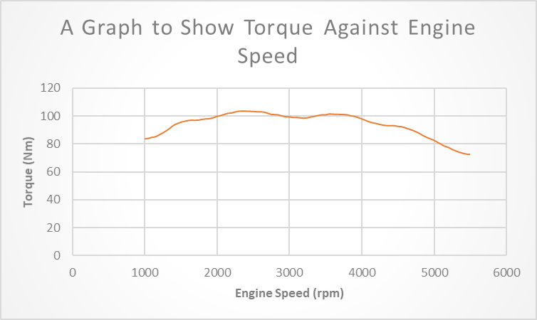

Table 1 : A Graph to Show Torque Against Engine Speed

The data in Table 1 above displays a torque-engine speed curve. A seen on the graph, the higher the engines speed, the higher the torque to a certain point, then the torque stars to decrease. The Low-End-Torque zone can be found at the lower engine speeds on the graph. From the torque increasing at low engine speeds, one can conclude that the vehicle can start moving from stand still quickly. Torque is needed to get a vehicle to move from stand still or moving at slow speeds such as in traffic because it has little or no momentum.
The middle of the graph where the torque is somewhat steady is called the power band. For the best vehicle performance during acceleration maximum engine power should be used for shifting up in gears. During an up-gear shift, the engine speed drops while at maximum torque giving an ideal acceleration.
The end of the graph where the torque drops at high engine speeds is called high-end torque zone. The decrease in torque is because if the resistance from the road increases, the torque increases due to the load, but if at max torque already the engine will stall. Another name for this stage of the graph is the stable torque region.

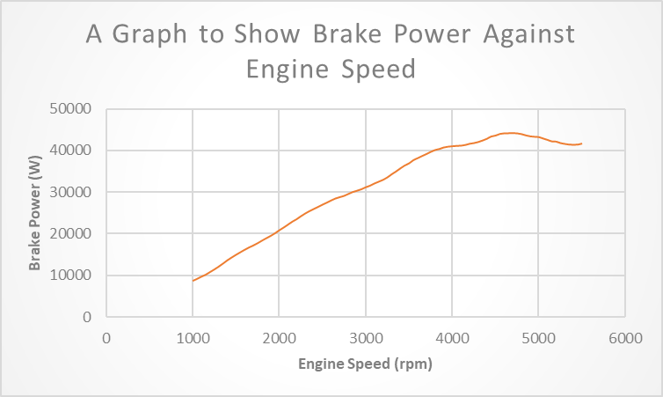

Table 2 : Graph to show Brake Power Against Engine Speed
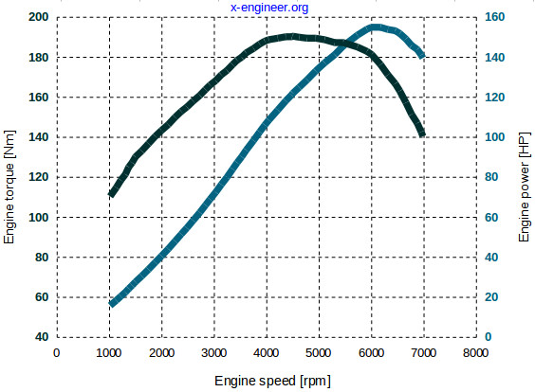
The data in Table 2 above displays a Brake Power-engine speed curve. From the calculation of brake power, one can already see that brake power is dependent on torque and engine speed. Knowing this, similarities can be seen from the torque and brake power graphs. The fluctuations in Table 1 occur around the same time variations can be seen on the curve in Table 2. Thus, one can assume if more power is needed, this can be achieved by increasing the torque or the engine speed.
Table 3 : A Graph Showing Torque and Power Against Engine Speed
Similarities can be seen between Table 3 and Table’s 1 and 2. The power and torque can be seen decreasing at roughly the same time, proving that there is a relationship between power, torque and engine speed. The fluctuations also occur around the same time in Table 3 showing that the increase in torque effects the increase in power. There is a difference in the max engine speed, due to the fact the test is using a better engine dynamometer and a bigger sized engine than the ones used in this investigation.

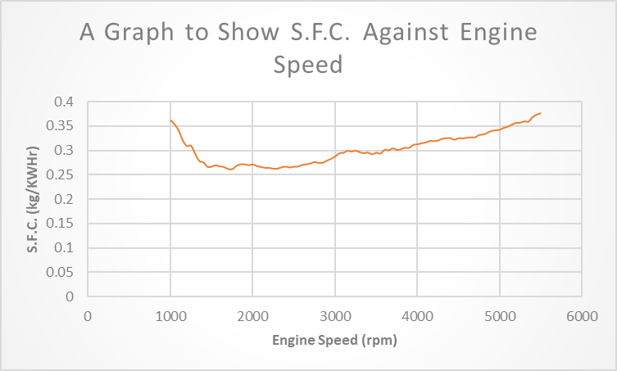
Table 4 : Graph to Show SFC Against Engine Speed

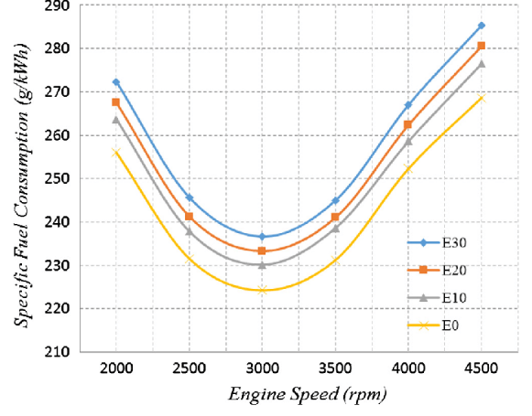
The data in Table 4 displays an SFC-engine speed curve. Relating Table 4 to Table 1, one can see that there is a decrease in SFC when there is an increase in torque. From the graph, it is shown that at the decrease in SFC there is higher load on the engine. During this period the throttle tends to be more open. Relating Tables 4 and 5, one can see the there is a better specific fuel consumption when the engine is undergoing higher louds, thus making the overall efficiency better.
Table 5 : A graph Showing SFC against Engine Speed

5.0 Conclusion
A good understanding of how to use an engine dynamometer is gained from executing this engine performance testing. This includes how to programme both step and sweep test thus knowing the differences between the two and knowing the advantages and disadvantage of the two. This outcome of this test follows previous reports and other tests, proving that the test was a success. The DETAQ software that the dyno uses can do all the calculations used in this investigation and also make graphs with those values from the calculations, but for the purpose of this investigation, gaining the knowledge of what the engine dynamometer gives a greater understanding of what the dyno actually measures. One can also use the data gained from the dyno to partially diagnose an engine.

6.0 Evaluation
- Possible errors during this investigation involve over fuelling the engine at the start of the step test.
- This investigation could have also been executed by programming a sweep test. A sweep test is similar to the step test where is starts at a certain rpm and takes measurements in increments, e.g. every 50 rpm. The step test takes data points every 50 rpm and keeps the engine at that rpm and takes a steady reading while the sweep test continues to increase the engine speed. The testing phase is faster for the sweep test, there is no overheating but there is less resolution of data.

7.0 Further Work
Ideally with infinite money and time, this investigation would involve testing multiple engines, multiple times and with different fuels. A better engine dynamometer would be used to gather more accurate results. A climate control rig would be used to keep the temperature, humidity and pressure the same throughout all the testing phases. This would make differences between engines easier.

8.0 References
1) x-engineer.org. (2016). Power vs Torque. [online] Available at:
https://x-engineer.org/automotive-engineering/internal-combustion-engines/performance/power-vs-torque/
[Accessed 3 Jan 2020]
2) kurz.com. (2019) Understanding the Relationship Between RPM and Torque. [online] Available at:
https://kurz.com/understanding-relationship-between-rpm-torque/
[Accessed 3 Jan 2020]
3) world-nuclear.org. (2018). Heat Value of Various Fuels. [online] Available at
https://www.world-nuclear.org/information-library/facts-and-figures/heat-values-of-various-fuels.aspx
[Accessed 3 Jan 2020]
4) researchgate.net. (2017). Applied Thermal Engineering. [online] Available at:
https://www.researchgate.net/figure/Specific-fuel-consumption-in-relation-to-engine-speed_fig9_315886056
[Accessed 3 Jan 2020]
5) Frisco, D.F. (2014) A study of Brake Thermal Efficiency and BSFC of Diesel Engines. Italy: University of Padova.
6) Basile, A., Iulianelli, A., Dalena, F. and T Nejat Veziroğlu (2019). Ethanol : Science and Engineering. Amsterdam, Netherlands: Elsevier.

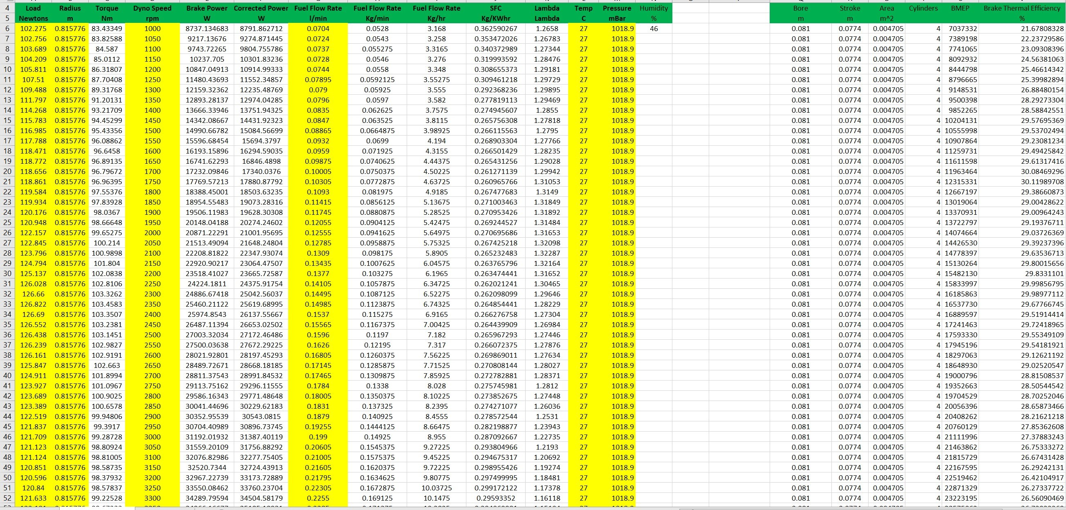
Appendices


