ACDA6020 LAB #2

FT-IR ORGANIC TESTING

REPORT IS DUE NOVEMBER 02, 2023

submitted via MOODLE as ONE .doc file

The maximum mark available is 50 points and it is based on the accuracy of your observations and discussion.
Correct observations and their analysis are worth 25 points and up to 25 points are for properly structured and detailed report.
Remember to provide a list of supporting literature.
Up to 3 points will be deducted for errors in referencing style.
Up to 2 point will be deducted for unprofessional presentation, e.g. the scan is not cropped, original document is creased, text impossible to read, etc.

ATTACH THE ORIGINAL DATA SHEET !!!

Guidance for lab report:
- Title page, TOC, etc
- Purpose (Aim) of the experiment, max 130 words
  - Indicate the laboratory’s topic
  - List the main tasks
- Hypothesis: based on the previous experience and knowledge, what do you expect to observe? Why?
- Variables: independent, dependant, controlled
- Theory (Background information) supported by literature, max 300 words
  - Basic concepts, principles and laws, definitions
  - Chemical equation and formulas for calculations
  - Applications/importance of the method and technique in OME
- Chemicals and equipment
- Procedure, max 100 words
- Observations/Data (as of the Data Sheet provided below)
- Calculations
- Results and Discussion: How do the observations compare to your hypothesis — do they match? What are primary sources of experimental errors? max 200 words
- Conclusion, max 100 words
- References (IEEE)

FTIR Organic Testing
Introduction
FTIR (Fourier Transfer Infra Red Spectroscopy) is an analytical technique specialised in the qualitative analysis of organic compounds. The technique is widely used in multiple industries such as pharmaceuticals, forensics, ecology, motorsports, defence and healthcare.
The technique is based on the excitement and vibration of bonds between organic elements, these bonds will absorb a certain amount of energy from a directed infra-red beam, what is left over or emitted is characteristic of that bond – giving us an idea of identification.
FTIR works best on organic, non-reflective samples and thus is not suitable for the analysis of metals. This is partially due to the type of bonds that metals create with other elements (that of ionic bonding). The FTIR excels at plastics, oils, medications and organic explosives/ propellant traces.
In OME FTIR is an excellent tool for the analysis of the organic components of an explosive device (primarily nitrates but also long chain hydrocarbons and alcohols). This can be particularly useful for analysing environmental damage left from poorly stored munitions, intelligence gathering from IEDs or homemade explosives and for analysing components from recovered foreign munitions.
Briefing
To outline the effectiveness of the FTIR and the capabilities of the equipment, you are given the following scenario.
“During a raid on a suspected terrorist cell in the UK, a large amount of apparent bomb-making equipment was found, alongside this equipment was discovered evidence to suggest that these were designed to disseminate a finely grained white powder into the atmosphere (of which many bags were found strapped to completed devices). The white powder seems to originate from large packs of tablets. The relatively low amount of actual explosives found strongly indicates a delivery method rather than the explosives being the primary method of causing damage. Due to the lack of protective equipment found it is surmised that the idea behind these is a testbed or proof of concept for the dispersal device.”
You are tasked with finding out what the powder is via FTIR to enable this intelligence to be put into a report to the home office.
Method
You are given a small sample of the pills that were located alongside the devices designated A B and C. Crush the pills in the mortar and pestle provided into a fine powder and transfer to a plastic weigh boat.
Take the weigh boats to the FTIR, ensure the machine is setup with the following specifications
- Absorption mode
- 10 scans
- 10 seconds duration per scan
Once this has been confirmed, clean down the machine with IPA and blue roll. Once cleaned then you may begin the test proper.
Take a background scan to eliminate background contamination from the sample. Add your first sample to the sample UATR unit and clamp down. Once clamped, name the new sample and run a scan.
Observe the peaks and note down anything you feel is important (large peaks, broad, narrow etc).
Repeat until all samples are done, you should aim for 3 repeats of each sample.
Save a picture of your spectra lines.
Begin to identify the peaks and then the functional groups in the general and fingerprint zones.
After you have identified key functional groups and peaks you will then use the library function to find out if the sample can be identified from existing spectra in the database.

Results
Results table
Sample ID | Key general peaks/ functional groups | Key Fingerprint peaks/ functional groups

Questions/ Discussion
Explain in further detail how the FTIR gets readings from the samples presented.
……………………………………………………………………………………………………………………………………………………………………………………………………………………………………………………………………………………………………………………………………………………………………………………………………………………………………………………………………………………………………………………………………………………………………………………………………………………………………………………………………………………………………………………………………………………………………………………………………………………………………………………………………………………………………………………………………………………………………………………………………………………………………………………………………………………………………………………………………………………………………………………………………………………………………………………………………………………………………………………………………………………………………………………………………………………………………………………………………………………………………………………………………………………………………………………………………………………
Why is there a general and fingerprint zone on the spectra?
…………………………………………………………………………………………………………………………………………………………….………………………………………………………………………………………………………………………………………………………………………………………………………………………………………………………………………………………………………………………………………………………………………………………………………………………………………………………………………………………………………………………………………………………………………………………………………………………………………………………………………………………………………………………………………………………………………………………………………………………………………………………………………………………………………………………………………………………………………………

What sort of elements/ compounds are not suitable for FTIR analysis – suggest an alternative analysis for explosive residues and justify your choice.
………………………………………………………………………………………………………………………………………………………………………………………………………………………………………………………………………………………………………………………….……………………………………………………………………………………………………………………………………………………………………………………………………………………………………………………………………………………………………………………………………………………………………………………………………………………………………………………………………………………………………………………………………………………………………………………………………………………………………………………………………………………………………………………………………………………………………………………………………………………………………………………………………………………………………………………………………………………………………………………………………………………………………………………………………………………………………………………………………………………………………………………………………………………………………………………………………………………………………………………………………………………………………………………………………………………………………………………………………………………………………………………………………………………………………………………………………………………………………

Identify the main group peaks (present in all samples, inc approx. numbers) from the firearm discharge residue spectra provided using the table provided below.
…………………………………………………………………………………………………………………………………………………………………………………………………………………………………………………………………………………………………………………………………………………………………………………………………………………………………………………………………………………………………………………………………………………………………………………………………………………………………………………………………………………………………………………………………………………………………………………………………………………
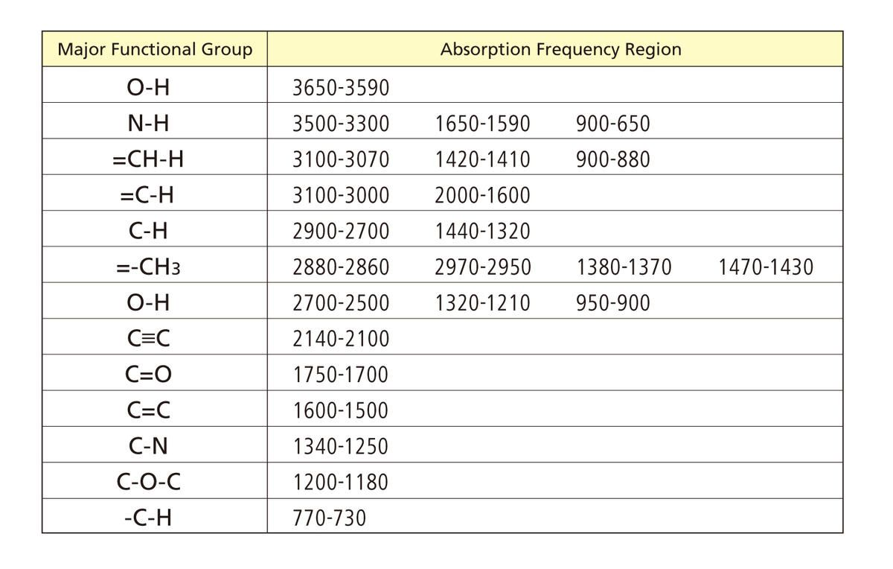

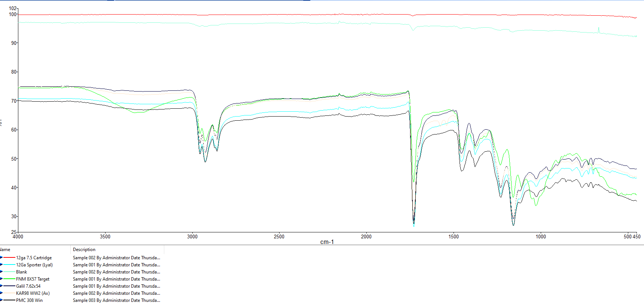
You are now to write up the experiments results, you are required to highlight specific bonds of interest and if your analysis matches up with what has been found by the library. Do you agree with the suppositions presented? Explain why. Please also discuss why FTIR is suitable for this investigation and deliver your recommendations for further analysis.
This should be written as if it was going to a non-specialist who is expected to understand your findings.

