  University Of Wales Trinity Saint David | Introduction to Web and Database Concepts (ACCA4023_LON)  Name: Damian Szast  Student ID: 2513630  Due Date: 24 March 2026  Lecturer: Abida Perveen

Contents:

Implementation 3
Entity-Relationship Diagram (ERD) 4
Normalisation Compliance 6
Query Development 8
Validation and Testing 11
Forms and Reports 13
Reflection 16
Conclusion 17

Implementation
Scenario Description: MediLink Pharmacy manages medicines, prescriptions and customer details manually. As data is manually added and edited, errors and inefficiencies occur [1]. Microsoft Access is a good was to automate stock control, prescription management, sales transactions and supplier tracking [2].
The main objectives are to track inventory – expiry dates and low stock. Access can maintain customer details, Supplier information and create reports to control stock.
This DBMS will ensure that there are no inconsistencies with data. It will also make data entry much easier, with its forms, queries and reports [2].
By using a system like Microsoft Access, efficiency can be improved compared to manual systems, as there is less likelihood of human error. In addition, the ability of the system to link different parts of the system, such as the stock control system and the prescriptions system, can help with organisation.
The benefits will include:
Reduced errors and improved accuracy.
Efficient inventory and sales tracking.
Enhanced customer service.
Support for regulatory compliance.
______________________________________________________________________________
- Scenario Analysis
Entities: Stock, Suppliers, Medicines, Customer, Customer Prescription.
- Stock Attributes: StockID, MedicineID, StockLevel, ReorderLevel
Relationship:
Each Stock item refers to one Medicine (1 Medicine → many Stock records)

- Suppliers Attributes: SupplierID, SupplierName, Phone, Email, Address
Relationship:
One Supplier supplies many Medicines - Suppliers 1 → ∞ Medicines

- Medicines Attributes: MedicineID, MedicineName, Category, Description, UnitPrice, SupplierID
Relationship: Each Medicine is supplied by one Supplier. Each Medicine can appear in many prescriptions

- Customer Attributes: CustomerID, FirstName, LastName, DateOfBirth, Phone, Email
Relationship: One Customer can have many Prescriptions
Customer 1 → ∞ Prescriptions

- Customer Prescription Attributes: PrescriptionID, CustomerID, MedicineID, DoctorName, IssueDate, DosageInstructions
Relationship: Each Prescription belongs to one Customer. Each Prescription may include one or more Medicines
Identify and describe the main entities involved in the scenario, detailing their attributes and the relationships connecting them

Entity-Relationship Diagram (ERD)
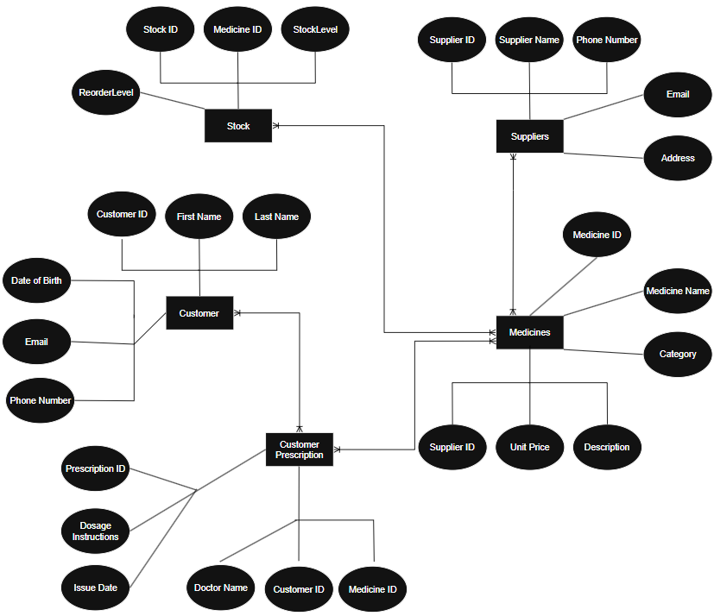

Data structure Development
tblCustomer:
CustomerID – autonumber
FirstName - Short Text
LastName - Short Text
Phone - Short Text
Email - Short Text
DOB - Date/Time

tblCustomerPrescription:
PrescriptionID – autonumber
CustomerID - Number
MedicineID - Number
DoctorName - Short Text
IssueDate – Date and Time
DosageInstructions – Long Text

tblMedicines:
MedicineID – autonumber
MedicineName – Short Text
Category - Short Text
Description - Short Text
UnitPrice – Currency
SupplierID– Number

tblStock:
StockID – Autonumber
MedicineID – Number
StockLevel– Number
ReOrderLevel – Number

TblSuppliers:
SupplierID – autonumber
SupplierName – Short Text
Phone - Short Text
Email- Short Text
Adress – Short Text

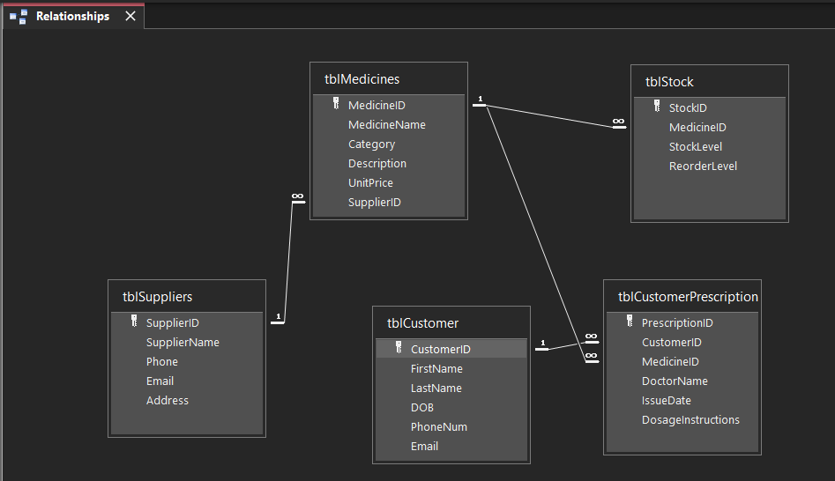

The ERD shows the main entities used in the MediLink Pharmacy database. It includes Customers, Medicines, Suppliers, Stock and Customer Prescriptions. Every entity has its own attributes and a primary key to easily identify records. The relationship was linked to show how the entities connect.

E.g One supplier can have many medicines

Relationships like this help connect data together which enforces the database structure.

Normalisation Compliance
I normalised “The MediLink” pharmacy to Third Normal Form (3NF). I done this to reduce redundancy and improve data integrity.

1NF: All the data is stored in atomic values with no repeating groups. Every medicine and prescription is in a separate record and doesn’t have lots of values in one field. Every table has a Primary Key e.g. CustomerID

2NF: Every Non key attribute fully relies on the Primary Key. MedicineID has attributes like MedicineName, Category and UnitPrice. Those depend on the MedicineID being there. This ensures there are no partial dependencies.

3NF: Data is separated to avoid duplication. For example, supplier details are stored only in the Suppliers table and linked using SupplierID. Instead of being repeated in the Medicines table. Also, UnitPrice is stored only in Medicines and not in Stock.

This database is now in 3NF and only depends on the Primary Key which reduces redundancy. This also helps the data to be consistent and accurate for the whole pharmacy system.

Sample Data Population
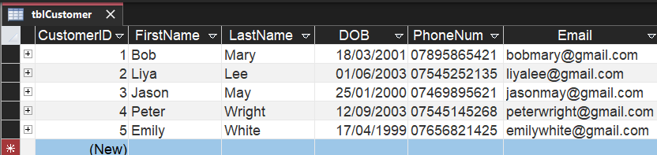

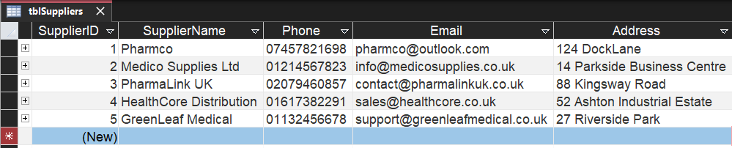

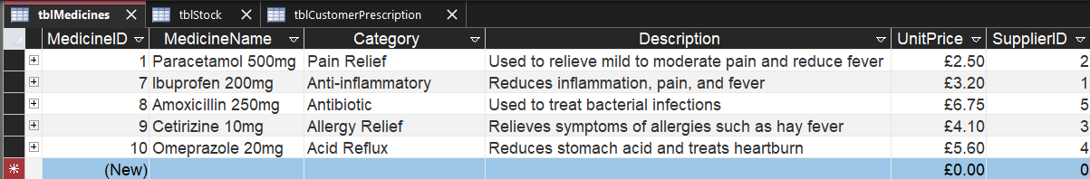

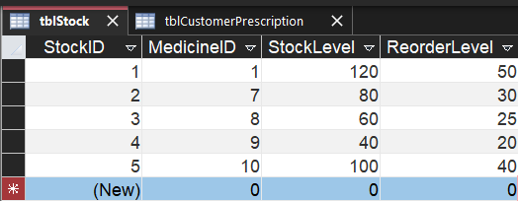

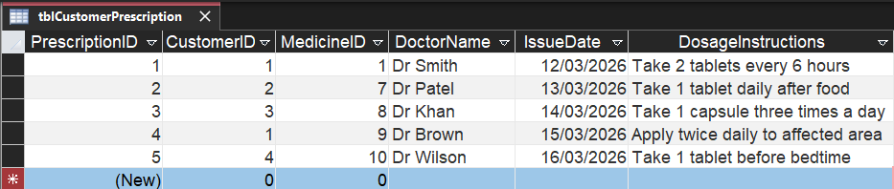

Query Development
The queries are applicable in a real pharmacy as they will aid in decision-making. For instance, the low stock query will enable pharmacy staff to easily identify which medications to restock. This prevents stock outages. The customer prescription queries will enable pharmacists to easily access customer information, hence enhancing customer service. Overall, the queries are beneficial as they enhance efficiency through easy access to critical information.
Query 1:
This query shows what medicines running low and what needs ordering.
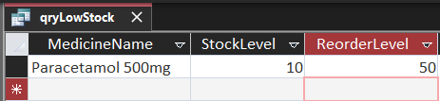
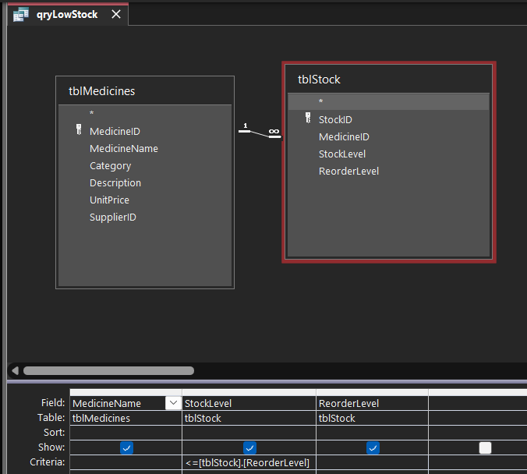
Query 2:
This query shows all medicines with their suppliers, allowing the pharmacy to track which supplier provides each medicine.
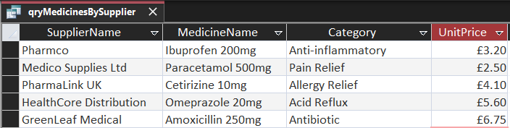
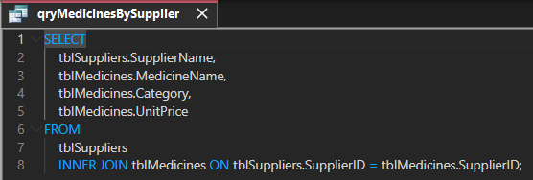
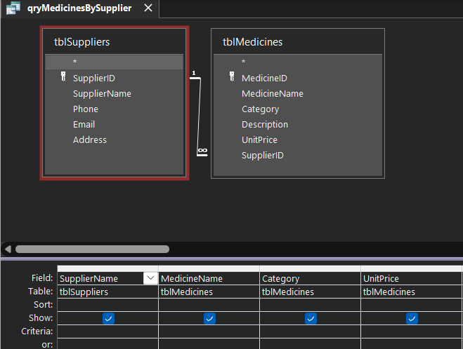

Query 3:
This query shows the customers prescription details. This includes the customer name, prescribed medicine, doctor and issue date. It helps manage and review patient prescription history.
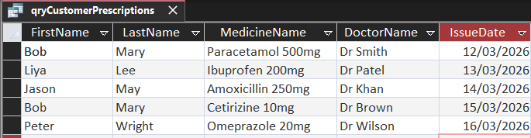

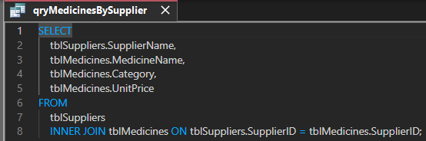
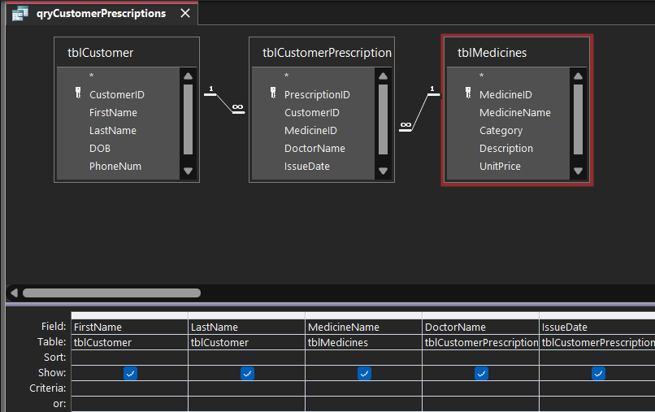
Query 4:
This query allows the user to enter a CustomerID and view all prescriptions for that specific customer. It provides a quick way to access an individual patient’s prescription history.
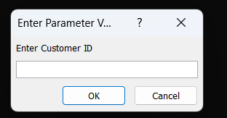

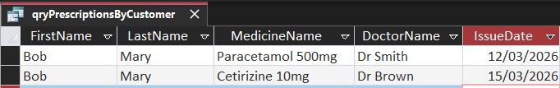

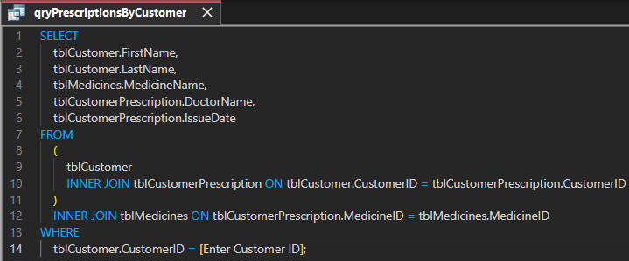
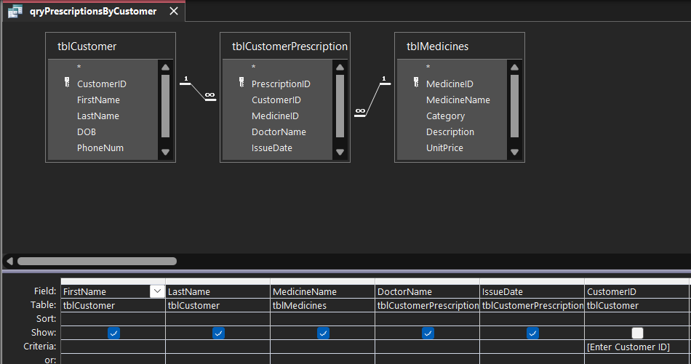

Validation and Testing
My database was tested by adding a range of different valid and invalid data. This was done to ensure that the rules and data types were working correctly. Queries were also run to confirm that accurate results were returned. Relationships were tested by attempting to enter invalid foreign key values to ensure referential integrity was enforced.

Test Case | Action | Expected Result | Actual Result
Valid Customer Data | Enter correct name, phone, email | Data saved successfully | Passed
Invalid Data Type | Enter text in StockLevel | Error message | Passed
Missing Required Field | Missing Required Field | Record not saved | Passed
Low Stock Query | Run qryLowStock | Shows only low stock items | Passed
Relationship Test | Enter invalid MedicineID in prescription | Access prevents entry | Passed

Validation
Validation was applied using appropriate data types such as Number, Short Text and Date/Time. The primary keys made all records unique. The foreign keys ensured the relationships between tables was consistent. Referential integrity was enforced to prevent invalid data entry between related tables.
Validation is particularly significant in the pharmacy system since invalid data may have serious consequences, like incorrect prescriptions or out-of-stock medications. The pharmacy system ensures that only valid data is entered into the database through the enforcement of data types and referential integrity constraints.
Issues and Fixes
During the creation of my database I came across some issues/errors. Data Types were not set correctly which caused errors in queries and relationships. This issue was solved by changing fields to the appropriate data types. Additionally, duplicate fields were removed from tables such as Stock to improve normalisation and structure.

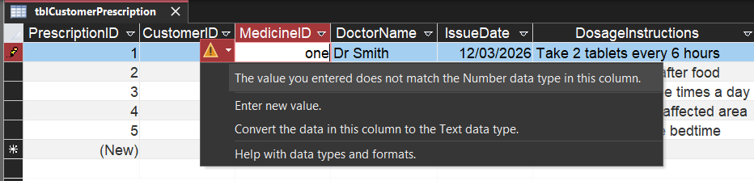
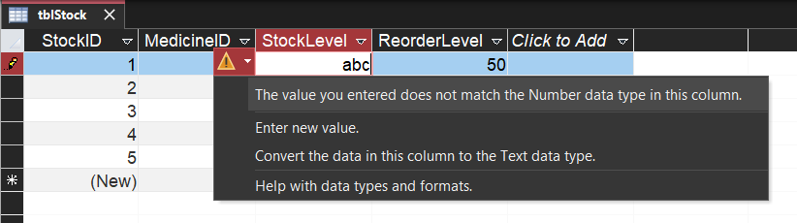
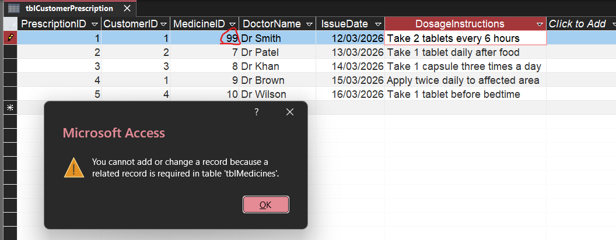

Forms and Reports
Forms were made for every table to allow for easy data entry and editing. This provides users with a user-friendly way to access and edit data. Reports were made to preview data in a clear view which allows for information to be easily reviewed [3].
Customer Form
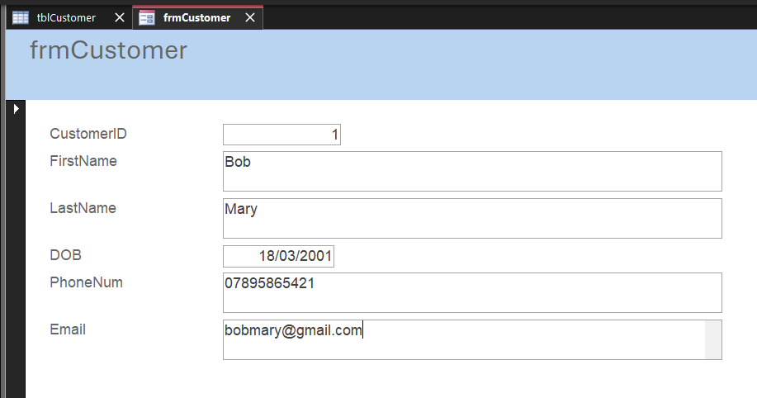
Customer Prescription Form
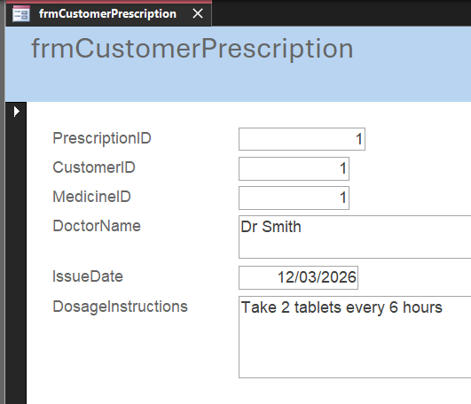
Medicine Form
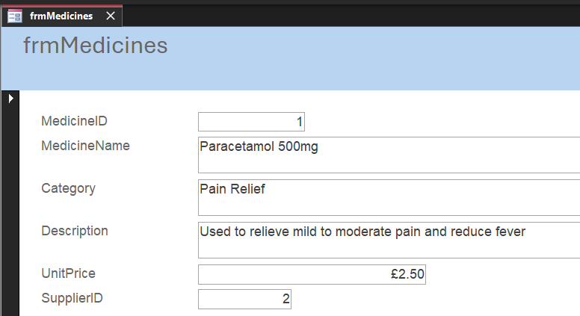
Stock Form
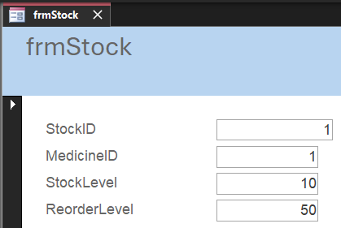
Supplier Form
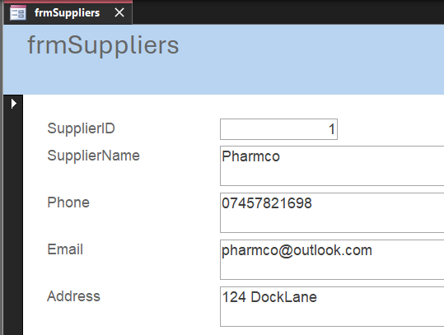

Customer Report
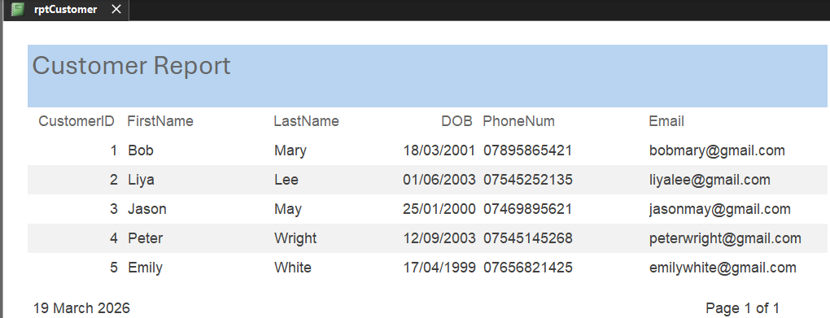
Customer Prescription Report
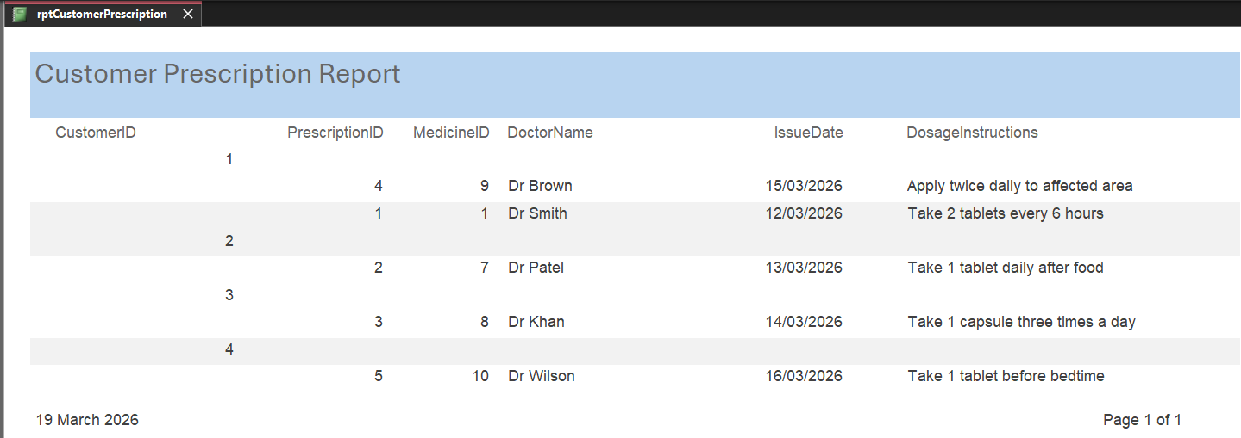
Medicine Report
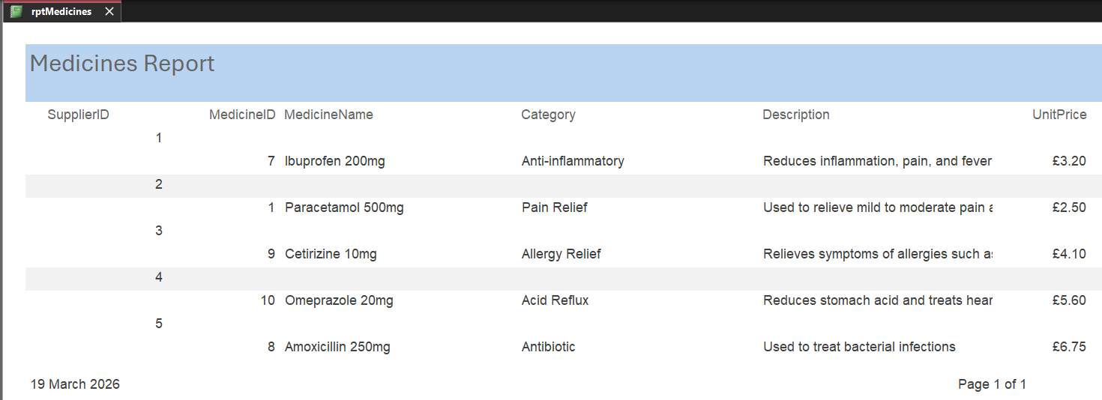

Stock Report
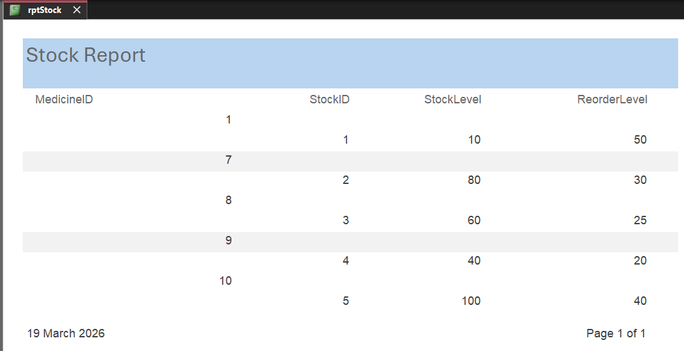
Suppliers Report
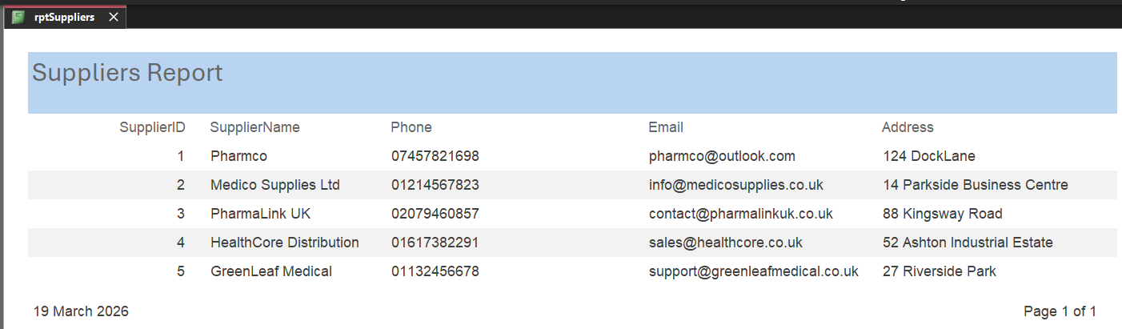

Reflection
One of the main problems I encountered while developing the database for MediLink Pharmacy was ensuring that the correct data types were set for each table, as well as defining relationships between tables correctly. I solved this by fixing the data types [4].
Another issue I came across was following the Third Normal Form (3NF). This involved splitting up the data into multiple tables to prevent data redundancy. [5]
The database could be improved by creating a better user interface could be added to allow for better interaction with the database.

Conclusion
The MediLink Pharmacy database was successfully designed and implemented by me using Microsoft Access. The system is effective. It manages customers, medicines, stock and prescriptions in a structured way. To reduces any mistakes and to improve data integrity data was normalised and relationships were enforced [1].
Queries, forms and reports were created for an effective/user friendly experience. This allows for efficient data entry, retrieval, and analysis [5].
Overall, the system meets the requirements and provides a reliable solution for managing pharmacy data.

References
[1] R. Elmasri and S. B. Navathe, Fundamentals of Database Systems, 7th ed., Pearson, 2015.
[2] Microsoft, “Database design basics,” Microsoft Support, 2026. [Online]. Available: https://support.microsoft.com/en-gb/office/database-design-basics-eb2159cf-1e30-401a-8084-bd4f9c9ca1f5
[3] Microsoft, “Create a form in Access”, Microsoft Support. Available: https://support.microsoft.com/
[4] Microsoft, “Data types for Access desktop databases”. Available: https://support.microsoft.com/
[5] Microsoft, “Create queries, forms, and reports in Access”. Available: https://support.microsoft.com/

