How to engage employees throughout the employee lifecycle

Student name: Andreea Girboiu
Student ID no.: 2119260
Module Code and title: BMIH5005 Personnel Resourcing and Development
Lecturer: Kathryn Roberts

The employee life cycle is defined as the different stages associated with the professional journey of the employees (Michaga et al., 2022). This essay is based on the case example of Premier Inn Hotel regarding handling the business's resource requirements. The organisation was founded in the year 1987. Whitbread was the founder of the hotel. Currently, the business is catering its services at a global level. This report will discuss all the different ways the business gets to engage with the employee throughout the life cycle of the employment. The external and internal factors and their influence will also discuss in the essay.
Human resource management is all about handling the different needs and requirements of the business concerning managing the employees at a workplace. The human resource department must look at all the different areas associated with the employee life cycle. The employee life cycle comprises attraction, recruitment, onboarding, development, retention, and separation (Mahmoud et al., 2022). The external factors of the business environment also influenced the recruitment practice appointed by the Premier Inn Hotel. The political stability of the United Kingdom has been a crucial area and factor that can support the business in recruiting employees. The Premier Inn Hotel is proliferating globally, allowing the company to recruit and attract employees. The political relationship of the United Kingdom with other countries at a global level allowed the business to expand in other international markets. The expansion of the business always required the business to hire more staff and employees so that the brand could entertain operations at such an international location (Ghani et al., 2022).
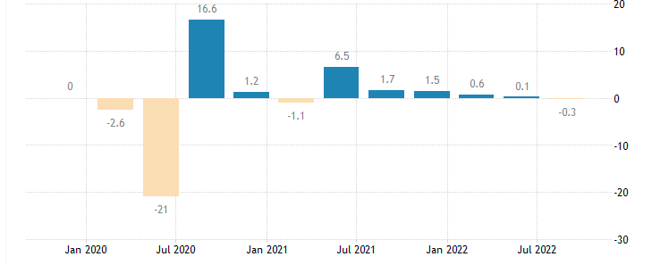
Figure 1: UK GDP Growth
(Source: tradingeconomics.com, 2023)
The above chart shows that the economy of the United Kingdom is growing at a rate of .3% in July 2022. In January 2022, the growth rate was 6.5%, and so on (tradingeconomics.com, 2023). The Premier Inn Hotel get to recruit more staff due to the economic growth of the country, which could allow the brand to attract more travellers into the business. The journey of the employees starts with attraction, recruitment, onboarding, development, retention, and separation. The economic growth and progress of the United Kingdom do influence and channel the Premier Inn Hotel at all stages of the employee life cycle (Hajal, 2022). The social condition of the United Kingdom is such that people are educated and skilled, which has supported the businesses like Premier Inn Hotel to appoint skilled employees at all the different designation roles in the business. Society in the United Kingdom is also aware of the rights of the employees at the workplace, which has allowed the business to cope with all the different employee-related regulations and laws while hiring the employees over all the different designations roles in the business. Social awareness has favoured the brand to allocate all the potential amenities to the employees in the process of the employee life cycle (Colmekcioglu, Dineva and Lu, 2022). For example, the social awareness and social environment of the United Kingdom do require the Premier Inn Hotel to create a suitable and employee-oriented environment of the business where the shifts are allocated timely manner, and also the brand needs to allocate all the suitable benefits to the employees working with the organisation.
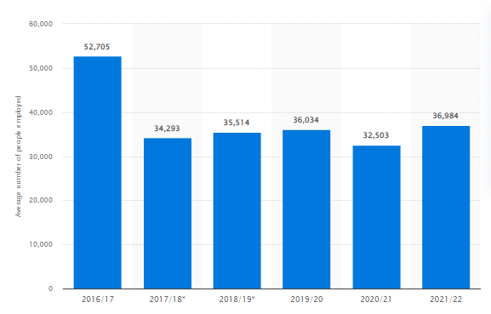
Figure 2: Employees in Premier Inn Hotel
(Source: statista, 2023)
The above stated is the number of employees working with the Premier Inn Hotel. In 2019 the total of employee’s company was 36034 whereas, in 2020, the numbers were 36034; in 2021, it was 32503; and in the year 2022, the total number of employees of the company was 36984 (Statista, 2023). The technological advancement of the United Kingdom has supported the hotels in the country to attract the most skilled employees over all different designation positions in the business. Using technology for the business could allow the brand to issue job advertisements and other documents, which can support the brand in attracting the best potential candidate over the different designation’s role in the organization (Jones et al., 2022). Companies in the current space like to use the latest technologies like artificial intelligence, robotics, digital channels, and other technologies to channel business operations. The hotel also implements innovative room technologies. The hotel employees are required to cope with all these technologies in the process of the employment life cycle. The brand is also included with the various corporate social responsibilities that could support the Premier Inn Hotel to create a loyal brand image in the market. A better brand reputation has supported the business in attracting potential candidates. The company also has supported top the equality law and other environmental factors that could lead the brand to improve the employment life cycle of every employee. It has allowed the business to retain the staff in the business for longer time duration (Kimbu et al., 2023). The company also copes with the laws and regulations such as anti-discrimination in all the states of the employment life cycle such as attraction, recruitment, onboarding, development, retention, and separation. The role of legal factors of the external environment is significant for the business to implement all of them to channelises effectively the payment life cycle in the business.
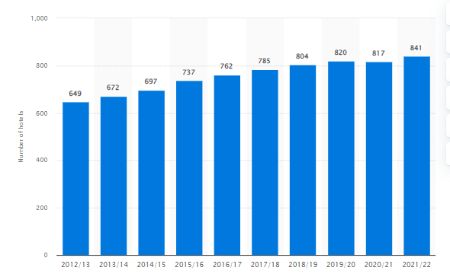
Figure 3: Total Hotels of Premier Inn
(Source: statista, 2023)
The chart above shows the total number of hotels that the Premier Inn Hotel operates in the country. In 2019, the whole hotel chain operated by the brand was 804; in 2020, it was 820; in 2021, it was 817; and the brand owned 841 hotels in 2022 (Statista, 2023). The company has valued every stage of the employee life cycle with the support of a progressive business culture. This is a great strength of the brand, which could allow the brand to cater for the employees of the business and their associated requirements in the best manner. The company could successfully retain the staff in the business, which could also result in an increased number of hotels (Galow and Peleg, 2022). This is one of the most significant levels of advantage and benefits owned by the company as a result of catering the best quality of treatments to employees at all stages of the employment life cycle, such as attraction, recruitment, onboarding, development, retention, and separation. The human resources department is also required to host different sessions and events to improve the motivation level of employees. The business's culture always plays a vital role in improving the employment life cycle duration. The employees at the current time want to work with those business houses and organisations that hold a progressive environment (Izaola, Akizu-Gardoki and Oregi, 2022). The Premier Inn Hotel try to cater for a friendly work environment for the employees of the business, which can further allocate suitable working situation and condition to the business.
One of the Premier Inn Hotel's significant strengths is that it focuses on improving employee engagement. In such a process, the organisation host parties and other such events. All these played a significant role in effectively retaining and sustaining the business to grow in the market. The engagement with the business's employees focuses on supporting the need and requirements of the human resources and employees part of the business (Razzak, Blackburn and Saridakis, 2022). The internal environment and structure of the business are one of its core strengths which supported the employees of the business to get the proper growth chances and opportunities. The organisation hierarchy contains multiple designations and positions, which are the core and adequate strength the business's employees have supported to sustain for a longer duration. Today, the labour market environment is such that employees want to be a part of businesses that can cater to better designations and lucrative salaries and employment benefits (Middleton et al., 2022). In increasing the employment life cycle, for example, the Premier Inn Hotel has tried to focus on improving the organisation hierarchy. This has favoured the brand to effectively contribute to attracting the employees to put efforts for achieving better designations in the business.
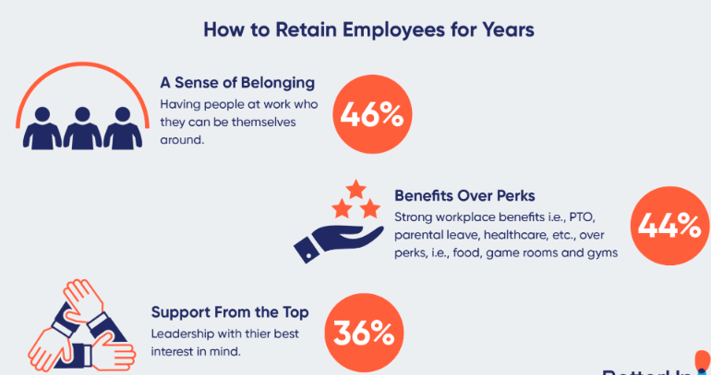
Figure 4: Retaining Employees
(Source: Maggie Wooll, 2021)
Engagement at the workplace of the employees is the core and suitable approach hotels use to retain employees in the business (Bichler, Petry and Peters, 2022). The chart above shows that 46% of the employees who improved their life cycle felt that a sense of belonging worked and inspired them to sustain their employment in the organisation. 44% believe that getting suitable perks and benefits is the source of retention at the workplace. 36% of the employees get support from the top management, which could allow them to keep employed at the same organisation (Maggie Wooll, 2021). The need for employee retention is crucial and significant for the employees who have allowed and inspired them to keep working for the same organisation. One of the core advantages of the Premier Inn Hotel is to retain the business staff. The hospitality sector requires experienced staff so hotels can improve their performance by enhancing the business's customer satisfaction level (Stewart, Patrick, and Reeves, 2022). For example, in industry, other businesses are also focusing on improving employee satisfaction to retain the staff in the business and improve the employment life cycle of the organisation. For example, team engagement can be improved by hosting a regular interactive session with the employees, addressing the issues, focusing on the growth of employees and other areas and factors that do work for the business.
The Premier Inn Hotel has focused on using high-touch and soft-touch onboarding models to improve employee engagement at the workplace. This practical model could allow the brand to engage at an average level. In the hospitality sector, employees get to address many issues due to the constantly changing shifts and other areas. All this requires that the business focus on improving the engagement level at the workplace so that the manager knows about all the issues the employees are addressing and facing by the employees working with the organization (Opazo Breton et al., 2022). This is an important tactic or approach that is suitable and works effectively for the brand to address the problems of the employees along with improving the culture of the business. Generally, concerning the hospitality sector business, engagement is rare, which allows the business to focus on employee engagement with the support of team meetings and hurdles (Portes, 2022). This is the most suitable approach or tactic used by the business to improve the engagement level of employees at a workplace. For example, in the hospitality industry also, other businesses focus on hosting the employee meeting regularly, which can offer the human resources of the business to put their opinions and thoughts about the different issues which they are going through in order to cope with their functional role and responsibilities in the business. The engagements also allow the employees to put the alternative options that can solve or address the issues they are going through (Vyas, 2022). The Premier Inn Hotel also created an employee grievance centre that can directly interact with the employees and focus on addressing the employees' issues. The life cycle of employment involves multiple stages, and the engagement with the employees creates a positive impact at each stage or level of employee engagement in the business. The tight shifts and delaines of the projects have already created pressure and workload for the employees in the hotel, and in such a situation, the employment life cycle is the core and suitable area and tactics which do favor and support the business to effectively contribute to the retentions of the employees at the workplace.
The employment life cycle contains stages like attracting employees, recruiting staff, onboarding, development, retention, and separation. Employee engagement is the sole basis for the hospitality sector business that favours the brand to improve the cycle of the employment life cycle in the business. The core factor contributing to the hotels in the process of improving the life cycle of employment is the culture of the business. The progressive culture of the hotel does create a direct impact or influence on the employment life cycle handled and managed by the business. The employee engagement model that can improve employee retention is high-touch onboarding and low-touch onboarding, which do contribute for the employees to improving employee engagement in a workplace.

REFFERENCES
Bichler, B.F., Petry, T. and Peters, M., 2022. ‘We did everything we could’: how employees’ made sense of COVID-19 in the tourism and hospitality industry. Current Issues in Tourism, 25(23), pp.3766-3782.
Colmekcioglu, N., Dineva, D. and Lu, X., 2022. “Building back better”: the impact of the COVID-19 pandemic on the resilience of the hospitality and tourism industries. International Journal of Contemporary Hospitality Management, (ahead-of-print).
Galow, A.M. and Peleg, S., 2022. How to slow down the ticking clock: Age-associated epigenetic alterations and related interventions to extend life span. Cells, 11(3), p.468.
Ghani, B., Zada, M., Memon, K.R., Ullah, R., Khattak, A., Han, H., Ariza-Montes, A. and Araya-Castillo, L., 2022. Challenges and strategies for employee retention in the hospitality industry: A review. Sustainability, 14(5), p.2885.
Hajal, G.E., 2022. Teleworking and the jobs of tomorrow. Research in Hospitality Management, 12(1), pp.21-27.
Izaola, B., Akizu-Gardoki, O. and Oregi, X., 2022. Life Cycle Analysis Challenges through Building Rating Schemes within the European Framework. Sustainability, 14(9), p.5009.
Jones, O.R., Barks, P., Stott, I., James, T.D., Levin, S., Petry, W.K., Capdevila, P., Che‐Castaldo, J., Jackson, J., Römer, G. and Schuette, C., 2022. Rcompadre and Rage—Two R packages to facilitate the use of the COMPADRE and COMADRE databases and calculation of life‐history traits from matrix population models. Methods in Ecology and Evolution, 13(4), pp.770-781.
Kimbu, A.N., Adam, I., Dayour, F. and de Jong, A., 2023. COVID-19-induced redundancy and socio-psychological well-being of tourism employees: Implications for organizational recovery in a resource-scarce context. Journal of Travel Research, 62(1), pp.55-74.
Maggie Wooll, 2021 Looking to improve company culture [Online] Available Through < https://www.betterup.com/blog/fun-activities-at-work> [Accessed on 9 Febuary 2023]
Mahmoud, A.B., Reisel, W.D., Fuxman, L. and Hack‐Polay, D., 2022. Locus of control as a moderator of the effects of COVID‐19 perceptions on job insecurity, psychosocial, organisational, and job outcomes for MENA region hospitality employees. European Management Review, 19(2), pp.313-332.
Michaga, M.F.R., Michailos, S., Akram, M., Cardozo, E., Hughes, K.J., Ingham, D. and Pourkashanian, M., 2022. Bioenergy with carbon capture and storage (BECCS) potential in jet fuel production from forestry residues: A combined Techno-Economic and Life Cycle Assessment approach. Energy Conversion and Management, 255, p.115346.
Middleton, S.E., Letouzé, E., Hossaini, A. and Chapman, A., 2022. Trust, regulation, and human-in-the-loop AI: within the European region. Communications of the ACM, 65(4), pp.64-68.
Opazo Breton, M., Gillespie, D., Pryce, R., Bogdanovica, I., Angus, C., Hernandez Alava, M., Brennan, A. and Britton, J., 2022. Understanding long‐term trends in smoking in England, 1972–2019: an age–period–cohort approach. Addiction, 117(5), pp.1392-1403.
Portes, J., 2022. Immigration and the UK Economy after Brexit. Oxford Review of Economic Policy, 38(1), pp.82-96.
Razzak, B.M., Blackburn, R. and Saridakis, G., 2022. Employees' working life and performance of UK ethnic minority restaurants: a qualitative approach. Benchmarking: An International Journal, 29(1), pp.47-67.
statista, 2023 Average number of people directly employed by Premier Inn Hotel [Online] Available Through < https://www.statista.com/statistics/755720/whitbread-employment/> [Accessed on 9 Febuary 2023]
statista, 2023 Number of Premier Inn Hotels in UK [Online] Available Through < https://www.statista.com/statistics/739855/whitbread-premier-inn-hotels/> [Accessed on 9 Febuary 2023]
Stewart, K., Patrick, R. and Reeves, A., 2022. A time of need: exploring the changing poverty risk facing larger families in the UK. Journal of Social Policy.
tradingeconomics.com, 2023 United Kingdom GDP Growth Rate [Online] Available Through < https://tradingeconomics.com/united-kingdom/gdp-growth> [Accessed on 9 Febuary 2023]
Vyas, L., 2022. “New normal” at work in a post-COVID world: work–life balance and labor markets. Policy and Society, 41(1), pp.155-167.

