

BMHP5014
RemindMe
Noreen Akhtar
2321475
Table of Contents
Written Pitch 3
The Problem 3
The Innovation 3
Why Now? 4
Impact 4
Implementation Plan 4
Addressing Barriers 5
Recommendations & Call to Action 6
Professional Poster 6
Reference 7

Written Pitch
Directed to: Chief Executive Officer, NHS England
This letter introduces the RemindMe Dementia Companion App, an AI-driven solution to support residents' information needs in the context of dementia and recommends its national deployment within NHS-funded care homes throughout the United Kingdom.

The Problem
Currently, more than 982,000 people in the UK have dementia, and by 2040, this is expected to increase to 1.6 million. Dementia is the single biggest cause of death in England and Wales and has a cost on the UK economy of around £34.7 billion per year (Filipa Landeiro et al., 2024). Yet, care provision is still under-resourced, fragmented, and not personalised to the same extent as is needed. Non-adherence to medication, profound loneliness, and rapid cognitive decline are common issues faced by older people living in residential facilities — not because they are being cared for badly, but simply because there is not enough capacity. Despite the fact that cognitive stimulation therapy and person-centred care are recommended as first-line non-medical interventions by NICE, it continues to be challenging to deliver these interventions at scale.

The Innovation
RemindMe is an AI tablet companion application specially developed for elderly adults with mild to moderate dementia in residential care (Hackett et al., 2020). It comprises five interconnected modules: photos and AI narration for a personalised Memory Lane function; the facial recognition system FaceConnect to identify family members visiting residents, reducing confusion and distress; a visual and audio reminder system for medicines, MedAlert; a daily cognitive mini-game system, CogniTrack, that collects anonymous data for clinical review; and a conversational AI partner that interacts with each resident according to their communication level and preferences, VoiceBuddy.
Designed to be intuitive, the application offers large fonts, easy-to-navigate menus, and voice activation. No prerequisite digital literacy is needed on the part of citizens. Families will have access to a companion app so they can get in touch and share their memories; a co-produced, person-centred digital experience which embraces the values of the Care Act (2014) and the principles of personalised care championed by NHS England.

Why Now?
When is the right time for this innovation? The aim of the NHS Long Term Plan is clearly to increase the use of personalised care and digital health (Gavin et al., 2024). The UK Government's 10-Year Dementia Strategy highlights technology as a central element to the improvement of dementia outcomes. As NHS Digital pushes for AI to be used in care pathways, they are building the technical platform and political appetite for implementation. RemindMe is not a guess — it is based on proven technology being used as part of the healthcare community, and customised for a population that is extremely vulnerable — one that is frequently underestimated in the digital health revolution (Jennifer Jimenez et al., 2023).

Impact
There are consistent reports of the beneficial effect of cognitive stimulation and social engagement on slowing cognitive decline in individuals with early to moderate dementia. RemindMe is an evidence-based approach that is directly implemented digitally and scalable (Bessey, 2025). The FaceConnect feature helps solve a known source of acute stress – when the resident does not recognise the family carer – that leads to family carer burnout and resident agitation (Hobbs-Regular, 2024).
The MedAlert system is expected to help prevent medication errors, which are thought to involve a large number of people living in care homes with dementia (Fawzy, 2026). RemindMe's ability to link MedAlert to a carer's dashboard will complement, not supplant, care staff, leaving more time for human interaction (Adekoya, 2025). The module CogniTrack helps to identify decline at the early stages, thereby allowing clinical teams to modify care plans ahead of decline, not after it has occurred.

Implementation Plan
Phase 1 (Months 1–3) includes co-production processes with residents, families, and care staff using participatory design workshops, ethical approval through processes with the Health Research Authority, and adherence to the Mental Capacity Act (2005), GDPR (2018), and the CQC Standards. Citizen engagement in co-design is not only an ethical good practice, but is an effective way of ensuring that the product is truly representative of the lived experience of the people to whom it will belong.
Phase 2 (Months 4-6) is a three-site pilot in care homes across Wales, the North West, and London, which have been selected to capture geographical and demographic diversity (Gobster et al., 2023). All data collection will follow NHS Digital Data Security Standards. Two hours of structured training will be provided for staff, and a simple digital guide will be provided for family members.
In Phase 3 (Months 7 – 9), the evaluation is focused on intensive assessment with the use of the standardised outcome measures and qualitative feedback from residents, carers, and families (Budgett et al., 2023). The results will be leveraged to further tune the application prior to wider deployment.
Phase 4 (Months 10-18) is the period of NHS commissioning and national rollout, which will be supported by existing healthcare technology suppliers, Skills for Care, and the Alzheimer's Society.
Key stakeholders are NHS England, providers of care homes, CQC inspectors, technology developers, family carers, and most importantly, the residents as co-designers.

Addressing Barriers
I recognise that there are some major issues around digital health adoption in care settings: digital exclusion, staff resistance, concerns around data privacy, and funding challenges. RemindMe tackles these right head-on. The design of the interface is especially aimed at the group of users who are not very digitally literate. There is limited and organised staff training (Jeffery, 2025). All data is encrypted, stored in the UK on NHS-approved servers, and fully GDPR-compliant. As far as funding is concerned, the app is expected to generate worthwhile cost savings per resident each year as a result of minimising medication errors and decreasing acute hospital admissions, in addition to the humanitarian argument.
There's a greater social argument, too. Effective care of older people with dementia in a care home setting reduces the load on family carers, reduces hospital admissions, and maintains the dignity of older people in their last years. This is what we call Value Creation, not just financial value creation, but Moral and Social value creation.

Recommendations & Call to Action
I call on NHS England to fund a formal pilot to roll out RemindMe to 10 care homes within its next financial year, with plans for national rollout that will coincide with implementation of the 10-year Dementia Strategy. NHS Digital, as the technical governance partner, and the Alzheimer's Society as the public engagement partner.
RemindMe is no ordinary app; it's a statement of values. Elderly individuals with dementia are entitled to dignity, connection, and all the advantages of today's technology, it says (Pageau et al., 2023). Innovation in health and social care needs to be delivered to the most vulnerable in our communities, not to those in acute care.
The proof is in the pudding. The need is urgent. Technologies are available. The leadership, the investment, and the courage to act are what is required now. I want YOU to be that voice of change. Commission RemindMe. Transform dementia care. Act now.

Professional Poster
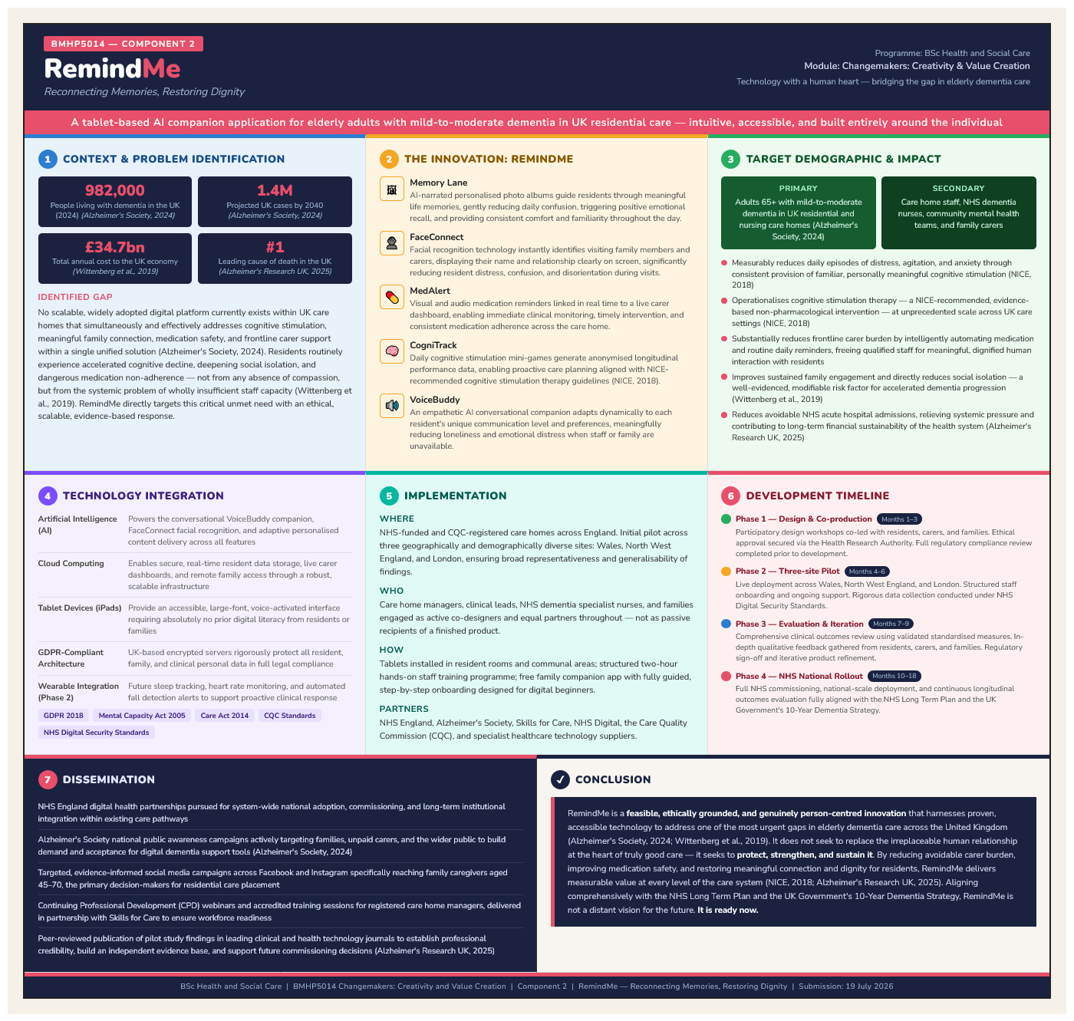

Reference
Alzheimer's Society (2024). How many people have dementia in the UK? London: Alzheimer's Society. Available at: https://www.alzheimers.org.uk/blog/how-many-people-have-dementia-uk
Alzheimer's Research UK (2025) Dementia is still the UK's biggest killer. Available at: https://www.alzheimersresearchuk.org/news/dementia-is-still-uks-biggest-killer-where-do-we-go-from-here/
Adekoya, A. (2025). Alert Systems for Missing Persons Living with Dementia: From Policy to Implementation. [online] Uwaterloo.ca. Available at: https://uwspace.uwaterloo.ca/items/056a33ec-03cc-4c42-9b33-302c338519b7
Bessey, D. (2025). Scaling Smart: The Potential of Digital Strategies to Promote Breastfeeding in Low‐ and Middle‐Income Countries. Maternal & Child Nutrition, [online] 22(1). doi: https://doi.org/10.1111/mcn.70147
Budgett, J., Sommerlad, A., Kupeli, N., Zabihi, S., Olsen, A. and Cooper, C. (2023). Setting individualised goals for people living with dementia and their family carers: A systematic review of goal-setting outcome measures and their psychometric properties. Dementia, 23(2). doi: https://doi.org/10.1177/14713012231222309
Fawzy, A. (2026). Addressing Informal Caregiver Burden: Technology and Toolkit for Medication Management in Older Adults. [online] Uwaterloo.ca. Available at: https://uwspace.uwaterloo.ca/items/ff121bfa-7e68-4282-ab38-643e8edca825
Filipa Landeiro, Harris, C., Groves, D., O’Neill, S., Kuljinder Singh Jandu, Tacconi, E.M.C., Field, S., Patel, N., Göpfert, A., Hannes Hagson, Leal, J. and Ramón Luengo-Fernández (2024). The economic burden of cancer, coronary heart disease, dementia, and stroke in England in 2018, with projection to 2050: an evaluation of two cohort studies. The Lancet Healthy Longevity, 5(8). doi: https://doi.org/10.1016/s2666-7568(24)00108-9
Gavin, J.P., Clarkson, P., Muckelt, P.E., Eckford, R., Sadler, E., McDonough, S. and Barker, M. (2024). Healthcare professionals' and commissioners’ perspectives on the factors facilitating and hindering the implementation of digital tools for self-management of long-term conditions within UK healthcare pathways. PLOS ONE, [online] 19(8), p.e0307493. doi: https://doi.org/10.1371/journal.pone.0307493
Gobster, P.H., Kruger, L.E., Schultz, C.L. and Henderson, J.R. (2023). Key Characteristics of Forest Therapy Trails: A Guided, Integrative Approach. Forests, 14(2), p.186. doi: https://doi.org/10.3390/f14020186
Hackett, K., Lehman, S., Divers, R., Ambrogi, M., Gomes, L., Tan, C.C. and Giovannetti, T. (2020). Remind Me To Remember: A pilot study of a novel smartphone reminder application for older adults with dementia and mild cognitive impairment. Neuropsychological Rehabilitation, 32(1), pp.1–29. doi: https://doi.org/10.1080/09602011.2020.1794909
Hobbs-Regular, C. (2024). Who cares for the carers? Development of an educational resource: identification, prevention and mitigation of burnout for psychiatric nurses in Newfoundland and Labrador Health Services. [online] Scholaris.ca. Available at: https://memorial.scholaris.ca/items/f4018884-eb05-4872-9216-b7b4baecd26b
Jeffery, S. (2025). The Low-Code AI Maturity Model. Berkeley, CA: Apress. doi: https://doi.org/10.1007/979-8-8688-1730-4
Jennifer Jimenez, Alberto del Rio, Arianna N. Berman and Miriam Grande (2023). Personalising Digital Health: Adapting Health Technology Systems to Meet the Needs of Different Older Populations. Healthcare, [online] 11(15), pp.2140–2140. doi: https://doi.org/10.3390/healthcare11152140
National Institute for Health and Care Excellence (2018) Dementia: Assessment, management and support for people living with dementia and their carers. NICE guideline NG97. London: NICE. Available at: https://www.nice.org.uk/guidance/ng97
Pageau, F., Gaëlle Fiasse, Lennart Nordenfelt and Emilian Mihailov (2023). Care of the older person and the value of human dignity. Bioethics, 38(1), pp.44–51. doi: https://doi.org/10.1111/bioe.13251
Wittenberg, R., Hu, B., Barraza-Araiza, L., and Rehill, A. (2019). Projections of older people with dementia and costs of dementia care in the United Kingdom, 2019–2040. CPEC Working Paper 5. London: LSE. Available at: https://www.lse.ac.uk/cpec/assets/documents/Working-paper-5-Wittenberg-et-al-dementia.pdf

