Communication within Cloud Cubes
An Evaluation of Communication Methods, Challenges and Recommendations
Programme: BA (Hons) Business Management
Module: Understanding Organisational Structure and Culture
Module Code: LCBB4009
Assessment: Component 2: Individual report
Lecturer: Dr Aso Abdullah

Student Name: Taher Mahmood
Student number: 2427065

Word Count: 1530
Submission Date: 12/07/2026

Table of Contents
1. Introduction 1
2. Communication within Cloud Cubes 1
2.1 Communication Structure 1
2.2 Communication Methods and Technologies 2
3. Communication Challenges at Cloud Cubes 4
4. Recommendations 5
5. Conclusion 6
Reference List 8

1. Introduction
Communication is essential to organisational success because it enables individuals and teams to share information, coordinate activities and achieve common objectives. Effective communication supports decision-making, collaboration and problem-solving, whereas poor communication can result in misunderstandings, reduced productivity and weaker organisational performance (Buchanan and Huczynski, 2023; Robbins, Coulter and Randel, 2021).
This report examines communication within Cloud Cubes, a proposed software development studio previously analysed in Component 1. As the organisation grows and adopts a matrix organisational structure, effective communication becomes increasingly important for coordinating functional departments, project teams and client relationships. The report evaluates the communication methods used within Cloud Cubes, examines the communication challenges associated with organisational growth and presents recommendations to improve communication effectiveness and support organisational performance.

2. Communication within Cloud Cubes

2.1 Communication Structure
Buchanan and Huczynski (2023) define communication as the process of exchanging information and meaning between individuals and groups to achieve organisational objectives. Hargie (2016) expands this view by arguing that effective organisational communication also develops shared understanding, trust and employee engagement. Within growing organisations such as Cloud Cubes, effective communication supports planning, coordination and decision-making across multiple functional departments and project teams.
Cloud Cubes operates a matrix organisational structure that combines functional departments with project-based teams to improve flexibility and resource utilisation. Employees belong to specialist departments, such as Development, Cloud & DevOps and QA & Testing, while also contributing to multiple client projects. This dual reporting structure enables specialist knowledge to be shared across projects but also increases communication complexity because employees report to both functional and project managers (Burton, Obel and Håkonsson, 2015). As shown in Figure 1, this structure combines functional reporting lines with project-based coordination to support resource sharing across multiple software development projects.
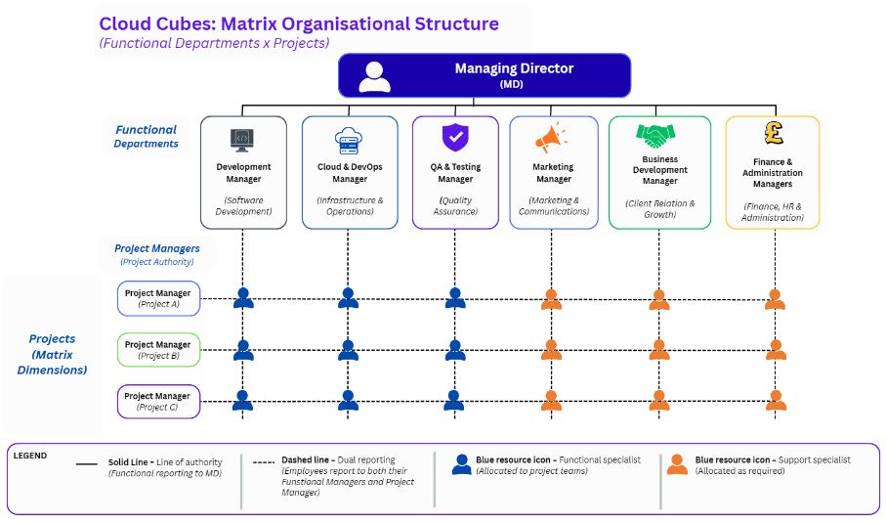
Within this structure, communication flows vertically between management and employees to communicate organisational objectives and operational decisions, while horizontal communication enables collaboration between functional departments working on the same project (Robbins, Coulter and Randel, 2021). Although this communication model improves organisational flexibility, matrix structures require clearly defined reporting responsibilities and communication processes to minimise role ambiguity and coordination challenges (Burton, Obel and Håkonsson, 2015).
Figure 1: Cloud Cubes Matrix Organisational Structure.
Source: Author's own illustration.

2.2 Communication Methods and Technologies
Cloud Cubes combines formal and informal communication methods to support software development projects. Formal communication, including emails, project documentation, sprint planning meetings and sprint reviews, provides accountability and maintains an auditable record of organisational decisions. Informal communication through Microsoft Teams, daily stand-up meetings and spontaneous discussions enables rapid problem-solving and continuous information sharing. Research by Pikkarainen et al. (2008) found that frequent communication within agile software development improves transparency and collaboration, while Hummel et al. (2013) argue that informal communication strengthens coordination across multidisciplinary teams.
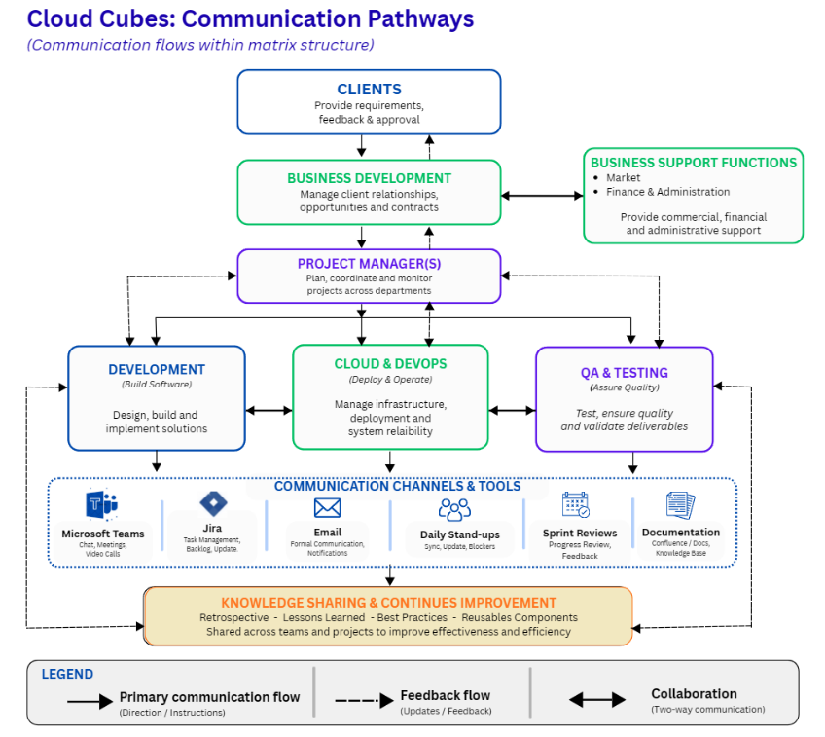
As shown in Figure 2, communication with external clients is managed primarily through the Business Development department, providing a consistent point of contact for commercial discussions, project requirements and contractual matters before project information is communicated to project managers and functional teams.
Figure 2: Communication Pathways within the Cloud Cubes Matrix Structure.
Source: Author's own illustration.
Internally, project managers coordinate communication between Development, Cloud & DevOps and QA & Testing using Microsoft Teams, Jira, email, sprint reviews and project documentation throughout the software development lifecycle. Retrospectives and lessons learned further support organisational learning by transferring project knowledge to future work.
Cloud Cubes' adhocracy culture further supports these communication practices by encouraging employees to share ideas, collaborate across functional boundaries and contribute to continuous improvement (Cameron and Quinn, 2011). This culture complements the matrix structure by promoting open communication, knowledge sharing and innovation across project teams. As the organisation expands, however, maintaining effective communication across multiple reporting relationships, projects and functional departments will require clear communication processes and effective coordination.

3. Communication Challenges at Cloud Cubes
While Cloud Cubes' matrix structure supports collaboration and resource sharing, it also introduces communication challenges that require careful management as the organisation grows. By combining functional departments with project teams, specialist knowledge can be shared across multiple projects, improving flexibility and resource utilisation (Burton, Obel and Håkonsson, 2015). This collaborative approach enables developers, cloud engineers and quality assurance specialists to work together throughout the software development lifecycle, supporting responsive decision-making and cross-functional collaboration.
One of the principal strengths of Cloud Cubes' communication approach is the adoption of agile communication practices. Daily stand-up meetings, sprint reviews and regular team discussions encourage continuous information exchange, enabling issues to be identified and resolved quickly. Pikkarainen et al. (2008) found that agile communication improves transparency and collaboration within software development projects. Similarly, Hummel et al. (2013) argue that frequent communication strengthens coordination between multidisciplinary teams. These practices reduce communication delays and improve responsiveness to changing client requirements.
Knowledge sharing also contributes to organisational learning within Cloud Cubes. Project documentation, retrospectives and lessons learned enable knowledge gained during one project to be transferred to future projects, reducing repeated mistakes and improving project efficiency. This continuous learning approach reflects the organisation's collaborative culture and supports innovation through shared learning (Schein and Schein, 2017). Consequently, communication supports both information exchange and organisational learning.
Despite these advantages, the matrix structure also presents communication challenges. Employees working across multiple projects may receive instructions from both functional managers and project managers, increasing the risk of conflicting priorities, role ambiguity and delayed decision-making (Burton, Obel and Håkonsson, 2015). Although dual reporting enhances organisational flexibility, it may also reduce accountability if communication responsibilities are not clearly defined. Consequently, Cloud Cubes must establish clear reporting procedures and communication protocols to minimise confusion as the organisation grows.
As Cloud Cubes expands, employees are likely to receive increasing volumes of emails, instant messages and meeting invitations, making it more difficult to prioritise important information. Buchanan and Huczynski (2023) argue that excessive communication can reduce productivity, while Wiatr and Skowron-Mielnik (2023) suggest that remote and hybrid working environments may further reduce opportunities for informal knowledge sharing. These factors highlight the importance of balancing digital communication with meaningful interpersonal interaction.
Communication with clients also requires careful management. Cloud Cubes uses the Business Development department as the primary point of contact for external communication, helping to ensure consistent messaging and reduce the risk of conflicting information being provided to clients. Although this approach promotes consistent client communication, it may delay the transfer of urgent information if communication becomes overly centralised. Therefore, maintaining effective coordination between Business Development, project managers and functional teams is essential to ensure client requirements are communicated accurately and efficiently.
Overall, the effectiveness of communication at Cloud Cubes will depend on balancing the flexibility of its matrix structure with clearly defined reporting responsibilities, effective leadership and appropriate use of collaborative technologies. Successfully managing these challenges will support organisational performance as the business continues to grow.

4. Recommendations
To support effective communication as Cloud Cubes continues to grow, the organisation should implement several practical measures to improve coordination, knowledge sharing and leadership communication. Burton, Obel and Håkonsson (2015) suggest that clearly defined reporting responsibilities reduce role ambiguity within matrix organisations. Implementing a formal communication policy would help employees understand when to communicate with functional managers, project managers and the Business Development department, reducing conflicting instructions and improving coordination.
Cloud Cubes should continue investing in digital collaboration technologies such as Microsoft Teams, Jira and Confluence to centralise project information and improve knowledge sharing. Standardising the use of these platforms would reduce information duplication and enable employees to access accurate project information more efficiently. Hummel et al. (2013) highlight that collaborative communication technologies improve coordination and information sharing within agile software development teams. A central knowledge base would also enable lessons learned from completed projects to be reused, supporting continuous organisational learning.
Leadership should encourage regular communication through daily stand-up meetings, sprint reviews, retrospectives and one-to-one meetings. Olutoye and Asikhia (2022) argue that effective leadership communication positively influences employee engagement and organisational performance because it promotes trust, clarity and employee commitment. Therefore, Cloud Cubes should foster an open communication culture where employees feel comfortable sharing ideas, providing feedback and reporting problems, reducing misunderstandings within its matrix structure.

Finally, Cloud Cubes should provide communication and leadership training for both functional managers and project managers. Matrix organisations depend upon collaboration across multiple reporting relationships, requiring managers to possess effective interpersonal, communication and conflict management skills (Burton, Obel and Håkonsson, 2015). Developing these capabilities would improve coordination, minimise misunderstandings and strengthen decision-making.

5. Conclusion
Communication plays a critical role in supporting organisational performance, particularly within matrix organisations where collaboration occurs across multiple functional departments and project teams. This report has demonstrated that Cloud Cubes' combination of formal communication methods, agile working practices and digital collaboration technologies provides a strong foundation for effective project delivery and organisational learning. However, the analysis also highlights that the benefits of a matrix structure are accompanied by communication challenges, including dual reporting relationships, information overload and increased coordination requirements.
Overall, Cloud Cubes has established a communication framework that supports collaboration across functional departments, project teams and external clients. As the organisation grows, maintaining effective communication will depend on clearly defined reporting responsibilities, effective leadership and continued investment in collaborative technologies. By addressing these challenges, Cloud Cubes will be well positioned to support innovation, organisational performance and sustainable growth.

Reference List

Buchanan, D.A. and Huczynski, A. (2023) Organizational behaviour. 11th edn. Pearson.
Burton, R.M., Obel, B. and Håkonsson, D.D. (2015) Organizational design: A step-by-step approach. 3rd edn. Cambridge University Press.
Cameron, K.S. and Quinn, R.E. (2011) Diagnosing and changing organizational culture: Based on the competing values framework. 3rd edn. Jossey-Bass.
Hargie, O. (2016) ‘The importance of communication for organisational effectiveness’. In: Lobo, F. (ed.) Psicologia do Trabalho e das Organizações. Braga: Axioma, pp. 15–32.
Hummel, M., Rosenkranz, C. and Holten, R. (2013) ‘The role of communication in agile systems development’, Business & Information Systems Engineering, 5(5), pp. 343–355.
Olutoye, F.A. and Asikhia, O.U. (2022) ‘Leadership communication and organisational performance: A review’, International Journal of Business and Management Review, 10(3), pp. 1–17.
Pikkarainen, M., Haikara, J., Salo, O., Abrahamsson, P. and Still, J. (2008) ‘The impact of agile practices on communication in software development’, Empirical Software Engineering, 13(3), pp. 303–337.
Robbins, S.P., Coulter, M. and Randel, A.E. (2021) Management. 15th Global edn. Pearson.
Schein, E.H. and Schein, P.A. (2017) Organizational culture and leadership. 5th edn. Wiley.
Wiatr, A. and Skowron-Mielnik, B. (2023) ‘Hybrid work and communication challenges in contemporary organisations’, Sustainability, 15(9), Article 7283.

