Application Development

Student number: 1806461 Name: Amelia Kate Moseley
The following report discusses a brief segment of research into recent application development trends. It goes on to walk through the development stages of an implementation with a design based on the Manjaro Linux site, looking at this site because of its uses of transitions of the styling on scroll to give an interactive feel to the site. The implementation aimed to be designed from a mobile first approach and makes use of various methods to help ensure the web app meets this requirement (namely media queries in the CSS, and the bootstrap framework). The web app then goes on to utilise the GitHub API, providing a search box on one of the pages to browse repositories. Lastly the report documents test cases for the code and reviews the attempt at the implementation.

Table of Contents
Introduction 3
1 – Application Development Concepts 4
1.1 – Development trend examples 4
2 – Requirements 4
2.1 – Website Introduction 4
2.2 – Mobile First Strategy 4
2.3 – Content Display Strategy 5
2.4 – API to use and Functionality Implemented 5
3 – Design and Implementation 5
4 – Evaluation 11
4.1 – Test Cases 11
4.2 – Review of Implementation 12
5 – References 14

Introduction

As hardware and software capabilities progress, the demand for webpages with increased flexibility and functionality increases. As such development trends must adapt to suit the needs of clients, developers, and the potential userbase. More and more web applications are making use of various APIs built on recent versions of JavaScript, it is important therefore for developers to stay up to date on what is available to use, and the functionality + limitations of the API. This report intends to document several recent, no older than 2016, development trends and focus in on one. An implementation is to be made utilising the development trend mentioned earlier and consume an API. The process of development for the implementation shall be documented, starting from what is required from the application, a showing various test cases showing how the application has been modified and bug fixed and different stages along the way.

1 – Application Development Concepts

– Development trend examples
To be able to think about current development trends and what trends suit the purposes of the individual, one must first find examples of said trends and understand what they mean for the potential development of a web application.
- Mobile first design [1] – Previously the focus has been around responsive design as mobile devices became more readily available, the interface adapting based on the device size usually making use of breakpoints. Based on this the idea has shifted slightly. With responsive design by itself the web pages tend to be designed around computers first, and mobile devices after; this could cause potential issues with the flexibility of the page and loading times. Mobile first design is exactly how it sounds, developing the webpages based on mobile screen-sizes first, and adapting the design to work with computer screens. [2] talks about the importance of interface design being flexible between different devices and discusses the use of mobile first design as a development option.
- Abandoning jQuery – Modern JavaScript API standards vastly reduce the need for the jQuery framework. More recent web applications have taken to using vanilla JavaScript equivalents of the functionality available in the jQuery framework. With the newer API standards in place, using JavaScript by itself increases the performance of web application pages. [3] discusses the transition from jQuery to vanilla JavaScript.
- Fetch API – The Fetch API is a newer, better way of performing asynchronous requests, compared to XMLHttpRequest [4]. Fetch works on a promise-based system, which allows the developer to be able to write much clearer code when making asynchronous requests. The function returns a promise, this promise can then be used to gather data based on the request. This data will more than likely take the form of JSON. Fetch works very well with RESTful APIs.

2 – Requirements

2.1 – Website Introduction
The proposed website is to be based around the enterprise and innovation group project module the author is a member of. This website is to act as an information site about the idea behind the group, and the group project itself. It intends to inform potential investors, or other interested parties, about the areas of technology in which the group is working and provide a place to document the progress of current projects/propose ideas for future projects.

2.2 – Mobile First Strategy
During the development stages of the website various strategies have been employed to ensure that the website is designed from a mobile first approach. The first of these strategies is the use of the Bootstrap framework. The Bootstrap framework is built around the idea of a mobile first approach, providing flexible components with breakpoints added in the background. To work alongside Bootstrap, media queries have been utilised. There are several media queries, some relating to all the sites pages and some specifically for individual pages. These queries were added to ensure that the content on the page is laid out in a nice arrangement and adjust according to the current viewport. To decide on the minimum width for the various queries, the developer tools available for web-browsers was used on responsive mode, and the viewport size adjusted to see how the elements on the page react at different page widths. The main set of queries is focused on the navbar of the page. At larger viewport widths the font-size of the navbar is increased slightly to make it easier to read, and at smaller viewports the left + right padding is lower to ensure that the text on the navbar buttons looks the same at each viewport width (making sure that buttons with more than one word don’t end up with the words stacked on top of each other.

2.3 – Content Display Strategy
With the index page, transitions have been included on the navbar and the background image. Depending on the viewport size, these transitions trigger at different scroll heights to ensure that the same intended impact from the transition is felt regardless of the device the site is being viewed on.

2.4 – API to use and Functionality Implemented
Initially the idea was going to be to use a weather API (e.g AccuWeather) and have the sites styling adjust based on weather in the users given location (based on the IP location API available in the AccuWeather API). Instead it was decided to use the GitHub API, providing a search box to allow the user to search for GitHub repositories through the web application. The JavaScript fetches JSON data from the GitHub API based on the contents of the search field and displays the title and description of the repositories (with the title inside an anchor element linking to the repository) each separated into a Bootstrap card. Pagination has been included, with each page showing 30 results. It is worth noting that no authorization key has been passed to the GitHub API, as such there is a limit rate per hour based on the device’s IP address. If a site is being made with the intention of being live, an authorization key would need to be generated on the GitHub website, this would greatly increase the limit rate (too many requests in a short time would still result in requests being blocked for some time in order to prevent a DoS attack).
On the index page of the site, JavaScript functions have been written to add and remove styling based on the current scroll height.

3 – Design and Implementation
In the index.js file there are 7 defined functions: the main function scrollResponse which is called within the event listener, showContent/hideContent for hiding and showing the div over the image on the homepage (if the scroll height is greater than 0 the div is hidden, when the page is scrolled back to the top the div is shown), addOpacity/removeOpacity fill in the navbar with colour/remove the background colour based on the scroll height (the function is called at different scroll heights based on an if statement block testing the width of the page), and makeGrayscale/makeColor (CSS uses the American spelling of colour, so the code uses that spelling to make sure no mistakes are made when adjusting the styling) which make the background image colour or grayscale based on scroll height (the function calls are within the same if statement block). These functions, minus scrollResponse, work by either adding or removing the appropriate classes from the selected element in the HTML (using the querySelector to get either ID or class names).
In the project-research.js file there are 3 named functions, and 3 anonymous functions. The main anonymous function is the window onload event listener. This function includes a call to the fetch API within it to fetch data from an API (which therefore has been marked as asynchronous). The two other anonymous functions are within the on-click event listeners for the search and clear buttons, search calls the getRepos function (which takes the getUrls function as input), and clear removes returned results from the HTML and clears the search box. The simplest named function, capitalise, is declared outside the event listener, it takes a string as input and returns the string with the first character capitalised. Capitalise is used as part of the formatting of the results being added to the HTML, it gets passed the labels for the pagination buttons as they are retrieved from the JSON. getUrl gets the search text from the search field, replaces the spaces with plus signs, and appends the formatted string to the generic GitHub repository search query. getRepos holds the main logical code in the JavaScript file and is marked as asynchronous. It starts by passing the url from getUrl to the fetch function and storing the returned result as JSON data. Next link data relating to the result pagination is gathered from the JSON, if there are more than 30 results these links will exist and will allow for navigation buttons to scroll through the pages of results, given 30 or less results this the link header will return null and the link formatting code will be skipped. Then data from the JSON is looped through and added to the HTML in the form of Bootstrap cards. The outer loop is a while with a boolean flag as the condition each iteration of this loop makes a new card deck, the inner loop goes through 3 results at a time adding them to the current deck, a separate count variable is iterated throughout the looping. If the count + 1 is greater than the number of results on the current page the Boolean flag is set to false and the inner loop is broken out of. Finally, based on the header link information gathered earlier, pagination buttons are appended to the bottom of the div with event listeners to call the getRepos function using the formatted header links.


Figure 1 Home page scrolled up

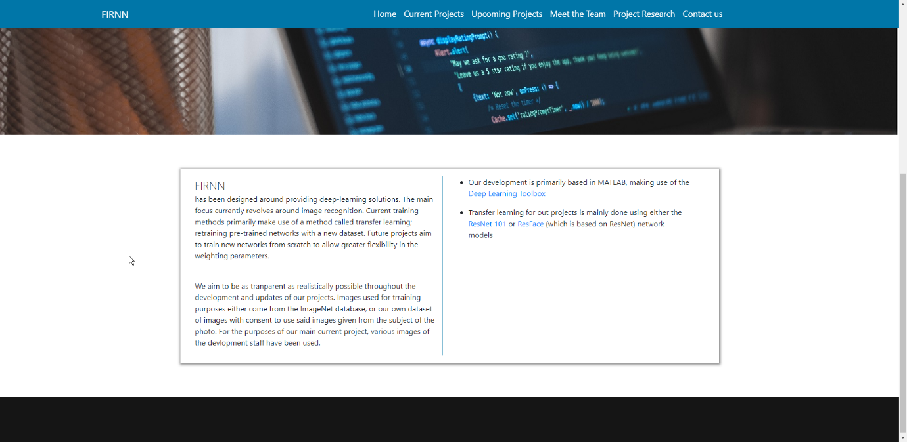
Figure 2 Home page scrolled down

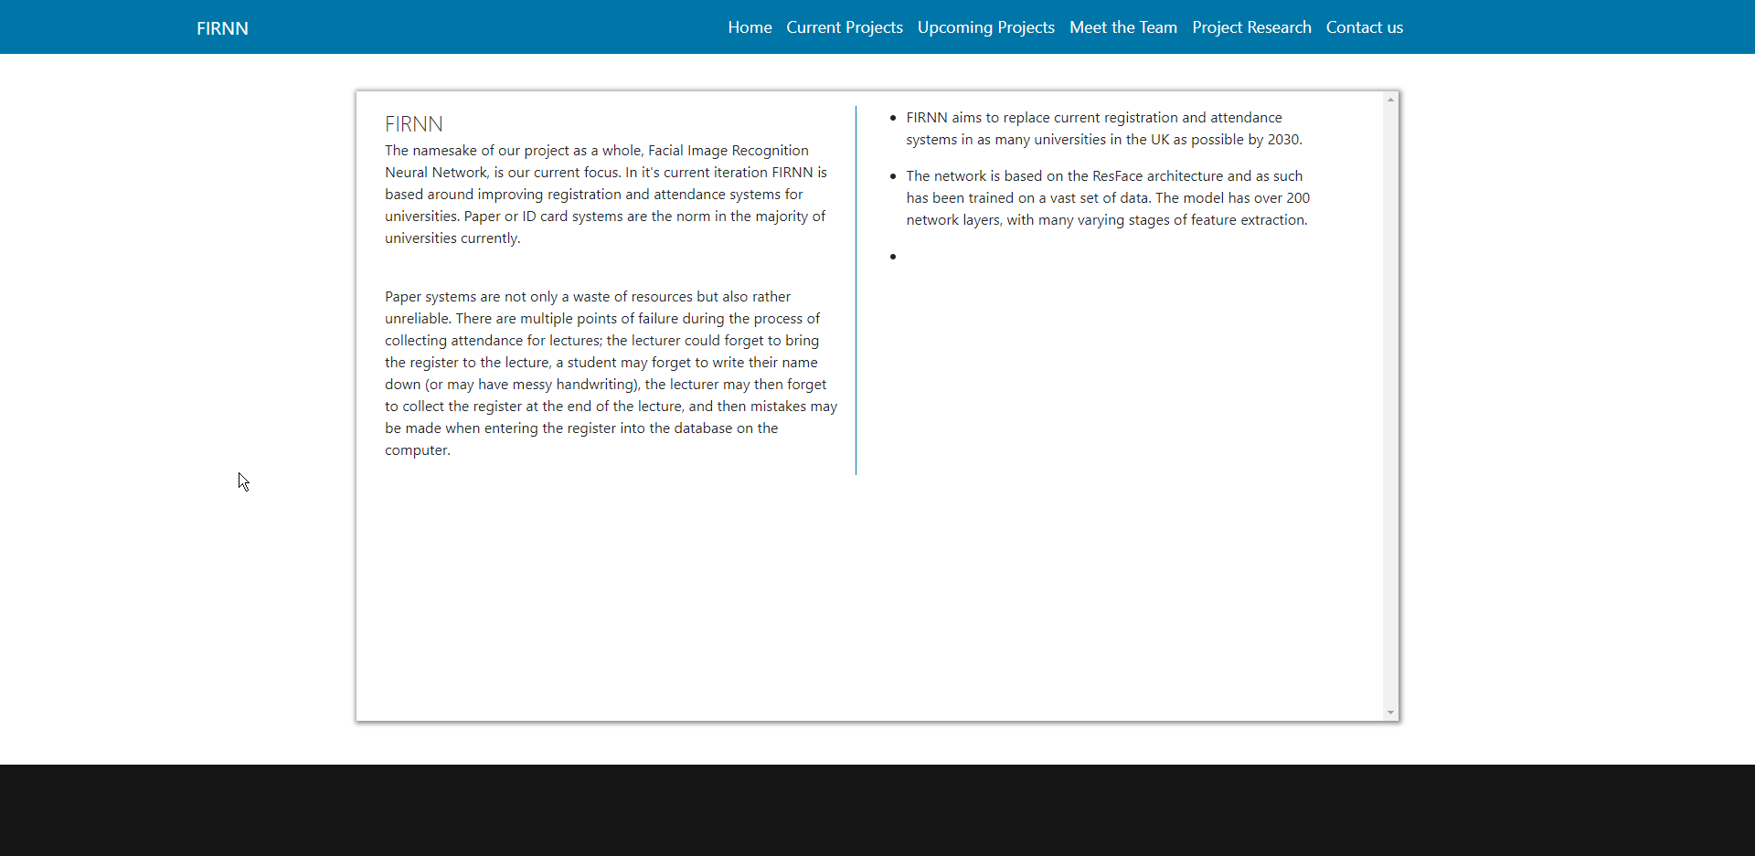
Figure 3 Current projects

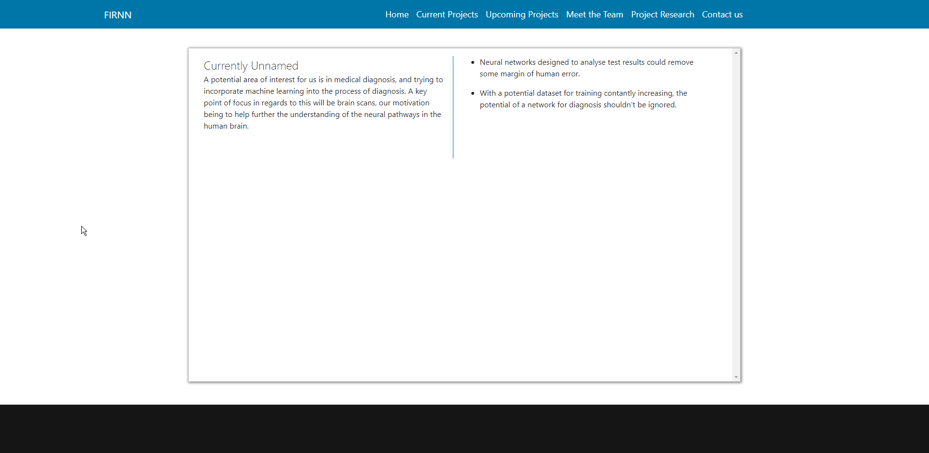
Figure 4 Upcoming projects

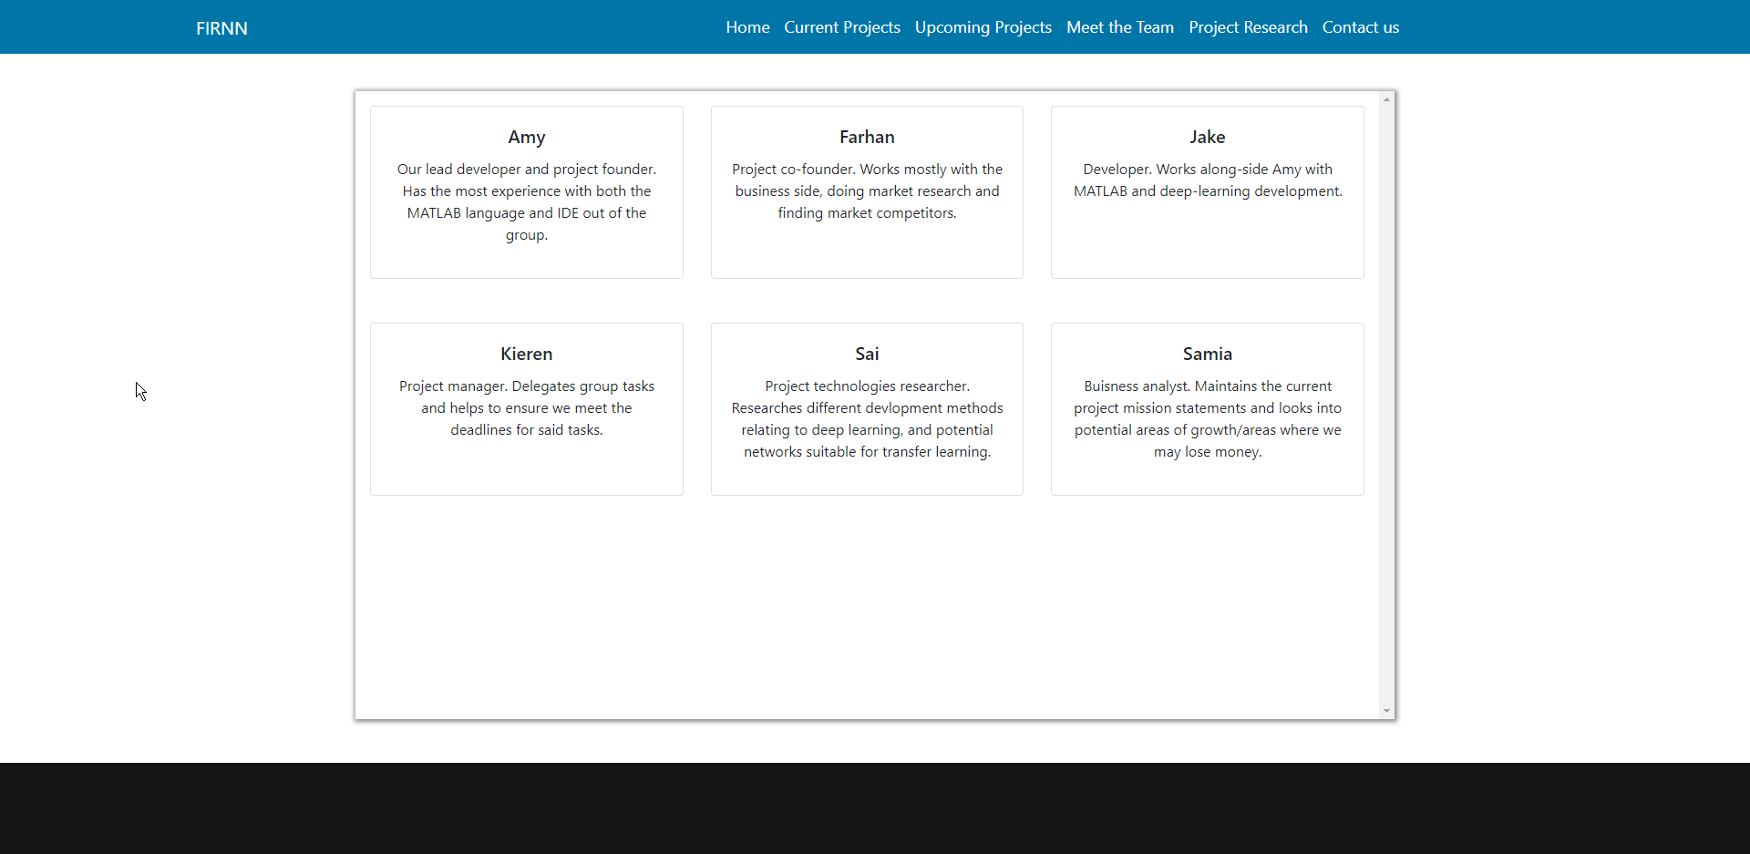
Figure 5 Meet the team

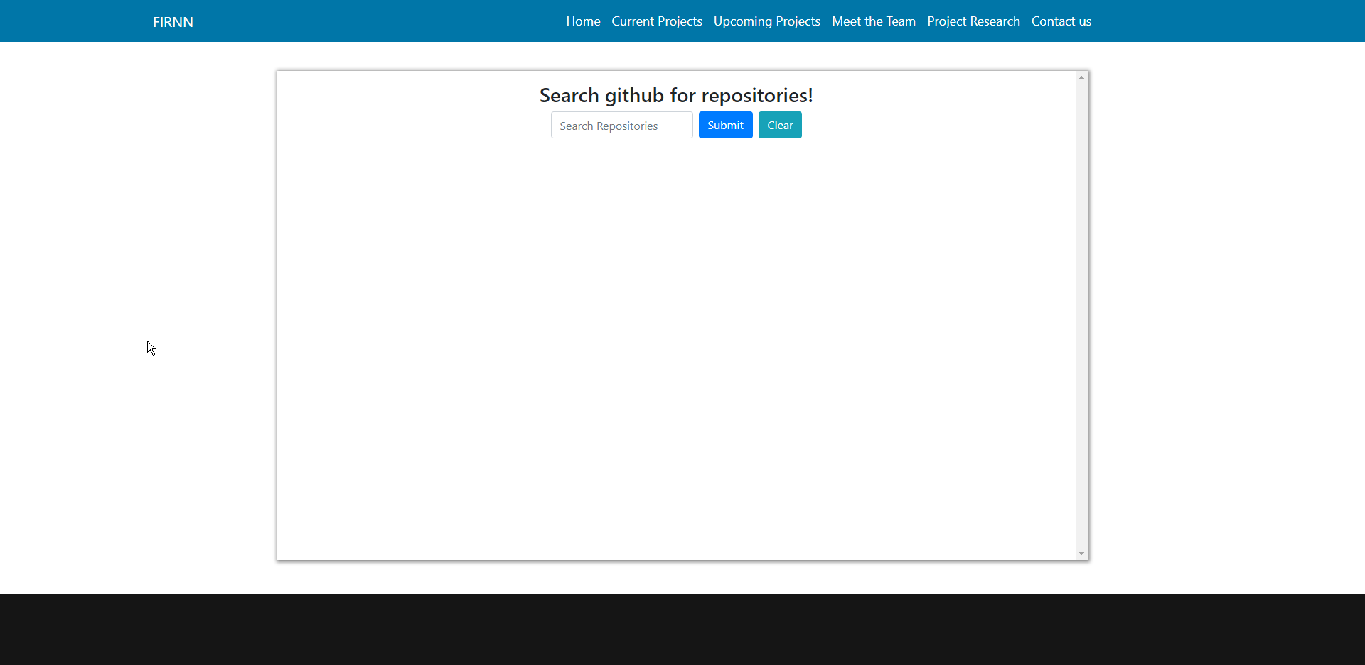
Figure 6 Project research no search results

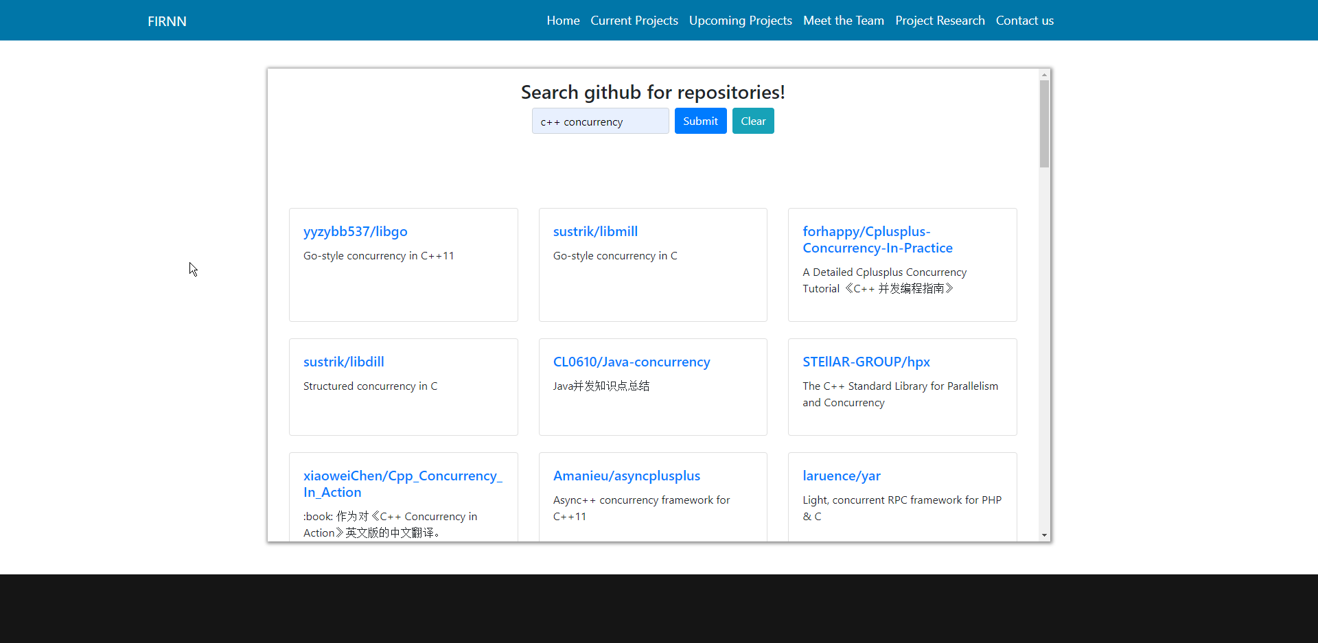
Figure 7 Search results scrolled up

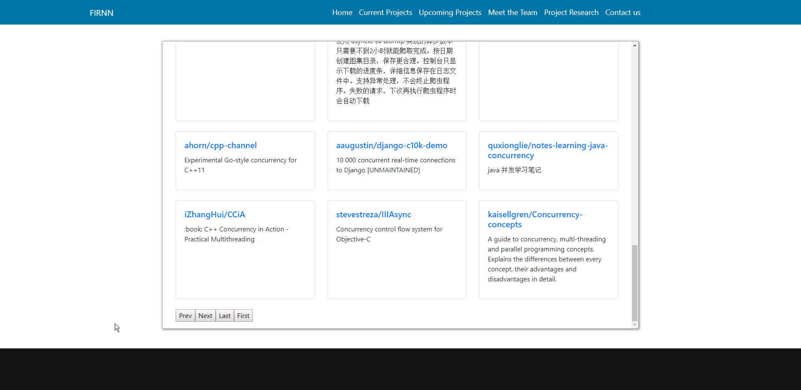
Figure 8 Search results scrolled down showing pagination buttons

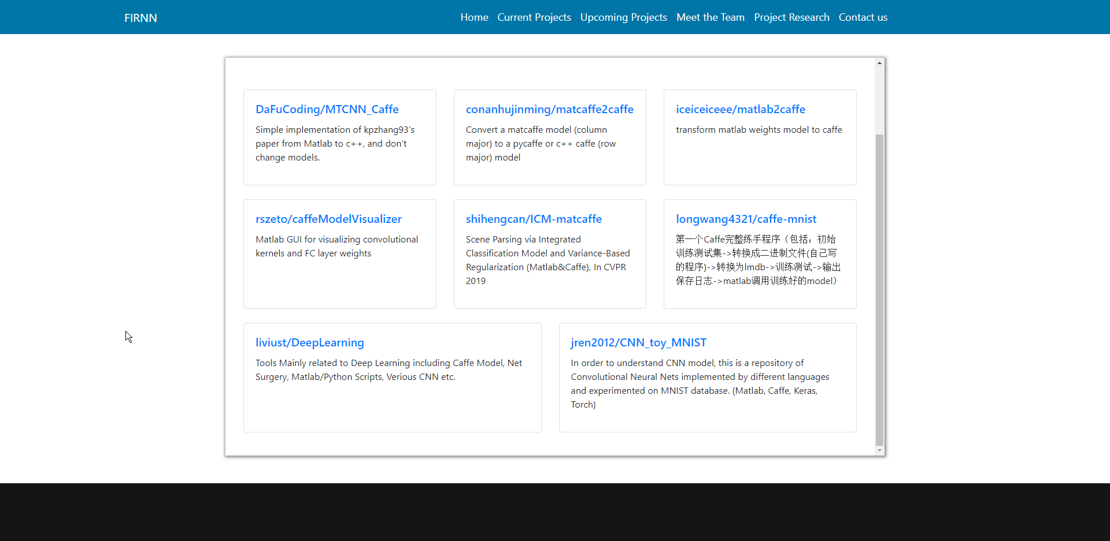
Figure 9 Search results less than 30 results (no pagination buttons)

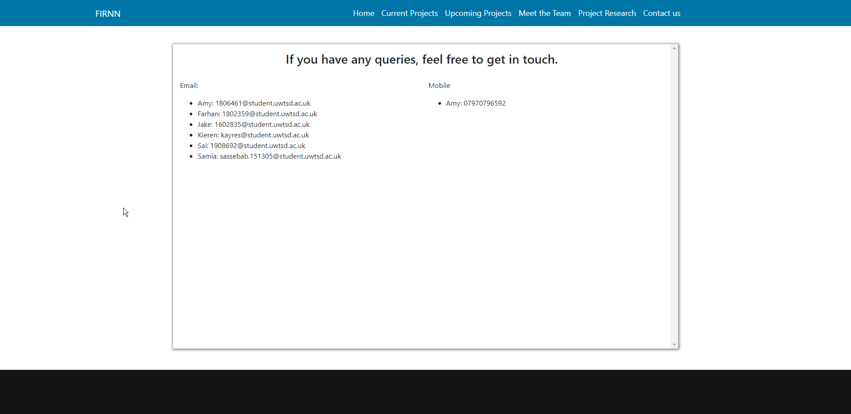
Figure 10 Contact us

4 – Evaluation

4.1 – Test Cases

Code Tested | Date | Input | Expected Result | Actual Result | Pass/Fail
addOpacity/removeOpacity | 23/11/19 | N/A | Navbar background colour transitions based on scroll height | Navbar background colour transitions based on scroll height | Pass. Need to add series of if-statements to trigger the transition at different scroll heights depending on the viewport width
makeColour/makeGrayscale | 23/11/19 | N/A | Image transitions from grayscale to colour/colour to grayscale based on scroll height | Image going gray, but not going back to colour | Fail. Was using two separate images, one colour and one gray and trying to switch between them. Learnt about the filter style property, will use that in next test.
makeColour/makeGrayscale | 24/11/19 | N/A | Image transitions from grayscale to colour/colour to grayscale based on scroll height | Image going gray, but not going back to colour | Fail. Forgot to remove link to the other image in the HTML
makeColour/makeGrayscale | 24/11/19 | N/A | Image transitions from grayscale to colour/colour to grayscale based on scroll height | Image transitions from grayscale to colour/colour to grayscale based on scroll height | Pass. Image starts out with grayscale filter applied, separate to the make-grayscale styling. Then when the page is scrolled down/up, make-grayscale/make-color are added/removed.
getRepos (testing with a static url rather than using the search box) | 25/11/19 | N/A (at this stage just using a static url, the function isn’t taking url as input, that will be added later) | JSON data outputted to the console | JSON data outputted to the console | Pass.
getRepos (url same format as before) | 25/11/19 | N/A (same as above) | Add certain data from the JSON to the HTML | Nothing | Fail. Was using .forEach(), will try again with a normal for loop.
getRepos (url same format as before) | 25/11/19 | N/A (same as above) | Add certain data from the JSON to the HTML | Data added to HTML element | Pass (TODO format results)
getRepos using getUrl function | 28/11/19 | Query from the search box | Add certain data from the JSON to the HTML | Data added to HTML element | Pass (TODO format results)
getRepos using getUrl function | 29/11/19 | Query from the search box | Add data to HTML and in a more formatted way | Results displaying in bootstrap cards | Pass (TODO add pagination)
getRepos with pagination | 3/11/19 | Query from search box and links from JSON header | Display buttons at bottom of results if there is more than one page of results (30 items per page) | Works if there are more than 30 results, throws an error otherwise | Fail, didn’t provide a way to break out of the loop early. Should use a while as the outer loop rather than a for
getRepos with pagination | 3/11/19 | Query from search box and links from JSON header | Display buttons at bottom of results if there is more than one page of results (30 items per page) | Displaying nicely formatted results separated into bootstrap card decks. | Pass

4.2 – Review of Implementation
Given the final implantation that has been reached, the general feel of the web application is easy to navigate and transitions nicely between different screen sizes. The colouring could have been altered on the homepage to make the navbar easier to read when the page is scrolled up, but the desired effect of the styling transitioning from one to another on scroll was achieved nicely and doesn’t seem to affect page loading time all that much. Interactive elements could potentially have been added to some of the other pages, but with the site aiming to act as an information page for development projects, the general layout and feel to the other pages is clean, simple, and gets the point across. In terms of the API used, the GitHub API is certainly easy to use, and there is potential to expand the range of the search for other queries than repositories. Also, in a full implementation the API authorization key [5] should be used to increase the request per hour limit, but for test purposes it is suitable to leave it as it is. While the styling within the media queries is quite basic, they do their job effectively and help to maintain a clean transition between viewport dimensions.

5 – References

[1] | S. Douglas, “Mobile first design - everything you need to know,” Justinmind, 22 January 2018. [Online]. Available: https://www.justinmind.com/blog/complete-guide-to-mobile-first-design/. [Accessed 20 November 2019].
[2] | S. Nagro and R. Campion, “A method for multimedia user interface design for mobile learning,” in 2017 Computing Conference, London, 2017.
[3] | D. J. Bridie, S. Matsumoto and S. Kusumoto, “unjQuerify: Migration of jQuery Snippets to Modern Vanilla JavaSript APIs,” in 2018 25th Asia-Pacific Software Engineering Conference (APSEC), Japan, 2018.
[4] | S. Das, “Fetch API,” geeksforgeeks, [Online]. Available: https://www.geeksforgeeks.org/fetch-api/. [Accessed 2 December 2019].
[5] | GitHub, “Authorizations | GitHub Developer Guide,” GitHub, 2019. [Online]. Available: https://developer.github.com/v3/oauth_authorizations/. [Accessed 9 December 2019].

marking criteria and Student FEEDBACK

This section details the extent to which the assessment criteria are demonstrated by you, which in turn determines your mark. The marks available for each category of skill are shown. Lecturers will use the space provided to comment on the achievement of the task(s), including those areas in which you have performed well and areas that would benefit from development/improvement.

Common Assessment Criteria Applied (Assignment 1) | Marks available | Marks  awarded
1. Engagement with Literature Skills

Very good summary overview of some current application trends but you have not selected any to discuss in further detail. Please ensure that you have understood the assignment brief and verify what is unclear with your tutor. Expand the scope of reference sources consulted to further improve research tasks. (Grade mark: 40.00%) | 25 | 10
2. Knowledge and Understanding Skills

3. Cognitive and Intellectual Skills

A detailed set of test cases has been developed for the different set of JavaScript functionality added to the website. (Grade mark: 75.00%) | 20 | 15
4. Practical Application Skills

A very good attempt featuring a simple website. Although the website itself is quite basic, the implemented API is overall very good. As the website has very basic content, it does not really enable you to really demonstrate responsive functionality. Nonetheless, you have used media queries and have made the basic content responsive to some degree. Generally, I would have liked to see some more advanced content and use of HTML. For the index page JavaScript, aim to improve your coding style e.g. avoid several levels of nested if .. else blocks and refactor repeated code into functions with parameters for what varies. (Grade mark: 65.00%) | 50 | 32.5
5. Transferable Skills for Life and Professional Practice

The report is of a good standard. See your report for some suggested improvements. (Grade mark: 70.00%) | 5 | 3.5

Assignment Mark (Assessment marks are subject to ratification at the Exam Board. These comments and marks are to give feedback on module work and are for guidance only until they are confirmed. ) | Late Submission Penalties (tick if appropriate) |  | 61%
 | Up to 1 week late (40% Max) |  | 61%
 | Over 1 week late (0%) |  | 61%

