BUSINESS PLAN (TERM 2)
COURSE: MANAGING ENTERPRISE IN 21 CENTURY
LECTURER: MALANI GUNARATNAM
COUESE CODE: BMSW 4006

Name of students:
Nathaniel Smith – 1908672 (Team leader)
Aissatu Djalo – 19008378
Sheikh Nasima Ali – 1906866
Ivaylo Dosev – 1909471

Table of Contents

Nathaniel Smith – 1908672 (Team leader)
Executive statement 1
-Skills and Experience 1.1
-Product and services – 1.2
-Objectives – 1.3
-History Ethics and Values – 1.4
-Solid description of the market -1.5
-Viability and potential – 1.6
-Start up funds – 1.7
-3 year plan – 1.8
-conclusion – 1.9

Sheikh Nasima Ali – 1906866
Operations – 2
-Management Team 2.1
-Ownership roles and responsibilities 2.2
-Business options 2.3
-Food packaging supplier 2.4
-legal status and licensing 2.5

Aissatu Djalo – 19008378
Marketing - 3

- Market analysis 3.1
- Market research and segment strategy 3.2
- Types of customers 3.3
- Types of products and service 3.4
- Marketing and promotion 3.5
- Main competitors 3.6
- Key suppliers 3.7

Ivaylo Dosev – 1909471
Finances – 4
-Financial projection 4.1
-Sales and forecast 4.2
-Direct cost 4.3
-Overhead 4.4
-Fixed assets 4.5
-Investment 4.6
-Start up costs 4.7
-Report 4.8
- Projected cash flow 4.9
-Projected profit and loss 5
-Projected balance sheet 5.1

PowerPoint slides – 6

-Executive statement 6.1
-Objective 6.2
-Marketing 6.3
-Finances 6.4

References - 7


Business Plan
VEGAN CORNER
11/05/2020

Work experience/qualifications 1.1

Nathaniel – CEO Has over 8 years experience in the hospitality sector, also holds a level 5 Advance nutritional advisor diploma . “Being transparent in what is in our meals and where it comes from is a key component of our business values” Nathaniel has invested £5,000 towards the start up funds of the business.

Nasima – CEO Has 10 years of experience in the restaurant industry, also worked as a head chef in a restaurant. “Using my experience to provide an efficient service in the fast food environment is key to maintain and improve sales”. Nasima has invested £5,000 towards the start up funds of the business.

Aissatu - CEO Has over 3 years experience as a marketing manager and an IT web designer. “ Our marketing strategy will attract potential customers”. is teaching cooking classes. One called ‘Everyday Cooking’ and another ‘Vegetarian Cooking’ which gives her the understanding and knowledge of the necessary vitamins, minerals and proteins required to enrich a delicious vegetarian diet. She also has attended ‘Food Allergy courses and ‘Food Labelling’. These all will be beneficial to the business as we need to be able to label our products properly making sure that we consider all food allergies and nutrition’s. Aissatu has invested £5,000 towards the start up funds of the business.

Ivaylo – CEO Has over 10 years of experience of the catering industry as he has worked in many restaurants and fast food chains, also also holds a Diploma in Professional Cookery. “Having a healthy, vegan and well presented meal puts Vegan corner ahead of the rest” ivaylo has invested £5,000 towards the start up funds of the business.

Executive statement - 1

Product and services – 1.2

Service
We are a fast food take away trailer (B2C) business located in “Coulson St, Spitalfields, London E1 7TF”. What makes us different from the rest of the food trailers in our area is that we have implemented an App. The app gives us the ability to uphold our fast service promise, by allowing customers to pre order their meals.

Product

Here at Vegan corner our endeavour is to provide organic Vegan meals, which focuses on affordability. Our focus is to provide our customers with a high nutritional meal also being transparent on what is in our meals. We also pride ourself on maintaining an environmental friendly approach by using biodegradable packaging. Having control of our own fruit, vegetables and grain gives us the ability to provide a consistent high quality product.

Our menu consists of:

Hot drinks/ Cold drinks | hot chocolate (seasonal)  Apple, Orange, Mango juice  Fruit smoothies  Distal water  Herbal tea (seasonal) | £1.20  £1.70  £2.00  £1.00  £1.10
Salads | avocados, plum tomatoes, red onions and mixed leaf (with lemon and agave dressing)  Mixed leaf, organic grains and avocado (with lime dressing) | £3.00  £2.50
Starter | super vegan hummus ( with seamoss)  Lentil and sweet potato soup (with seamoss) seasonal soup | £2.50  £3.00
Meals | Chickpea curry, served with Red Rice or Quinoa and a drink  chickpea burger served with sweet potato fries or squash chips and a drink  Beetroot and lentil burger served with sweet potato fries or squash chips and a drink | £9.00  £9.00  £9.00
Dessert | Pea-can pie  Vegan cheesecake  Vegan fruit cake | £2.20  £2.20  £2.20

Objectives – 1.3

Our vision here at Vegan corner is to contribute to society by being a business that provides a healthy fresh vegan option, without loosing the integrity of flavour. With 100% of our food coming from our own urban farm, it gives us the confidence to supply a consistent quality of fruit and veg. Having our own urban farm cuts the cost down on purchasing goods which improves our ROI. We also aim to have an environmental friendly approach by working with “ Decent packing” to ensure all packing that we provide are biodegradable.

History Ethics and Values – 1.4
All of our team are vegans and have some experience in the hospitality business. It was vital that from CEO level to the customer service team, that we share the same core values to keep the integrity of our identity at Vegan corner. We provide biodegradable packing to ensure our brand maintains its ethical foundations.

Solid description of the market -1.5
The demand for vegan food is on the rise according to Mintel Global New Products Database (GNPD) also during the year 2018 the United Kingdom had the highest manufacturing of vegan products. (Mintel reports 2018).

The amount of vegans are on the rise. Surveys shows non vegans also buy vegan meals.
Over 542,000 people are currently on a vegan diet according to a survey taken in the United Kingdom, with a 3.5% rise in the last ten years. It seems the vegan incentive Is being inspired by the younger generation. The 15-34 age bracket make up 43% of the vegan community, in contrast to the 65 and over which only stands at 14%. These numbers show us that there will be more people converting their diet over to vegan in the near future. Overall around 1.68 million people in the UK are Either Vegan or vegetarian.(De Boo 2018)

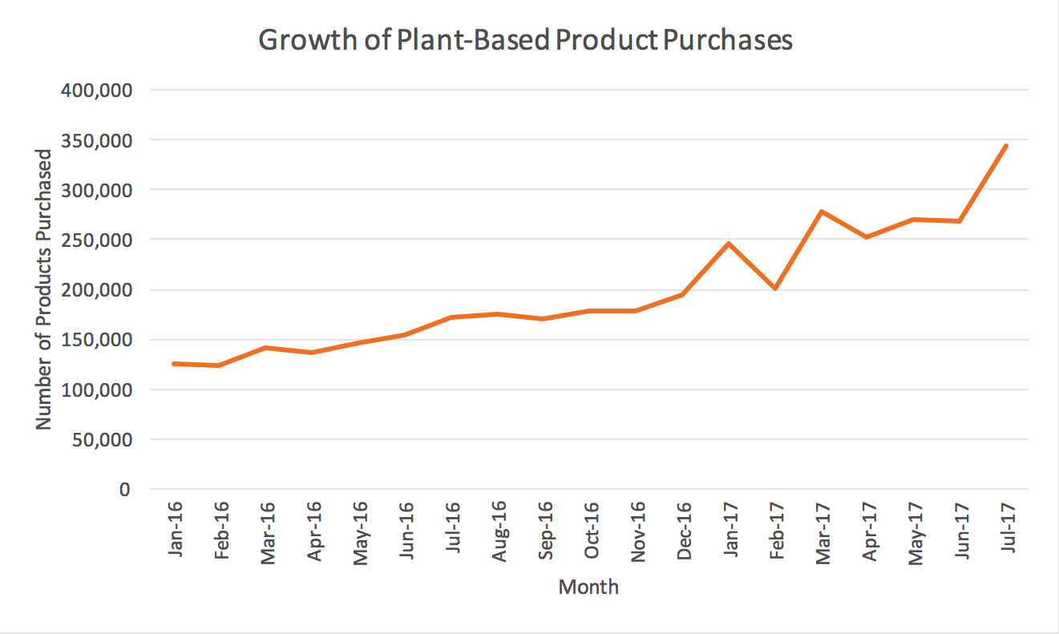
(Millot 2017)

Viability and potential – 1.6

Having one of the fastest service in the food trailers on the market gives us more potential customers than are competitors. According to Neil Patel having high quality customer service
improves revenue also attracting more potential customers. (Neil Patel 2017)

The pricing of an average vegan meal at a restaurant is £37.55 according (caterer.com 2019). Here at Vegan corner our main meal price will be £9.50. A lot of vegans convert back into eating meat within the first year because of lack of information of guy nutrition and meal Plans. This this is where we come in. We also give a detail explanation of what is in our meals, also providing information on the health benefits. The majority of vegan restaurants have not implemented a service that provides vital information to their customers in terms of health.

We are the only fast food trailer in the local area with an app booking system. We handle only vegan products to insure our stock has no cross contamination from meat products.

Start up funds – 1.7

Our start up capital will be £20,000 which has been invested by our four CEO’s

3 year plan – 1.8

1st year– To invest more in the marketing strategies and advertisement, also implemented some of our customer feedback and providing a delivery service during peak hours.

1 - 2 years – Our financial forecast tells us we would be able to open up a restaurant. Having a restaurant would further grow our brand. This will give us the ability to be more competitive and our grow some of our main competitors such as: All Nation Vegan House which is a vegan take away service launched in 2017, their business is based in organic and vegan food.

Hornbeam Café which is a non-profitable operation that works with a large group of eco initiative to help the less fortunate in the area.

Box Park which is a food and retail park that was found in 2011 in Shoreditch with a turnover of 58% to 12.5m, the success of the first location they have more location in London its famous place where food lover tend to go for a good fast food with significant number of vegan food there are enough for customers to experience a different cuisine.

3rd year - To open up a chain of restaurants around London that would put us in a strong Positions to compete with some the major food cuisines in and around London.

Conclusion 1.9

The vegan market is on the rise, based on the numbers shown it is a good time to get into the hospitality industry in regards to vegan cuisine. Our direction to start of as a trailer allows the four of us to gain the capital needed to open up the restaurant after two years. We all have the experience and the expertise in our respected fields to run and maintain the business without any external support. Spitalfield food market is a primed place in the heart of London for food trailers, due to the lack of exclusive vegan restaurants around the area puts us in a strong position to generated a vast amount of customers. Our USP focuses on organic vegan food also providing meal plans for our customers through our App. Our geolocation app allows gives us the ability to reduce queuing tim, which promotes high a quality service. Utilising our own urban farm gives us the ability to grow high quality fruit, vegetables and grains, keeping our costs down. It also gave us the financial power to partner up with “Decent packaging” to provide our customers with biodegradable packaging, which also ties into our key values.

Operations 2

Work Experience and Skills
This is a quick overview demonstrating why these people have the right skills, experience and qualifications to operate the mobile food trailer.

Nasima has more than 10 years of experience in the food and restaurant industry servicing as a head chef in a restaurant. Running the full operation of the kitchen and catering for special events. She will bring food preparation skills and expertise’s to the business to make sure there is a high quality and efficient cooking standards in the kitchen. Also previously done administration work in a fast food chain working with their advertising and sales team.

Nathaniel has served as a manager at a top restaurant for over 8 years and supervised the daily duties and tasks for the restaurant. Has a Higher National Diploma in Hospitality and a level 5 Advance nutritional advisor diploma. He has very good customer relationship skills and is working in the events field, arranging and organising major events where he is able to demonstrate his general cooking abilities. He has many useful contacts in the food industry.

Aissatu is teaching cooking classes. One called ‘Everyday Cooking’ and another ‘Vegetarian Cooking’ which gives her the understanding and knowledge of the necessary vitamins, minerals and proteins required to enrich a delicious vegetarian diet. She also has attended ‘Food Allergy courses and ‘Food Labelling’. These all will be beneficial to the business as we need to be able to label our products properly making sure that we consider all food allergies and nutrition’s. She also has over 3 years’ experience as a marketing manager and IT web designer

Ivaylo has a level 3 diploma in Agriculture and has done an apprenticeship in Farm Management. He has volunteered in the Local Farming Community Scheme promoting awareness of environmental work and helping out in cooking classes. He has previously worked in the distribution section and handling of goods, delivering food to a vast number of food companies. He has started his own Urban Farming business where he is producing organic fruit and vegetables using sustainable agriculture and food production method.

All the members share the same interest in the Vegan style of cooking and have all had a Vegan diet for the past 4 to 5 years, so promoting and selling the vegan experience and lifestyle will come naturally to them and they also will have knowledge of what the customers’ expectations are, without compromising on any of the flavours. Everyone on the team have a good understanding of vegan cooking and therefore can create a balanced heathy meal plans taking into consideration good nutrition’s, vitamins, proteins and any allergies to attract Vegan’s, Healthy Eaters and Non-vegan’s.

Management Team 2.1

This is an overview of the management team and roles and responsibilities that the 4 individuals will have towards the business. (Ward. S) All the members will be part time employees and will take in rotate doing different jobs and running of the business. As mentioned, they all have a vast range of knowledge, skills and experience and as it is a takeaway service not all four members need to work at one time. Three members of the team are sufficient enough for the running of the food trailer and if necessary, the fourth member could help at busy times or special events. This will help to utilise the experience and knowledge that all partners have in the different fields. Will also allow us to keep our costs and wages down. In the future once the business has been established and has expanded then in the next 1 to 2 years, we may consider hiring more staff to increase our productivity.

Over time this structure will grow, and changes will occur. Meaning that it will be monitored, revised and definitely updated.

Ownership Roles And Responsibilities 2.2

Nasima CEO 25% Dealing with the daily preparation and cooking of the food. Planning and modifying the menu and Managing the business. Serving the customers and doing general administrative work for the business. Dealing with the Sales aspects of the business. Driver of the food trailer.

Nathaniel CEO 25%
Managing and supervising the operation of the business also doing the cooking. Dealing with the Financial and Legal aspect of the business as well as advertising the business to potential clients. One of the drivers for the mobile food trailer.

Aissatu CEO 25%
Dealing with the daily preparation and cooking of the food. Planning and modifying the menu. Serving the customers and running the business. Designing the Website and the App. Also, one of the drivers for the mobile food trailer.

Ivaylo CEO 25%
Producing the produces (organic vegetables and fruits) and supplying to the business from his urban farm. Dealing with suppliers. Cooking and serving the customers. One of the drivers for the mobile food trailer.

As a new business we will be developing and launching our own ‘App’ for the business this will allow customers to pre order their meals which no other mobile food trailers have implemented. We will be the first to introduce this and will attract customers as it will be a convenient way for them to place an order. The App will help us to manage and control the queues at lunch times and busy periods This will be done by our IT designer Aisha, who will also design our website. Enabling us to keep our outgoing costs down. All the members of the team will be trained to use the App. We will continue to improve our software and in the future we will be considering doing delivering, that will be our short-term goal after establishing the business.

Business Operations 2.3

This is a plan that gives a clear information on how the business will run. Description of location, equipment, facilities, suppliers and anything that contributes to the daily running of the business. (Ward. S)
As this is a direct distribution (selling straight into the customers hand), it is simple and profitable. At a later stage other distribution processes will be included.

We will not be outsourcing our produces as our USP states we will be using all produces from our own Urban farm. He will supply us with our fresh organic fruit and vegetables. This will help to keep costs low and generate more profit.

Location: Coulson Street, Spitalfields, London E1 7TF (food Market). Spitalfields Market is one of East London’s top hot spot for food and drink and there is always something interesting and exciting happening there. There are a vast range of family friendly restaurants there and our mobile food trailer will bring a different and unique experience to the potential clientele. The Market sells a variety of goods from handcrafted items, antique goods to high-end fashion and vintage clothing’s to dealing with arts and crafts. So, this is the ideal location for us, as there is a wide range of people our food trailer will attract. We have applied for vendors space through an online application form.

Time of opening will be from 11:30 am to 5:00pm before that, the members that are cooking will need to prepare the food. We will be using our own kitchen to do all preparation of food so that we can keep our costs down and then do general cooking of items in the food trailer. When we expand, we will consider hiring out a commercial kitchen for doing all the preparations as we will definitely need a larger space. The opening times were considered so that we can catch the lunch time trade and passing by customers to the market and also the traders in the market as they have no designated time for lunch.

The food trailer that we have bought for £13,000 has all facilities and equipment’s included in it for the running and functioning of the business including Kitchen sink, cooker, oven, countertops, refrigerator, griddles and other necessary utilises. (Mitchell.J) Whilst buying the trailer we needed to consider which equipment’s were necessary for our business, so a trailer that is fully loaded would not be practical for the business and not be cost effective. Having a trailer that has enough space for three to four members to work in is essential due to health and safety and good working environment.

Food Packaging Suppliers 2.4

We will be using Environmentally friendly plant-based compostable food packaging, this will include a range of products such as plates, bowls, cups, cutleries and take away containers. We are going to use a company called Decent Packaging. They have an online ordering system; all we have to do is create an account and there is a next day delivery service which will be time saving and very convenient. We can custom brand the packaging to suit our business which will make our products stand out from the rest of our competitors. We plan to keep only one supplier so that we can create a good relationship with them and pay our supplier monthly. It is very important to everyone in the business that we make a conscious effort to meet all sustainable, social and ethical requirements. This will allow us to fulfil our consumer needs through using reliable and stable products.

Legal Status and Licensing 2.5

There are many legal statuses and liceansings that need to be followed for a mobile food trailer.
When a new business is formed it is necessary that the business applies for a Food Business Registration with the local authority, this is free but needs to be registered at least 28 days before the business starts trading. (www.Gov.uk)
Once the business is registered, it will be inspected for a Food Hygiene Rating Scheme (FHRS), then the business will receive stars, the more stars the better 1-5. This is to promote the importance of good hygiene.
Need to get a Trading Licence from the local council to operate on public streets and roadsides.

Nationwide Caterers Association (NCASS) to get food safety qualifications to sell food to the public.
Level 2 Food Safety and Hygiene Certificate for handling, preparing and cooking food.
Level 3 Food Safety and Hygiene Certificate for anyone that is managing and supervising the team.

Hazard Analysis and Critical Control Point (HACCP) this is a documented plan of how the business will store, prepare and transport food safely and keep food safe from any biological, chemical and physic food hazards. (Dudd. G)

Business Insurance
Employers Liability Insurance which will cover the employer for any health and safety of employees.
Public Liability Insurance this is protection against any compensation claims made by customers and the general public regarding any hazards associated with the running of the business. (Dudd.G)

Register with HM Revenue and Customs (HMRC) for the street food business no matter how small. Making sure that there is an up to date record of the business’s money for income tax self-assessment each year.

Gas/electrical safety Certificates. This is needed to ensure the safety of everyone. A check to make sure that all appliances are installed safety and this needs to be done every 6 to 12 months’ time.

Marketing 3

In this segment of our business plan I am going to be discussing our market research, the types of customers we intend to reach with our products and the nature and ways we intend to satisfy their needs with our services; how we intend to promote our product in the market and who are our main competitors. We shall also be discussing how we intend to beat our competitor and reach out to those whom our main competitors have fail to reach and transform them from potential customers. We shall also be discussing who our intended main suppliers are and how their method of supplies will help our business grow.

Market Analysis 3.1
According to Independent. (Aug 2016). “The number of people in Britain who follow a vegan diet has increased 360 per cent over the course of the last decade”. As a result of this existing businesses are trying to meet ways to fit with “veganism” by creating new products to meet the consumers demand, Vegan Corner will use its strength, which is 100% vegetarian food from the beginning. The well-known companies such as PIZZA HUT and PRET MANGER did implemented vegan options; also, MC Donald’s have introduced various types of vegan offers in its menu due to the growth in the plant-based diet within the industry. Vegan Corner operate within the largest grown food and restaurant industry, while the industry has its ups and downs. The discrepancy is smaller than economy itself, it is no secret that human is required to eat and they eat-in and save money but knowing that place where it is a call or walking distance. This can be massive incentive. Restaurants are less affected by economy’s downturn which it does not mean that they are untouchable by the reception, The Vegan corner market segments has no specifics. It is for of all ages, social classes, and incomes. Unlike how the market or industry can make its separations. The Vegan Corner is suited for anyone in need of that educational and healthy food balance in day to day. As of start to a long-term goal The Vegan Corner will target families, individuals, and businesses to achieve its goals soon which is opening numerous of restaurants in corner of London and UK at large. As of start the Vegan Corner food trailer will be situated in a visible and busy area of London “Coulson St, Spitalfields, London E17TF. In the beginning Vegan Corner will be a takeaway service. The Vegan Corner will operate within the rapid casual slot or compartment in the restaurant industry. Vegan Corner main competitors is within vegan restaurants, and traditional restaurants which provides only healthy food.

Market research and Segment Strategy 3.2

According to our market research that we carried out on vegetarians buying and eating habits, we came to these conclusions and intend to approach the market as follows:
Vegan Corner will be focusing on families and individuals for multiple reasons.
1. As a takeaway service that is diverted. The Vegan Corner will take advantages of households where adults have less time to prepare meals
2. Through the Vegan Corner App. Our App is going to be available on google play store and App store for customers to download.
3. Mobile phones call. Customer can also call us direct through our central number where all purchase orders will be received.
4. Direct purchase. Customers can also buy directly from our stands and stores.
With these four services available to our customers Vegan Corner aims to reach and have a positive impact on all of consumers and potential customers while offering varieties of vegan food to customers. Vegan Corner will be educational and will offer guidelines to customers on what they are consuming. As a method of captivating customers and potential customers there will numerous educational classes available to customers that will be called “EVERYDAY COOKING” and “VEGETARIAN COOKING”. With this Vegan Corner aims to bring awareness on how important vitamins, minerals, and proteins are in every healthy diet. At the Vegan Corner there will be parts to win it competitive margin to rapidly attain the market. Vegan Corner promise consistency in its services and standard while delivering an outstanding experience of fast healthy food. According to Happy Cow. (2020) “Numerous studies have indicated that all animal products increase the risk of obesity, heart disease, cancer, diabetes, cataracts, stroke, hypertension, and other life threatening illnesses, while many vegetable foods protect against these same diseases”. Vegan Corner will always be there to support and give healthy alternative to our customers
Vegan Corners marketing will define the trust and affinity that is needed from seller to customer and potential customers, with the only message being affordable, healthy, and tasteful. With this we intend to achieve through several ways details to improve our Marketing Strategy.
Annual Sales Forecast Table
Graphical Representation
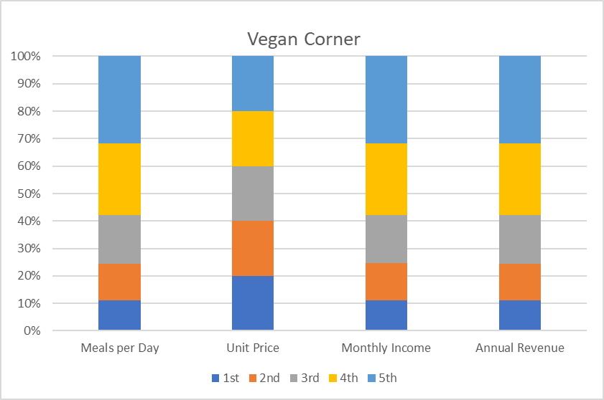

Types of customer 3.3
According to Populus. (2016). “The vegan society has evaluated that the plant-based diet consumers are gravitating in the UK market, as part of incentives for the public, there are some famous cooking shows that have implemented only vegan menus as part of the competition”. It is recognisable that there is a growth within the industry. According to Populous. (2016). “It varies from numbers to numbers of “healthy eaters” to a “loyal vegan”, although 52% of British shopping presents their attraction for plaint-based food only 2% of its total figure shows a clean 100% vegan diet at all times”. As the times go by the dominant reason behind Veganism becomes understandable. That is Health and Ethics related. According to Eddie Huang. (2019) “We need to change. I am going to go vegan because it takes 20 times less land to feed a vegan than a meat-eater and over 90% of the land cleared in the Amazon rainforest since 1970 is used for grazing livestock.”
Types of products and Services: 3.4
We will be selling organic vegan products such as listed below, as we are heading to the summer season hot drinks will not be available as we expect changes in the menu and customers request.
Types of Products
Salads  Avocado  Sweet potato  Falafel  Super vegan  Humous | Breads  Avocado and olives  Tomatoes  Super green  Humous
Cold Drinks  Fruit Drinks  Smoothies  Water  Cold Tea  Herbal | Sandwiches  Avocado  Super green vegan  Avocado and Humous  Vegan chili  Avocado olive | Fruits  Mangoes and lime  Pineapple  Berry Family  Fruit salad  Melon and Banana
Soups (seasonal)  Tomatoes and Mint  Mushroom  Peanut  Sweetcorn  Butter nut  Carrot | Wraps  Avocado and Herbs  Rocket potatoes  Super green  Vegan chili | Desert  Pea-can pie  Vegan cheesecake  Vegan fruit cake  Ginger bites  Almond bites

Marketing and Promotion: 3.5
Vegan Corner sales strategy will be focus on converting new and potential customers into long term customers alongside our fix customers “Loyal customers". Vegan Corner will achieve this with numerous of approaches:
- Vegan Corner Punch cards: For every 10 meals purchased, the 11th will be free of charge or complimentary from VEGAN CORNER. Punch cards is a successful way of growing revenue from a group of customers. There are greats levels of effectiveness in providing a punch card to customers. It gives them value for the money while saving on the 11th meal. It also shows our appreciation and validation on our consumers preferences.
- Everyday cooking and Vegetarian cooking: Our cooking classes will be offered through telephone calls, virtually and through the Vegan Corner App. With this extra service, we aim to gain customers trust by helping them understand and acknowledge the importance of Vegan Corner. Through these services, we intend reach our customers diversely and have an edge over our competitors. This will expand our sales as well as create long term customers.
- Location: The vegan corner food trailer will be situated between high streets and residential areas to enable access to customers. Sight attracts customers. Customers going either home or to work can quickly pick up their meals or place an order.
- Placing our food trucks in central places will also help us gain customers, as our Trucks shall be brandish with our Brand name and food Menu from Vegan Corner.
Advertisement:
- Vegan Corner will use THE TIMES Magazine as its main media advertising for the first month of its opening. With this we intend to reach and inform customer about the new organic food chain “Vegan Corner” in London. Flyers will be made available weekly, bearing address of Vegan Corner trailer stand in London.
- The VEGAN CORNER App is another method of marketing. Now adays everything moves on fast pace and people spend more time on their mobile devices. The new marketing trends today are Google, Snapchat, Instagram. Everything is connected to the internet.

Main competitors 3.6
Vegan Corner operates in comparisons to the new segments. This section is broadened in reaction to the growth and demand for higher standards in Vegetarian food. Since there is some sense of growth on demand within the industry from consumers in search of knowledge and better quality of food, it is important that the customers’ satisfaction remains the Vegan Corners top priority to succeed in this industry. Impression and experience have a great impact on people, especially in the Vegetarian Market. Its essential that we deliver exceptional customers services and products to have them returning and bringing potential customers. We will implement a “Diet Plan” method to help consumers to help them have a good understanding why Vegan food is healthy to their body and mind as well.
Competitors:
The following research was conducted through happycow.net to see who our competitors are.
- All Nation Vegan House: it is a vegan take away service launched in 2017, their business is based in organic and vegan food.
- Hornbeam Café: is a non-profitable operation that works with a large group of eco initiative to help the less fortunate in the area.
- Box Park: is a food and retail park that was found in 2011 in Shoreditch with a turnover of 58% to 12.5m, the success of the first location they have more location in London its famous place where food lover tend to go for a good fast food with significant number of vegan food there are enough for customers to experience a different cuisine.

We intend to compete with them with the marketing strategies mentioned under our marketing and promotion.

Key supplier: 3.7
As a vegan company we aim to produce the best of plant-based products for our consumers. This is our priority; we have an urban farm where we will be cultivating all a range of ingredients needed to prepare 100% organic vegan food for our customers. Quality and standard are the driving force for us to take this extra mile of producing everything. Food from the farm to the customers plate. In order to select our suppliers for packaging we have conducted research into numerous potential suppliers for our biodegradable packaging, while considering their prices and the suppliers credit terms. We have visited our main suppliers to ensure that products and services that they offer meets our standards. We have also verified with companies that buy packaging from these suppliers in search to ensure that quality and services are consistent, and we found a preferred supplier willing to supply at our own terms. We also have a numbered of alternative suppliers in case of any problems that may arise causing disruption in supply chain.
Decent packaging
Will supply the following products:
Bio Plates
Bio Bowls
Bio Lids
Bio Spoons
Bio Knifes
Bio Forks
Bio Cups
Bio Bags
Bio Straws

Finance 4

The hospitality industry has attracted many players in service provision and investment. The increase can be attributed to the ever-increasing tourism activities in the sector in the past decades. There is a very high need for accommodation activities, recreation facilities as well as food and beverages. However, there has been a minimal emphasis on the services for the people that do not eat animal product meats. Our investment is, therefore, aimed at providing mobile vegan food.

Financial projections 4.1

Financial resources form the back born and fundamental part of any organisation. For our introduction to the industry, we will need for the effective operation and meeting of the required costs as the business gains stability. Like any operating business, setting goals and objectives is vital to oversee and evaluate the growth process (Skinner, 2018).
Our primary financial objectives are:

✓ Quality service provision for the vegetarians
✓ Financial stability
✓ Return on investment
✓ Revenue growth
✓ Profit maximisation
✓ Ethical operation.

Within the first year in operations, the business is focused on ensuring that it provides the services to the customers effectively, the available resources can do the function with the ability on the firm to increase on the assets with the increase in need. The return on the investment of the owners should be realised within the shortest period possible in a proper way. The business has an objective of ensuring that all the legal and statutory documentation and requirements are entirely in order with within the first three months in operation. With the projected customer response and government support, the business should have attained financial stability within four months of activities where the revenue collected from the distribution of food is enough to settle all the recurrent business expenses and buy additional raw materials to enable the production process.
The business owners expect with the entry into the industry; the business will survive the industry forces and take advantage of the assumed vegan food sector. This will be strengthened by the mobile service provision nature to reach more potential customers. High sales are expected to maximise profits and the owner’s value in the investment.

Sales forecast 4.2

The current situation in the economy gives us the most top operational advantages as a mobile vegan food provider over physically located food dealers. This is because of the functional restrictions on people set by the government. The control measure of the spread of the pandemic. This will also limit our services to day operations giving us the opportunity as well as restriction to provide lunch and dinner meals only. With the comparison of the price in the industry, our food will sold at a relatively lower price:

The price for a meal at Vegan corner is £9

We are forecasting at serving 100 customers daily in the entry period. However, this target might be much lower due to the expected market demand. We predict rapid growth in demand and the number of customers at a rate of 20% weekly in the first two months, 15% in the subsequent five months, and after there a steady growth of 5%. This will help us make a revenue of about £950, 000.

Sales forecast
Sales |  | £950,000
Cost
Cost of sales |  | £317,000
Forecast Gross profit |  | £633,000
Operating expenses
Miscellaneous selling expenses | £50,000
Advertising | £1,000
Transport | £75,000
Market research and segmentation | £25,000 | (£151,000)
Forecast Gross profit |  | £482,000

Direct costs 4.3
A direct cost is an expense or price that can be directly tied to the operation of specified business activity (Gilbertson, Lehman and Debra, 2017). Direct costs are always assumed to the cost related to material and its conversion process and labour cost.

➢ Business structure: £8,000
➢ Cost of raw materials: £15,000
➢ Travelling and transportation: £75,000

Overheads 4.4

Overhead is an expense that is incurred by the business; apart from the direct costs (Wheeler, 2019). Overhead expenses help the business in the ordinary business operation that helps the business to maintain normal operations as well as growth. For example, the advertisement might to directly create an impact on the sales volume within one day, but continuous adverts give the potential customer the desire to taste the product. This, therefore, increases the sales volume as a result of the impact of advertisement. Market research, on the other hand, will enable the business to identify the specific target market and create segments based on the identified characters and similarities within the customers. This helps the business in addressing the particular customer needs and helps in the quick growth of the business in the industry. For instance, our business will deal with Vegan food; it will be, therefore, very important studying the market and identifying where we will enjoy high sales (Blocher et al, 2017). Some of the overheads that we will incur includes;

➢ Communication charges: £980
➢ Advertising costs: £1,000
➢ Market research and segmentation: £2,500
➢ Administrative costs: £3,000

Fixed assets 4.5

Fixed assets, also known as non-current assets, determine the ability of the business in effective service provision (Khan, 2018). The use of standard service helps in quality service as well as quantity service provision with less effort used even though the assets does not become part of the finished product. For our operation and provision of foodstuffs, we will need assets for use at the food preparation station as well as assets for use in the delivery process.

Fixed assets
Storage facilities | £4,000
Other utensils | £5,700
Oven | £700
Liquid fire protection system | £4,500
Business structure | £7,000

The assets are expected to be improved and expanded with an increase in the number of customers and demand.

Investments 4.6

The operations of the business are expected to be caught upon within the shortest period since we are dealing with the provision of essential services. This will, therefore, lead to high profits generated within the shortest period. However, these profits will not be invested in other investment opportunities; this will be ploughed back into the business to increase the owner’s worthy. Besides, ownership will be solemnly belonging to the five founders of the business. Any additional capital into the business apart from the owner’s capital increment will be accepted but in forms of loans or grants.

Start-up costs and funding 4.7

Our total start-up cost will be £20,000. This will be funded by an equal member contribution of £5,000 for the 6 members adding to £20,000. We will also take loans and expect to get some grands to help finance other necessities where the £20,000 budget will not have covered. Besides, the cost spend on inventory will be relatively low since the business owns an urban farm. The farm will supply with the necessary farm inventories where only the non-farm inventory will be purchased. This money will, therefore, be spend on decent packaging that is environment friendly.

Start-up costs and funding
Liquid fire protection system | £2,400
Business structure | £7,000
Pre-opening expenses | £800
Trailer | £13,000
Business app | £2,100
 | £20,000

After start-up, more expenses are expected to be incurred due to the projected rapid growth. This will lead to the business getting more services on credit terms to enable efficient operations. However, the finance department will remain vigilant to ensure that the business does not run bankrupt or fail to pay its dues as and when they fall due.

Reports 4.8

The business will be preparing annual reports to project its development, operational expenses as well as profit generation. The business will be making a cash flow statement, a statement of profit and loss, and a balance sheet on an annual basis. The reports will be presented as developed in the projected reports.

Projected cash flow 4.9
The cash flow statement shows all the money that comes into the business whether in the form of members contribution, cash form sales and other operations, and the money going outgoing as a form of expenses (Gilbertson, Lehman and Debra, 2017). The cash flow statement deals with the cash items and the main business operations. Our business will mainly be dealing with vegan food on mobile service provision.

Cash flow
CASH INFLOWS
Cash from other operations | £0
Owners capital | £30,000
Cash sales | £950,000
Cash from receivables | £5,000
Total cash received | £985,000
CASH OUTFLOW (EXPENSES)
Operation expenses | £448,000
Business bills | £235,000
Transportation | £150,000
Other cash expenditures | £97,000
Total cash spend on business operations | £466,840
Net cash flow | £578,160
Cash balance | £503,160

Projected profit and loss 5

A profit/loss statement shows the profits or losses that the company makes during a stated trading period (Gilbertson, Lehman and Debra, 2017). The profits or loss is determined with the number of activities the business carries out during the period being accounted. Our business entails the mobile distribution of vegan food; hence the sale of food will form our primary source of income for the business.

Profit and loss
Dated
INCOME
Income |  | £950,000
Cost of sales | £317,000 | (£317,000)
Gross profit |  | £633,000
EXPENSES
Business structure (Mobile structure) | £7,000
Miscellaneous selling expenses | £55,000
Market rent (145*48weeks) | £6,960
Advertisement | £1,000
Technology | £2,100
Transportation | £150,000
Market research and segmentation | £25,000
Food hygiene | £100
Salaries and wages | £120,000
communication | £15,000 | (£382,160)
Net Profit |  | £250,840

Projected balance sheet 5.1

A balance sheet statement shows the assets of the company and the capital and liabilities that finance the assets (Khan, 2018). The net assets should be balancing with a sum of all the capital and liabilities financing the company.

Balance sheet
Dated
Non-current assets
Business structure (Mobile structure) | £7,000
Trailer | £13,000
Business app | £2,000
Other long-term assets | £17,550 | £39,650
Current assets
Cash | £15,000
Bank | £6,900
Inventory | £6,050
Account receivables | £9,000 | £36,950
Total assets |  | £76,600
Liabilities and capital
Current Liabilities
Account payable |  | £25,000
Capital
Owners capital |  | £30,000
Total liabilities and capital |  | £76,600

PowerPoint slides 6

6.1

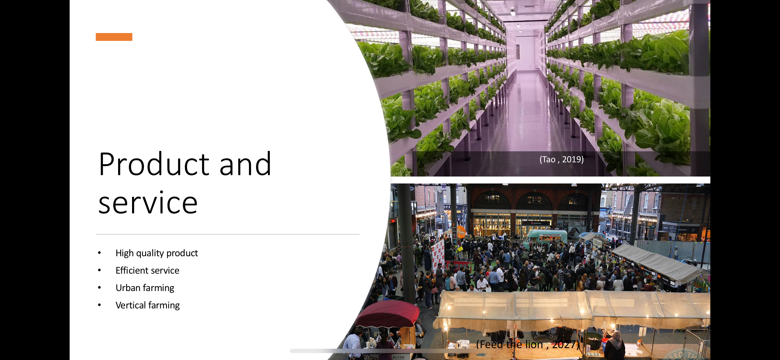

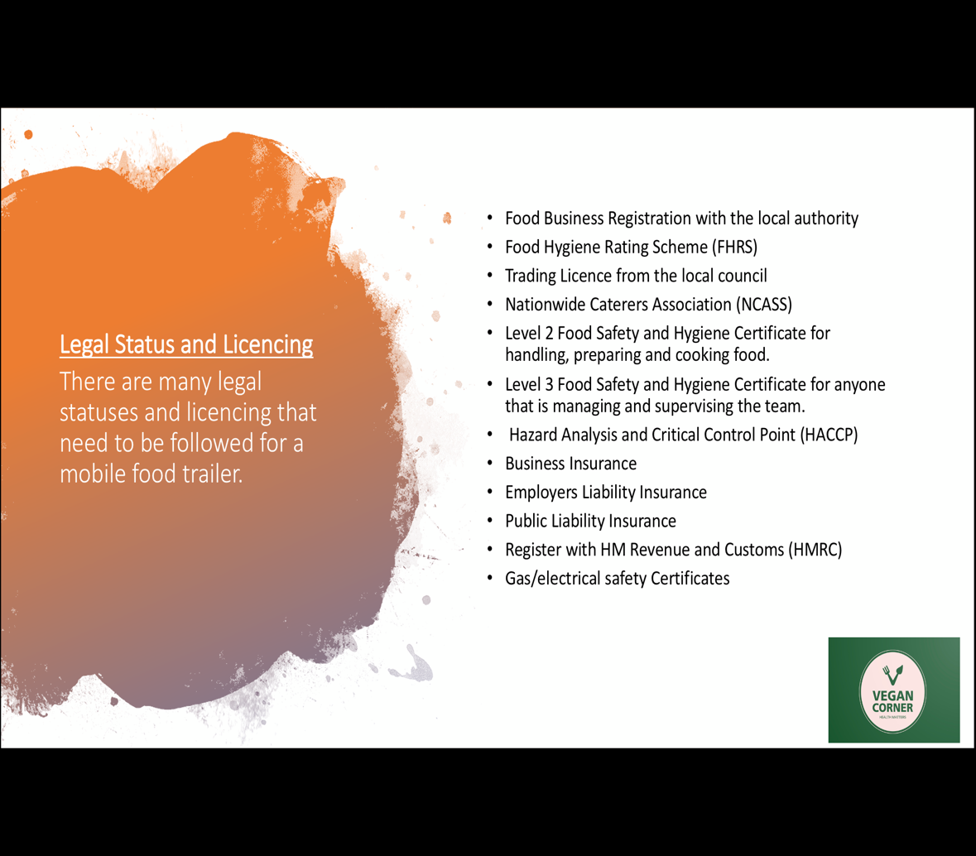
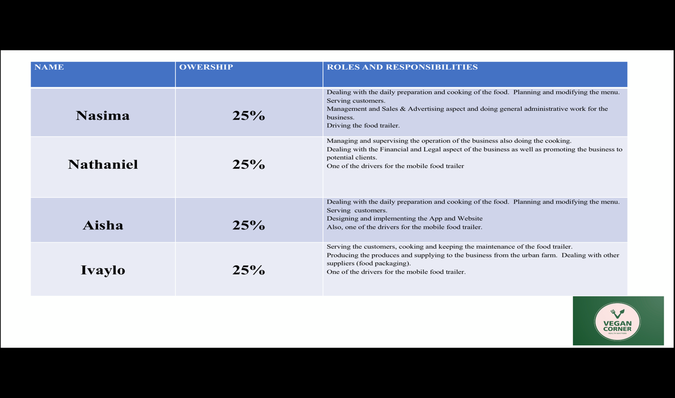
6.2

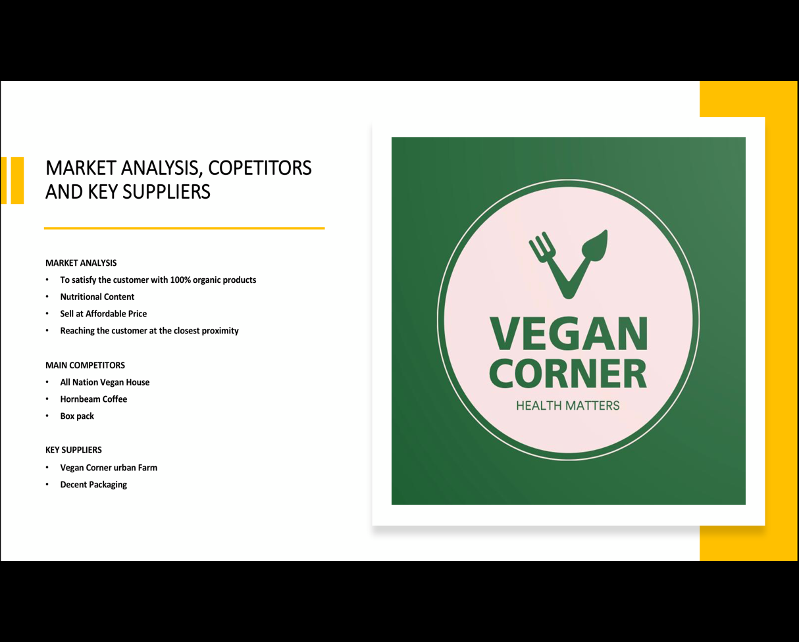
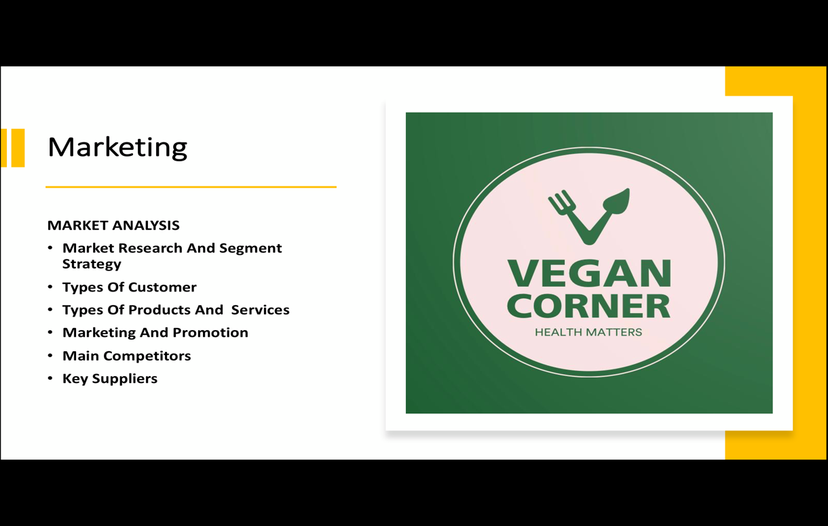
6.3


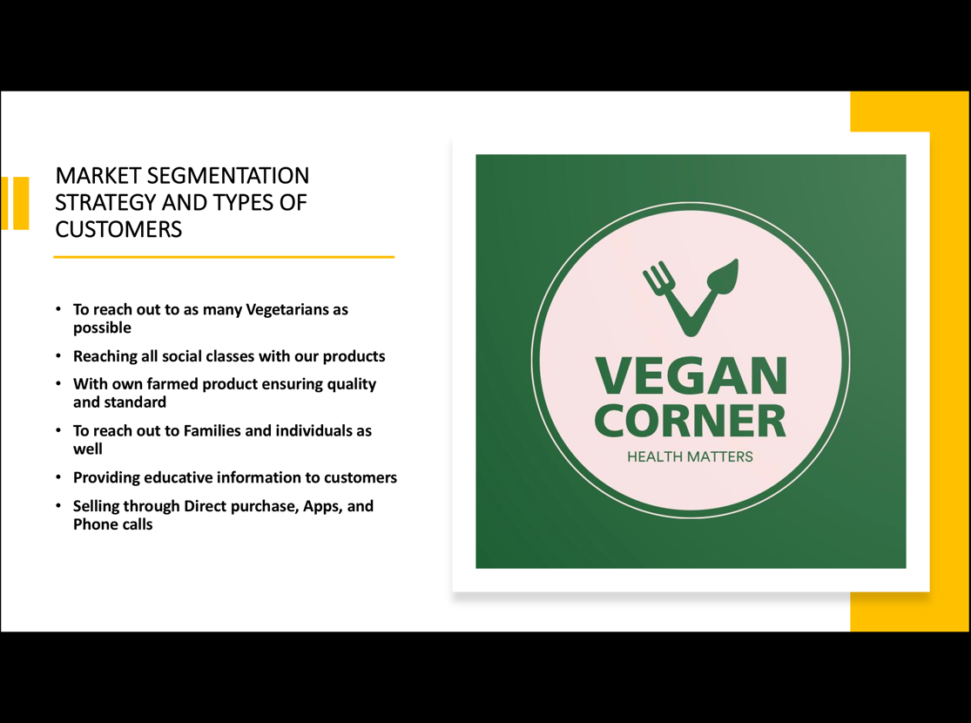

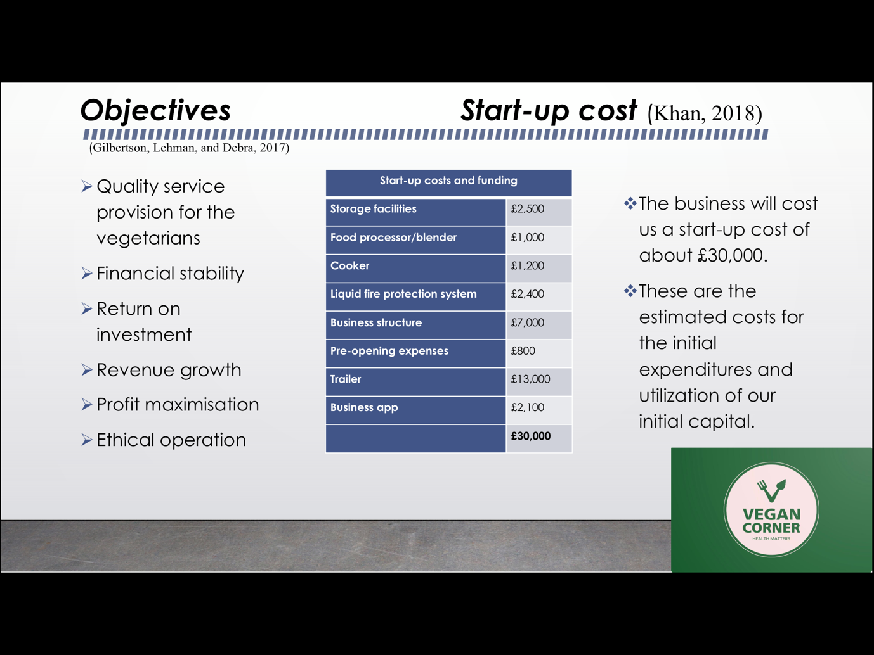
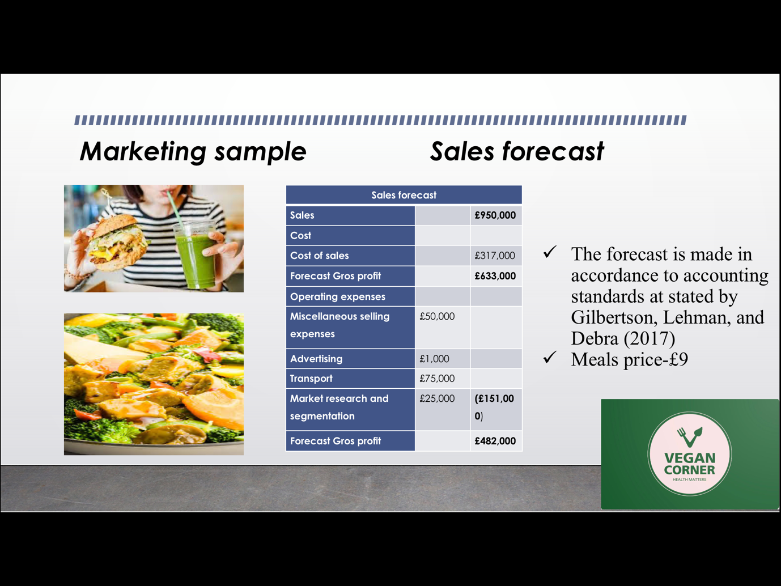
6.4

References 7

Khan, A. (2018). Fundamentals Of Public Budgeting And Finance. 5th ed. New York: McGraw-Hill.

Gilbertson, C., Lehman, M. and Debra, H. (2017). Fundamentals of Accounting. 11th ed. united states: South-Western Cengage learning.

Blocher, E., Stout, D., Juras, P. and Cokins, G. (2017). Cost Management. 5th ed. New York, NY: McGraw-Hill/Irwin.

Kinane, E. (2018, January 9). Just Eat Predicts That Vegan Will Be The Food Trend Of 2018. QSRMedia UK. Retrieved April 27, 2020, from https://qsrmedia.co.uk/research/news/just-eat-predicts-vegan-will-be-food-trend-2018

Mobile Catering licence in uk [accessed online] (24/04/2020)
https://www.streetfoodcentral.com/post/what-food-trailer-catering-license-do-i-need-for-the-uk
Dudd, G updated on March 29

Livekindly. (Aug 2019). Eddie Haung. Saving Amazon. Available at livekindly.co.uk. http://livekindly.co.uk. Accessed 7th May 2020.

de Boo, J. (2018, January 9). Veganism in the UK has grown over 261% in last decade. Retrieved April 27, 2020, from https://www.google.co.uk/amp/s/www.riseofthevegan.com/blog/going-vegan-biggest-trend-for-2018.amp

How to start a Mobile Food Catering Business [accessed online] (23/04/2020)
https://smallbusiness.chron.com/start-mobile-food-catering-business-4832.html
Gerard, J Accessed 20 April 2020

Happy Cow. (2020). Dr. Melanie Joy. Why go vegetarian? Available at happycow.net. http://happycow.net. Accessed 5th May 2020.

How to set up a Mobile Catering Business [accessed online] (18/04/2020)
https://www.nisbets.co.uk/howtosetupamobilecateringbusiness
Mitchell. J Accessed 20 April 2020

Millot, J. (2017, October 2). Plant-Based Products Are Blossoming Quickly. Julia Millot. Retrieved April 27, 2020, from https://1010data.com/company/blog/plant-based-products-are-blossoming-quickly/

Tao, M. (2019, May 3). Vertical farming. Robotics and Auto. Retrieved May 11, 2020, from https://roboticsandautomationnews.com/2019/05/03/top-25-vertical-farming-companies/22181/

Mintel. (2018). Mintel Market Research Store: Market Sizes & Market Trends Reports. Mintel. Retrieved April 27, 2020, from https://store.mintel.com/?_ga=2.211948241.437353511.1587984678-543028999.1587984678

Patel, N. (2017). How Amazing Customer Service Can Help You Double Your Revenue. Neil Patel. Retrieved April 27, 2020, from https://www.google.co.uk/amp/s/neilpatel.com/blog/increase-revenue-with-customer-service/amp/

Skinner, R. (2018). Cost and Management Accounting Practices. Australian Accounting Review, 3(6), pp.31-33.

How to write a Business Plan Outline [accessed online] (18/04/2020)
https://www.thebalancesmb.com/business-plan-outline-2947032
Ward. S updated Feb 02,2020

What is operation in a business plan [accessed online] (20/04/2020)
https://www.thebalancesmb.com/operating-section-of-business-plan-2947031
Ward. S updated Feb 02, 2020

Wheeler, S. (2019). The Ledger: Bookkeeping Ledger Account Book. Iowa City: University of Iowa Press

Caterer.com, Caterer. com. (2019, January 1). Why Should Restaurants Cater For Selective Eaters? Retrieved April 27, 2020, from http://www.caterer.com/insights/selective-eating/?PID=8905808&WT.mc_id=E_A_AF_CJ_TL_1&CJEVENT=21671f66887911ea832e03ea0a180511

Feed the lion. (2017, August 7). Street Eats By Halal Gems (Old Spitalfields Market) - Feed The Lion. Feed The Lion. Retrieved May 11, 2020, from https://www.feedthelion.co.uk/street-eats-halal-gems-spitalfields/

Independence. (Aug 2016). Available at independence.co.uk. http://independence.co.uk. Accessed 5th May 2020.

Populus. (2016). The Vegan society. Available at populus.co.uk. http://populus.co.uk. Accessed 4th May 2020.

Populus. (2016). Available at populus.co.uk. http://populus.co.uk. Accessed 4th May 2020.

Environmentally friendly food packaging uk [accessed online] (02/05/2020)
https://decentpackaging.co.uk/

Food Business Registration [accessed online] (24/04/2020)
https://www.gov.uk/food-business-registration

What laws and regulations are required for a mobile food trailer in uk [accessed online] (24/04/2020)

https://www.highspeedtraining.co.uk/hub/street-food-business/

about Spitalfields food market [accessed online] (03/05/2020)
https://www.spitalfields.co.uk/food-drinks/

