
BA (Hons) Leadership and Management Skills for the Workplace

Module: Understanding and Engaging in the Customer Experience
Module code: BMSW 5103
Student: Rupia Hussain-ID: 2010133
Lecturer: Zainab Atta

Assignment Title: Organisation’s quality systems and customer relationship management.
Task 1- How have internal and external factors including COVID-19 affected or influenced your selected organisation’s quality systems and controls for customers? (You can conduct either primary OR secondary research.
Task 2 - How can your selected organisation deal with the new situation and achieve its business objectives by developing and maintaining good customer relationships?
Identify the new situation (external and Covid 19 effects)
In applying the IDIC model – it should help to Sainsburys
Table of contents

Executive Summary…………………………………………………..…page 3
Introduction………………. ………….……….………………..………..page 3- 4
Company Context……………………………………………………….page 4
Models Review……………….………………………………………….page 7
IDIC
Marketing Mix
Porters 5 Forces
Application…………………………………………………………….….page 10
Recommendations …………………………………..………………....page 11
Conclusion…………………………………………………………….….pages 13
Reference ……………………………………………………………......Page 14

Executive Summary
The purpose of this report is to establish how my chosen organisation has used different know strategies technics and processes to build a solid customer base and retain a lifelong chain of customer loyalty. My chosen organisation is Sainsbury. The report will highlight the various CRM strategies that have been used to attract and retain customer satisfaction. How the organisation tackles general customer issues and unpresidential countless problems during the Covid-19 Pandemic. Effective marketing and customer relation strategies: IDIC, Marketing Mix 4Ps/7Ps, Porters 5, Payne’s Five Forces and many other recommended tools and ideas that can help build adequate customer satisfaction. Example of problems and solutions to eliminate the issues. Recommendations and suggestions to improve further to stay ahead of the competition in the competitive market.

Introduction
When running a business, many components are considered to create and maintain sales. CRM or ‘Customer Relationship Management are strategies, processes, people and ‘technology used to manage interactions with customers and potential customers according to Salesforce. [1] (Salesforce, 2019). It is detrimental to all successful businesses and organisations - without a substantial customer loyalty base, any other actions would be futile for growth and sustainability - it is the loyalty of customers that keeps a business relevant and alive.
Procedures and business rules are included in the process - data management and governance documentation of marketing, advertising, store ops etc. are required to research the current customer expectations and how possible improvements or additions can be done to reach customer perceptions to eventually reduce the customer gap. Sandra Gudat said on the CCG Retail Marketing Blog ‘customer management requires access to customer data, as well as cross-functional support of the business plan’ [2] (Gudat, 2020). Information such as the customers' age, occupation, billing address, and what they identify as, allows businesses to personalise services, products and promotions. Technology is used for a stable infrastructure, and applications such as communication between internal and external staff, coordination and ease of access to a variety of programs and apps. ‘Resources or people are a major part of the functional component of customer relationship management. This includes not only actual team members and their skillsets, but also the related organisational structure and incentives.[2] (Gudat, 2020)]. Processes, technology, and staffing are all strategies that go hand in hand to reach the business goal and overall objectives – which are often to ‘build customer relationships, increase sales, improve customer service, and increase profitability’ [2] (Gudat, 2020)].
There are however many threats that can shake the foundations of a customer base: they are in permanent change, becoming more demanding, more profiled, more informed and usually precisely know their own needs and desires however, we will evaluate how a multibillion-pound company managed to endure all these threats at once due to an unexpected predicament that impacted all lives and organisations and thrived and flourished with modern open-minded strategies.

Company Context
Sainsbury’s first originated in 1869 by John James Sainsbury and his wife Mary Ann Sainsbury in Drury Lane, Holborn, London, with Simon Roberts as the current CEO since 1st Jun 2020. It is now the second-largest chain of supermarkets in the United Kingdom with a 16.5% market share in the retail market.[3] (Wikipedia Contributors, 2019) revenues of £39.5 billion in 2021. The company now has approximately 189,000 employee's majority in customer-facing stores and eCommerce sites. Presently there are over 600 supermarkets and 800 convenience stores.
According to Forbes, as of May 13, 2021 ‘, Sainsbury’s operates through the following segments, the retail segment distributes food, general merchandise, and clothing. [4] (Forbes, n.d.) When Sainsbury’s included their clothing line Tu clothing launched in 2004, now boasting to be the sixth-largest retailer, also acquired Argos and Habitat in September 2016, the supermarket now supplies a variety from different segments and increases their brand awareness, therefore, serving customer engagement. According to Bizibl ‘With Argo's technology, Sainsbury’s could leapfrog its competitors and gain a significant share of the Millennials, Generation Z and Generation Alpha of digital consumers. Another motive for the bid is that Sainsbury’s could move Argos stores into their existing supermarkets. Sainsbury’s 1,300 stores could then become click-and-collect spots. [5] (bizibl.com, 2016). Reaching the most common touchpoints such as Facebook, social media, call and contact centres, direct mail, email, advertising, and retail stores increases brand exposure on a larger platform to a wider audience.
Nectar Card Scheme started in 2002 and has been a huge hit being the UK’s biggest loyalty programme offering incentives, coupons and a points system to take off from their next shopping Sainsbury’s said on their website, ‘As always, customers can collect and spend points with hundreds of brands, like Sainsbury’s and Argos. And how they spend these points is up to them. They can get money off their next shop or exchange them for rewards from any of Nectar's partners.’ (www.about.sainsburys.co.uk, n.d.) After having bought Nectar in 2018, they currently have over 18million active Nectar point collectors that can use their points on over 300 big brand partners - from travel sites such as British Airways, hotels, petrol from Esso, online sites eBay and clothing from ASOS. When I asked colleagues, friends and family about their opinion on their experience of Sainsbury’s customer service Razia Ahmed (from St. Albans, Hertfordshire) said ‘I have nothing bad to say about it, to be honest, I have a huge superstore in my town. Their prices are reasonable, and the staff are so nice. If I had to choose between Sainsbury’s and Tesco however, I would choose Sainsbury’s because I like their Nectar card system, I mostly use it on my next shopping and eBay’.
After carrying out a questionnaire relating to supermarkets' CRM strategies from 10 people, I collected the data and created the table below to display the results.
Figure. 1
WHICH SUPERMARKET GAVE THE BEST CUSTOMER EXPERIENCE? (Figure. 1)

SUPERMARKETS | NUMBER OF VOTES
WAITROSE | 0
SAINSBURY’S | 6
TESCO | 4
LIDL | 0
WHAT SUPERMARKET WEBSITE DO YOU VISIT MORE? (Figure. 2)

SUPERMARKETS | NUMBER OF VOTES
WAITROSE | 1
SAINSBURY’S | 4
TESCO | 5
LIDL | 0
Figure. 2
Figure 1. shows which supermarket gave the best customer experience to each of the 10 participants. From the table, we can see that Sainsbury’s offered the best service compared to Waitrose, Lidl and Tesco following close behind. This could be because Waitrose caters to a specific audience of the matured luxury-seeking type. Lidl is best known for mainly focusing on keeping its prices low rather than financing customer engagement. Figure 2. Shows which participants visit which supermarkets the most. Tesco was the most popular with Sainsbury's in second place.
Sainsbury's has become the prime example of unbeatable customer experience – a case study by Brand Success explains how a staff member assists a family with ‘an 8-week-old puppy' by listening to the customer and understanding them: The Sainsbury’s employee who answered the call directly, went straight to the dog food section. He confirmed that the brand was in stock, on the shelf, but the puppy variety that Herbie needed, was not, although it should have been there. He then promised to find the puppy food and call back within 10 minutes to confirm it was in the store. He checked the warehouse stock instantly. Called back within 5 minutes to confirm that the puppy variety was in the store and that he had left a couple of cases at the customer service desk, to make collection easier and quicker.’ [6] (Brand Success, 2014) This case study has summed up the consumer buying process between this interaction between the customer and the staff: the staff recognised the need of the customer by attentively listening to them, searched for the information by going to the dog food section and the warehouse stock instantly, evaluating of other alternatives from their current variety that are either cheaper, better in quality, or similar to their desired brand, making their purchasing decision easier by making it easier to access and post-purchase evaluating - this has led to a lifelong customer as the family then passed on their recommendation to their friends and family.
If apathy is lost before, during or after a transaction such as ignoring some customers, delaying, failing or simply not responding to emails, letters and phone calls makes customers second guess whether they want to continue a business relationship. This is when customer experience becomes paramount: having someone at the door to offer a basket, asking whether they need a hand with anything, supplying scanners to find out the total price of their shopping before going to the till scattering staff in every aisle, so customers have someone close by to ask for help, answering email, phone calls, fax promptly to avoid them waiting and having a courteous demeanour at all times generally improves the experience by appearing comforting and professional. Customers have come to expect better quality, better prices and faster service. Competition in the marketplace is based on quality, price and time. With the majority of staff in eCommerce and front-facing stores, Sainsbury’s has minimised keeping customers on long holding periods during the telephone call for support.
The objective is to have Total Quality Management which CRM advantageously serves: more sales leads, more revenues from cross-selling and up-selling, better margins, lower cost-of-sales, increased retention and recommendation, lower cost of customer acquisition, long-term unspecified new products and services arising from enhanced insight, stronger customer partnership, increased customer satisfaction delivering higher loyalty, willingness to pay and reduced costs-to-serve, realignment of assets to meet customer needs better.
During the Covid-19 pandemic, many businesses and supermarkets alike had suffered, many having to close chains or become bankrupt altogether (Mothercare Ltd. For example), According to The Guardian, Sainsbury’s though their sales were increasing, faced a £261 million annual loss due to safety equipment bought to protect staff and customers from the coronavirus. Despite, government regulations being put down to limit the entry of customers at any one time in stores, they managed to create a positive customer experience by supplying free face masks and antibacterial hand gel dispensers by the door, paper towels and disinfectant sprays readily available by the trolleys and baskets to personally sanitise themselves or done for them if unable to. “The UK’s second-biggest supermarket said it had spent £485 million on special bonus payments for staff who worked through the pandemic, extra staff to cover those who were isolated, additional safety measures in stores and pay for vulnerable staff who had to stay at home. Grocery sales rose 7.3%, as sales online more than doubled while general merchandise sales, which include the Argos chain, were up by just over 9% in 2021.’’ [7]. (Butler, 2021)
Another problem arose when further coronavirus restrictions were adopted which was most consumers were quarantined at home or shielding, reducing the number of customers in the store but online delivery services were increasing at a rapid speed – to keep up with the demand, the supermarket branched out to other delivery services to remain profitable and efficient. Robert, a journalist from BBC said, “Sales via rapid delivery, using Deliveroo, Uber Eats and Sainsbury’s Chop Chop service have grown particularly quickly, now totalling £50 million from almost nothing four years ago.’’ [8]. (Simpson, 2021) With people spending more time at home, home appliances and garden equipment were sought after. Argos did well with this new demand with total sales rising almost 11% as digital sales boomed. ‘Online jumped from 8% of grocery sales to 17% during the year.’ [8]. (Simpson, 2021)

Models Review

There are many CRM strategies companies use that apply to certain situations.
Marketing mix - includes multiple areas of focus as part of a comprehensive marketing plan. The term often refers to a common classification that began as the four Ps: product, price, placement, and promotion.
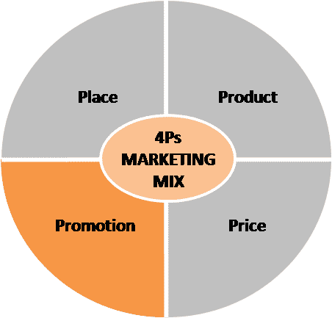 (Luenendonk, 2019)
Sainsbury’s continuedly to use these 4 marketing strategies. During the Covid pandemic made extra attempts of keeping the consistency of quality customer satisfactory service by maintaining and furthering the 7Ps Marketing Mix (people, process, and physical evidence) strategy. As the covid restriction were in full force the demand for more home deliveries grew. Customers’ desire and expectation were to have fresh groceries delivered to their homes quickly soon after they have placed the order online. Sainsbury understood and managed this demand competently by increasing more frequent delivery slots from early morning to late night deliveries, according to Leanly Bayley from Hello Magazine on average 850,000 weekly slots. This means they can prioritise elderly and vulnerable customers for online delivery [9] (Bayley, 2021). Gave priorities to NHS staff and special discounts in-store and online. Also making collection points from locally collection points. Where customers can collect their orders from their nearby collection point, at their convenient times. This attempt gives evidence of how serious the organisation is, about providing quality customer services. The company hired more delivery staff to keep these services running swiftly. Competing with not only high street companies but online-based companies like “Amazon fresh, Hello fresh” Sainsbury recognized the sensitive venerable time of covid, made many prompt robust changes to preserve customer satisfaction and retain customer loyalty.

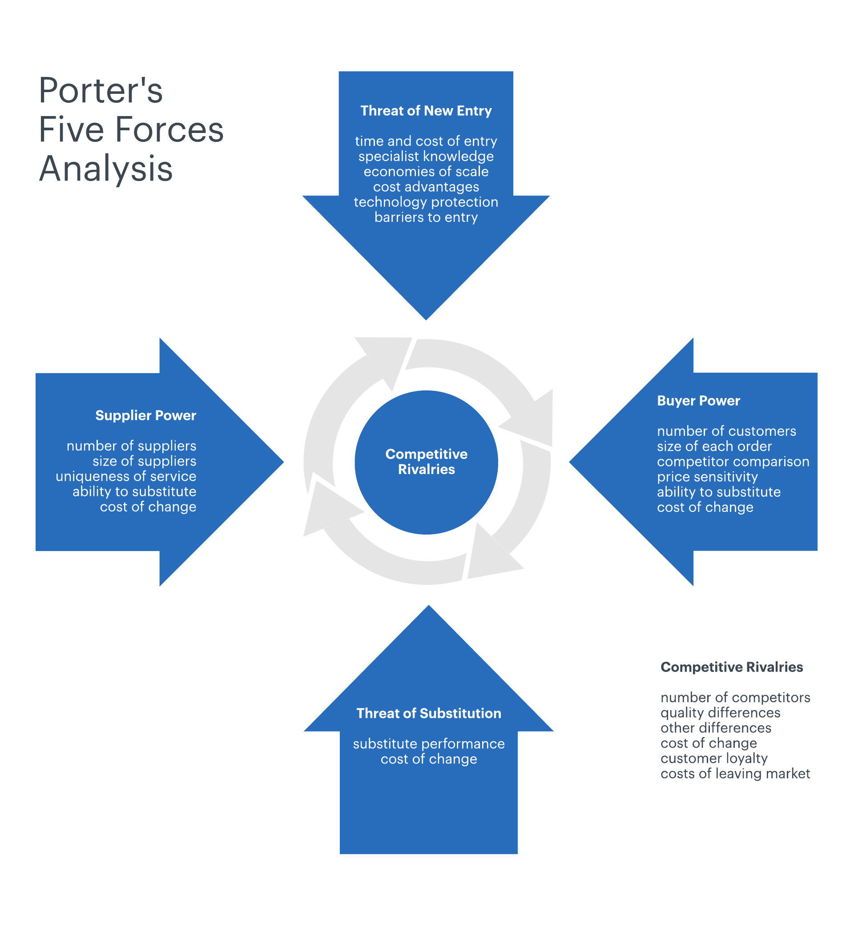 (Lucidchart.com, 2018)

Porter 5 Forces - is a business analysis tool that helps to explain why various industries can sustain different levels of profitability. The model was published in Michael E. Porter’s book, “Competitive Strategy: Techniques for Analysing Industries and Competitors” in 1980.: competition in the industry, the potential of new entrants into the industry, power of suppliers, power of customers, and the threat of substitute products. (Scott, 2020)

IDIC- identify customers as individuals and develop relations with them, differentiate customers by the needs they have from the organisation, interact organisations need to interact with customers on their needs, based on their value to the organisation, customise products and services of the organisation based on customers’ their needs) is a model developed by Peppers & rogers (1995) the model help to assess the expectations of customers and their value to the business. (Project Guru, 2019)

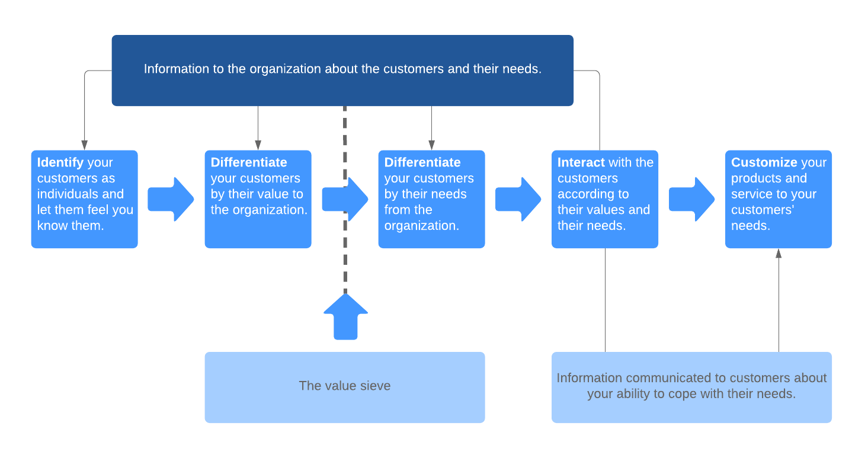 (Lucidchart, 2019)

Applications.

When it came to the dilemma Sainsbury's faced during the pandemic of which the demand for fresh food near the Christmas holiday in 2021 arose as health specialists recommended to strengthen people strengthen their immune system to contribute to the fight against coronavirus within the body, the shortage of delivery drivers to transport to warehouses and stores due to shielding rules and a mass of coronavirus restrictions added throughout the supply chain, for example, reducing or temporarily halting import-export transactions, however, Sainsbury's had to find a way to deliver as soon as possible to the onerous audience.
When researching the different array of CRM strategies, Sainsbury’s most likely used the IDIC CRM model to identify and apply a solution. IDIC is the most suitable technique compared to the ones listed above as we can identify the cause of the issue, - a simple SWOT Analysis would not be sufficient enough to examine and determine a solution to this complex problem - determining the strength, weakness, opportunity, and threat of the lack of food due to the supply, does not provide a feasible solution that can be put into action - it is best for theoretical solutions and to put the problem into a simpler explanation.
After differentiating the customer's current needs (the demand for more fresh food), the company needed to identify what customer audience is being affected the most. In this instance, people aged 45-55 were the most demanding. This may be because this generation is more health-conscious and has become more aware of carbon footprint and minimising greenhouse gas emissions. To develop the relationship between the customers, “The boss of Sainsbury’s has reassured customers there “will be plenty of food” this Christmas despite the supply chain crisis’’ reported Ben Chapman. [10] (Chapman, 2021). Assuring customers that there is a plan or solution to the ‘food crisis’, avoids a frenzy of uncertainty and unease – placing ‘waiting for stock’ shelf edges in stores signifies that more is on the way. Sainsbury’s tried to customise their products and services by searching for more local suppliers either in Europe or here in the UK for fresh food, restricting the number of one type of product is purchased to evenly distribute the food to all consumers as much as possible, also drove larger lorries to increase loading quantity and reduce going back and forth from location to location to shrink their carbon footprint. Sainsbury’s boss added “We are confident that even if the exact product you are looking for isn’t available, there will be a good alternative’’ [10] (Chapman, 2021).

Recommendations
Payne’s Five-step: CRM strategy ensures consistent good customer service in all areas of the company’s department not only on the shop floor. “Eighty-seven per cent of customers think brands need to put more effort into providing a consistent experience” (Bean, 2019)

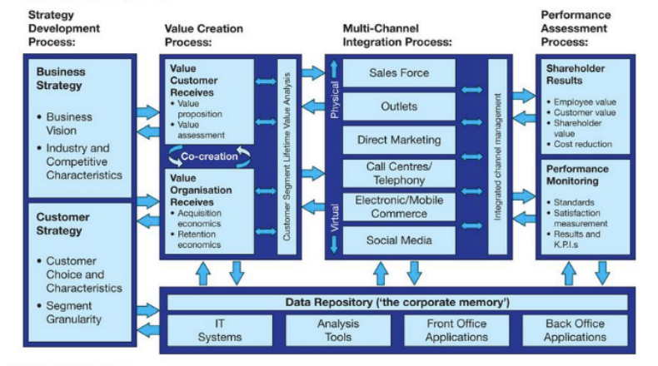 (Bean, 2019)

The strategy consists of 5 integrated processes
- Strategy development: this is divided into two parts business strategy focusing on the vision of the products and services. The second part is characteristic of current and potential customers.

- Value creation. providing customer value and the customers bring value to the organisation.

- Multichannel integration: when all department works together, the customer receives all-around cohesive customer service and a great customer experience.

- Performance assessment: evaluating the performance of strategies, if customers satisfaction is accomplished, if customers service representatives are active and performing well in all departments

- Information management: managing supporting the whole structure of CRM, IT system front office and back office digital applications and analysis tools, front-office applications, and back-office applications.
Sainsbury should benefit by using strategies like Payne as it covers many components that are related to the company. Especially in the performance assessment segment. To stay ahead in the strongly competitive market Sainsbury's needs to regularly analyse all department data collections and performance to think critically to find workable solutions.
SWOT analyses (strength, weakness, opportunity and threat). is a quick way to find simpler issues. Which is extremely helpful to pinpoint immediate threats. After diagnosing the problems, the relevant team can critically brainstorm evaluate and build relevant solutions.
In my little survey, another key point mentioned by the people who were surveyed was that big supermarkets like Sainsbury should do more to stop food wastage. which I personally also support and recommend all food industries should focus on to help eliminate so many food wastages. We see around the world people are dying of hunger. Increase shelf life, “best before date” on products that can last longer. Tackle food shortages around the world. However, after the pandemic, even England is falling short on many products around the country due to Covid and Brexit. Social and environmental Strategy like PESTEL Analyses (Political, Economic, Social, Technological, Legal and Environmental factors) is a great tool to analyse and act on for better the environments benefit. It will win the significant loyalty of environmentally conscious customers. Which can build up the chain of generations of customers from “word of mouth” another key tactic to retain and attract new and old customers. Good customer service leads to a great customer experience than becomes a customer’s delight. CRM to the lifelong chain of customer loyalty and trust.
Sainsbury’s should give serious thought to provide Halal food sections like Tesco to attract Muslims population. UK has over 3,372,966 Muslims living that about 4.4% a huge amount of potential customers chain to keep in mind. A great opportunity to increase customers and embrace culture products and increase profitability and stable sustaining customer relations.

Conclusion

After compiling the information and relating CRM strategies and seeing it being put into action during the difficult pandemic struggle that affected everyone and everything, I can see why Sainsbury’s has become the multibillion-pound company it is today as it has truly mastered CRM strategies and has consistently maintained customer retention and dare, I say a good majority will remain lifelong.
Compared to its equal competitor Tesco, Sainsbury’s possesses a more family 'feel' to it which may have also contributed to its success. However, after in-depth primary research, Ayesha Miah (from Luton, Bedfordshire) had this to say about both their loyalty schemes " I prefer Tesco's point system instead of Sainsbury's, to be honest, you get a lot more coupons to use which can give a 50% on my shopping and I can see on the shelf edge before going to the till the original price and the scheme price which saves me time and effort and just generally better. Also being a new mum and juggling a job means that I don’t have the luxury to go grocery shopping often. Sainsbury's coupons are short-dated and sometimes not relative to me." Sainsbury's could potentially further improve their CRM strategy by improving its customer data collection system and tailoring its promotions to customers, this can contribute to the customer expectations. It has been proven that 'short deadline' to sales has proven to put customers in a sense of hurry before it's all gone mindset and therefore drive sales up, however repetitive 'threats' can eventually become tiresome and an annoyance to consumers and ruin the customer experience. By extending the expiry dates Sainsbury's can cater to most customers' needs.

Reference

[1] Salesforce (2019). What is CRM? Customer Relationship Management - Salesforce UK. [online] Salesforce.com. Available at: https://www.salesforce.com/uk/learning-centre/crm/what-is-crm/ [Accessed 3 May 2022].
[2] Sandra Gudat (2020). The Definitive Guide to Customer Relationship Management. [online] CCG. Available at: https://www.customer.com/blog/retail-marketing/customer-relationship-management/ [Accessed 3 May 2022].
[3] Wikipedia Contributors (2019). Sainsbury’s. [online] Wikipedia. Available at: https://en.wikipedia.org/wiki/Sainsbury%27s [Accessed 2 May 2022].
[4] Forbes. (n.d.). J Sainsbury. [online] Available at: https://www.forbes.com/companies/j-sainsbury/ [Accessed 4 May 2022].
[5] bizibl.com. (2016). Why Retailers Should Watch The Proposed Sainsbury’s Argos Takeover With Interest. [online] Available at: https://bizibl.com/commerce/blog/why-retailers-should-watch-proposed-sainsbury%E2%80%99s-argos-takeover-interest [Accessed 3 May 2022].
[6] Brand Success. (2014). Case Study: Sainsbury’s Creating Great Customer Experiences. [online] Available at: https://www.brand-success.co.uk/puppy-shows-sainsburys-new-strategy-working-well/ [Accessed 3 May 2022].
[7] Butler, S. (2021). Sainsbury’s slumps to £261m loss on back of Covid costs. [online] the Guardian. Available at: https://www.theguardian.com/business/2021/apr/28/sainsburys-slumps-to-261m-loss-on-back-of-covid-costs [Accessed 6 May 2022].
[8] Simpson, E. (2021). Sainsbury’s: Cost of Covid has been high. BBC News. [online] 28 Apr. Available at: https://www.bbc.co.uk/news/business-56912064 [Accessed 3 May 2022].
[9] Bayley, L. (2021). How to secure a Sainsbury’s home delivery slot for a vulnerable person. [online] HELLO! Available at: https://www.hellomagazine.com/cuisine/2020040187271/sainsburys-elderly-shopping-slot-online/ [Accessed 4 May 2022].
[10] Chapman, B. (2021). Sainsbury’s boss insists there will be ‘plenty of food’ on shelves this Christmas. [online] The Independent. Available at: https://www.independent.co.uk/news/business/saisburys-christmas-food-shortages-supply-b1947079.html [Accessed 6 May 2022].
www.about.sainsburys.co.uk. (n.d.). Nectar. [online] Available at: https://www.about.sainsburys.co.uk/brands-that-deliver/nectar [Accessed 2 May 2022].
Project Guru. (2019). The IDIC model of Customer Relationship Management (CRM). [online] Available at: https://www.projectguru.in/customer-relationship-management/#:~:text=The%20IDIC%20(identify%2C%20differentiate%2C [Accessed 6 Feb. 2022].
Scott, G. (2020). Porter’s 5 Forces. [online] Investopedia. Available at: https://www.investopedia.com/terms/p/porter.asp [Accessed 3 May 2022].
find-and-update.company-information.service.gov.uk. (n.d.). SAINSBURY’S SUPERMARKETS LTD more information - Find and update company information - GOV.UK. [online] Available at: https://find-and-update.company-information.service.gov.uk/company/03261722/more [Accessed 3 May 2022].
Lucidchart (2019). 4 CRM Models That Boost Customer Loyalty | Lucidchart Blog. [online] Lucidchart.com. Available at: https://www.lucidchart.com/blog/crm-models [Accessed 6 May 2022].
Luenendonk, M. (2019). Marketing Mix | Promotion in Four P’s. [online] Cleverism. Available at: https://www.cleverism.com/promotion-four-ps-marketing-mix/ [Accessed 6 May 2022].
Lucidchart.com. (2018). How to Define Strategy Using Porter’s Five Forces. [online] Available at: https://www.lucidchart.com/blog/what-is-strategy [Accessed 6 May 2022].
Bean, J. (2019). What is a CRM Model? [online] Business 2 Community. Available at: https://www.business2community.com/sales-management/what-is-a-crm-model-02235682 [Accessed 6 May 2022].

