Computer Fundamentals Report
27/11/24
Computer system fundamentals (ACCA4028)
Rhys Jones
(2419998)

Contents
Computer Fundamentals Report 1
Introduction 2
Task1 2
PC – Computer Build 2
PC – Input & Output Devices 4
PC – Software & Network Connectivity 4
PC – Final cost + build 5
Task 2 6
PC-Components 6
PC- Input & Output Devices 8
PC- Software and Network Connectivity 8
Conclusion 9
References 10

Introduction

This report involved designing a computer for a person based on a scenario and completing an analysis based on my home desktop. Both tasks required extensive research into their components and comparisons. In both of the functions, a list of the components that went in both of the builds was required to be created.

Task1

PC – Computer Build
The first task is to create a PC for an elderly person based on a use case scenario we were given. To start this task, I researched what I would need to run Windows 10 Home even though it is an older operating system, it is more refined because it has been around longer and tested thoroughly. The image [1] below is from Microsoft outlining the minimum system requirements.

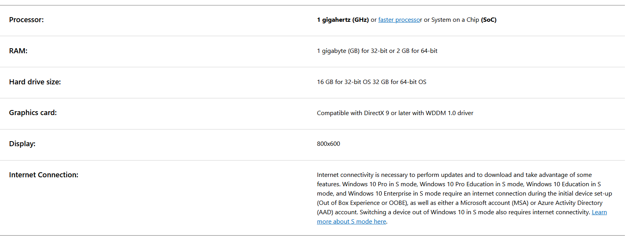

After researching this, I started to build the PC using my general knowledge of components and the minimum requirements. I started with the CPU, as this would allow me to choose the speed of the PC and a motherboard that corresponds with the CPU. All of the specifications were found on the manufacturer's website. [2] [3]

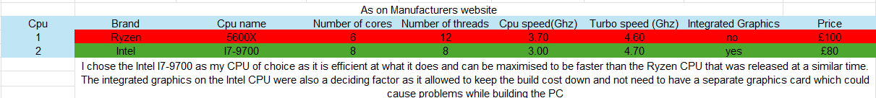

Now that I had chosen a CPU, I found a motherboard that would fit with it. When researching motherboards, I tried to find one that would maximise the CPU's full potential, as this would also further justify my choice of CPU. [4] [5]
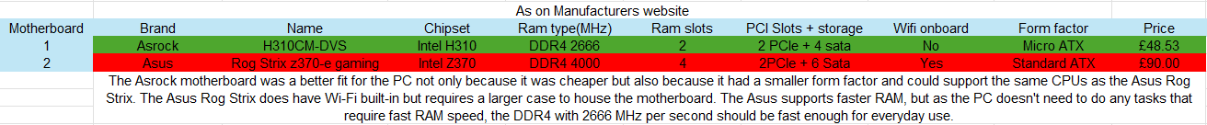

The Asrock motherboard is a really priced and efficient motherboard for everyday use. I needed a CPU cooler that would fit the motherboard and the CPU, and after some more research, I found an Intel e97379-003. It is really slim, so it can be put in a smaller form factor case, which helps with the scenario's small form factor. Since the motherboard only supports up to 2666MHz RAM, I chose the Corsair Vengeance LPX. [6] With two 8 GB sticks, the PC will still function even if one of them becomes faulty. The motherboard and CPU allow dual-channel memory technology to be used, which doubles the speed of data transfer between the CPU and the RAM. This will allow for a faster PC overall since it can read the memory faster and perform tasks faster. I could have used 1 ram stick, but this would have limited the PC's capabilities to a certain extent and made it slower in general. The next thing I needed for a functioning PC was a boot drive as the motherboard does not have any slots for NVMe; buying an adapter adds, needless to say. I went with a hard disk drive, as they still function as excellent storage devices. However, they do not have the same speed capabilities as NVMe storage devices. The storage device needs to have enough room for Windows 10 and extra space for any apps or files that need to be stored on the PC. [7] [8]

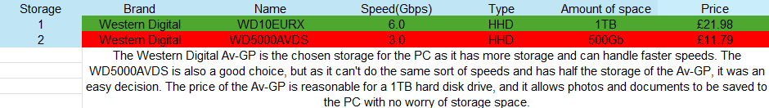

This hard drive should be plenty for everyday use and maybe a bit excessive, but for £10 more, it is worth the investment. Next, I needed to find a power supply that would run this PC; the calculated wattage of the PC was around 165w, meaning I needed something more significant.

The PSU I chose was a Holdfirturn ARX 500W, which would give headway for any upgrades the person might want to make on the PC. As stated in the scenario, the final piece for the PC was a case to house the components with a small form factor. The chosen case was an Aerocool CS-103, as it was inexpensive and still has a user-friendly front panel.

PC – Input & Output Devices

Now that the PC build is done, the next step is to figure out the input and output devices, such as a keyboard and monitor. Starting with the monitor, I chose an AOC 21.5-inch screen, which would be big enough, especially if we set the scale to 175%, as shown in the image below. This makes everything larger, making it more eligible for people who have a hard time seeing.

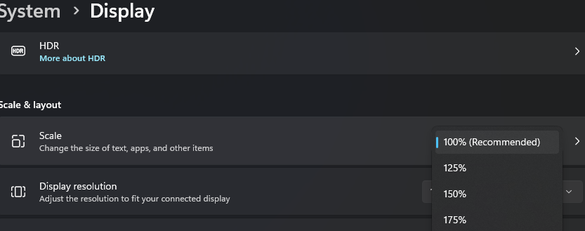

Following the scenario, the person asked for a full-size keyboard; after researching budget full-size keyboards, I settled on a Logitech MK270, which also comes with a mouse and the batteries required to run it. Next, I found a pair of low-cost but quality headphones, the Sony Zx310, that have audio when the user is on a Skype call. Along the same lines as the Skype call, the Webcam I chose was a Yimona B099DF2RNS as it has 1080p camera quality and a microphone, which then means no additional cost is required in buying a separate microphone.

PC – Software & Network Connectivity

The operating software that will be used in the PC is Windows 10; as the scenario states, the user wants to take a course to learn how to use Microsoft Windows. Windows 10 has a very user-friendly system and more courses available online and on YouTube, which is why it was chosen. As a choice, Windows 11 could have been selected, but it is often referred to as less user-friendly as it had a profound change in interface from other Windows operating software.

To make sure the user stays safe on the internet and to keep any virus off the computer, the suggested anti-virus software is Malwarebytes, which has one of the best records as a scanner because it can detect known and unknown viruses. A downside to using Malwarebytes is that it is not the best-paid antivirus software, but it can cost up to £120 per year. The final aspect to consider for the pc is the network connectivity. If there is a router nearby, then all the user needs to do is plug in the ethernet chord. Still, if there is no access to this, then as a wireless alternative, I found the TP-Link Mini Wireless N, which is a wireless adapter that allows the user to connect to the internet.

PC – Final cost + build

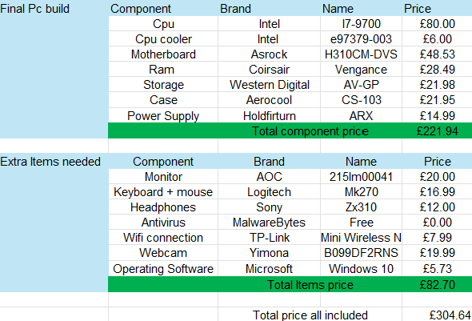

This was the final build of the PC, and it cost £304.64, which is reasonable for all the components and extra items found. The prices will be linked in the reference section.
[9] [10] [11] [12] [13] [14] [15] [16] [17] [18] [19] [20] [21]

Task 2

PC-Components

I have an I7-13700k on my personal computer, which has a base clock frequency of 3.40 GHz. It was one of the best CPUs when I built my PC. The CPU has 8 threaded performance cores and 8 efficiency cores. It can be overclocked up to 5.40 GHz, which made it one of the fastest CPUs back in 2022. [22] The image below shows my CPU running at 5.15 GHz. This gives me a fast response on any tasks I do on my PC and can allow me to do heavy CPU tasks as I don’t use a high percentage of the CPU

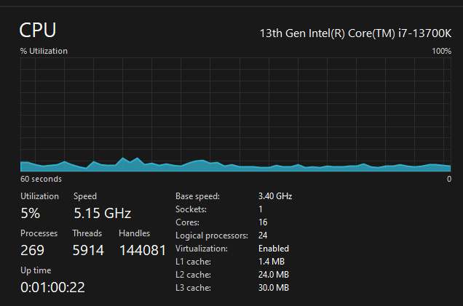

The motherboard I picked to go with the CPU is a Gigabyte Z690 UD DDR4, which supports up to 5333 MHz RAM and Quad-channel memory, which allows both RAM sticks to be used simultaneously. The Z690 was my motherboard of choice as it has 3 m.2 slots with speeds of up to 64 GB/s and 7000MB/s read speeds.

For the PC, I chose a Corsair Vengeance RAM 4 sticks of 16GB with a speed of 3600MHz. Since the motherboard has Quad channel memory on all 4 of the slots, it gives me a higher bandwidth, allowing a faster PC. I chose only to run the speed at 2666 MHz, as this still provides a high-speed computer but doesn’t put a heavy load on the RAM.

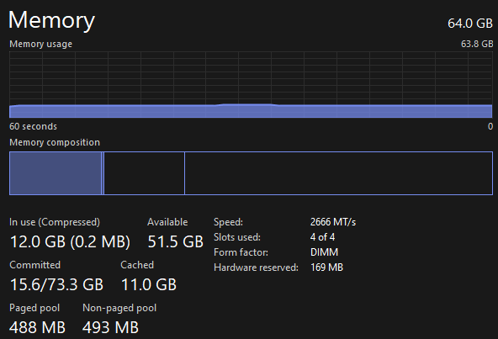

The GPU I chose for my PC is a Rog Strix GeForce RTX 3070 Ti, which gives me high performance in gaming because of the 8GB of dedicated GPU memory. This GPU's clock speed is 1845MHz, which gives it 19Gbps of memory speed. This is fast enough for anyone who doesn’t need ultra-high performance. [23]

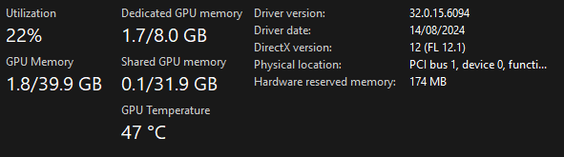

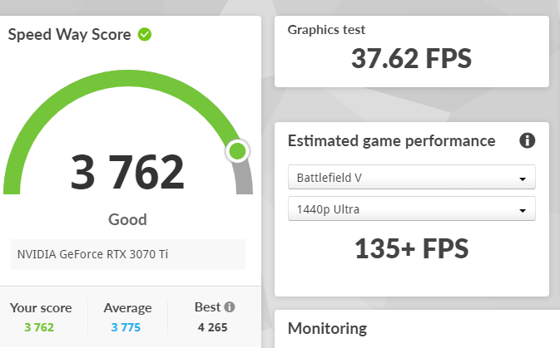

This second image shows the score it gets compared to all other GPUs today, with modifications being made.

Next Is the various storage devices I have with a Samsung 980 Pro SSD [23] As my main boot drive, having an SSD gives way faster booting times than an SSD. The read speed of this is 2,900MB/s, which is really noticeable on startup. I have 8TB of HDD 2x4TB, which is used to store photos and documents from my life.

PC- Input & Output Devices

My input devices include a Logitech Mk270 mouse and keyboard that allow me to use my PC. I also have a Logitech c920S HD webcam, which enables me to have meetings from home for university. My output devices include 2 1920x1080 HD Philips monitors and a pair of Subzero SZ-MH200 headphones for audio output.

PC- Software and Network Connectivity

I currently use a SIM card in an adapter to connect the network to the PC with an ethernet cable. I used https://www.speedtest.net to get the results below.

With 386 Mbps, the Wi-Fi is fast enough to download anything in rapid time.

My current operating software is Windows 11 with Explorer Patcher downloaded to make it look more like Windows 10, as Windows 11 has a non-friendly user interface for long-time Windows users. I have downloaded the complete Microsoft Office package, as it allows me to do my university work with relative ease. I use my computer to play some computer games and can run them usually above 120FPS because of all the high-end components in my pc. For antivirus, I use Windows security as it has become an excellent antivirus software in recent years due to Microsoft spending money on upgrading it. Finally, there is a lot of PC tuning software on my PC to make it run faster and increase performance on high stress tests.

Conclusion

Doing this report gave me a lot of insight into what makes computers run smoother, with lots of my time doing component research such as cores and memory bandwidth. Designing a PC for non-high-end use proved challenging as I would constantly get lost in looking at higher-end components that the user would not necessarily use in the first task. The second task gave me a better insight into my PC, looking at how fast I could make my PC if I did some more research into better memory and how well my motherboard cancouldndle it.

References

[1] | Unknown, “Windows 10 Specification,” Microsoft, [Online]. Available: https://www.microsoft.com/en-gb/windows/windows-10-specifications. [Accessed 05 01 2025].
[2] | Unknown, “Intel i7-9700 Processor,” Intel, [Online]. Available: https://www.intel.com/content/www/us/en/products/sku/191792/intel-core-i79700-processor-12m-cache-up-to-4-70-ghz/specifications.html. [Accessed 29 12 2024].
[3] | Unknown, “AMD Ryzen™ 5 5600X Desktop Processors,” AMD, [Online]. Available: https://www.amd.com/en/products/processors/desktops/ryzen/5000-series/amd-ryzen-5-5600x.html. [Accessed 29 12 2024].
[4] | Unkown, “H310-DVS,” Asrock, [Online]. Available: https://www.asrock.com/mb/Intel/H310CM-DVS/#Specification. [Accessed 29 12 2024].
[5] | Unknown, “ROG STRIX Z370-E GAMING,” Republic Of Gamer , [Online]. Available: https://rog.asus.com/uk/motherboards/rog-strix/rog-strix-z370-e-gaming-model/. [Accessed 29 12 2024].
[6] | Unknown, “Vengeance LPX,” Corsair, [Online]. Available: https://www.corsair.com/uk/en/p/memory/cmk16gx4m2z2666c16/vengeancea-lpx-16gb-2-x-8gb-ddr4-dram-2666mhz-c16-amd-ryzen-memory-kit-black-cmk16gx4m2z2666c16#tab-techspecs. [Accessed 29 12 2024].
[7] | RS.online, “WD AV-GP,” [Online]. Available: https://docs.rs-online.com/3b71/0900766b81323706.pdf. [Accessed 29 12 2024].
[8] | Unkown, “Western Digital WD5000AVDS 500GB 3.5" SATA Drive,” Disctech, [Online]. Available: https://www.disctech.com/Western-Digital-WD5000AVDS-500GB-SATA-Hard-Drive. [Accessed 29 12 2024].
[9] | None, Intel Processor.
[10] | None, Intel Socket 1150 1151 1155 1156 Heatsink & Fan CPU Cooler.
[11] | None, Asrock H310CM-DVS Intel® H310 LGA 1151 (Socket H4) micro ATX.
[12] | None, Corsair CMK16GX4M1A2666C16 Vengeance LPX 16 GB (1 x 16 GB) DDR4 2666 MHz C16 XMP 2.0 High-Performance Desktop Memory, Black.
[13] | None, Western Digital AV-GP - 1TB Desktop SATA Hard Drive - OEM.
[14] | None, Aerocool CS-103 Mini Tower Case - Black.
[15] | None, Holdfiturn ATX PC Power Supply 500W with 12cm Silent Cooling Fan Power Supply PSU 3xSATA/6-PIN 12V/26 Pin Ready(20+6)/2x6-PIN Molex/1xFloppy.
[16] | A. 2. i. c. monitor.
[17] | None, Logitech MK270 Wireless Keyboard and Mouse Combo for Windows, 2.4 GHz Wireless, Compact Mouse, 8 Multimedia and Shortcut Keys, 2-Year Battery Life, for PC, Laptop, QWERTY UK English Layout - Black.
[18] | None, Sony ZX310 On-Ear Headphones - Black.
[19] | None, TP-Link 300Mbps Mini Wireless N USB WiFi Adapter, ideal for smooth HD video, voice streaming, and online gaming,USB 2.0, Supports Windows 10/8.1/8/7/XP, Mac OS, and Linux(TL-WN823N).
[20] | None, Webcam for PC with Microphone - 1080P FHD Webcam with Privacy Cover & Webcam Mounts, Plug and Play USB Web Camera for Desktop & Laptop Conference, Zoom, Skype, Facetime, Windows, Linux, and macOS.
[21] | None, Microsoft Windows 10 Home OEM KEY Global.
[22] | Unkwon, “Intel® Core™ i7-13700K Processor,” Intel, [Online]. Available: https://www.intel.com/content/www/us/en/products/sku/230500/intel-core-i713700k-processor-30m-cache-up-to-5-40-ghz/specifications.html. [Accessed 29 12 2024].
[23] | Unknown, “ROG-STRIX-RTX3070TI-O8G-GAMING,” Republic Of Gamers, [Online]. Available: https://rog.asus.com/graphics-cards/graphics-cards/rog-strix/rog-strix-rtx3070ti-o8g-gaming-model/. [Accessed 29 12 2024].
[24] | Unkown, “980 NVMe™ M.2 SSD 250GB,” Samsung, [Online]. Available: https://www.samsung.com/uk/memory-storage/nvme-ssd/980-1tb-nvme-pcie-gen-3-mz-v8v1t0bw/?srsltid=AfmBOooA5warCrZEB3xBCa2ykZDnqW-isBB851ocn3Oug571g50JS9QP. [Accessed 19 12 2024].

