BA Business Management
Marketing Fundamentals – LCBB4004
Lecturer: Afzal Munna
ASSIGNMENT 1
Boris Vladimirov – 2124687

ASSIGNMENT 1
Tesco Blog

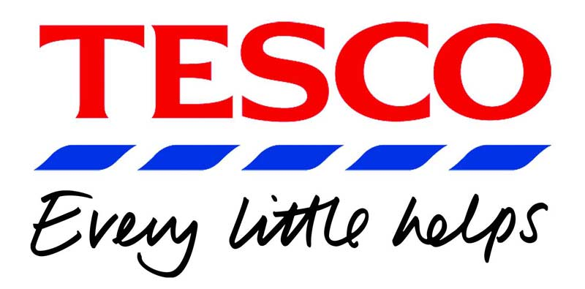
Table of Contents
1. Tesco’s variety of food and services 3
2. Support our farmers and suppliers 3
3. Environmental responsibilities 4
4. Supporting charities and communities 4
5. Modern Slavery strategy 5
6. Diversity and Inclusion in the work environment 6
7. Rewarding our colleagues 7

1. Tesco’s variety of food and services

Tesco is one of the biggest retailers in the UK with 4074 stores including franchise stores operating in the United Kingdon and the Ireland. In Tesco, customers can find a huge variety of both traditional food and international cuisine as well as fresh vegetables and fruits, fish and meat, vegetarian and vegan products, frozen products, bakery, household products, cosmetics, clothing, a wide variety of drinks and refreshments, and many more. Along with the large variety of food and household products, customers can also find a wide range of services that we offer. At Tesco, we aim to offer a high class of services to our customers which include Tesco Bank, Tesco Mobile, Tesco petrol station, and Insurance services. Using our services our customers can save time and money and can take advantage of special offers and discounts designed especially for them. And to make things even better, we offer our customers a Tesco Club Card with which our clients can take advantage of additional discounts and offers, as well as collect points for even greater discounts and vouchers with which they can pay for various services.

References:
Bedford, E., 2022. UK, Ireland: Tesco stores 2012-2019 | Statista. [online] Statista. Available at: <https://www.statista.com/statistics/490947/tesco-group-stores-united-kingdom-uk/#:~:text=How%20many%20Tesco%20stores%20are,have%20been%20increasing%20since%202012.> [Accessed 18 July 2022].

2. Support our farmers and suppliers

Our farmers and suppliers have always played an important role in the success of our business. We aim to create a long-term relationship with our farmers and suppliers so we can support and grow together and continue to offer our clients the quality and price they expect from Tesco. We have worked with our suppliers and farmers to implement different initiatives to protect our supply chain and maintain high production standards. When it comes to sustainability and innovations our aim is the same – to create confidence so that our supplier partners can invest and plan the future.
- Tesco Sustainable Dairy Group (TSDG) includes more than 520 dairy farmers. The TSDG group ensures that the price we pay for the milk is fair, which is reflective of the price of the product. Since 2007 we have invested £300m over the market price for milk and in March 2022 we announced a 20% rise in the price we pay to the farmers.
- Tesco Sustainable Lamb Group (TSLG) – includes more than 120 farmers who benefit from the price of their lamb above market price.
- Improved payment term for small suppliers – Smaller suppliers have been among the most impacted in the food business since the start of the pandemic. 2000 of our suppliers can benefit from the immediate payment of their invoices, instead of the standard 14 days.
- Produce – Most of our product suppliers benefit from long-term contracts that contain agreed-upon sales quantities, as well as pre-planting and cost estimates. This gives our suppliers the assurance they need to grow the appropriate amount for the next season

References:
Wood, S., 2022. Supporting our farmers and suppliers. [online] Tesco PlC. Available at: <https://www.tescoplc.com/blog/supporting-our-farmers-and-suppliers/> [Accessed 10 August 2022].

3. Environmental responsibilities


At Tesco, we think about the environment and understand how dangerous and harmful food and non-food plastic packaging waste can be to nature and society. In the last few years, we have made many changes to reduce plastic and non-recyclable waste with our program 4Rs – Remove, Recycle, Reuse, Reduce. We no longer use secondary lids on creams and yogurt, we remove the non-recyclable plastic bags from the vegetable and fruit section and replaced them with fully recyclable ones, also we remove the plastic trays in many food products and completely remove the packaging on most of our non-food products. Since 2019, Tesco’s Merchandise team has reduced our yearly packaging footprint by approximately 42 million pieces of plastic.
27 million pieces have been removed from Christmas decoration products, gift bags, greetings cards, and plastic wraps.
13 million polystyrene pieces have been removed from the packaging of the TVs, radios, cooking appliances, and many household products. We no longer use plastic for our home and garden range.
70 000 pieces have been removed from our toys and games range.
We aim to continue improving our products' packaging and reduce plastic where possible. As part of our 4Rs program, by 2025 our target is to remove 5 billion single-use plastic items.

References:
Bolton, G., 2022. Reusable packaging update. [online] Tesco PLC. Available at: <https://www.tescoplc.com/blog/reusable-packaging-update/> [Accessed 7 August 2022].
Bristow, J., 2021. Removing plastic from products throughout the store. [online] Tesco PLC. Available at: <https://www.tescoplc.com/blog/removing-plastic-from-products-throughout-the-store> [Accessed 3 August 2022].

4. Supporting charities and communities

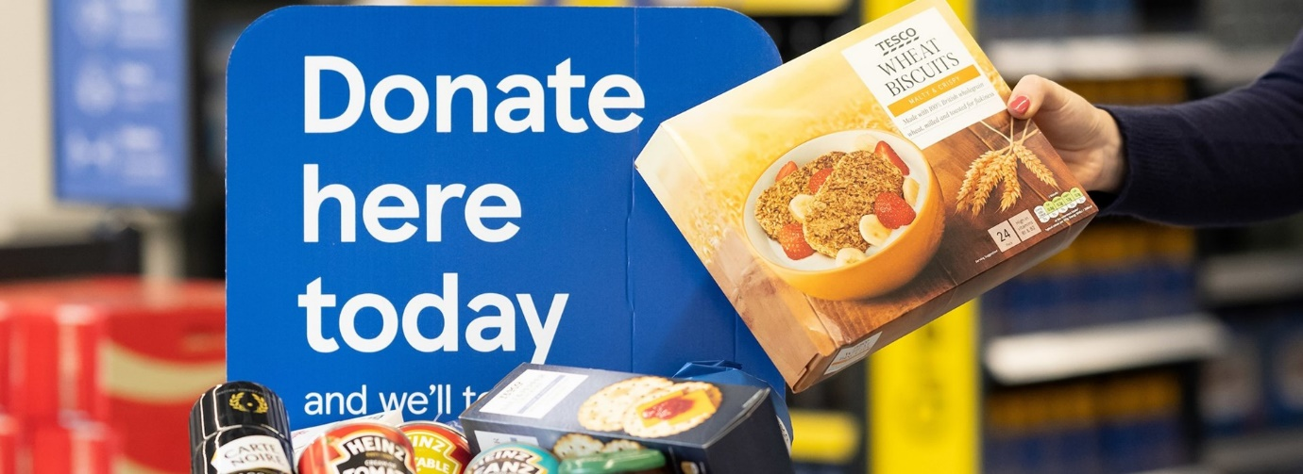
At Tesco, we know how important it is to support those in need. Our charity partnership allows us to assist people when they are most in need. We are proud to support organizations like British Heart Foundation and Diabetes UK, Cancer Research UK, anti-poverty charities, and local foodbanks. Everyone who wants to help and join us is welcome. Just choose a product from our list, go to the nearest store, and leave it in the specially designed collection point. We are in partnership with FareShare who helps us with the distribution of the food. We donate around 2 million meals a month for those who are in need. We are in a close relationship with British Red Cross and since 1997 we have donated £14.6m thanks to our colleagues and our customers. Together we achieve to provide more than 140 million meals since 2016 and support 46 000 Community groups with £93m in grants for the same period. In 2018 we started a partnership with The Price’s Trust with the aim to help 10 000 young people with their employability and skills. By September 2019 we have helped 25 000 people and our ambition now is to reach more than 50 000 young people. Our goal is to continue helping and supporting those in need and contribute to the community’s good. Together, we can achieve a lot and can save and improve lives.

References:
Taylor, E., 2020. Tesco supports 25,000 young people through its partnership with the IGD and the Prince’s Trust. [online] Tesco PLC. Available at: <https://www.tescoplc.com/updates/2020/supporting-25-000-young-people-igd-and-the-prince-s-trust/> [Accessed 10 August 2022].

5. Modern Slavery strategy

One of Tesco’s highest priorities in our human rights strategy is to tackle and completely eradicate modern slavery both in our organization and the distribution network. With the help of stakeholders including the Ethical Trading Initiative (ETI), the Customers Goods Forum (CGF), and key suppliers, in 2020 we revised our Modern Slavery Strategy. After consideration of the areas of risk, we set four main regions or supply chains in which we are in a very good position to request a change. Those areas are:
- UK and Central Europe own operations
- UK seasonal workers
- Thailand and Malaysia
- Priority fisheries
Our approach to eradicating modern slavery is based on five key factors.
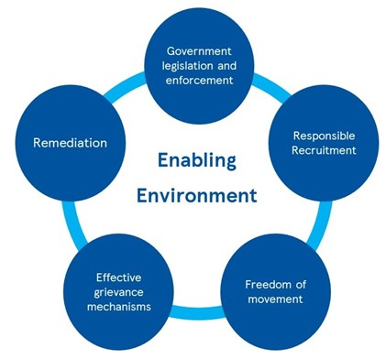
All factors are important, and we continue to work on them. However, we put our main focus on responsible recruitment given that the recruitment costs and fees are the main indicators of Modern Slavery. We are dedicated to eliminating all recruiting fees and expenses across our supply chain, however, due to the hidden nature of many recruitment fees and costs, this can be difficult. Our approach may differ in some regions due to varying government engagement and legislation levels. Since 2019 Tesco works closely with the anti-slavery charity Unseen, which runs a free 24/7 Modern Slavery and Exploitation Helpline.

References:
Tesco PLC. 2022. Modern Slavery strategy. [online] Available at: <https://www.tescoplc.com/sustainability/documents/policies/modern-slavery-strategy-1/> [Accessed 10 August 2022].

6. Diversity and Inclusion in the work environment

At Tesco, we treat everyone fairly and with respect. Our colleagues are our most valuable resource, and we want them to always feel safe and be themselves. We strive to create a working environment in which everyone has an equal opportunity to develop and grow because we know that our colleagues will help us to build our success in our business. To understand the importance of inclusion we provide the colleagues in our network with training and support.
- Recruitment – we aim to recruit a wide group of candidates from various backgrounds. At Tesco, we don’t tolerate any form of racism, discrimination, and violence. All candidates and colleagues will be treated fairly and with respect.
- Armed Forces – we focus on three main groups-former members, current, and their families.
We provide support to any former member of the armed forces to find a civilian job not only in Tesco. We understand and appreciate the skills they have acquired and strive to help them in the best possible way.
We offer support for colleagues who are reservists. We provide them with two weeks of additional paid leave during the mandatory annual training and five days for their reservist activities.
For the families of serving members of the armed forces, we are flexible and allow them to have time off when they need it to be with their families. We support family members who must relocate due to military reasons.
- Women in Tesco – Tesco is a member of the 30% club, a movement of Chairpersons and CEOs working to promote gender diversity at all levels of the business. We have joined the Tech She Can project, coordinated by PWC, to inspire more females to seek jobs in banking, management, and high tech. We intend to achieve 30% female participation on Tesco Bank and Executive Committee by the end of 2022, in accordance with the HM Treasury Women in France Charter. We want everyone to feel welcome in our team.
References:
Tesco PLC. 2021. How we create an inclusive working environment. [online] Available at: <https://www.tescoplc.com/sustainability/documents/policies/how-we-create-an-inclusive-working-environment/> [Accessed 6 August 2022].

7. Rewarding our colleagues

Tesco has 300 000 colleagues in the UK and more than 345 000 worldwide. We offer competitive pay rates and benefits as well as long-term careers for all our colleagues in different roles and with different skills. In the last 10 years, we increase the pay rate by more than 40% from 7.14 to 10.10. In April 2022 we increased the pay rate by 5.8% which is equivalent to a £200m investment in our colleagues.
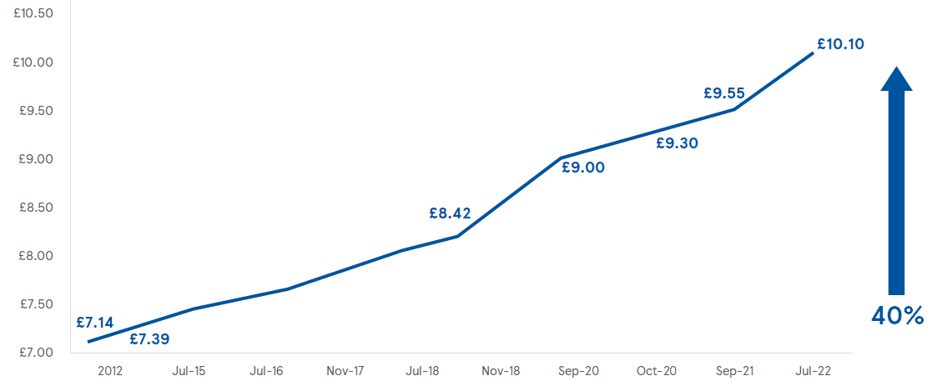
We provide a benefits package to support our colleagues across our network. When the value of these benefits is taken into account, the comparable hourly pay in the UK is £11.16 or £11.86 for London colleagues. After a survey carried out over the last three years about working at Tesco and the additional benefits, the result shows that between 79-82% of our colleagues would recommend Tesco as a great place to work. Our colleagues can benefit from a 10% discount, 20% discount on F&F clothing including school uniforms, competitive deals and a 10% discount on Tesco Mobile, as well as £1500 annual Colleague Clubcard discounts. We also provide competitive pension plans, Buy As You Earn scheme which gives opportunities for our team members to buy Tesco shares regularly from their gross salary, Cycle to work scheme, and a fully confidential Employee Assistance program which includes advice on Mental health, Finances, Career and development, Legal information.

References:
Tesco PLC. 2022. [online] Available at: <https://www.tescoplc.com/sustainability/colleagues/reward/> [Accessed 10 August 2022].

