
Effective Teamwork and Communication
BMSW4009

Student Name: Julia Heron
Student ID: 2413228

Submission Date: 14 March 2025
Table of Contents
Introduction 1
Definition of Effective Teamwork 1
My Natural Roles within the team 1
Findings 2
What I have learnt and how I have implemented the learning 2
Conclusion 5
Lesson learnt from the teamwork 5
Future actions to improve my roles in teamwork 5
Reference 6

Introduction

Definition of Effective Teamwork
Good teamwork is the foundation for successful collaboration in both professional and academic environments. According to Salas, Sims, and Burke (2005), good teamwork involves shared goals, mutual respect, open communication, and a strong sense of interdependence where team members rely on each other’s skills and contributions. Teams that perform well are not just collections of talented individuals, but cohesive units where the whole is greater than the sum of its parts (Scholl, 2013).

My Natural Roles within the team
Reflecting on my personal experiences, I naturally adopt a role that combines the Implementer and Coordinator as described by Meredith Belbin (2011). I excel at organising tasks, ensuring the team has a clear plan, and facilitating communication to keep everyone aligned. My organisational skills allow me to break large tasks into smaller, manageable steps and delegate where necessary to leverage team members’ strengths. One of my strengths is being able to listen actively and ensure all voices are heard during discussions. Although I am not very confrontational, I understand that debates are important, and I have developed my skills to encourage people to state their opinions and discuss them. Nevertheless, I realized that there is a tendency to be rather pragmatic which at times may prevent me from considering more conceptual and creative approaches..

Findings

What I have learnt and how I have implemented the learning
This module has been very insightful in highlighting that effective teamworking is founded on developing positive relationships in the team as well as embracing on communication. One thing I have realized is the importance of individual and group interaction in the development of trust, conflict solving and making everyone feel accepted in the team. Perhaps the most valuable lesson that was discussed during the course was the concept of the psychological safety at the workplace by Edmondson (1999). There has to be trust between the members of a team whereby the members can freely come out and say what they feel regarding certain issues without fear. This concept helped me to pay attention to how I manage to influence the emotional tone in a group. I also made efforts towards creating a good group working atmosphere with special regard to encouraging the less talkative members and acknowledging everyone’s input.
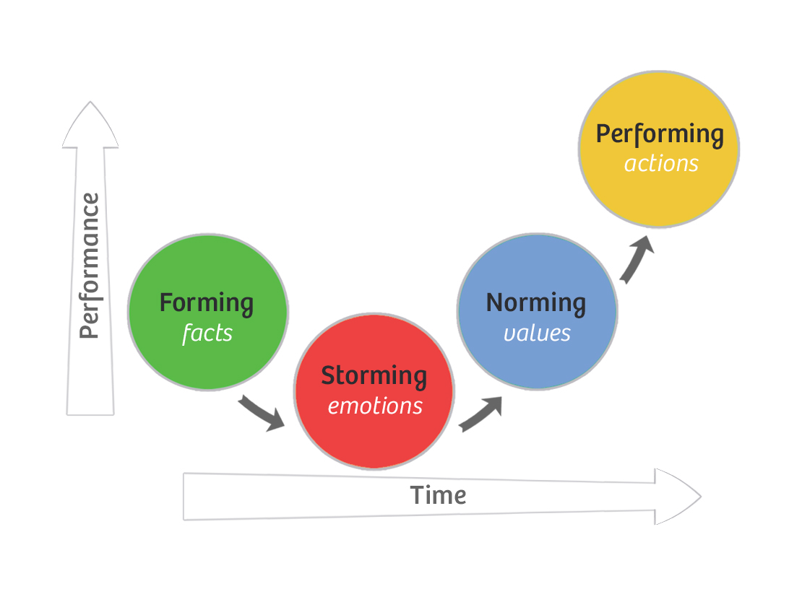
Figure 1: Tuckman’s Team Development Model (Agile Coffee, 2023).
Tuckman’s Team Development Model that he proposed in 1965 was useful in explaining the manner in which people in a team interact as the progress through a certain stage. In the forming stage, people did not share much information about themselves and others and the communications were formal (Tuckman, 2001). During storming, conflicts arose in organization of work and expectations concerning productivity. Instead of viewing it as animosity between two people, I understood it to be a characteristic of relationship dynamics. I fostered communication breakdowns which made us be able to solve some misunderstandings so as to avoid or mend broken relations due to misunderstanding and disrespect (Agile Coffee, 2023).
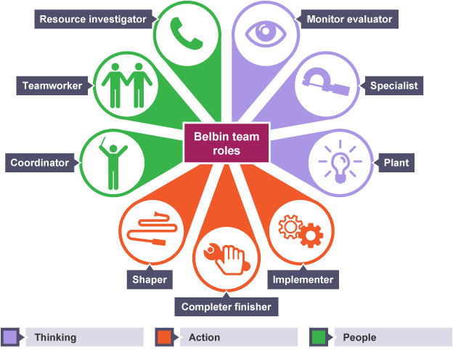
Figure 2: Belbin’s Team roles (source: Nguyen, 2017)
Belbin’s Team Roles (2011) also helped me to understand that how roles of each member influences relationship within the team. As for my self-estimations, I determined that I am an Implementer and a Coordinator at the same time, but the latter may seem controlling if I try to manage the group too much. From the feedback received from my teammates, I gained more awareness of how important it is to embrace the working style of inputs from the Plants or the focus on details from the Completer-Finishers (Nguyen, 2017). This I was able to create better relations in a team and ensured that everyone’s opinion is valued. Scholtes’ Five Team Competencies (2018) backed up the necessity of constructing a relationship alongside constructing a process in a group project (Scholtes, 2018). Besides, I implemented regular discussions aimed at discussing goals and timetables, as well as learning about the working preferences of each employee, which helped to improve interpersonal relations. The daily stand-ups did not only concern coverage and completion but also served to inquire about everyone’s state of mind, further strengthening the relational aspect of trust. Lastly, the Emotional Intelligence model developed by Goleman (1998) assisted me in understanding how my self-control about feelings, interpersonal understanding and interpersonal skills impacts on relations within the team. In some of the conflicts I engaged in the use of the active listening skills and paraphrasing in order to demonstrate that I have listened and understood the other party. It also helped to minimize defensiveness and enhance the quality of relationships as well as the problem solving capacity of the team

Conclusion

Lesson learnt from the teamwork
Team work within this module has provided me with an opportunity to learn about myself more so in terms of how I conduct myself and perform when in a group. One thing I discovered about myself is that I am a self-motivated person who assumes the responsibility of an organiser and coordinator. In particular, I was always in charge of planning and organizing the work among the team members and setting deadlines. Thus, on the one hand, the organizational strength helped me to stay on track in my work, but on the other hand, it had a negative impact, as I truly understood that sometimes I pay attention more to as a task than to people in the team. I learned from my peers that my task orientation could be interpreted as domination or rigidity when others wanted to discuss new ideas or simply take it easy. This experience showed me that hierarchy can be healthy if it is accompanied by the freedom to change some aspects of the project; it also revealed that teamwork is not only about accomplishing the set goals but also about building rapport and providing an opportunity to contribute for every member of the team.

Future actions to improve my roles in teamwork
In order to improve my work in future teams, I can do the following:
- Schedule daily or weekly meetings with the team members to review the project progress and cheque if there are any interpersonal problems.
- Ensure the creative input of all the members, especially the introverted ones, by giving them an opportunity to contribute their ideas (Lim et al., 2023).
- Use attentive listening skills in order to comprehend the reasons behind the actions and decisions of the other members of the team.
- Think about my actions during and after the interaction with group members and how it influences their participation and feelings (Smith, 2024).
- Integrate task orientation with relationship orientation, understanding that trust is as valuable as effective work.

Reference
Agile Coffee (2023). Tuckman Model of Group Development. [online] Agile Coffee. Available at: https://agilecoffee.com/toolkit/tuckman-model/.
Edmondson, A. (1999) ‘Psychological Safety and Learning Behavior in Work Teams’, Administrative Science Quarterly, 44(2), pp. 350-383.
Goleman, D. (1998) Working with Emotional Intelligence. New York: Bantam Books.
Lim, S. L., Bentley, P. J., Peterson, R. S., Hu, X., and McLaren, J. P. (2023). Kill Chaos with Kindness: Agreeableness Improves Team Performance Under Uncertainty.
Meredith Belbin, R. (2011). Management teams: Why they succeed or fail. Human Resource Management International Digest, 19(3).
Nguyen, M. (2017). Learn Belbin Team Roles through Reflection. [online] {Dotnet}.Share(knowledge). Available at: https://dotnetsharing.wordpress.com/2017/09/19/learn-belbin-team-roles-through-reflection/.
Salas, E., Sims, D.E. and Burke, C.S. (2005) ‘Is There a “Big Five” in Teamwork?’, Small Group Research, 36(5), pp. 555-599.
Scholl, W., (2013). Effective teamwork—A theoretical model and a test in the field. In Understanding group behaviour (pp. 127-146). Psychology Press.
Scholtes, P. (2018). The Leaders Handbook.
Smith, D. V. (2024). A study of leadership's role in building relationships among virtual team members (Doctoral dissertation, Liberty University). Available at: https://digitalcommons.liberty.edu/doctoral/5467/
Tuckman, B.W., (2001). Developmental sequence in small groups. Group Facilitation, (3), p.66.

