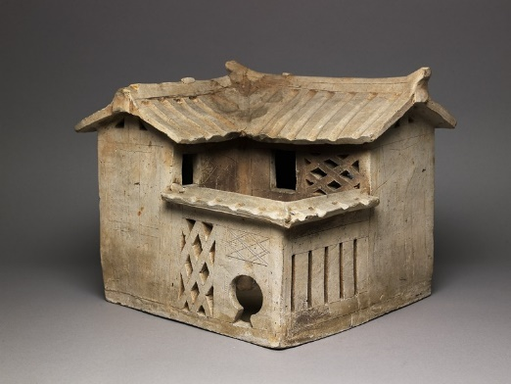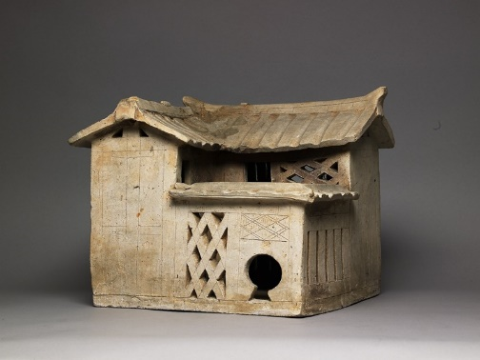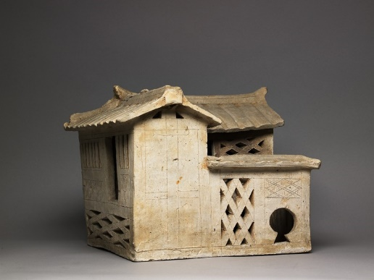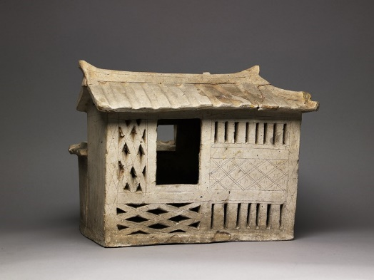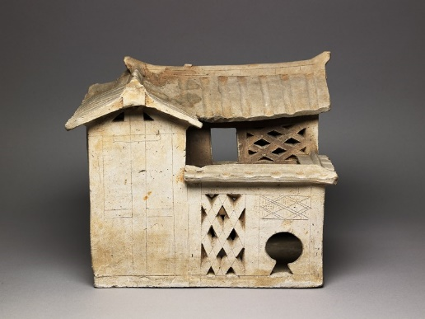 Burial model of a house, Guangdong province (place of creation) date – Han Dynasty (c.206BC – AD220) . earthenware, with traces of brown glaze, funerary equipment, model. Eastern art. China. Accession no. EA1969.51 (ashmolean) http://collections.ashmolean.org/object/457636
The ancient Chinese believed in a life after death that was very similar to this world. To allow them to enjoy this afterlife, the rich and powerful members of China’s ruling elite wished to have all of the comforts of their past life. During the Han dynasty (206 BCE-220CE) elaborate burials included beautifully crafted bronze vessels for food and drink and models of servants, granaries and even farm animals. The body of the dead person might also be further protected with finely carved pieces of jade, a stone that was believed to have magical qualities. https://www.dur.ac.uk/whatson/event/?eventno=10004

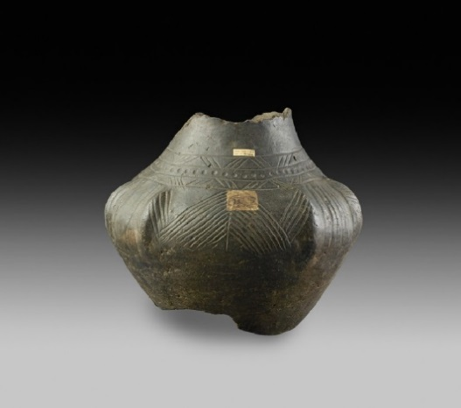 Burial-urn. Anglo-Saxon, fifth or sixth century AD. Lower ground floor… gallery 2 … the ashmolean story…. Antiquities… accession no.AN1685.B.682 http://collections.ashmolean.org/object/404070

Burial urns and grave goods
Anglo-Saxon burial urns were typically hand-made out of pottery, and often decorated with various motifs. These included bosses, stamps and linear incised marks, as well as freehand designs.[40] The most notable of these motifs was the swastika, which was widely inscribed not only on crematory urns but also on certain pieces of weaponry, various brooches and other forms of (often female) jewellery. Archaeologist David Wilson remarked that the swastika "undoubtedly had special importance", suggesting that it was the symbol of the pagan god Thunor. He accepted that through increasing usage, it might have become a "purely decorative device with no real symbolic importance."[41] Another symbol that appears on urns and other artefacts is the rune ᛏ; this represented the letter T and has been associated with the god Tiw.^{[42]} In rare cases, such as at Baston, Lincolnshire,^{[43] and} Drayton, Norfolk,[44] lids were made for these urns; the most elaborate known example – from Spong Hill, Norfolk – is decorated with a seated human figure with its head in its hands.[45] Several examples used stones as lids.[46] There are also a number of cases where "window urns" have been uncovered, containing pieces of glass inserted into the fabric of the pottery.[47] Examples of this have been found at such sites as Castle Acre in Norfolk,^{[48]} Helpston in Nottinghamshire,^{[49] and} Haslington in Cambridgeshire.[50] There are also a few rare cases, such as at Cleatham in Lincolnshire,[51] where instead of making a new pot to bury cremated remains in, Anglo-Saxon peoples re-used older Late Romano-British period urns or pots in their funerary rites.[47] In certain cases, pottery urns were substituted by bronze bowls,[52] with examples being found at Sutton Hoo in Suffolk,[47] at Coombe in Kent,^{[53] at} Illington in Norfolk,^{[54] and at} Snape in Suffolk.^{[55]}
Like inhumations, cremated remains were sometimes deposited along with grave goods, however sites containing grave goods constitute only "about half of the known cremations".[56] Sometimes, these items were placed on the cremation pyre along with the corpse, and were therefore damaged by the fire. They were then placed, along with the skeletal remains, within an urn for burial. At other times, these grave goods were placed inside the urn unburnt, meaning that they remained intact and undamaged.[57] The most common grave goods placed in cremation graves were "toilet implements", among them bronze and iron tweezers, razors and blades, shears and ear-scoops; some were full-sized, but others were miniatures of no practical use.[58] Also common were bone and antler combs, some of which had been deliberately broken prior to inclusion.[58] https://infogalactic.com/info/Burial_in_Anglo-Saxon_England

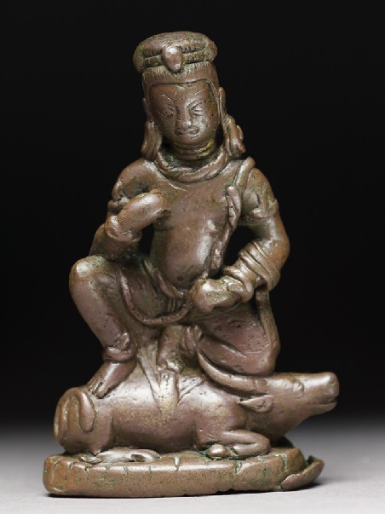 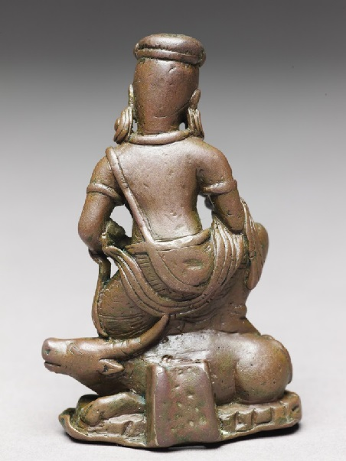Figure of Yama, god of death on his buffalo. Nepal (place of creation). 10th century (AD901 – 1000). Bronze, partly hollow cast.
Dimensions
8.3 x 5.3 x 2.8 cm max. (height x width x depth)
figurine,
religious/ritual equipment
Accession no. EA1999.58
http://www.jameelcentre.ashmolean.org/object/EA1999.58

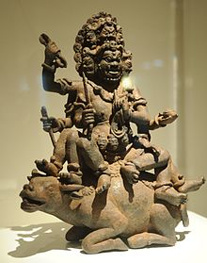 H B 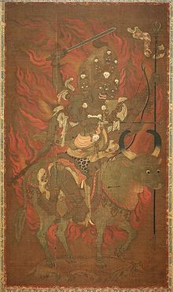

Hinduism[edit]
Main article: Yama (Hinduism)

Yama is revered in Tibet as the Lord of Death and as a guardian of spiritual practice.
In Hinduism,^{[8] Yama is the} lokapala ("Guardian of the Directions") of the south and the son of Surya. Three hymns (10, 14, and 35) in the 10th book of the Rig Veda are addressed to him.[9] In Puranas, Yama is described as having four arms, protruding fangs, and complexion of storm clouds with a wrathful expression; surrounded by a garland of flames; dressed in red, yellow, or blue garments; holding a noose and a mace or sword; and riding a water-buffalo.[10] He wields a noose with which he seizes the lives of people who are about to die.[11] Yama is the son of Surya and Saranyu. He is the twin brother of Yami, brother of Shraddhadeva Manu and the step brother of Shani. His wife was Goddess Dhumorna and his son was Katila.[12] There are several temples across India dedicated to Yama.[13]

Buddhism[edit]
Yamnataka, 13th century, Japan.
Main article: Yama (Buddhism)
In Buddhism, Yama (Sanskrit: यम) is a dharmapala, a wrathful god or the Enlightened Protector of Buddhism that is considered worldly,[14] said to judge the dead and preside over the Narakas ("Hell" or "Purgatory") and the cycle of rebirth.
The Buddhist Yama has, however, developed different myths and different functions from the Hindu deity. In Pali Canon Buddhist myths, Yama takes those who have mistreated elders, holy spirits, or their parents when they die. Contrary though, in the Majjhima Nikaya commentary by Buddhagosa, Yama is a vimānapeta – a preta with occasional suffering.^{[15]}
In other parts of Buddhism, Yama's main duty is to watch over purgatorial aspects of Hell (the underworld), and has no relation to rebirth. His sole purpose is to maintain the relationships between spirits that pass through the ten courts, similar to Yama's representation in several Chinese religions.^{[16]}
He has also spread widely and is known in every country where Buddhism is practiced, including China, Korea, Vietnam, Japan, Bhutan, Mongolia, Nepal, Thailand, Sri Lanka, Cambodia, Myanmar, Laos, and United States.

