How do we commemorate? How do Memorials create personal meaning in a public place?

Jessica Arthur 1702721
Graphic Design
Word count: 1863
Lecturer: Louise Burston

Introduction

This report explains the importance of commemorating, why we commemorate and the impact it makes in a public place. All through the ages commemorating has been practiced all over the world and though there is no one way to commemorate, or one way to feel, some memorials can be a positive experience and mark an historical event that also gives a personal connection or on the other hand can be a painful and distressing experience and showing the implications or consequences of an event. The placement of the memorial is also a big factor of what that memorial means to the place and how it has been situated to help the public viewing to be an empathizing and have an emotional experience, it is also allows viewer to pause and acknowledge the sacrifices that were made. The positioning of the memorial also comes into play whether it makes the public look up or down at the memorial, giving it meaning and a personal outreach, some memorials make the viewer be part of the experience stirring emotion and feelings that have a strong impact.

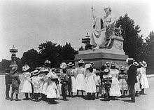(Greenough,1840)

In Washington DC the George Washington monument (Greenough,Horatio,1840) the symbolism is portrayed as Greek god, pointing up to heaven, with a muscular torso signifying strength, and left hand has got a idolized sword indicating it’s important to look up to him, He is positioned up high on a large plinth so you have to look up to him, a traditional monument with classical details, high art and well crafted. High culture depicts a person to be looked up to and statues will be placed high on a pedestal, so you have to look up in order to see the sculpture, they will be placed in significant areas that represent them or their status within society, sitting or standing over looking everyone shows the importance of that person. High culture is more private and formal. Low culture however is very different just like the flat memorial for aids victims where personal tiles are made from fabrics and lied out in different areas, a portable memorial so to speak, where everyone comes together as one and expresses emotion they may cry or share stories with others of their experience of that person who passed due to the decease, helping each other with their losses and probably feeling less alone knowing it has happened to so many other families. When many lives are lost commemorating helps the families or loved ones, just like the unknown soldier memorial a single soldier represents ALL soldiers that died in ANY war, as many who died on the battlefield didn’t receive proper funerals and had to have make shift burial where they fell and as a nation we strongly believe everyone should have a proper resting place as they deserve nothing less. It also advises and warns the dangers of war to those generations who don’t know about the history, when this big event happens younger generations will ask what that means? and why it happened, so we are able to explain and so them the lives lost for us to have the lives and freedom we have to today.

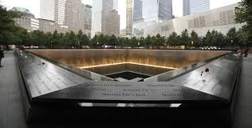 (Libeskind, 2006)

In comparison the (9/11) memorial by Libeskind is a memorial where you have to look down, and makes the viewer think and focus inwards, using the foundations of the remnants of both the buildings to make enough impact to visualize the enormous devastation caused, there is also pools of water in the centre of each piece this could be there to reflect maybe. Both North and South towers include in the surrounding of the memorials the names of each person who lost their lives that day. It’s important to remember to show younger generations the importance to stand together after such a terrible event and the impact of war or terrorism “is a memorial a stored memory that needs to be shown as natural form” (Byatt, 2008)

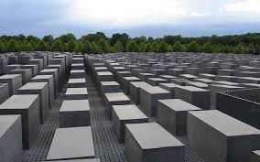 (Eisenman, 2003)

A powerful example of a memorial that has sparked curiously and interest all over the world is the Holocaust Monument, people will travel far and wide to pay their respect as we as to experience the awful devastation of lives lost in the Jewish community in Berlin, our thirst for knowledge and curiosity takes us to visit memorials or monuments all over the world to have an experience, travellers will always touch the monument or take pictures not to forget what they emotionally felt whilst visiting. People will document enough information to try and put themselves in the positions of others to feel some kind of connection, it is said to be the “international Monument” (Olin, 2003) This memorial is the actual architecture of the remnants of the city walls, White crosses are painted on to show where people tried to escape, its massive scale impacts immediately making you feel uneasy and overwhelmed, creating and un nerving experience, the large concrete blocks make you disorientated they are so high above you your unable to see around them which can give a sense of enclosure. On the other hand the opposite effect like a negative response to a monument or memorial can be equally as powerful, destroying a monument or memorial will be interrupted completely different for different groups or cultures, for instance the viewing that was recording on view of the statue of Saddam Hussein getting toppled and destroyed (Archive, 2003) was a powerful statement, it shows the anger and hatred towards this man and everything he stood for, destroying the statue was symbolism of and end to an era and end to all the sadness and damage this man caused, both the country and its occupancies.

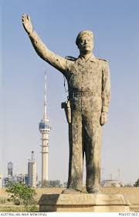 (Ezzat, 2002)

His statue was positioned in the Firdos square in Baghdad a focal point and a monument you cannot miss stands a massive 12 metres in honour of his 65th birthday, his stretched up high arm almost like authority gesture or command is the highest point of the statue, he’s stood quite sternly and the obvious showing of a gun on his hip suggests he is a murderer and suggesting he well kill to get what he wants and to earn the respect and power that he desires it also indicates violence and extremism. This toppling of the statue went global also, people around the world felt for the people who had their lives torn upside down by this man, woman, children, all cruelly treated day in day, living their lives in fear with no sight of peace and order. The tearing down of the statue showed a physical end to the regime allowing people to regain something back that he took from them, people dragged the head of the statue through the streets showing total disrespect for the man that once controlled them all and what he represented, videos show them stamping and hitting the statue once it was dragged from its pedestal where it once stood high and proud, it was hit with sledge hammers, kicked, slapped and shown complete resentment towards it, this represented freedom and the overall end to Saddam Hussein.
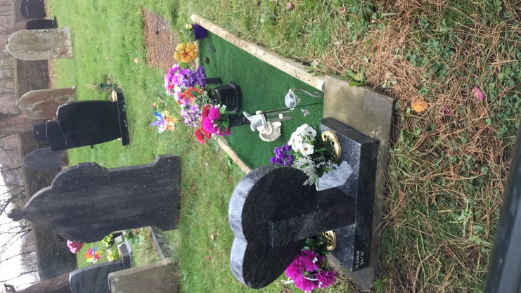 (arthur, 2018)
Another form of a memorial can be one to one and a more personal. An Individual remembrance can be personal and done alone or you may confide in a friend or family member where they will talk about that person you have lost, remembering and sharing thoughts on how it’s affecting the individual, going through emotions and stages of loss such as Denial, Anger, Bargaining, Depression, Acceptance. Which is the usual process for grieving, Individuals may remember by looking through photographs or looking at a keepsake off that person, maybe a lock of hair, piece of jewelry or ashes this is where an object can become sentimental and important to the individual. This is when a memorial can become a shrine to your loved ones or a place where you spend time and reflect or a place of solace, each memorial in this circumstances will always be individual and unique, the narrative behind the designs will differ and the sentiment in each object placed on the memorial will mean a small memory or representation of an emotion, almost like gifts to the one who has departed, maintaining the memorial to show the respect and importance of that person. Showering a grave with endless flower arrangements, small ornaments, pots, messages etc. giving the sense of giving back to that individual can make a person cope with the grieving process, it can be always sad when seeing a grave un marked or unkempt, no flowers, or its over grown does anyone really want to be forgotten? Some who prefer not to visit a loved at the grounds of where they lay, may make a small memorial of their own, subconsciously, or consciously, People may select a certain shelf where photos are placed of that person maybe the glasses they wore or of a lock of hair near. Or they could plant a tree or shrub that represents the person lost, each year it grows adding ribbons or carving into it or just a place to sit and read but each time it’s looked at it, that object will then almost become remembrance as time passes and acceptance practiced and that person may not be in your mind as much but it sparks the memories you don’t want to lose always evoking presence of the person almost forcing you to think of them and becoming physical manifestation of a memory. In Victorian times families would photograph their recently passed and sometimes used props within the photo too, early photographer’s slogans were “secure the shadows, ere the substance fades”
(newspaper, 1851). It may seem odd to photograph the dead but that was part of the process then, just like we visit the recent passing of a family member post-mortem in chapel of rest or some families have them at home for a few days to say goodbye. Usually the deceased person (usually a child in them times) would look like they are just sleeping but the items they presented around them would signify that person was in fact dead the items consisted of drooping flowers nearby or a presence of a dead bird, or even a cut cord. This form of remembrance was high culture as usually it was wealthy Europeans or later the Americans that photographed the deceased.

In conclusion as stated before there is not one way to commemorate or a right or wrong way to feel, it’s a natural progression of curiosity and thirst for knowledge and understanding what your feeling, It’s a processes, whether good or bad, it’s the human why for mind to accept a certain event or dramatic experience in your life, It brings meaning to death and grieving and helps answer some of your questions, whilst bringing people peace and solace and also bringing people closer together making a negative into a positive experience. It’s an important act to commemorate as it’s important to remember, to carry on legacies or iconic figures roles within communities, commemorating shows solidarity and respect too, after all without memories would we be able to progress successful without learning through prior mistakes.

Bibliography

Anon., n.d. s.l.:s.n.
Archive, A., 2003. you tube. [Online]
Available at: https://www.youtube.com/watch?v=Vd-M3Y-IprU
[Accessed 11 december 2018].
arthur, j., 2018. mothers grave. cardiff: s.n.
Byatt, H. H. W. &. A., 2008. Memory an anthology. London: Chatto & Windus.
Eisenman, P., 2003. Holocaust Memorial. [Art] (Berlin).
Ezzat, K., 2002. [Art].
Greenough, H., n.d. The George Washington Memorial. [Art].
Libeskind, D., 2006. 9/11 Memorial & musuem. [Art].
Major, L. H. & Perlmutter, D. D., 2005. The Fall of a Pseudo-Icon: The Toppling of Saddam Hussein's Statue as Image Management. Visual Communication Quarterly, , 12(1), pp. 38-45.
newspaper, a. m., 1851. Athens Messenger Newspaper Archives, Nov 14, 1851, p. 3. [Online]
Available at: https://newspaperarchives.com/athens-messenger-oct-31-1851-p-3/
[Accessed 11 dec 2018].
Olin, R. s. N. &. M., 2003. Monuments and Memory, Made and Unmade. Chicago: The University of Chicago Press.

