Programme: BA International Hotel Management

Module: Management and Organisational Behaviour
Assignment No.: 1
Assignment Title: Academic Essay
Student ID Number: 2120533

Contents
Task 1 1
Blake and Mouton's managerial grid 1
Impoverished Style 2
The Produce or Perish Style 3
Middle-of-the-Road Style 3
The Country club style 3
The Team Style 4
Task 2 4
Task 5
Team: 6
Individual 7
Conclusion 8
References 8

Task 1

The concept of leadership is of paramount importance as it signifies the act of guiding a collective of persons towards a shared objective (Bashir, 2022). In accordance with the corporate objective, leaders are tasked with a multitude of consequential responsibilities to discharge. Effective leadership necessitates the establishment and maintenance of a robust linkage between the endeavors, duties, and exertions of an organisation's workforce. In his capacity as a leader, Craig Poole, the general manager of Hilton, has a diverse range of responsibilities (Cardoso, 2022). According to Adair, the action-centered paradigm is employed for the purpose of assessing the efficacy of leaders. This document proposes the recommendation of a specific leadership style to the general manager of Hilton. These models are employed to demonstrate the efficacy of managers in executing their duties and exhibiting leadership qualities across different domains within the organisation (Murcio, 2021).

Blake and Mouton's managerial grid
A study at Ohio and Michigan Universities found that leadership is a combination of task-centered and employee-centered styles. Blake and Mouton's managerial grid scale identifies five distinct leadership traits, focusing on human resources and production capacity (Wanjiku, 2022). Craig Poole, a successful general manager at Hilton Doubletree, exemplifies a balanced leadership style that prioritizes team needs and results. He encourages a welcoming work environment, increasing output and employee satisfaction (Cho, 2018). The Blake and Mouton Managerial Grid's balanced leadership states produce optimal customer output, emphasizing the importance of collaboration and outcomes in a company (Ismail, 2023).
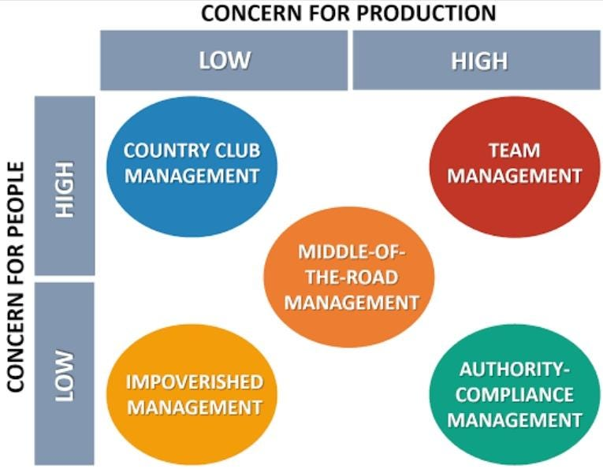
Figure 1Blake and mountain managerial grid(Harter, 2023)

The analysis of Craig Poole's overall performance, encompassing both individual and team performance of leaders, is conducted with the Blake Mouton Managerial Grid. The evaluation of leadership effectiveness and the presence of any ineffective leadership traits will be conducted using the Blake and Mouton management grid (Harter, 2023). This grid effectively represents the manager's personal management approach and job effectiveness. This argument contends that the grid developed by Blake and Mouton exclusively focuses on the examination of these two elements as a means to evaluate leadership aptitude (Baltaci, 2017).

Impoverished Style
The Impoverished Style is characterized by a low level of care for both individual well-being and overall productivity of the organisation. Managers choose this approach to safeguard work positions and maintain job seniority, avoiding accountability for errors (Cardoso, 2022). The Country Club Style emphasizes the well-being and satisfaction of individuals while placing a lower priority on productivity. Managers employing this approach prioritize the well-being and safety of their employees, expecting an enhancement in performance (Murcio, 2021). The individual demonstrates a harmonious integration of his concern for individuals and his drive for productivity, recognizing that achieving success necessitates a simultaneous consideration of both aspects. Poole's leadership philosophy centers around the establishment of interpersonal connections with his team members and fostering an environment that promotes ongoing communication. In his capacity as a leader, he will significantly disregard the thoughts, perspectives, and opinions of his group (Rockett, 2023).

The Produce or Perish Style
The Produce or Perish Style is characterized by a strong emphasis on productivity and a relatively low consideration for the well-being of individuals within the organisation. Managers adopt this style prioritize achieving high levels of output while placing less importance on employee needs and concerns (Saltik, 2023). Craig's ambitious undertaking to revitalize a dilapidated hotel located in one of Pennsylvania's most economically disadvantaged and crime-infested areas, ultimately rebranding it as The Doubletree by Hilton in Reading, is unquestionably a unique narrative that embodies themes of optimism, opportunities for redemption, and the influential role of the hospitality industry. This critical assessment aims to thoroughly examine the complexities of this change, analyze its implications, and assess its possible impact on the wider sector (Simha, 2022).

Middle-of-the-Road Style
The Middle-of-the-Road Style aims to achieve a balance between the objectives of the organisation and the needs of its employees. This style requires compromise on many aspects, such as production, and may not fulfill both individual and general population demands (Anders, 2021). Mr. Poole appropriately attributes this notable achievement to a culture and values framework that aligns flawlessly with the Hilton and Doubletree principles. This prompts an important inquiry: if these values and principles were universally adopted by the brand, it is conceivable that the entire firm would witness a substantial increase in guest pleasure, revenue, and shareholder returns. This insight highlights a potential missed chance for Hilton to replicate the performance observed in Reading throughout its broader operations (Bashir, 2022).

The Country club style
The evaluation instils within us a feeling of intrigue. The aforementioned statement alludes to the existence of barriers that impede other General Managers (GMs) from embracing this plainly efficacious and gratifying leadership approach. Regrettably, the assessment fails to provide a comprehensive analysis of the aforementioned difficulties (Cardoso, 2022). An investigation into the obstacles and potential remedies could yield useful insights for the industry, presenting a strategic plan to reproduce the achievements of The Doubletree by Hilton in Reading in various different settings. Craig's successful revitalization of a financially challenged hotel, resulting in its transformation into a prosperous symbol of optimism and exceptionalism in Reading, Pennsylvania, serves as a source of inspiration (Murcio, 2021). Although the achievement of this initiative is indisputable, a thorough analysis of the difficulties and barriers encountered by other general managers (GMs) in implementing comparable leadership strategies would have enhanced this evaluation and rendered it more applicable to the wider hospitality sector (Todăriţă, 2021).

The Team Style
Lastly, the Team Style places significant emphasis on both the well-being of individuals and the achievement of production goals, fostering a culture of collaboration and dedication among the workforce. In an impressive accomplishment, Craig assumed the responsibility of recruiting around 200 persons, a significant portion of whom has limited or no prior expertise in the service and hospitality industry (Abardeh, 2022). The individual in question had a propensity for considering factors beyond mere resumes, instead prioritizing individuals who exhibited a shared sense of optimism towards their urban environment and a sincere enthusiasm for the field of hospitality (Burke, 2021). Significantly, individuals who had previously been convicted of a crime, commonly referred to as ex-felons, were provided with a notable opportunity for rehabilitation, so providing them the possibility to reconstruct their life and make constructive contributions to their families and the wider community. The demonstration of inclusivity and social responsibility exhibited in this action is deserving of commendation (Saltik, 2023).

Task 2
The Three Circles Model, also known as Action Centered Leadership (ACL), was introduced by renowned leadership authority John Adair in 1973. This model has gained significant recognition and influence in the field of leadership. This statement emphasizes the fundamental acts necessary for effective team leadership, as opposed to the specific leadership style one adopts (Adair, 2009). These actions are categorized into three distinct domains:
  - Task refers to the series of acts undertaken in order to accomplish a specific objective.
  - Team discusses the strategies employed at the group level to foster efficient teamwork and enhance group cohesion.
  - Individual actions that specifically target the distinct needs of each team member(Braun, 2012).
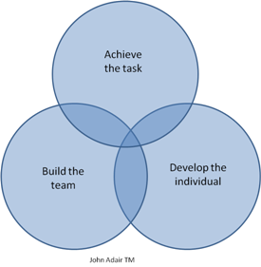

Craig Poole is a highly skilled hotel manager who has demonstrated exceptional managerial abilities. According to Kuttner and Mayer-Glenn (2022), the individual in question possesses a comprehensive understanding of the three fundamental components of the Action Centered Leadership approach and has demonstrated adeptness in their appropriate application (Bashir, 2022). Consequently, it may be inferred that this individual exhibits the capacity to assume a leadership role. Poole's exceptional managerial and leadership skills are acknowledged due to the positive outcomes, increased confidence, enhanced support for professional teams, and productivity development that result from his ability to effectively maintain a suitable equilibrium. Consequently, the efficacy of his organisation is enhanced (Cardoso, 2022).

Task
Craig has been overseeing the overall effectiveness of the approach and assessing the group's progress updates. The individual has accomplished this task through the process of modifying, reviewing, and reevaluating the software. According to Li and W (2018), Craig Poole and his team prioritize competencies, morals, openness, and a focused approach towards achieving objectives. They also demonstrate the ability to anticipate and resolve group disputes, conflicts, or disagreements (Cho, 2018). Regularly evaluating the composition and substance of a group is essential for fostering cooperation, creativity, and team spirit inside the collective. According to Müller and Jain (2018), the group's independence and authority will experience a progressive growth. The team will experience increased motivation as a result, leading to the successful completion of its tasks and goals (Murcio, 2021). It is vital to ascertain if Craig has exerted deliberate efforts to stimulate the group's motivation, foster their cohesion, and facilitate their acknowledgment. This phenomenon has effectively highlighted their imperfections while simultaneously facilitating and amplifying collective discussions within and outside the organisation (Todăriţă, 2021). Craig Poole has been assigned the responsibility of engaging with the general public, collecting input, and providing constructive criticism regarding the overall progress of the project. As a manager, you are expected to fulfill certain promises to each employee. Understanding the unique attributes of each team member, encompassing their individual personalities, talents, achievements, desires, objectives, and concerns, has proven to be highly advantageous (Baltaci, 2017). Furthermore, it has provided them with assistance in managing ideas, challenges, barriers, and organisational modifications. This phenomenon has significantly facilitated the identification of individuals' educational goals and obligations. Additionally, it has been instrumental in providing social acknowledgement and commendation, validating one's exertion and extraordinary accomplishments when necessary, and fostering personal growth, professional advancement, and enhanced social status through the aforementioned attributes (Rockett, 2023). Craig Poole's exceptional leadership has prioritized the recognition, development, and utilization of each team member's strengths and traits, with the ultimate goal of fostering personal independence and authority (Simha, 2022). Craig Pooles regularly establishes a strong correlation between the collective endeavors of the team and the outcomes achieved, so exemplifying effective leadership.

Team:
The establishment and sustenance of a cohesive team According to Armitage and Sowman (2020), Craig Poole, an employee at the Doubletree Hilton, implements all aspects of John Adair's methodology in order to achieve a state of equilibrium in terms of significance and achievement. This equilibrium is anticipated to be achieved by finding the appropriate balance among the three elements (Murcio, 2021). Craig, being a capable leader, demonstrates the ability to adjust his level of attention towards the three variables in accordance with the specific circumstances, all the while considering the interdependent nature of these variables within his company context. Craig Poole is a seasoned professional in the hotel industry, serving as a dynamic manager and regional director of marketing (Abardeh, 2022). According to Kuttner and Mayer-Glenn (2022), the ability of a strategic leader to establish strong connections and foster consensus can contribute to the enhancement of both top and bottom-line sales. The inspiration for this notion can be attributed to John Adair's action-centered management mission paradigm, which has proven to be very compatible with the challenges faced by contemporary executive leaders and has contributed significantly to his achievements (Bashir, 2022). Craig carefully evaluates the various performance-related factors present in his environment. Craig uses the performance characteristics that are essential for success in his situation while constructing his assessment, as well as locally relevant data, into the framework (Rockett, 2023).

Individual
The establishment of personal needs is a crucial aspect of effective management. In light of this, it is evident that Craig Poole has demonstrated a very effective management approach by his diligent execution of the following responsibilities associated with task completion (Ismail, 2023). He has demonstrated his proficiency in articulating the activities carried out in accordance with the task-based management approach of the organisation, together with the group's aims, objectives, rationales, and orientation. The individual in question has made significant contributions to the identification of resources, personnel, policies, processes, strategies, and methodologies, with a special focus on areas such as finances, communications, and information technology (Simha, 2022). Furthermore, Craig Poole has devised a comprehensive strategy for the successful completion of the assignment, encompassing project specifications, key performance indicators (KPIs), timelines, a strategic framework, and a well-defined methodology (Anders, 2021). Craig's research demonstrates that the utilization of an informal contract and a negotiation team facilitates the articulation of rules, dependability, scheduling, and data delivery aspects, while also serving as a means of regulation. This paper aims to elucidate the function and associated obligations of a particular entity, while also outlining the objectives, metrics, and reporting criteria that are relevant to its operations (Rockett, 2023).

Conclusion
According to Adair's analysis, the correlation between collaboration and individuals' authority highlights the effectiveness and relevance of Craig Poole's leadership within the company context, resulting in optimal productivity (Kuttner& Mayer-Glenn, 2022). Craig Poole specializes in leadership, with a particular focus on team development and meeting the individual needs of team members through smart growth strategies. Craig Poole places great importance on the integration of workplace dynamics and productivity as a fundamental aspect of his leadership style. The individual in question possesses outstanding leadership qualities, characterized by uncommon foresight, adeptness in team-building, exemplary managerial aptitude, and remarkable analytical acumen. Furthermore, cultivating strong interpersonal connections within the organisational context is crucial for a leader to effectively demonstrate their aptitude for leadership.

References

Abardeh, H.C., 2022. Finding a Path to Success for the Hilton Atlanta Downtown Hotel. SAGE Publications: SAGE Business Cases Originals.
Adair, J.O.H.N., 2009. Functional leadership. NHRD Network Journal, 2(5), pp.2-7.
Alyafei, O., 2023. Analysis of Leadership Style: A Case of One Leader. Journal of Human Resource and Sustainability Studies, 11(3), pp.511-520.
Anders, A.D., 2021. Human-centered leadership development: A communication-based approach for promoting authentic and transformational leadership. International Journal of Business Communication, p.23294884211056558.
Baltaci, A. and Balcı, A., 2017. Complexity leadership: A theorical perspective. International Journal of Educational Leadership and Management, pp.30-58.
Bashir, I., Rana, R.A., Naseem, A., Ghafoor, A. and Mumtaz, B., 2022. A Comparative Analysis of Situational and Style Leadership Theories. Competitive Education Research Journal, 3(1), pp.127-134.
Braun, F.C., Avital, M. and Martz, B., 2012. Action‐centered team leadership influences more than performance. Team Performance Management: An International Journal, 18(3/4), pp.176-195.
Burke, W.W., 2021. Blake, Robert R., and Jane S. Mouton: Concern for people and production. The Palgrave handbook of organisational change thinkers, pp.213-222.
Cardoso, L.E., 2022. Hilton world wide holdings in travel & tourism industry (Doctoral dissertation).
Cho, K.W., Yi, S.H. and Choi, S.O., 2018. Does Blake and Mouton’s managerial grid work?: the relationship between leadership type and organisation performance in South Korea. International Review of Public Administration, 23(2), pp.103-118.
Hakan, K.O.C., Kiliclar, A. and Yazicioglu, I., 2013. The analyzing leadership styles of turkish managers in the scope of the Blake and Mouton’s managerial grid. International Journal of Business and Social Science, 4(11), pp.96-109.
Harter, N., 2023. QUESTIONS ABOUT A PERSON-CENTERED LEADERSHIP. Exploring Personhood in Contemporary Times: From Leadership to Philosophy, p.1.
Ismail, H.N. and El-Farr, H., 2023. Leadership Grid.
JD, D., 2023. Leadership Styles. Available at SSRN 4560197.
Murcio, R. and Scalzo, G., 2021. Person-centered leadership: the practical idea as a dynamic principle for ethical leadership. Frontiers in Psychology, 12, p.708849.
Rockett, G., 2023. History/overview of Hilton. The Routledge Handbook of Diversity, Equity, and Inclusion Management in the Hospitality Industry.
Saltik, Z., 2023. Behavioral Approaches to Leadership. In Leadership Approaches in Global Hospitality and Tourism (pp. 40-60). IGI Global.
Simha, A., 2022. Behavioral and Style Approaches to Leadership. In Leadership Insights for Wizards and Witches (pp. 27-32). Emerald Publishing Limited.
Todăriţă, E.T., 2021. Leadership Style Determination according to Robert Blake and Jane Mouton’s Managerial Grid. In International conference KNOWLEDGE-BASED ORGANISATION (Vol. 27, No. 1, pp. 241-246).
Wanjiku, A.M. and Kungu, P., 2022. leadership style and performance of five star hotels in Nairobi county, Kenya. European Journal of Economic and Financial Research, 6(1).

