Student: Radu Andreescu (2026729)
Module: Workplace Culture and Its Impact on Organisational Efficiency
(BMSW5105_BIRM)
Lecturer: Dr. Khaza Ahmed

Individual Written Report
Just Eat TakeAway.com

Table of Contents
1.1 Introduction 3
2.1 Organisational structure of Just EatTakeaway.com 3
3.1 External factors influencing work culture 6
4.1 Key elements of ethical organisational culture at Just EatTakeaway.com 9
5.1 Barriers and recommendations 11
6.1 Conclusion 13
7.1 References 14

Introduction

Just EatTakeaway.com is a leader in food delivery business. It started in Netherland in
2000 as TakeAway.com and in Denmark as Just Eat in 2001. Later on those 2 companies emerged in 2020 creating a big innovative organisation. At the moment they operate with those brands in over 20 markets, even more through partners, and are connecting over 680.000 partner restaurants to final customers.
The process of developing a small business, an idea to a world leading company went through many organisational transformations that included setting values and developing business ethics that was direct involved in the late success. The way the structure of organisation evolved, how values occurred and how they face the business environment is the subject of the current report.
Organisational culture it is a system of shared values with the purpose of distinguishing an organisation by other one in a manner that emphasize a set of characteristics compliant with the community needs and values. If the process of creating an ethical business based on values embraced by employees and highlighted through example by management and leadership match the values of the society and its needs, performance is the result and the outcome is coming as a good profit turnover (Paais and Pattiruhu, 2020).

2.1 Organisational structure of Just EatTakeaway.com

An organisation structure it is about how jobs are formally divided , about how tasks are coordinated , what is the framework of leadership (Judge and Robbins, 2017). At the very beginning organisations starts with a flat structure and they evolve like an organism to adapt to the external and internal environment trying to find the most efficient way to fulfil some important functions like speciality, needed departments, structure of leadership, control, how decision process is centralised or not, formalisation and boundaries.
Just EatTakeaway.com was a small organisation at very beginning that expanded fast covering more and more areas including partnerships with more businesses and expanding from a simple idea to a leader in food delivery.
A simplistic view over the business looks like in the fallowing figure:

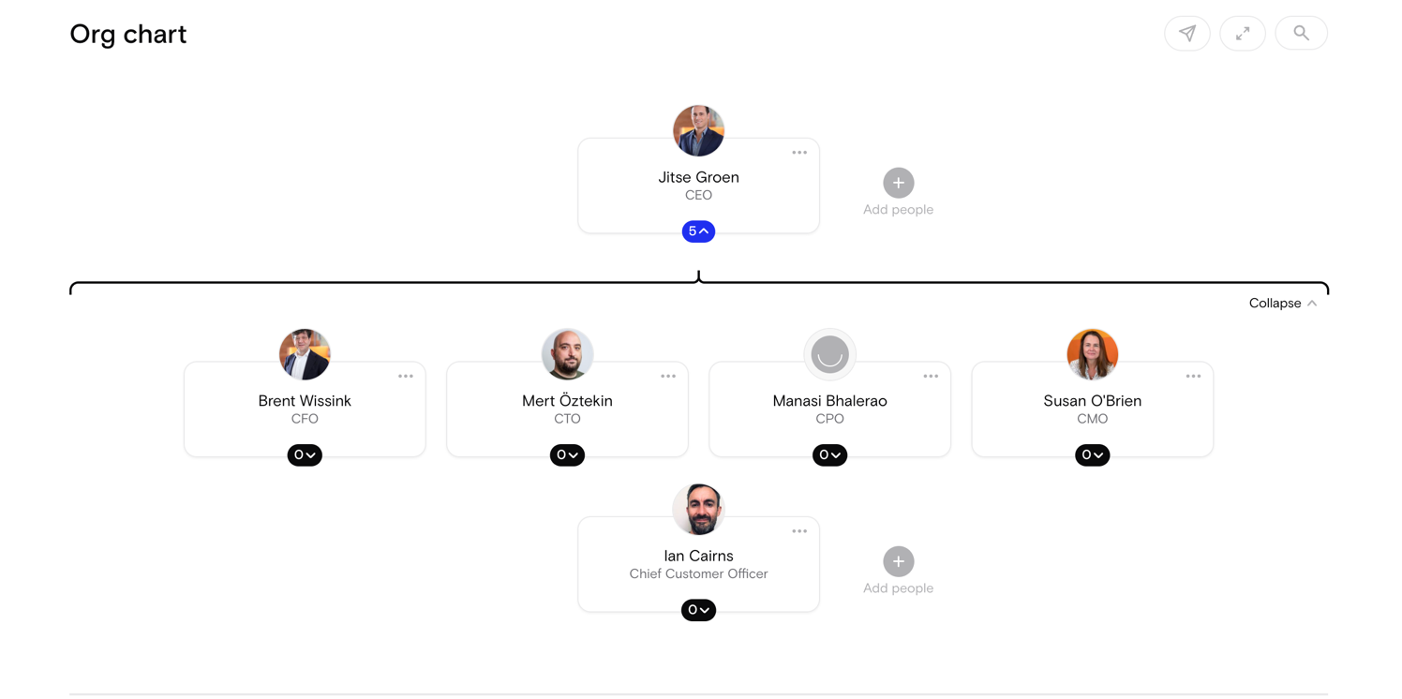
(The Org, 2022)

A more realistic structure and more accurate we an see in the fallowing chart:
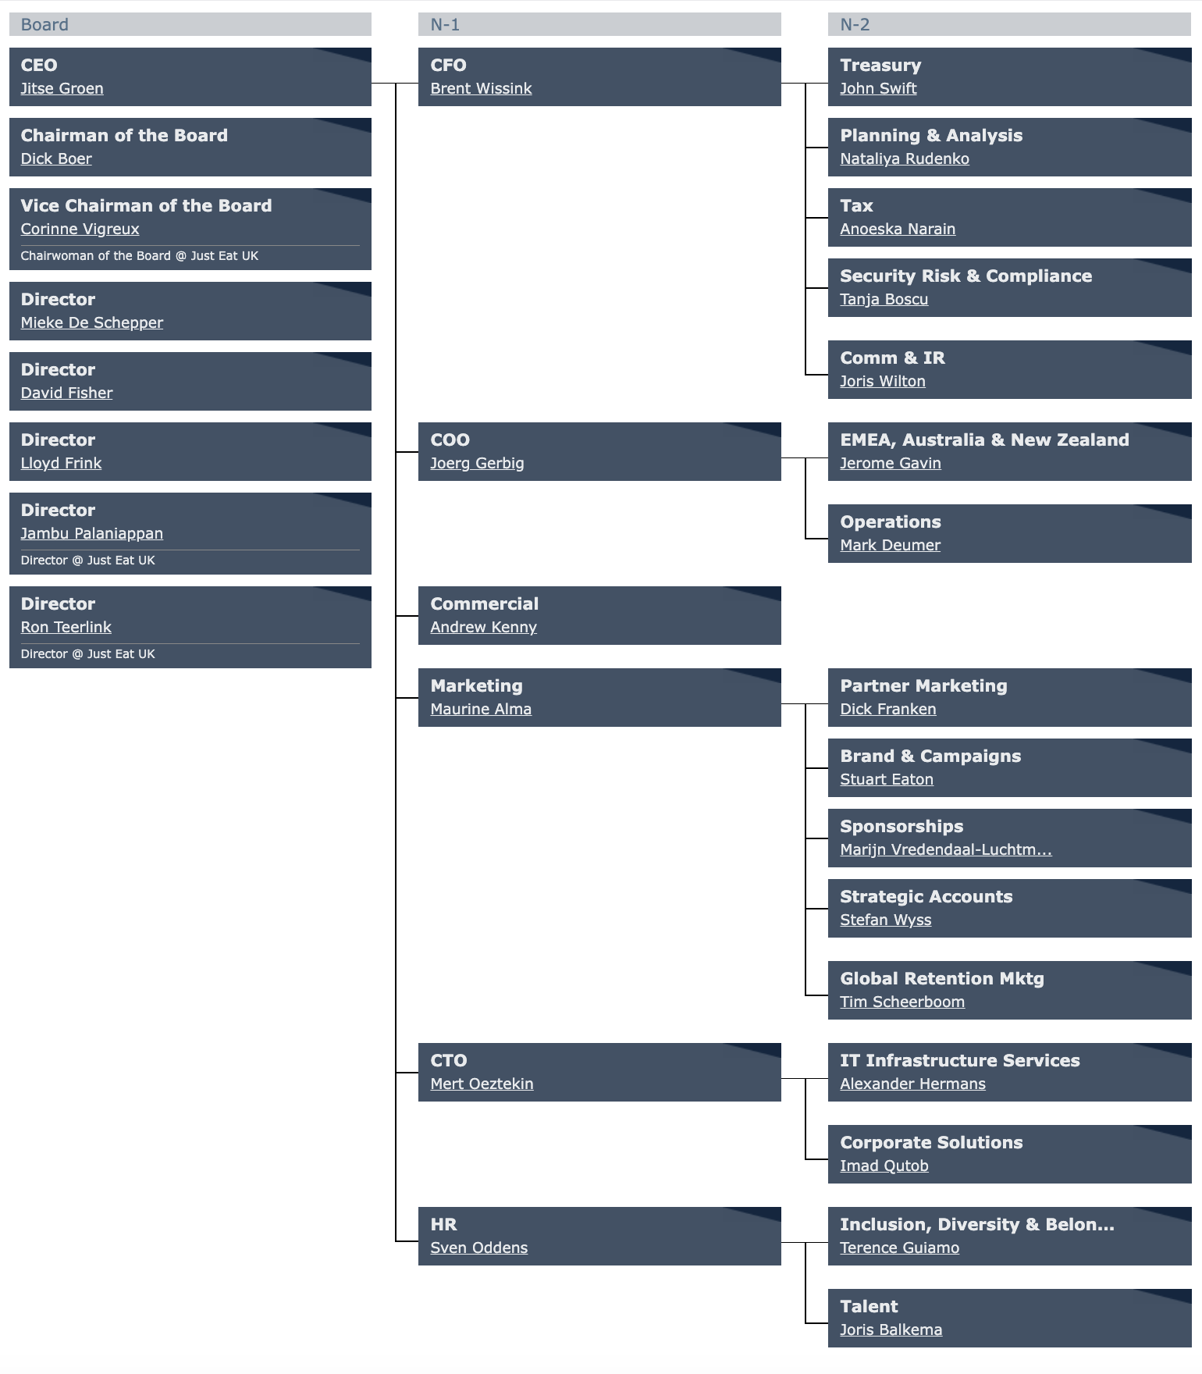
(The official board, 2022)
From the figure we can identify 2 types of structures. First and most obvious is the functional structure. This structure derives from the need of separation based on type of activities. It creates a separation based on logical similarities and the purpose of jobs. It is a very efficient structure with the role of reducing specialisation scale (Ahmady, Mehrpour and Nikooravesh, 2016).
It is also obvious from the Official board that there is another type of structure and this is Geographical structure. EMEA , New Zealand and Australia, Japan , has their own structures integrated in this functional one. To adapt the organisational structure and to find the perfect mix is important for the efficiency both financial and organisational.
At operational level where the people deliver to the final customers the food the type of organisation is of amoebae type. The company adopted a mix of structures able to get the most efficient approach for the functions they have in the big picture.
The structure is the frame but this frame is filled with the organisational culture. The shape influence the content. We should not look at the culture and structure like something organisation holds forever but like a flexible notion that changes as the organisation grows and also as the organisation interacts with external environment. It is a process of adapting to the market and social values that has as a result a distinguished profile and adds value to the social ecosystem as every organisation is part of it. A shared and assumed coulture creates a climate , a working climate as well a climate that defines the relationship between organisation and it’s customers and social environment (Judge and Robbins, 2017).

3.1 External factors influencing work culture

Organisation reacts and adapts to external environment. Without this surviving attribute the risk of being off the market is huge and no company afford this. To have a better understanding of the external environment and how it influence Just EatTakeway.com organisation a PESTLE analysis will be conducted. Understanding of external environment is of a vital importance for management and for analysing and PESTLE provides a systemic approach (Ho, 2014). The reaction and the changes of organisation reflects in the organisational culture. It is important to understand what culture is in this context and the easy way to define it is about peoples behaviour ethic or not and is more and more acknowledged that fine tuning organisational culture by the management the organisational performance can be improved (Sinclair, 1993).

Political | Economical | Social | Technological | Legal | Environment
Brexit | Inflation | Inclusion | 5G technology | New standards post Brexit | 0 emission policy
War in Ukraine | Economic recession | Level of education | AI technology | Health and Safety | Recycling
Emigration policy | Logistic supply issues | Attitudes | Tech developments of competitors | Data protection | Climate change

Political factors can influence the organisation culture. Brexit is one of the factors and it has many ways to be an important factor. European regulations do not affect anymore the economical environment, the workforce looses a wide recruitment area as European countries are not participating to workforce market anymore. War in Ukraine has also a big and major impact. The consequences that organisational culture has to adapt are affected by higher energy costs, and all the economical depression. The price of the food is also rising up because of the war. Just Eat customers will have to pay higher bills for the food they order. Emigration policy promoted by UK government will also contribute to a climate with less future employees for the company. Those are just few factors and not the only ones influencing the organisational culture.

Economic factors are also important in shaping organisational culture. Inflation diminishes the company profits and lower the strength of investments founds that organisation has available, economic recession will diminish the power of buying of the customers and will directly affect the income and profits of the company. Logistic supply issues that are a problem worldwide also impacts the organisation as the business partners have shortages of ingredients. It will always reflect in less product available or prices increases for customers. It also creates problems for organisation when they have to buy more electric bicycles for delivery because of the delays for components and batteries. As economical changes are dynamic also the factors are changing and challenging in an interactive way the organisational culture.

Social factors with impact on organisation are inclusion , as society has a strong desire to create more inclusive environments and Just Eat adjust to fulfil this situation. Efforts are made to create a welcoming working place for people of different background in all aspects. Level of education is a social factor with big impact on organisational culture as the company has to adapt to society. Facing different markets with different levels of education in a large geographical area company adapts organisational needs from human resources policies to training programs and all their subsequent subdomains to level of education from each society. Attitudes of the society are also important and must reflect in the way organisational culture is responding to social environment. If customers are highly preoccupied by environment themes, vegetarianism diets, protecting the environment those values must be adopted in the organisation culture to show that the company is emphatic to what society and customers desire.

Technology plays a major role for Just EatTakeaway.com. This organisation is a pioneer in food delivery having multiple patents registered from systems of searching and creating offers regarding user profile interest to algorithms that can calculate delivery time incorporating distance and food preparing times. 5G technology connect to the internet more and more home devices, Alexa is part of them and company is developing new ways to order based on verbal communication between customer and 5g home media objects directly to restaurants. New technologies are adopted and new challenges shapes the organisational culture. AI technology can deal with customer services at basic levels and also ease the work of customer support provided by company. Deliveroo, Uber Eats, Glovo are just some of the competitors. Their tech changes also shapes the way organisational culture changes to adapt the challenges.

Legal factors are directly affecting the culture as they are mandatory. New standards in UK or elsewhere must be adopted by organisation, health and safety regulations are the policies defining the health and safety inside the company, data protection enforce the behaviour company must fallow in order to protect privacy of the customers. GDPR in Europe and UK and national legislation in other countries regulate how the culture of the organisation act on the subject.

Environment it is an important subject in public agenda. 0 emission policy engaged company in trying to change the delivery fleet in an electric one that is eco-friendly. Recycling is a major concern for society, so the restaurants and partners are encouraged to provide biodegradable bags and to reduce plastic using wood cutlery or encouraging customers to order mentioning that they do no desire cutlery. Climate change is an environmental factor that company is considering offering conditions that are more environment friendly at workplace, in offices, in relation with customers and trying to avoid by all means to be one of the factors that creates negative change. Every step that organisation is taking to adapt its culture to the needs of society, where society are business partners or just community, it is one that reflects in the end in how community embrace the business and is accountable in the way profits are maintained at high rates.

4.1 Key elements of ethical organisational culture at Just EatTakeaway.com

When an organisation I born the ethic of the founder(s) become the ethic of organisation. First employers are chosen usually as people sharing same values and ethics and later on the organisation when develops the new employees are selected according the values and ethics shared by the first ones. This is culture creation. Later on as it develops and the interaction with external environment starts to shape the organisational culture the values and ethics are better defined and they are used in the employment selection process and nourished through trainings and marketing campaign. This is how culture creation transforms in culture maintenance. It is also scientifical researched that is a direct connection between ethical management and the example in values shared by management and company innovativeness (Huhtala, Kangas, Lämsä and Feldt, 2013).
It is a debate still if managers should or should not try to change individual ethics in company as it is a debate still how the ethics are influencing overall organisation performance but is more and more clear nowadays that there is a pressure from society and community that businesses have a set of values and ethics that confirm the public agenda and also is obvious that a coherent set of values and ethics in a company has good returns in profits and offers a more desired working place for employees (Mullins, 2007).
Just EatTakeaway.com are introducing themselves as welcoming company with opportunities for growth and the chance to influence organisation at a global scale. The cultural environment is welcoming for positive , collaborative, driven by performance willing to learn and increase their potential employees. Talent oriented as it can be seen in the organisational structure this is the type of values and environment the organisation tries to cultivate.
For external environment their set of values and drives are to empower every food moment connecting people with hundreds of thousands of food producers of any kind from restaurants to artisans, all over the world in a huge variety of cuisines and customer tastes as market leaders delivering more than great food with care for restaurant partners and customers.
Operating in over 25 markets with employees with over 100 different nationalities they promote a strong message of inclusion, diversity and belongingness and even a stronger message of corporate social responsibility reducing carbon footprint, reducing plastic packaging among partners, increasing electric fleet. The social footprint is marked by good opportunities, rewarding ones both for staff and the communities where they live, office staff or couriers.
To analyse effectiveness of organisational culture at Just EatTakeaway.com we will use a proper tool, McKinsey 7s framework. It stands for seven elements important for organisation success: strategy, structure, systems, shared values, style, staff and skills.

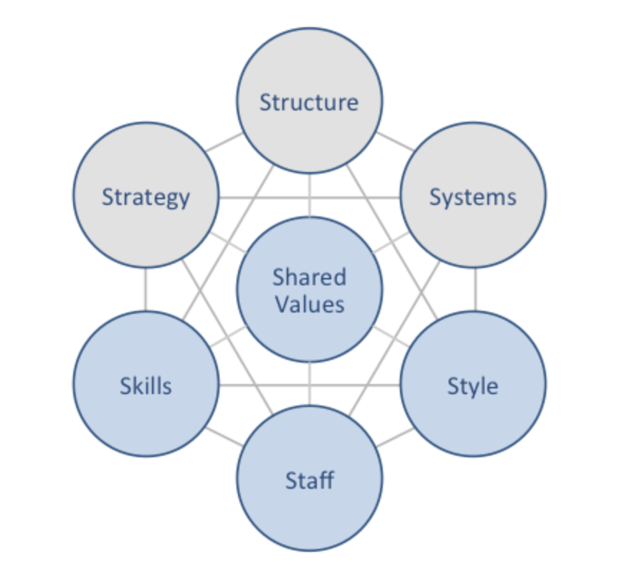

Strategy
They have few strategies in place to integrate and to develop a good organisational culture and with a strong ethical message like accelerating the e-delivery increasing continuously their fleet of electrical vehicles, introducing packaging innovation partnering with Notpla to introduce fully compostable packaging along partner restaurants, supporting charities and having environmentally friendly offices.
Structure
Just EatTakeaway.com has a mix of structures from functional structure of management relating to divisions and departments, to flat structure in small areas and amoeba structure for couriers. Operating in over 35 countries they also have a geographical structure to cover EMEA, Australia and New Zealand and Japan.

Systems
Organisation has multiple systems in place some starting with their online platform and the mobile app, integrating training systems for partner restaurant to train their staff when they join platform in food and hygiene, a system for training couriers a system for classification based on reviews and feedback from customers for restaurants etc.
Skills
The skills required are innovative employees, willingness to grow and to enhance performance, positive and solution oriented. Those are just some of the skills required for the ethic and setting of organisation.
Staff
Staff is inclusive, welcoming, positive, they have a talent pool division offering training and trying to figure for each employee a career path where their skills are used at maximum of potential. Having employees from over 100 different nationalities diversity is one of the assumed values.
Style
Designed style is about enhancing food experience, bringing excellent food for everyone, builds on past bringing future to everyone with top quality in services.
Shared Values
Just EatTakeAway.com stands for leading industry, delivering excellent food with care for customers and restaurants. It is a responsible business with policy of sustainability. Inclusive, divers, positive with ethics and respect for employees and customers.
Strategy, Structure and Systems are hard elements of the organisation while Skills, Staff and Style are soft elements.

5.1 Barriers and recommendations

In time many tools were developed to analyse the health of an organisation. Some of them are very precise and they are all designed to give a good overview and to help healing and overcoming barriers, much needed processes if organisation wants to overcome difficulties and to progress. Beer’s Model focuses on leadership issues, bad strategy and communication (Beer and Nohria, 2000) as issues that can be improved for organisation to overcome grouped in 6 silent barriers.
Another tool more detailed and accurate is OHI (Organizational health Index) like McKinsey OHI that goes in much more detail and better structured to identify the barriers and factors to improve, grouped in 9 chapters analysing 37 Behaviours, Actions and Processes. It is successfully used and it can go even further more targeted to more extensive processes like it was for Indonesian Telekom analysing 57 practices (Harjanti and Gustomo, 2017).
For this report will use Hannan and Freeman theory of organisational ecology.

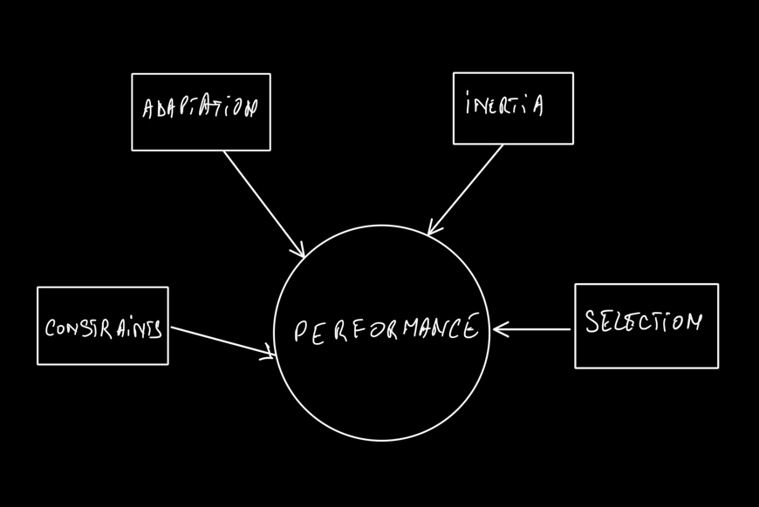

This model argue that organisation effectiveness is related to the environment where it operates.

Constraints: Internal factors met barriers of communication given the multitude of ethnicities and nationalities (over 100) The approach of organisation is to find ways to improve communication and to use diversity as an asset in creativity and innovation. External constraints are related to an environment with a very dynamic expansion, strong competitors: Uber Eats, Glovo, Deliveroo. Post Brexit workforce diminished and is hard to find new employees yet the company offer a good package and rewards for workers, the reviews on indeed website and Trustpilot shows that workforce is happy and they have a reduces workforce turnover.
Adaptation: Innovation and creativity are qualities well promoted in the organisational culture. New technologies are researched and the company is trying new ways to make ordering food a fun experience , easy for everyone and they innovate new ways of addressing public concerns like environmental issues. In Germany they offer possibility in partnership with restaurants to deliver food in reusable containers in a pilot project. The policy of organisation is to overcome barriers in adaptation being with one step ahead competition. Organisational structure and the model of leadership has a good positive impact on adaptation (Ben, Chan and Nel, 2000).
Inertia: Organisation it is aware of the barriers caused by inertia and has multiple programs and trainings together with upskill opportunities for staff to create all conditions to overcome such a problem.
Selection: Just EatTakeAway.com is leader on the market. One of the reason for holding this position is the ability to adapt and to face the challenges of the business environment. Sometimes partnerships with other producers of recyclable packaging or the response to the society needs for a clean environment promoting deliveries with green emissions increasing the electric fleet are the assets that makes organisation lead and getting stronger from selection process in the ecology of the market environment.

Performance can be improved maintaining the policies and values that made organisation successful, having a good reputation as employer and providing a desirable workplace, exploring new technologies and enhancing the talent acquisition to increase creativity. Using tools to check organisational health periodically can prevent inertia and other barriers to occure and gives the advantage of succeeding on ecological selection that operates in the business environment and moreover to keep up the leader position.

6.1 Conclusion

Just EatTakeaway.com is a leading organisation, innovative and setting new trends as food delivery service, offering new ways to experience food and being connected to the community. Investing in innovation, having a strong message about internal and external values and having a positive business ethic it is attractive for employees and offers a good connection with community participating to the concerns and problems in a forthcoming solution oriented manner.

7.1 References

Ahmady, G.A., Mehrpour, M. and Nikooravesh, A., 2016. Organizational structure. Procedia-Social and Behavioral Sciences, 230, pp.455-462.

Beer, M. and Nohria, N. eds., 2000. Breaking the code of change (Vol. 78, No. 3, pp. 133-141). Boston, MA: Harvard business school press.

Bell, C., Chan, M. and Nel, P., 2014. The impact of participative and directive leadership on organisational culture: An organisational development perspective. Mediterranean Journal of Social Sciences, 5(23), pp.1970-1970.

Harjanti, S.S. and Gustomo, A., 2017. Organizational Health Index and Organizational Agility Maturity Criteria as Measurement Tools of Organizational Transformation Effectiveness. Jurnal Manajemen Teknologi, 16(1), p.2017.

Ho, J.K.K., 2014. Formulation of a systemic PEST analysis for strategic analysis. European academic research, 2(5), pp.6478-6492.

Huhtala, M., Kangas, M., Lämsä, A.M. and Feldt, T., 2013. Ethical managers in ethical organisations? The leadership‐culture connection among Finnish managers. Leadership & Organization Development Journal.

Judge, T.A. and Robbins, S.P., 2017. Essentials of organizational behavior. Pearson Education (us).
Just eat takeaway.com - org chart (no date) THE ORG. Available at: https://theorg.com/org/just-eat-takeaway-com/org-chart (Accessed: November 18, 2022).
Mullins, L.J., 2007. Management and organisational behaviour. Pearson education.
Org chart just eat takeaway.com (no date) The Official Board. Available at: https://www.theofficialboard.com/org-chart/just-eat-takeaway-com-2 (Accessed: November 18, 2022).

Paais, M. and Pattiruhu, J.R., 2020. Effect of motivation, leadership, and organizational culture on satisfaction and employee performance. The Journal of Asian Finance, Economics and Business, 7(8), pp.577-588.
Sinclair, A., 1993. Approaches to organisational culture and ethics. Journal of Business ethics, 12(1), pp.63-73.

